Inspections of Australia’s immigration detention
facilities 2019
Report
December 2020

Contents
Human Rights Commissioner’s foreword 4
1 Introduction 7
2 Background 9
2.1 Immigration detention in Australia 9
2.2 2018 inspections 9
2.3 Methodology 10
2.4 Relevant human rights standards 11
2.5 COVID-19 and immigration detention 12
2.6 Refugees and asylum seekers subject to third country processing 13
2.7 Key statistics 15
2.8 Facility information 19
(a) Summary of inspections 19
(b) Perth Immigration Detention Centre 21
(c) Yongah Hill Immigration Detention Centre 21
(d) Adelaide Immigration Transit Accommodation 22
(e) Melbourne Immigration Transit Accommodation 22
(f) Villawood Immigration Detention Centre 23
(g) Brisbane Immigration Transit Accommodation 23
(h) Alternative places of detention 24
3 Key observations and concerns 26
3.1 Children 26
(a) Two young children at BRP 27
(b) Definition of child detention 30
(c) Unaccompanied 17-year-old at MITA 32
(d) Children on Christmas Island 35
3.2 Health care 36
(a) IHMS health services 36
(b) Access to specialist health care 39
(c) Medical transferees from Nauru and PNG 41
(d) Dental care 43
(e) Drug and alcohol rehabilitation 45
(f) Mental health care 47
(g) Mental health care at BITA 51
(h) Responses to self-harm and suicide 53
(i) Continuity of care 56
(j) Privacy and confidentiality 58
3.3 Physical safety 59
3.4 Placements and escort 60
(a) Placements 60
(b) Use of restraints during escort 62
3.5 Programs and activities 67
3.6 Excursions 72
3.7 Hotel APODs 74
(a) Accommodation 76
(b) Shared facilities and outdoor space 78
(c) Freedom of movement 85
(d) Pat searches 86
(e) Food 87
3.8 Physical conditions of detention 87
(a) Dormitory-style accommodation in low and medium security compounds 87
(b) High-security compounds 91
(c) Dargo compound 98
(d) Closure of Blaxland 100
(e) Recreational space and facilities 103
(f) High-care accommodation 116
3.9 Communication 121
(a) Mobile phones 121
(b) Visits 125
3.10 Length of detention 133
3.11 Status resolution 136
(a) Contact with status resolution officers 136
(b) Assistance provided by status resolution officers 140
(c) Risk of constructive refoulement 143
3.12 Alternatives to closed detention 143
Appendix 1 – List of recommendations 148
Appendix 2 - Human rights standards relevant to immigration detention 156
Appendix 3 - Residence determinations 161
Appendix 4 – Further photos taken during the Commission’s inspections in 2019 163
Endnotes 197

Human Rights Commissioner’s foreword
For several decades, the Australian Human Rights Commission has expressed deep and longstanding concern about the human rights of people held in Australia’s immigration detention facilities. As a result of our most recent inspection process, that concern has deepened.
Some of the issues of greatest concern to the Commission are as follows.
- A number of hotels, which have been temporarily repurposed as ‘alternative places of detention’ (APODs), provide very limited access to communal or outdoor facilities. While APODs are generally to be used only for short periods, many people are currently detained in these facilities for long periods, with significant negative consequences for their health and wellbeing.
- Many asylum seekers and refugees, who have serious medical conditions, have been transferred from Papua New Guinea and Nauru to Australia for assessment and treatment. While some of these people have been permitted to receive their care in the community, a large number remain in closed detention facilities where the Commission holds strong concern about their physical and mental health.
- The Commission also expresses alarm about the mental health of the broader detention population, with concerning rates of self-harm. Current treatment practices appear inadequate to deal with this problem.
- Almost all people in immigration detention rely on having a mobile phone to stay connected to family, friends, legal representatives and other professionals. While the Commission accepts that it may be legitimate to remove the mobile phone from a particular individual if it is shown that their use of a mobile phone would present an unacceptable security risk, we are concerned about plans to make it easier to remove access to mobile phones in situations beyond this one.
Moreover, as the Commission and other experts have observed many times in the past, almost every human rights problem in closed immigration detention is made worse the longer an individual is detained. Throughout 2019, the average period that an individual was held in immigration detention was close to or just above 500 days. As I write this foreword in 2020, the average period of detention has increased further. By the middle of this year, it was 553 days. Most recently, in September 2020, it had reached 581 days—the highest ever recorded.
This is orders of magnitude greater than any comparable jurisdiction. That people are detained for so long in Australia’s immigration detention system is not the necessary consequence of irregular migration, which affects many parts of the world. People are detained for long periods in Australia’s immigration detention network because of Australia’s current legal and policy framework.
Many developed countries face similar challenges to Australia in controlling their borders and, more specifically, in determining which non-citizens are permitted to enter and remain in the country. Some of these challenges have been made more difficult by events since the conclusion of the Commission’s inspections—especially the COVID-19 pandemic.
Since the inspections in this report were undertaken in 2019, the Government has re-opened the immigration detention facility on Christmas Island and increased its use of APODs, including in Darwin. While other jurisdictions have acted decisively to remove from closed detention people deemed to pose a low risk to the community, Australia’s immigration detention population has increased over the course of 2020. By November 2020, over 1,500 people remained in immigration detention.
The Government should act urgently to reduce the total number of people in immigration detention. Over a significant period of time, the Commission has identified many individuals for whom closed detention was not justified.
The urgency of this issue is increased as a result of the present pandemic and the ease with which infection spreads in places of closed detention. Noting the expert advice of the Australasian Society for Infectious Diseases, the Australasian College for Infection Prevention and Control and others, the Commission urges the Government to remove from immigration detention anyone who is not considered to pose a significant threat to the Australian community.
On 30 November 2020, the Commission received the Department of Home Affairs’ formal response to this report’s 44 recommendations. That response is published alongside this report.
The Department agrees, in whole or in part, with nine of the Commission’s recommendations in this report. In relation to some, it is unclear what steps the Department plans to take in order to implement them in whole or in part. The Department has stated that it accepts nine further recommendations ‘in principle’, but on those issues the Department disagrees with the Commission regarding the need for changes in law, policy or practice. The Commission is pleased that there are some areas of agreement with the Department on recommendations in this report. However, we urge the Government to give further consideration to all of the report’s recommendations.
As a liberal democracy, Australia takes its human rights obligations seriously. This means we should confront a difficult truth: we can and we must do better to protect the human rights of people subject to immigration detention.
This could start by building on some positive change. For example, since the Commission’s inspection process concluded, the number of children in immigration detention has reduced.
While the Commission remains concerned that a small number of children remain detained, most notably two very young children on Christmas Island, it is commendable that the Government has significantly reduced the total number of children in detention over the last few years. The Commission considers that the small number of children who remain in immigration detention should be housed, with their parents or guardians, in the community.
Finally, this report makes a number of practical recommendations to improve the mental and physical health, as well as the broader wellbeing, of people whom the Government determines must remain in detention. These recommendations would enable genuine risks in immigration detention to be managed safely, while also protecting the human rights of all people held in immigration detention.

Edward Santow
Human Rights Commissioner
3 December 2020

Introduction
The Australian Human Rights Commission (Commission) has conducted inspections of immigration detention facilities in Australia since the mid-1990s. This has included periodic monitoring of detention facilities across the country and inspections carried out during three national inquiries into immigration detention.
The Commission’s detention inspections assess whether Australia’s immigration detention system complies with Australia’s obligations under international human rights law. For many years, the Commission has expressed a range of concerns about aspects of the detention system, which may lead to breaches of international human rights law.
This report documents the Commission’s key observations and concerns in relation to treatment and conditions in immigration detention arising from inspections of all facilities on the Australian mainland conducted during the second half of 2019. Some of the issues that the Commission identifies are specific to individual facilities and others are systemic in nature and relevant to Australia’s network of immigration detention facilities.
The rationale for the Commission undertaking such inspections is to identify problems in the way that detainees’ human rights are being protected and to suggest ways of addressing those problems. While the report documents some good practices, its primary focus is on issues of concern identified by the Commission. This report makes 44 recommendations to address these concerns.
The Commission acknowledges the contributions of the following independent medical consultants: Dr Bernadette Wright, Dr Jane Standish, Dr Penny Abbott and Dr Edward Heffernan. They each participated in an inspection of an immigration detention facility alongside Commission staff and provided advice on issues relating to the health and/or health care of people in immigration detention.
The Commission also acknowledges the assistance provided by the Department of Home Affairs (Home Affairs) and the Australian Border Force (ABF) in facilitating the Commission’s detention inspections. The Commission is grateful to the staff of Home Affairs, the ABF and detention service providers who assisted the Commission team during the inspections.
In accordance with usual practice, the Commission provided a copy of this report to Home Affairs on 28 August 2020 to provide an opportunity for response to the Commission’s findings and recommendations prior to publication. The Commission requested that Home Affairs provide a response to this report in the usual period for comment, which is 28 days. The Commission understands that additional demands on resources over recent months delayed Home Affairs’ response to this report. On a number of occasions since the original deadline for response of 24 September 2020, the Commission agreed to requests from Home Affairs for extensions of time to provide a response. The Commission received a response from Home Affairs on 30 November 2020 which has been published alongside this report.

Background

Immigration detention in Australia
Under s 189 of the Migration Act 1958 (Cth) (the Migration Act), immigration detention is mandatory for all ‘unlawful non-citizens’ (that is, non-citizens within Australia who do not hold a valid visa), regardless of circumstances. Once detained, unlawful non-citizens must remain in detention until they are either granted a visa or removed from Australia.
The detention of an unlawful non-citizen is not based on an individual assessment of the need for detention. All unlawful non-citizens must be detained, regardless of whether they individually pose an unacceptable risk to the community.
The Migration Act does not require that unlawful non-citizens be detained in purpose-built, closed immigration detention facilities. In some circumstances, people in detention can be released from closed facilities into alternative, community-based arrangements. Community alternatives to detention include:
- release on short-term visas, such as Bridging Visas
- residence determinations (also known as community detention), whereby the Minister makes a determination under s 197AB of the Migration Act that a person is to reside in a specified place rather than being held in a detention facility.
Both options involve the Minister exercising a personal, non-compellable, discretionary power under the Migration Act.

2018 inspections
During 2018, the Commission conducted a series of inspections of immigration detention facilities focusing on risk management practices in immigration detention.
In preceding years, the Commission had identified a significant shift in risk management practices in immigration detention. This shift emerged largely as a result of the changing composition of the immigration detention population, specifically the increase in the number and proportion of people in detention who have had visas cancelled on character grounds.
The Commission expressed concern about some risk management strategies, including:
- Inaccurate risk assessments may result in people in detention being subject to restrictions that are not warranted in their individual circumstances.
- The use of restraints during escort outside detention facilities has become routine and may in some cases be disproportionate to the risk of absconding.
- Conditions in high-security accommodation compounds and single separation units are typically harsh, restrictive and prison-like.
- Restrictions relating to excursions, personal items and external visits are applied on a blanket basis, regardless of whether they are necessary in a person’s individual circumstances.

Methodology
Between August and November 2019, the Commission conducted inspections of the following immigration detention facilities:
- Perth Immigration Detention Centre (PIDC)
- Yongah Hill Immigration Detention Centre (YHIDC)
- Adelaide Immigration Transit Accommodation (AITA)
- Melbourne Immigration Transit Accommodation (MITA)
- Villawood Immigration Detention Centre (VIDC)
- Brisbane Immigration Transit Accommodation (BITA).
The Commission also inspected several ‘alternative places of detention’ (APODs) in Melbourne and Brisbane (see Section 2.8(h) below).
During the inspections, the Commission met with representatives from Home Affairs, ABF and contracted detention service providers, Serco and International Health and Medical Services (IHMS); conducted inspections of the physical conditions of detention in each facility; and held over 280 interviews with people detained across the six facilities and in APODs.
The Commission engaged a number of independent medical consultants with expertise across psychology, psychiatry, paediatrics and general practice (Dr Bernadette Wright, Dr Jane Standish, Dr Penny Abbott and Dr Edward Heffernan) to participate in the inspection of an immigration detention facility alongside Commission staff, and provide advice on issues relating to the health and/or health care of people in immigration detention. An independent medical consultant participated in the Commission’s inspections of all facilities, except for AITA.
In conducting the inspections, the Commission focused on gathering information about conditions and treatment in immigration detention. This included information about the following: case management and status resolution; treatment in detention, such as safety and security and use of restraints; health care; accommodation and other facilities; recreation and activities; communication and visits; and impacts of detention.
The Commission considered the material gathered during the inspection by reference to international human rights law standards that are relevant to immigration detention, as outlined below.
The Commission’s methodology reflects international guidelines for the conduct of detention inspections, including a core focus on prevention of harm. This preventative approach involves considering root causes and risk factors related to human rights issues.

Relevant human rights standards
There are nine core international human rights instruments, of which seven have been ratified by Australia. These treaties contain obligations that are relevant to the conditions and treatment of people in immigration detention:
- International Covenant on Civil and Political Rights (ICCPR)
- International Covenant on Economic, Social and Cultural Rights (ICESCR)
- Convention against Torture and Other Cruel, Inhuman or Degrading Treatment or Punishment (CAT)
- Convention on the Rights of the Child (CRC)
- Convention on the Rights of Persons with Disabilities (CRPD)
- Convention on the Elimination of All Forms of Discrimination against Women (CEDAW)
- Convention relating to the Status of Refugees (the Refugee Convention).
Australia has a range of specific obligations towards refugees and asylum seekers under the last of these conventions.
Some key obligations relevant to conditions and treatment in immigration detention include those relating to: security of the person; humane treatment in detention; freedom from arbitrary detention; freedom from torture and other cruel, inhuman or degrading treatment or punishment; privacy; freedom of religion; freedom of expression and association; education; an adequate standard of living; health, participation in cultural life; protection of the family; and, consideration of the best interests of the child.
Further information about relevant standards can be found in Appendix 2 to this report, as well as in the Commission publication, Human rights standards for immigration detention.

COVID-19 and immigration detention
Since the Commission completed its inspections in the second half of 2019, the outbreak of the coronavirus (COVID-19) pandemic has introduced significant new challenges for Australia’s immigration detention facilities.
It has been widely recognised that COVID-19 poses heightened risks to people in all forms of detention, including immigration detention facilities and prisons, where adequate physical distancing may be difficult or impossible. The Department of Health has recognised that people in correctional and detention facilities are among those most at risk of contracting the virus in Australia.
COVID-19 is also acknowledged as a significant health risk for individuals who are at higher risk of developing severe illness. This includes elderly people, people with chronic medical conditions and people with compromised immune systems.
While the inspections for this report took place before the pandemic, many of the matters dealt with here are of elevated importance because of COVID-19. People detained in immigration detention facilities live in close proximity and generally share living arrangements. Implementing adequate physical distancing in such conditions would be very difficult. In addition, many people in immigration detention would be at higher risk of developing severe illness if they contracted COVID-19. Relevant factors identified in this report include:
- some immigration detention facilities were operating over their operational capacity (see Section 2.8(a))
- there is overcrowding in some compounds with dormitory-style accommodation (see Section 3.8(a))
- people in immigration detention facilities generally share bedrooms as well as toilet and shower facilities with other people, in some cases with large numbers of other people (see Section 3.8)
- significant numbers of people in immigration detention have pre-existing health conditions that may put them at higher risk if they contract COVID-19 (see Section 3.2(a)).
The Commission acknowledges the work of the Australian Health Protection Principal Committee (AHPPC) in providing advice to the Government on preventing and managing a potential outbreak of COVID-19 in detention settings. The AHPPC endorsed guidelines developed by the Communicable Diseases Network Australia (CDNA Guidelines) for addressing risks posed by COVID-19 for Australia’s correctional and other detention facilities. The CDNA Guidelines are necessarily broad, in that they apply to all forms of detention and correctional facilities in Australia, including prisons, juvenile detention centres, youth justice centres and immigration detention facilities. They do not refer to the specific characteristics of Australia’s immigration detention facilities, and their application to this context requires consideration of the particular issues that arise in this environment and the use of clinical judgment.
Public health experts, including the Australasian Society for Infectious Diseases (ASID) and the Australasian College for Infection Prevention and Control (ACIPC), have advised that an effective response to protecting the health of people in immigration detention and the broader community requires a significant reduction of the numbers of people in immigration detention, in addition to other risk mitigation strategies to prevent and manage an outbreak of COVID-19.
The Commission is currently conducting a targeted review of the management of COVID-19 risks in Australia’s immigration detention facilities. The review will consider these matters in the context of Australia’s obligations under international human rights law, with particular reference to expert public health and infectious diseases advice. The Commission will document its findings and recommendations in a report.

Refugees and asylum seekers subject to third country processing
At the time of the Commission’s 2019 inspections, there were 196 refugees and asylum seekers subject to third country processing detained in immigration detention facilities in Australia. Most people the Commission interviewed in this group had been transferred to Australia from Papua New Guinea and Nauru for medical treatment and/or assessment. Only a few had been transferred as accompanying family members.

Figure 1: Number of refugees and asylum seekers subject to third country processing in onshore immigration detention at the time of the Commission’s 2019 inspections.

The Commission has expressed serious concerns about treatment and conditions, including availability of timely and appropriate health care, for refugees and asylum seekers subject to third country processing in PNG and Nauru. The Commission considered the repeal of the ‘medevac legislation’ in December 2019 to be a retrogressive measure in relation to the right to the highest attainable standard of physical and mental health.
Refugees and asylum seekers subject to third country processing, who have been transferred to Australia, are defined as ‘transitory persons’ under the Migration Act. Transitory persons are subject to mandatory immigration detention in Australia. As outlined in Section 2.1, the Minister can exercise a personal and non-compellable power to release a person from a closed facility into alternative, community-based arrangements.
Transitory persons are not able to apply for any visas in Australia unless the Minister exercises a personal and non-compellable power to ‘lift the bar’ and allow an individual to lodge a visa application.

Key statistics
Beginning in 2013, there was a significant reduction in the number of people in immigration detention. This reduction was largely due to the release of a significant number of asylum seekers from closed detention into alternative community arrangements; and a decrease in the number of people entering detention, following a significant decline in boat arrivals to Australia.
However, since mid-2016, the number of people in detention has ranged between 1,200 and 1,500.
Figure 2: Number of people in immigration detention—July 2013 to December 2019.

Figure 3: Number of people in immigration detention—2019.

The average length of detention has remained at over 400 days since mid-2015. It exceeded 500 days for the first time on public record by December 2018. Throughout the course of 2019, the average remained close to or just above 500 days—the average did not drop below 483 days, and the highest average was 509 days at the end of the year.
The average length of detention continued to increase in 2020, with 581 days in September 2020—which is the highest ever recorded. On average, the number of people in very long-term detention (two years or longer) comprised around 22% of the detention population during 2019, which is an increase from around 20% in 2018.
The length of time in immigration detention is far higher in Australia than in comparable jurisdictions. For example, in the United Kingdom, in December 2018, 87% of all detainees had been in immigration detention for under 6 months and 30% for fewer than 28 days. In Canada, the average length of detention was 12.3 days between January and March 2019.

Figure 4: Average length of time in immigration detention—July 2013 to December 2019.

Figure 5: Average length of time in immigration detention—January 2019 to March 2020.

The Migration Amendment (Character and General Visa Cancellation) Act 2014 (Cth), which came into effect in December 2014, significantly broadened the scope of s 501. These changes led to a substantial increase in visa refusals and cancellations under s 501. Consequently, the number of people in immigration detention due to character-related visa decisions also increased from 2015 onwards.
Figure 6: People in immigration detention by reason for detention—January 2015 to December 2019.

Throughout 2019, people detained due to having their visa cancelled (either under s 501 or another provision) consistently comprised around half of the overall detention population.
During the first half of 2019, the number of people detained due to visa cancellation under s 501 was only slightly higher overall than those whose visa was cancelled under other provisions. However, those in detention as a result of s 501 cancellations were substantially higher in the second half of 2019.

Figure 7: People detained due to visa cancellations—2019.

Facility information

Summary of inspections
The table below provides an overview of the main purpose-built facilities the Commission inspected in 2019, and the dates that these inspections took place. It also contains information about the capacity of each facility, where available, as well as the number of detainees at each facility at or around the time of the Commission’s inspections.

Table 1: Summary of the Commission’s 2019 inspections.
Facility | Dates of inspection | Operational capacity | Surge capacity | Population at or around the time of inspection
PIDC | 12 August | 32 | 40 | 25
YHIDC | 13-15 August | 420 | 460 | 327
AITA | 27 August | 25 | 38 | 32
MITA (including BRP) | 9-12 September | 263 | 309 | 260
VIDC | 23-26 September | 480 | 559 | 450
BITA | 11-14 November | 119 | 140 | 120
Total |  | 1339 | 1546 | 1214
This table does not include information about the capacity or population of any offsite APODs in operation at or around the time of the Commission’s inspections. As outlined further below in Section 2.8(h), the Commission inspected two offsite APODs during its 2019 inspections—a hotel in Preston, Melbourne, where 23 people were detained, and a hotel in Kangaroo Point, Brisbane, where 72 people were detained.
As outlined in the table above, the operational capacity of all purpose-built immigration detention facilities, excluding all offsite APODs, is 1,339 and the total number of people detained in these facilities at the time of the Commission’s 2019 inspections was 1,214.
Each facility is able to accommodate population numbers over operational capacity to a limit, which is referred to as their ‘surge capacity’. In exceptional circumstances, a facility may need to operate at surge level capacity, however, the Commission considers that this would only be appropriate for very short periods of time.
In addition, the Commission has previously found that offsite hotel APODs are not appropriate places of detention and should only be used in exceptional circumstances and for very short periods of time. These concerns are ongoing and documented further in Section 3.7 of this report.
The Commission does not consider that the surge capacity of each facility nor the capacity of offsite APODs provide suitable additional capacity to accommodate higher numbers of detainees for longer periods.
Since the Commission’s inspections in 2019, the number of people in immigration detention has continued to increase. In September 2020, the total number of people in immigration detention facilities, including all offsite APODs, was 1,534.
Numerous risks are presented by increasing numbers of people in closed immigration detention facilities, and these are heightened significantly because of COVID-19. The Commonwealth Ombudsman has stated that increasing numbers of detainees during COVID-19 will increase the risk, should the COVID-19 virus occur in one of the facilities, and recommended that the numbers of people held in immigration detention facilities be reduced. The Commission shares these concerns. Consistent with the view of public health and infectious diseases experts, the Commission has urged the Government to release people detained in closed immigration detention facilities into community detention, if those people do not pose a security risk to the community.

Perth Immigration Detention Centre
The PIDC is a small, medium-security detention facility adjacent to Perth airport. It currently accommodates adult men and women.
The facility is currently divided into two main compounds, a larger compound for men and a smaller compound for women, which both contain small outdoor and indoor recreational areas. There is a small, shared dining area that doubles as an activities space for both men and women. It also contains two ‘high care accommodation’ rooms used for single separation.
Facility staff reported that people with complex mental health needs are often placed at PIDC.

Yongah Hill Immigration Detention Centre
YHIDC is a large, high-security detention facility with a securitised perimeter including high fencing, anti-climb measures and other security features. It is located in the town of Northam in Western Australia, approximately 100 kilometres from Perth. It accommodates adult men.
The YHIDC has two main accommodation compounds, Falcon and Hawk, that are used for detainees assessed as low to medium risk by facility staff. In addition, four new high-security accommodation compounds (Cassowary, Eagle, Kingfisher and Swan) have been in operation since December 2018. These new compounds are used for detainees assessed as high risk by facility staff. At the time of the Commission’s previous inspection in 2018, these compounds had been constructed but were not yet in use.
Detainees in these high-security compounds have more restricted access to shared spaces and facilities outside of their compounds, compared to those in the Falcon and Hawk compounds. The Swan compound is the most restrictive and is used for detainees that have the highest risk rating as assessed by facility staff. Kingfisher is used for detainees who, for various reasons, are assessed by facility staff to require protection from others.
YHIDC has an expansive, central outdoor area (called the ‘Green Heart’) that is used for recreation. It contains two full-size soccer fields, a large outdoor gym, two full-size basketball courts and some gardening plots. There is also a large activity complex with various purpose-built facilities, such as a large kitchen for cooking classes, a woodwork studio and an indoor gym.
YHIDC also has several smaller ‘health care’ compounds, located next to the medical facilities. These are used for people who have significant health care needs. YHIDC also has a ‘high-care accommodation’ unit used for single separation.

Adelaide Immigration Transit Accommodation
AITA is a small, low-security detention facility. It currently accommodates adult men and women across three compounds—Kangaroo, Emu and Platypus. There is also a self-contained unit (Koala) with disability access that can accommodate up to two people with higher needs.
AITA has a small central outdoor courtyard with a volleyball court and an indoor common area that is used for meals and visits.

Melbourne Immigration Transit Accommodation
Following significant infrastructure works, the site of the original MITA facility (which was a low-security facility designed for short-term detention) has been split into two separate complexes. MITA North is a high-security complex with high fences and other extensive security features that has been in operation since 2018 and is used to detain adult men. The complex is divided into four main accommodation compounds (Dargo, Erskine, Ford and Glenelg). Dargo is used for detainees who for various reasons are assessed by facility staff to require protection from others. The complex also contains the Shaw compound, a ‘high-care accommodation’ unit used for single separation.
MITA South is a medium-security complex that is divided into three accommodation compounds. The Avon compound accommodates adult men. At the time of the Commission’s inspection, there was one teenager in an annex in the Avon compound. The Bass 1 and Bass 2 compounds accommodate adult men and adult women respectively.
Both complexes contain access to outdoor areas and shared facilities, however compared to other larger immigration detention facilities, such as YHIDC and VIDC, these recreation areas are generally older, smaller and more limited. There is no movement of detainees between these two complexes to access facilities or services.

Villawood Immigration Detention Centre
VIDC is a large, high-security detention facility located in the western suburbs of Sydney. It has undergone extensive refurbishment since 2011, with much of the previous infrastructure demolished and replaced with new accommodation and facilities.
VIDC is used to detain adult men and women across several compounds. La Trobe and Lachlan are lower-security compounds that accommodate adult men. Lima, also a lower-security compound, is used to accommodate adult women.
Hotham, Mackenzie and Mitchell are self-contained, medium to high security compounds that accommodate adult men. They each contain an outdoor courtyard, a full-size soccer pitch, a half-size basketball court and other facilities such as a small gym and an educational classroom. The Hotham compound, located closest to the medical facilities, typically accommodates people with significant health conditions and/or other significant needs. The Hotham compound also contains 12 ‘high-care accommodation’ rooms used for single separation.
VIDC contains a large, central ‘community area’ with various facilities such as an indoor gymnasium, a gym, educational classrooms, a shop and a large, grassy oval. This area is only accessible to those in the lower-security compounds.
At the time of the Commission’s inspections, the Blaxland high-security compound, which is separate from the main facility, was the only compound that had not yet undergone refurbishment. Since the Commission’s inspections of VIDC in September 2019, the Blaxland compound has closed. The transfer of people from Blaxland to the new high-security compound was completed in March 2020.

Brisbane Immigration Transit Accommodation
Similar to MITA, the BITA was also originally a low-security facility used for short-term detention. It has also been split into two separate areas.
The low security ‘residential’ area of the facility contains four accommodation compounds (Bedarra, Carlisle, Daintree and Eucalyptus). It is used to accommodate people who are assessed by facility staff to present a low to medium risk. The ‘residential area’ contains an outdoor grassed area with a garden, a full-size basketball court, an indoor gym and a small common area that is used for meals.
At the time of the Commission’s inspection, the ‘residential area’ was being used exclusively to detain adult men. Staff advised that BITA has not had any women in the main accommodation areas since September 2018.
Fraser and Moreton are high-security compounds set apart from the ‘residential area’ with high fencing, anti-climb measures and other security features. They are used to detain adult men who are assessed to present a high risk by facility staff. There is a small, fenced outdoor area with a half-size basketball court that may be accessed by those detained in Fraser and Moreton on a rostered basis, and the shared dining area is also used for programs and activities. The Hamilton compound, located adjacent to Fraser and Moreton, is a ‘high-care accommodation’ unit used for single separation.

Alternative places of detention
APODs are closed detention facilities that are set up for people whose needs cannot be adequately met in other facilities, or where there is inadequate capacity in other facilities. Some APODs are purpose-built for detention, while others were built for another purpose (such as hospitals and hotels) but have been temporarily designated as places of detention for the purposes of the Migration Act.
The Commission inspected three APODs. The first was the Broadmeadows Residential Precinct (BRP). BRP is a small, permanent purpose-built APOD adjacent to MITA. It is a low-security facility that provides residential-style accommodation. It contains 10 three-bedroom units with fully equipped kitchens in each unit, where people can cook their own meals. Two units have been built to ensure disability access. At the time of the Commission’s visits, two infants resided at BRP with their respective mothers.
The Commission also inspected a hotel in Preston, Melbourne, which had been temporarily designated as a place of detention and in operation since July 2019. At the time of the Commission’s inspection, it consisted of two wings (East and South) across one level of the hotel. At the time of inspections, 23 adult men were detained there. They were all subject to third country processing and had been transferred to Australia from Papua New Guinea for medical assessment and/or treatment.
The third APOD inspected was a hotel in Kangaroo Point, Brisbane, which had been temporarily designated as a place of detention and had been in operation since February 2019. Prior to February 2019, there was an APOD operating at another hotel in Brisbane, which the Commission inspected in 2018. Facility staff informed the Commission that they relocated to Kangaroo Point due to space constraints. At the time of the Commission’s inspection, it was much larger than the Melbourne hotel APOD and included an entire building of the hotel with four levels (the Lockerbie building) and a few levels of another building (the Walmsley building). At the time of inspection, there were 71 adult men and one adult woman detained there, with capacity for 84 people. They were all subject to third country processing and had been transferred to Australia from Nauru or Papua New Guinea for medical assessment and/or treatment.

Key observations and concerns
During its 2019 inspections, the Commission’s key observations and concerns related to:
- children
- health care
- physical safety
- placements and escorts
- programs and activities
- excursions
- hotel APODs
- physical conditions of detention
- communication
- length of detention
- status resolution
- alternatives to closed detention.
These issues are detailed in the following sections—some observations and concerns relate to individual facilities and some apply to all immigration detention facilities.
By far the most important, urgent and consistent concerns raised by people in immigration detention during interviews with the Commission were the length of their detention and resolving their immigration status.

Children
The number of children in closed immigration detention has decreased markedly since 2012, and community-based alternatives to closed detention are most commonly used for children. There were five children in closed immigration detention facilities during the Commission’s 2019 inspections:

- two young children resided with their respective mothers at BRP (the mothers were interviewed by the Commission during its inspection)
- an unaccompanied teenager was detained at MITA (the teenager was interviewed by the Commission)
- two children, aged two and four years old, were transferred to an immigration detention facility on Christmas Island with their parents from BRP shortly prior to the Commission’s inspection of MITA.
For over 30 years, the Commission has expressed strong concern about the human rights impact of closed immigration detention on children. The current number of children in detention is significantly lower than at some other times over the past three decades, and this is to be commended.

However, as outlined in greater detail below, the Commission is deeply concerned about the respective situations of the children who remain in immigration detention. Since the Commission’s 2019 inspections, one mother with a young child at BRP was granted a bridging visa and released from immigration detention to reside in the Australian community in August 2020. The Commission welcomes the Government’s decision to allow this mother and her young child to reside together in the Australian community.

Two young children at BRP
The two young children, both 18 months old, were in the low-security BRP adjacent to MITA, each in a self-contained unit with their respective mothers. The units at BRP are spacious, well-furnished and comfortable. Each unit contains a fully equipped kitchen, where people can cook their own meals. The units open onto a shared outdoor common area, containing seating, shaded areas, garden beds and children’s play equipment. The external fences are lower and less imposing than those typically used for immigration detention facilities.
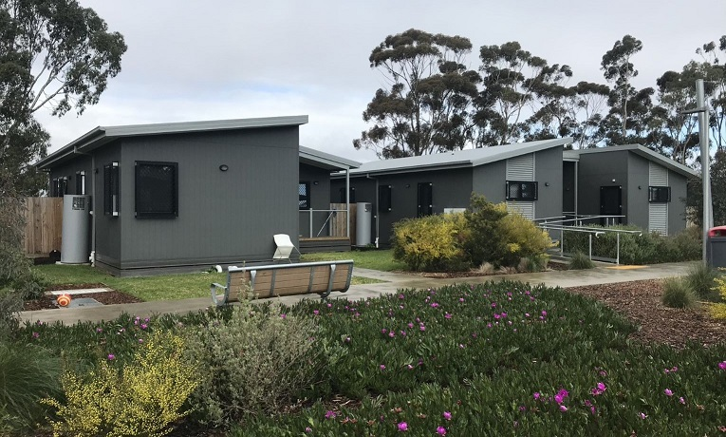
Accommodation units, BRP, MITA
During interviews, the two mothers raised concerns about restrictions on learning and socialisation for their children in immigration detention. Both reported that they were permitted to take their children on a weekly excursion to a public library to participate in a playgroup run by the local council. They recognised that some officers exercised more discretion than others but expressed concern about the close supervision by officers during these excursions. One mother said:

When they give us a trip to the library, [my child] doesn’t like it. Three officers come with us and they stand close where they can see us. If my child starts to run, I chase her and then the officers chase me … I want to go somewhere that she can explore.

One mother reported that her requests for additional excursions to the zoo or the aquarium had not been approved.

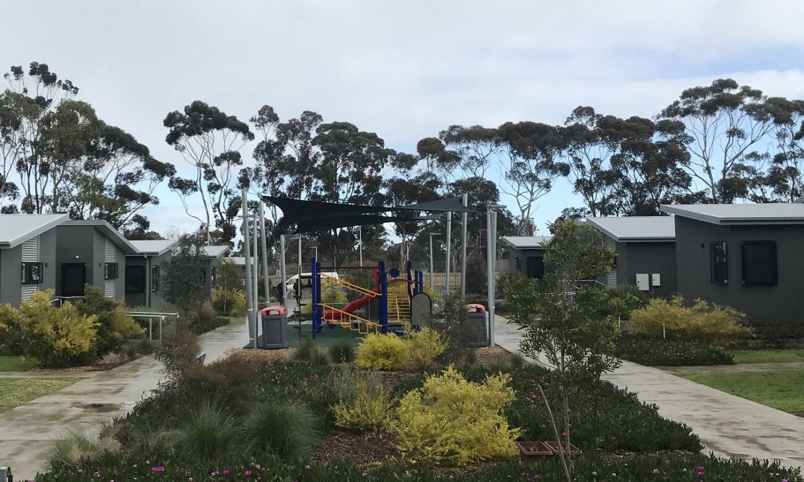

Outdoor area and children’s playground, BRP, MITA

While family members are able to visit children in immigration detention, there were restrictions on infants at BRP spending time with both of their parents. For example, one mother said:

Visits with my husband can be a few hours. When he wants to give our daughter gifts, they have to go through property and security. He brought a baby book, but it had pop-up pages and it was not allowed, I don’t know why. My husband can play with our daughter, but he is not allowed to hug or kiss me. I am not allowed to bring a cooked meal to the visitor centre, they make me throw it out before I meet him.

Both mothers said that they would like their children’s fathers to be able to visit them in their units at BRP, instead of at the visitors’ centre at MITA. They said this would allow them to spend time as a family in a more private setting and engage in more normal activities together such as making a home cooked meal and playing with their child in a more residential environment.

Early childhood experiences for children under five years old lay the developmental foundations for learning, health and behaviour throughout life. The Commission observed that, despite efforts made by facility staff, the nature of immigration detention makes it difficult (if not impossible) to cater to the specific needs of children and families, including opportunities for children to learn and socialise with peers and have an appropriate family-based environment. The developmental needs of young children cannot be met in closed immigration detention, and furthermore the adverse, long-term impacts of childhood detention are well established.

Definition of child detention
As outlined above, there were five children in closed immigration detention at the time of the Commission’s inspections. However, this figure was not reflected in the then-current publicly available Home Affairs statistics, which indicated that there were fewer than five children in closed detention at the time.

During inspections, the Commission sought clarification from facility staff in relation to the discrepancy. Facility staff advised that two of the five children living in closed detention facilities were legally allowed to live in the community, and so were not considered by the Department to be ‘detained’. These two children were living in detention facilities with their mothers, who were detained under the Migration Act. For that reason, they were not included in the relevant statistics. Facility staff indicated that the Department refers to children in this position as ‘guests’ in immigration detention.
The legal status of one of the children was confirmed by one mother, who explained that she was asked to sign paperwork in order to provide consent for her child to remain with her in immigration detention. She said:
They were going to take her away. Now they say that I requested for [my child] to live in detention. She is a ‘guest’ but she is locked in. I am breastfeeding. She goes out for some days with her father, but it is unsettling for her.
Both mothers reported that they are the primary caregivers for their respective children, and that the fathers are not in a position to provide the full-time care that their young children require in the community. One infant had been residing with their mother in immigration detention for eight months and the other since birth.
The UN Working Group on Arbitrary Detention (the UN WGAD) has considered the circumstances of one of these children. Given this child has the visa status of her father, who resides in the community, the Government considers that she is residing in detention due to a decision made by her parents, which may be withdrawn at any time, rather than being detained by the Government. However, the opinion of the UN WGAD is that the situation of this child qualifies as detention.
The Commission agrees with the assessment of the UN WGAD. Australian law does not require these infants to be detained; however, if they are to remain with their respective mothers, who are the primary caregivers and who are both in immigration detention, the Government has effectively required that the infants must also be detained.
Applying relevant international law, the Commission’s human rights standards for immigration detention make clear that children should not be detained, except as a last resort and for the shortest possible period. There is also an emerging consensus that the relevant human rights standard for immigration detention is one of ‘no detention’ (see Appendix 2 for further information). For example, the Joint General Comment from the UN Committee on the Protection of the Rights of All Migrant Workers and Members of Their Families, and the UN Committee on the Rights of the Child, states that detaining children as a measure of last resort is not applicable in immigration proceedings as it would be contrary to the best interests of the child and the right to development. The Joint General Comment states that any kind of immigration detention of children should be prohibited by law and should be fully implemented in practice. The Commission recently recommended that the Australian Government legislate to prohibit placing children in closed immigration detention and use alternative community-based measures.
The Commission’s Standards further state that children should not be separated from parents or primary caregivers unless this is in the best interests of the child. Furthermore, primary care-givers of children should not be detained unless they are individually assessed as posing an unacceptable risk to the Australian community and that risk cannot be met in a less restrictive way. The Commission also notes that Australia has obligations under article 17(1) of the ICCPR and article 16(1) of the CRC not to subject anyone to arbitrary or unlawful interference with their family.
In accordance with its obligations under international human rights law, Australia must consider the best interests of the child. In the Commission’s view, the detention of children, especially very young children, in closed immigration detention facilities is never appropriate and cannot be justified. Community-based alternatives to closed detention are readily available and already most commonly used for children and their families in Australia. The Commission considers that all parents with children, including unaccompanied children, should be able to reside in community-based alternatives to closed immigration detention.

The Minister for Home Affairs or the Minister for Immigration, Citizenship, Migrant Services and Multicultural Affairs should release all parents with dependent children, including unaccompanied children, into community-based alternatives to closed immigration detention.

The Commission considers that the situation of a child who resides with one or more detained parents is functionally identical to that of a child who is themselves detained. The effects of the detention environment on the child will be the same in both cases. Home Affairs refers to the first category of child as a ‘guest’. However, the only way such a child would be able to leave detention would be to remove the child from their detained parent or parents. Especially where a detained parent is the primary caregiver, this would almost never be in the best interests of the child.

Consequently, the Commission’s view is that all children residing in closed immigration detention facilities (including APODs) should be included in the Department’s reports on immigration detention statistics. Regardless of whether, for its own purposes, the Government seeks to categorise children who are in immigration detention, for reasons such as those referred to above, separately, it is important to understand clearly the number of children who are in immigration detention at any moment in time. This will enable appropriate public scrutiny of the detention of children in Australia.

The Department of Home Affairs should include all children residing in closed immigration detention facilities (including alternative places of detention) in its immigration detention statistics.

Unaccompanied 17-year-old at MITA
The 17-year-old unaccompanied teenager was detained in the medium-security Avon compound in the main facility at MITA. He had separate sleeping and bathroom quarters with a small common room in an annex; however, he shared other areas in the compound with adult men. He had been in immigration detention for two years.

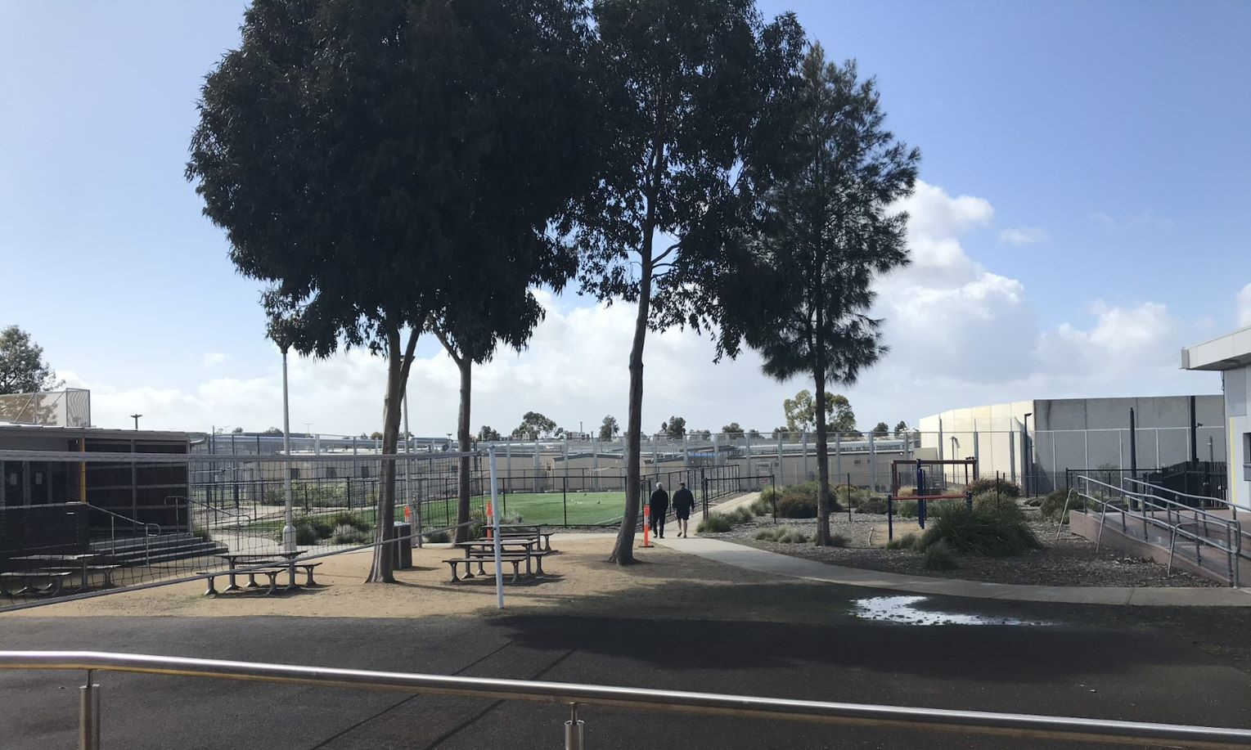

Avon compound, MITA
The teenager told the Commission that he receives individual tuition for one hour each day by a facility staff member. He said that it was difficult to engage in these classes because it was not ‘proper school’ and requested increased hours with a qualified teacher, who was not also a facility employee. He had no opportunities to engage in social or learning activities with other teenagers of a similar age. Facility staff at MITA informed the Commission that they offered individual tuition with a teacher within the facility as well as opportunities to develop other skills such as computer courses.
Access to education is vital for healthy teenage development. Schooling provides opportunities to build social networks and to develop knowledge and skills to facilitate the transition to adulthood. In accordance with its obligations under international human rights law, Australia is required to provide children in detention access to the same level of education as any other child in Australia with similar needs.
During an Inquiry conducted in 2004, the Commission found that the education available onsite to children in immigration detention facilities between 1999 to 2002 did not meet relevant human rights standards. Numerous barriers to providing an adequate education for children within facilities were identified: insufficient curriculum design and implementation; inadequate assessment of educational needs; insufficient infrastructure and resources; a shortfall and a high turnover of qualified teachers; inadequate hours of schooling that fell well under the standard six-hour day in Australian schools; and low attendance levels particularly amongst older children, due to mental health issues and the absence of a sufficiently stimulating curriculum. The Commission also observed that where arrangements for external schooling were made, this resulted in a significant improvement in the level of education provided to children in detention.
Even where education is available and adequate for children in immigration detention, it is well established that the stress of being in detention can have a negative impact on teenage learning (such as the ability to concentrate and absorb new information). The Commission has previously found that detention impedes the social and emotional maturation of teenagers, and puts them at high risk of mental illness, emotional distress and self-harming behaviour.

While the Commission does not have sufficient information to assess whether the education available to the teenager at MITA meets relevant human rights standards, the limited hours of tuition provided and the absence of a learning environment with peers is cause for concern.
The Commission considers that arrangements for children in immigration detention to access education externally in Australian schools, where they are able to learn and develop alongside their peers, is preferable, and all efforts should be made to facilitate this.

The Department of Home Affairs should ensure that all children in closed immigration detention have the opportunity to access education externally in Australian schools.

The teenager reported that, while most staff in the Avon compound were ‘good and respectful’, two incidents involving two different officers, which had since been addressed by facility management, had significantly affected his mental health and his ongoing perception in relation to his physical safety.

He reported routine use of restraints (metal handcuffs) during escort, and that he had previously been subject to the use of a body belt during escort. He also said that previously he had been isolated in the annex in handcuffs under the supervision of six Serco officers.

Australia must ensure that all children are safe, and any child deprived of their liberty should be treated with humanity and respect for the inherent dignity of the human person, in a manner which takes into account the needs of persons of his or her age. In 2016, the Australian Government developed a Child Safeguarding Framework, designed to ensure that the Australian Government meets its child protection and wellbeing obligations in an immigration context (including in relation to immigration detention).

The Commission considers that the use of physical restraints, as well as other practices employed to manage the risk and behaviour of adults (such as single separation), are not suitable for children and teenagers and may cause significant and disproportionate harm. The use of physical restraints and single separation should not be applied to children or teenagers in immigration detention as a security measure or as a means of discipline.

The Department of Home Affairs should prohibit the use of physical restraints and single separation on children and teenagers in immigration detention.

Children on Christmas Island
As noted above, two children, aged two and four years old, were transferred to an immigration detention facility on Christmas Island with their parents from BRP shortly prior to the Commission’s inspection of MITA.
The Commission did not inspect the Christmas Island Immigration Detention Centre because during planning for its 2019 inspections these facilities had only recently been re-opened and at the time nobody was detained there. The Commission was therefore not able to see the children or interview their parents during its inspections in 2019.
In September 2019, the Human Rights Commissioner, Edward Santow, and the then National Children’s Commissioner, Megan Mitchell, wrote to the Minister for Immigration, Citizenship, Migrant Services and Multicultural Affairs, the Hon David Coleman MP, outlining concerns that the measures taken in relation to this family—especially their detention—did not comply with Australia’s international human rights obligations to uphold the best interests of the child. The Commission has previously recommended, as a matter of urgency, that the Minister exercise his power to remove these children, and their parents, from closed detention on Christmas Island and place the family in community detention.
The Commission’s concerns about the safety and well-being of this family and their two young children are ongoing.

Health care

IHMS health services
IHMS is contracted by Home Affairs to provide primary and mental health care services in Australia’s immigration detention facilities. The IHMS health service in each facility is ‘nurse-led’: nurses triage all requests for health care; all appointments are initially made with a nurse; nurses undertake detailed health assessments, planning of health care, delivery of treatments, ongoing monitoring of treatment and management of medicines; and the service is led by managers and team leaders who are also nurses.
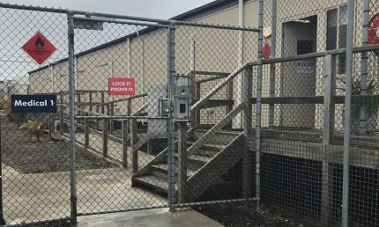
IHMS health clinic (Medical 1), MITA
The nurses are all registered nurses, and some have specialisations in areas such as mental health. They work in multidisciplinary teams with other health professionals, such as general practitioners, to whom they will refer people in detention, if required. IHMS staff can refer people to external providers (such as medical specialists or allied health services) in relation to health care that is not available from IHMS in the facility (see Section 3.2(b) on access to specialist health care and Section 3.2(f) on mental health).
The composition and number of health professionals in the IHMS staff team varied across each facility. However, it generally comprised staff in the following roles: a health services manager; a clinical team leader and administrator to manage and coordinate the health service; and general practitioners, registered nurses and mental health nurses to deliver health services. At some facilities, IHMS employed health professionals in additional roles. For example, MITA and VIDC also had a drug and alcohol clinical specialist nurse, a counsellor and a mental health team leader to coordinate the provision of mental health services, and YHIDC had two part-time psychiatrists.
In most facilities, the IHMS health service operated from Monday to Friday, but the IHMS health service at AITA and the mental health clinic at BITA operated over the weekend. Outside the operating hours of the IHMS health service, Serco staff at all facilities could call the Health Advice Service (HAS), a nurse-led phone advice service, if required. Facility staff can also request external emergency medical assistance whenever this is required.
People in detention can request an appointment with the health service by completing a medical request form and putting it into a collection box. IHMS staff at all facilities collect the medical request forms daily, and a nurse will review the requests, assess their priority and then allocate accordingly. For example, at MITA the nurses triage these requests to identify whether they will provide an appointment immediately, in 24 hours, three days or seven days.
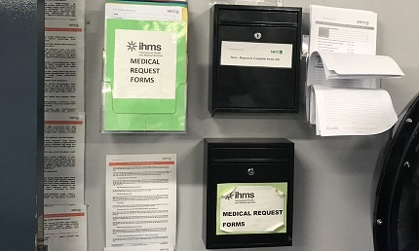
Medical request forms box, Bass 2, MITA
In some facilities, health staff advised there are other ways for health appointments to be made. People detained at YHIDC, for example, could call the IHMS health service directly by phone to make an appointment and at MITA IHMS staff said they would also accept referrals from other facility staff such as a Serco welfare officer. IHMS staff at PIDC and AITA said that most appointments were made with IHMS staff directly, and that this was feasible given the much smaller number of people at these facilities.
IHMS staff at all facilities advised that waiting times for appointments vary depending on the assessment of priority, as well as the capacity of a particular clinic or service. For example, health staff at PIDC advised that it may take one to two days for an appointment with the general practitioner, but at least two weeks for an appointment with a psychiatrist.
People in immigration detention provided a variety of views at each facility in relation to IHMS health services generally. These views were largely consistent within each facility.
Some people told the Commission that they were satisfied with the health services provided by IHMS. For example, one person with complex health needs said, ‘Every day I see IHMS and they look after me well and give me the medicine that I need.’ Another said that the ‘health staff are good, and they will always see me when I ask.’
Some people at the larger facilities (VIDC, YHIDC, MITA and BITA) said that, while they had no problems with the health service once they were able to access it, it could take a long time to get an appointment. For example, one person said, ‘You can’t rely on getting help when you really need it, and some people just give up.’ This issue was not raised by people interviewed at PIDC or AITA.
Some people said they were not getting the health care they needed. These concerns usually related to mental health care or access to specialist health care (see further details in Sections 3.2(b) and 3.6(f) below).
A small number of people expressed some concerns about the general approach of IHMS staff. For example, one person said, ‘They don’t believe us, whatever I say, it is not credible to them’. Another said he had little faith in long-term health staff because he believed they were no longer trying to help their patients. A few people said that they no longer engage with IHMS because they were not able to assist with their immigration situation or they felt they could manage their health better on their own by, for example, going to the gym.
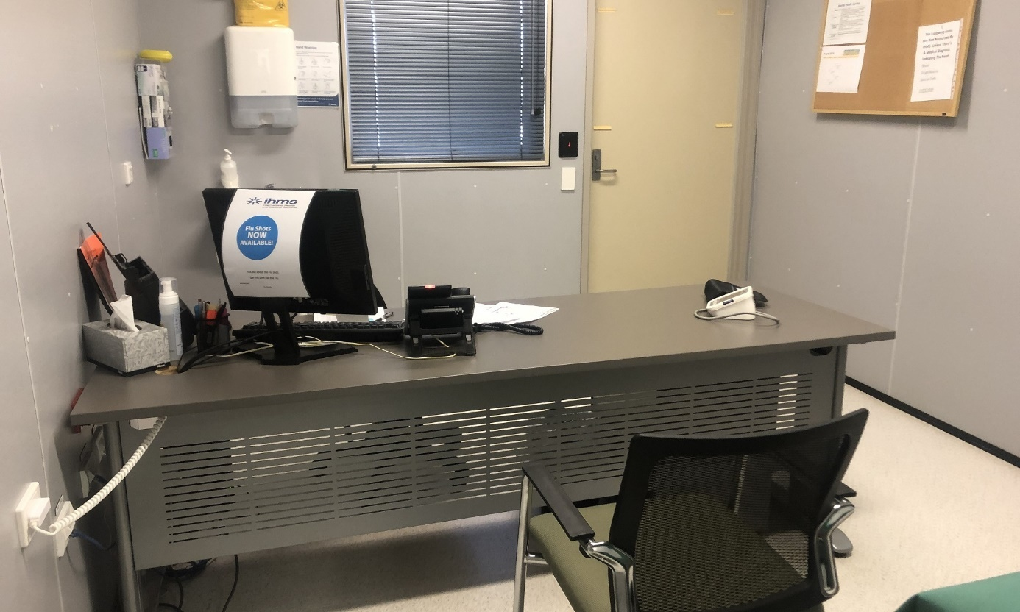
IHMS consultation room, YHIDC
IHMS staff consistently reported that significant numbers of people in immigration detention had complex health conditions, including both physical and mental health issues. One IHMS staff member observed that there was often a need for tertiary level care (as distinct from the primary level care provided by IHMS), due to the complexity of health needs. Common physical health issues reported across facilities included hepatitis C, diabetes, chronic lung disease, high blood pressure and mobility issues. Common mental health issues included PTSD and trauma-related symptoms, mood and anxiety disorders and psychotic disorders. Some IHMS staff reported a growing number of elderly people in immigration detention, who were very unwell with multiple chronic conditions.
All IHMS staff interviewed by the Commission felt that they had an appropriate level of autonomy in treating patients, and that any recommendations they made in relation to a person’s health were generally respected and facilitated by other ABF and Serco facility staff.

Access to specialist health care
When people in detention require specialist health care that cannot be provided by the IHMS health service (such as dental, optometry or physiotherapy), IHMS often contracts external providers. IHMS advised that its preference was for contracted specialist health care to be delivered onsite. Facilities generally had regular scheduled visits from some external providers, but this varied across facilities.
For example, YHIDC has a psychologist that attends once per fortnight to deliver up to 22 hours of psychology every month, a dental clinic that operates one to one and a half days per week (it also services PIDC), a physiotherapist that attends once per week, and an optometrist that attends once per month. MITA has a dental clinic that operates once per week, a radiologist three times per week, and a dietician and an optometrist attend once per month. At MITA, there was also access to a maternal child health nurse. At BITA a psychiatrist attends once per week for four to five hours, and physiotherapy and optometry are also delivered onsite.
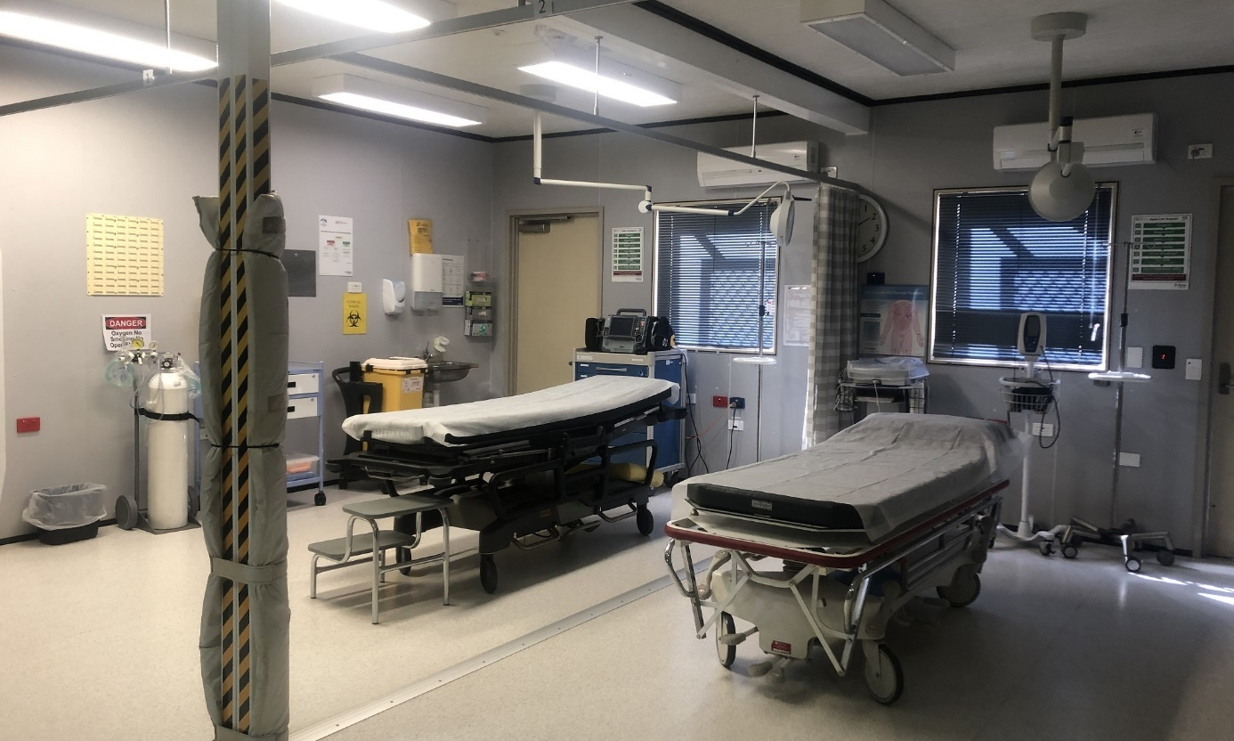
IHMS emergency bay, YHIDC
Where IHMS or another contracted external provider is not able to provide the required health care, IHMS makes referrals through the public health system. IHMS staff informed the Commission that they provide health services in immigration detention to a standard of care broadly comparable to that available to the Australian community in the public health system.
Upon referral, the person will be added to a public waiting list to access the required medical assessment and/or treatment. IHMS staff advised that waiting times could be lengthy (in some cases a matter of years), but that these were commensurate with the waiting times for others seeking similar treatment in the Australian community through the public health system.
IHMS staff informed the Commission that, in exceptional circumstances, they could seek costs approval from Home Affairs to arrange an appointment in the private health system, but such approval was rarely sought.

Medical transferees from Nauru and PNG
One particular concern that emerged during inspections was the waiting times for refugees and asylum seekers transferred from Nauru and PNG for the specific purpose of receiving medical treatment and/or assessment in Australia to access the health care they required. People in this cohort were spread across a number of facilities, but most were detained at MITA, BITA and the hotel APODs in Melbourne and Brisbane (see Section 2.6).
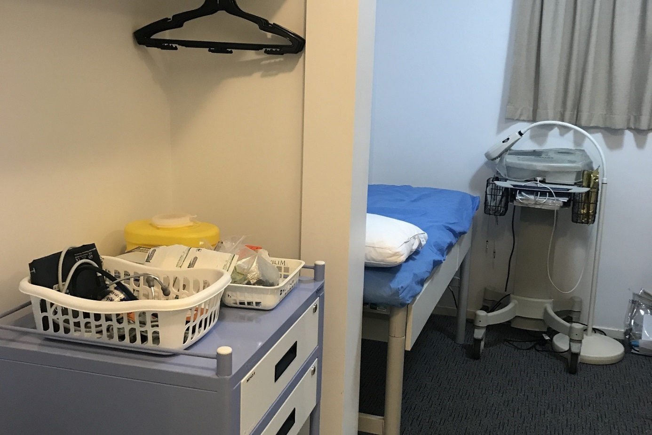
IHMS clinic, Brisbane hotel APOD
The Commission interviewed 69 people in this cohort and most reported delays in accessing the medical treatment and/or assessment for which they were transferred. This issue applied across all relevant facilities.
These people had been in immigration detention in Australia for varying periods following their transfer from Nauru or PNG. However, a significant number, in particular at BITA and the hotel APOD in Brisbane, reported that they had been in Australia for 6 months or more, and in a few cases for one year.
People in this group reported various physical and mental health issues, and in many cases multiple health issues. Most said they had not yet seen the relevant specialist or received treatment (often surgery or other significant treatment); some were waiting for radiology, medical imaging or similar treatment before they could have an appointment with a specialist; and some were on a waiting list for treatment. Some people appeared confused about what health care they could access, and how long they would need to wait to access this.
Most people said they had been waiting long periods in Nauru and PNG for proper assessment and treatment of their health conditions prior to their transfer to Australia. For example, one person reported that he developed a hernia four years ago in PNG where he was unable to access the required treatment. The hernia had limited his ability to eat and drink adequately and he had lost a lot of weight. He was transferred to Australia for surgery to repair the hernia, as well as an assessment of his kidneys by a specialist, and he reported that he was on a waiting list for surgery and had not yet seen a specialist. In other words, no allowance appeared to have been made for the fact that he had already been waiting for four years in PNG.
Many people also reported difficulty managing symptoms while waiting for treatment and were concerned that their health conditions would deteriorate further. For example, one person reported experiencing instability and lack of sensation in his legs as a result of a lower back issue that had developed four years previously in Nauru. He reported that he was on a waiting list for surgery and had been advised by IHMS that this could take one year or more.
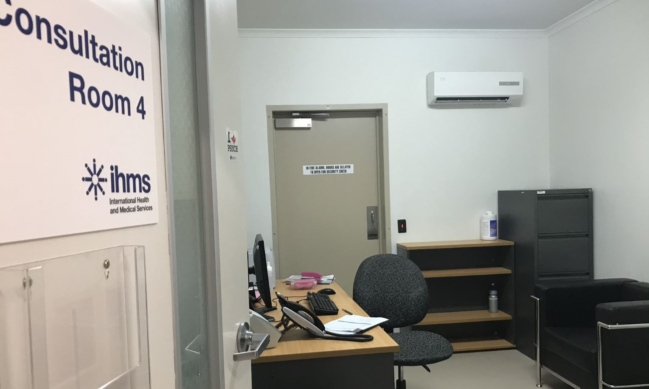
IHMS consultation room, MITA
IHMS staff informed the Commission that medical transferees from Nauru and PNG were, like other people in detention, referred for treatment and/or assessment under the public health system where this could not be provided by IHMS or a contracted external provider. As outlined above, waiting times to access the required treatment or procedure under the public health system can be lengthy. IHMS staff advised the Commission that the length of time a person has waited for assessment or treatment in Nauru or PNG is not considered in accessing health care through the public health system. ABF and IHMS staff told the Commission that it was challenging to manage the expectations of this group in relation to waiting times.
It is of significant concern that many refugees and asylum seekers transferred to Australia for the specific purpose of medical treatment and/or assessment have not received the health care they require in a timely manner. In the Commission’s view, the health needs of this group differ significantly from those of people in the Australian community, and those of other groups of people in immigration detention. As outlined above, they were transferred to Australia for medical reasons, and many waited long periods in Nauru and PNG for proper assessment and treatment of their health conditions prior to their transfer to Australia.
Where a person in this group cannot access the medical treatment and/or assessment they require through the public health system within a month of arrival in Australia, alternative arrangements should be made to ensure timely access to the required health care. In these circumstances, the Commission considers that Home Affairs should ensure immediate access to health care through the private health system and provide funding for this.

As a matter of urgency, the Department of Home Affairs should ensure immediate and expedited access to medical treatment and/or assessment for all medical transferees from Nauru and PNG through the public health system.

Where medical transferees from Nauru and PNG cannot access the medical treatment and/or assessment they require through the public health system within a month of arrival in Australia, the Department of Home Affairs should ensure immediate access to health care through the private health system and provide funding for this.

Dental care
Dental care in immigration detention is delivered by external providers. In some facilities, dental care is delivered onsite; in others, it is delivered at an offsite dental clinic.
An external dentist delivers dental care onsite at YHIDC for people detained at YHIDC or PIDC. Generally, the dental clinic at YHIDC operates from one to one and a half days each week. However, at the time of the Commission’s inspections, the dental chair was broken, and the dental clinic had not been in operation for about two months. Dental care at MITA and VIDC is also delivered onsite, with a dentist attending one day each week at MITA, and three days per week at VIDC. At BITA and AITA, dental care is delivered at an offsite dental clinic.
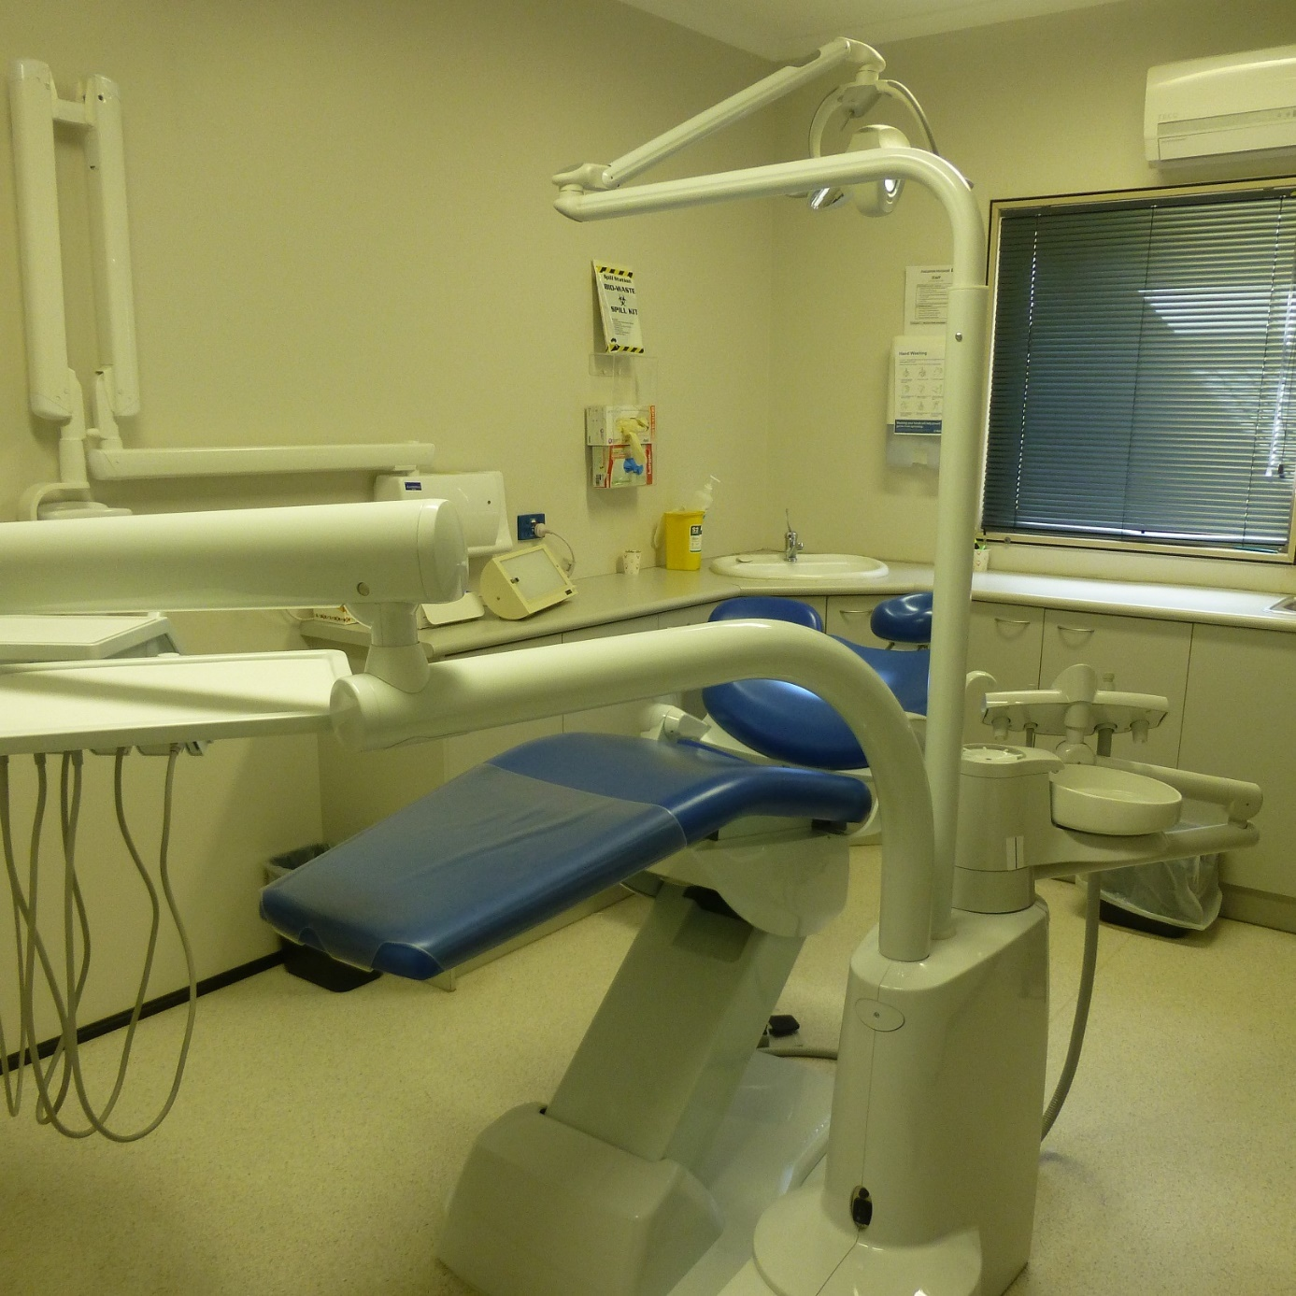
Dental chair, IHMS health service, YHIDC
People interviewed at YHIDC, MITA and BITA reported some delays in accessing dental care. A significant number of people at YHIDC reported waiting over two months to see the dentist, and in a few cases over a year. Some said they were experiencing considerable tooth and/or gum pain and were having difficulty chewing their food. Some people at MITA and BITA also reported delays, but this did not appear to be as widespread as at YHIDC.
IHMS staff at YHIDC acknowledged delays in dental care because the dental chair was broken, and this had caused a backlog of dental appointments. Given the considerable delay to repair the chair, and the number of people in detention who complained about delays in accessing dentistry during this period, the Commission considers that an alternative option for dental care should have been arranged for people at YHIDC and PIDC during this time.
A small number of people the Commission interviewed reported more severe dental issues that required significant treatment. People in this situation commonly reported that recommended dental care plans provided by dentists or requests for dentures, bridges or implants had not been approved. IHMS staff at MITA advised that where costs for dental treatment exceeded $2,000, they must seek costs approval from Home Affairs, however the Commission does not have information about any relevant national policies in relation to dental care for people in immigration detention.
Most said that their unresolved dental issues were causing significant pain and/or difficulties eating solid food. For example, one person reported that he was unable to eat food regularly at mealtimes as there were often no soft options. IHMS was providing him with protein mixes as a supplement, but he did not find this sufficient.
It appears that the needs of people with more severe dental issues are not being adequately met by the dental care provided in immigration detention. Ongoing dental issues and associated dental pain that are not addressed in a timely manner can lead to the deterioration of a person’s general health (for example, if this impacts a person’s ability to eat or drink) and may impact a person’s mental health.

Drug and alcohol rehabilitation
As was the case during the Commission’s 2018 inspections, facility staff continued to report concerns about the presence of illicit drugs within immigration detention facilities. The presence of illicit drugs was also referred to by people detained in some facilities as a factor that made them feel unsafe.
In its previous report, the Commission recommended that drug and alcohol rehabilitation be introduced as a core component of the health care services and activities delivered in immigration detention. The Commission suggested that these services could form part of the contractual obligations of detention service providers to ensure consistent access across the immigration detention network. In response, Home Affairs advised that they were implementing a new policy regarding the provision of nationally consistent drug and alcohol services, including opioid substitution programs, counselling and peer support arrangements.
All facilities provide access to opioid substitution programs where required. At the time of the Commission’s inspections, VIDC, MITA, YHIDC and PIDC were meeting a need in those facilities by providing opioid substitution programs. However, not all facilities offered specialist drug and alcohol counselling and peer support programs. The Commission notes that while people in detention can access opioid substitution programs, these programs are not suitable for all drug users and do not provide holistic rehabilitation services.
Since the Commission’s inspections in 2018, there had been some increases in the availability of specialist drug and alcohol counselling and peer support programs at VIDC. VIDC had a drug and alcohol clinical specialist nurse, who conducts monthly health promotion, outreach activities and group therapy sessions. The specialist nurse works closely with the mental health team, including the counsellor, and the program draws on the SMART (Self-Management and Recovery Training) Recovery program that is run in Australian prisons. There were plans to expand this program to MITA and at the time of inspections, MITA had recently hired a drug and alcohol clinical specialist nurse. The Commission welcomes these developments.
However, at facilities such as YHIDC and PIDC, people on opioid substitution programs were not offered specialist drug and alcohol counselling and peer support programs. IHMS staff at YHIDC reported that further resources would be needed if they were to offer a more holistic approach to drugs and alcohol, including counselling, peer support and education, in addition to opiate substitution.
A small number of people in detention told the Commission that they required support in relation to drug, alcohol and/or gambling addictions and either were not aware of any support they could access or had been advised that this was not available. In addition to facilities where holistic drug and alcohol support was not available, the Commission also heard this from several people detained at VIDC. This may indicate a need to improve communication in relation to services available at VIDC or that the program is not meeting all needs.
A small number of IHMS staff indicated that there is an expectation that they would report drug use in the facility to the ABF and Serco. Different service providers may have different responses to drug use—IHMS may seek to refer a person to drug and alcohol counselling, whereas the ABF and Serco may place a person in a higher security compound. The Commission considers that there may be difficulties balancing a person’s health care needs with any security considerations in current responses to drug use in immigration detention.
The Commission suggests that Home Affairs continues to develop drug and alcohol rehabilitation services and activities in immigration detention. The Commission considers that an independent evaluation of the program at VIDC by drug and alcohol specialists, including an assessment of the program’s accessibility, could inform steps to improve and expand the program across immigration detention facilities.

The Department of Home Affairs and IHMS should commission an independent evaluation of the drug and alcohol program at VIDC.

Mental health care
IHMS health services in all facilities deliver mental health care under a ‘nurse-led’ model by specialist mental health nurses. Where a person requires mental health support, they can request an appointment with a mental health nurse, who will undertake an initial assessment, and can make referrals to other IHMS colleagues such as a counsellor or general practitioner as required. IHMS may also refer to an external provider, where a service cannot be offered by the IHMS staff team; for example, psychology, psychiatry or torture and trauma counselling.
Some IHMS health services employed mental health professionals in addition to mental health nurses. At the time of inspections, the IHMS health services at VIDC and MITA had an on-staff mental health leader and counsellor, and YHIDC had two on-staff part-time psychiatrists. There were no on-staff psychologists at any facility.
The IHMS health services had different arrangements in place in each facility with external providers for services such as psychology and psychiatry. For example, YHIDC had a psychologist attend fortnightly with access of up to 22 hours per month; BITA had a psychiatrist attend weekly for four to five hours; PIDC had a psychiatrist attend fortnightly for two hours; AITA had a psychologist attend weekly for one day (who also delivered torture and trauma counselling) and a psychiatrist attend every two months for one day; MITA had a psychologist attend weekly with access of up to 40 hours per month (this was new); and VIDC had a psychiatrist attend two days per week.
IHMS health services at all facilities provided referrals to torture and trauma counselling. In most cases (except for AITA), this was provided by the relevant state-based member of the Forum of Australian Services for Survivors of Torture and Trauma (FASSTT) network. Most appointments with these services occurred onsite at the facility, except for BITA where all torture and trauma counselling appointments occurred offsite with the Queensland Program of Assistance to Survivors of Torture and Trauma (QPASTT).
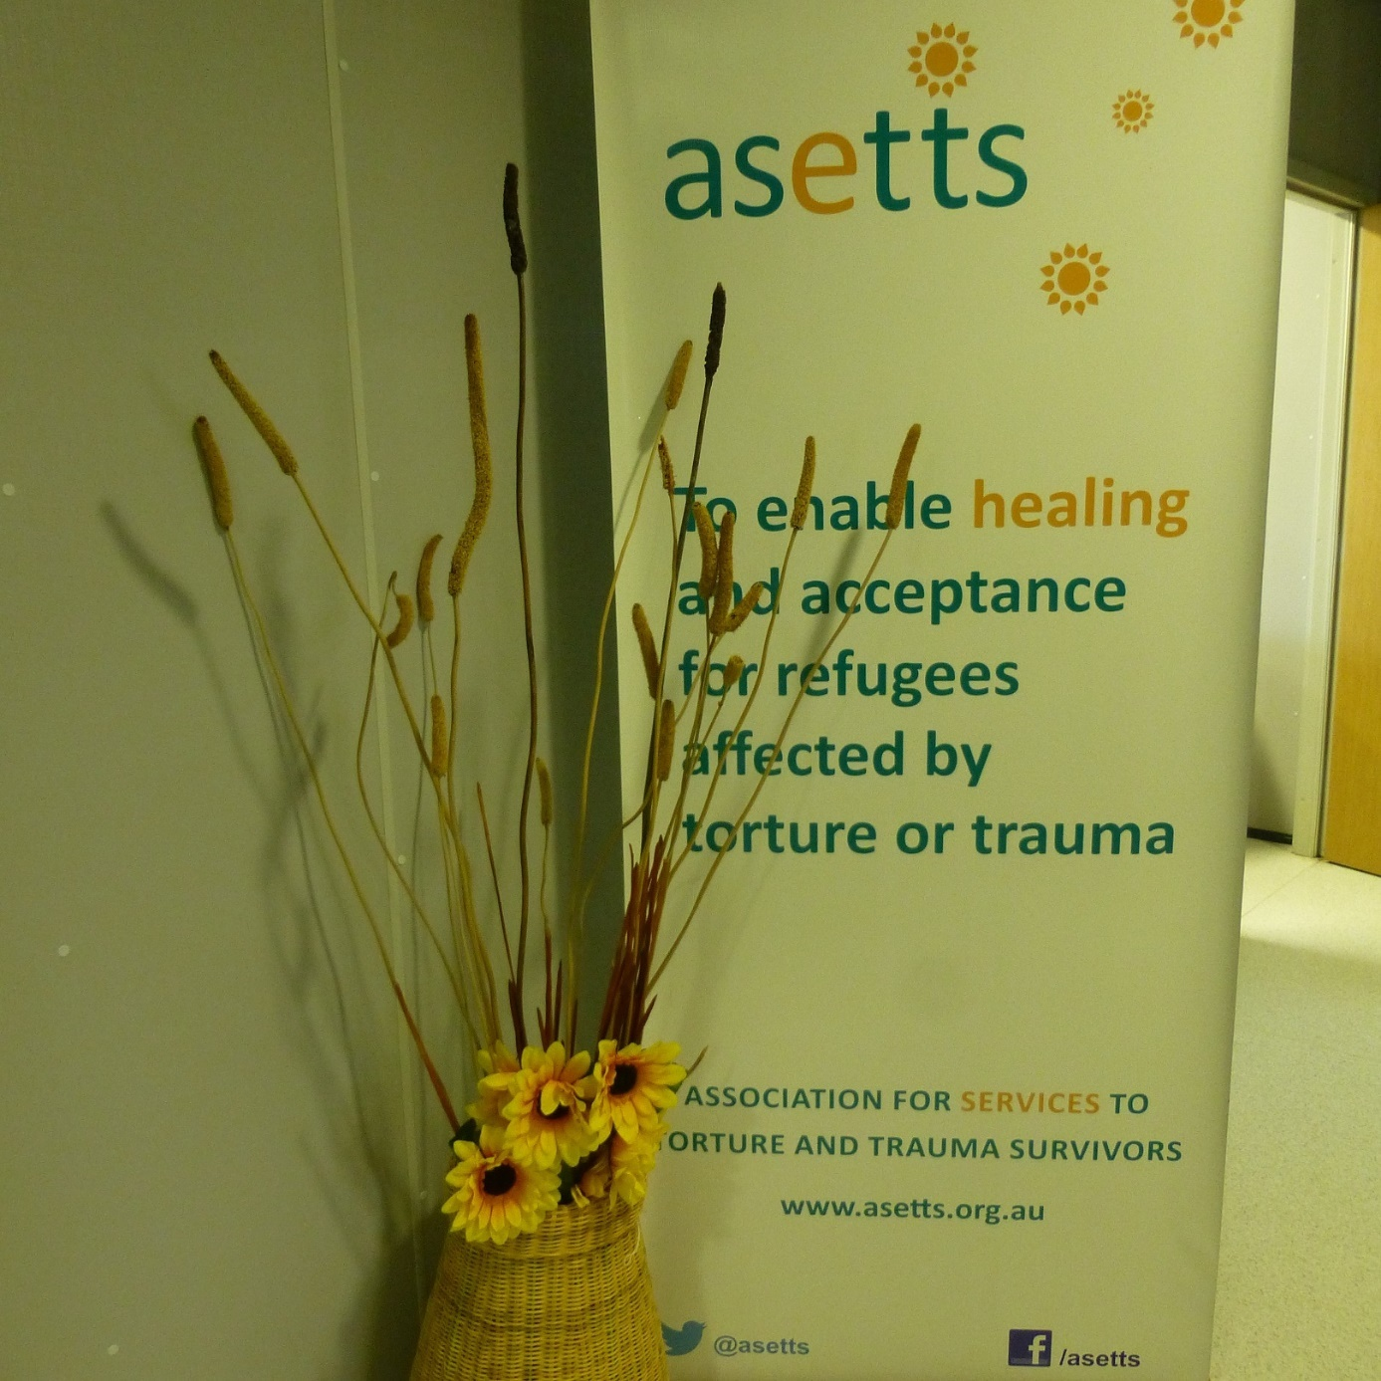
ASETTS banner, IHMS health service, YHIDC
During interviews with the Commission, many people reported concerns about their mental health. This was consistent across all facilities. They reported experiencing depression, anxiety, stress, difficulties sleeping, problems with concentration and/or memory and lack of motivation. One person said, ‘It is mentally stressful to pass the days. Pounding in my head is so heavy I can’t think.’ Another said, ‘I am really tired. I don’t feel normal, I can’t be happy.’ Some people said they find it difficult to participate in activities, leave their rooms or talk to others. In some cases, the Commission observed distress, fatigue, and a few people presented as withdrawn.
Many people also reported that the length of time they had spent in detention and the uncertainty of their situation was contributing to or causing their mental health issues (see Section 3.10).
IHMS staff reported significant numbers of people in detention with complex health needs, including mental health issues (see Section 3.2(a)). Some IHMS staff attributed the complexity of mental health needs to an increasing number of people who have spent a long time in immigration detention. Other facility staff, including IHMS staff, recognised that while prolonged immigration detention is a factor, there are other relevant factors such as pre-existing conditions, individual resilience and family background. Most facility staff reported that mental health is complex and difficult to manage in immigration detention.
Most people who reported mental health issues (particularly those who had spent a year or more in detention) said they had accessed mental health support from the IHMS health service, and many reported taking some form of medication provided by the health service in relation to their mental health.
Some people provided positive feedback on available mental health services. One person said, ‘I see mental health nurses and the psychiatrist, they are good. I wasn’t talking before I came here, now I am.’ Those accessing torture and trauma counselling generally noted the importance of this service for their mental health and wellbeing.
However, many people (including some of those who provided some positive feedback) felt the mental health care provided was not helpful or of limited effectiveness given their ongoing detention and uncertain future. One person said, in relation to his mental health, ‘It is like you are on a sinking boat and you empty it out but then it keeps filling up again.’ Another said, ‘I feel alright when talking to the mental health people but then I have to go back and I see the fences, the same people and I can't sleep and I lose my appetite.’
Some people also expressed concerns about the way in which IHMS staff responded to their mental health issues. In relation to mental health care specifically, the Commission heard comments to the effect that ‘IHMS don’t have feelings’ and ‘it is like speaking to a robot.’ One person said that some IHMS staff minimise the way people feel and say things like ‘others are in a worse condition than you.’ Another person said, ‘I see IHMS every 3 months, but they tell me not to worry. How can I not worry? I am stressed about my family.’ Others expressed concern that mental health is not taken seriously enough. For example, one person said, ‘You need to be extreme or threatening self-harm for any action to be taken. People are given tablets and sent away.’
Many people at the larger facilities (VIDC, MITA, YHIDC and BITA) reported that it was difficult to access mental health support when required. One person recounted their experience seeking regular support from a psychologist:
When I first arrived, I went to health and spoke to a nurse and said I would like to see a psychologist and she noted this down. Two weeks later I saw the nurse again and they told me that I needed to fill in the form to request to see the psychologist. Two weeks later I saw the psychologist. I was feeling really down and not doing well, couldn't sleep. I said I needed to see psychologist again and they told me I needed to fill in another form.
Some people said they were not able to access mental health support in a timely manner after a distressing event, such as a visa refusal, the suicide of a friend, death of a family member or notice of removal. One person said that after an unsuccessful outcome at the Tribunal, ‘I was very low and I needed help. It took three weeks for me to get in to see someone and by then it was too late.’ Similarly, another person said, ‘I put in a request to see the mental health nurse two to three weeks ago. I was very anxious about my removal and I wanted to speak to a someone. No point in going now.’ Several people requested more mental health education, promotion and peer support groups, and a few people said that IHMS staff should engage more proactively with people about their mental health.
The Commission acknowledges the challenges of providing mental health care in the immigration detention environment. Often the detention environment itself contributes to, exacerbates, or causes a deterioration of a person’s mental health, particularly where people have been detained for prolonged periods (see Section 3.10).
The Commission cannot assess individual claims about access to services. However, the volume of concerns the Commission heard suggests that the nature and amount of mental health care should be improved. In particular, the Commission is concerned about the risk of people failing to receive timely access to mental health support when they need it most.
The Commission proposes that Home Affairs commission a comprehensive, independent, expert review of the adequacy of mental health care provided in immigration detention. The Commission also suggests that the review include an element of ongoing monitoring and reporting in relation to mental health care in immigration detention.

The Department of Home Affairs should commission a group of independent mental health experts to conduct a comprehensive review of the mental health care provided in immigration detention.

Mental health care at BITA
While mental health issues were prevalent across all immigration detention facilities, the Commission received a particularly high number of reports of mental health conditions from refugees and asylum seekers transferred from PNG and Nauru for medical reasons (including mental health). This was particularly prevalent at BITA and the hotel APOD in Brisbane, where most people in this group were detained at the time of the Commission’s inspections (see Section 2.6).
The Commission received a higher number of reports from people detained at BITA and the hotel APOD in Brisbane, as compared with other facilities, that they had not been able to access ongoing mental health care that they felt they needed. Many people said that while they had an initial appointment with a psychiatrist, who had prescribed some form of medication, they had received no further support for their mental health conditions. Some said they were accessing torture and trauma counselling from QPASTT, but a significant number of people reported that they were waiting for an appointment with QPASTT or they did not know that this was a service they could access.
As outlined above, the IHMS health service at BITA had a psychiatrist attend weekly for four to five hours and could refer people to QPASTT for torture and trauma counselling and employed 1.9 full-time equivalent (FTE) mental health nurses. While there was a small IHMS health clinic at the hotel APOD in Brisbane, which operated two days a week with a general practitioner, most health care (including mental health care) was still provided from the IHMS health service at BITA. Compared to other facilities, the IHMS health service at BITA had significantly fewer resources available to provide mental health care, given the high numbers of people with mental health conditions detained there.
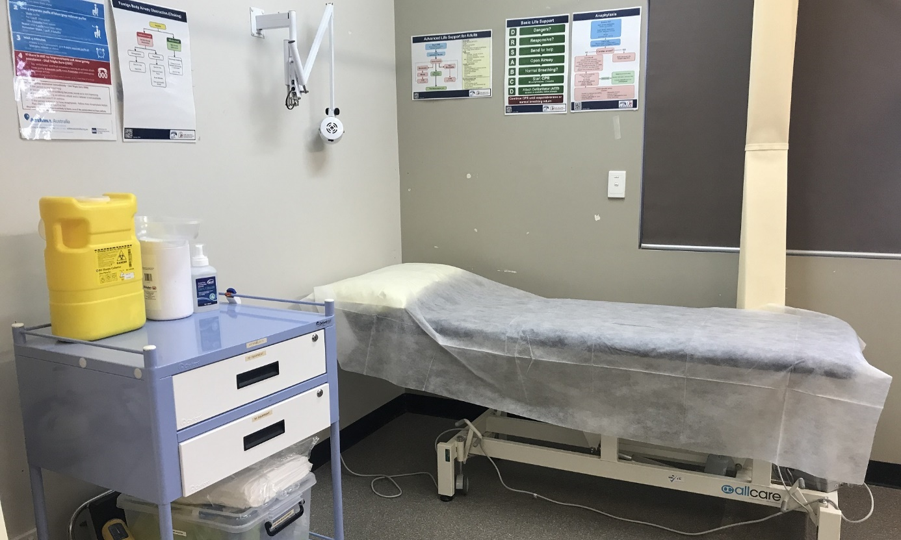
IHMS consultation room, BITA
Notably, the IHMS health service at BITA did not provide any access to psychologists. The ability to access psychological interventions (talking therapies), particularly in a group with a high prevalence of mental health problems and trauma experiences, is considered a key component of good mental health care. Psychologists work with psychiatrists, medical doctors who undertake psychiatric assessments to determine diagnostic and treatment planning, and other health professionals, including nurses, to provide multidisciplinary and holistic mental health care, which frequently includes psychological therapy.
The Commission acknowledges that mental health care will vary depending on the needs of an individual. However, given the prevalence of mental health conditions for people detained at BITA and the hotel APOD in Brisbane, it appeared that psychological care should be offered as a form of treatment.
The Commission acknowledges that there have been significant pressures on resources at BITA over the last 12 months, with a sizeable increase in population as a result of medical transfers from Nauru and PNG. Within resourcing and facility constraints, the Commission observed that facility staff at BITA were trying their best to adjust to an influx of people with complex medical needs.
However, the Commission was concerned that the IHMS health service team was not adequately resourced to meet the mental health needs of people detained at BITA and the hotel APOD in Brisbane. The Commission considers that the capacity and expertise of the mental health clinic at BITA should be increased, including appropriate access to psychologists.

The Department of Home Affairs should increase the capacity and expertise of the IHMS mental health clinic at BITA, including appropriate access to psychologists.

Responses to self-harm and suicide
A considerable number of people in each facility reported they had engaged in self-harm or attempted suicide while in immigration detention. Some people, in particular at MITA and VIDC, also referred to the prevalence of self-harm and suicide as a factor that made them feel unsafe. Some people expressed grief about people they knew who had committed suicide in immigration detention.
Facility staff advised that they have a protocol, referred to as Supportive Monitoring and Engagement (SME), which they apply where an individual is identified to be at risk of self-harm or suicide. Facility staff explained that such individuals are assessed by the IHMS health service to assess their level of risk. There are five levels of risk under SME, which determine the frequency and mode of monitoring. For example, if a person is assessed as high risk, they will receive constant one-on-one monitoring by a Serco officer at arm’s length or line of sight. Following guidance of IHMS staff, the Serco officer will ensure the person is in a safe environment, engage where appropriate and observe and record behaviour. Facility staff confirmed that, in some cases, individuals assessed to be at risk of self-harm or suicide are subject to 24-hour-a-day direct personal supervision by a Serco officer.
In some cases, facility staff advised that single separation in a ‘high-care accommodation’ compound may be used. A small number of people the Commission spoke to reported that they had been held in the ‘high-care accommodation’ following a self-harm attempt (see Section 3.8 (f) on high-care accommodation).
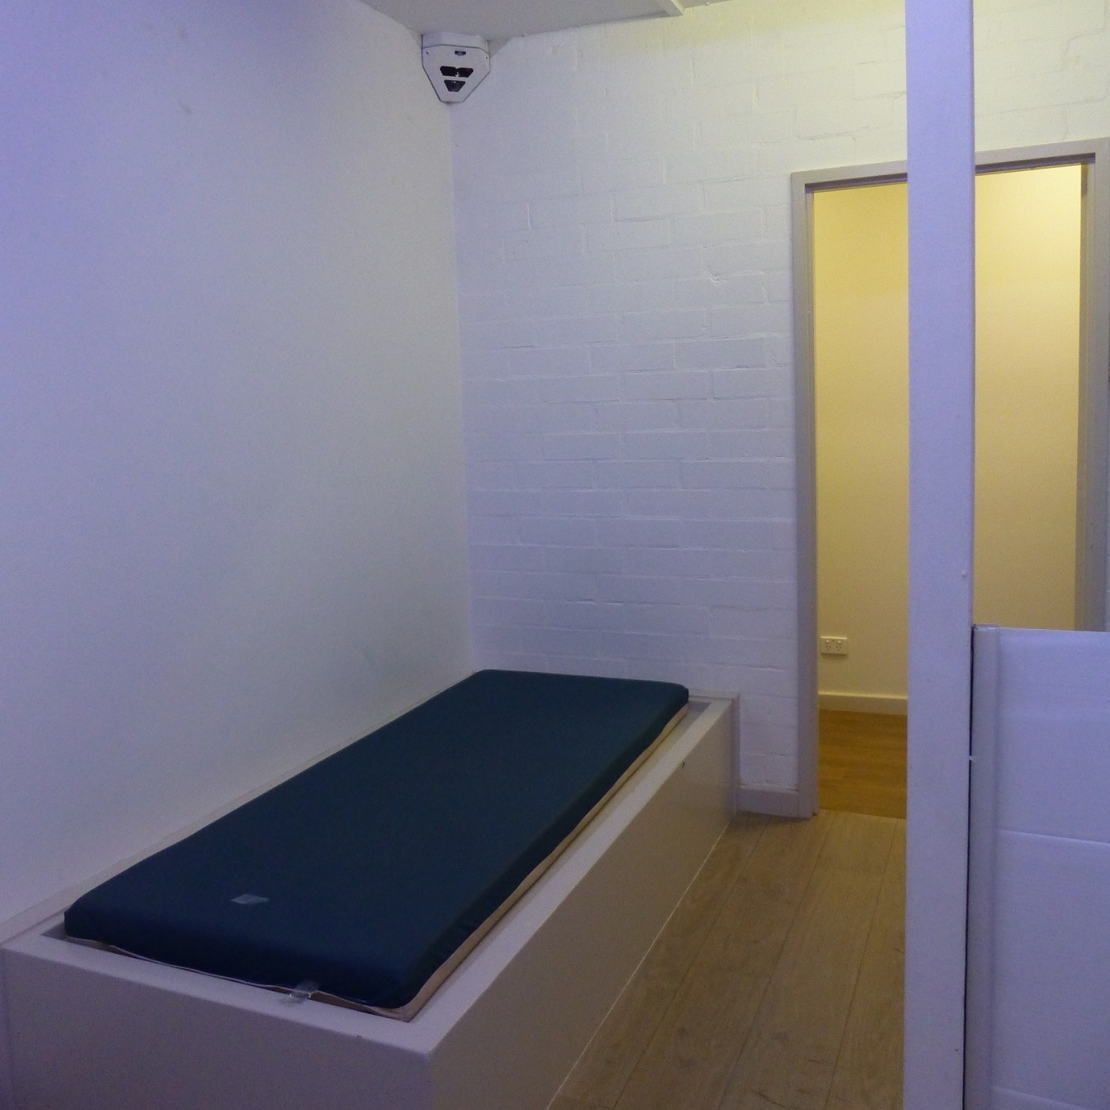
High-care accommodation, PIDC
For all people subject to SME, facility staff reported that a mental health clinician assesses a person’s level of risk daily, and the length of time a person is subject to one-on-one monitoring is subject to their assessment. If the risk assessment is lowered, the monitoring and engagement by Serco officers will be revised. For example, the step down from constant one-on-one monitoring is to 30-minute checks, and a further step down is to three checks each day. Facility staff advised that if a person cannot be safely managed in immigration detention, they would be sent to a hospital for inpatient care.
The Commission interviewed a small number of people who reported that they were being monitored by Serco officers in relation to their mental health in response to suicidal ideation or self-harm attempts. They said that a Serco officer would follow them closely in the facility, including when they were in their room or the bathroom, or that they had a Serco officer regularly check on them throughout the day. Some reported that the close monitoring by Serco officers was important for their safety, while others expressed significant discomfort with these arrangements.
One person with schizophrenia found that being followed by a Serco officer was therapeutic when he experienced psychotic symptoms and said that he would often request this support. Another person said he was moved to a room on his own with monitoring from Serco officers after he self-harmed, and that he felt he received the support he needed to assist with his distress.
However, others reported concerns in relation to the role of Serco officers. One person said:
I wanted to hurt myself and the security guards started to guard me so I'm scared to talk to the doctors and nurses. When I say something to the nurse, they tell Serco and then they start guarding us, that places bad character on us.
Another person reported that his roommate was on constant supervision by a Serco officer for one week. He said, ‘This really upset him as the Serco guard would come into the room all the time and made him feel uneasy and disrupted his sleep.’
The Commission observes that the SME commonly involves significant restrictions on freedom of movement and privacy, as a person may be subject to 24-hour-a-day direct personal supervision by a Serco officer, including when they are in their rooms or going to the bathroom. Such restrictions must be applied carefully, with appropriate oversight, so that they do not restrict human rights more than is necessary and proportionate.
The role of non-clinical staff in constant one-on-one monitoring and engagement may not be suitable to establish a safe environment for all people at risk of self-harm or suicide in immigration detention. As outlined above, some people reported feeling that close supervision by Serco officers was punitive, which may heighten levels of discomfort and distrust.
The Commission acknowledges that facility staff may have limited options available to ensure a person’s safety when a risk of self-harm or suicide has been identified.
Given the complexity of responses to self-harm and suicide in a detention environment, the Commission considers that an independent review of the use of SME may assist in determining whether current practices are in line with medical advice and Australia’s human rights obligations. Given concerns raised with the Commission about the role of Serco officers in monitoring and engagement, it would be beneficial for alternative options for monitoring and engagement to also be investigated.

The independent review of mental health care in Recommendation 8 should include review of the use of Supportive Monitoring and Engagement to determine:
– whether current practices are in line with medical advice and Australia’s human rights obligations
– the impacts of current practices on people in immigration detention
– alternative options for monitoring and engagement.

Continuity of care
Some people in immigration detention have pre-existing medical conditions that require ongoing care. While some of these people reported no significant interruption in their medical care on entering immigration detention, others reported significant delays in accessing the care they needed and had previously been receiving. This experience varied, depending on whether people entered immigration detention from prison, had been transferred from Nauru or PNG for medical treatment, or from another immigration detention facility.
The Commission spoke to a significant number of people who had been transferred to immigration detention from prison at the end of their sentences and had an ongoing need for medical care. Most of these people reported that they did not experience significant interruptions to their medical care following their transfer to immigration detention. Only a few people in this situation felt there had been some delays.
IHMS staff at some facilities described some recent measures to reduce gaps in access to ongoing health care for people transferred from prison. For example, IHMS staff at VIDC advised that, in the last year, Home Affairs commenced notifying the Justice Health and Forensic Mental Health Network, which provides health care to people in prisons in NSW, that a person will be transferred to immigration detention upon their release. This allowed IHMS staff at VIDC to access relevant medical information prior to their arrival from prison.
IHMS staff at MITA and BITA reported that they generally did not receive timely medical handovers (medical records and/or briefings from prior treating practitioners) for people transferred from Nauru and PNG. Facility staff said that they usually received notice of a transfer from Nauru or PNG a few days prior to arrival, and IHMS staff received medical handovers the day before or the day of arrival, and in some cases this may take longer. Some IHMS staff commented on the poor quality of medical handovers from Pacific International Hospital (PIH) in PNG and, in some cases, this could cause delays in providing medical care: for example, by requiring re-assessments. Most people who had been transferred from PNG and Nauru did not provide feedback specifically relating to continuity of care, but some said the health care in Australia was better than in PNG or Nauru.
The Commission heard concerns from people at YHIDC, MITA and VIDC that transfers between immigration detention facilities had caused significant delays to their medical care. They reported that after transfer to an immigration detention facility in another state, the process of referral for a specialist health appointment had to start again. Some people in these circumstances had already been waiting significant periods to access specialist health care. For example, one person reported that he had been on a waiting list for surgery for over a year and had recently received a date for his surgery. Shortly after, he was transferred to a detention facility in another state and advised he must wait a further six months for the surgery.
IHMS staff confirmed that when a person is transferred to a detention facility in another state, the referral process for specialist health appointments, assessments and treatments must re-start, and people may lose their place on the public health waiting list.
Transfer and placement decisions are made centrally by the ABF Detention Placements team, with limited input from facility staff (see Section 3.4(a)). Prior to a transfer between detention facilities, a ‘Fitness for Travel Assessment’ (FFTA) is generally conducted by a health professional to determine whether a person can undertake travel. Departmental policy outlines that an FFTA can be undertaken ‘on the papers’ and must consider:
- the physical and mental health of the detainee/transferee
- the mode of transport required
- whether additional clinical or mental health support is required during travel
- any other special considerations such as, the administration of medication during travel.
IHMS staff reported that the FFTA is conducted by IHMS centrally and provided to the ABF Detention Placements team who make the final decision about whether a transfer is to proceed. In some cases, IHMS staff at the detention facility of origin may be consulted in relation to the FFTA. The Commission heard concerns from IHMS staff that the FFTA is too narrow in scope. While it assesses a person’s ability to travel, it does not assess the impacts of a person’s transfer and placement in another detention facility on their health care.
In order to ensure the health impacts of a person’s transfer are properly considered, policies regulating transfers and placements should be revised to require that the impacts of transfer and placement at another detention facility on a person’s health and their continuity of care are undertaken by the person’s treating health professional prior to their transfer. This assessment should consider physical and mental health conditions and treatment, referrals and appointments for specialist treatment and personal history. In addition, people should not be selected for non-voluntary transfer where that would interfere with their timely access to health care.

The Department of Home Affairs should revise transfer and placement policy to require that a person’s treating health professional assess the impact of transfer and placement at another detention facility on a person’s health and their continuity of care prior to any transfer. This assessment should consider:
– physical and mental health conditions and treatment
– referrals and appointments for specialist treatment
– personal history.

The Department of Home Affairs should revise transfer and placement policy to ensure that people are not selected for involuntary transfer to another immigration detention facility where this would interfere with their timely access to health care.

Privacy and confidentiality
Some people reported that Serco officers were present in the consultation room during external medical appointments, or the door was left open and Serco officers were able to hear the medical appointment. Some people said that it depends on which Serco officers are on escort whether it is possible to speak privately with the doctor. Others reported that sometimes, but not always, the treating doctor or nurse asks the Serco officer to leave the room. Most concerns of this nature were raised by people at MITA and VIDC.
Serco staff informed the Commission that their policies require accompanying Serco officers to maintain ‘line of sight’ during offsite medical appointments to manage the risk of absconding. The positioning of Serco staff during escort may vary depending on the configuration of the room of the offsite visit.
The Commission appreciates that Serco manages a range of risks during transport and escort, including the risk of absconding. In order to manage these risks, the Commission understands it may be necessary for Serco officers to be stationed at particular exits during an offsite visit (such as points of entry/exit to the consultation room or building). However, stationing officers inside consultation rooms or within earshot of the appointment may not be necessary, reasonable or proportionate in an individual’s circumstances.
Patients should be able to communicate freely and confidentially with health professionals, and their medical information should remain private. Consequently, the Commission considers that anything that detracts from these rights should be permitted only as a last resort, where it is necessary and proportionate to manage identified risks that apply to the particular individual in question. Where there is a single entry and exit to a medical consultation room, there would need to be compelling reasons to establish that it is necessary for an officer to be present to prevent a person absconding.

The Department of Home Affairs and Serco should revise policies in relation to escort protocols for offsite health appointments to ensure confidentiality and privacy is only restricted as a last resort, where necessary and proportionate to manage identified risks in an individual’s circumstances.

Physical safety
A significant number of people interviewed at VIDC, YHIDC and MITA reported that they were apprehensive about their physical safety and that they may be at risk of harm by others. There were very few concerns about physical safety raised by people interviewed at BITA, PIDC and AITA.
However, a higher number of people at VIDC raised concerns about physical safety during interviews with the Commission than at other facilities. Several people at VIDC reported experiencing or witnessing physical violence between detainees in immigration detention.
Some people at VIDC expressed dissatisfaction with the responses of the ABF and Serco to such incidents. Some reported that the police were not often involved in any response or investigation and that the perpetrators often faced no consequences. A few people who reported that they had experienced a serious injury following an assault by another person in detention said that they felt ABF or Serco staff were unwilling to refer an incident to the police, or that they had discouraged them from doing so. Some people also reported difficulties accessing CCTV footage in relation to incidents of physical violence.
Facility staff at VIDC informed the Commission that if a party requests police involvement they would consider the incident further, and they would generally report incidents involving physical violence to the Australian Federal Police (AFP). In addition, they said that people in immigration detention could make their own police complaints.
The Commission cannot assess the merits of allegations in relation to specific incidents, or the responses of facility staff. However, it is concerning that a significant number of people at VIDC, YHIDC and MITA said they felt unsafe, and that at VIDC, reported witnessing or experiencing physical violence. The accounts provided by people at VIDC also suggest that some people do not understand protocols for police reporting, may feel discouraged from making a police complaint or that facility staff do not always refer appropriate matters to the police.
Human rights standards require that facility staff provide protection from violence in all areas of an immigration detention facility and should notify the police of all incidents of violence such as assault.
The Commission considers that policies and procedures in relation to physical violence in immigration detention should be reviewed to ensure that adequate strategies to protect the physical safety of people in detention and clear police reporting protocols are implemented.

The Department of Home Affairs should review policies and procedures in relation to physical violence in immigration detention, with a view to ensuring adequate strategies to protect the physical safety of people in detention and clear police reporting protocols are implemented.

Placements and escort

Placements
Decisions about which facilities people will be detained in are made at a national level by the ABF Detention Placements team. Home Affairs has previously informed the Commission that placement decisions are ‘part of a process of assessing and minimising risk to other detainees, service providers, visitors and staff’. Factors such as medical needs (considered as a priority), family and community links, and the need for balance across the network are also considered.
Facility staff informed the Commission that where there are concerns about a person’s placement, they can request a reconsideration by the ABF Detention Placements team. For example, facility staff at YHIDC said that in circumstances where a person had children in another state, they would generally request that their placement be reconsidered.
Several people at each facility raised concerns about being separated from their immediate families, including young children, partners and parents, who resided in other states. These people commonly reported being unable to see their family regularly, mostly due to financial or travel constraints. For example, one person said that their elderly parents could not travel interstate to visit them due to ill health. Some people said that they had no social connections in the town or city of their detention facility and so they received no visits.
A few people told the Commission that they had been relocated to be closer to their families, and one person said that ABF staff had recently discussed with them a possible transfer due to family separation.
Several people at YHIDC said it was difficult to see their families in Perth due to its location—YHIDC is in Northam, which is approximately two hours’ drive from Perth. One person said that his wife and child, who live in Perth, were unable to visit very often because his wife does not own a car, and it was too expensive for her to rent a car to visit regularly. Another said it was very difficult for his wife and three young children to travel from Perth to YHIDC because his wife was working and caring for the children without other support. One person said that previously it had been possible for people at YHIDC to arrange family visits at PIDC, which is located near Perth airport, but this was no longer the case.
A small number said they had requested transfer to another facility to be closer to family. Some had not received a response at the time of interview, while others said they had been advised that they could not be transferred due to ‘operational reasons’, lack of capacity at another facility or safety concerns. A few said they had not received an explanation.
As outlined elsewhere in this report, immigration detention facilities were experiencing some capacity issues at the time of the Commission’s 2019 inspections (see Section 3.8 (a)). The Commission appreciates that this would have made it more challenging to locate all people in facilities close to their ordinary place of residence.
However, the Commission remains concerned about the significant negative impacts that placement decisions can have on people in detention when they result in separation from family. As recommended following inspections in 2018, family links should be considered as a priority in decision making regarding placements.
The remote location of YHIDC also creates special challenges for families to visit people detained at YHIDC, even when families reside in Perth. The Commission considers that where families face significant barriers to visit YHIDC, visits should be facilitated at PIDC.

The Department of Home Affairs should consider family links as a priority when making decisions about placements across the detention network.

Where families face significant barriers to visit people detained in YHIDC, facility staff should facilitate visits at PIDC.

Use of restraints during escort
A key theme of the Commission’s inspections of immigration detention facilities in 2017 and 2018 has been the use of mechanical restraints—handcuffs—on people during escorts outside detention facilities, such as during transfers between immigration detention facilities as well as escorts to medical or court appointments. This continued to be a concern raised by some people in their interviews with Commission staff in 2019.
The Department’s policy was previously that the use of restraints during escort between or outside an immigration detention facility applied to all people in detention who had a serious or violent criminal history, those who had a history of escape and those whose risk assessment by Serco resulted in a ‘high risk’ rating. Risk assessments are developed using an algorithm (referred to as the Security Risk Assessment Tool) that determines a person’s risk rating based on inputs from Serco staff and are used to determine the types of risk management measures that will be applied to a person in immigration detention, including the use of restraints during escort. The Commission has previously identified a number of concerns about the risk assessment process conducted by Serco, including whether the risk rating system is sufficiently nuanced to avoid the unnecessary use of restrictive measures.
In response to the Commission’s inquiry into the use of force in immigration detention, Home Affairs indicated that the policy on the use of restraints during escort had changed and that a new policy had come into effect on 10 January 2019. Home Affairs stated:
Under departmental operational policy, the pre-planned use of force, including application of restraints, may only be applied to a detainee where an individual assessment of their risk shows that it is warranted and the relevant Australian Border Force (ABF) Detention Superintendent has provided written approval for such force to be used in the particular circumstances and prior to that force being applied.
During the Commission’s inspections in 2019, which followed this change in policy, facility staff advised that all requests for the planned use of force, including the use of restraints during escort, are submitted to the relevant ABF Detention Superintendent for approval on a case-by-case basis. The Commission was informed that the Superintendent considers the following information in such decisions:
- a person’s risk assessment by Serco
- security considerations for the escort operation—for example, the lay-out of a destination building
- a health assessment by IHMS.
IHMS staff informed the Commission that the health assessment involves completion of a standard form to indicate whether the use of restraints should be precluded due to a physical condition, mental health condition or a history of torture and trauma. The assessment does not consider the impact that non-attendance at a medical appointment would have on a person’s health condition or treatment.
It appeared that IHMS staff teams at each detention facility may adopt differing approaches to this assessment. For example, IHMS staff at VIDC advised that they understood their role in providing such a heath assessment was to comment on whether the use of restraints will cause physical harm, rather than mental harm. IHMS staff at other facilities indicated that they also consider the mental health impacts as part of this assessment.
Facility staff advised that the number of approvals sought for the planned use of force can be quite high, particularly at larger facilities. For example, facility staff at YHIDC indicated that the Superintendent may receive 15 to 20 requests each day. Some facility staff observed that the process relies on the ability of the Superintendent to allocate sufficient time to individually review such requests.
Serco staff advised that they use an ‘Enhanced Escort Position’ (EEP) whether or not a person is placed in handcuffs during escort. The EEP involves the positioning of a Serco officer on either side of a person with their palm placed at the back of the person’s arm.
While the use of restraints during escort (in most cases metal handcuffs) remained widespread during inspections in 2019, there appeared to be a reduction in the overall use of restraints since previous inspections in 2017 and 2018.
During interviews in 2019, a higher number of people reported that restraints were not applied to them or were applied less frequently. For example, some people said that they had not been restrained during escorts; that they had previously been restrained during escort but this was no longer the case and instead they were closely escorted by Serco officers; or that they were restrained during transfer to an offsite appointment but had restraints removed during the appointment (for example, at a Tribunal hearing or while seeing the doctor or receiving treatment).
A reduction in the use of restraints during escorts was more evident at some immigration detention facilities than others. Reports suggest that the use of restraints was more routine at VIDC than at other facilities.
The cohorts of people detained at particular facilities may also have led to a reduction in the use of restraints during escorts. For example, most refugees and asylum seekers transferred from PNG and Nauru who were detained at MITA or BITA reported that they were not restrained during escort. Facility staff at BITA advised that restraints during escorts are not generally used for people in this group.
While it appears that the use of restraints for escorts outside immigration detention facilities has reduced, the Commission is concerned that they continue to be used in ways that are not demonstrated to be necessary and proportionate in each individual case, and which can cause significant distress to affected people. Particular issues include:
- The Superintendent’s assessment of the need for restraints during escort is informed by the risk assessment process which may produce outcomes that do not accurately reflect a person’s risk profile and may lead to the unnecessary use of restraints.
- Restraints can be unnecessary for people with restricted mobility, caused by physical disability, frailty or old age. A few people reported being handcuffed while in a wheelchair, and one person reported being handcuffed to a hospital stretcher bed.
- Restraints can be left on inappropriately or where they cause discomfort or distress, such as during medical consultations or while a person is attempting to eat or use the toilet.
- Restraints can be left on for the duration of an external escort, which in some cases (such as during lengthy transfers) may result in people being restrained for many hours or most of the day. For example, one person reported being handcuffed for 16 hours during transfer by car between facilities, causing bruising to wrists and arms.
- Restraints can cause significant distress for some people in immigration detention, with some people reporting that they had refused to attend appointments (including medical appointments) due to advice from Serco that they would be restrained.
These concerns are similar to those expressed by the Commission following inspections in 2018.
The Commission welcomes efforts to reduce the use of restraints where possible. However, policies and procedures regarding the use of restraints require improvement to ensure that people in detention are not subject to more restrictive measures than are necessary.
Following an inquiry into the use of force in immigration detention, the Commission set out detailed recommendations on the use of restraints. While acknowledging that Home Affairs did not accept some of these recommendations, they remain relevant now, and inform some of the recommendations below.
As outlined above, the Superintendent is provided with a person’s general risk assessment (as produced by the Security Risk Assessment Tool) and security considerations for the escort operation by Serco, but this information does not include an assessment of what is required to mitigate any specific risks posed by an individual in relation to the particular escort operation.
The Commission considers that policy and procedures should be revised to require that a new individualised risk assessment in the context of the particular escort operation is provided to the relevant ABF Detention Superintendent whenever restraints are proposed for a particular person. This should include an assessment of whether that operation can be conducted safely without the need for restraints to be applied. The Commission notes that the EEP is applied whether or not restraints are used during escorts.

The Department of Home Affairs should revise policy and procedures to require that a new individualised risk assessment in the context of the escort operation is provided to the relevant ABF Detention Superintendent on each occasion the use of restraints is proposed. This assessment must consider whether that escort operation can be conducted safely without the need for restraints to be applied.
It is unnecessary to use restraints where people have restricted mobility and pose a low risk of absconding, such as when a person is in a wheelchair or a stretcher bed. Restraints should not be used on people who have a physical disability or are frail and/or elderly.

The Department of Home Affairs should revise policy and procedures to make clear that restraints should not be used on people who have a physical disability or are frail and/or elderly.
Restraints should not be used when they may adversely affect a person’s health condition or treatment. As outlined above, some people in immigration detention reported that they refused to attend medical appointments due to advice from Serco that they would be restrained. The Commission considers that the templates used by IHMS staff to conduct health assessments in relation to the use of restraints should be updated to seek information on the impact that non-attendance at a medical appointment would have on a person’s health condition or treatment.
In addition, it is concerning that the mental health impacts of the use of restraints are not considered in the health assessments conducted by all IHMS staff teams. Home Affairs and IHMS should ensure that all IHMS staff consider whether the use of restraints will cause mental harm (as well as physical harm) as part of their health assessment.

The Department of Home Affairs and IHMS should update the health assessment templates to include information on the impact that non-attendance at a medical appointment would have on a person’s health condition or treatment.

The Department of Home Affairs and IHMS should ensure that all IHMS staff consider whether the use of restraints will cause mental harm (as well as physical harm) as part of their health assessment.

Programs and activities
Recreational programs and activities for people in immigration detention facilities are offered at all facilities. These are developed and managed by Serco in line with relevant policies. Facility staff informed the Commission that it is Home Affairs’ policy that people in immigration detention are not able to participate in programs and activities that constitute work or lead to a qualification or certification.
Consistent with inspections in 2017 and 2018, facility staff continued to report challenges in providing activities to people in immigration detention, which were sufficiently meaningful to prevent boredom and to provide structure and routine. Most cited the inability to provide vocational training, and others also referred to the limitations of facility infrastructure.
There was variation in the programs and activities offered at each facility. While all facilities offered educational activities, sports and fitness, games, art and crafts and religious services, the form and frequency of these activities varied.
Some differences can be attributed to the extent and nature of facilities available. For example, the facilities at YHIDC allow for a much wider range of activities compared to other detention centres and APODs. YHIDC has a range of dedicated, purpose-built facilities for activities, which include an art room, a workshop for a woodwork program and a large kitchen for cooking classes, educational classrooms and a music room.
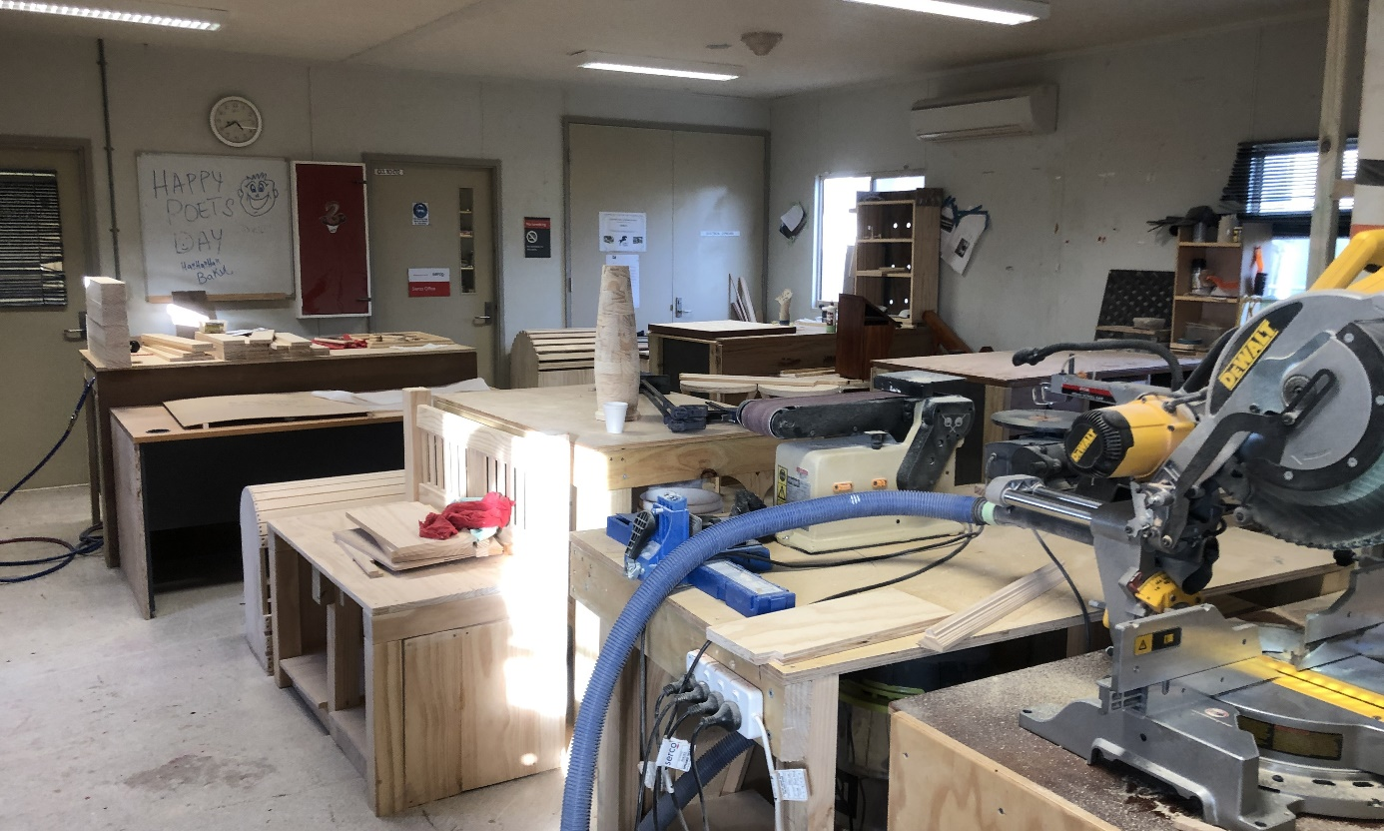
Woodwork workshop, YHIDC
Following inspections in 2018, the Commission suggested that YHIDC could provide a possible model to improve activities at other immigration detention facilities. During inspections in 2019, the Commission identified some improvements elsewhere. For example, facility staff said that a new purpose-built kitchen for cooking classes at MITA was almost complete, and that plans for building a ‘multipurpose’ room at AITA had been approved.

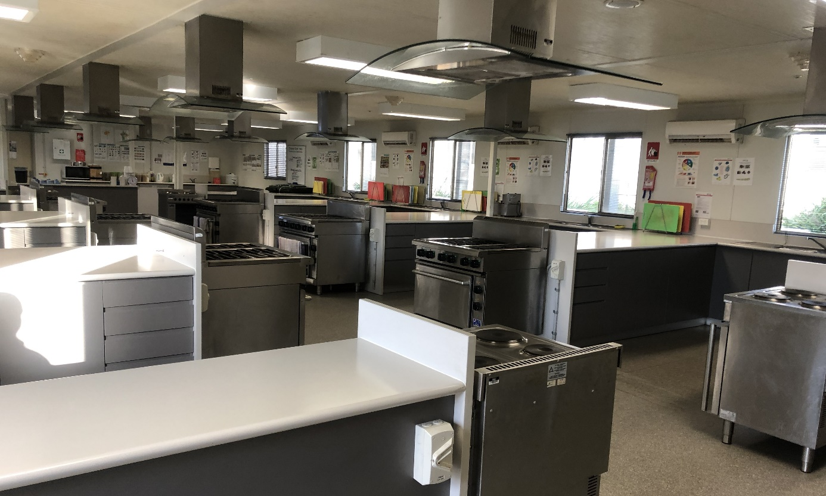
Purpose-built kitchen, YHIDC
There were a range of views about the activities program at each facility. Some people provided positive feedback in relation to programs and activities in general, and others identified activities that they personally enjoyed. The Commission heard much positive feedback in relation to opportunities to undertake cooking classes or to prepare one’s own meals. Cooking classes were offered at YHIDC, AITA and PIDC and the accommodation units at AITA and BRP included self-contained kitchens where people could cook their own meals.
Most people interviewed reported general satisfaction in relation to access to religious services and the availability of spaces for prayer. However, some people said that they would like to be able to attend places of worship in the community as part of their religious practice (see Section 3.6).
A significant number of people at each facility said that they did not find activities interesting or meaningful. Some people said that the activities were of a poor quality or that they were not age appropriate. For example, one person at VIDC told the Commission:
I would like to be able to fix things and do activities that involve building. There is an activity here where you can make things with match sticks and glue, but it is for kids.
Some people reported that they only attended activities to receive ‘points’ to purchase personal items, such as phone credit, cigarettes or snacks. People in detention can earn additional points through participation in activities. A number of people said that they did not attend activities.
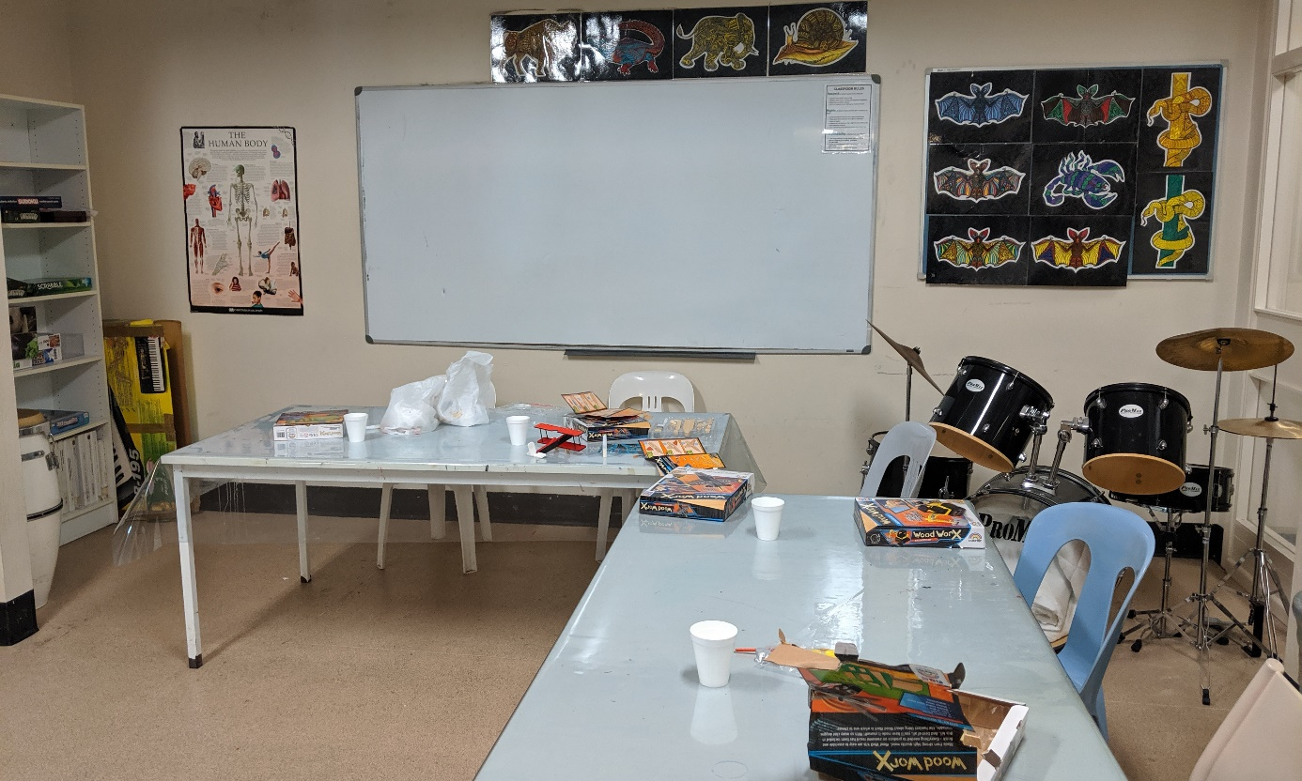
Activities room, Blaxland compound, VIDC
Some people expressed frustration that they did not learn new skills, and many said they would like to undertake study or vocational training. Some contrasted the activities available in detention with those available in prison, noting the lack of opportunities for education and employment in immigration detention. One person who was previously in prison said:
Life was easier in prison as I was working and earned $70 per week and I was studying. I did a course on rural operations, and another on business.
The Commission is aware that a few facilities provide some information about how online study options can be accessed, however facility staff do not facilitate or support people to undertake any online study. While a few people said they had successfully completed online courses, many said they could not afford the fees or found it very difficult to undertake self-study and learn in an online environment.
Some expressed the view that the programs and activities available in detention were insufficient, particularly on weekends, or that facilities available for activities were inadequate. This was a prominent issue for people at the hotel APODs in Melbourne and Brisbane due to inadequate facilities and access to outdoor space (see Section 3.7).
The Commission is concerned that the limitations of current recreational programs and activities in immigration detention may contribute to boredom, frustration, lack of engagement as well as health problems.
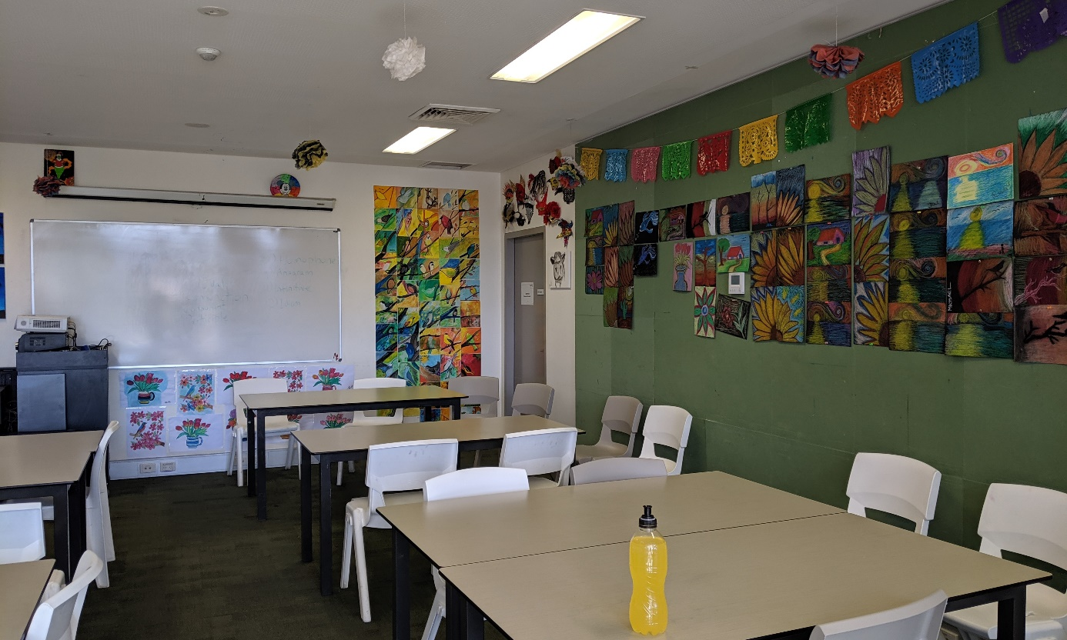
Classroom, VIDC
Following inspections in 2018, the Commission recommended that Home Affairs review its policy on access to vocational training, with a view to enhancing educational opportunities for people held in immigration detention for prolonged periods. Home Affairs responded that it would consider how such educational opportunities could be enhanced.
Restricting access to study and vocational training may be justifiable in situations where people are only held in detention for very short periods. However, when immigration detention becomes prolonged, there is no compelling rationale for this rule. As discussed in Section 2.7, the length of time people spend in immigration detention has increased.
There were no significant improvements in the programs and activities offered to people in detention between inspections in 2018 and 2019. The Commission considers that access to recognised programs of study and vocational training is essential to ensure people in immigration detention have access to adequate and appropriate adult education.

The Department of Home Affairs should revise its programs and activities policy to give people in immigration detention access to recognised programs of study and vocational training.

Excursions
In late 2017 access to excursions for people in immigration detention was restricted. The Commission discussed this policy and its impacts on people in detention in its report following inspections in 2018. These restrictions on excursions remain in place.
During inspections in 2019, facility staff informed the Commission that closed immigration detention facilities (with the exception of AITA and the BRP) do not offer a regular schedule of excursions due to concerns about people—especially those considered to be ‘high risk’—absconding.
With the exception of a few people at AITA and the BRP, nobody the Commission interviewed said that they had participated in excursions in recent times. A number of people reported that they had participated in excursions prior to the introduction of restrictions, without incident. They recalled participating in excursions such as attending the swimming pool, going for walks at a park or visiting the mosque or temple for prayer.
Facility staff at AITA informed the Commission that they offer four excursions each week to church, and that there are no blanket restrictions on who can attend. The Commission only interviewed a small number of people at AITA—one person reported regularly attending these excursions, and another reported that they were not permitted to attend.
The two mothers with toddlers at BRP reported attending weekly excursions to a public library. One person at the hotel APOD in Brisbane said that about six months ago they were able to participate in excursions to a park and a library, but these excursions no longer occurred. Nobody else the Commission spoke to at BRP or any of the other APODs reported participating in excursions.
Excursions can play a key role in promoting the wellbeing of people in immigration detention, particularly those who have been detained for prolonged periods. Excursions can also provide important opportunities for religious observance by allowing people to attend places of worship and practise their religion in community with others.
The Commission’s human rights standards for immigration detention state that restrictions on excursions should be imposed on an individual basis and only if they are necessary and proportionate for the purpose of managing a particular risk.
The Commission appreciates that restrictions on excursions may be reasonable in some circumstances, such as where a person presents a significant risk to the safety of others or is likely to abscond. However, applying a blanket restriction on excursions to all people in immigration detention, or in a particular facility, without assessing the risks of each individual, is unlikely to be necessary or proportionate.
The Commission welcomes efforts by facility staff at AITA and BRP to facilitate excursions for some people. While AITA is a small facility, the population includes people with a range of risk profiles, including people designated as ‘high risk’. This demonstrates that while the composition of immigration detention (including at AITA) has changed significantly in recent years, it is possible to run a safe and secure excursions program.
Following inspections in 2018, the Commission recommended that access to excursions should only be restricted when it is necessary and proportionate in an individual’s circumstances. The Commission notes Home Affairs’ position that current settings in relation to excursions are appropriate to current cohorts in immigration detention, and that meaningful programs and activities can be delivered without the need to facilitate excursions.
Nevertheless, the Commission considers that the blanket restrictions on excursions applied to most people in immigration detention (with the exception of AITA) should be reconsidered. Excursions should be available to people in immigration detention, and only restricted when necessary and proportionate in an individual’s circumstances.
As an initial step towards increasing access to excursions in immigration detention, the Commission suggests that other facilities could pilot an excursion program similar to what is currently offered at AITA. Such a pilot program would provide the opportunity for Home Affairs, in consultation with facility staff, to reconsider current policy settings. The Commission considers that any review of such a pilot program should consider the benefits of excursions for people in immigration detention, in addition to relevant security considerations.

The Department of Home Affairs should only restrict access to excursions when it is necessary and proportionate in an individual’s circumstances. An excursion program should be piloted at each immigration detention facility, with a view to reconsidering current restrictions on excursions.

Hotel APODs
The Commission inspected two hotels in Melbourne and Brisbane that had been designated as alternative places of detention (APODs) (see Section 2.7 (h)).
As noted above, APODs can be designated in locations such as hospitals, mental health facilities, aged care facilities and hotels. APODs are generally used to meet the needs of a small number of individuals for the shortest period necessary. For example, a hospital may be designated as an APOD for the duration of a person’s medical treatment after which they would be returned to an immigration detention facility.
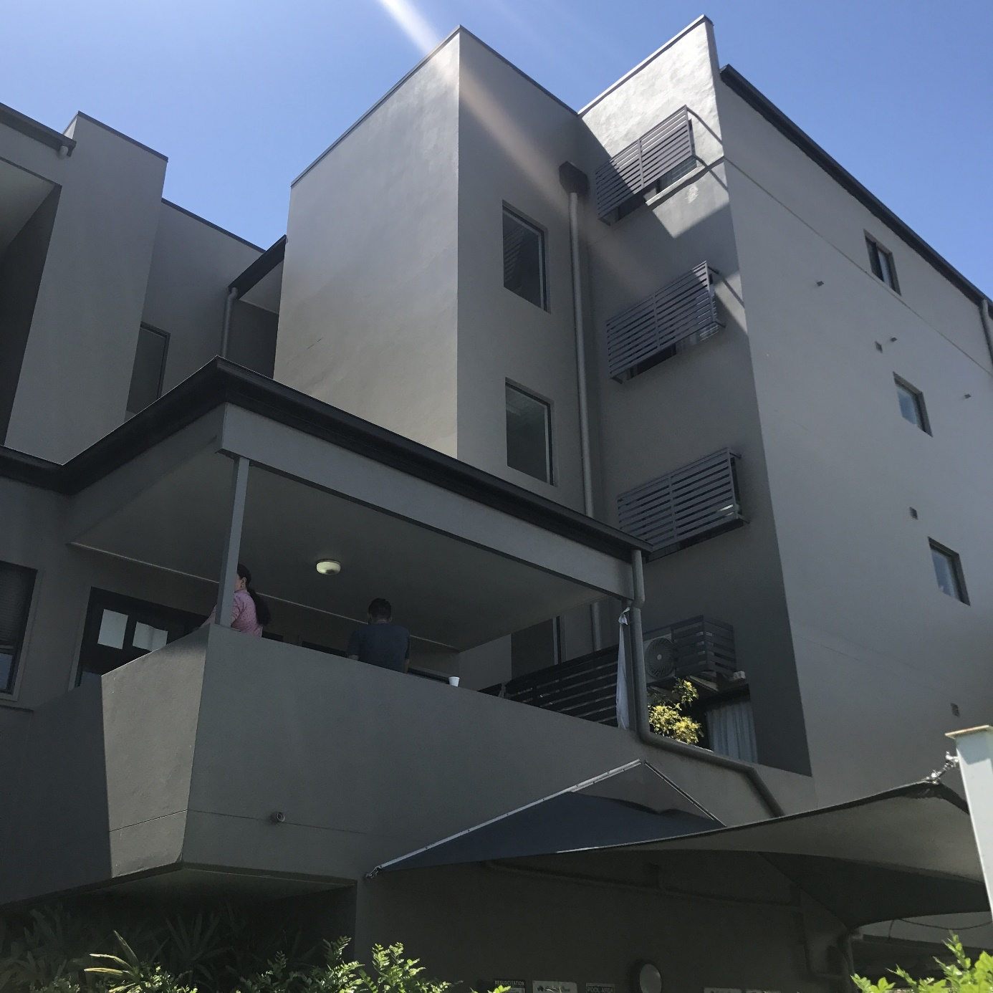
Lockerbie building, Brisbane hotel APOD
The hotel APODs in Brisbane and Melbourne were established in response to the transfer of significant numbers of refugees and asylum seekers from Nauru and PNG for medical treatment and/or assessment (see Section 2.6), who could not all be accommodated at MITA or BITA due to limited capacity. Facility staff at BITA advised the Commission that the hotel APOD in Brisbane is an expansion of BITA and is treated as another site of the facility with the application of the same policies and procedures.
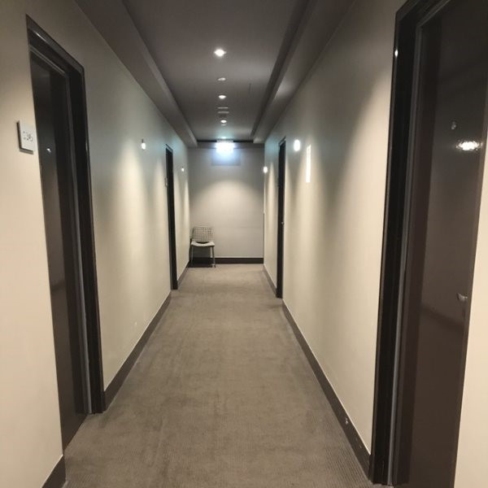
Corridor, Melbourne hotel APOD
The structure and layout of the hotel APODs in Melbourne and Brisbane are different. At the time of the Commission’s 2019 inspections, the APOD in Melbourne was much smaller, and set up primarily across one floor of a hotel. The APOD in Brisbane included one hotel tower with four levels (the Lockerbie building) and a few levels of another tower (the Walmsley building).

Accommodation
At the Melbourne APOD, people were accommodated in two and three-person hotel rooms. Each room contained a shared bathroom with a toilet and shower and a small kitchenette. Any windows in the room or bathroom were locked and could not be opened.
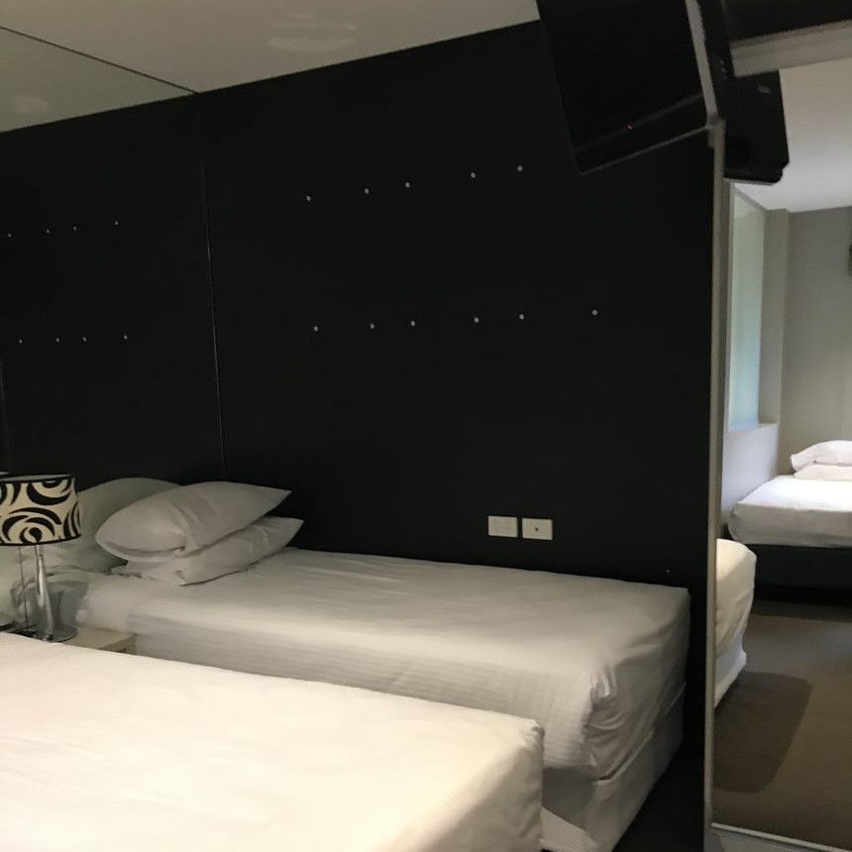
Three-person room, Melbourne hotel APOD
The accommodation at the Brisbane APOD was more spacious. There were single rooms and two-person units, each with a shared bathroom with a toilet and shower and a kitchenette. The two-person apartments also contained a lounge area with a TV. Most rooms also contained balconies; however, these were locked and not accessible. Like the Melbourne APOD, any windows in the room or bathroom were also locked and could not be opened.
Most people that the Commission interviewed reported that they were satisfied with the accommodation areas at both hotel APODs.
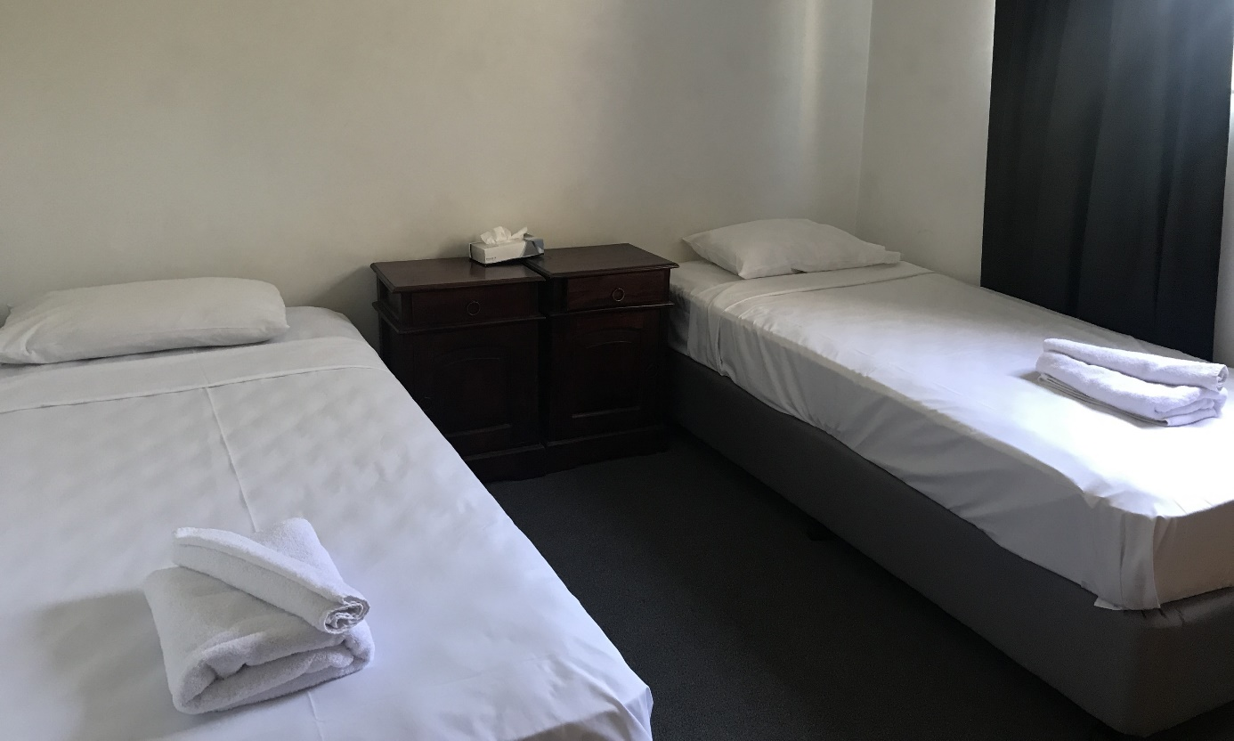
Bedroom in two-person unit, Brisbane hotel APOD
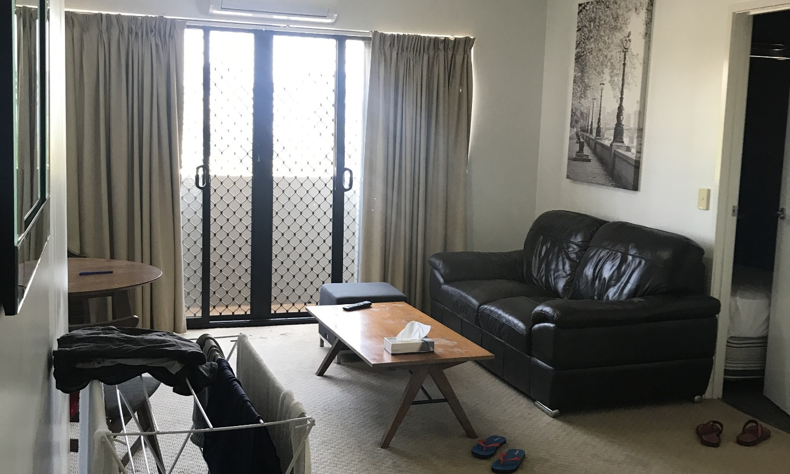
Lounge area in two-person unit, Brisbane hotel APOD

Shared facilities and outdoor space
While the accommodation areas at the hotel APODs were somewhat more spacious (particularly at the Brisbane APOD) than those at MITA and BITA, the shared facilities and outdoor space were significantly more limited at the hotel APODs.
At the Melbourne APOD, there were two small, shared areas on the same floor as the accommodation area—a small common room and a ‘multipurpose’ room. The multipurpose room contained a pool table, a small table for activities and five computers. There was also a dining room area downstairs used for mealtimes and visits. It was not accessible outside of set mealtimes or arranged visits and could only be accessed under escort by Serco officers. The small indoor hotel gym was booked for use by people in the APOD for one set hour each day. There was no outdoor space.
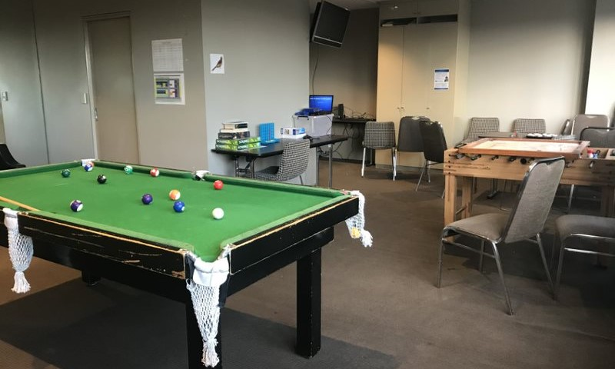
Multipurpose room, Melbourne hotel APOD
The Brisbane APOD had a small common room that was also used as a dining room and ‘multipurpose’ room in the Lockerbie building. There were no shared facilities in the Walmsley building. Serco officers escorted people from the Walmsley building to the Lockerbie building to access these spaces. The multipurpose room was used for activities as well as visits. Similar to the Melbourne APOD, there was no dedicated outdoor space. However, people in the Brisbane APOD had limited access to a small outdoor swimming pool three mornings each week for 30 minutes. At other times, the pool was available to other hotel guests. The people detained at the Brisbane APOD were able to use the area next to the swimming pool for a set period on the weekend to have a barbecue.
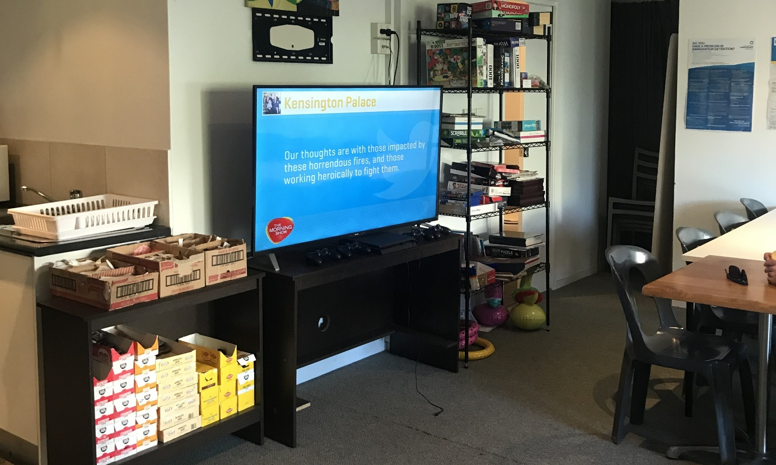
Common room/dining room, Brisbane hotel APOD
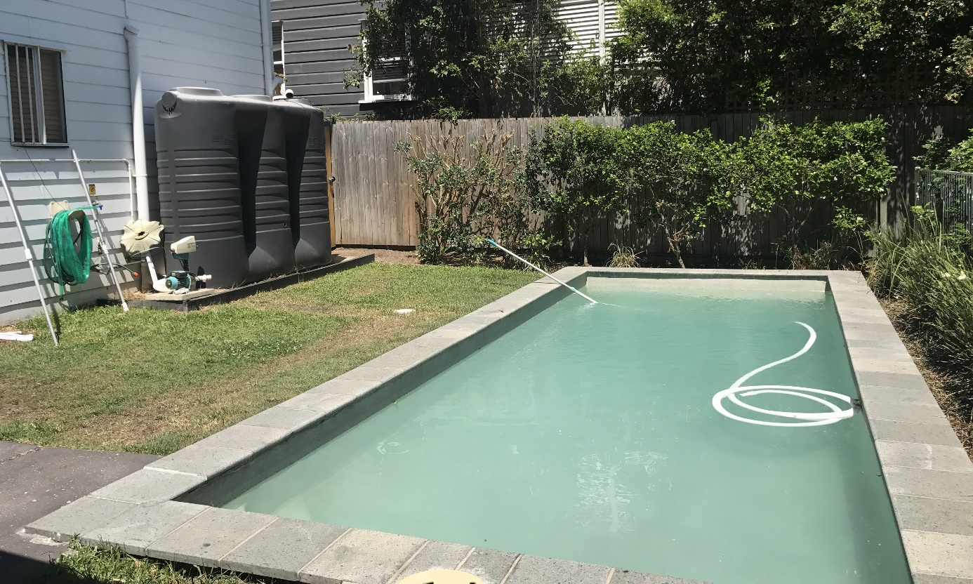
Hotel swimming pool, Brisbane hotel APOD
At the time of inspections, there were four trips each day from Monday to Friday from the Brisbane APOD to BITA. Each group of about 20 people would spend an hour at BITA. During this time, they could use the gym, join in organised activities run by staff at BITA, or spend time in the outdoor space in the residential compound at BITA.
However, there was no regular schedule of trips to access the shared facilities and outdoor space for people at the Melbourne APOD. People at the Melbourne APOD reported that there had previously been regular trips organised for them to use the gym at MITA, but these trips had not occurred for three to four weeks at the time of the inspection. Facility staff at MITA informed the Commission that they were working to put together a more structured program of trips to MITA to access shared facilities and outdoor areas and participate in other organised activities run by staff at MITA.
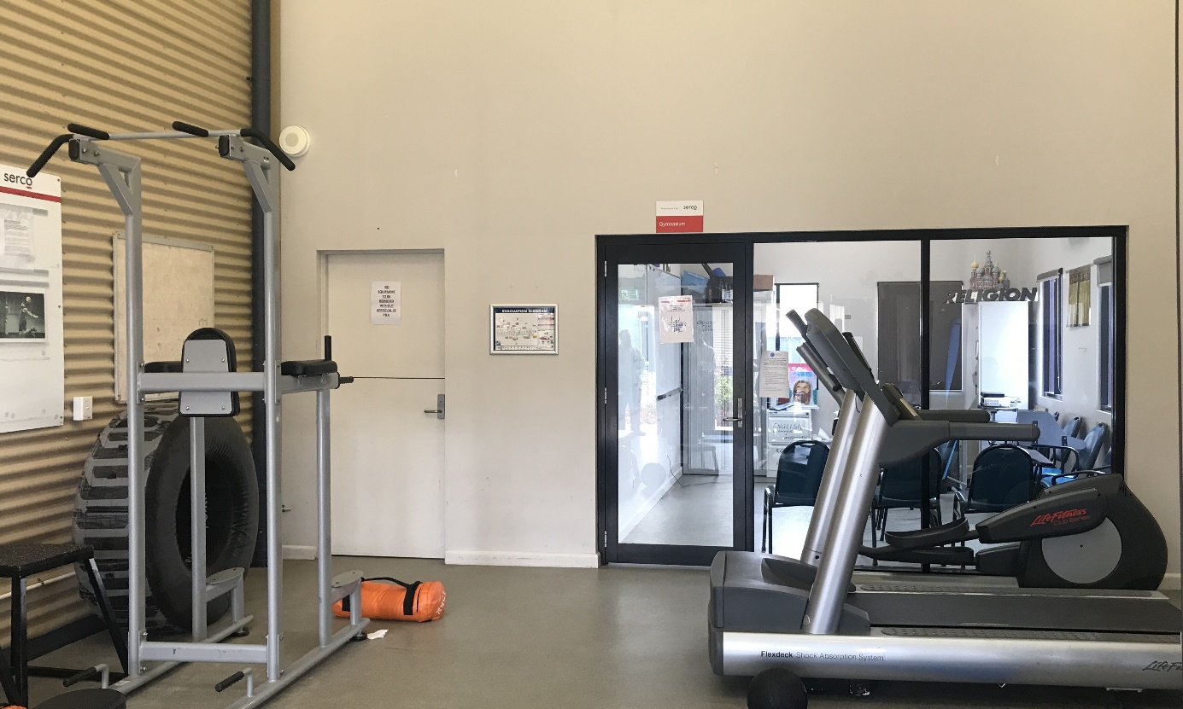
Gym, Residential area, BITA
During interviews with the Commission, people at the Melbourne APOD raised concerns that they did not get enough fresh air or sunlight. For example, one person at the Melbourne APOD told the Commission there is ‘no fresh air and you can’t see the sun.’ Several people commented that they felt ‘locked in’ and complained that they were not allowed to open any windows to let in fresh air. The Commission observed that the Melbourne APOD was entirely indoors, and some spaces had limited access to natural light. For example, the dining room area on the lower level had no windows. While the Brisbane APOD also had no dedicated access to outdoor space, it contained open air corridors on each level that provided fresh air and sunlight.
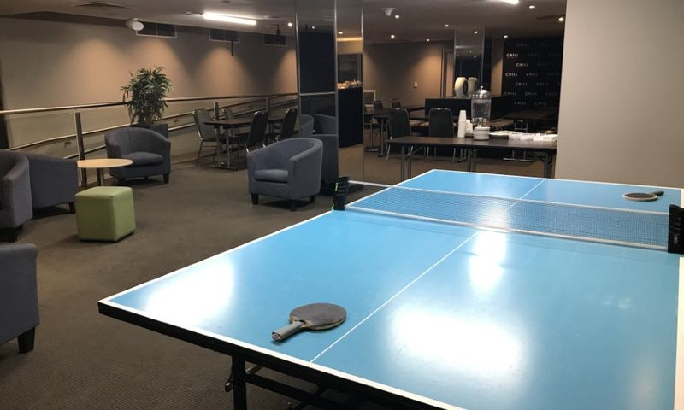
Dining and visits area, Melbourne hotel APOD
People at both hotel APODs told the Commission that they did not have enough access to outdoor space. Many people said that they wanted to go outside more often, and that current levels of access were insufficient. They variously spoke about wanting to go outside to walk, undertake other physical exercise and play sports. This issue was particularly pronounced at the Melbourne APOD where a few people reported that they had not been outside for three to four weeks since trips to the MITA gym had stopped.
In addition, people at both APODs reported that the shared facilities did not offer sufficient space for recreational or educational activities. Many people at the Brisbane APOD reported that it was difficult to join activities in the multipurpose room as these activities were capped at 16 people. For example, one person said that there are ‘races between people running to do the activities’. Several people at the Melbourne APOD said that the multipurpose room was always busy. For example, one person said that they attended English classes in the multipurpose room, but that it was ‘noisy and difficult to follow because there is no separate area for classes’.
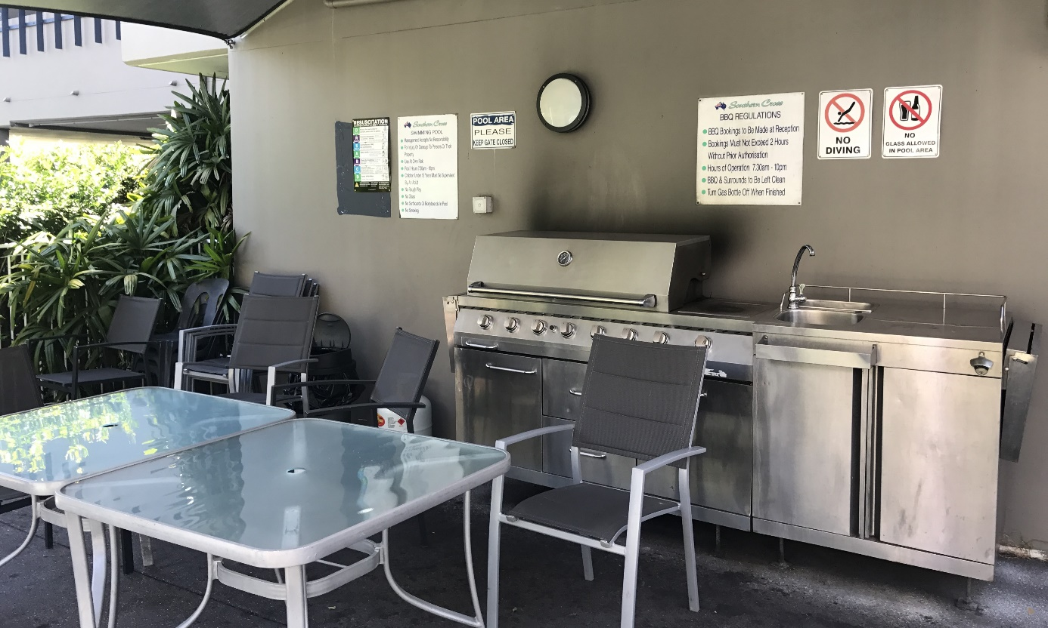
BBQ area, Brisbane hotel APOD
The Commission’s human rights standards for immigration detention state that there must be sufficient opportunities for association with peers and participation in cultural, spiritual and religious activities, including voluntary work in the community, sports, physical exercise and leisure activities and activities in the open air, to provide physical and mental stimulation. The hotel APODs in Brisbane and Melbourne lacked important features necessary to facilitate such opportunities, including significant outdoor areas, open space and shared facilities for exercise, recreation and activities.
The Commission appreciates that the ABF has faced challenges to find appropriate low-security accommodation for a significant number of vulnerable people transferred from Nauru and PNG to Australia at short notice. The Commission also recognises that the use of the hotel APODs in Brisbane and Melbourne may have initially been intended as a short-term measure, and that it may not have been known how long people would be detained there from the outset.
Most people the Commission interviewed reported that they had been detained at the hotel APOD for weeks or months. Some people at the Brisbane APOD, which had been in operation for longer, reported they had been detained there for six months or more.
The conditions of detention at the Melbourne and Brisbane hotel APODs are inadequate. They are extremely restrictive and lack sufficient outdoor space and facilities for exercise, recreation and activities. Such restrictive conditions and lack of access to these essential amenities appeared to be contributing to a decline in the physical and mental wellbeing of those detained in the hotel APODs.
The Commission considers that these hotel APODs are not suitable for use as places of detention on a semi-permanent basis for periods of weeks or months. While people remain detained in these hotel APODs, Home Affairs should identify other locations with more appropriate conditions, including adequate access to outdoor space and shared facilities for exercise, recreation and activities.
In general, the Commission considers that hotels are not appropriate places of detention, given their lack of dedicated facilities and restrictions on access to open space. Consistent with observations following inspections in 2018, the Commission considers that hotels should only be used as APODs in exceptional circumstances and for very short periods.

The Department of Home Affairs should ensure that hotels are only used as Alternative Places of Detention in exceptional circumstances and for very short periods of immigration detention.

The Department of Home Affairs should identify alternative placements, including community detention, for those detained in hotel APODs as a matter of urgency.
The Commission also considers that there is a need to explore further strategies to increase access to outdoor space and other shared facilities for people in the Melbourne and Brisbane APODs. This will provide more opportunities for engagement in exercise, recreation and other activities.
This is particularly urgent for those in the Melbourne APOD. As outlined above, at the time of inspections there was no access to outdoor space at the Melbourne APOD and no regular schedule of trips to MITA.
These strategies could include the introduction (or increase, in the case of the Brisbane APOD) of regular trips to MITA or BITA; and the introduction of excursions to other locations such as parks, sport fields or libraries.

The Department of Home Affairs should implement strategies to provide greater access to outdoor space and shared facilities for people detained in hotel APODs.

Freedom of movement
While people at the hotel APODs were not confined to their hotel rooms and could move around their hotel floor and use any shared spaces available on that floor, they were not able to move freely between hotel floors or hotel buildings.

This was especially restrictive for those without access to shared spaces on their hotel floor. For example, all people at the Melbourne APOD required Serco officers to escort them from their accommodation area to the downstairs dining room for lunch and dinner each day, or to the small indoor hotel gym. Similarly, the vast majority of those at the Brisbane APOD would require Serco officers to escort them from their accommodation area to the multipurpose room on the fourth floor or the dining room on the first floor (unless they resided on the first or fourth floor of the Lockerbie building).

At the time of the Commission’s inspections, a curfew from 7pm to 7am applied to the Walmsley building but did not apply to other areas of the Brisbane APOD. During these hours, people detained in the Walmsley building were confined to their rooms without access to any shared spaces. Indeed, several people interviewed by the Commission complained about the curfew at the Walmsley building.

Restrictions on freedom of movement within immigration detention facilities may be reasonable in some situations if they are necessary to manage risks and are proportionate in the circumstances. However, facility staff explained that the curfew at the Walmsley building existed because there were not enough staff on roster during these hours to escort people to the Lockerbie building. They did not indicate that the curfews were considered necessary for risk management.

While the hotel APODs in Brisbane and Melbourne were being used to detain a vulnerable cohort considered to be ‘low-risk’, they were extremely restrictive environments with limited freedom of movement. The conditions of detention at these APODs were significantly more restrictive than low security compounds in other immigration detention facilities (such as the residential compound at BITA).

The Commission considers that the curfew applied to people in the Walmsley building is unreasonable and unnecessary and only serves to amplify the restrictiveness of the environment. The Commission suggests that the use of curfews at the Walmsley building should be reviewed, with a view to removing curfews that are not strictly necessary to ensure safety and security. To the extent necessary, staffing should be increased to allow for the reduction or elimination of unnecessary curfews.

The Department of Home Affairs should consult with facility staff at the Brisbane Immigration Transit Accommodation about the use of curfews at the Walmsley building, with a view to removing curfews that are not strictly necessary to ensure safety and security.

Pat searches
During interviews with the Commission, many people at the Brisbane APOD raised concerns about the frequency of pat searches during trips between the APOD and BITA. They reported that they are subject to pat searches four times per trip—when leaving the APOD and before entering BITA, and then twice more on the reverse trip. For example, one person explained that when he attended BITA twice in one day—once to use the gym, and another time to attend a health appointment—he was pat searched eight times. Facility staff at BITA confirmed these reports about the frequency of searches and explained that policy and procedure require one pat search on exit from, and one on entry to, each immigration detention facility. They said a typical return trip from the Brisbane APOD to BITA requires four pat searches.
Many people reported that the frequency of pat searches can discourage attendance at appointments or accessing facilities at BITA. People detained at the Brisbane APOD attend BITA for health appointments, to use the gym, access outdoor space and other shared facilities, and for any meetings with status resolution officers from Home Affairs or professional visits such as with a lawyer. Several people said that they no longer attend BITA due to the frequency of pat searches. A few people also said that they find the pat searches to be ‘humiliating’, especially when they are conducted in front of other people.
Requiring pat searches at the point of entry and exit during direct trips between an APOD and a nearby immigration detention facility appears excessive to the Commission, especially given most of the people being searched are considered ‘low risk’ and are escorted by Serco officers between secure facilities. This practice affects people detained in APODs disproportionately as they generally require regular access to services or facilities at other nearby immigration detention facilities.
The Commission considers that the frequency of pat searches during direct trips between an APOD and a nearby immigration detention facility should be reviewed, with a view to significantly reducing the number of pat searches required.

The Department of Home Affairs and Serco should review the frequency of pat searches during escorts between Alternative Places of Detention and nearby immigration detention facilities to ensure that pat searches are only conducted when strictly necessary.

Food
People detained at the Brisbane APOD raised concerns with the Commission about the quality of the food provided for dinner. The Commission received no complaints in relation to the food provided at the Melbourne APOD.
The Brisbane APOD serves a daily hot lunch in the dining area and frozen meals for dinner that people can heat in the microwaves in the kitchenettes in their accommodation area. Many people at the Brisbane APOD said that they find the frozen dinners to be inedible, and some said that they do not eat them—instead they take additional food at lunch or eat other snacks that they can purchase or order from the canteen at BITA.
Facility staff at BITA advised the Commission that they were taking steps to provide both hot lunches and dinners at the Brisbane APOD. At the time of inspections, they were in the process of sourcing a third party to provide this service.
The Commission welcomes efforts by facility staff at BITA to improve the quality of meals provided at the Brisbane APOD. The Commission considers that people at the Brisbane APOD should have access to a hot meal for dinner and/or the option to cook their own hot meal like people detained at other facilities, including other APODs.

Physical conditions of detention

Dormitory-style accommodation in low and medium security compounds
Some low and medium security compounds have dormitory-style accommodation that contains more than one set of bunk beds and may accommodate between four to 10 people:
- all rooms in the residential compound at BITA contain two sets of bunks that accommodate up to four people
- most rooms in the Avon compound at MITA contain two sets of bunks that accommodate up to four people, and some rooms contain five sets of bunks that accommodate up to 10 people
- the Kangaroo and Emu accommodation areas at AITA contain rooms with two sets of bunks that accommodate up to four people
- all rooms in the male compound at PIDC contain a mixture of bunk and single beds that accommodate up to seven people—the space for each set of bunks was separated by curtains and was particularly small and dark.

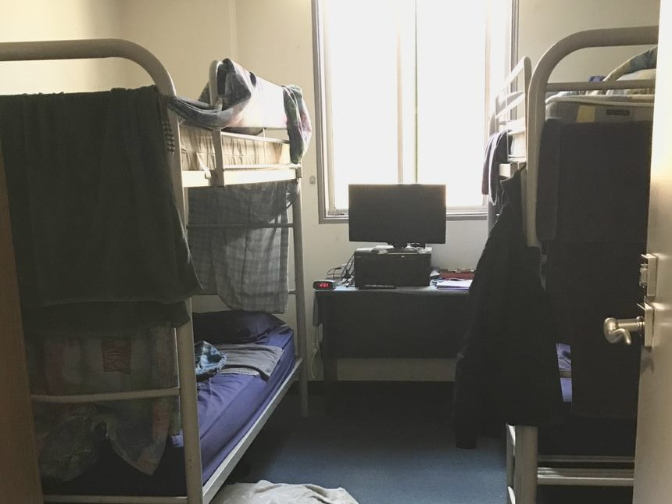
Four-person dorm, Avon compound, MITA
Most people the Commission interviewed from these compounds reported that all the beds in their rooms were usually occupied. Many also raised concerns about overcrowding. These concerns included: limited privacy due to the number of people in their room; difficulty or inability to sleep due to noise; hygiene issues in rooms and shared bathrooms due to high usage levels and irregular cleaning; and insufficient storage space for clothing and toiletries.
People in the Avon compound at MITA also raised concerns about lengthy waiting times to access the toilets and showers. The Avon compound has two floors with 18 rooms and shared toilets and showers on each level. There were seven showers available on the lower floor, however only two showers available on the upper floor.
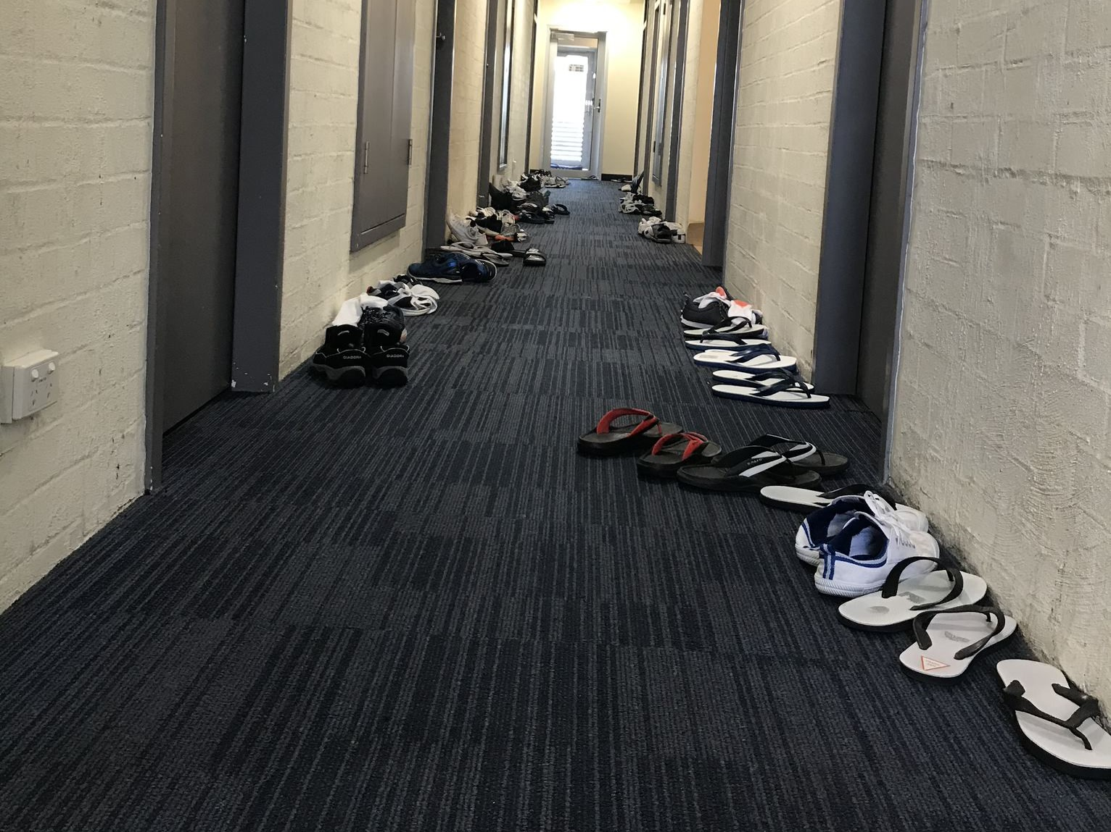
Avon compound, MITA
A number of people reported that these conditions were adversely affecting their health. For example, they reported that issues such as lack of sleep, insufficient access to quiet and private space, and that their inability to control their environment was compounding existing health conditions. Some said that health professionals had recommended that they are placed in a single room. A long-term detainee with significant mental health issues reported that he had been living in the 10-person room in the Avon compound for 10 months and that this was causing him considerable distress.
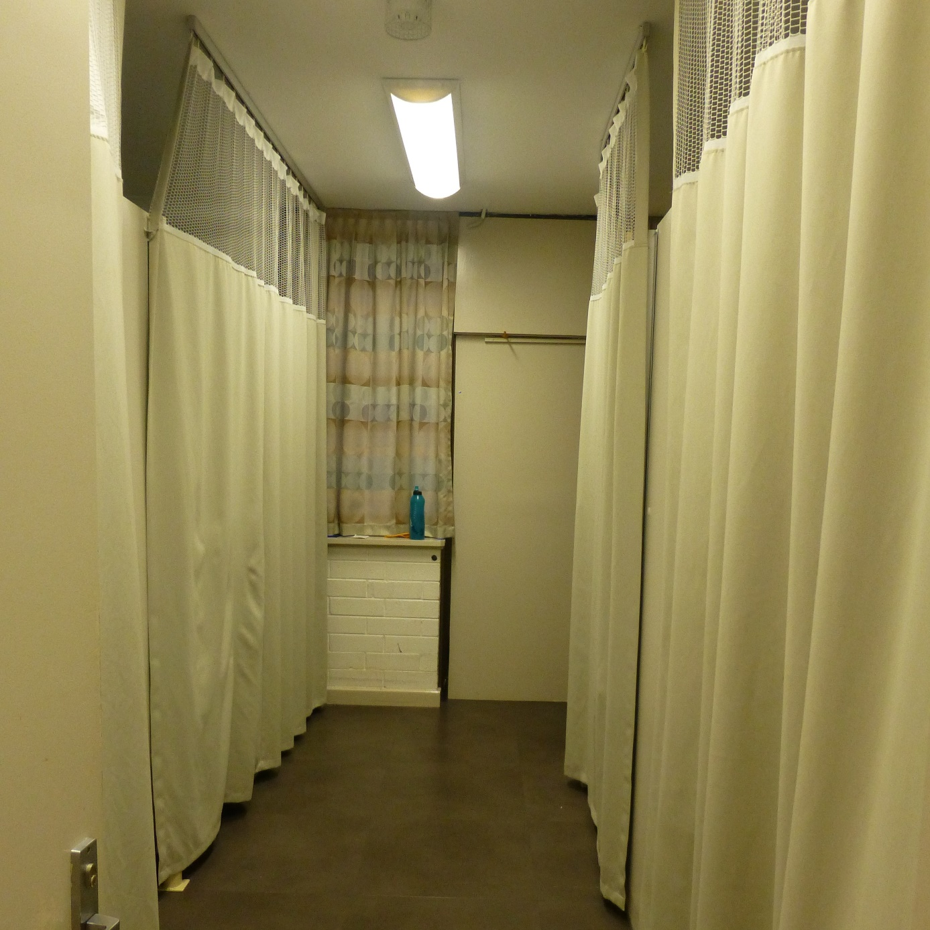
Male dorm, PIDC
The Commission acknowledges that low-medium security compounds, particularly at MITA and BITA, have had significant population increases due to transfers of people from Nauru and PNG, which has contributed to some of the issues reported above.
The number of people detained in these compounds was affecting conditions of detention. The dormitory-style accommodation available in these compounds, which is predisposed to issues such as overcrowding, could not give sufficient space or privacy to this number of people. Such conditions appeared to be adversely affecting the health and well-being of some people detained in these compounds. The Commission considers that these conditions of detention are unsuitable, especially for people with significant physical and/or mental health conditions.
The numbers of people in dormitory-style accommodation should be closely monitored to prevent issues such as overcrowding. Given the number of people detained in these compounds, strategies to reduce the numbers of people in these compounds should be considered. It would not be appropriate for this to include transfers to compounds or facilities with higher security settings, as people detained in these compounds are generally considered to be ‘low-risk’. In order to reduce the number of people in these compounds, the Commission considers that people detained in these compounds should be considered for release into alternative community-based arrangements.

The Minister and Department of Home Affairs should consider all people in dormitory-style accommodation in low-medium security compounds for release into alternative community-based arrangements.

High-security compounds
The larger immigration detention facilities all contain high-security compounds. Most of the high-security compounds currently in use have been constructed since 2017. They are used for people in immigration detention who are considered ‘high risk’ on the basis of facility staff assessment of their security risk, which includes a person’s risk assessment by Serco (as produced by the Security Risk Assessment Tool).
The high-security compounds included:
- the Dargo, Erskine, Ford and Glenelg compounds in MITA North complex
- the Cassowary, Eagle, Kingfisher and Swan compounds at the YHIDC
- the Moreton and Fraser compounds at BITA.
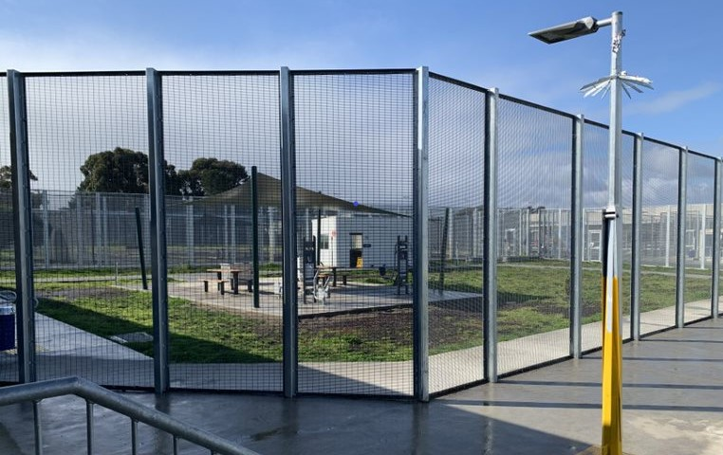
Outdoor courtyard, Erskine compound, MITA
At the time of the Commission’s inspections, the older Blaxland compound at VIDC was still in operation as a high-security compound. It has since closed, and a newly constructed high-security compound has opened and is currently in use (see Section 3.8 (d)).
The layout of these compounds is generally the same in each facility. Each compound is separated by high internal fences that enclose a small outdoor courtyard. Overlooking the courtyard is a covered outdoor balcony area and the indoor area contains a common area (that also serves as a dining area) that connects to corridors, which each contain a total of 10 rooms, with five along each side. These compounds generally contain two corridors of rooms (a total of 20 rooms) with capacity for up to 40 people. However, some compounds are smaller, such as the Swan compound at YHIDC and the Fraser compound at BITA, which have capacity for 20 people.
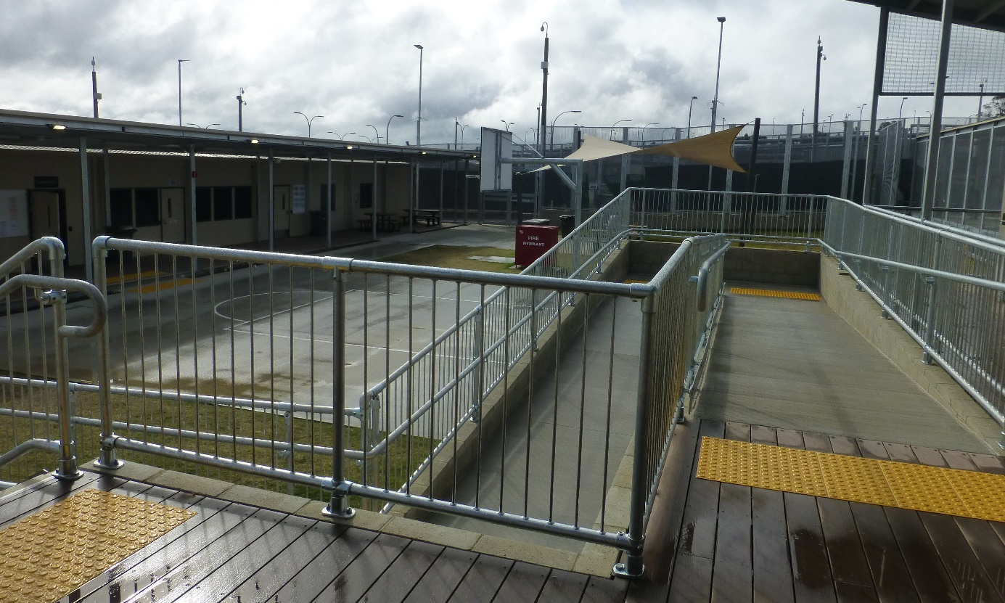
Cassowary compound, YHIDC
The Commission observed the following conditions in these compounds:
- Most furniture is made of hard materials (often metal) and fixed in place, and most seating comprised of metal stools and benches without backs.
- Bedrooms contain a single bunk bed and are generally shared between two people (except for Moreton compound at BITA where rooms are shared between three people).
- Each bedroom contains a bathroom with a toilet and a shower, but there is no door or solid partition between the bathroom and the sleeping quarters. In some compounds, curtains had been installed.
- The bathrooms in most compounds (except Moreton compound at BITA) contain combined metal toilet and sink units, where the sink is positioned directly above the toilet and its use requires leaning over the toilet bowl.
- Within each compound there is generally a small outdoor courtyard enclosed by high fencing with anti-climb mesh, some gym equipment, laundry facilities, an indoor common area with a kitchenette that provides tea, coffee and supplies for a cold breakfast (however there are no amenities for cooking) and a small computer room and a prayer room.
- The compounds at YHIDC each contained a basketball half-court, however this was not a feature within any of the high-security compounds at MITA or the Fraser compound at BITA.
- Compounds are separated by high internal fences with anti-climb mesh and visible security cameras overlooking the compounds, and the balcony area of the Fraser compound at BITA, which is used as a gym, was enclosed by security grilles.
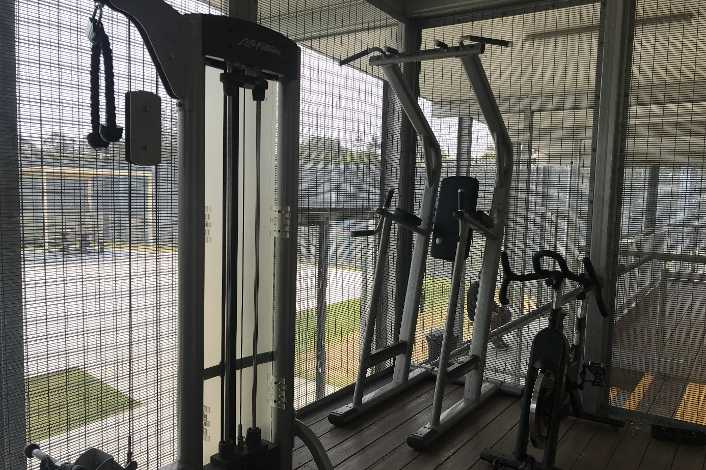
Gym, Fraser compound, BITA
People detained in the high-security compounds at MITA, BITA and YHIDC raised a range of concerns about the conditions of their detention. These concerns included: limited privacy due to the lack of doors between the bathroom and sleeping quarters; hygiene issues, particularly in relation to combined toilet and sink units (which are used for toileting, washing and shaving) as well as the lack of doors between the bathroom and sleeping quarters; lack of comfortable seating; safety issues arising from the lack of safety rails on bunk beds; insufficient access to secure storage space; not able to watch free to air television; limited access to outdoor space and facilities for meaningful activities; the prison-like nature of the infrastructure; and accessibility issues for elderly people or people with a disability.
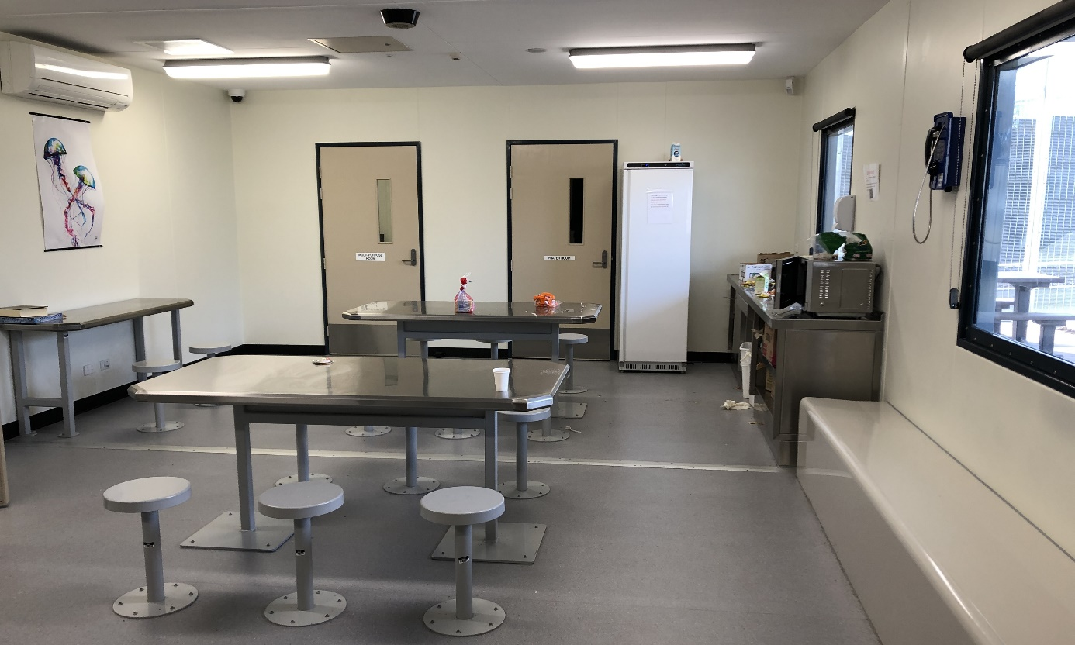
Indoor common area/dining area, Cassowary compound, YHIDC
The Commission is concerned that the infrastructure in these high-security compounds is harsh and prison-like and generally not appropriate for administrative detention. The compounds also do not offer adequate privacy, particularly due to the lack of bathroom doors, limited secluded spaces and the use of shared accommodation arrangements. The Commission observed that shower curtains had been installed in some compounds to provide some separation between bathrooms and sleeping quarters. Even with curtains installed, however, the Commission is concerned that this does not afford sufficient privacy under shared accommodation arrangements.
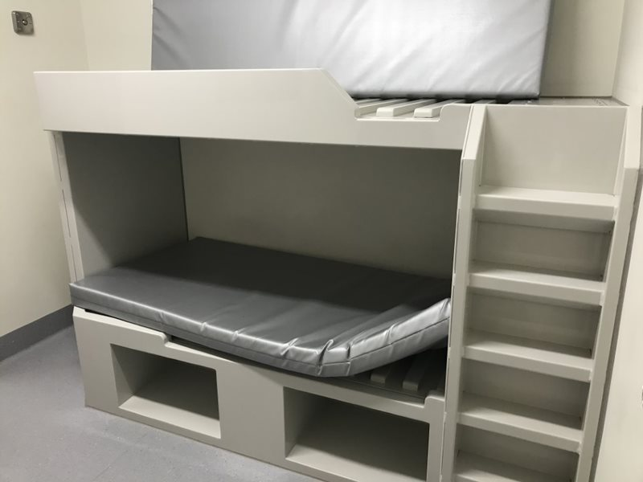
Bunk bed, Glenelg compound, MITA
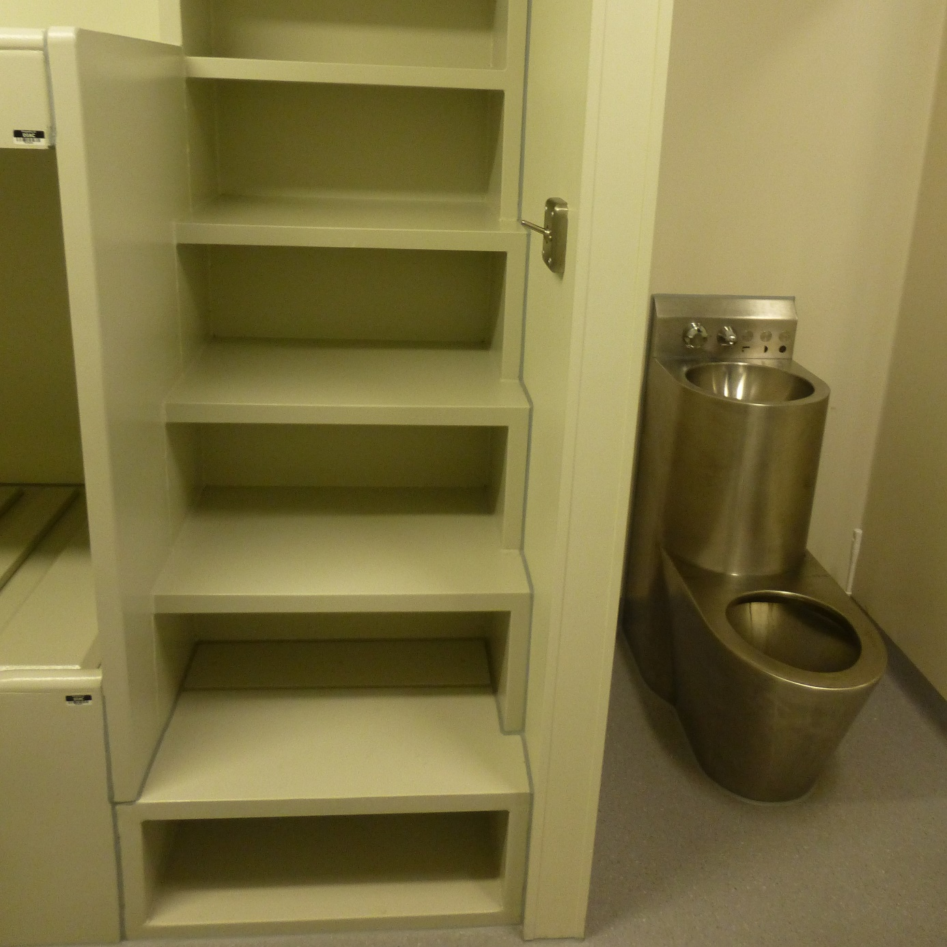
Combined toilet and sink unit next to sleeping quarters, Cassowary compound, YHIDC
The Commission has previously recommended that the high-security compounds be modified, to lessen some of their harsher and more restrictive elements, including by:
- installing doors to separate bathrooms from sleeping quarters
- replacing hard, fixed furniture with unfixed furniture made of more comfortable materials, such as couches, armchairs and chairs with back support
- replacing stainless steel bathroom fittings with plastic or ceramic fittings, including separate toilets and sinks
- installing beds with appropriate safety rails on the top bunk and secure storage facilities in bedrooms
- removing security grilles from balconies
- dismantling non-essential fences (such as those separating accommodation areas from outdoor common areas)
- limiting shared accommodation arrangements to the extent possible.
There have been no significant modifications to the infrastructure (including fixtures and finishes) since the Commission made this recommendation following inspections in 2018.

As a matter of urgency, the Department of Home Affairs should modify infrastructure (including fixtures and finishes) in the high-security compounds at BITA, MITA and YHIDC to lessen their harsh and restrictive conditions and ensure these facilities are appropriate for administrative detention.

Dargo compound
The Dargo compound in MITA North had opaque fencing around the perimeter of the compound. This compound is used for people in immigration detention who for various reasons are assessed by facility staff to require protection from others.
The Dargo compound is located next to a central thoroughfare in MITA North, which is used by people detained in all high-security compounds to access all shared facilities in the MITA North complex, such as the mess hall and the gym.
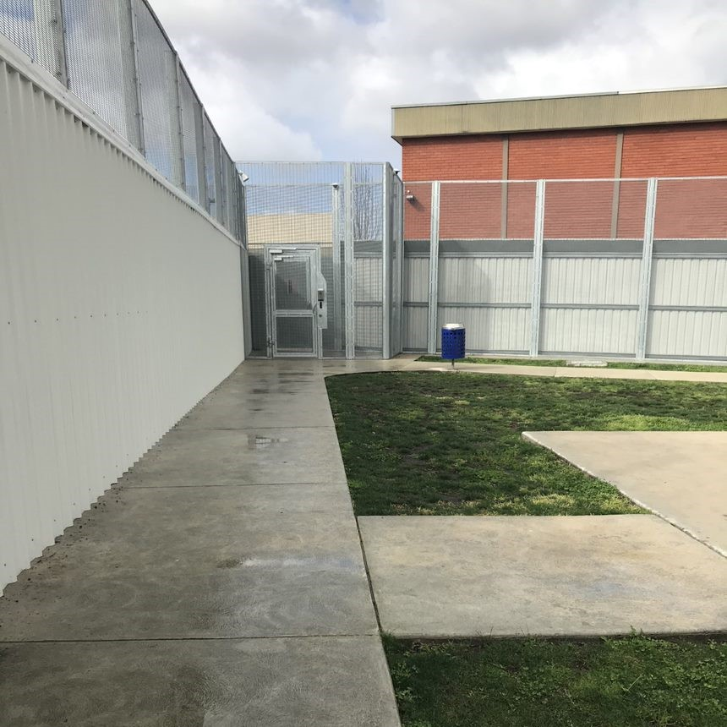
Opaque fencing, Dargo compound, MITA
The Commission observed that the opaque fencing around the Dargo compound was a particularly restrictive feature of the MITA North high-security complex. It prevented those detained in Dargo compound from any view out of the compound and exacerbated an already restrictive environment (as outlined in sections 3.12(c) above).
Most people the Commission interviewed from Dargo compound raised significant concerns including that the opaque fencing unnecessarily restricts their view, making them feel ‘caged in’; and that it has the effect of further ‘singling out’ and ‘stigmatising’ those in the Dargo compound.
Facility staff at MITA informed the Commission that the opaque fencing was installed in response to a recommendation made by the Commonwealth Ombudsman to address concerns about the safety of people in the Dargo compound. The location of the Dargo compound next to a central thoroughfare in MITA North may contribute to the safety concerns that the installation of opaque fencing around the compound seeks to address.
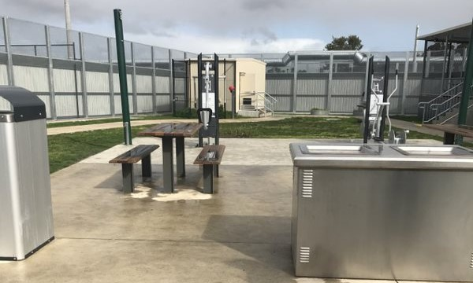
Outdoor courtyard, Dargo compound, MITA
The opaque fencing has had an adverse impact on the conditions of detention for people detained in the Dargo compound. This restrictive feature renders the Dargo compound inappropriate for use as a place of immigration detention. The Commission considers that the location of the Dargo compound should be reviewed to ensure that the safety needs of people in the Dargo compound are addressed, while also ensuring adequate conditions of detention.

In consultation with facility staff, the Department of Home Affairs should review the location of the Dargo compound at MITA to ensure that the safety needs of people in the Dargo compound are addressed, while also ensuring adequate conditions of detention.

Closure of Blaxland
At the time of the Commission’s inspection of VIDC, the Blaxland compound continued to be used for high-security accommodation. The Commission has repeatedly expressed concern about conditions of detention in this compound and has recommended that it be closed.
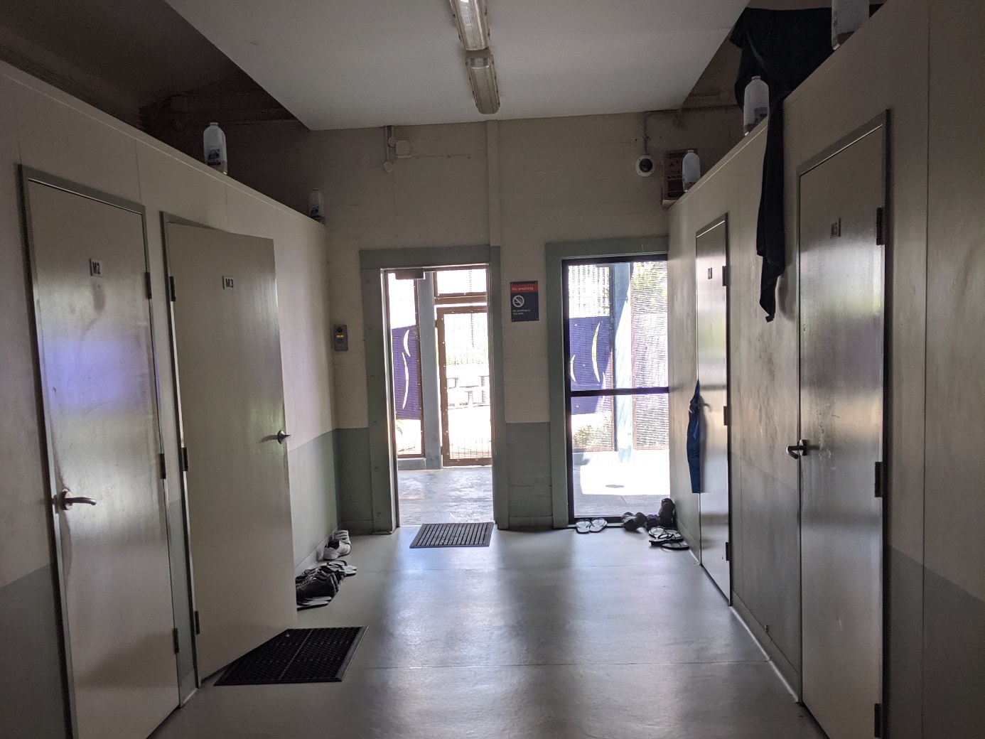
Dorm 1, Blaxland compound, VIDC
There are three separate accommodation areas in Blaxland compound. In Dorm 1, up to six people share dormitory-style bedrooms, with no enclosed ceilings and virtually no privacy. In Dorm 2, up to four people share a bedroom. Dorm 1 and Dorm 2 had limited natural light and people in these compounds were not able to control the light switches in the rooms and had to request for lights to be switched on and off through the intercom system. In Dorm 3, bedrooms contain single beds and accommodate up to two people. Each Dorm had a common area furnished with old, worn furniture and a kitchenette. The shared bathroom and laundry facilities in each Dorm were often dirty.
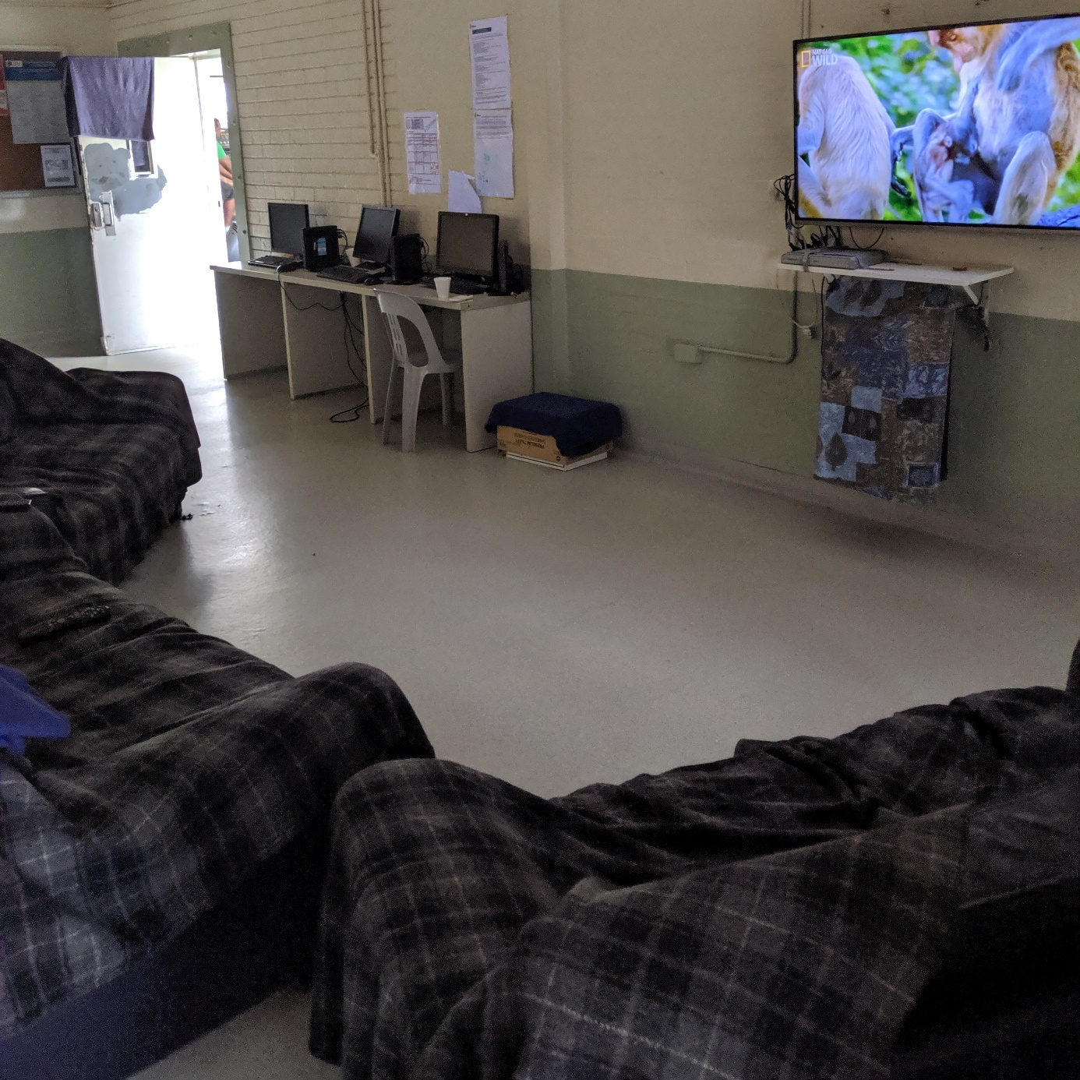
Common area, Dorm 2, Blaxland compound, VIDC
People in Blaxland compound raised significant concerns about their accommodation. Those living in the dormitory-style bedrooms in Dorm 1 and 2 reported that their bedrooms were cramped, offered ‘no privacy’, had poor temperature regulation, offered no independent lighting controls, and were noisy due to the number of people sharing the rooms and the lack of enclosed ceilings. Some people had hung up bed sheets around their bunks to provide some privacy.
Some also reported the presence of vermin and insects (such as rats, cockroaches and mosquitos) in accommodation areas. In Dorm 1 makeshift bottles of water and honey had been placed on top of a wall dividing each room to attract insects such as mosquitos. Several people raised concerns that the sanitation facilities were mouldy and unhygienic, and that there were only a small number of showers and toilets that were shared between large numbers of people.
The outdoor areas consisted of courtyards and a basketball court. These areas have limited shade, synthetic grass and insufficient space for people to run around. Dorms 1 and 2 share an indoor gym on rotation, while Dorm 3 has its own exercise equipment located in the outdoor courtyard.
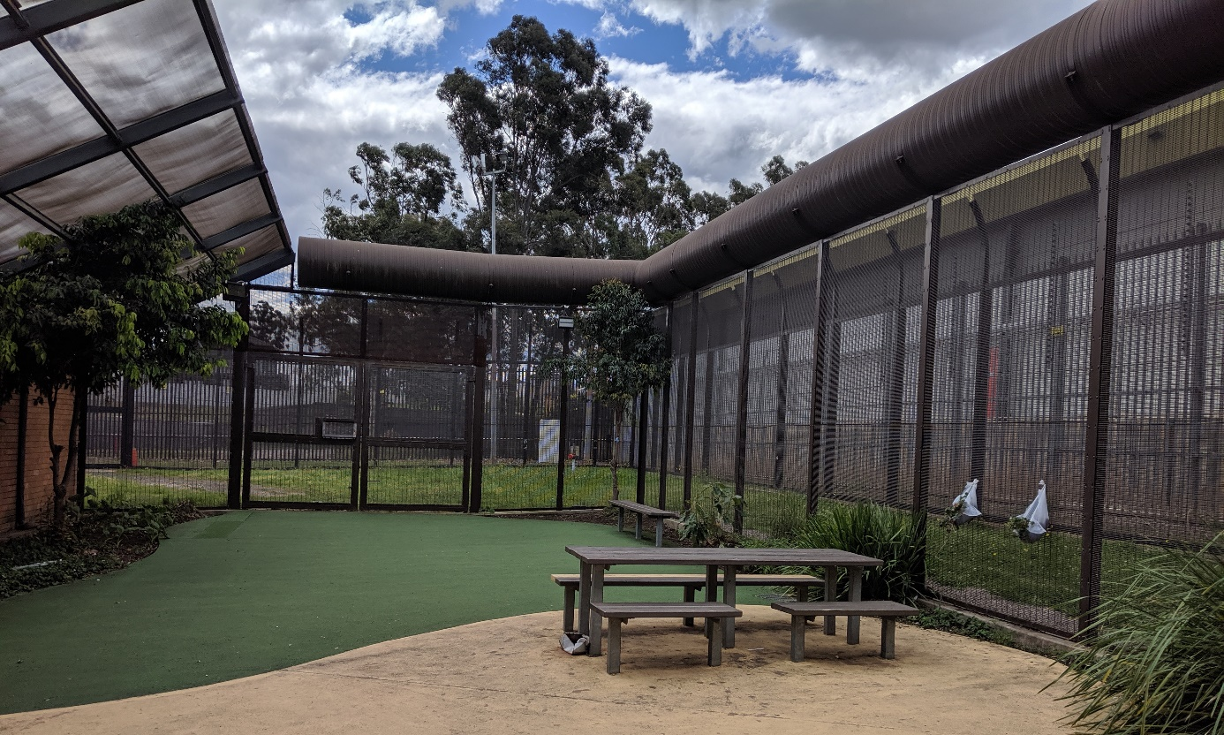
Outdoor area, Dorm 2, Blaxland compound, VIDC
Facility staff at VIDC advised that construction works were ongoing to establish a new high-security compound in the main complex. Since the Commission’s inspections of VIDC in September 2019, the Blaxland compound has closed. The transfer of people from Blaxland to the new high-security compound was completed in March 2020. The Commission welcomes the closure of the Blaxland compound.

Recreational space and facilities
Access to recreational space and facilities varies across compounds within and across immigration detention facilities. The level of access is generally determined by what recreational space and facilities are available within a particular compound, as well as whether compounds are subject to any ‘controlled movement’ policies, which limit freedom of movement within detention facilities, and may restrict access to recreational space and facilities outside of compounds.
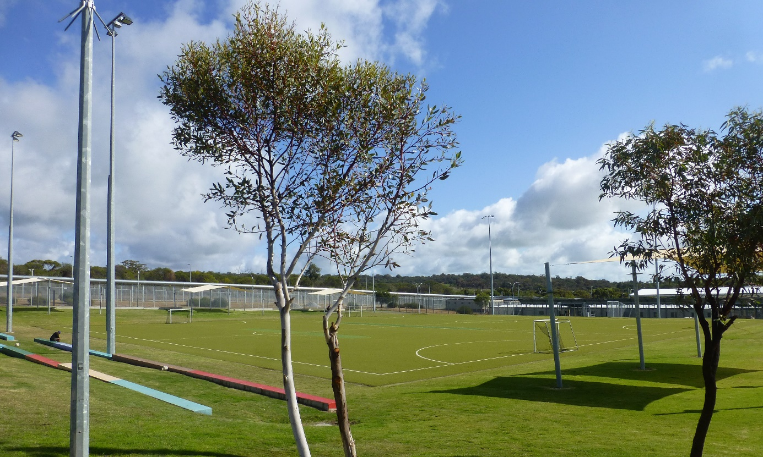
Green Heart, YHIDC
Since 2017 the Commission has observed an increase in the use of ‘controlled movement’ policies for the purposes of risk management (for example, to allow for separation of people who may pose a risk to others; or to prevent people in detention from congregating in large numbers and thereby reduce the risk of a major disturbance). Following inspections in 2017 and 2018, the Commission acknowledged that controlled movement policies aimed to ensure the safety of facility staff and people in immigration detention, but also raised concerns that these policies could have a significant impact on living conditions and access to recreational space and facilities for people in detention.
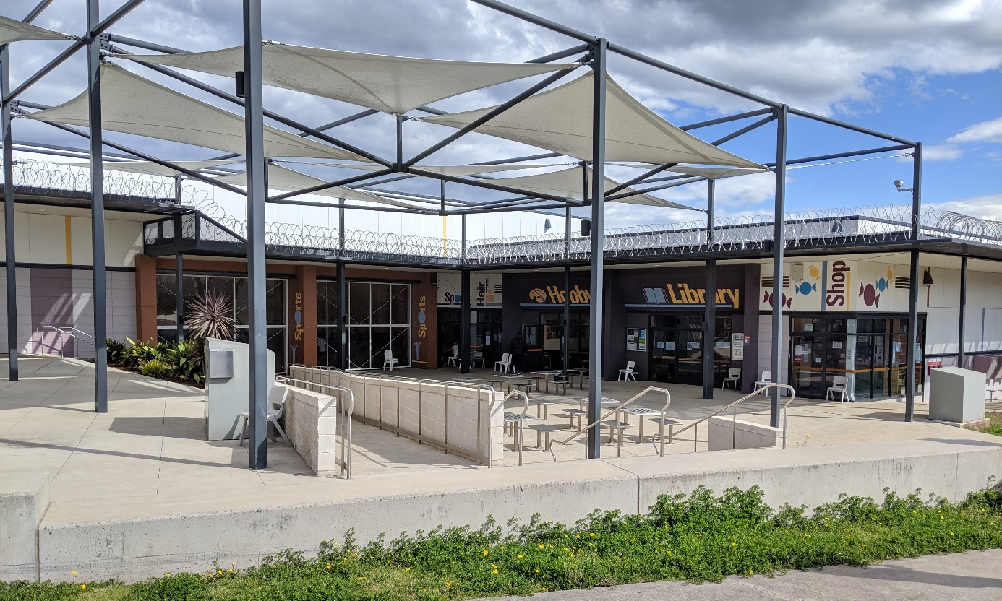
Community area, VIDC
During inspections in 2019 some lower-security compounds continued to operate on a more ‘open’ model and remained largely unaffected by controlled movement policies. People in these compounds could move relatively freely between their compounds and other areas in the facility. For example:
- The Falcon and Hawk compounds at YHIDC have full access to the expansive outdoor area (called the ‘Green Heart’) throughout the day, as well as the large activities complex. The Green Heart contains two full-size soccer fields, a large outdoor gym and two full-size basketball courts.
- The La Trobe compound at VIDC has full daily access (up until curfew at 8pm) to the large, central ‘community area’ that includes a large oval, well-equipped indoor gym, an indoor gymnasium for sport, as well as other facilities such as educational classrooms, a canteen and a coffee shop.
- The ‘residential’ compound at BITA also has full daily access to an open area with a garden and covered space, a small indoor gym and a full-size basketball court (although these facilities are not as large or well-equipped as the facilities referred to above that are available at YHIDC or VIDC).

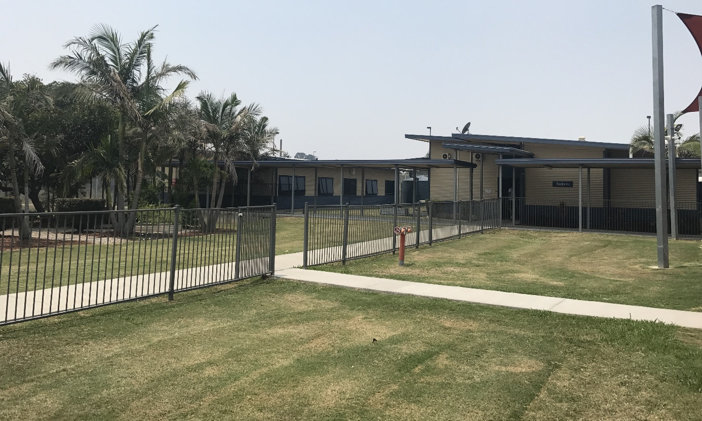
Outdoor area, residential compound, BITA
While there are significant differences in the quality and size of the amenities available at these facilities (for example, the infrastructure at BITA is older, smaller and much more limited than at YHIDC and VIDC), the Commission considers that people in these compounds generally have access to adequate recreational space and facilities.
There were also a large number of compounds subject to controlled movement policies in 2019. People in these compounds were not permitted to leave their compound unless they had rostered access to areas outside of their compounds. In most cases, they required escort by Serco officers in order to move between their compound and other areas in the facility. This included:
- the high-security compounds at MITA, YHIDC and BITA (as outlined in Section 3.8 (b))
- Bass 1 and Bass 2 compounds in the low-medium security MITA South complex
- the medium-security Mitchell, MacKenzie and Hotham compounds at VIDC
- the low-medium security Lachlan and Lima compounds at VIDC.
As outlined in Section 3.8 (b), the high-security compounds at MITA, YHIDC and BITA are harsh and restrictive and do not offer appropriate conditions for administrative detention. As described above, the compounds are small, enclosed spaces that contain accommodation areas, a small outdoor courtyard, some gym equipment (usually in a small room), an indoor common area with no comfortable seating, a small computer room and a prayer room. The high-security compounds at YHIDC and the Moreton compound at BITA each contained a half-size basketball court. However, this was not a feature in the high-security compounds at MITA or the Fraser compound at BITA.
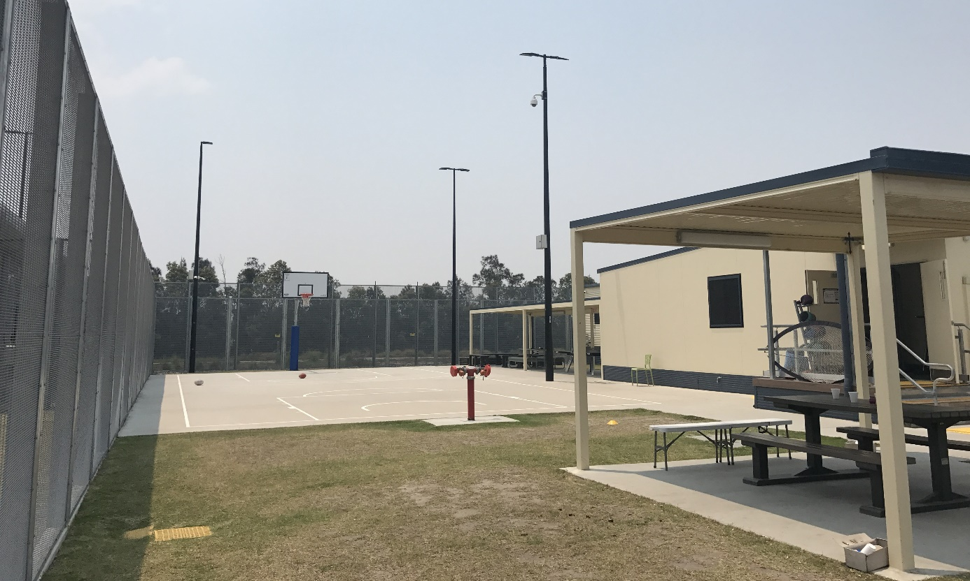
Outdoor area, Moreton compound, BITA
The high-security compounds have limited access to recreational space and facilities outside of the compounds. The MITA North complex had rostered access to an indoor gym, recreation hall, educational classroom and small outdoor courtyard for two to three hours each day. At YHIDC, the high-security compounds had rostered access to the ‘Green Heart’ at the centre of the facility. The Swan compound had access for one hour each day, Cassowary compound for two hours each day, and the Eagle and Kingfisher compounds for four hours either in the morning or the evening or two hours in the afternoon.
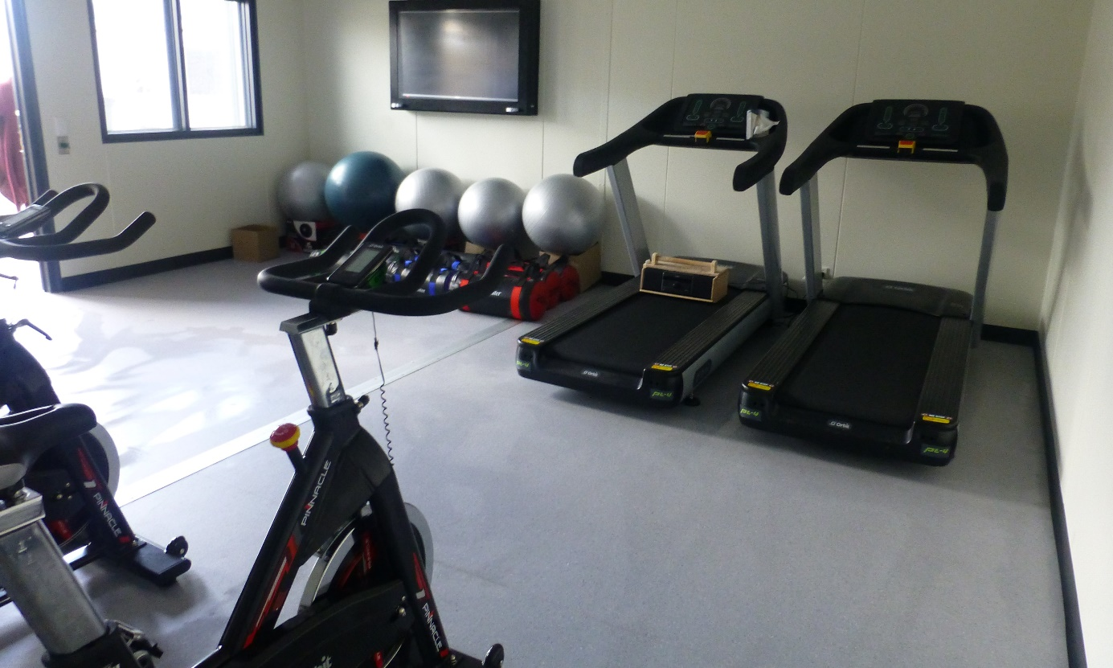
Gym, Swan compound, YHIDC
The high-security compounds at BITA had rostered access to a small outdoor area enclosed by high fences that contained a half-size basketball court. This was a significantly smaller area with access to less facilities than the areas that people in the MITA North complex and high-security compounds at YHIDC were able to access outside of their compounds.

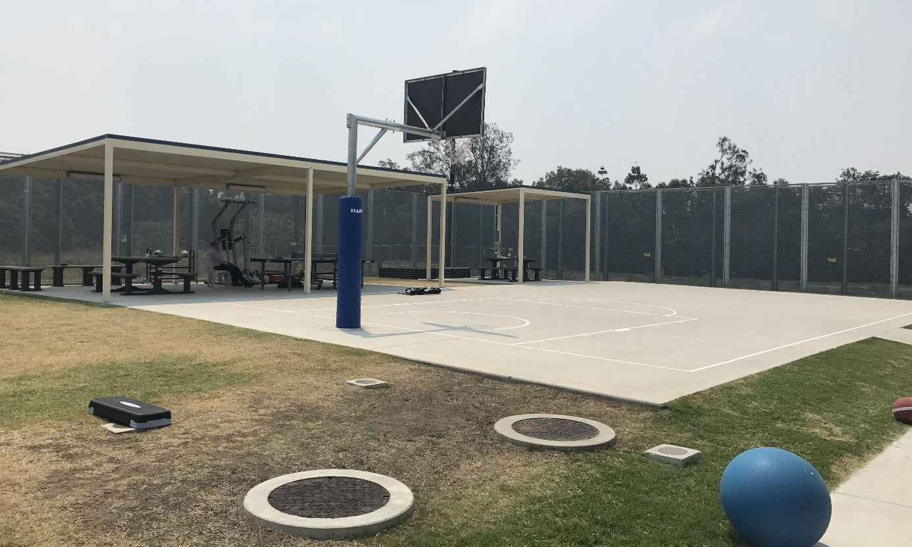
Recreation area, high-security compounds, BITA
The Hotham, Mackenzie and Mitchell compounds are larger than the high-security compounds outlined above and contain more ‘built-in’ facilities for exercise, recreation and activities. In addition to the accommodation areas (that also contained small common areas in each unit), these compounds also contained a soccer field, basketball court, outdoor garden area, a classroom and a ‘recreation’ room that contained some gym equipment, a ping pong table and a pool table. People in the Hotham, MacKenzie and Mitchell compounds did not have access to any other recreational space or facilities outside their compounds. They did not have any access to the large central ‘community area’ at VIDC.
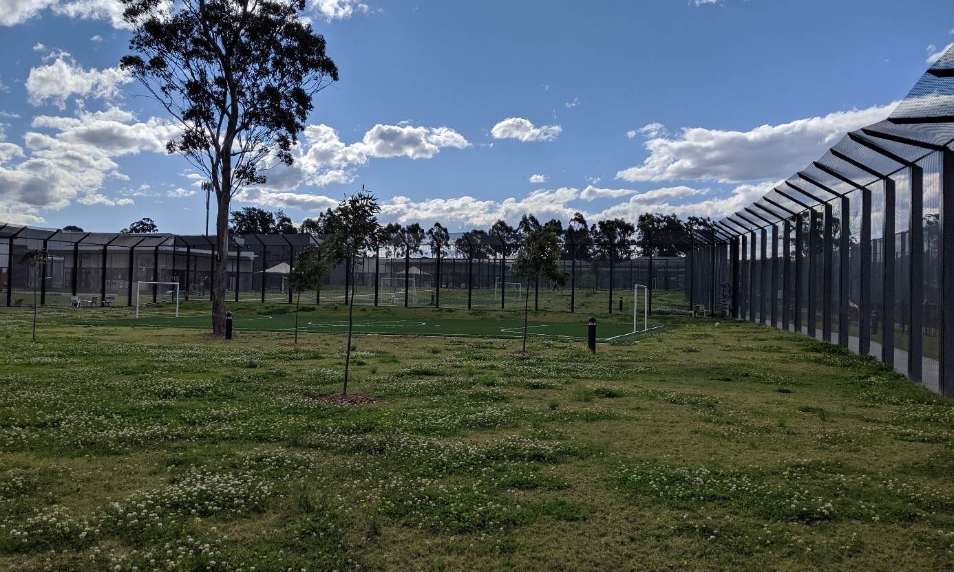
Soccer field in Hotham compound with a view of Mitchell and MacKenzie compounds, VIDC
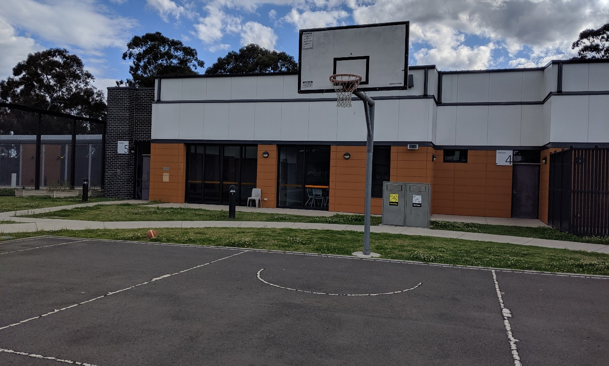
Hotham compound, VIDC
The Bass 1 and Bass 2 compounds at MITA are smaller with less recreational space and facilities as compared to the Hotham, Mackenzie and Mitchell compounds at VIDC. The Bass 1 compound contained a shared indoor common area with a small kitchenette (for tea and coffee), some computers, a lounge area with a TV, a pool table and a tennis table and a separate prayer room. It also contained an outdoor courtyard including an artificial turf area with a basketball hoop.
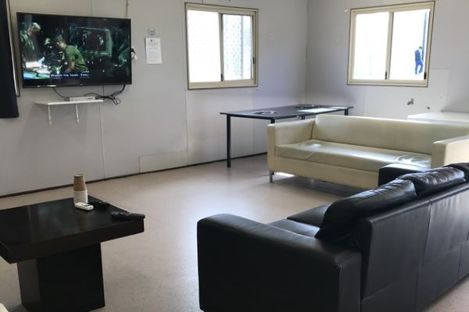
Common area, Bass 1, MITA
The Bass 2 compound that is used to detain women is smaller than Bass 1, however contains much lower numbers of people. It contained an outdoor courtyard with a half-size basketball court, a small room with limited gym equipment, a shared indoor common area with a lounge area with a TV, a table for activities and some computers.
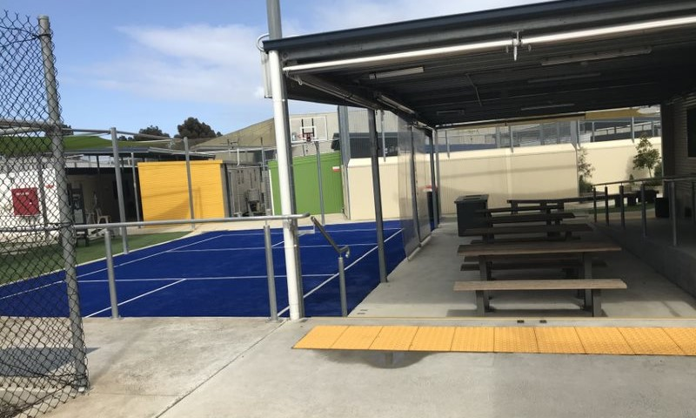
Outdoor area, Bass 2, MITA
There was restricted movement between the Avon compound and Bass 1 compounds which are adjacent in the MITA South complex. The Avon compound is larger than Bass 1 and Bass 2 and contains more recreational space and facilities. People in the Bass 1 compound had rostered access to facilities available in the Avon compound, including a full-size synthetic soccer pitch, an outdoor courtyard with a volleyball net and a well-equipped indoor gym.

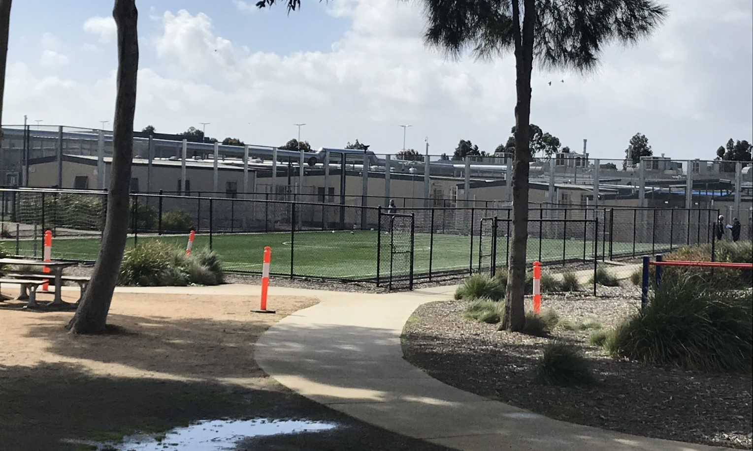
Soccer pitch, Avon compound, MITA
The Bass 2 compound had less access to the facilities in Avon compound than Bass 1. At the time of the Commission’s inspections, the women in Bass 2 could only use the indoor gym in the Avon compound for two hours each week. Access to the synthetic soccer pitch had ceased due to a recent incident that occurred on the soccer pitch. Facility staff at MITA advised that they were reviewing the incident, and options to reintroduce access to the soccer pitch for Bass 2.
The ‘lock-down’ of the Lachlan and Lima compounds at VIDC that was in place during the Commission’s inspection of VIDC in 2018 had been slightly relaxed in 2019. The lock down of these compounds had occurred due to concerns that the transfer of a new cohort considered to be ‘high-risk’ may pose risks to the safety of women and people who had been convicted of certain sexual offences.
The Lachlan and Lima compounds were originally designed to operate on a more ‘open’ model, whereby the people detained there would have free access to the community area (like the La Trobe compound). Consequently, access to recreational space and facilities within these compounds is more limited. Both compounds contain a full-size basketball court, and Lachlan also contains a demountable block that is used as a classroom.
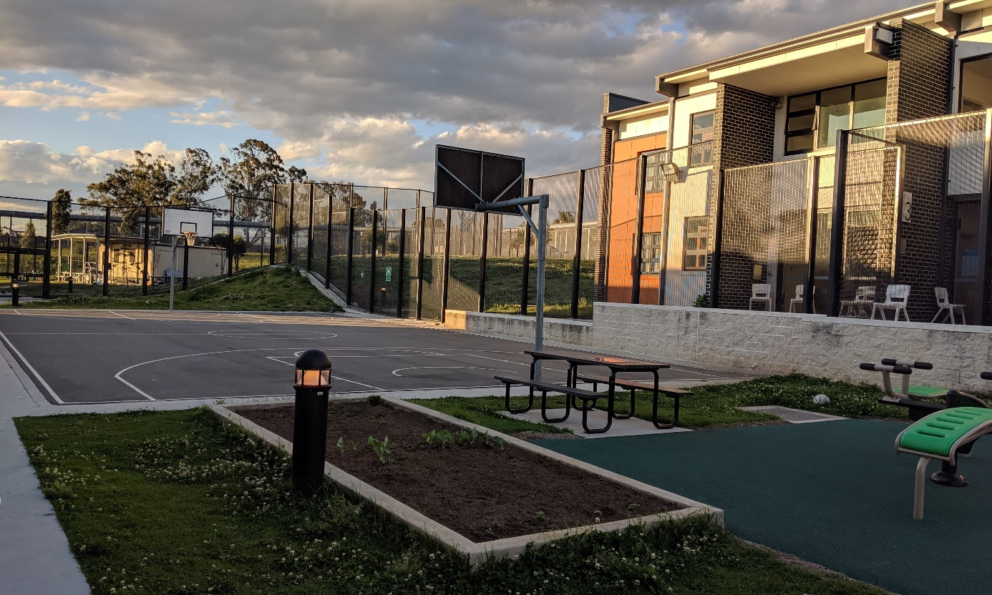
Outdoor area, Lima compound, VIDC
During inspections in 2019, the Lima and Lachlan compounds had alternate access on every second day to the ‘community area’ and the gym. They had access to the gym from 6am to 8am, and to the community area from 4.30pm to 6pm. A few people in the Lima compound reported that some services available in the community area, such as the coffee shop, canteen and library, were not operational during their allocated access time.
The high-security compounds at YHIDC, MITA and BITA do not have access to adequate recreational space and facilities to engage in meaningful activities. The controlled movement policies applied to these compounds result in people spending significant periods of time within compounds that are generally harsh and restrictive and have limited recreational space and facilities. As outlined in section 3.8(b), the Commission considers that these conditions are unnecessarily restrictive and generally not appropriate for administrative detention.
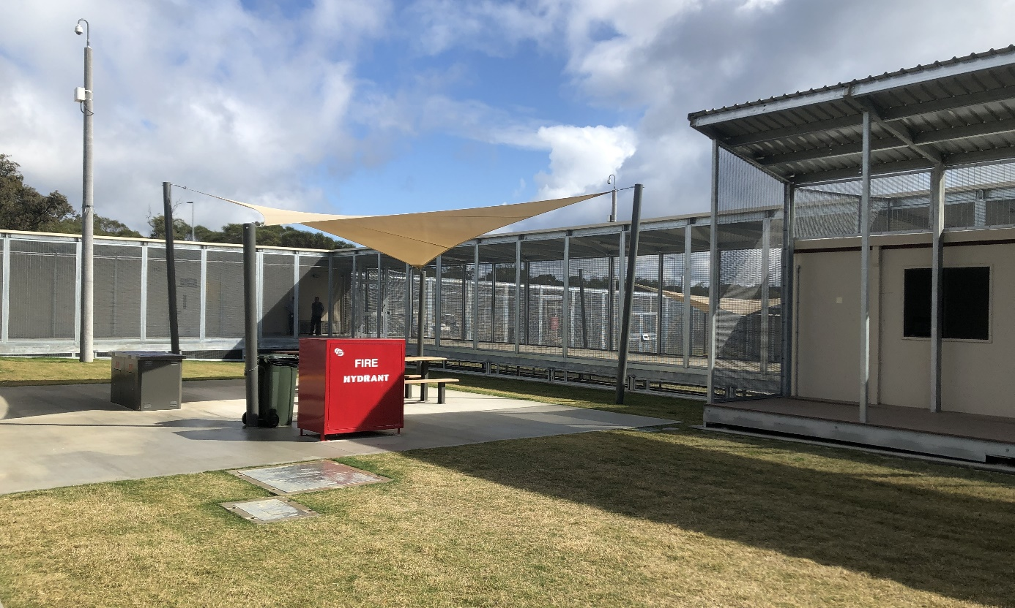
Outdoor courtyard, Swan compound, YHIDC
While the Hotham, Mackenzie and Mitchell compounds—as well as Lima and Lachlan compounds at VIDC and Bass 1 and Bass 2 compounds at MITA—generally provide satisfactory conditions of detention and access to facilities, they are typically smaller and more cramped than lower-security compounds that operate on a more ‘open’ model, and they have less access to recreational space and facilities outside of their compounds.
Following inspections in 2018, the Commission recommended that facility staff implement strategies to provide increased access to outdoor space and facilities for exercise, activities and recreations for people detained in medium and high-security compounds (such as by rostered access to facilities in adjacent lower-security compounds). This recommendation remains relevant, including for the lower security Lachlan and Lima compounds at VIDC. There is a need to further develop strategies to increase the access that people in these compounds, in particular high-security compounds, have to facilities for exercise, recreation and activities outside of their compounds.
The Commission acknowledges that some strategies have been put in place—for example, people detained in the Bass compounds at MITA have some access to facilities in the Avon compound, and people detained in the Lima and Lachlan compounds at VIDC now have some access to the community area. However, the Commission considers that this access should be increased, and a similar approach could be used to provide increased access to recreational spaces and facilities for people in the medium-security compounds at VIDC and the high-security compounds at YHIDC, MITA and BITA.
In addition, the Commission suggests consideration be given to the additional resources and infrastructure required to ensure adequate access to facilities for exercise, recreation and activities in circumstances where is it necessary for an accommodation compound to operate under a ‘controlled movement’ policy.

The Department of Home Affairs and facility staff should implement strategies to provide increased access to outdoor space and facilities for exercise, activities and recreation for people detained in medium and high-security compounds (such as rostered access to facilities in adjacent lower-security compounds).

The Department of Home Affairs and facility staff should consider the additional resources and infrastructure required to ensure adequate access to facilities for exercise, recreation and activities, in circumstances where controlled movement is necessary, and provide the required resources for this.

High-care accommodation
Most of the purpose-built immigration detention facilities inspected by the Commission in 2019 contained a ‘high-care accommodation’ unit used for single separation (except for AITA). These included:
- 12 high-care accommodation rooms in the Hotham compound at VIDC
- eight high-care accommodation rooms in the Shaw compound at MITA
- ten high-care accommodation rooms at YHIDC
- one high-care accommodation room in the Hamilton compound at BITA
- two high-care accommodation rooms in the centre of PIDC.
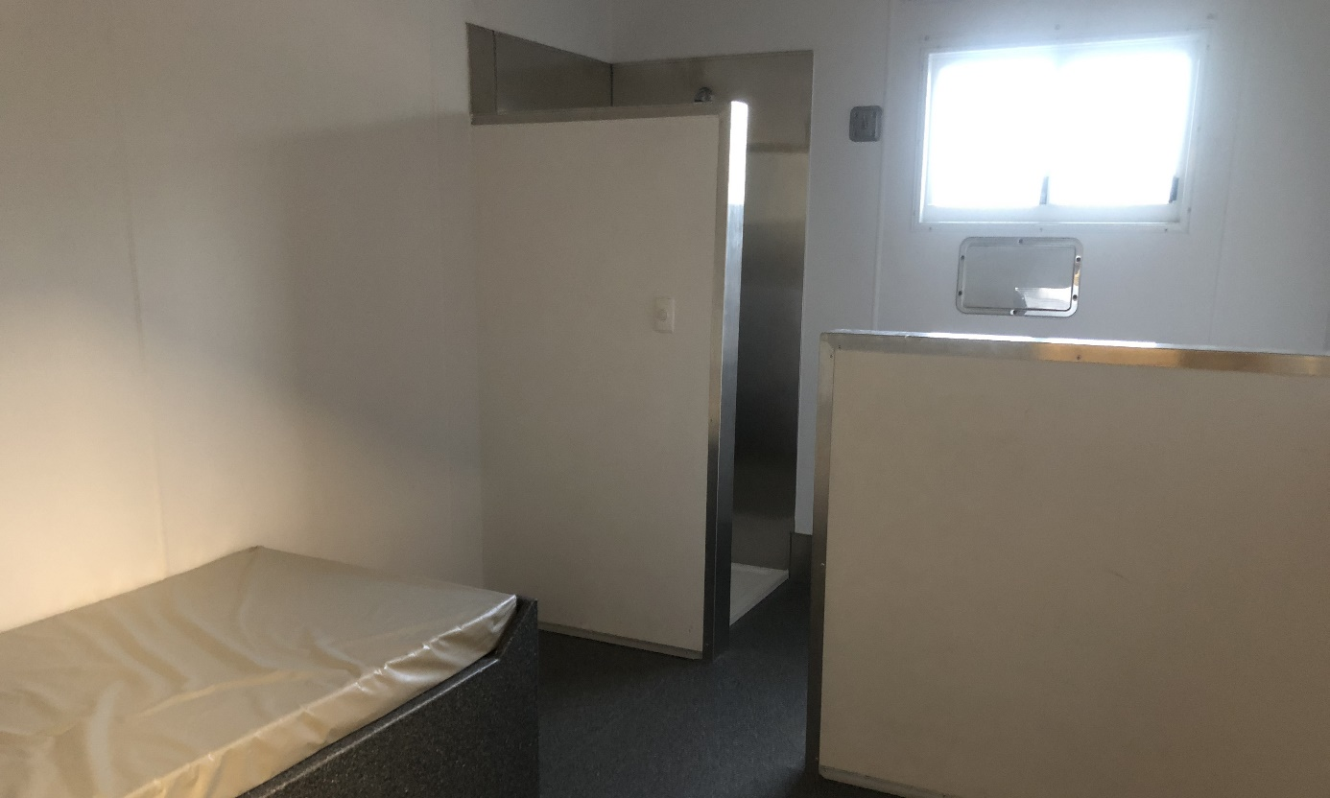
High-care accommodation, YHIDC
These units typically comprise a series of single-occupancy bedrooms that are sparsely furnished with hard, fixed furniture. Bathrooms contain stainless steel fittings and are located within the room, with some separated by walls or partitions (but not doors). The rooms are constantly monitored via CCTV.
‘High-care’ units also generally contain small common areas with seating, televisions and basic kitchen and laundry facilities. People being held in single separation under ‘open door’ arrangements can move freely between their rooms and these common areas. Those being held under ‘closed door’ arrangements are confined to their rooms.
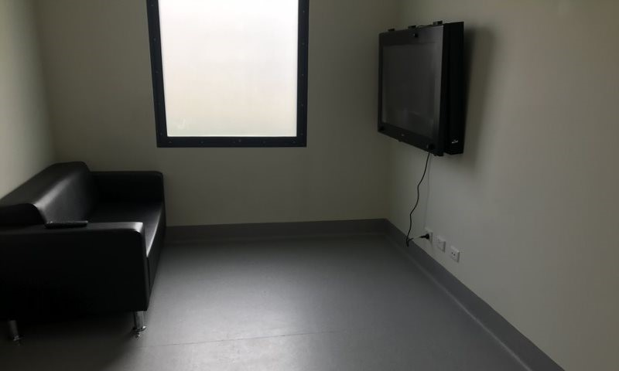
Day room, Shaw compound, MITA
In addition to ‘high-care accommodation’, the YHIDC also has several small ‘health care’ compounds, located next to the IHMS medical centre, that can be used for separate detention. People are generally held in these compounds if they have significant health care needs.
The ‘health care’ compounds are significantly less restrictive than ‘high-care accommodation’ units: furniture is more comfortable and is not fixed in place; bathrooms offer more privacy and fittings are not exclusively stainless steel; and the common areas are larger and open onto an outdoor courtyard. The location of these compounds next the IHMS medical centre also allows for frequent checks by health staff if required. The ‘health care’ compounds also have rostered access to the ‘Green Heart’ at certain times of the day.
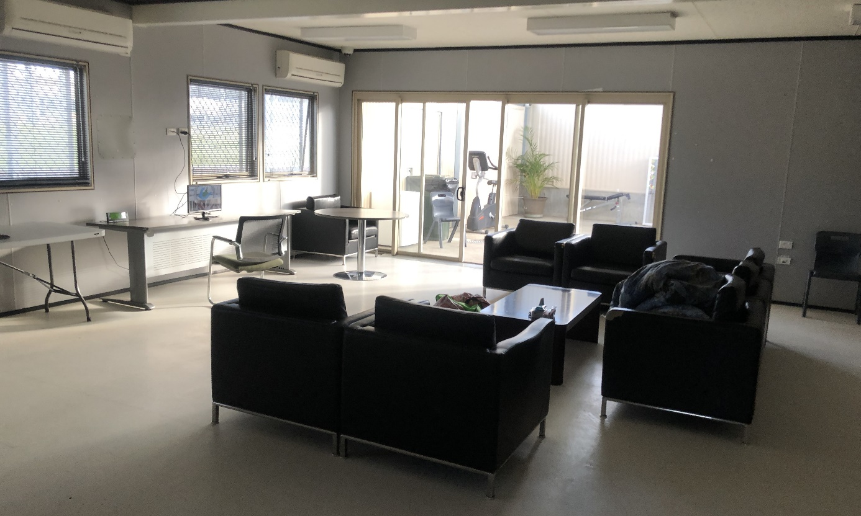
Common area, Health care compound, YHIDC
Only a small number of people interviewed by the Commission reported that they had been held in a ‘high-care accommodation’ compound for the purposes of single separation during their time in immigration detention. A few people reported that this was in response to concerns about their mental health arising from a ‘mental health episode’ or self-harm.
Following the Commission’s inspections in 2018, Home Affairs previously advised:
High-care accommodation is to be used in the best interest of a detainee or in the best interest and safety of other detainees, departmental staff and contractors. High-care accommodation must always be for the shortest practicable time. Placement in high-care accommodation must be approved by the relevant ABF Detention Superintendent (Facility) for periods of less than 24 hours and by the ABF Commander Detention Operations (National) for periods exceeding 24 hours.
Facility staff informed the Commission that single separation in the high-care accommodation is primarily used for behaviour management but may also be used for health reasons. The examples of health reasons provided included if someone requires medical isolation due to diagnosis of an infectious condition or if they have a mental health condition and pose a risk of harm to themselves. In the case of YHIDC, facility staff advised that the ‘health care’ compounds are generally used where single separation is required for health reasons.
Facility staff also affirmed that approvals for placement in the high-care accommodation for periods of less than 24 hours are sought initially from the Superintendent and that longer periods require the approval of the ABF Commander. They also indicated that they seek to return people in high-care accommodation to regular accommodation as soon as possible. However, there is no overall limit on the amount of time that people can be held in isolation or separate detention.
The Commission acknowledges that there may be some circumstances in which there is a need to use separate accommodation for people in immigration detention (such as where a person poses a serious risk of harm to others). However, the Commission is concerned that conditions in ‘high-care accommodation’ units are typically harsh and highly restrictive.
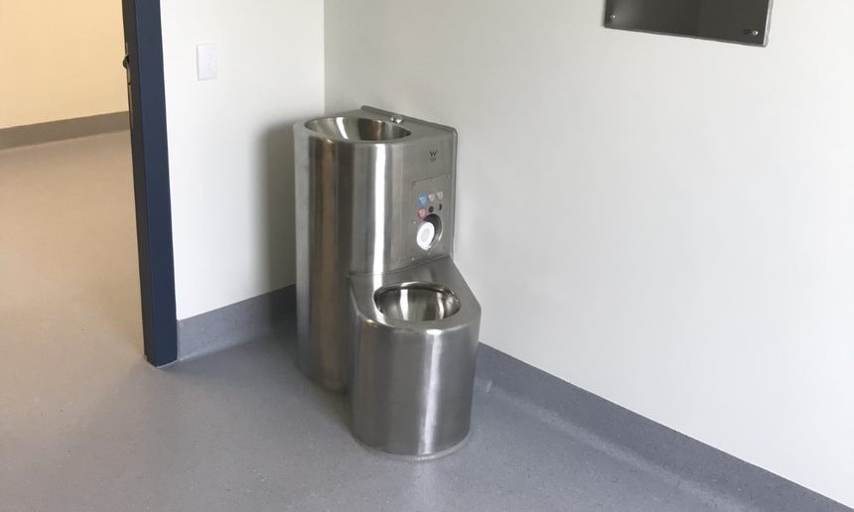
Combined toilet and sink unit in high-care accommodation, Shaw compound, MITA
In the Commission’s view, these prison-like conditions would not be necessary, reasonable, or proportionate in any but the most exceptional cases. These conditions are particularly unsuitable for people with significant mental health issues or who are at risk of self-harm.
The Commission considers that conditions in the ‘health care’ compounds at YHIDC are more appropriate for short-term separate detention for health reasons, including where a person has significant mental health issues or is at risk of self-harm. The proximity of these compounds to the YHIDC medical facility allows health staff to regularly check-in with those in the compound and provides a more therapeutic, health-focused response. The Commission acknowledges that most facilities, with the exception of YHIDC, have limited options for separating people in immigration detention other than through the use of high-care accommodation, due to lack of appropriate facilities.
Drawing on the model of the ‘health care’ compounds at YHIDC, the Commission considers that it would be beneficial to investigate alternative options for separating people in detention where the use of high-care accommodation is not warranted—for example where single separation is required for health reasons, including if they have a mental health condition and pose a risk of harm to themselves. This should include consideration of the additional facilities required to provide appropriate alternative options for separate detention in these circumstances.

In consultation with facility staff, the Department of Home Affairs should investigate alternative options for separating people in detention in circumstances where separation is necessary, but the restrictions associated with ‘high-care accommodation’ would be unreasonable or disproportionate.

Communication

Mobile phones
Nearly all people the Commission spoke to in 2019 reported that they relied on their mobile phone (mostly smartphones) as their primary method of communication with family, friends, legal representatives and other professionals.
Beginning in February 2017, the possession and use of mobile phones and SIM cards in immigration detention facilities was prohibited. However, in June 2018 the Federal Court of Australia ruled that this mobile phone policy was invalid on the basis that it was not authorised by any provision of the Migration Act. Since this decision, people in immigration detention have been permitted to possess and use SIM cards and mobile phones of any kind, including smartphones.
Most people provided strong positive feedback on the benefits of mobile phone access. This included: regular (in most cases daily) contact with their families and friends; access to video-calling and instant messaging using applications such as WhatsApp; access to the internet; and having contact with family and/or legal representatives at a suitable time, in privacy and for as long as needed. Mobile phone access was particularly important for people whose families lived interstate or overseas and were unable to visit regularly or at all.
Several people spoke about the positive impacts of being able to communicate regularly with family on their mental health. For example, one person explained that he used his mobile to video-call his family every day and said that ‘speaking to them on the mobile really helps when you are going through anxiety and depression, it gives you hope’.
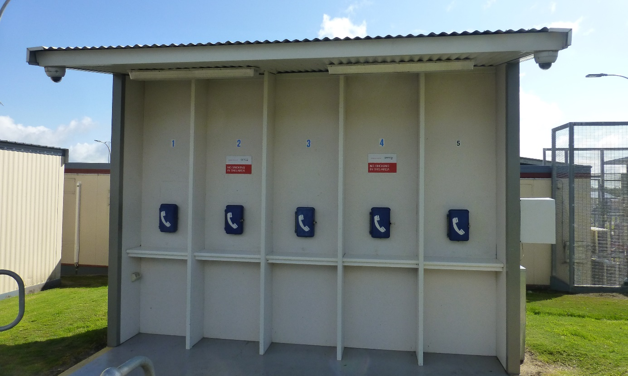
Phones, Hawk compound, YHIDC
Relatively few people raised concerns about access to communication facilities in detention or their ability to maintain contact with family members and friends outside detention, which appears to be largely attributable to mobile phone access.
Some people specifically noted that they were now able to use their mobile phones for communication that would previously have required the use of a landline phone or desktop computer, and that access to mobile phones improved their ability to do this. They referred to a range of issues in relation to the access and use of landline phones and desktop computers in detention including: limited and rostered access to these facilities (in particular computers); the absence of a video function on computers; lack of privacy; concerns that phone calls and correspondence were monitored; slow internet connection on desktop computers; and poor maintenance of communication facilities.
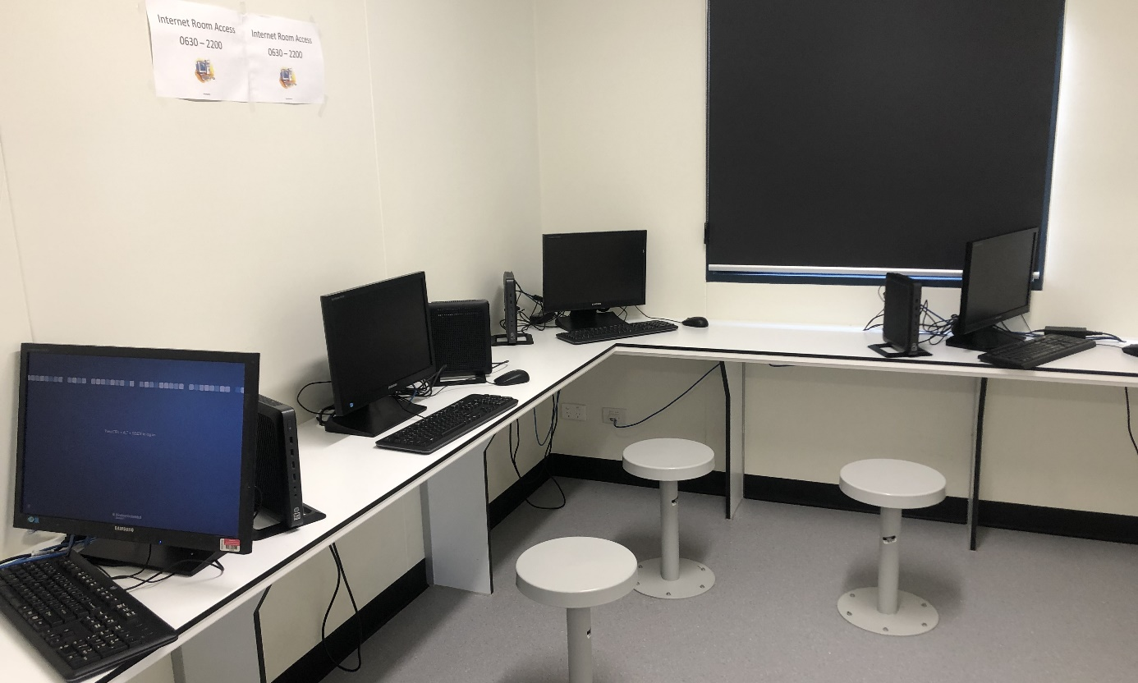
Computer room, Cassowary compound, YHIDC
Facility staff at some facilities (YHIDC, MITA and PIDC) reported that unrestricted access to mobile phones created significant challenges to ensure the privacy and safety of staff. They reported that some people in detention used their mobile phones to take photos or video recordings of staff, which could then be distributed publicly without permission. Staff provided examples where such photos or recordings of staff were posted on social media. They also highlighted a small number of cases in which this had resulted in applications for intervention orders through the court system.
Some facility staff acknowledged that access to mobile phones had significant benefits, such as allowing more regular contact with family members, which had a positive impact on mental health.
The Commission recognises the challenges presented in cases where mobile phones are used in the manner that affects the privacy and safety of staff. However, information gathered by the Commission suggests that only a small proportion of people in immigration detention are using their mobile phones inappropriately, and incidents of a serious nature involving mobile phone use are exceptional rather than commonplace.
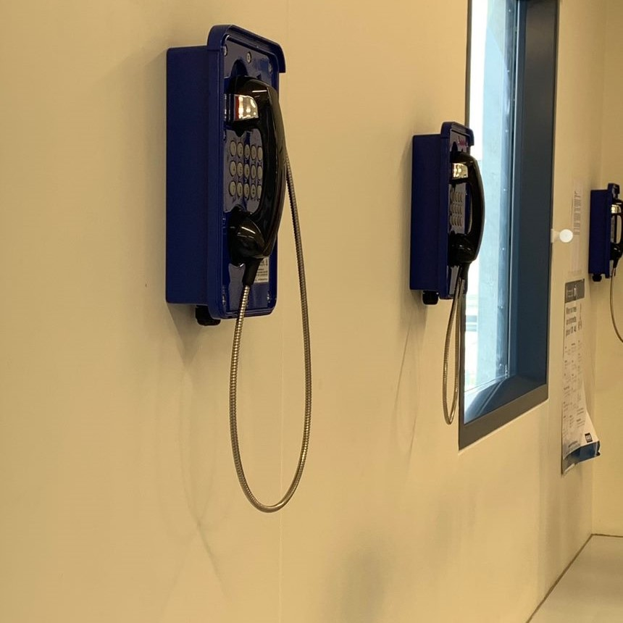
Phones, Dargo compound, MITA
The Commission strongly opposes any blanket prohibition on mobile phones in immigration detention, or at a particular immigration detention facility, as it would not be a necessary, reasonable or proportionate response to the risks arising from their use. Any limits on access to mobile phones should be imposed on an individual basis, and only if the individual is found to have used their mobile phone to conduct unlawful activity, or carry out other forms of serious misconduct.
The Commission considers that mobile phones, including smartphones, are a vital resource for people in immigration detention to maintain regular contact with family, friends and legal representatives and offer significant benefits for the wellbeing of people in detention. They are also essential to bridge significant gaps that can occur between in-person visits (where applicable), as outlined further in section 3.9 (b).
In the Commission’s view, the communication enabled by mobile phones (in particular smartphones) cannot be replicated by other facilities such as landline phones and desktop computers in the detention environment. They allow communications that can occur at convenience, in privacy and for as long as needed and they also offer important functions such as video-calls. Overall, mobile phones significantly improve access to communication with people outside detention, and the quality of those communications.

Visits
The size and capacity of facilities for visits at each immigration detention facility varied significantly:
- PIDC has a very small visiting room that can hold up to four to five people at a time and is generally used for one visit at a time.
- The common area at AITA is also used for visits (as well as dining) and generally they have about five groups in each session.
- VIDC contains visiting areas that cater to different compounds in the facility. The large and well-furnished Logan visiting area is used for people in the low-risk compounds (La Trobe, Lima and Lachlan). It contains an outdoor area with a children’s playground. There is a separate visiting area for those in the higher risk compounds (Hotham, Mitchell and McKenzie).
- MITA also contains two visiting areas: a large, spacious and well-furnished visiting area that caters to MITA South and BRP; and a separate visits area for MITA North.
- At YHIDC all visits take place in a small area shared by people from all compounds, which has capacity for about 21 people (both detainees and visitors) in each session. It contains a room next to the visiting area for children that was sparsely furnished with limited toys.
- BITA contains a small visiting room shared by people from all compounds, which has capacity for about 15 people (both detainees and visitors) in each session.
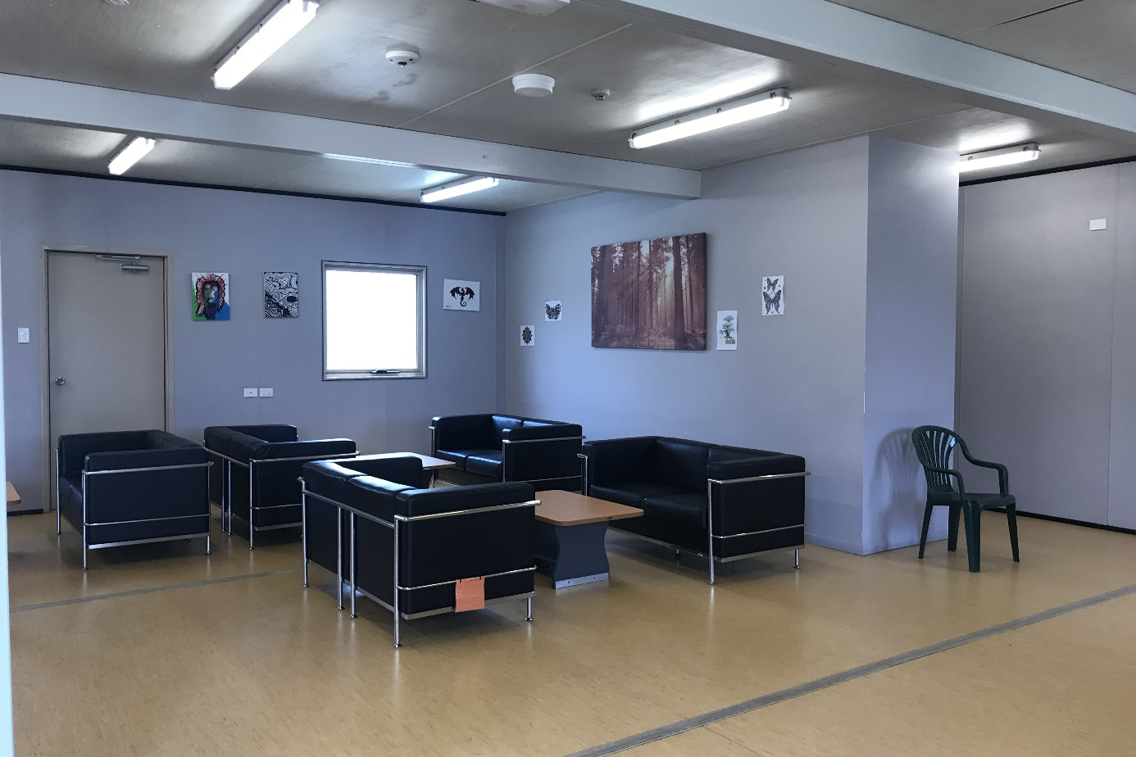
Visits room, BITA
Several people at YHIDC raised concerns that some applications for visits lodged by family members were refused due to lack of capacity in the visits room. The Commission observed that the visiting room at YHIDC was particularly small relative to the population. Facility staff at YHIDC informed the Commission that it was unusual for the visits to be fully booked.

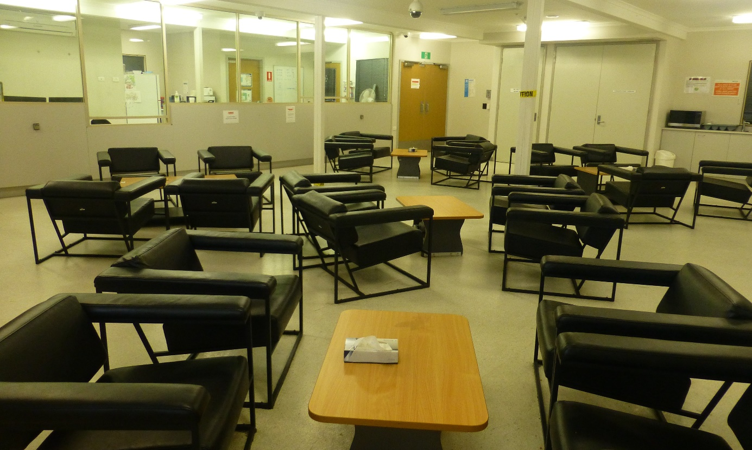
Visits room, YHIDC
At most facilities a few people raised concerns that there was insufficient space or facilities to play with young children during visits. For example, some people highlighted lack of access to outdoor spaces to play with their children and others said that the available toys were limited and very old. The Logan visiting area at VIDC was the only facility that also contained access to an outdoor area with a children’s playground.

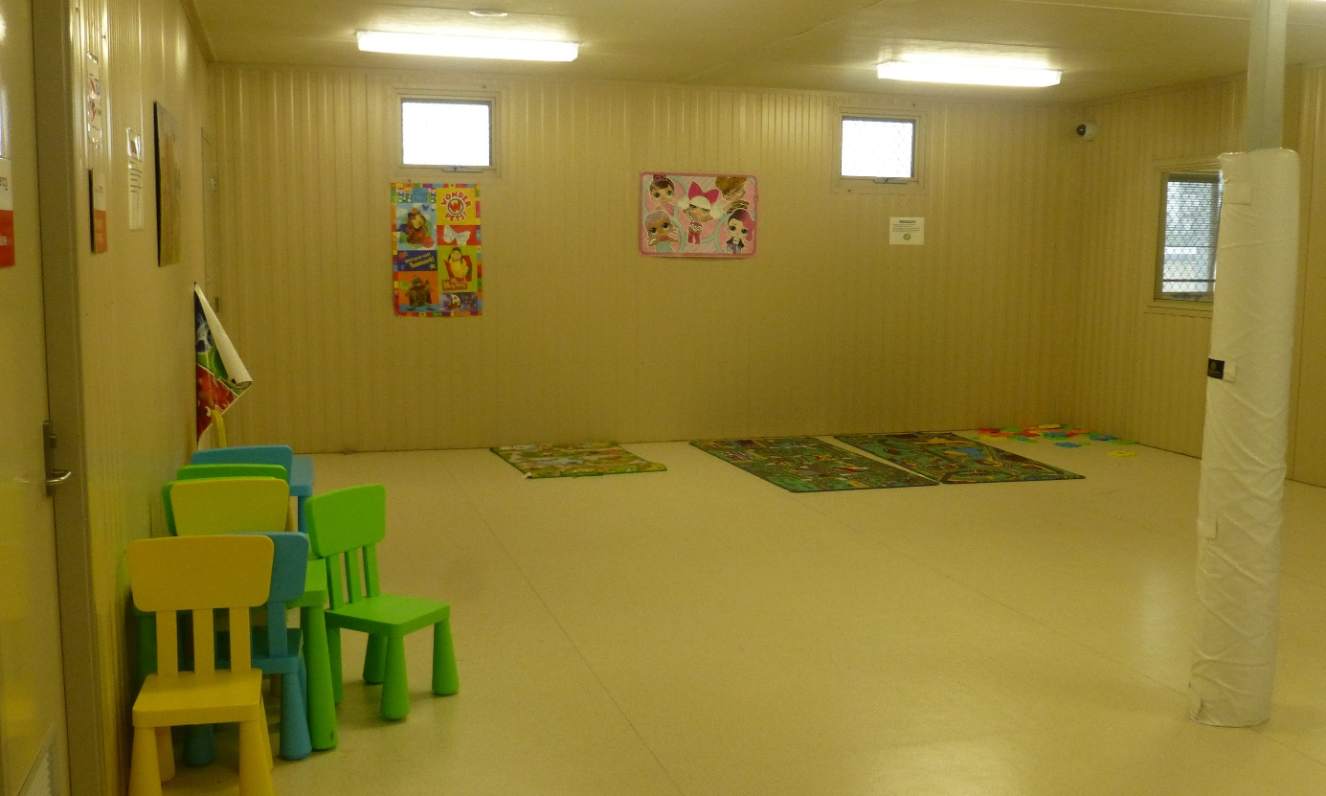
Children’s area next to visits room, YHIDC
Most facilities allocate two hours for each visiting session. However, at BITA visits run for 1.5 hours, and at VIDC visits commence at 12pm and finish at 8pm and people can spend the whole time with their visitors, without any time limits. The Commission heard positive feedback about the visits program from people at VIDC, in particular their ability to spend significant periods of time with family and friends during visit sessions.

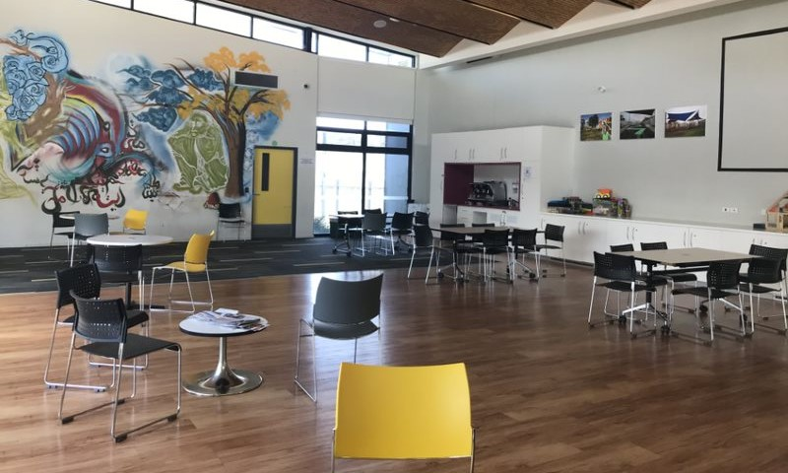
Visits room, MITA South
A significant number of people at MITA raised concerns about the way staff facilitate visits. They reported that there are often delays in staff notifying people that their visitors have arrived, and delays in arranging staff to escort people to their visits. They said that these delays eat into their allocated visit time of two hours, which are then cut short. The Commission considers that facility staff at MITA should ensure people are able to spend the full two hours of their allocated visit time with family and friends.
People across the detention facilities raised concerns in relation to their ability to have physical contact with their partners and families during visits. People reported that the officers who supervise the visits often have different approaches to physical contact during visits. For example, people said that during some visits they were able to have some physical contact, whereas during other visits they were not permitted to have any. One person said that during some visits he was able to kiss his partner and at other times he was told that this was not allowed. Another person said that ‘my understanding is that we can have contact, but it is confusing and inconsistent’.
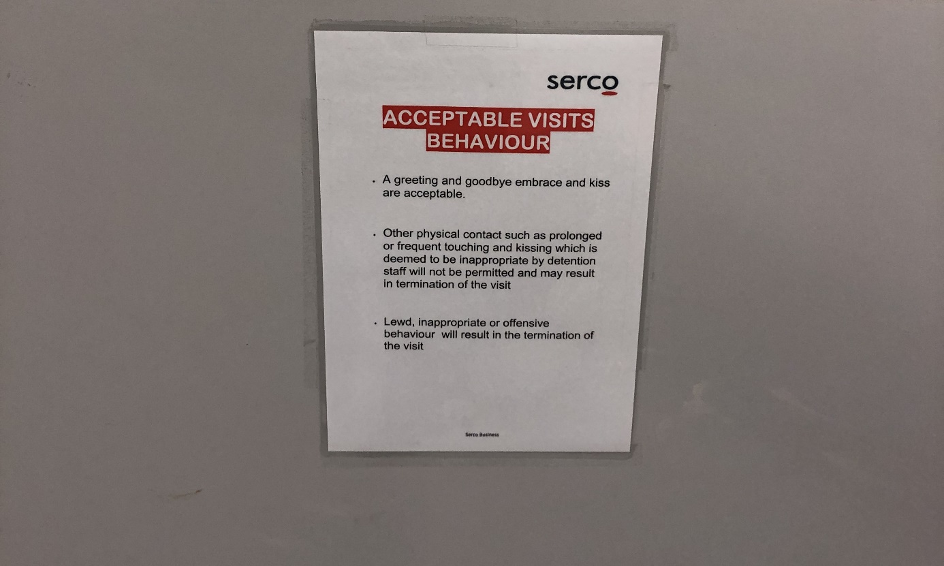
Sign displayed in visits room, YHIDC
People also raised concerns about the types of physical contact that were considered inappropriate. For example, one person reported that an officer told him he was not allowed to hug his wife, and another person said that an officer told him not to hug his child. Incidents of this nature appeared to cause significant distress for people in detention and their families.
Some people also said that they felt they did not have enough privacy for their visits as officers stood very close and were able to hear their conversations. For example, one person said that officers sometimes joined in with conversations during visits because they were standing so close.
Facility staff advised that people in detention can greet and have ‘everyday contact’ in the visiting area, however that inappropriate physical contact would not be permitted. In addition, facility staff indicated that there were also security considerations in relation to the passing of contraband during visits.
The Commission’s human rights standards for immigration detention state that visitors should be able to ‘make appropriate physical contact with detainees they are visiting’ and that visits should take place ‘in private’.
The information gathered by the Commission indicates that there is inconsistency in the way that officers enforce standards of appropriate physical contact during visits. The Commission is concerned about reports that some people have not been permitted any physical contact with their visitors during some visits. Some circumstances in which officers were reported to restrict physical contact appeared to be unreasonable. For example, the Commission considers that people in detention should be able to hug and kiss their family and friends during visits.

The Department of Home Affairs and Serco ensure that appropriate physical contact is permitted during visits, and that visits take place privately.
As outlined in the Commission’s Risk Management report following inspections in 2018, there are a range of policies that regulate visits to immigration detention facilities that continue to be applied, including:
- Personal visitors (such as family members and community groups) must apply for a visit through an online form at least five business days in advance of the visit. If they are over the age of 18, personal visitors must also provide 100 points of identification to support their application. Visitors must reapply each time they seek to visit a detention facility.
- Food brought into detention facilities by visitors must be commercially packaged and labelled, factory sealed, and have a visible and valid expiry date; must not have any metal or glass packaging; and must be of a quantity that can be eaten during the visit. Any leftover food must be disposed of at the end of the visit.
- Visitors must undergo screening procedures, which may include metal detectors and drug trace detection.
During interviews with the Commission, people in detention raised mostly the same concerns in relation to these policies as they did in 2018:
- The visit application process can be complicated and cumbersome for some visitors. For example, regular visitors must apply five business days in advance, fill in the lengthy online form and provide ID for every visit; and the online form may be difficult to use for some visitors (such as those who have limited English language skills or computer literacy).
- Significant time can pass between in person visits with family and friends due to delays between lodging the visits application (which must be lodged five business days in advance via the online system), receiving approval to visit and then attending to visit at an allocated appointment. One person compared this to the visits system in prison and said, ‘In prison you could call family and friends if you were not doing well and they could come the next day.’ This can cause significant challenges for family members visiting from interstate, who often need to arrange flights and accommodation.
- People who do not have 100 points of identification may be unable to visit people in detention. For example, one person said that family and friends who did not have passports were often unable to meet these requirements.
- Drug trace detection machines may return ‘false positives’ or detect traces of substances from other sources (such as the visitor’s work environment or money), with visitors potentially denied entry as a consequence.
- Restrictions on food prevent visitors from bringing in home-cooked food and fresh food (such as fruit), and can make it difficult for visitors to bring in substantial meals (the latter being a particular issue for visitors who have travelled long distances, booked lengthy visits or are visiting with children). Many people the Commission interviewed expressed that sharing a home-cooked meal with their family during visits was very important to them. For example, one person said that this allows ‘some aspect of normal family life.’
The Commission appreciates that these policies were introduced with the aim of improving safety and security, in particular to prevent the entry of contraband and perishable foods that may cause illness; and ensuring that Home Affairs ‘has accurate information about the identity of individuals visiting its facilities’.
However, applying the entry conditions and restrictions described above to all visitors may not be necessary, reasonable and proportionate in the circumstances. These measures do not appear to be appropriate, for example, for regular visitors to immigration detention facilities, who have a proven track record of complying with entry requirements and have never been suspected of bringing in contraband or presenting incorrect information about their identity. For example, the Commission considers that for regular visitors who meet these conditions, it would be unnecessarily cumbersome to require them to submit a separate application form and identification for every visit, and unreasonable to restrict them from bringing home-cooked food to visits.
The Commission notes that Home Affairs is piloting the Community Support Sector Visitor Programme (CSSVP) at VIDC, a ‘trusted visitor’ program for community groups that visit immigration detention facilities on a regular basis. The CSSVP was introduced in recognition of the administrative burden placed on community support sector groups, who frequently apply to visit large numbers of people in detention, with a view to streamlining the entry requirements for these visitors.
The Commission considers that similar strategies could be adopted for other regular visitors who routinely comply with entry conditions, have never been suspected of bringing in contraband or presented incorrect information about their identity.
Where regular visitors meet these conditions, the Commission also suggests it would be beneficial to review the restrictions that apply to these visitors (in particular those that apply to food) to ensure that restrictions are only applied when necessary to manage specific risks in a visitor’s individual circumstances.

The Department of Home Affairs should revise entry conditions for regular visitors, who routinely comply with entry conditions, and are not reasonably suspected of bringing in contraband or presenting incorrect information about their identity by:
- streamlining entry requirements for these visitors in a similar manner to the CSSVP, and
- reviewing restrictions that apply to these visitors, with a view to ensuring that restrictions are only applied when necessary.

Length of detention
Facility staff and people in immigration detention across all facilities consistently raised the length of time in immigration detention as a key issue of concern during the Commission’s 2019 inspections. The average length of time in immigration detention facilities has continued to increase since 2013, and throughout 2019 the average remained close to or just above 500 days (see Section 2.7).
A significant proportion of the people interviewed by the Commission during its 2019 inspections reported that they had been in closed immigration detention for at least two years, and in some cases for far longer. Of the 281 people interviewed during inspections in 2019, 170 (60%) reported that they had been held for over two years and of these people 110 (39%) reported over five years. A few people the Commission spoke to reported that they had been in immigration detention facilities for 10 years or more.
Many people the Commission interviewed (in particular people who had been in closed detention for two years or more) reported that their ongoing detention and the uncertainty of their situation was causing, contributing to, or exacerbating mental health issues. One person said, ‘My situation in detention is very frustrating, it makes me sick’ and another that ‘mentally I would be better if I had a decision on my visa’. A person who had previously been in jail said, ‘In jail you know your release date, but there is no end here in detention’. Some people, who had been in immigration detention for very prolonged periods, said they felt their ongoing detention was a form of punishment, rather than an administrative process.
Many facility staff observed that people are now spending much longer in immigration detention facilities and that such situations are complex and can be difficult to manage. As outlined above, IHMS staff reported significant numbers of people with complex health, including mental health, needs. Some IHMS staff attributed the complexity of mental health issues to an increasing number of people who have spent a long time in immigration detention facilities. Other staff said that while prolonged closed immigration detention is a factor, there are other relevant factors such as pre-existing conditions, individual resilience and family background.
Prolonged detention is a risk factor for mental ill-health, as the negative impacts of immigration detention on mental health tend to worsen as the length of detention increases. This is of particular concern in the current context given the consistently high average length of detention in recent years, and the large number of people being held in closed facilities for prolonged periods.
Following inspections in 2018, the Commission recommended that the Australian Government introduce legislation to ensure that the necessity for continued immigration detention is periodically assessed by a court or tribunal up to a maximum time limit. The Commission repeats this recommendation, which is now even more pressing given the longer periods that people are detained. Independent oversight of the necessity of closed detention, and the introduction of an overall time limit on closed detention, would help to reduce the likelihood of closed detention becoming so lengthy as to breach human rights.
In addition, the Commission repeats its previous recommendation that a review take place to identify factors contributing to the high average length of immigration detention since 2015, and strategies to reduce the average length of immigration detention. As noted in Section 2.8, the time spent in immigration detention is far higher in Australia than in comparable jurisdictions, such as the United Kingdom and Canada. By considering approaches in comparable jurisdictions, Australia could identify proven ways of reducing the average length of time in immigration detention without compromising Australia’s sovereignty or system of orderly migration.

The Australian Government should introduce legislation to ensure that the necessity for continued immigration detention is periodically assessed by a court or tribunal, up to a maximum time limit.

The Department of Home Affairs should conduct a review to identify:
– factors contributing to the high average length of immigration detention since 2015
– strategies to reduce the average length of immigration detention.
As outlined above, over half of the people the Commission interviewed reported that they had been detained for two years or more. As noted in Section 2.11, on average 22% of the population in immigration detention facilities in 2019 had been detained for two years or longer.
In publicly available Home Affairs statistics, people in immigration detention facilities who have been detained for two years or more are grouped together. These statistics do not distinguish periods of detention longer than two years. The Commission considers that this information should be disaggregated, given the significant number of people that are being detained for two years or more. This would provide a more accurate account of the length of time people are detained in closed facilities and improve public scrutiny over prolonged detention, which is a serious risk factor for human rights breaches such as arbitrary detention.

The Department of Home Affairs should further breakdown the length of time people grouped in two years and above have been detained in its monthly statistical reports on immigration detention.
Some people the Commission interviewed, who reported being in closed immigration detention in Australia for very prolonged periods, belonged to one of the following groups:
- those owed protection who have had their protection visas refused or cancelled on character grounds
- those owed protection with adverse security assessments.
As outlined further in Appendix 3, persons subject to an adverse security assessment issued by the Australian Security Intelligence Organisation (ASIO) or who present character issues that may indicate they fail the character test, are generally not considered for alternative, less restrictive forms of detention such as community detention as a matter of Government policy. In addition, those found to be owed protection cannot be involuntarily returned to their country of origin, as this would contravene Australia’s non-refoulement obligations arising under international law.
Persons subject to visa cancellations or refusals on character grounds or adverse security assessments, who have also been found to be owed protection obligations under international law (assessed to be a refugee or owed complementary protection), can therefore remain indefinitely in closed immigration detention facilities.
The Commission has previously investigated complaints in relation to refugees with adverse security assessments in closed immigration detention. In these cases, the Commission found that ongoing detention in closed immigration detention facilities, in circumstances where there was a failure to individually assess whether they could be placed in a less restrictive form of detention, such as community detention, was arbitrary. The Commission is concerned that the ongoing detention of people found to be owed protection, who have had their visas cancelled or refused on character grounds or have an adverse security assessment in closed immigration detention facilities, may amount to arbitrary detention under international law.

Status resolution
Status resolution (formerly case management) is managed by Home Affairs. Status resolution officers are allocated to people in immigration detention and their role is to assist with progressing immigration pathways in a timely manner within current legal and policy settings.

Contact with status resolution officers
Upon transfer to an immigration detention facility for the first time, Home Affairs advised that a person generally has an appointment with a status resolution officer within one to three days of arrival. During this initial appointment, the officer will conduct an interview to gather general information about a person, including their identity; consider whether a person would like to return to their home country on a voluntary basis; and what a person’s options are should they remain in immigration detention in Australia.
After this initial appointment, status resolution staff advised that they provide different levels of service to different groups of people in detention based on assessment of the type of detainee and achievable practical outcomes. This was contained in a policy document that outlined different levels of service; for example, Service Level One required contact every three months and Service Level Two required contact each month. Status resolution staff advised that Service Level One was generally applied to people in immigration detention as a result of a visa cancellation under s 501 (see Section 2.8). Status resolution staff also said that there had been an overall reduction in regular, face-to-face contact initiated by status resolution officers, in a shift to encourage self-agency from people in immigration detention.
People in immigration detention could also request contact with a status resolution officer. At all facilities, an appointment could be requested with a status resolution officer by completing a request form and placing it in a designated request box for collection, and at BITA this could also occur by phone call or text message to a designated mobile number. The request boxes were checked daily by facility staff.
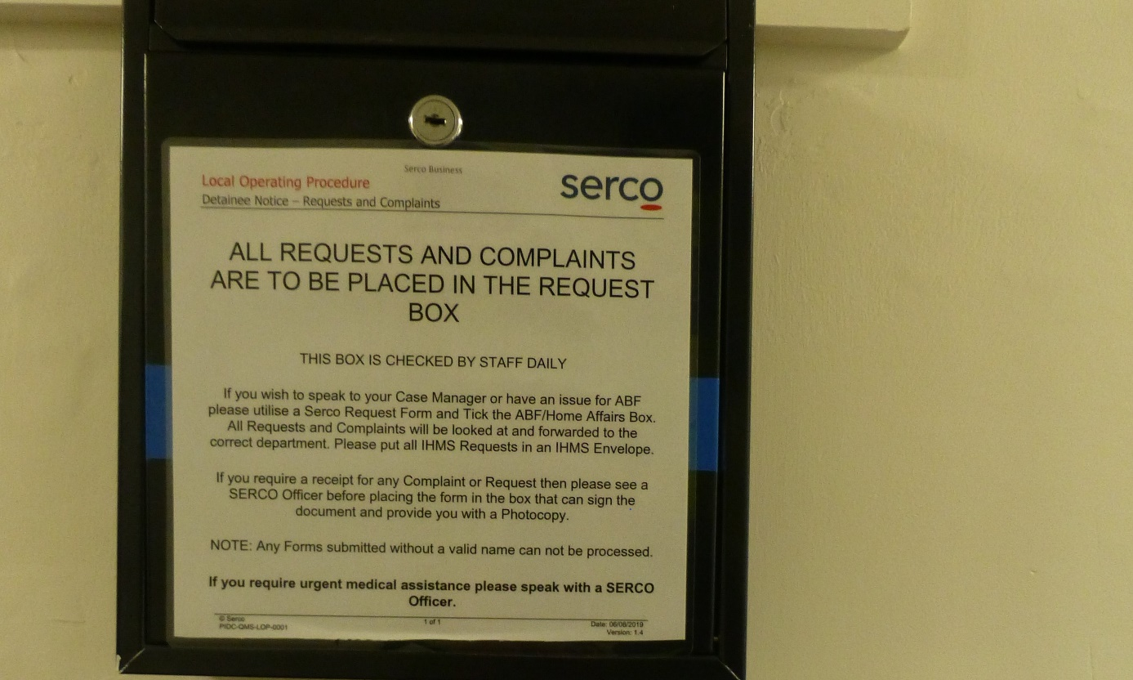
Request and complaints box, PIDC
The way in which status resolution officers communicated with people in immigration detention varied across facilities. In most facilities, the primary method of communication was face to face with some phone contact. However, in some facilities communication with some people in detention was either entirely, or mostly, by phone, and some would not have any face-to-face contact with their status resolution officer.
Home Affairs staff at YHIDC informed the Commission that about half of the population are managed by a status resolution officer locally with access to face-to-face contact. However, the other half are managed remotely by phone with no access to face-to-face contact. They said that allocation of a remote officer did not affect the service provided, and that in some circumstances, for example, where contact by phone was not working, they could review the appropriateness of remote management.
While people at BITA and the Brisbane hotel APOD could request face-to-face appointments with status resolution officers in interview rooms at BITA, they generally communicated with status resolution officers by calling or texting a designated mobile phone. Home Affairs staff at BITA advised that the mobile phone was monitored daily by status resolution staff, who would return calls and text messages. They said that often it was difficult to provide responses because people would not answer their mobile phones, and that most communication occurred by text message.
While a small number of people said that they received regular contact from their status resolution officer or were able to easily contact them if they needed, a significant number of people at most facilities (except AITA) raised concerns about the level of contact they had with status resolution officers. People reported limited contact from status resolution officers, and that there could be significant delays in receiving a response after they put in a request. Some said that they only heard from their status resolution officer when there was a development in their legal matter in relation to their immigration status; for example, when a tribunal or court handed down a decision in relation to their case.
Limited contact with status resolution officers created uncertainty for some people, particularly those without legal representation or with limited English. Some did not appear to clearly understand where their cases were up to, and if any progress had been made, what the next steps were or what options they had.
The concerns people raised about contact with status resolution officers during interviews with the Commission were particularly prevalent at YHIDC, PIDC and BITA and the Brisbane hotel APOD. Many people interviewed in these facilities reported that they rarely met with a status resolution officer in person, and that contact was usually very brief and conducted over the phone (or by text message in the case of people at BITA and the Brisbane hotel APOD). A number of people said that they did not know how to contact their status resolution officer and a small number of people said that they didn’t have a status resolution officer or didn’t know who they were. Some people said that they found it very difficult to contact their status resolution officer in these circumstances. For example, one person said it was difficult to make contact because it was hard to speak on the phone, he did not know who he would speak to, and he felt too upset and depressed.
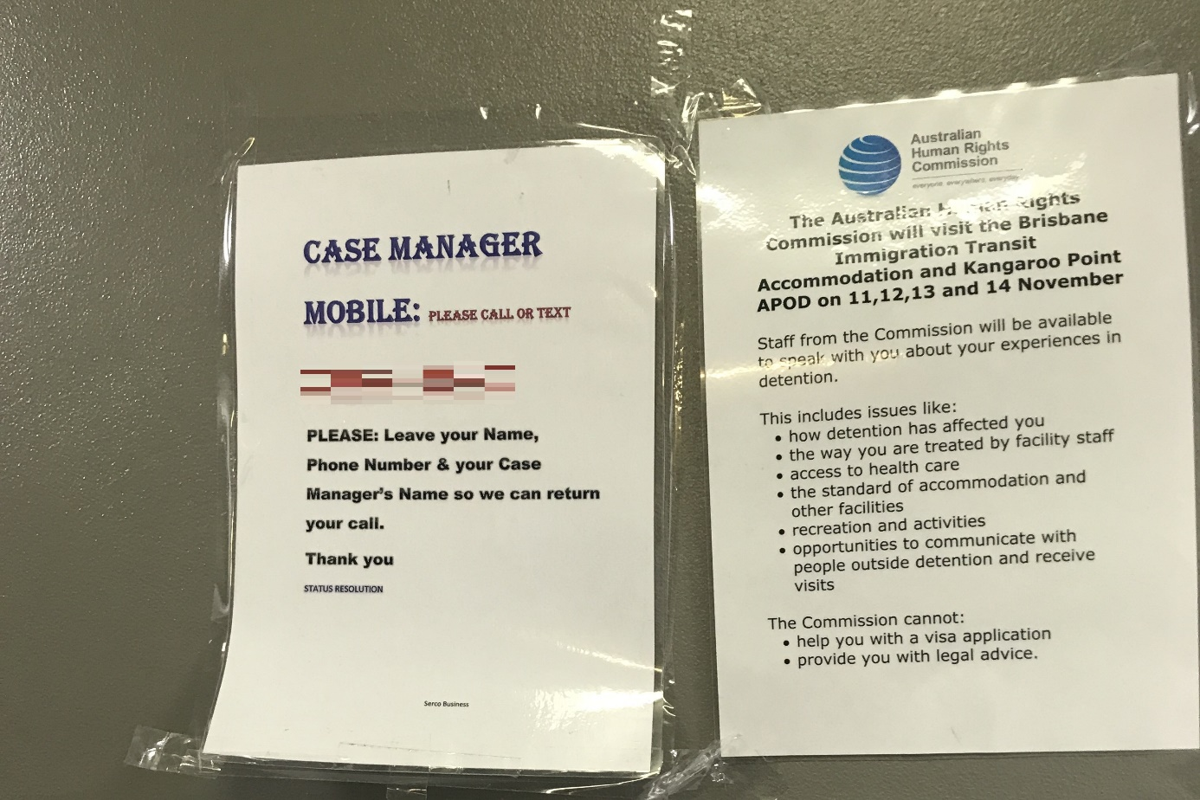
Notice board, Brisbane hotel APOD
The Commission observes that status resolution staffing levels at immigration detention facilities would make it difficult to maintain regular contact with all people in immigration detention. The staffing levels at BITA and YHIDC were particularly small relative to the size of the detention population. At the time of the Commission’s inspections, Home Affairs advised that there were two to four officers at BITA and nine at YHIDC, which is significantly fewer staff compared with other facilities relative to their respective populations.
The significant number of concerns raised by people in detention about infrequent contact with status resolution officers and the lack of understanding some people had about their own cases, as well as status resolution staffing levels and modes of contact with detainees, suggest that the delivery of status resolution services could be improved.
People in immigration detention are a particularly vulnerable cohort, and many face difficulties articulating their needs or understanding complex processes. As a result, the Commission considers that unnecessary barriers to the delivery of services should be eliminated. This includes ensuring that all people in immigration detention have the opportunity for regular, face-to-face contact, initiated by a status resolution officer. This would assist individuals understand their options, reduce some uncertainty and ensure status resolution officers are aware of a person’s individual circumstances. This should occur irrespective of any legal developments in a person’s case.

The Department of Home Affairs should ensure that all people in immigration detention have the opportunity for regular, face-to-face contact with status resolution officers and it should provide adequate resourcing for this.

Assistance provided by status resolution officers
Many people the Commission spoke to raised concerns that status resolution officers were not able to assist resolve their situation or progress their case in a timely manner. This included people who provided positive feedback about status resolution officers.

While some people acknowledged that officers do the best they can within their limited roles, many commented that officers were not able to provide clear information about: the status or progress of their case; reasons that decisions have been made; any next steps or available options; or timeframes. They reported that typical responses to queries put to officers about their cases included that:

- there is no news or information

- they must wait for a particular event to occur, such as a decision in relation to their visa from Home Affairs or a decision from a tribunal or court to be handed down, without providing a timeframe, or indication of what the next steps are

- they are unable to provide an indication of prospects or reasons for a decision because it is a matter for the Minister to determine.

Generally, people the Commission interviewed did not consider that status resolution officers proactively assist people to resolve their immigration status or seek to understand their individual circumstances. The Commission acknowledges that, in some instances, these comments may reflect the scope and limits of the status resolution officer role, rather than the performance of individual officers. However, taking this into account, the Commission still considers that it would be desirable to enable status resolution officers to do more to assist people in immigration detention to resolve their status.

The Commission is concerned that the limited role of status resolution officers, including their infrequent contact with people in immigration detention outlined above, may contribute to delays in progressing immigration pathways. This may result in people being detained for longer than necessary or missing opportunities to progress their cases due to a lack of knowledge or support. In light of the increasing time people are spending in immigration detention (see section 3.2), the role of status resolution officers should be reviewed to determine the extent to which they currently address the needs of people in detention, and how they could operate more effectively, including by reducing the time spent in immigration detention.

The Department of Home Affairs should commission an independent review of the role of status resolution officers to determine:
− the extent to which status resolution is currently addressing the needs of people in detention
− how status resolution can operate more effectively to assist people in immigration detention to resolve their status, including by reducing the time spent in immigration detention.

Some people reported that they had received independent legal advice regarding their immigration status; however, few reported having access to ongoing legal representation. Many people reported that they were unable to afford a private lawyer and relied on limited free legal services to access legal advice and assistance. People who had their visas cancelled and were unable to afford a private lawyer often said that they had been unable to access any free legal advice or assistance in relation to their migration matters. In some cases, people reported that they had missed deadlines to appeal migration decisions as a result. A small number of people specifically indicated that either they were not aware that a lawyer could assist them, or that they did not know how to access any legal assistance.

Home Affairs staff informed the Commission that Departmental policy does not permit status resolution officers to provide people in immigration detention with any referral information in relation to migration agents, lawyers or free legal services. They advised that it is the responsibility of individuals to seek avenues for legal assistance, and that status resolution officers must maintain impartiality in this regard.

The Commission notes the important role of legal advice and assistance in ensuring that people in immigration detention understand their legal options, and can navigate and engage with complex, and often time-sensitive, legal processes. The inability to access legal advice and assistance would likely have a significant negative impact on the ability for people in immigration detention to understand, navigate and engage with these sometimes-complex legal processes.

In addition to the utility of legal assistance for people in immigration detention, such assistance can also improve the overall immigration decision and review processes, reducing the burden on decision makers and making it more likely that important, probative evidentiary material is made available and considered. With these factors in mind, the Commission has previously expressed concern regarding significant reductions in Australian Government funding for free legal assistance for people seeking asylum who arrived in Australia without a valid visa (whether by boat or plane), including those in immigration detention. This concern is ongoing.

Separately, and at a minimum, the Australian Government should provide practical support to people in detention in making contact with lawyers who have indicated that they are willing and able to provide some legal advice and assistance pro bono or otherwise at no cost. The Commission does not accept that providing such referral support necessarily would compromise the impartiality of status resolution officers. After all, it is common for courts and other dispute resolution bodies, for whom impartiality is of fundamental importance, to provide such referral support. Therefore, the Commission considers that status resolution officers should be required to support people in immigration detention access legal advice and assistance by providing information and referrals to relevant services.

The Department of Home Affairs should revise relevant policy to require status resolution officers to provide people in immigration detention with appropriate information and referrals to access legal advice and assistance.

Risk of constructive refoulement
A small number of people raised concerns that they felt significant pressure from status resolutions officers to return to their home country ‘voluntarily’, in circumstances where they were unable to return due to risk of persecution or others forms of serious harm. The people who raised these concerns reported that they had been found to be owed protection obligations under international law or had not yet had the opportunity to have their protection claims assessed.
They reported that they had been advised by their status resolution officer that if they did not consent to return, they would otherwise remain in an immigration detention facility or they would be involuntarily removed. In some cases, they reported that this message had been consistently repeated to them over the course of a series of engagements with a status resolution officer. One person said, ‘Every time I speak to [status resolution officer] they ask me why are you not going back. I say I can’t go back because they will kill me in [home country].’ This situation was causing considerable distress, and in a few cases, people reported that it was severely affecting their mental health.
The Commission is not able to assess the veracity of these claims. As a general principle, any element of compulsion or undue pressure to return to an individual’s home country would mean that this return is not truly voluntary. If proven, such conduct could have grave and irreversible consequences for affected individuals and may be contrary to Australia’s non-refoulement obligations.
It is a matter of serious concern that some people in detention perceive pressure from some status resolution officers to return to their home country when they have established protection needs or have not had the opportunity to have their refugee claims assessed through a fair and thorough process. If a person is indirectly but effectively compelled to return to a situation where they are at risk of persecution or other forms of serious harm as a result of such pressure this could amount to constructive refoulement.

Alternatives to closed detention
As outlined in Section 2.1, there is no legal requirement for people without valid visas to be detained in closed immigration detention facilities, and people may be released from closed detention into alternative community-based arrangements, such as community detention or on short-term bridging visas.
The Commission has long recommended that the Migration Act be amended to ensure that closed immigration detention is only used in circumstances where it is strictly necessary to manage unacceptable risks to the community. A short period of closed detention aimed at managing risks to the Australian community may be justifiable under international law, provided that the risks cannot be managed in a less restrictive way, and that detention is necessary, reasonable and proportionate in the individual’s circumstances.
During inspections over many years, the Commission has consistently identified cases in which closed immigration detention did not appear to be justified. The Commission continued to encounter such cases during its 2019 inspections.
During interviews with the Commission in 2019, many people reported that status resolutions officers had never discussed alternatives to closed detention with them. Some said that they had sought to apply for release but were informed that they were not eligible; or had applied for release and been rejected.
Status resolution staff advised the Commission that in very limited circumstances, they can make referrals for the Minister to consider alternatives to closed detention, such as community detention, but ultimately the decision lies with the Minister. Some staff observed that it was very difficult for people in detention to be considered for alternatives to closed detention because they will often not meet the guidelines for referral to the Minister.
These comments reflect current legal and policy settings outlined in Section 2.1. Both options for people in closed detention to be released into alternative, community-based arrangements involve the Minister exercising a personal, non-compellable, discretionary power under the Migration Act.
In addition, there are broad categories of people who are generally excluded even from being referred for the Minister’s consideration. For example, anyone who arrived in Australia on or after 1 January 2014, and asylum seekers whose claims have been rejected at both the primary and review stages, are generally excluded from consideration of community detention (see Appendix 3). As outlined in Section 3.10, persons subject to visa cancellations or refusals on character grounds or adverse security assessments are also excluded from consideration of community detention. Therefore, people in these categories, who have also been found to be owed protection obligations under international law, can remain indefinitely in closed immigration detention facilities. The Commission notes that not all people who fall into these broad categories would necessarily present an unacceptable risk to the Australian community, or pose risks that cannot be effectively managed by other means, and some may present no risk to the community at all.
The consideration of alternatives to closed detention does not occur on a routine basis for most people in closed immigration detention facilities. In some cases, this may not occur. A person could be excluded from consideration under relevant guidelines or relevant circumstances may not have come to the attention or consideration of a status resolution officer. Given the limited role and contact that status resolution officers have with people in detention (as outlined above in Sections 3.11 (a) and (b)), the Commission considers that it may be difficult for status resolution officers to maintain a comprehensive and up-to-date understanding of a person’s individual circumstances or routinely consider their suitability for alternatives to closed detention.
The Commission considers that all people in closed detention should be routinely considered for alternative community-based arrangements to closed detention, such as community detention or the grant of a short-term bridging visa. Broad categories of people in closed detention should not be excluded from consideration as a general rule.
This requires an individual assessment of a person’s circumstances to assess whether they could be placed in a less restrictive, community-based alternative to closed detention. This assessment should identify any relevant risks and protective factors, and how any identified risks could be managed, for example, by a requirement to reside at a specified location, curfews, travel restrictions, reporting requirements or sureties.

The Minister and Department of Home Affairs should routinely consider all people in closed detention for release into alternative community-based arrangements.

The Department of Home Affairs should provide the following assessments in all referrals to the Minister to consider alternative community-based arrangements:
− identify relevant risks and protective factors
− how any identified risks could be managed, for example, by a requirement to reside at a specified location, curfews, travel restrictions, reporting requirements or sureties.
There were significant numbers of refugees and asylum seekers subject to third country processing in immigration detention facilities in Australia at the time of the Commission’s 2019 inspections (see Section 2.6).
Many people the Commission interviewed in this group expressed concerns about the adverse impacts of prolonged detention (in most cases six years or more) on their physical and mental health. They all reported that they were initially detained upon their arrival in Australia (usually on Christmas Island) and then detained in regional processing centres in PNG or Nauru.
As outlined in Section 2.6, most people in this group had been transferred to Australia from PNG and Nauru for the purpose of medical treatment and/or assessment. At the time of the Commission’s inspections people had been held in closed detention since their transfer to Australia for various periods ranging from a few days to one year. However, a significant number had been in immigration detention for 6 months and over.
Some reported that the health conditions for which they were transferred, in particular mental health conditions, were adversely affected by their ongoing closed detention since their arrival in Australia. For example, one person who had been transferred relatively recently to Australia for medical treatment in relation to a mental health condition said:
It is ok to be here for now but I can’t be here for long term, I need to live in the community for my mental health. I have a long history of problems and I need good care. My problem is that I need freedom, enough detention. If they hold me in detention for much longer, my mental health will decline.
Another person, transferred to Australia for similar reasons said, ‘I have been getting counselling, but it can’t help me properly. I have been badly affected by my time in Manus. I am not sure how long I can continue like this.’
Most people in this group reported that status resolution staff had referred their cases to the Minister to consider them for community detention. Some reported that they were waiting for a decision, and others that they had been advised that the Minister had refused to intervene in their case and allow them to be released from closed detention into community detention. Many people, in particular those who had been notified of the Minister’s refusal, expressed confusion in relation to the process. Some said that they did not understand why others like them had been released into community detention, while they remained in closed detention. One person said, ‘They tell us that we have been declined for community detention but give us no reason. This makes us more stressed and frustrated. I just applied again for community detention and now I am waiting again.’
Status resolution staff informed the Commission that all people in this group were being referred to the Minister for consideration for community detention shortly after their arrival in Australia. In circumstances where the Minister refused to make a residence determination, status resolution staff said that they could refer the case to the Minister again at a later date, or where there is a material change in a person’s circumstances.
Status resolution staff at MITA advised that it was generally their practice to refer cases to the Minister again two to three months after a refusal, whereas the practice at BITA was to do so three to six months later. Some status resolution staff said that it was difficult to deliver news to people in this group that the Minister had refused to make a residence determination, as they were unable to provide any reasons for the Minister’s decision. They observed that the absence of any reasons often caused confusion and distress for people.
Refugees and asylum seekers subject to third country processing are a particularly vulnerable group of people, given their prolonged detention (cumulatively in Australia and offshore) and complex physical and mental health conditions. The Commission is concerned that the ongoing detention of people in this group in closed facilities in Australia may adversely impact their health, and in some cases frustrate the medical purpose of their transfer to Australia. Furthermore, people in this group are generally considered to be low risk by facility staff and the Commission was unable to identify any legitimate reason for their ongoing detention in closed facilities.
The detention of most refugees and asylum seekers transferred from Nauru and PNG for medical treatment and/or assessment in closed facilities may not be necessary, reasonable and proportionate in the individual’s circumstances. The Commission considers that community detention would be more appropriate for most people in this group. In addition, the Commission is concerned that closed detention may be an unsafe environment for some people in this group who have serious mental health conditions.

The Minister for Home Affairs or the Minister for Immigration, Citizenship, Migrant Services and Multicultural Affairs should release all refugees and asylum seekers transferred from PNG and Nauru for medical treatment and/or assessment into community detention, unless an individual assessment identifies risks that could not be managed in community detention.

Appendix 1 – List of recommendations

The Minister for Home Affairs or the Minister for Immigration, Citizenship, Migrant Services and Multicultural Affairs should release all parents with dependent children, including unaccompanied children, into community-based alternatives to closed immigration detention.

The Department of Home Affairs should include all children residing in closed immigration detention facilities (including alternative places of detention) in its immigration detention statistics.

The Department of Home Affairs should ensure that all children in closed immigration detention have the opportunity to access education externally in Australian schools.

The Department of Home Affairs should prohibit the use of physical restraints and single separation on children and teenagers in immigration detention.

As a matter of urgency, the Department of Home Affairs should ensure immediate and expedited access to medical treatment and/or assessment for all medical transferees from Nauru and PNG through the public health system.

Where medical transferees from Nauru and PNG cannot access the medical treatment and/or assessment they require through the public health system within a month of arrival in Australia, the Department of Home Affairs should ensure immediate access to health care through the private health system and provide funding for this.

The Department of Home Affairs and IHMS should commission an independent evaluation of the drug and alcohol program at VIDC.

The Department of Home Affairs should commission a group of independent mental health experts to conduct a comprehensive review of the mental health care provided in immigration detention.

The Department of Home Affairs should increase the capacity and expertise of the IHMS mental health clinic at BITA, including appropriate access to psychologists.

The independent review of mental health care in Recommendation 8 should include review of the use of Supportive Monitoring and Engagement to determine:
– whether current practices are in line with medical advice and Australia’s human rights obligations
– the impacts of current practices on people in immigration detention
– alternative options for monitoring and engagement.

The Department of Home Affairs should revise transfer and placement policy to require that a person’s treating health professional assess the impact of transfer and placement at another detention facility on a person’s health and their continuity of care prior to any transfer. This assessment should consider:
– physical and mental health conditions and treatment
– referrals and appointments for specialist treatment, and
– personal history.

The Department of Home Affairs should revise transfer and placement policy to ensure that people are not selected for involuntary transfer to another immigration detention facility where this would interfere with their timely access to health care.

The Department of Home Affairs and Serco should revise policies in relation to escort protocols for offsite health appointments to ensure confidentiality and privacy is only restricted as a last resort, where necessary and proportionate to manage identified risks in an individual’s circumstances.

The Department of Home Affairs should review policies and procedures in relation to physical violence in immigration detention, with a view to ensuring adequate strategies to protect the physical safety of people in detention and clear police reporting protocols are implemented.

The Department of Home Affairs should consider family links as a priority when making decisions about placements across the detention network.

Where families face significant barriers to visit people detained in YHIDC, facility staff should facilitate visits at PIDC.

The Department of Home Affairs should revise policy and procedures to require that a new individualised risk assessment in the context of the escort operation is provided to the relevant ABF Detention Superintendent on each occasion the use of restraints is proposed. This assessment must consider whether that escort operation can be conducted safely without the need for restraints to be applied.

The Department of Home Affairs should revise policy and procedures to make clear that restraints should not be used on people who have a physical disability or are frail and/or elderly.

The Department of Home Affairs and IHMS should update the health assessment templates to include information on the impact that non-attendance at a medical appointment would have on a person’s health condition or treatment.

The Department of Home Affairs and IHMS should ensure that all IHMS staff consider whether the use of restraints will cause mental harm (as well as physical harm) as part of their health assessment.

The Department of Home Affairs should revise its programs and activities policy to give people in immigration access to recognised programs of study and vocational training.

The Department of Home Affairs should only restrict access to excursions when it is necessary and proportionate in an individual’s circumstances. An excursion program should be piloted at each immigration detention facility, with a view to reconsidering current restrictions on excursions.

The Department of Home Affairs should ensure that hotels are only used as Alternative Places of Detention in exceptional circumstances and for very short periods of immigration detention.

The Department of Home Affairs should identify alternative placements, including community detention, for those detained in hotel APODs as a matter of urgency.

The Department of Home Affairs should implement strategies to provide greater access to outdoor space and shared facilities for people detained in hotel APODs.

The Department of Home Affairs should consult with facility staff at the Brisbane Immigration Transit Accommodation about the use of curfews at the Walmsley building, with a view to removing curfews that are not strictly necessary to ensure safety and security.

The Department of Home Affairs and Serco should review the frequency of pat searches during escorts between Alternative Places of Detention and nearby immigration detention facilities to ensure that pat searches are only conducted when strictly necessary.

The Minister and Department of Home Affairs should consider all people in dormitory-style accommodation in low-medium security compounds for release into alternative community-based arrangements.

As a matter of urgency, the Department of Home Affairs should modify infrastructure (including fixtures and finishes) in the high-security compounds at BITA, MITA and YHIDC to lessen their harsh and restrictive conditions and ensure these facilities are appropriate for administrative detention.

In consultation with facility staff, the Department of Home Affairs should review the location of the Dargo compound at MITA to ensure that the safety needs of people in the Dargo compound are addressed, while also ensuring adequate conditions of detention.

The Department of Home Affairs and facility staff should implement strategies to provide increased access to outdoor space and facilities for exercise, activities and recreation for people detained in medium and high-security compounds (such as rostered access to facilities in adjacent lower-security compounds).

The Department of Home Affairs and facility staff should consider the additional resources and infrastructure required to ensure adequate access to facilities for exercise, recreation and activities, in circumstances where controlled movement is necessary, and provide the required resources for this.

In consultation with facility staff, the Department of Home Affairs should investigate alternative options for separating people in detention in circumstances where separation is necessary, but the restrictions associated with ‘high-care accommodation’ would be unreasonable or disproportionate.

The Department of Home Affairs and Serco ensure that appropriate physical contact is permitted during visits, and that visits take place privately.

The Department of Home Affairs should revise entry conditions for regular visitors, who routinely comply with entry conditions, and are not reasonably suspected of bringing in contraband or presenting incorrect information about their identity by:
- streamlining entry requirements for these visitors in a similar manner to the CSSVP, and
- reviewing restrictions that apply to these visitors, with a view to ensuring that restrictions are only applied when necessary.

The Australian Government should introduce legislation to ensure that the necessity for continued immigration detention is periodically assessed by a court or tribunal, up to a maximum time limit.

The Department of Home Affairs should conduct a review to identify:
– factors contributing to the high average length of immigration detention since 2015
– strategies to reduce the average length of immigration detention.

The Department of Home Affairs should further breakdown the length of time people grouped in two years and above have been detained in its monthly statistical reports on immigration detention.

The Department of Home Affairs should ensure that all people in immigration detention have the opportunity for regular, face-to-face contact with status resolution officers and it should provide adequate resourcing for this.

The Department of Home Affairs should commission an independent review of the role of status resolution officers to determine:
− the extent to which status resolution is currently addressing the needs of people in detention
− how status resolution can operate more effectively to assist people in immigration detention to resolve their status, including by reducing the time spent in immigration detention.

The Department of Home Affairs should revise relevant policy to require status resolution officers to provide people in immigration detention with appropriate information and referrals to access legal advice and assistance.

The Minister and Department of Home Affairs should routinely consider all people in closed detention for release into alternative community-based arrangements.

The Department of Home Affairs should provide the following assessments in all referrals to the Minister to consider alternative community-based arrangements:
− identify relevant risks and protective factors
− how any identified risks could be managed, for example, by a requirement to reside at a specified location, curfews, travel restrictions, reporting requirements or sureties.

The Minister for Home Affairs or the Minister for Immigration, Citizenship, Migrant Services and Multicultural Affairs should release all refugees and asylum seekers transferred from PNG and Nauru for medical treatment and/or assessment into community detention, unless an individual assessment identifies risks that could not be managed in community detention.

Appendix 2 - Human rights standards relevant to immigration detention
Arbitrary detention
Australia has an obligation under article 9 of the International Covenant on Civil and Political Rights (ICCPR) not to subject anyone to arbitrary detention. According to the United Nations Human Rights Committee, ‘arbitrary detention’ includes detention that, although lawful under domestic law, is unjust or disproportionate. In order for the detention of a person not to be arbitrary, it must be a reasonable, necessary and proportionate measure in all the circumstances.
Australia has further obligations under article 9 of the ICCPR to ensure that anyone who is arrested has the right to be informed of the reasons for their arrest and the charges against them, and that anyone who is detained has the right to challenge the legality of their detention in court.
These obligations require Australia to ensure that people are only detained in closed immigration detention facilities when it is reasonable, necessary and proportionate in their individual circumstances (such as where they pose an unacceptable health or security risk), and for a limited period of time. Community-based alternatives to detention should be used wherever possible. People held in immigration detention should be informed of the reasons for their detention and be able to seek judicial review of whether their detention is arbitrary.
Treatment of people in detention
Australia has obligations under articles 9(1) and 10(1) of the ICCPR respectively, to uphold the right to security of the person and ensure that people in detention are treated with humanity and respect for the inherent dignity of the human person. Australia also has obligations under article 7 of the ICCPR and articles 2(1) and 16(1) of the Convention Against Torture and other Cruel, Inhuman or Degrading Treatment or Punishment (CAT) not to subject anyone to torture or to cruel, inhuman or degrading treatment or punishment, and to take effective measures to prevent these acts from occurring.
These obligations require Australia to ensure that people in detention—including immigration detention—are treated fairly and reasonably, and in a manner that upholds their dignity. They should enjoy a safe environment free from bullying, harassment, abuse and violence. Security measures should be commensurate with identified risks, and should be the least restrictive possible in the circumstances, taking into account the particular vulnerabilities of people in detention. Measures that may constitute torture or cruel, inhuman or degrading treatment or punishment (such as collective punishment, corporal punishment, excessive use of force and holding people incommunicado) should be prohibited.
Conditions of detention
Australia has a range of obligations under the International Covenant on Economic, Social and Cultural Rights (ICESCR) relevant to the material conditions of immigration detention. These include the right to education (articles 6(2) and 13); the right to an adequate standard of living, including adequate food, clothing and housing (article 11); the right to the highest attainable standard of health (article 12); and the right to take part in cultural life (article 15(1)(a)).
Australia’s obligations under the ICCPR and the CAT to treat people in detention with humanity and respect, and not to subject anyone to cruel, inhuman or degrading treatment or punishment, are also relevant to conditions of detention. In addition, Australia has an obligation under articles 17 and 18 of the ICCPR to uphold the right to privacy and freedom of religion respectively.
These obligations require Australia to ensure that immigration detention facilities are safe, hygienic and uphold human dignity. People in detention should have their basic needs met and have access to essential services (such as health care and primary and secondary education) to a standard commensurate with those provided in the Australian community.
People in immigration detention should have opportunities to engage in meaningful activities and excursions that provide physical and mental stimulation. People in detention should also be able to profess and practise the religion of their choice, including through being able to attend religious services, receiving pastoral visits from religious representatives and celebrating major religious holidays and festivals.
In light of the negative impact of detention on mental health, the length of immigration detention should be limited to the minimum period necessary to achieve a legitimate aim, and community-based alternatives to detention should be used wherever feasible.

Communication, association, and complaints
Australia has a range of obligations under the ICCPR relevant to communication between people in immigration detention and their family members, friends, representatives and communities outside closed detention.
These include the right to freedom of expression and to seek, receive and impart information and ideas (article 19(b)); the right to freedom of association with others (article 22); and the right of ethnic, religious and linguistic minorities, in community with the other members of their group, to enjoy their own culture, to profess and practise their own religion and to use their own language (article 27). Under the ICESCR, Australia also has an obligation to uphold the right to take part in cultural life (article 15(1)(a)).
In addition, Australia has obligations under articles 23(1) of the ICCPR and 10(1) of the ICESCR to afford protection and assistance to the family as the natural and fundamental group unit of society. Australia also has obligations under article 17(1) of the ICCPR and article 16(1) of the Convention on the Rights of the Child (CRC) not to subject anyone to arbitrary or unlawful interference with their family.
These obligations require Australia to ensure that immigration detention does not have a disproportionate impact on people’s ability to express themselves, communicate and associate with others, and remain in contact with their family members, friends, representatives and communities. People in immigration detention should be able to receive regular visits, and should have access to adequate communication facilities (such as telephones and computers) as well as news and library services. People in detention should, if possible, be located in facilities within a reasonable distance from their family members, friends and communities.
External communication, particularly access to complaints processes, is also essential for the prevention of torture and other cruel, inhuman or degrading treatment or punishment. Australia has obligations under articles 13 and 16(1) of the CAT to ensure that anyone who alleges that they have been subjected to torture or to cruel, inhuman or degrading treatment or punishment, has the right to complain to and have their case examined by competent authorities.
To ensure these obligations are upheld, people in immigration detention should have opportunities to raise concerns and issues regarding treatment and conditions in detention, and make complaints both internally and to independent monitors (including the Commission and the Commonwealth Ombudsman), without fear of repercussions.

Detention of children
Australia has an obligation under article 3(1) of the CRC to ensure that in all actions concerning children, the best interests of the child shall be a primary consideration.
Australia also has an obligation under articles 37(a), (b) and (c) of the CRC to ensure, respectively, that children are not subjected to torture or other cruel, inhuman or degrading treatment or punishment; that children are only detained as a last resort and for the shortest appropriate period of time; and that children in detention are treated in a manner that takes into account the needs of people their age.
There is an emerging consensus that the obligations under article 37(b) of the CRC apply specifically in the context of juvenile detention facilities, and that the relevant standard for immigration detention is one of ‘no detention’. For example, a Joint General Comment issued by the Committee on the Protection of the Rights of All Migrant Workers and Members of Their Families and the Committee on the Rights of the Child provided the following advice on the application of article 37(b):
Offences concerning irregular entry or stay cannot under any circumstances have consequences similar to those derived from the commission of a crime. Therefore, the possibility of detaining children as a measure of last resort, which may apply in other contexts such as juvenile criminal justice, is not applicable in immigration proceedings as it would conflict with the principle of the best interests of the child and the right to development.
In light of this principle, the General Comment affirmed that:
Children should never be detained for reasons related to their or their parents’ migration status and states should expeditiously and completely cease or eradicate the immigration detention of children. Any kind of child immigration detention should be forbidden by law and such prohibition should be fully implemented in practice.
The Independent Expert leading the Global Study on Children Deprived of Liberty, Professor Manfred Nowak, reported to the United Nations General Assembly on 11 July 2019. The Global Study argues that the detention of children in immigration facilities is never appropriate and cannot be justified as a measure of last resort, as there are always other options (such as community detention) and urges countries to prohibit and end all forms of migration-related detention of children and their families.
In its Concluding Observations (2019), the Committee on the Rights of the Child recommended that the Australian Government amend the Migration Act to prohibit the detention of asylum seekers, refugee and migrant children.

Appendix 3 - Residence determinations
As outlined in Section 2.1, if the Minister thinks that it is in the public interest to do so, the Minister may make a determination (a residence determination) that a person is to reside at a specified place rather than being held in a detention facility (more commonly referred to as community detention). The residence determination must specify the conditions that the person subject to the determination must comply with.
The Minister has issued guidelines for referring cases for consideration of a residence determination (or community detention) under s 197AB. These guidelines outline the types of cases that should be and generally should not be referred to the Minister for consideration (other than in exceptional circumstances or on request).
The guidelines generally exclude referral of the following cases for consideration:
- anyone who arrived in Australia on or after 1 January 2014
- people transferred from an offshore processing centre to Australia for medical treatment or any other reason
- asylum seekers whose claims have been rejected at both the primary and review stages
- where ASIO has issued an adverse security assessment
- where a person’s continued presence in Australia would pose a threat to an individual in Australia, to Australian society or security, or may prejudice Australia’s international relations
- people who present character issues that may indicate they fail the character test under s 501
- people who have been charged with an offence and are awaiting the outcome of the charge
- where a person knowingly fails to provide information, or provides misleading information, about their identity (such as age, nationality, citizenship or ethnicity)
- where there is a real chance the person may not comply with the conditions specified in the determination (such as not residing at the specified address) or cause harm to the Australian community
- people whose removal is considered imminent (within three months from the time of consideration)
- people whose visa grant is considered imminent.

Appendix 4 – Further photos taken during the Commission’s inspections in 2019
Perth Immigration Detention Centre
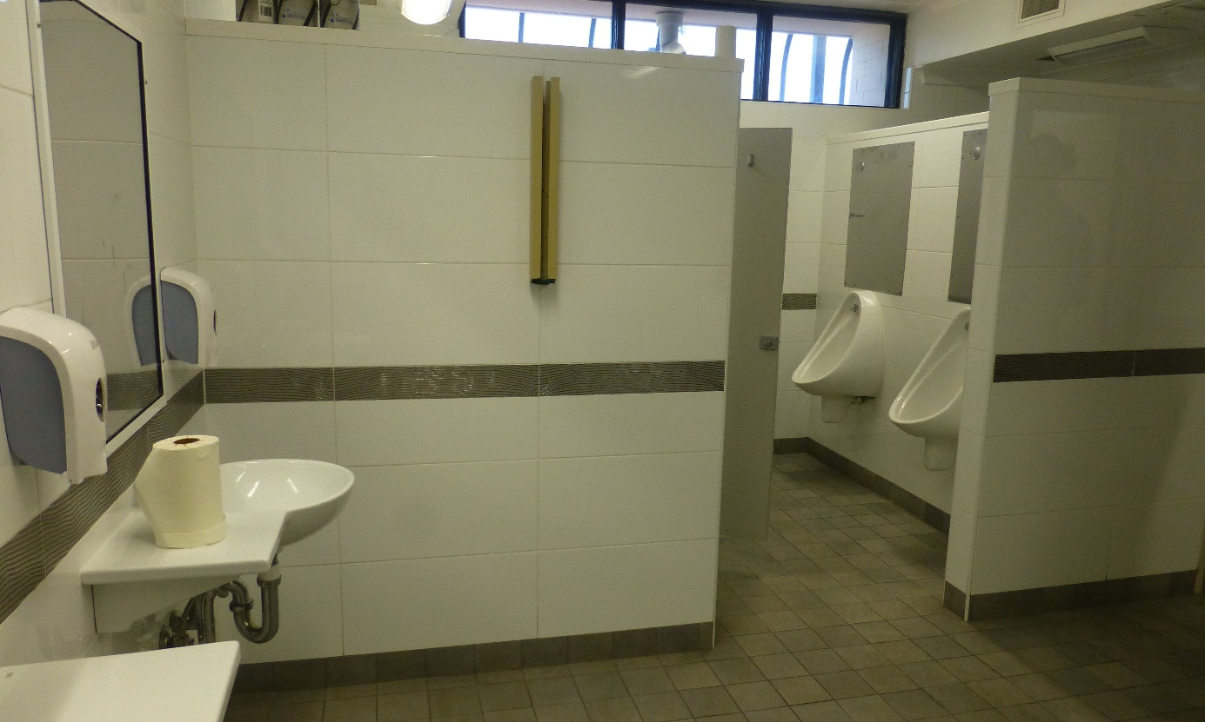
Shared bathroom in male compound, PIDC
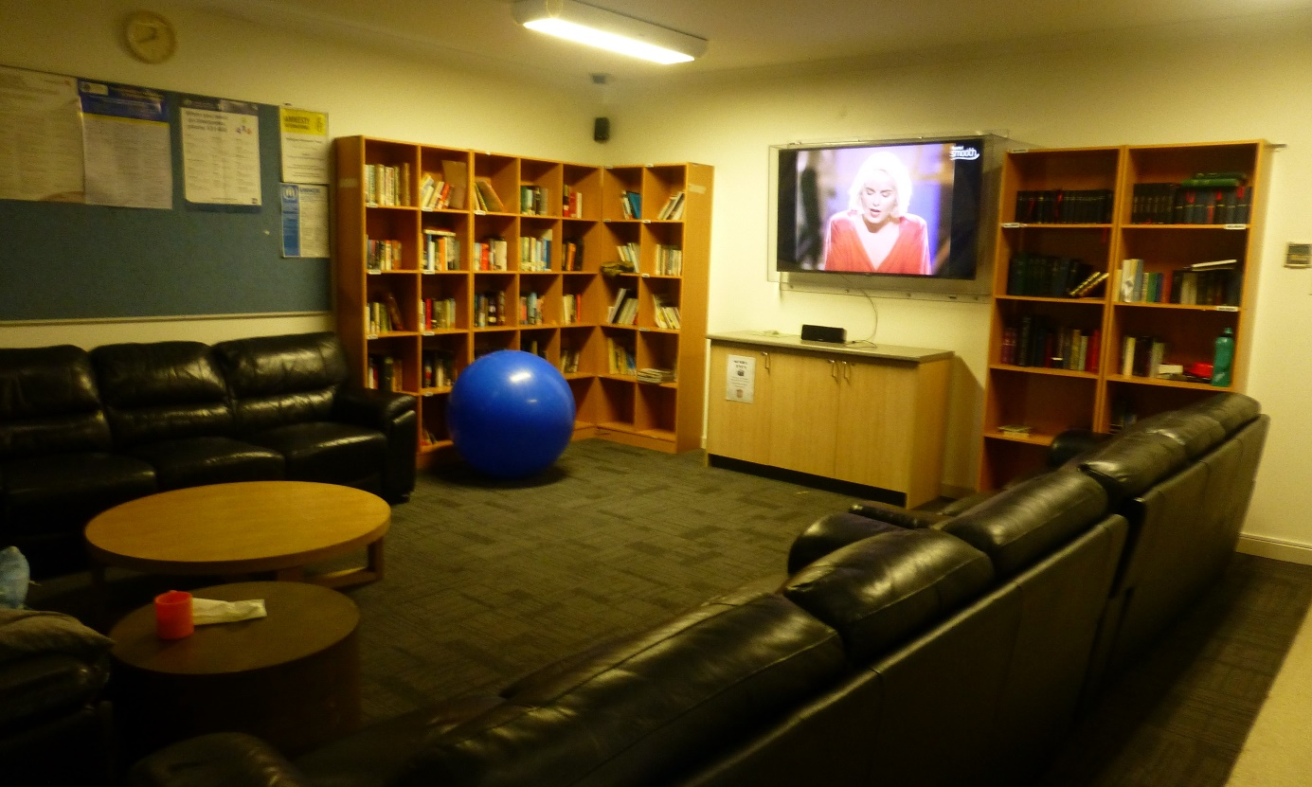
Common area in male compound, PIDC
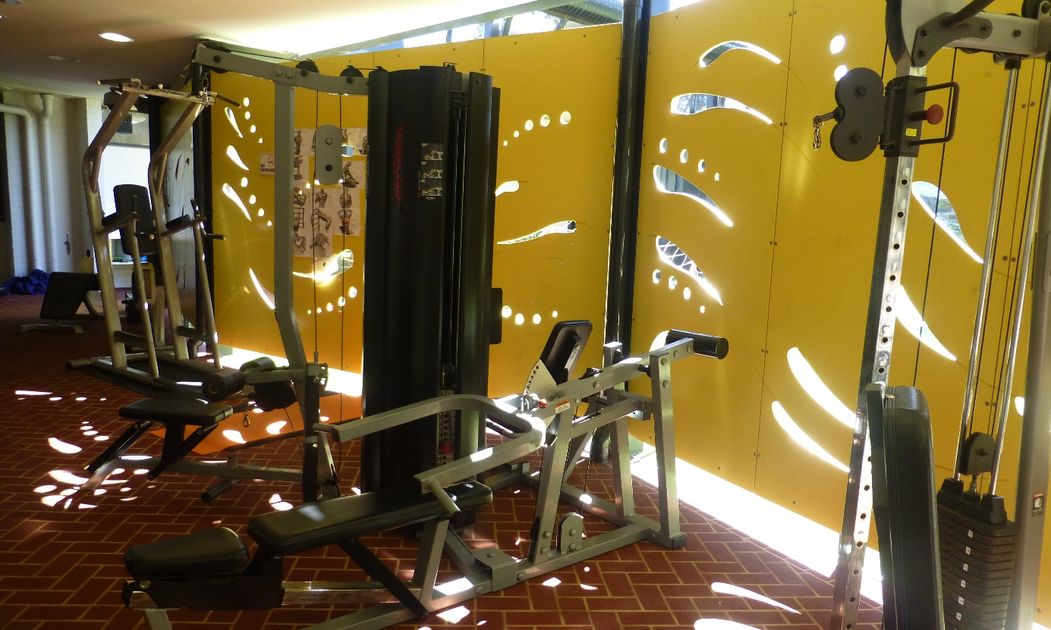
Gym, PIDC
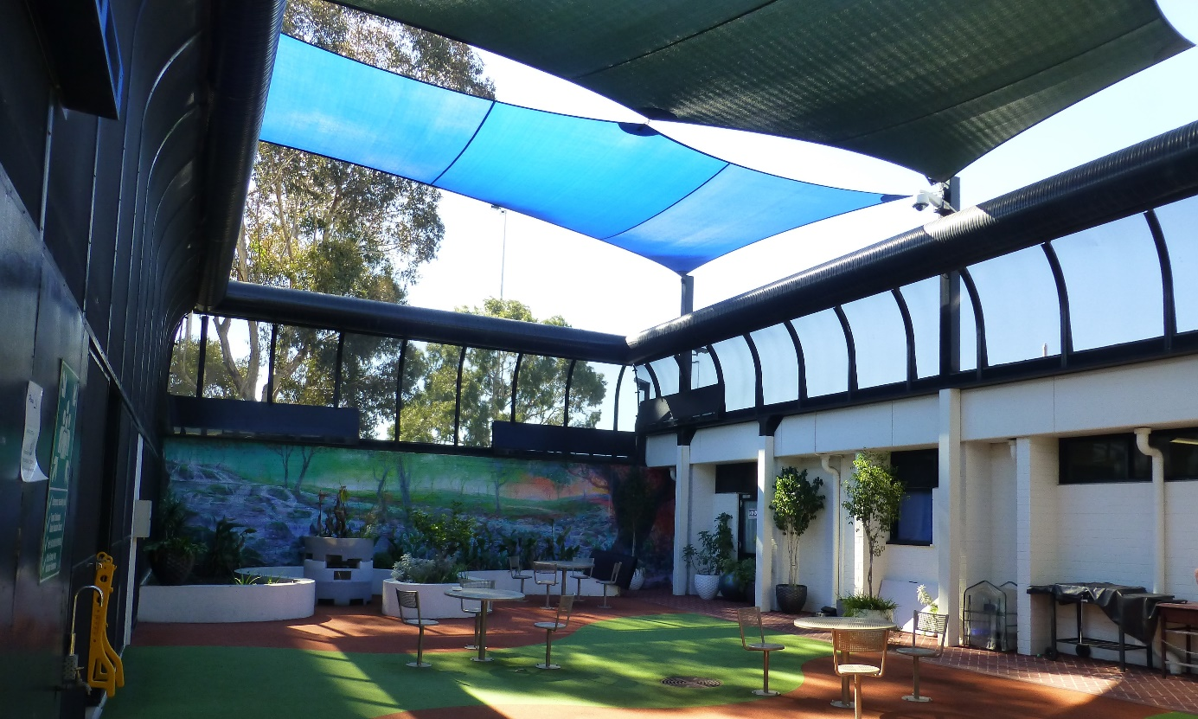
Outdoor area in women’s compound, PIDC

Yongah Hill Immigration Detention Centre
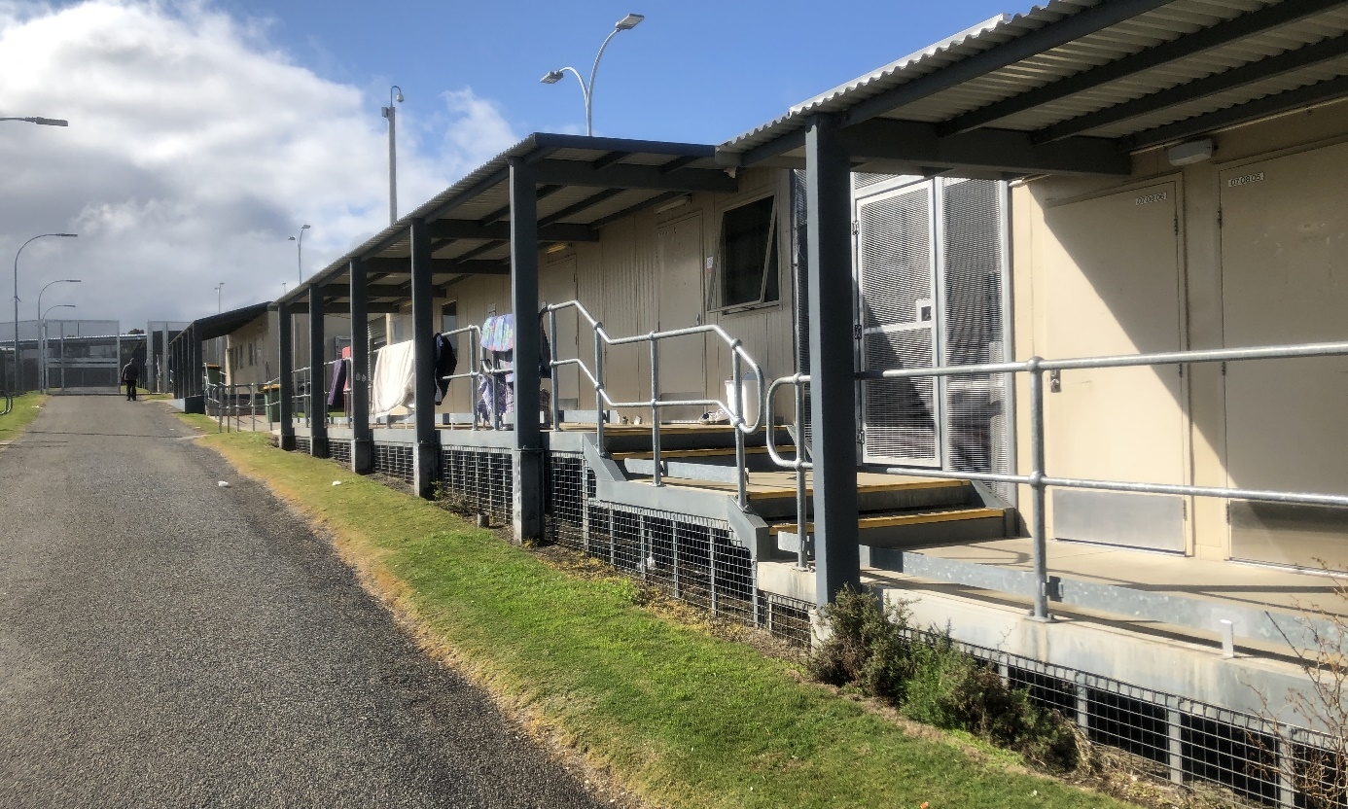
Hawk compound, YHIDC
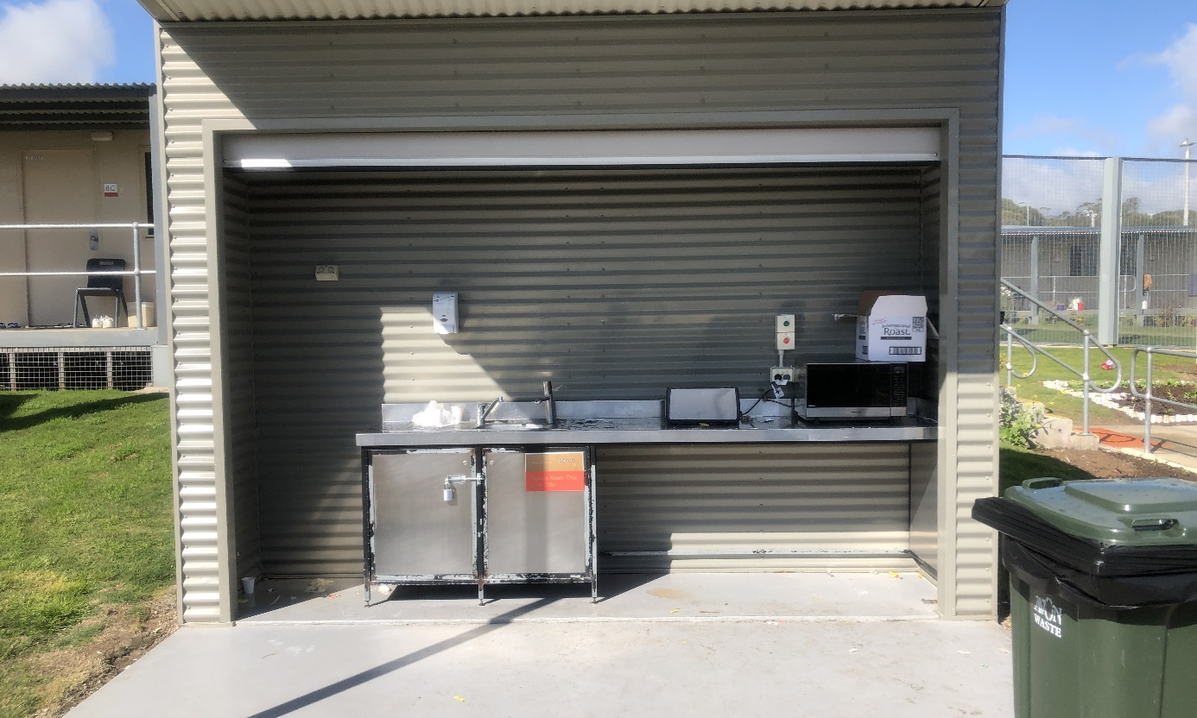
Outdoor kitchenette, Hawk compound, YHIDC
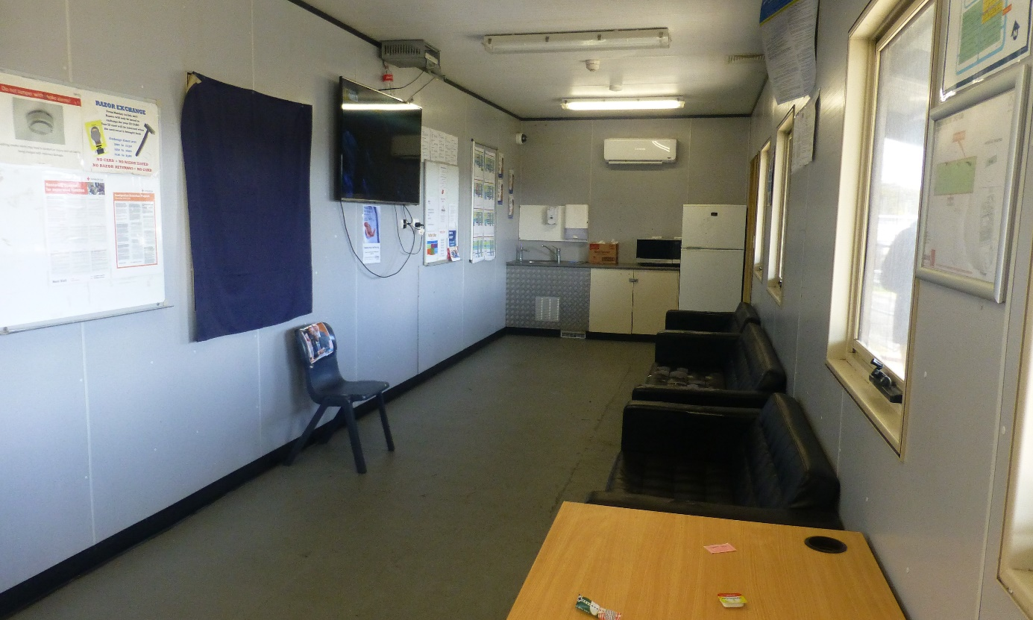
Common room, Hawk compound YHIDC
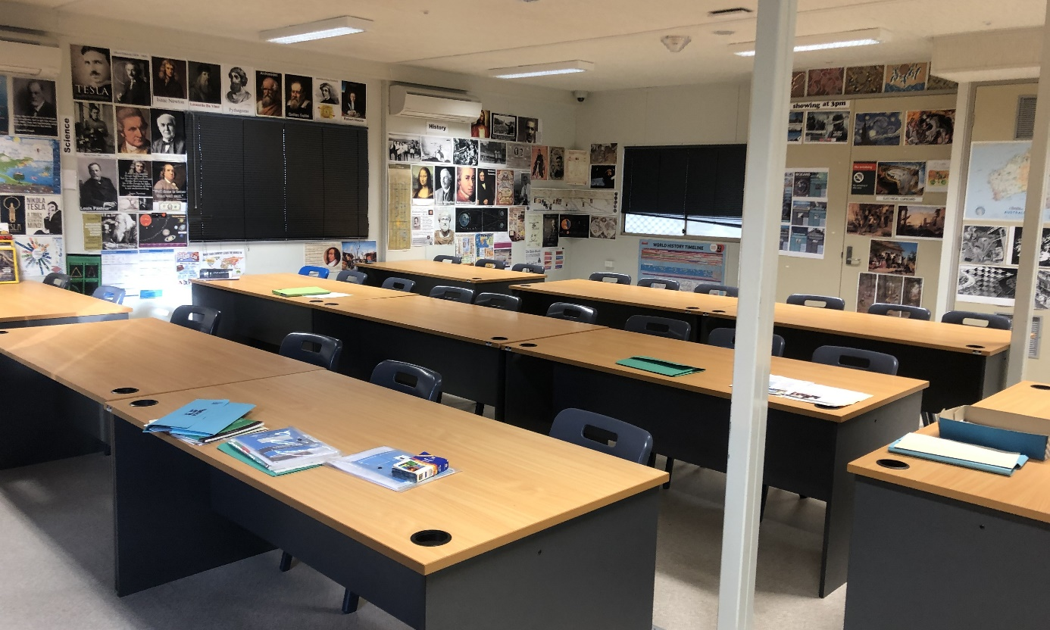
Classroom in the activities block, YHIDC
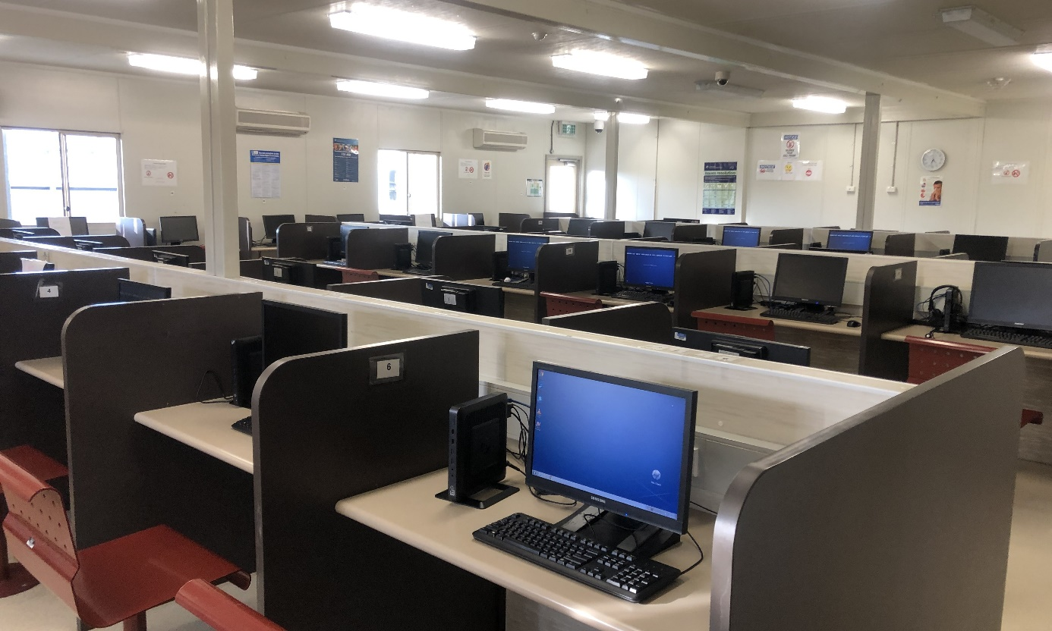
Computer room in the activities block, YHIDC
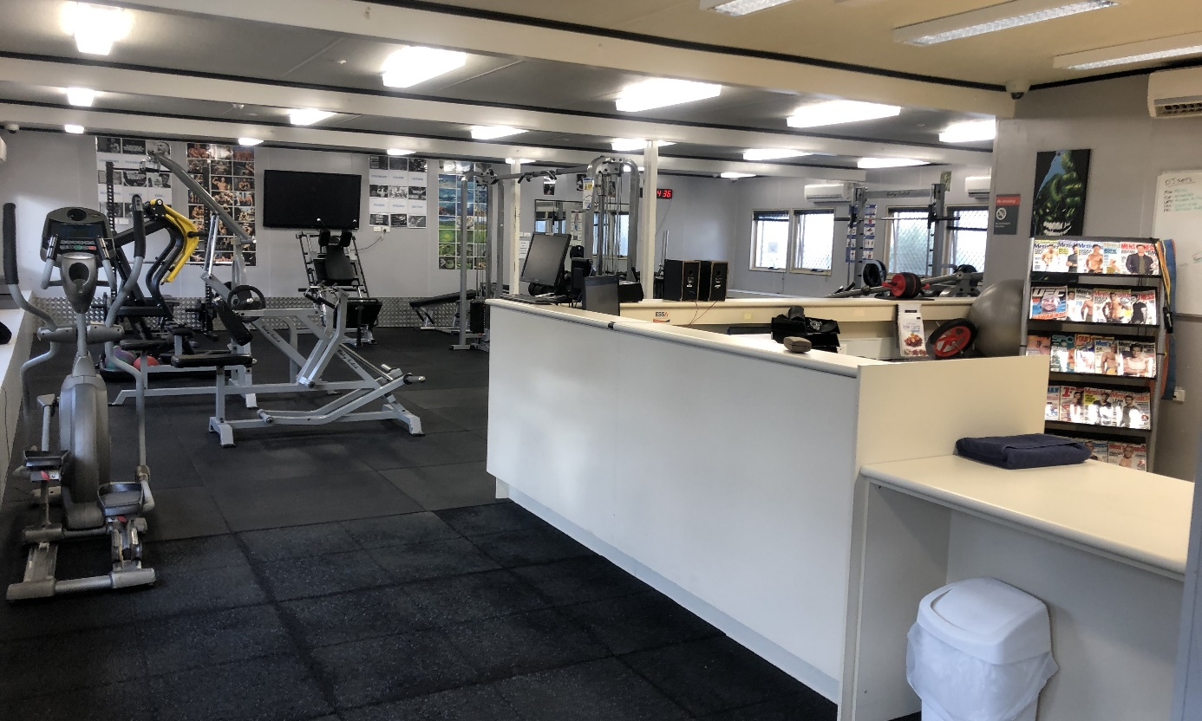
Gym in the activities block, YHIDC
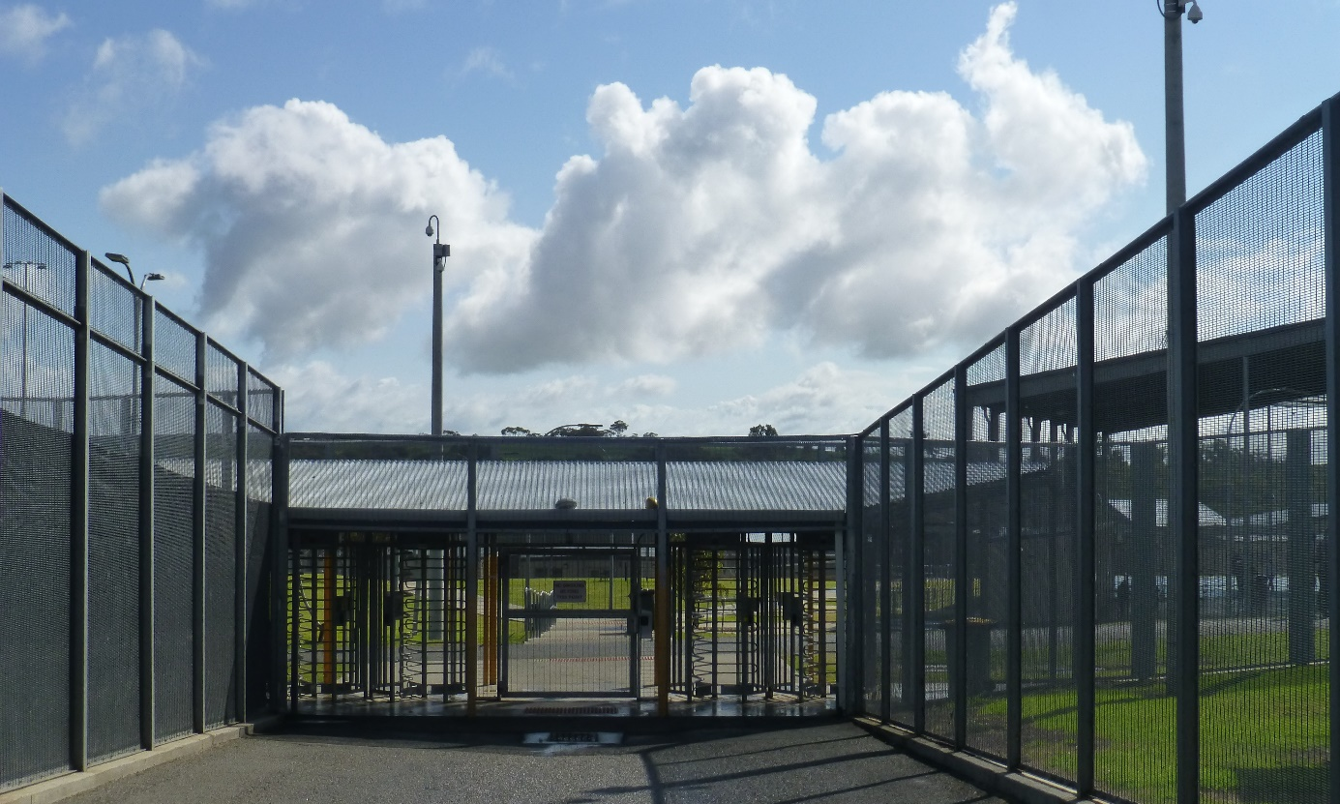
Gate from compounds to the Green Heart, YHIDC
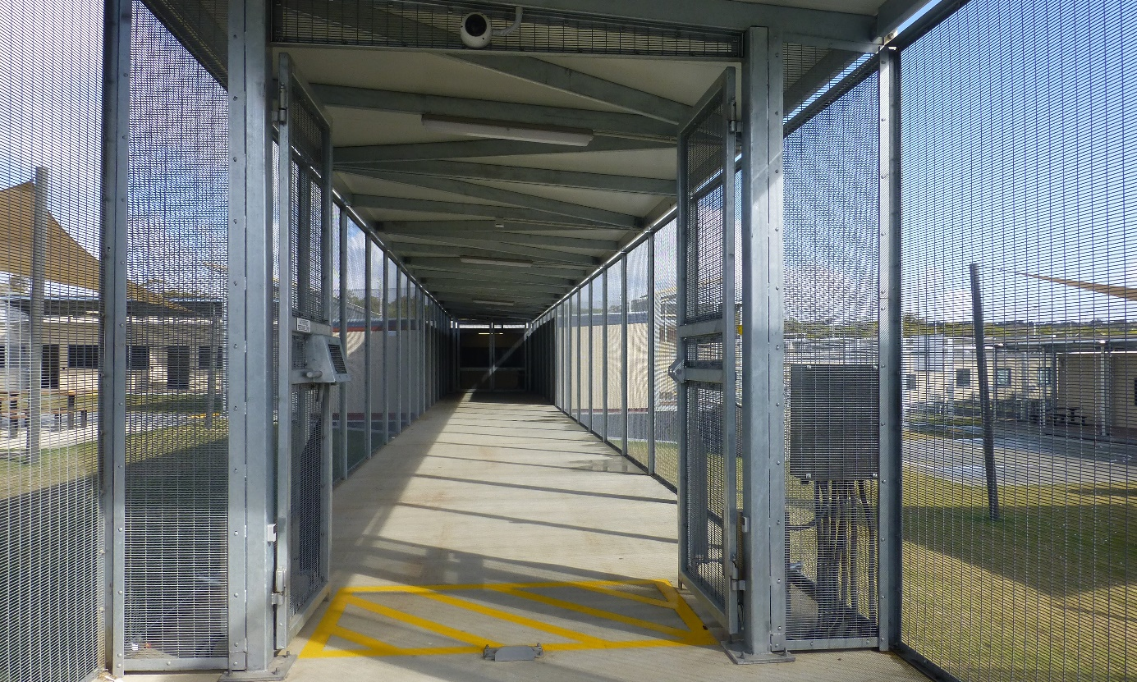
Walkway between high-security compounds, YHIDC
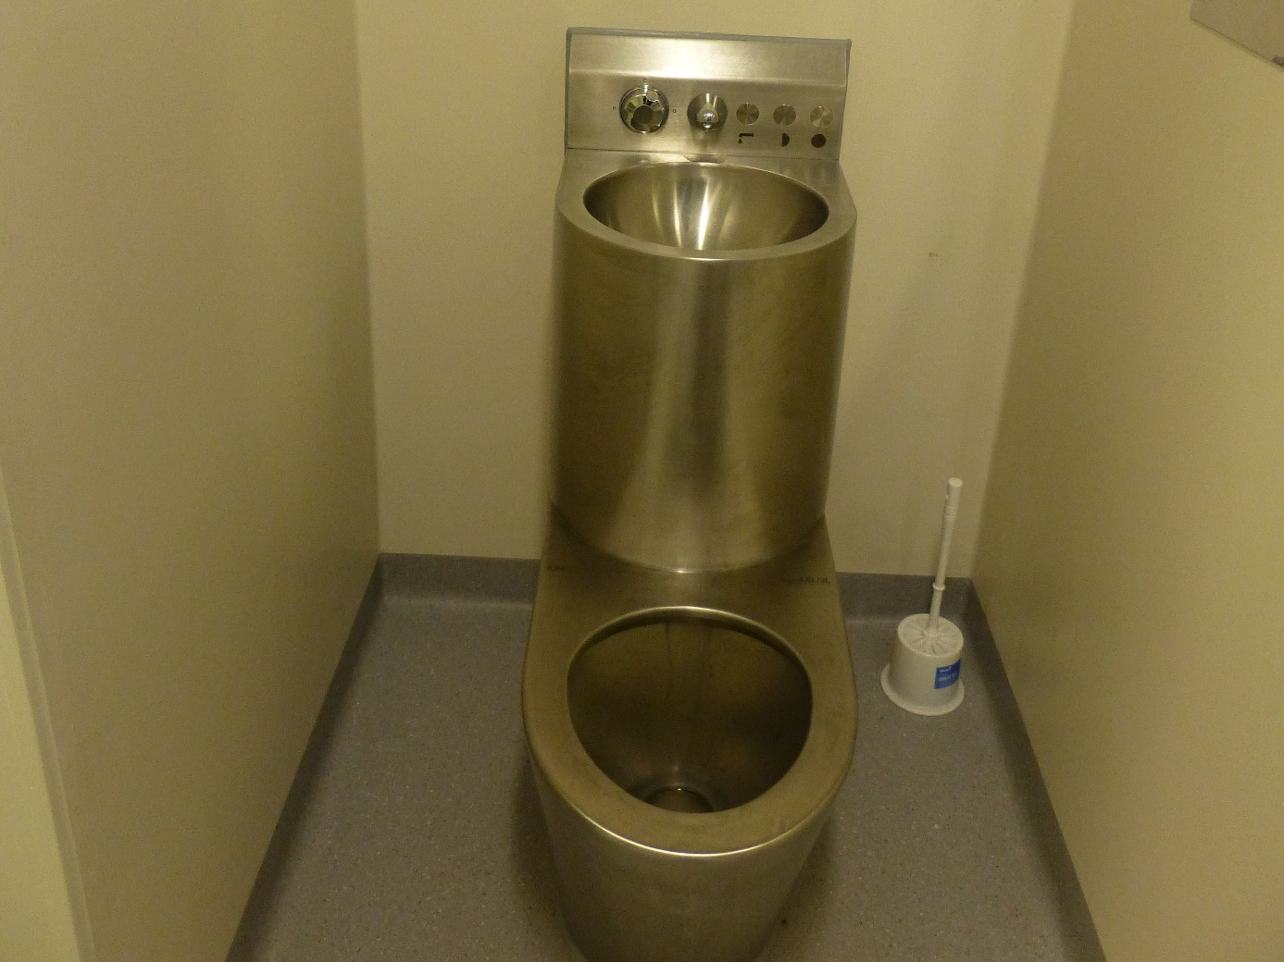
Combined toilet and sink unit, Cassowary compound, YHIDC
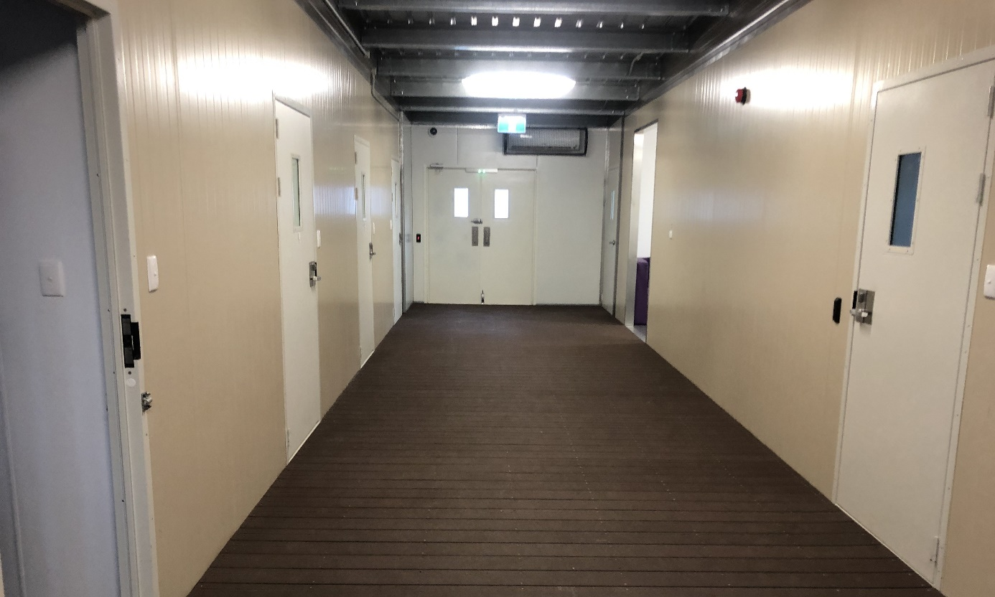
High-care accommodation unit, YHIDC
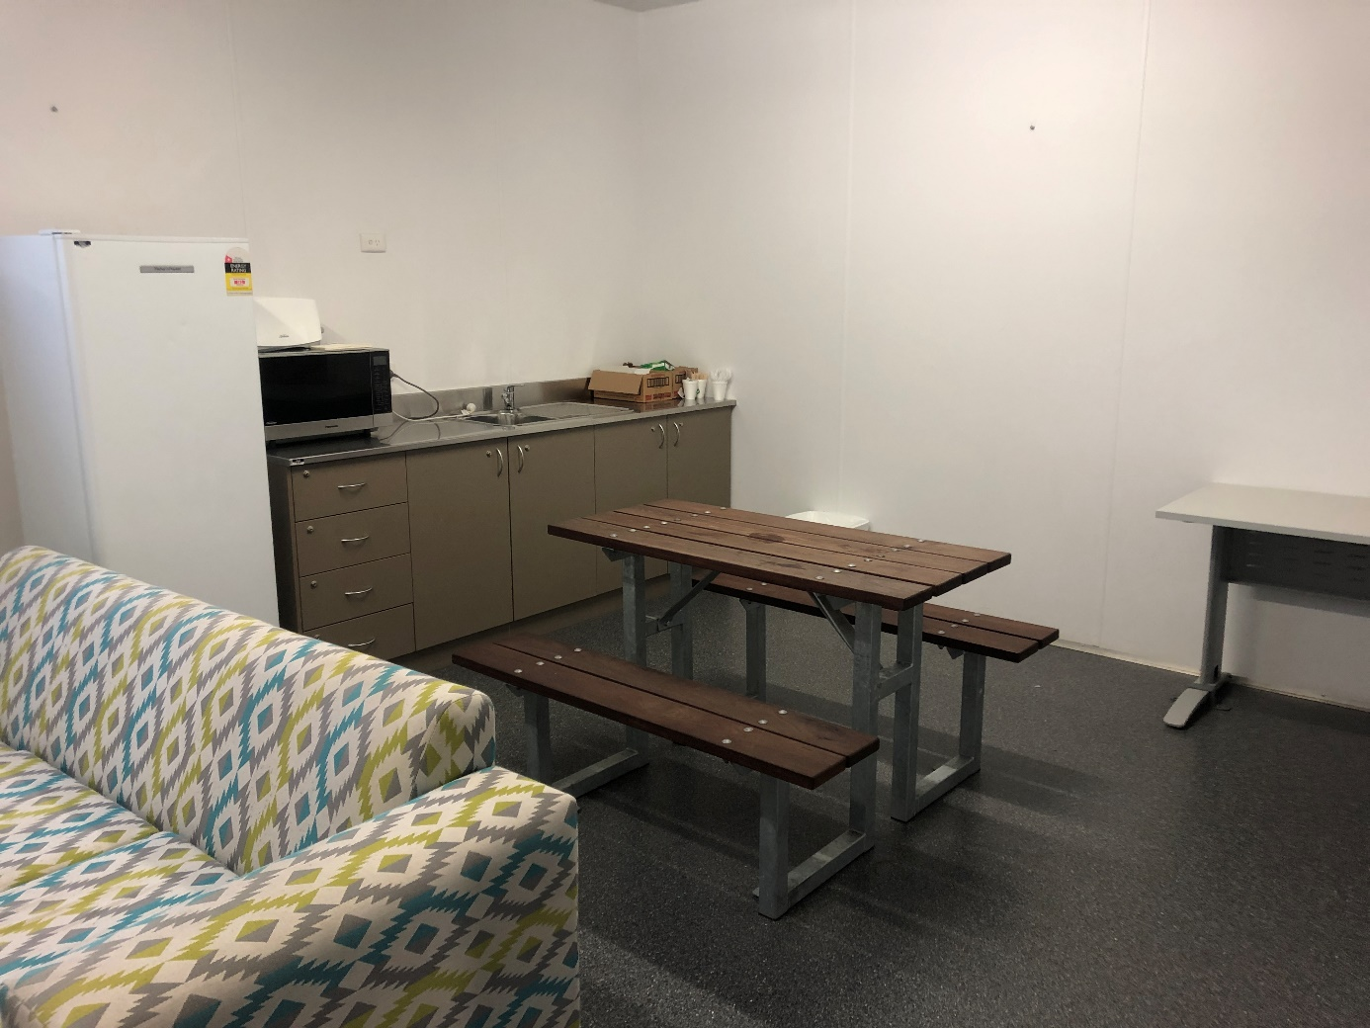
Day room, high-care accommodation unit, YHIDC
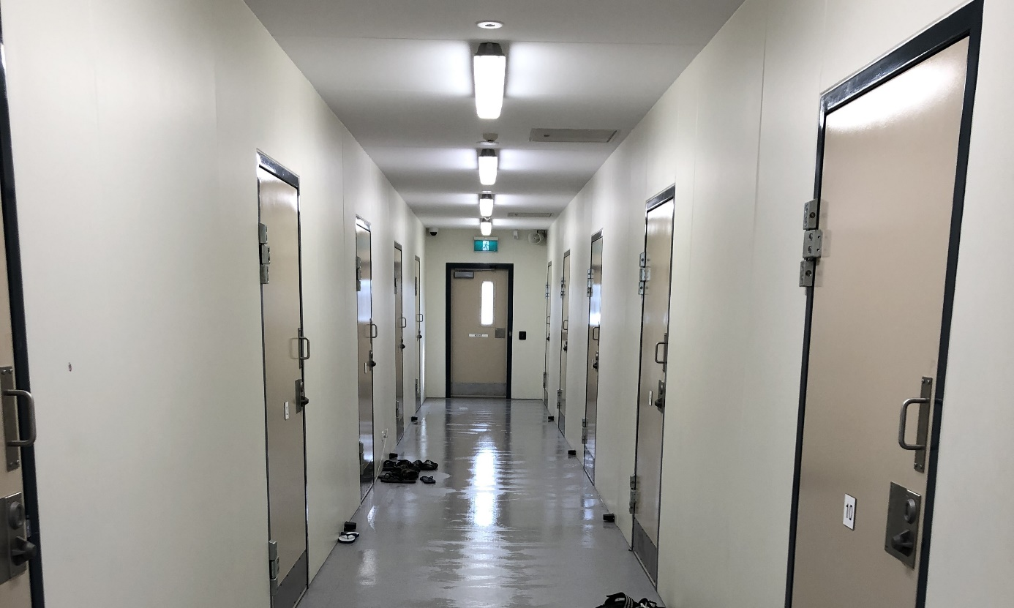
Accommodation area, Cassowary compound, YHIDC

Adelaide Immigration Transit Accommodation
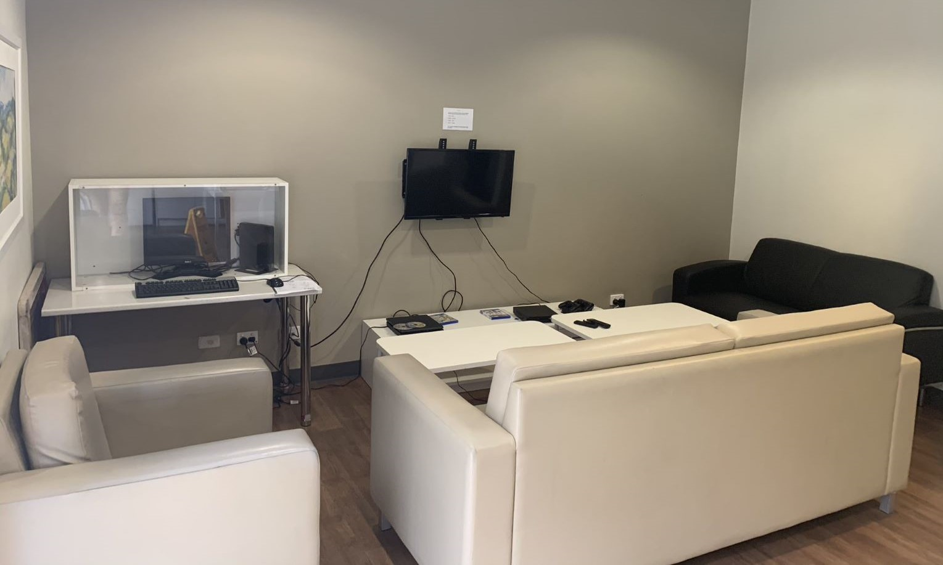
Common area in unit, Kangaroo compound, AITA
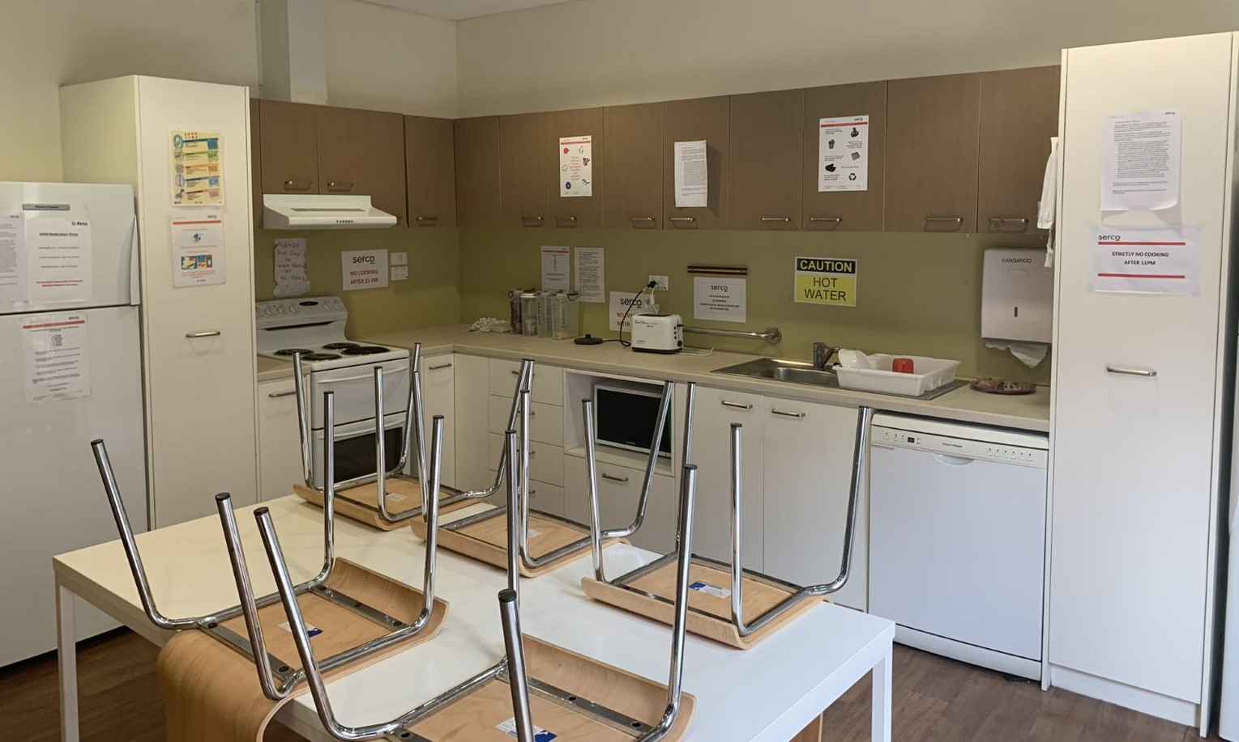
Self-contained kitchen in unit, Kangaroo compound, AITA

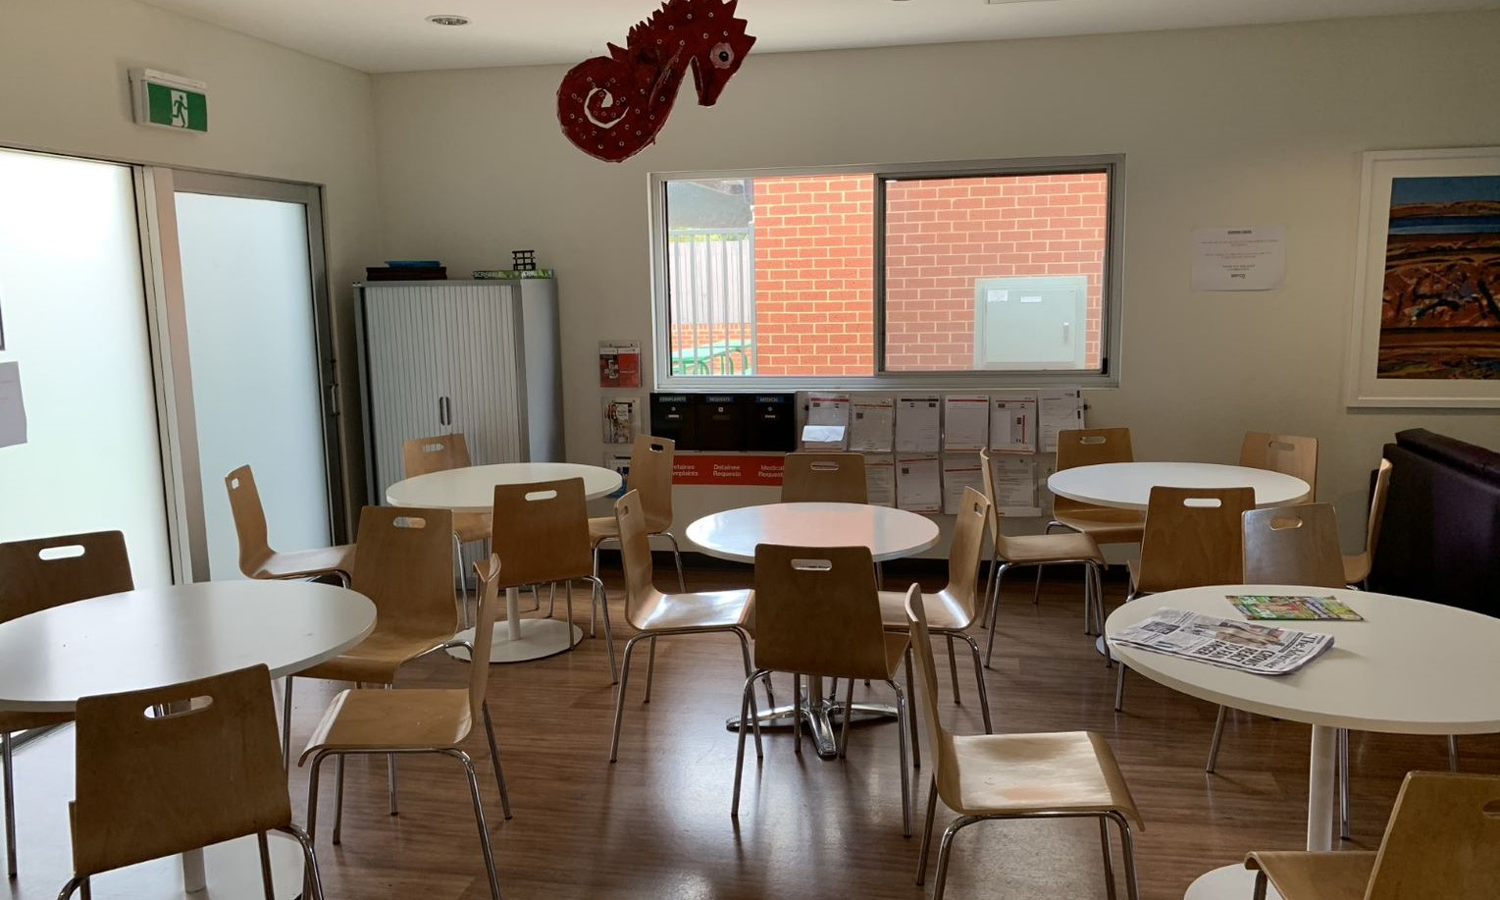
Dining and visits, AITA
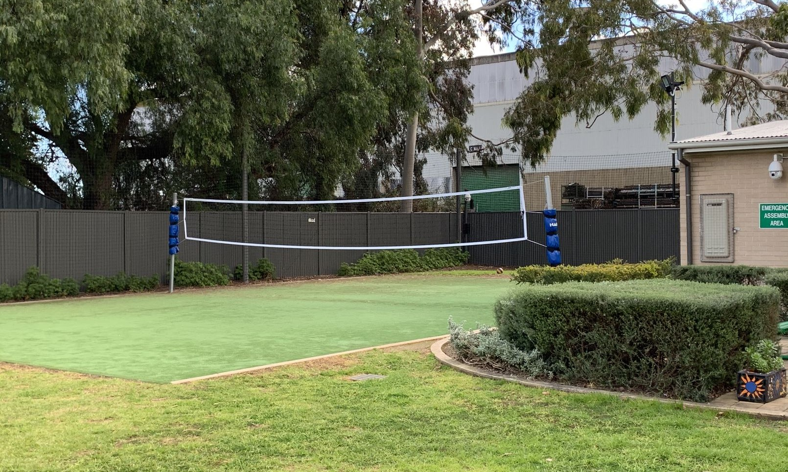
Outdoor area, AITA
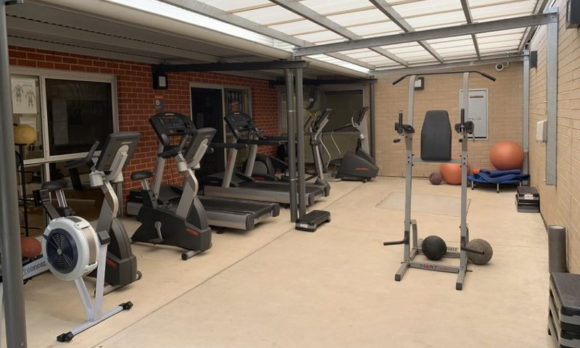
Gym, AITA
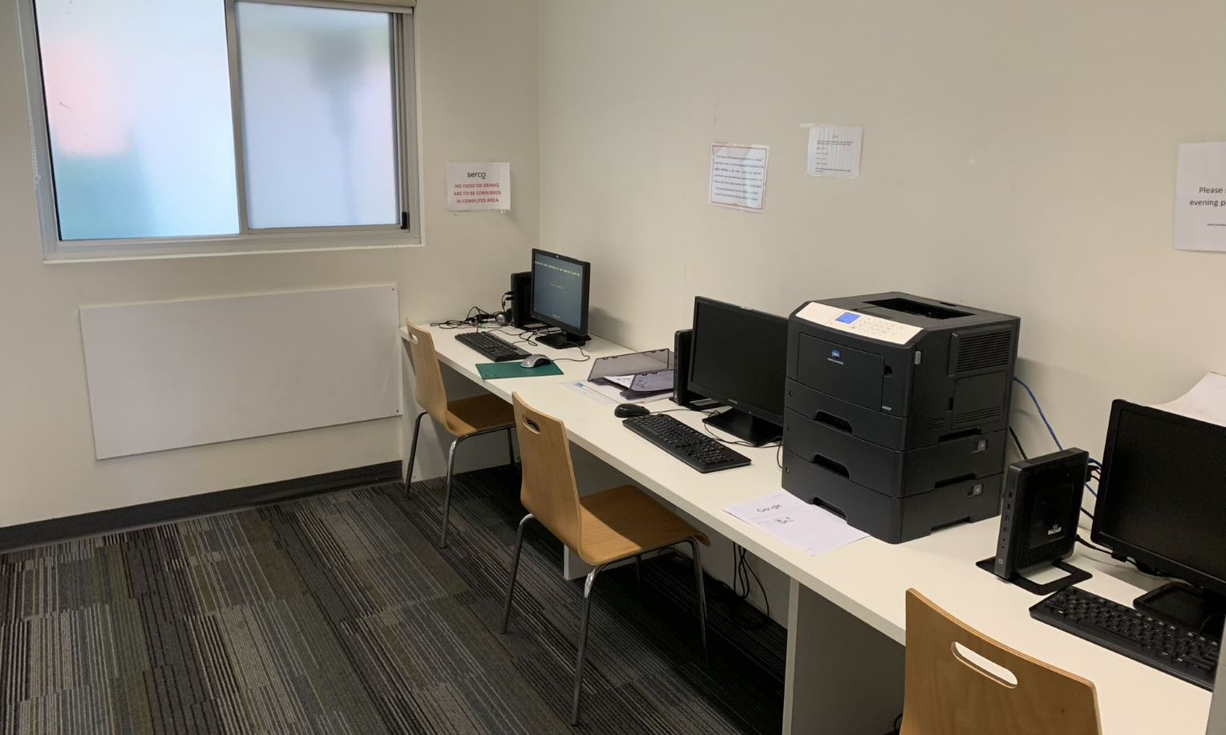
Computer room, AITA

Melbourne Immigration Transit Accommodation
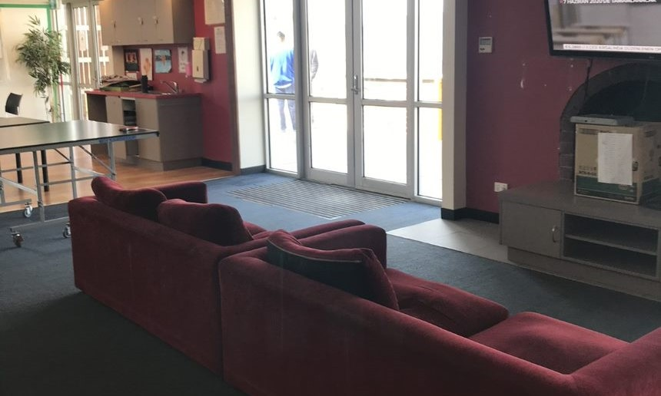
Common area, Avon compound, MITA
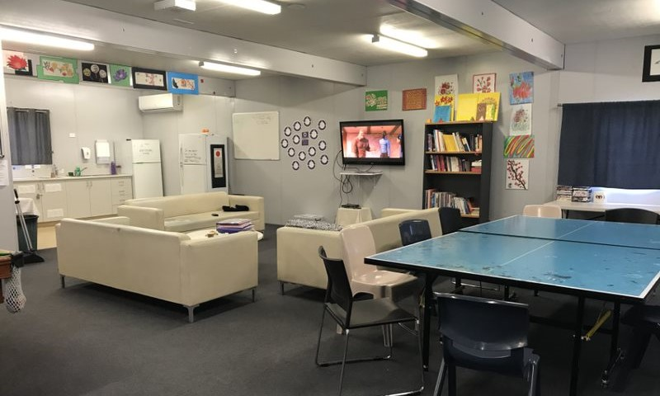
Common area, Bass 2, MITA
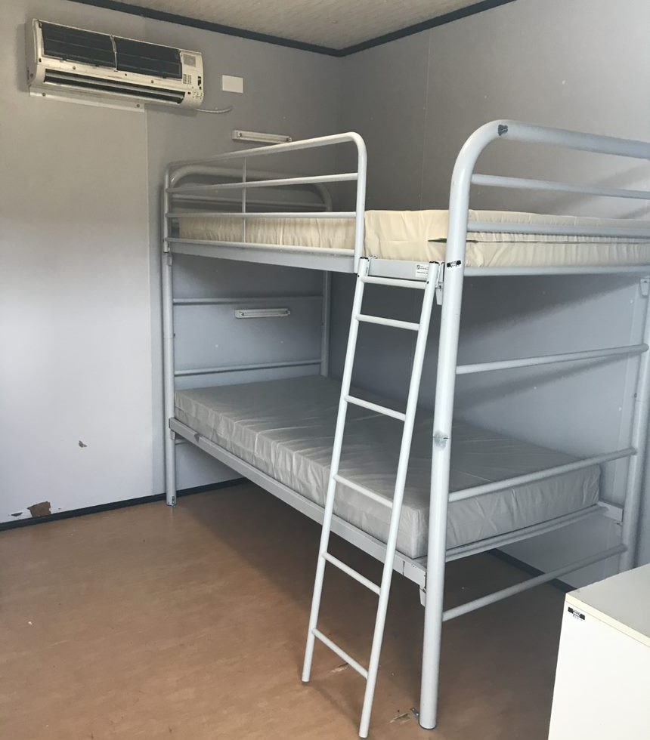
Bedroom in Bass 2, MITA
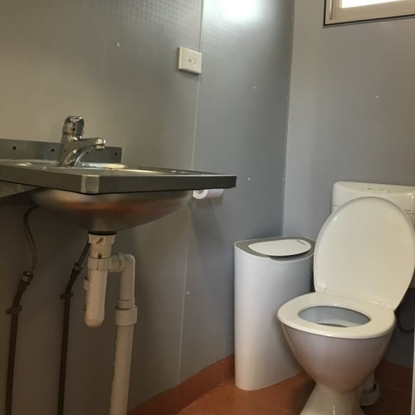
Bathroom in Bass 2, MITA
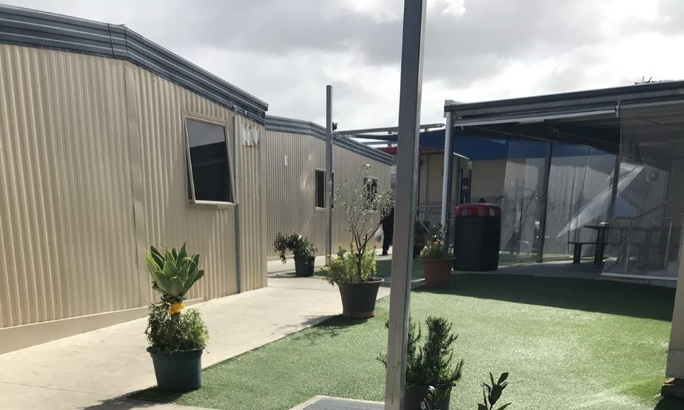
Courtyard, Bass 1 compound, MITA
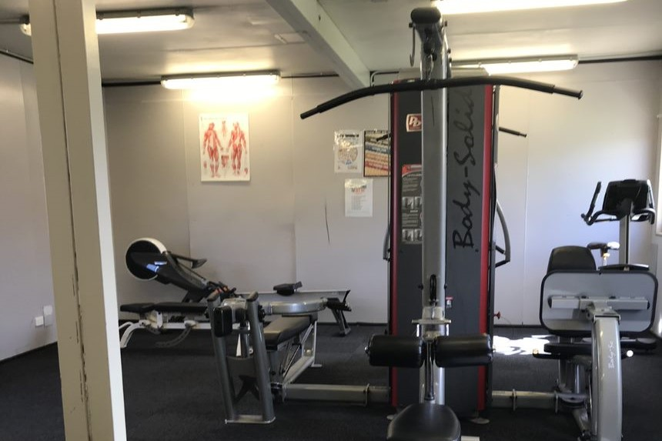
Gym, Bass 1 compound, MITA

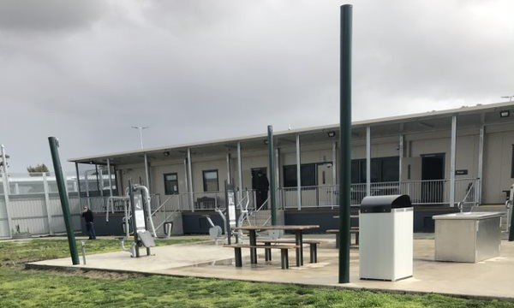
Dargo compound, MITA
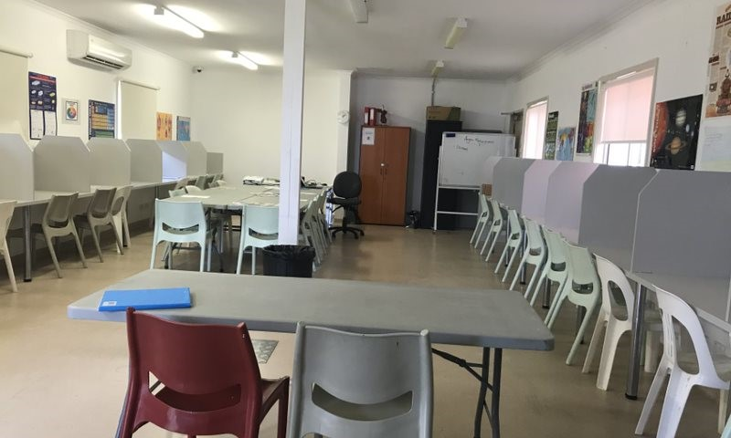
Classroom, MITA North
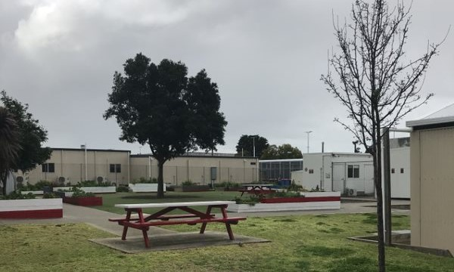
Outdoor courtyard, MITA North
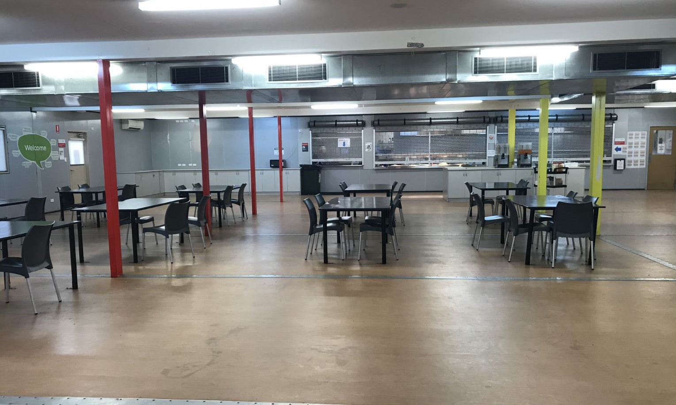
Dining area, MITA North
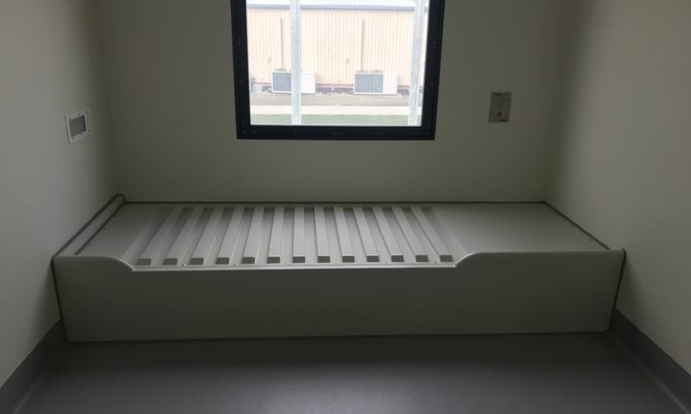
High-care accommodation, MITA
Villawood Immigration Detention Centre
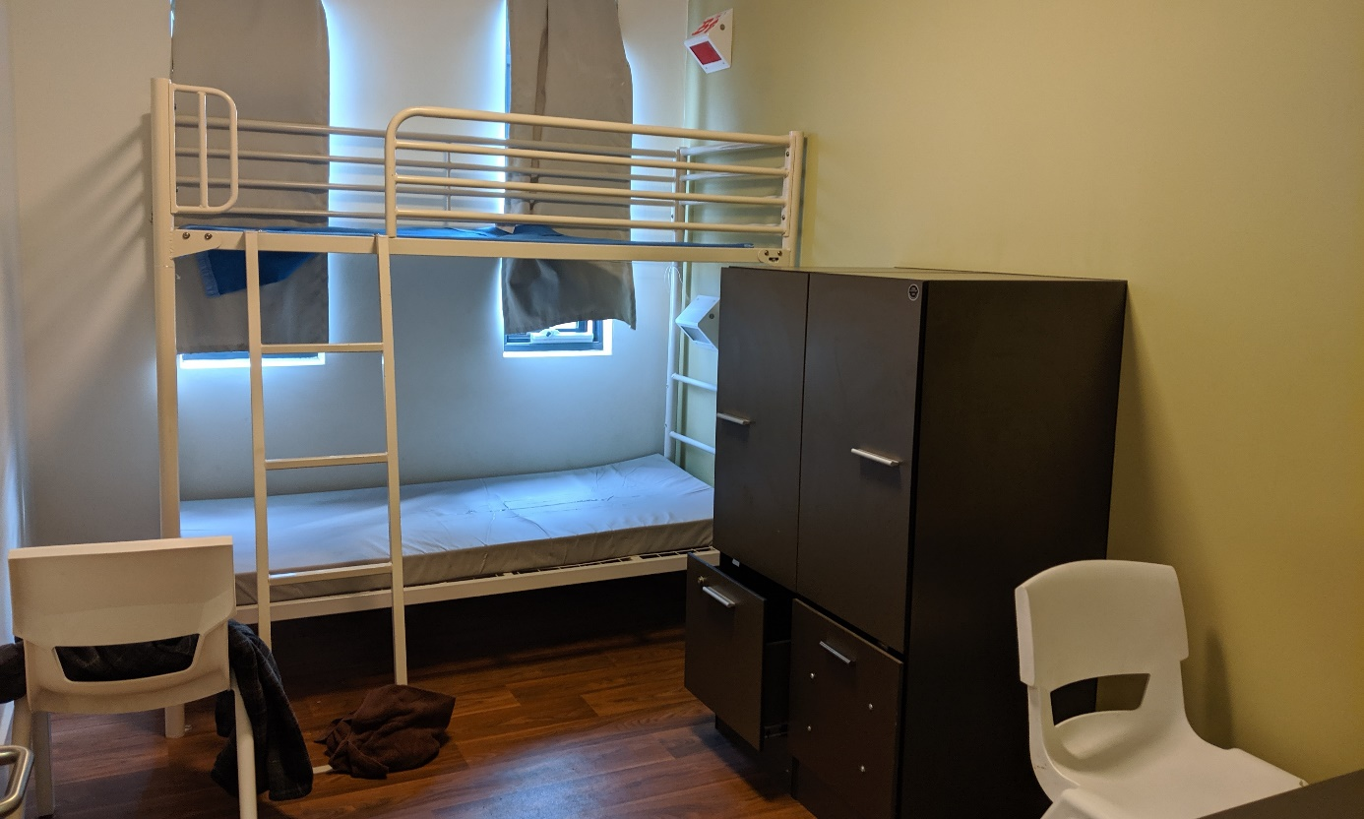
Bedroom in Lachlan compound, VIDC

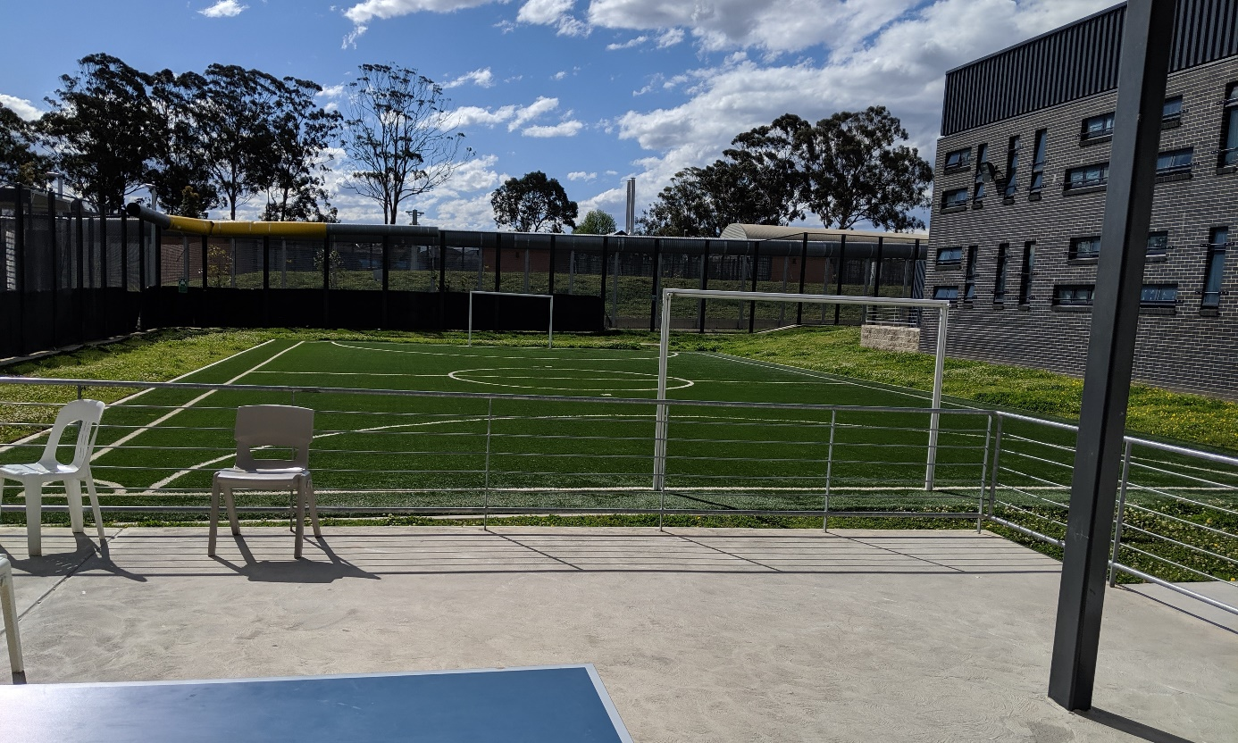
Outdoor area in La Trobe compound, VIDC
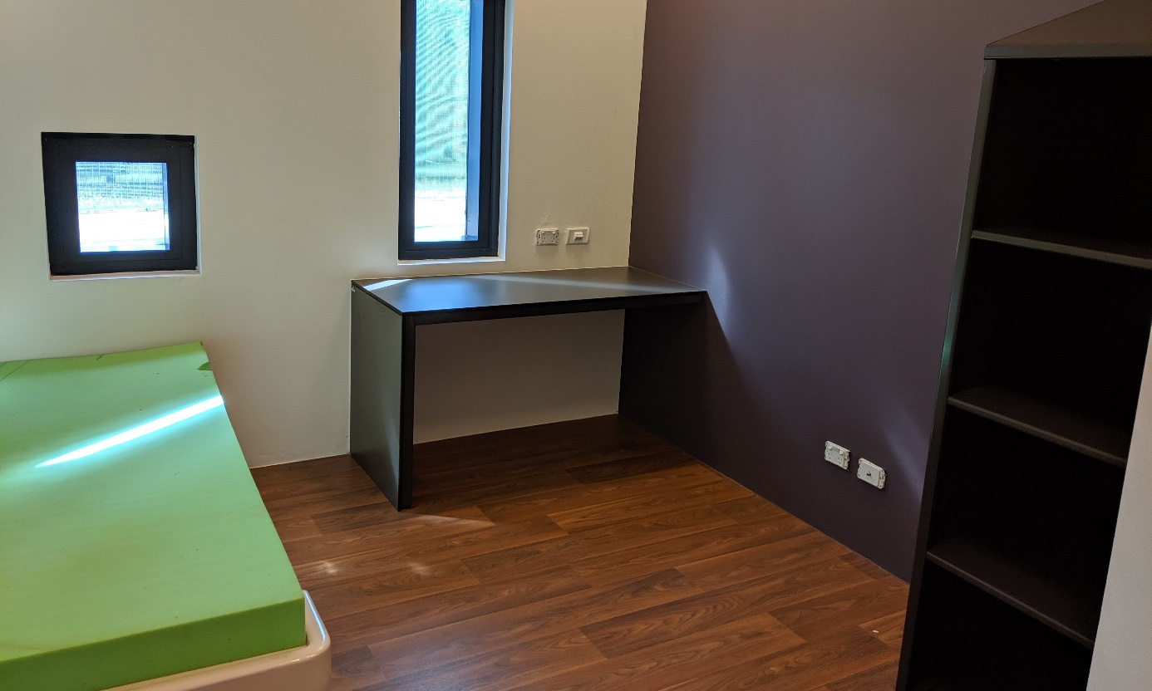
High-care accommodation, VIDC
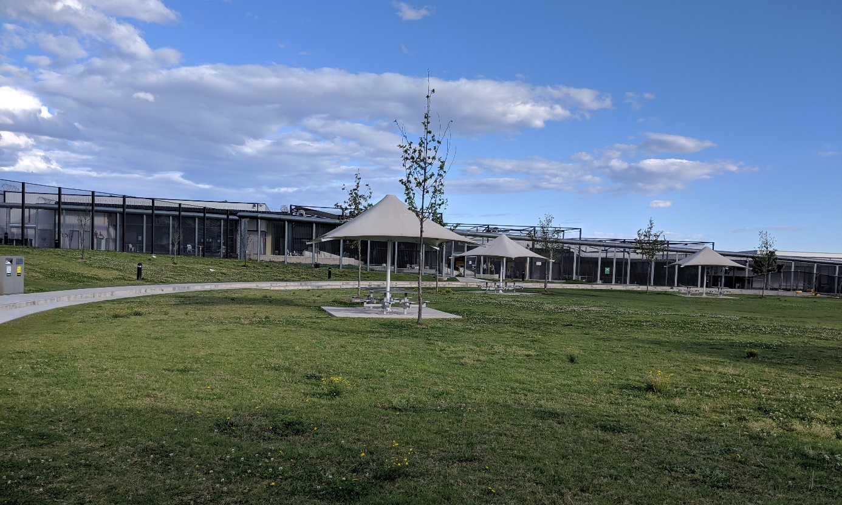
Community area, VIDC
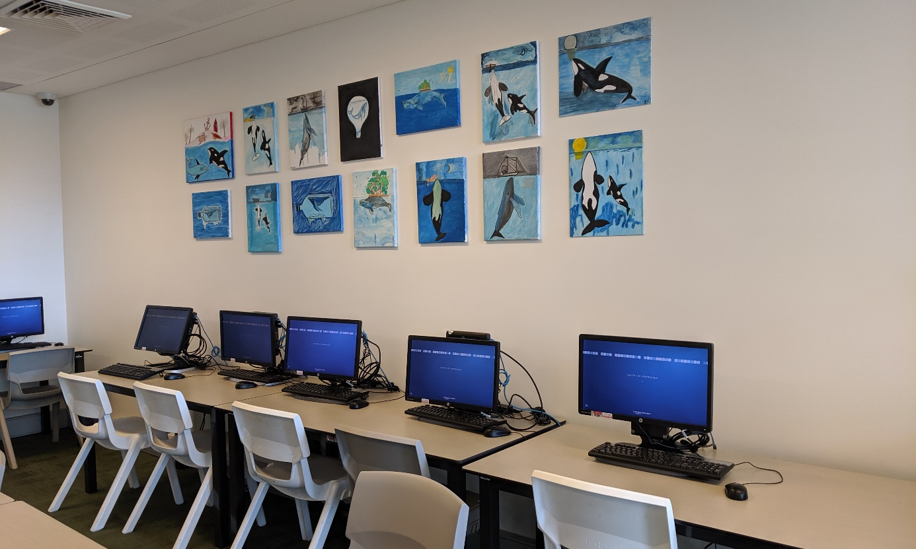
Computer room in community area, VIDC
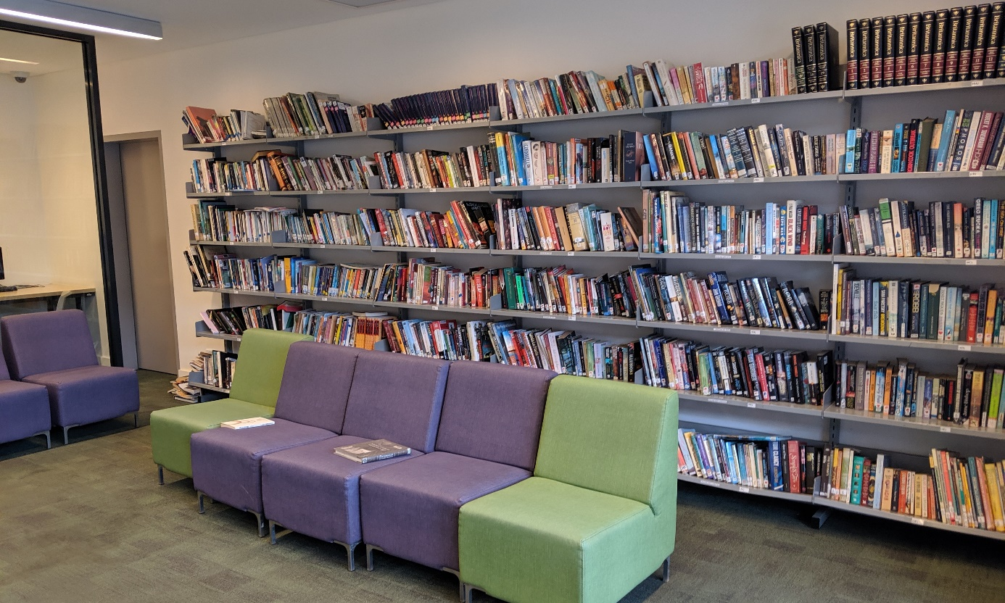
Library in community area, VIDC
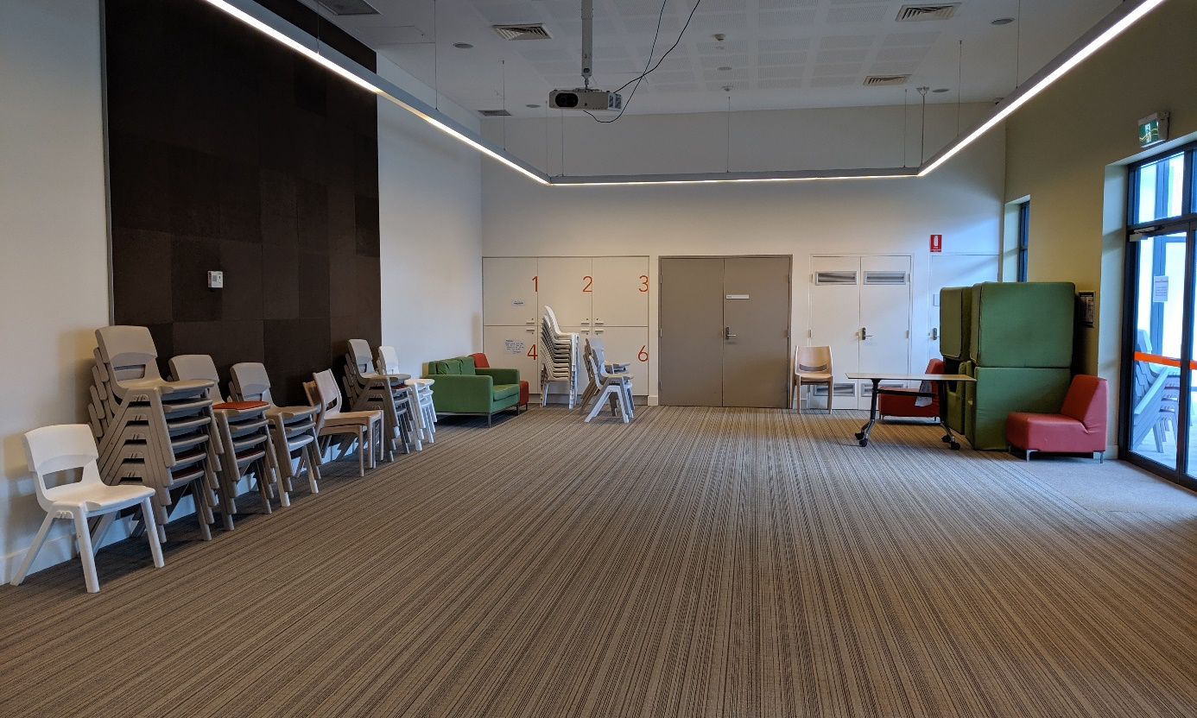
Multipurpose room in Logan visits area, VIDC

Brisbane Immigration Transit Accommodation
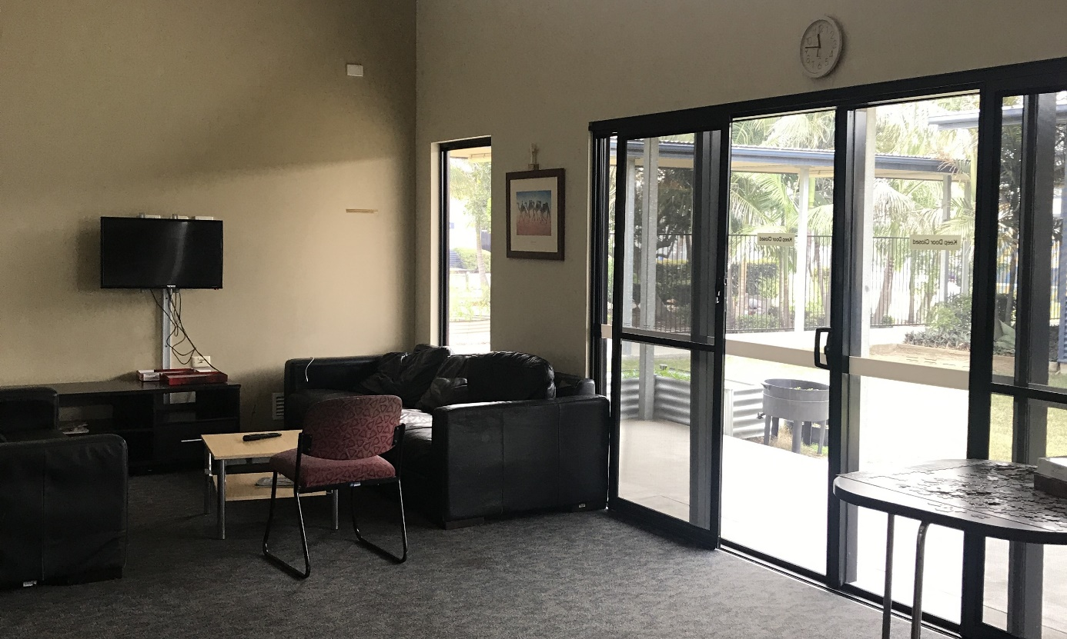
Common room in residential accommodation area, BITA
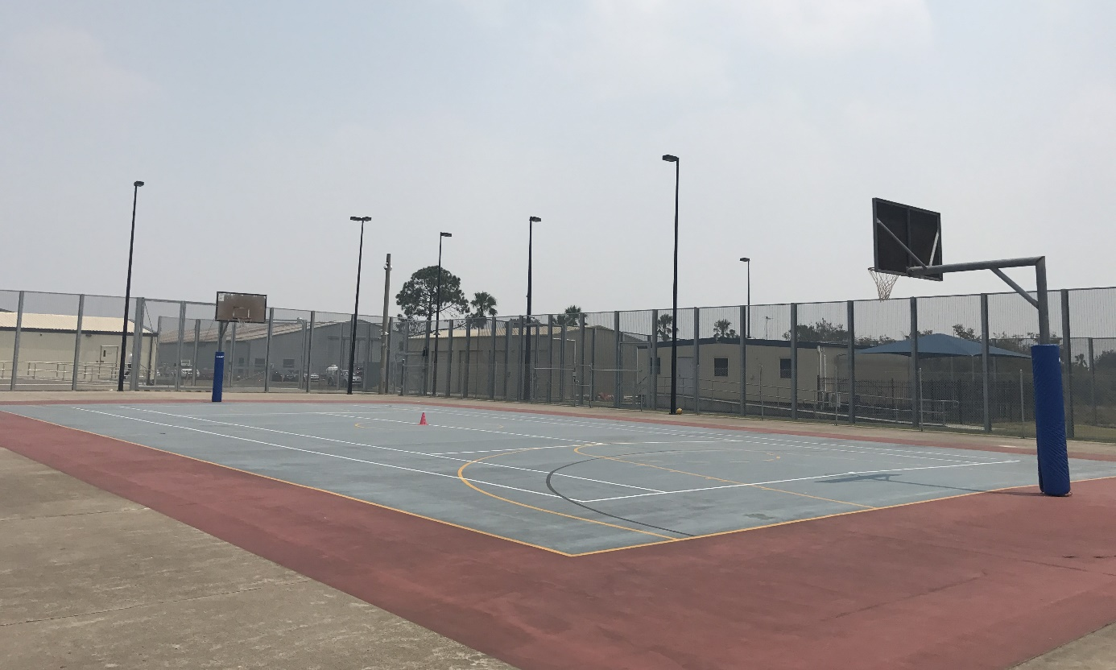
Basketball court, residential area, BITA
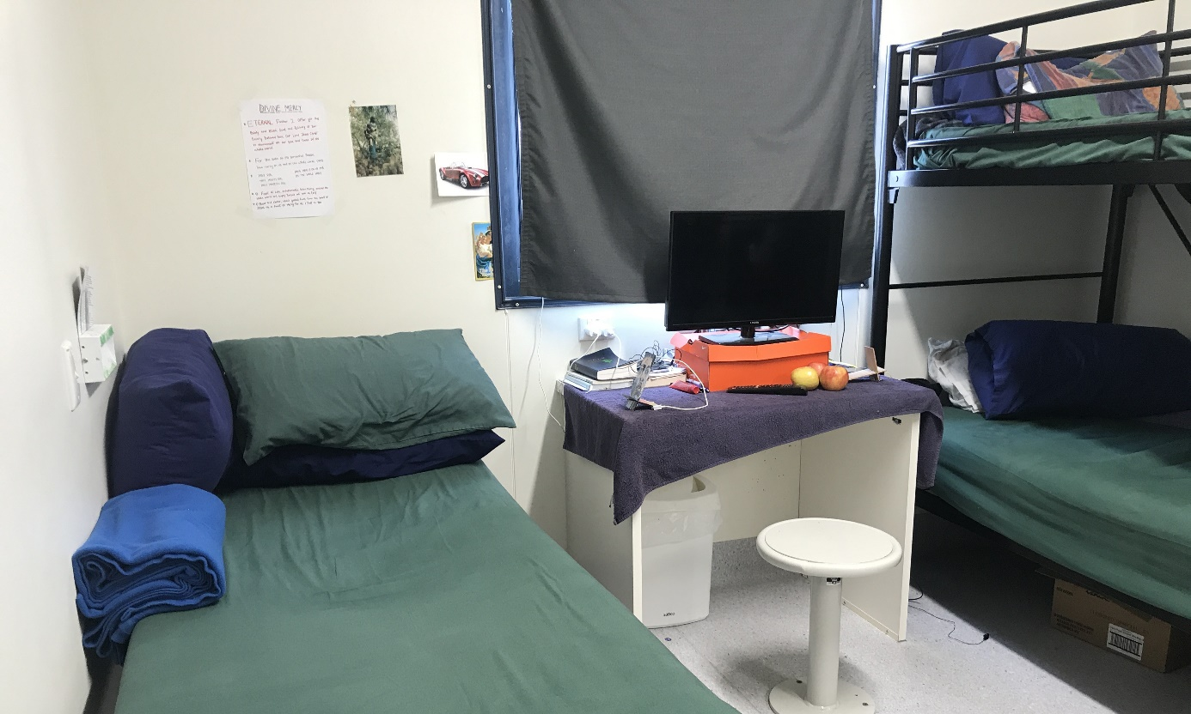
Three-person bedroom, Morton compound, BITA

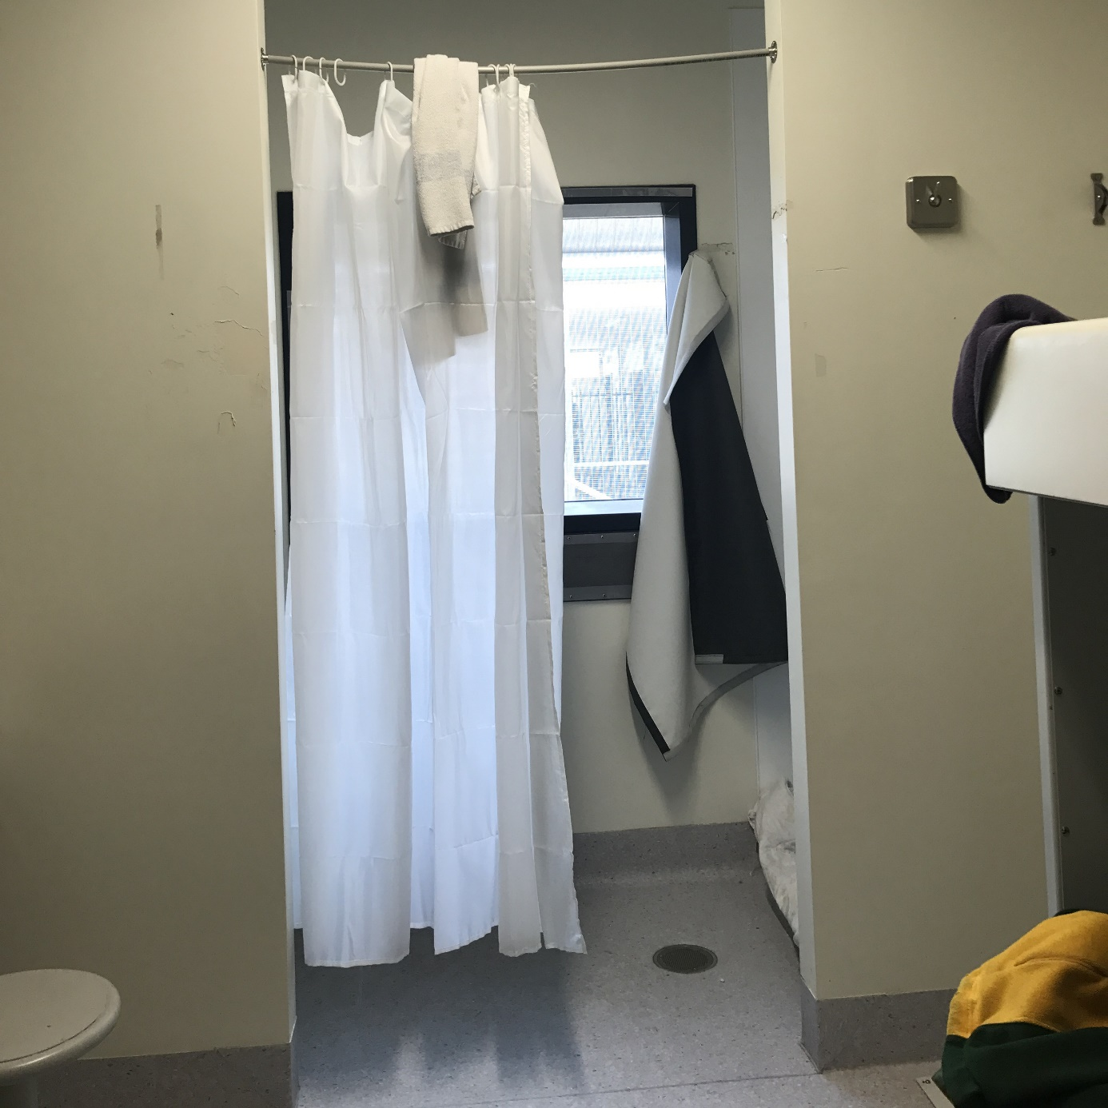
Curtain separating bathroom from sleeping quarters, Fraser compound, BITA
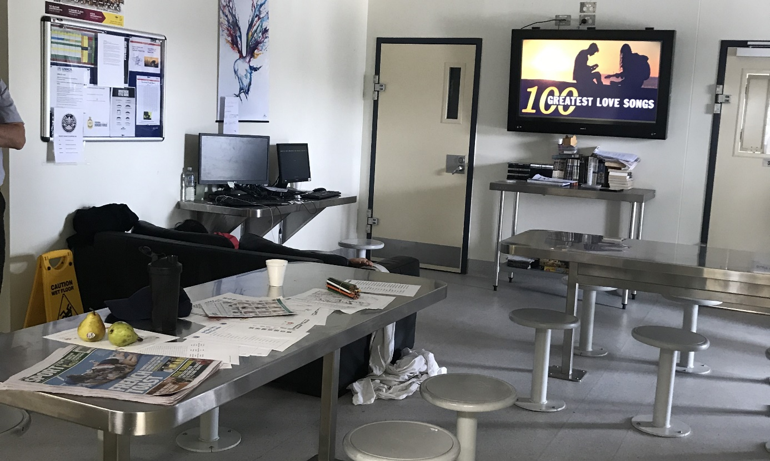
Common area, Fraser compound, BITA
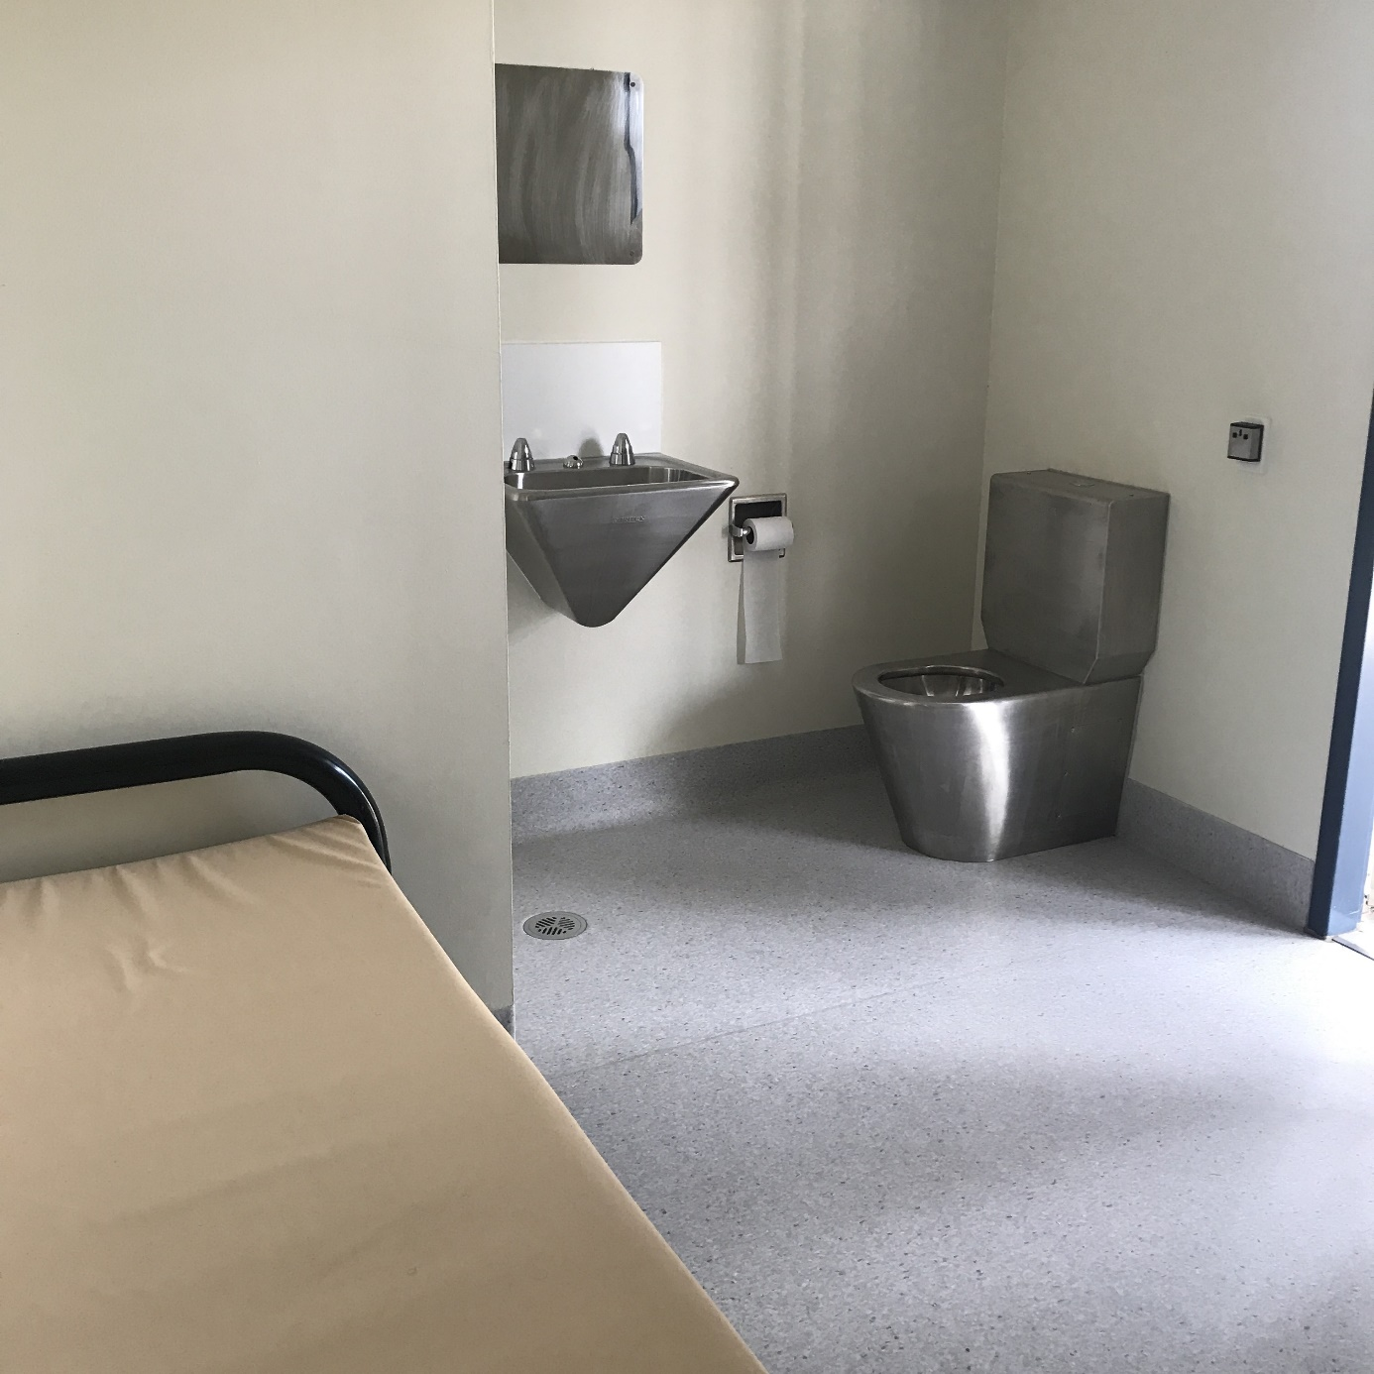
High-care accommodation, BITA

Alternative places of detention
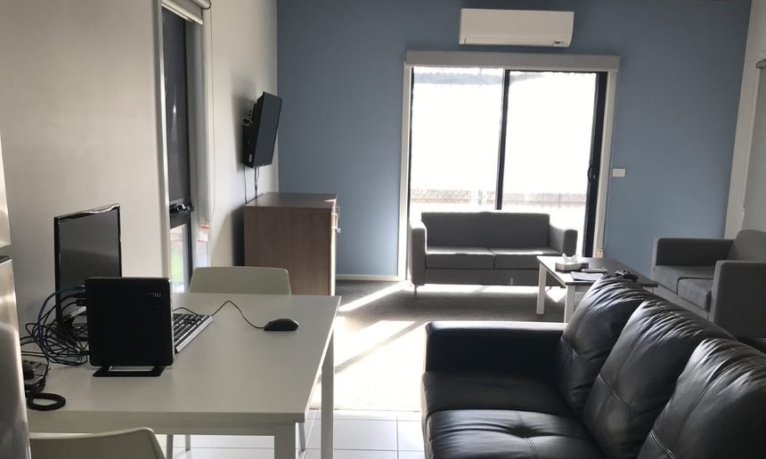
Lounge room, BRP, MITA
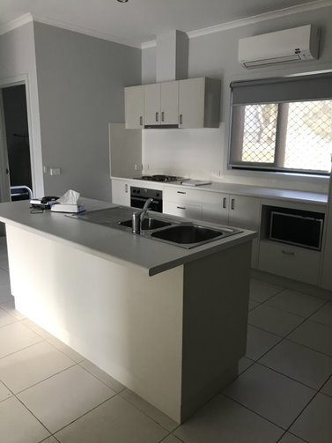
Self-contained kitchen, BRP, MITA

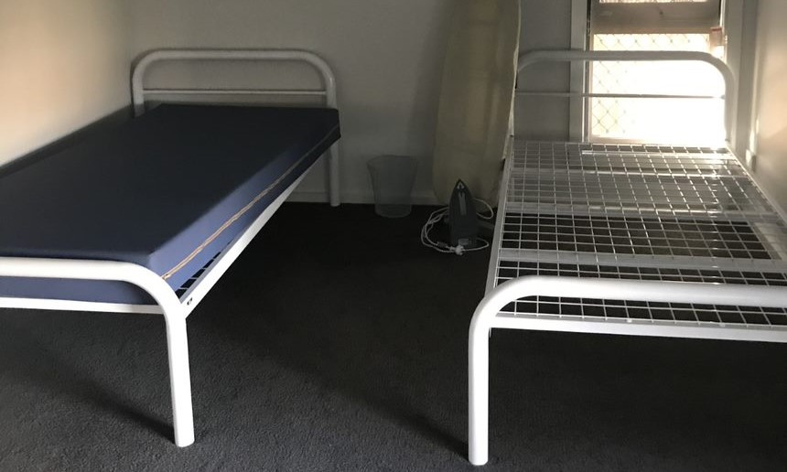
Bedroom, BRP, MITA

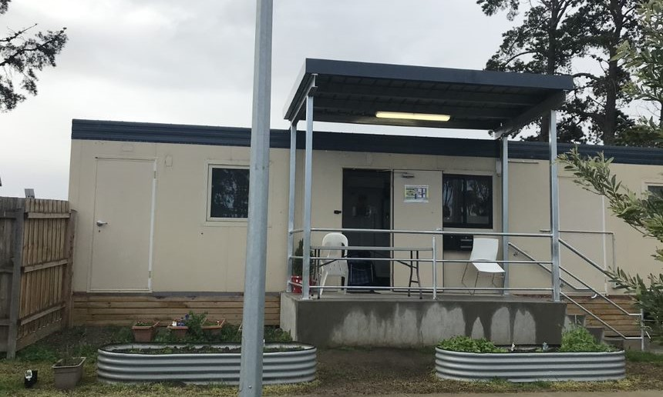
Activity block, BRP, MITA
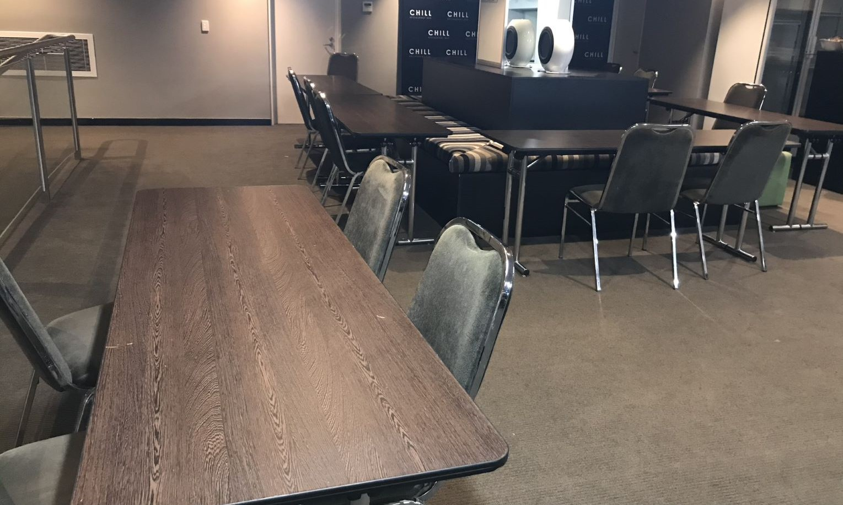
Dining area, Melbourne hotel APOD
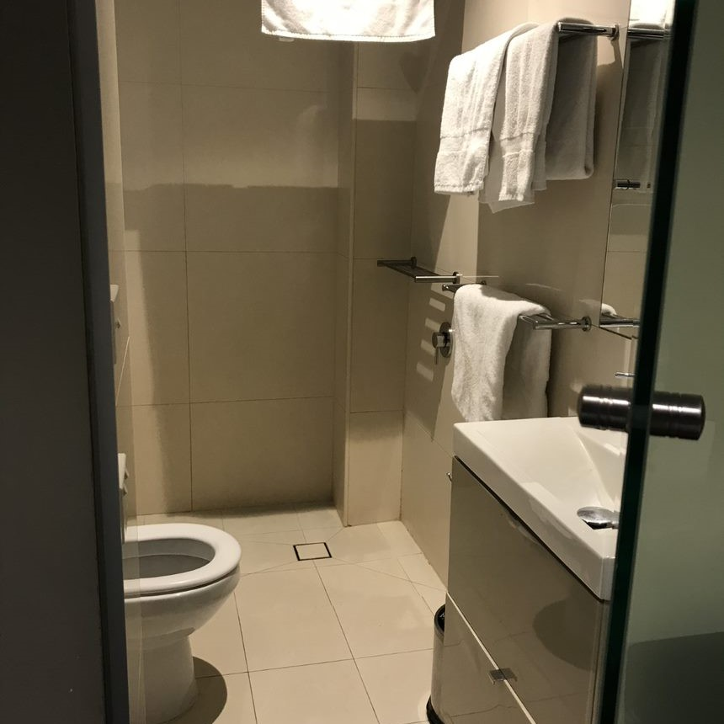
Bathroom, Melbourne hotel APOD
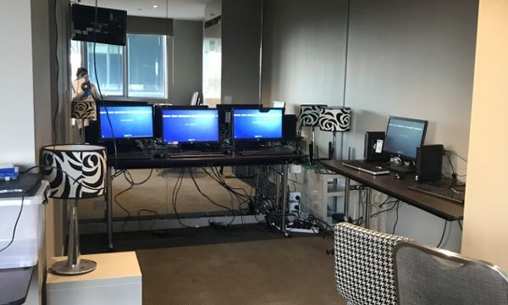
Computers in the multipurpose room, Melbourne hotel APOD
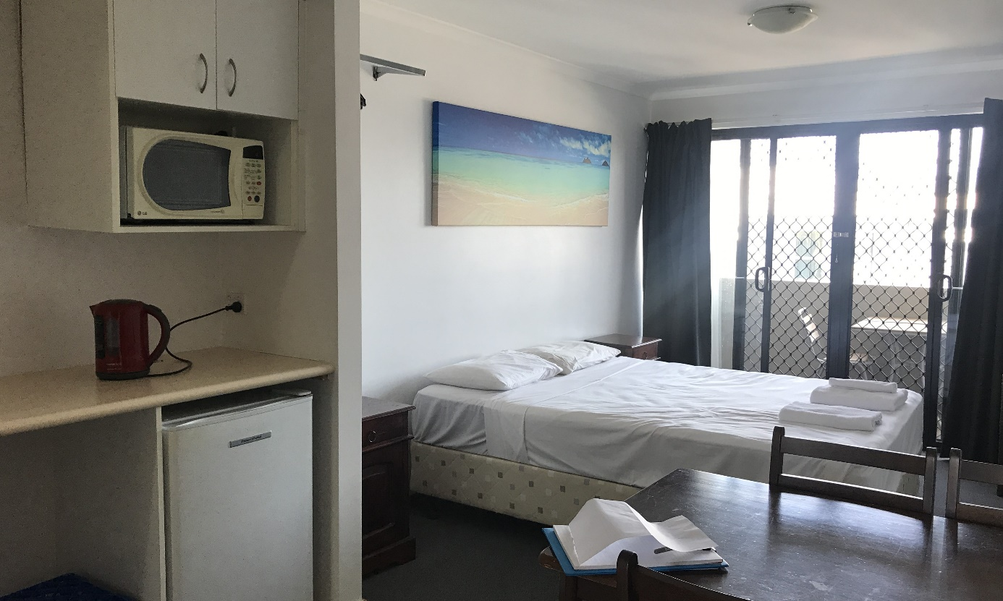
Single unit, Brisbane hotel APOD

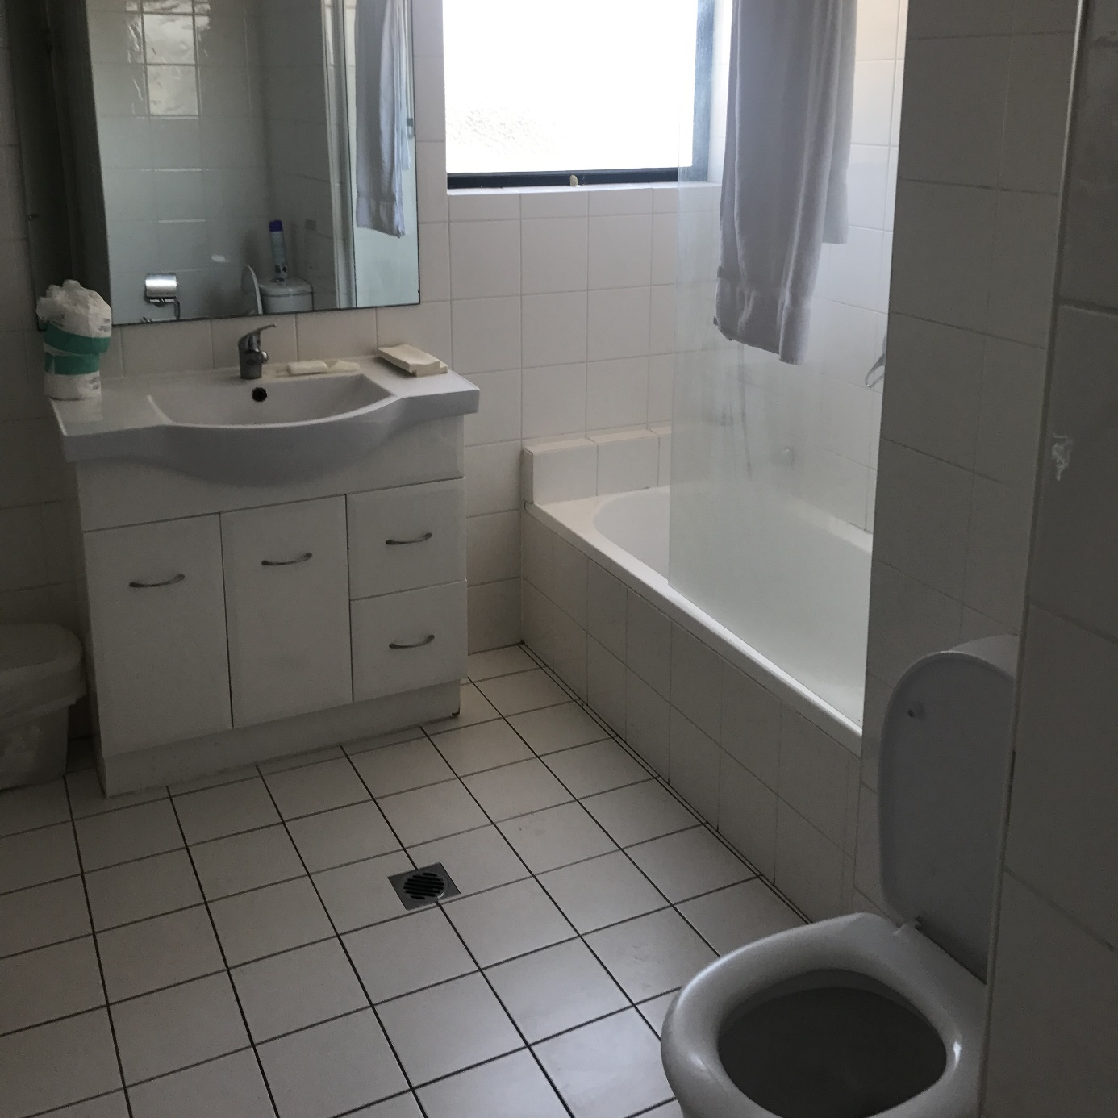
Bathroom, Brisbane hotel APOD
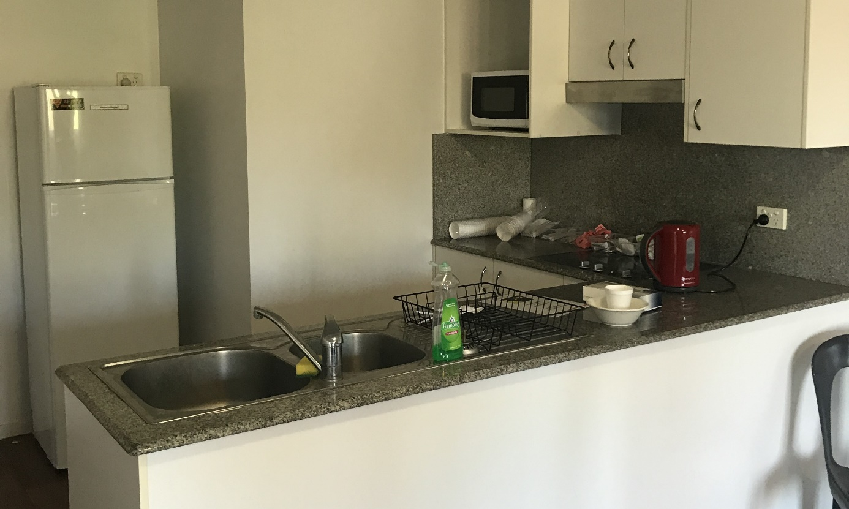
Kitchenette in two-person unit, Brisbane hotel APOD

Endnotes

Reports from previous inspections of immigration detention facilities can be found on the Commission’s website at <https://www.humanrights.gov.au/our-work/asylum-seekers-and-refugees/publications>.
Human Rights and Equal Opportunity Commission, Those Who’ve Come across the Seas: Detention of Unauthorised Arrivals (Report, 1998); Human Rights and Equal Opportunity Commission, A Last Resort? National Inquiry into Children in Immigration Detention (Report, 2004); Australian Human Rights Commission, The Forgotten Children: National Inquiry into Children in Immigration Detention (Report, 2014).
Australian Human Rights Commission, Asylum Seekers, Refugees and Human Rights: Snapshot Report (2nd Edition) (Report, 2017).
Migration Act 1958 (Cth) s 189.
Section 5 of the Migration Act defines ‘immigration detention’ to include ‘being held by, or on behalf of, an officer in another place approved by the Minister in writing’.
Migration Act 1958 (Cth) s 197AB.
In 2018 the Commission inspected four immigration detention facilities, including Villawood Immigration Detention Centre, Brisbane Immigration Transit Accommodation, Melbourne Immigration Transit Accommodation and Yongah Hill Immigration Detention Centre, as well as several ‘alternative places of detention’ in Brisbane and Melbourne. See Australian Human Rights Commission, Risk Management in Immigration Detention (Report, 2019).
Australian Human Rights Commission, Risk Management in Immigration Detention (Report, 2019) 10.
Australian Human Rights Commission, Risk Management in Immigration Detention (Report, 2019).
The Commission did not inspect the Christmas Island Immigration Detention Centre because during planning these facilities had only recently been re-opened and nobody was detained there. Half-way through the Commission’s inspections, a family of four including two children were transferred to Christmas Island, and at the time of writing they remain in detention there. The Commission released a statement in relation to this family that can be found on the Commission’s website at <https://www.humanrights.gov.au/about/news/commissioners-call-compassionate-approach-tamil-family>.
Subcommittee on Prevention of Torture and Other Cruel, Inhuman or Degrading Treatment or Punishment, Guidelines on National Preventive Mechanisms, 12th Sess, UN Doc CAT/OP/12/5 (9 December 2010); Subcommittee on Prevention of Torture and Other Cruel, Inhuman or Degrading Treatment or Punishment, The Approach of the Subcommittee on Prevention of Torture to the Concept of Prevention of Torture and Other Cruel, Inhuman or Degrading Treatment or Punishment under the Optional Protocol to the Convention against Torture and Other Cruel, Inhuman or Degrading Treatment or Punishment, 12th Sess, UN Doc CAT/OP/12/6 (30 December 2010); Association for the Prevention of Torture and Inter-American Institute for Human Rights, Optional Protocol to the UN Convention against Torture Implementation Manual (Manual, 2010); Association for the Prevention of Torture, International Detention Coalition and United Nations High Commissioner for Refugees, Monitoring Immigration Detention: Practical Manual (Manual, 2014).
Australia has not ratified the International Convention on the Protection of the Rights of All Migrant Workers and Members of Their Families, or the International Convention for the Protection of All Persons from Enforced Disappearance.
Australian Human Rights Commission, Human Rights Standards for Immigration Detention (Report, 2013).
See, eg, United Nations Office on Drugs and Crime et al, ‘UNODC, WHO, UNAIDS and OHCHR joint statement on COVID-19 in prisons and other closed settings’ (Joint Statement, 13 May 2020) <https://www.who.int/news-room/detail/13-05-2020-unodc-who-unaids-and-ohchr-joint-statement-on-covid-19-in-prisons-and-other-closed-settings>; Communicable Diseases Network Australia, CDNA National Guidelines for the Prevention, Control and Public Health Management of COVID-19 Outbreaks in Correctional and Detention Facilities in Australia (Guidelines, Version 3.0, 31 March 2020) <https://www.health.gov.au/resources/publications/cdna-guidelines-for-the-prevention-control-and-public-health-management-of-covid-19-outbreaks-in-correctional-and-detention-facilities-in-australia>; ‘What you need to know about coronavirus (COVID-19)’, Department of Health (Cth) (Web Page, 22 May 2020) < https://www.health.gov.au/news/health-alerts/novel-coronavirus-2019-ncov-health-alert/what-you-need-to-know-about-coronavirus-covid-19#who-is-most-at-risk>.
‘What you need to know about coronavirus (COVID-19)’, Department of Health (Cth) (Web Page, 22 May 2020) <https://www.health.gov.au/news/health-alerts/novel-coronavirus-2019-ncov-health-alert/what-you-need-to-know-about-coronavirus-covid-19#who-is-most-at-risk>.
‘What you need to know about coronavirus (COVID-19)’, Department of Health (Cth) (Web Page, 22 May 2020) < https://www.health.gov.au/news/health-alerts/novel-coronavirus-2019-ncov-health-alert/what-you-need-to-know-about-coronavirus-covid-19#who-is-most-at-risk>; Communicable Diseases Network Australia, CDNA National Guidelines for the Prevention, Control and Public Health Management of COVID-19 Outbreaks in Correctional and Detention Facilities in Australia (Guidelines, Version 3.0, 31 March 2020) <https://www.health.gov.au/resources/publications/cdna-guidelines-for-the-prevention-control-and-public-health-management-of-covid-19-outbreaks-in-correctional-and-detention-facilities-in-australia>.
Communicable Diseases Network Australia, CDNA National Guidelines for the Prevention, Control and Public Health Management of COVID-19 Outbreaks in Correctional and Detention Facilities in Australia (Guidelines, Version 3.0, 31 March 2020) <https://www.health.gov.au/resources/publications/cdna-guidelines-for-the-prevention-control-and-public-health-management-of-covid-19-outbreaks-in-correctional-and-detention-facilities-in-australia>.
Communicable Diseases Network Australia, CDNA National Guidelines for the Prevention, Control and Public Health Management of COVID-19 Outbreaks in Correctional and Detention Facilities in Australia (Guidelines, Version 3.0, 31 March 2020) 2 <https://www.health.gov.au/resources/publications/cdna-guidelines-for-the-prevention-control-and-public-health-management-of-covid-19-outbreaks-in-correctional-and-detention-facilities-in-australia>.
Australasian Society for Infectious Diseases and the Australian College of Infection Prevention and Control, ‘ASID ACIPC Joint Statement: COVID-19 and detainees – recommendation for action’ (Joint Statement, 19 March 2020) <https://www.asid.net.au/groups/covid-19/covid-19-media>.
This data was provided by the Department of Home Affairs.
Australian Human Rights Commission, Submission No 54 to Senate Standing Committee on Legal and Constitutional Affairs, Parliament of Australia, Migration Amendment (Repairing Medical Transfers) Bill 2019 [Provisions] (21 August 2019); Ms BK, Ms CO and Mr DE on behalf of themselves and their families v Commonwealth of Australia [2018] AusHRC 128; Australian Human Rights Commission, 'Media Statement - Children on Nauru' (Media Release, 23 October 2018); Elizabeth Elliott and Hasantha Gunasekera, The Health and Well-Being of Children in Immigration Detention: Report to the Australian Human Rights Commission – Monitoring Visit to Wickham Point Detention Centre, Darwin, NT (Report, 2016); Australian Human Rights Commission, The Forgotten Children: National Inquiry into Children in Immigration Detention (Report, 2014).
Australian Human Rights Commission, Submission No 54 to Senate Standing Committee on Legal and Constitutional Affairs, Parliament of Australia, Migration Amendment (Repairing Medical Transfers) Bill 2019 [Provisions] (21 August 2019).
Migration Act 1958 (Cth) s 5(1).
Migration Act 1958 (Cth) s 189.
Migration Act 1958 (Cth) s 46B.
‘Immigration Detention Statistics’, Department of Home Affairs (Webpage), <https://www.Homeaffairs.Gov.Au/Research-and-Statistics/Statistics/Visa-Statistics/Live/Immigration-Detention>.
‘Immigration Detention Statistics’, Department of Home Affairs (Webpage), <https://Www.Homeaffairs.Gov.Au/Research-and-Statistics/Statistics/Visa-Statistics/Live/Immigration-Detention>.
‘Immigration Detention Statistics’, Department of Home Affairs (Webpage), <https://Www.Homeaffairs.Gov.Au/Research-and-Statistics/Statistics/Visa-Statistics/Live/Immigration-Detention>.
‘Immigration Detention Statistics’, Department of Home Affairs (Webpage), <https://www.Homeaffairs.Gov.Au/Research-and-Statistics/Statistics/Visa-Statistics/Live/Immigration-Detention>.
Home Affairs Committee, Immigration detention (House of Commons Paper No 14, Session 2017-19) 68 <https://publications.parliament.uk/pa/cm201719/cmselect/cmhaff/913/913.pdf>.
Canada Border Services Agency, Quarterly Detention Statistics – 2018 to 2019 (Webpage, 20 August 2019) <https://www.cbsa-asfc.gc.ca/security-securite/detent/qstat-2018-2019-eng.html>.
‘Immigration Detention Statistics’, Department of Home Affairs (Webpage), <https://www.Homeaffairs.Gov.Au/Research-and-Statistics/Statistics/Visa-Statistics/Live/Immigration-Detention>.
‘Immigration Detention Statistics’, Department of Home Affairs (Webpage), <https://www.Homeaffairs.Gov.Au/Research-and-Statistics/Statistics/Visa-Statistics/Live/Immigration-Detention>.
‘Key Visa Cancellation Statistics’, Department of Home Affairs (Webpage), <https://www.Homeaffairs.Gov.Au/Research-and-Statistics/Statistics/Visa-Statistics/Visa-Cancellation>.
‘Immigration Detention Statistics’, Department of Home Affairs (Webpage), <https://www.Homeaffairs.Gov.Au/Research-and-Statistics/Statistics/Visa-Statistics/Live/Immigration-Detention>.
‘Immigration Detention Statistics’, Department of Home Affairs (Webpage), <https://www.Homeaffairs.Gov.Au/Research-and-Statistics/Statistics/Visa-Statistics/Live/Immigration-Detention>.
‘Immigration Detention Statistics’, Department of Home Affairs (Webpage), <https://www.Homeaffairs.Gov.Au/Research-and-Statistics/Statistics/Visa-Statistics/Live/Immigration-Detention>.
The Department of Home Affairs provided requested information for MITA, VIDC and BITA in advance of the Commission’s inspection dates, and as such the numbers provided for these facilities are not representative of exact numbers at the time of the Commission’s inspection.
As at 1 September 2019, noting the Commission’s inspection of MITA and the BRP was from 9 to 12 September. BRP is a permanent APOD which is adjacent to the main facility.
As at 1 September 2019, noting the Commission’s inspection of VIDC was from 23 to 26 September.
As at 18 October 2019, noting the Commission’s inspection of BITA was from 23 to 26 September.
Australian Human Rights Commission, Risk Management in Immigration Detention (Report, 2019) 35-36.
‘Immigration Detention Statistics’, Department of Home Affairs (Webpage), <https://www.Homeaffairs.Gov.Au/Research-and-Statistics/Statistics/Visa-Statistics/Live/Immigration-Detention>.
Commonwealth Ombudsman, Statement by the Commonwealth Ombudsman Michael Manthorpe on the management of COVID-19 risks in immigration detention facilities (Statement, July 2020) 5-6.
Australian Human Rights Commission, ’Commission concerned for detainees during COVID-19’ (Media Release, 16 July 2020).
The Commission considered how facility staff assess risk and assign risk ratings to people in immigration detention during inspections in 2018. See Australian Human Rights Commission, Risk Management in Immigration Detention (Report, 2019).
‘Immigration Detention Statistics’, Department of Home Affairs (Webpage), <https://www.Homeaffairs.Gov.Au/Research-and-Statistics/Statistics/Visa-Statistics/Live/Immigration-Detention>.
Rachel Mealy and Robert French, ‘Tamil asylum seeker family from Biloela taken to Christmas Island detention centre, lawyer says’, ABC (online, 31 August 2019) <https://www.abc.net.au/news/2019-08-31/tamil-asylum-seeker-family-taken-to-christmas-island-lawyer-says/11467312>.
See, eg, Australian Human Rights Commission, The Forgotten Children: National Inquiry into Children in Immigration Detention (Inquiry, 2014); Australian Human Rights Commission, Children’s Rights Report 2019 — In Their Own Right: Children’s Rights in Australia (Report, 2019).
Rebekah Holt, ‘Two-year-old girl and mother released after years in Australian immigration detention’ SBS News (online, 26 August 2020) <https://www.sbs.com.au/news/two-year-old-girl-and-mother-released-after-years-in-australian-immigration-detention>.
Raisingchildren.net.au: the Australian parenting website, Child development: the first five years (Webpage, 13 August 2020) <https://raisingchildren.net.au/newborns/development/understanding-development/development-first-five-years>; Fox et al, ‘How the timing and quality of early experiences influence the development of brain architecture’ (2010) 81(1) Child Development 28.
See, eg, Louise K Newman and Zachary Steel, ‘The child asylum seeker: psychological and developmental impact of immigration detention’ (July 2008) 17(3) Child & Adolescent Psychiatric Clinics of North America 665.
UN Working Group on Arbitrary Detention, Opinion No 2/2019 concerning Huyen Thu Thi Tran and Isabella Lee Pin Loong (Australia), Opinions adopted by the Working Group on Arbitrary Detention, 84th sess, 23 April – 3 May 2019, UN Doc A/HRC/WGAD/2019/2 (Advanced Edited Version, 6 June 2019).
UN Working Group on Arbitrary Detention, Opinion No 2/2019 concerning Huyen Thu Thi Tran and Isabella Lee Pin Loong (Australia), Opinions adopted by the Working Group on Arbitrary Detention, 84th sess, 23 April – 3 May 2019, UN Doc A/HRC/WGAD/2019/2 (Advanced Edited Version, 6 June 2019) para 105.
Convention on the Rights of the Child, opened for signature 20 November 1989, 1577 UNTS 3 (entered into force 2 September 1990) art 37.
United Nations Committee on the Protection of the Rights of All Migrant Workers and Members of Their Families and Committee on the Rights of the Child, Joint general comment No 4 (2017) of the Committee on the Protection of the Rights of All Migrant Workers and Members of Their Families and No 23 (2017) of the Committee on the Rights of the Child on State obligations regarding the human rights of children in the context of international migration in countries of origin, transit, destination and return, UN Doc CMW/C/GC/4-CRC/C/GC/23 (16 November 2017) para 10.
United Nations Committee on the Protection of the Rights of All Migrant Workers and Members of Their Families and Committee on the Rights of the Child, Joint general comment No 4 (2017) of the Committee on the Protection of the Rights of All Migrant Workers and Members of Their Families and No 23 (2017) of the Committee on the Rights of the Child on State obligations regarding the human rights of children in the context of international migration in countries of origin, transit, destination and return, UN Doc CMW/C/GC/4-CRC/C/GC/23 (16 November 2017) para 5.
Australian Human Rights Commission, Children’s Rights Report 2019—In Their Own Right: Children’s Rights in Australia (Report, 2019).
Australian Human Rights Commission, Human Rights Standards for Immigration Detention (Report, 2013) 54.
Australian Human Rights Commission, Human Rights Standards for Immigration Detention (Report, 2013) 54.
International Covenant on Civil and Political Rights, opened for signature 16 December 1966, 999 UNTS 171 (entered into force 23 March 1976) art 17(1); Convention on the Rights of the Child, opened for signature 20 November 1989, 1577 UNTS 3 (entered into force 2 September 1990) art 16(1).
Convention on the Rights of the Child, opened for signature 20 November 1989, 1577 UNTS 3 (entered into force 2 September 1990) art 2(1), art 28(1).
Human Rights and Equal Opportunity Commission, A last resort? National Inquiry into Children in Immigration detention (Report, 2004) Chapter 12.
Human Rights and Equal Opportunity Commission, A last resort? National Inquiry into Children in Immigration detention (Report, 2004) 636 – 638.
Human Rights and Equal Opportunity Commission, A last resort? National Inquiry into Children in Immigration detention (Report, 2004) 636 – 638.
Australian Human Rights Commission, The Forgotten Children: National Inquiry into Children in Immigration Detention (Report, 2014) 150.
Australian Human Rights Commission, The Forgotten Children: National Inquiry into Children in Immigration Detention (Report, 2014) 151.
Convention on the Rights of the Child, opened for signature 20 November 1989, 1577 UNTS 3 (entered into force 2 September 1990) art 19.
Convention on the Rights of the Child, opened for signature 20 November 1989, 1577 UNTS 3 (entered into force 2 September 1990) art 37(c).
Department of Immigration and Border Protection, Child Safeguarding Framework (2016) <www.border.gov.au/ReportsandPublications/Documents/child-safeguarding-framework.pdf>.
Rachel Mealy and Robert French, ‘Tamil asylum seeker family from Biloela taken to Christmas Island detention centre, lawyer says’, ABC (online, 31 August 2019) <https://www.abc.net.au/news/2019-08-31/tamil-asylum-seeker-family-taken-to-christmas-island-lawyer-says/11467312>.
Australian Human Rights Commission, ’Commissioners call for compassionate approach for Tamil family’ (Statement, 2 September 2019).
Australian Human Rights Commission, Risk Management in Immigration Detention (Report, 2019) 56.
Department of Home Affairs, Response to the Australian Human Rights Commission Risk Management in Immigration Detention Report (Response to Recommendations, 2019).
‘The role of the psychiatrist in Australia and New Zealand’, The Royal Australian and New Zealand College of Psychiatrists (Webpage), <https://www.ranzcp.org/news-policy/policy-and-advocacy/position-statements/the-role-of-the-psychiatrist-in-australia-and-new>.
Department of Immigration and Border Protection, Detention Health—Fitness to Travel Assessments—Procedural Instruction (17 November 2018) 4.2.2.
Australian Human Rights Commission, Human Rights Standards for Immigration Detention (Report, 2013) 19.
Department of Home Affairs, Response to the Australian Human Rights Commission Risk Management in Immigration Detention Report (Response to Recommendations, 2019).
Department of Home Affairs, Response to the Australian Human Rights Commission Risk Management in Immigration Detention Report (Response to Recommendations, 2019).
Australian Human Rights Commission, Risk Management in Immigration Detention (Report, 2019) 56.
Use of force in immigration detention [2019] AusHRC 130, [65] – [69].
Australian Human Rights Commission, Risk Management in Immigration Detention (Report, 2019) 21. See also Use of force in immigration detention [2019] AusHRC 130, [75] – [109].
Australian Human Rights Commission, Risk Management in Immigration Detention (Report, 2019) 21 – 22. See also Use of force in immigration detention [2019] AusHRC 130, [75] – [109].
Use of force in immigration detention [2019] AusHRC 130, [186] – [187].
Use of force in immigration detention [2019] AusHRC 130, [186] – [187].
Australian Human Rights Commission, Risk Management in Immigration Detention (Report, 2019) 29 – 30; Australian Human Rights Commission, Inspection of Adelaide Immigration Transit Accommodation (Report, 2017) 11 – 12; Australian Human Rights Commission, Inspection of Brisbane Immigration Transit Accommodation (Report, 2017) 11 – 12; Australian Human Rights Commission, Inspection of Christmas Island Immigration Detention Centre (Report, 2017) 14 – 15; Australian Human Rights Commission, Inspection of Maribyrnong Immigration Detention Centre (Report, 2017) 15; Australian Human Rights Commission, Inspection of Melbourne Immigration Transit Accommodation (Report, 2017) 13 – 14; Australian Human Rights Commission, Inspection of Perth Immigration Detention Centre (Report, 2017) 12 – 13; Australian Human Rights Commission, Inspection of Villawood Immigration Detention Centre (Report, 2017) 15 – 16; Australian Human Rights Commission, Inspection of Yongah Hill Immigration Detention Centre (Report, 2017) 13 – 14.
Use of force in immigration detention [2019] AusHRC 130.
Australian Human Rights Commission, Risk Management in Immigration Detention (Report, 2019) 65.
Australian Human Rights Commission, Risk Management in Immigration Detention (Report, 2019) 65.
Department of Home Affairs, Response to the Australian Human Rights Commission Risk Management in Immigration Detention Report (Response to Recommendations, 2019).
Australian Human Rights Commission, Human Rights Standards for Immigration Detention (Report, 2013) 42.
Australian Human Rights Commission, Risk Management in Immigration Detention (Report, 2019) 31.
Department of Home Affairs, Response to the Australian Human Rights Commission Risk Management in Immigration Detention Report (Response to Recommendations, 2019).
Australian Human Rights Commission, Human Rights Standards for Immigration Detention (Report, 2013) 51.
Australian Human Rights Commission, Risk Management in Immigration Detention (Report, 2019) 49.
Unlike other high-security compounds, the Moreton compound at BITA is not a purpose-built high-security compound.
Australian Human Rights Commission, Risk Management in Immigration Detention (Report, 2019) 39.
Human Rights and Equal Opportunity Commission, Summary of Observations Following the Inspection of Mainland Immigration Detention Facilities (Report, January 2007) 25, 33; Human Rights and Equal Opportunity Commission, Summary of Observations Following the Inspection of Mainland Immigration Detention Facilities (Report, December 2007) 43 – 44; Australian Human Rights Commission, Immigration Detention Report: Summary of Observations Following Visits to Australia’s Immigration Detention Facilities (Report, December 2008) 47; Australian Human Rights Commission, Immigration Detention at Villawood: Summary of Observations from Visit to Immigration Detention Facilities at Villawood (Report, 2011) 16 – 17, 30; Australian Human Rights Commission, Inspection of Villawood Immigration Detention Centre (Report, 2017) 17 – 19. Note that the Blaxland compound was previously known as Stage One. Australian Human Rights Commission, Risk Management in Immigration Detention (Report, 2019) 39.
Australian Human Rights Commission, Risk Management in Immigration Detention (Report, 2019) Section 3.4(a); Australian Human Rights Commission, Inspection of Maribyrnong Immigration Detention Centre (Report, 2017) 17; Australian Human Rights Commission, Inspection of Melbourne Immigration Transit Accommodation (Report, 2017) 15 – 16; Australian Human Rights Commission, Inspection of Christmas Island Immigration Detention Centre (Report, 2017) 17 – 19.
Note that there were also three annexes in Dorm 3 at Blaxland that could be used for single separation, however as outlined in Section 3.10(d), the Blaxland compound has since closed.
Department of Home Affairs, Response to the Australian Human Rights Commission Risk Management in Immigration Detention Report (Response to Recommendations, 2019).
However, given their small and limited facilities for activities and exercise, the Commission considers that these compounds would not be appropriate for longer-term separate detention.
Australian Border Force, ‘New Measures to Combat Illegal Activity within Immigration Detention Facilities’ (Media Release, 21 November 2016).
ARJ17 v Minister for Immigration and Border Protection (2018) 250 FCR 446, [103–104].
Australian Human Rights Commission, Submission No 26 to Senate Standing Committee on Legal and Constitutional Affairs, Parliament of Australia, Migration Amendment (Prohibiting Items in Immigration Detention Facilities) Bill 2020 [Provisions] (11 June 2020) [27].
Australian Human Rights Commission, Submission No 26 to Senate Standing Committee on Legal and Constitutional Affairs, Parliament of Australia, Migration Amendment (Prohibiting Items in Immigration Detention Facilities) Bill 2020 [Provisions] (11 June 2020) [27].
The Blaxland compound at VIDC contained its own visits area, but as outlined in Section 3.10(d), the Blaxland compound has since closed.
Australian Human Rights Commission, Human Rights Standards for Immigration Detention (Report, 2013) 32.
Australian Human Rights Commission, Risk Management in Immigration Detention (Report, 2019) 58.
Department of Immigration and Border Protection, Detention Services Manual—Chapter 8—Visitor Management (Manual, 18 March 2018).
Department of Immigration and Border Protection, Detention Services Manual—Chapter 8—Safety and Security in Detention—Items Not Permitted in Immigration Detention (Manual, 1 July 2016).
Department of Immigration and Border Protection, Detention Services Manual—Chapter 8—Visitor Management (Manual, 18 March 2018).
Department of Immigration and Border Protection, Changes to Visitor Conditions and Application Forms (Document Released under the Freedom of Information Act 1982, 10 April 2018); ‘Immigration Detention in Australia—Visit Detention’, Australian Border Force (Webpage), <https://www.abf.gov.au/about-Us/What-We-Do/Border-Protection/Immigration-Detention/Visit-Detention>.
At the time of inspections, this program was only available at VIDC.
See, eg, Zachary Steel et al, ‘Psychiatric Status of Asylum Seeker Families Held for a Protracted Period in a Remote Detention Centre in Australia’ (2004) 28(2) Australian and New Zealand Journal of Public Health 23; M von Werthern et al, ‘The Impact of Immigration Detention on Mental Health: A Systematic Review’ (2018) 18(1) BMC Psychiatry 382.
Australian Human Rights Commission, Risk Management in Immigration Detention (Report, 2019) 68.
Australian Human Rights Commission, Risk Management in Immigration Detention (Report, 2019) 68.
‘Immigration Detention Statistics’, Department of Home Affairs (Webpage), <https://www.Homeaffairs.Gov.Au/Research-and-Statistics/Statistics/Visa-Statistics/Live/Immigration-Detention>.
Convention Relating to the Status of Refugees, opened for signature 28 July 1951, 189 UNTS 137 (entered into force 22 April 1954) art 33(1); Convention against Torture and Other Cruel, Inhuman or Degrading Treatment of Punishment, opened for signature 10 December 1984, 1465 UNTS 85 (entered into force 26 June 1987) art 3(1).
Immigration detainees with adverse security assessments v Commonwealth of Australia (Department of Immigration and Citizenship) [2013] AusHRC 64, [113] - [114]; Sri Lankan refugees v Commonwealth of Australia (Department of Immigration & Citizenship) [2012] AusHRC 56, 43.
Australian Human Rights Commission, Lives on Hold: Refugees and Asylum Seekers in the ‘Legacy Caseload’ (Report, 2019) 32-39.
See reports from previous inspections of immigration detention facilities on the Commission’s website at <https://www.humanrights.gov.au/our-work/asylum-seekers-and-refugees/immigration-detention-reports-and-photos>.
Australian Human Rights Commission, Risk Management in Immigration Detention (Report, 2019) 67; Australian Human Rights Commission, Inspection of Brisbane Immigration Transit Accommodation (Report, 2017) 23; Australian Human Rights Commission, Inspection of Christmas Island Immigration Detention Centre (Report, 2017) 33; Australian Human Rights Commission, Inspection of Maribyrnong Immigration Detention Centre (Report, 2017) 28; Australian Human Rights Commission, Inspection of Perth Immigration Detention Centre (Report, 2017) 20; Australian Human Rights Commission, Inspection of Villawood Immigration Detention Centre (Report, 2017) 27.
International Covenant on Civil and Political Rights, opened for signature 16 December 1966, 999 UNTS 171 (entered into force 23 March 1976) art 9.
UN Human Rights Committee, General Comment No.35, UN Doc CCPR/C/GC/35 (16 December 2014) [12].
A v Australia [1997] Human Rights Committee, Communication No. 560/1993, UN Doc CCPR/C/59/D/560/1993 5.8; Van Alphen v Netherlands [1990] Human Rights Committee, Communication No. 305/1988, UN Doc CCPR/C/39/D/305/1988 9.4.
International Covenant on Civil and Political Rights, opened for signature 16 December 1966, 999 UNTS 171 (entered into force 23 March 1976) art 9.
International Covenant on Civil and Political Rights, opened for signature 16 December 1966, 999 UNTS 171 (entered into force 23 March 1976) art 9(1), art 10(1).
International Covenant on Civil and Political Rights, opened for signature 16 December 1966, 999 UNTS 171 (entered into force 23 March 1976) art 7; Convention against Torture and Other Cruel, Inhuman or Degrading Treatment or Punishment, opened for signature 10 December 1984, 1465 UNTS 85 (entered into force 26 June 1987) art 2(1), art 16(1).
International Covenant on Economic, Social and Cultural Rights, opened for signature 16 December 1966, 993 UNTS 3 (entered into force 3 January 1976) art 6(2), art 11, art 12, art 13, art 15(1a).
International Covenant on Civil and Political Rights, opened for signature 16 December 1966, 999 UNTS 171 (entered into force 23 March 1976) art 7, art 10(1); Convention against Torture and Other Cruel, Inhuman or Degrading Treatment or Punishment, opened for signature 10 December 1984, 1465 UNTS 85 (entered into force 26 June 1987) art 2(1), art 16(1).
International Covenant on Civil and Political Rights, opened for signature 16 December 1966, 999 UNTS 171 (entered into force 23 March 1976) art 17, art 18.
International Covenant on Civil and Political Rights, opened for signature 16 December 1966, 999 UNTS 171 (entered into force 23 March 1976) art 19(b), art 22, art 27.
International Covenant on Economic, Social and Cultural Rights, opened for signature 16 December 1966, 993 UNTS 3 (entered into force 3 January 1976) art 15(1)(a).
International Covenant on Civil and Political Rights, opened for signature 16 December 1966, 999 UNTS 171 (entered into force 23 March 1976) art 23(1); International Covenant on Economic, Social and Cultural Rights, opened for signature 16 December 1966, 993 UNTS 3 (entered into force 3 January 1976) art 10(1).
International Covenant on Civil and Political Rights, opened for signature 16 December 1966, 999 UNTS 171 (entered into force 23 March 1976) art 17(1); Convention on the Rights of the Child, opened for signature 20 November 1989, 1577 UNTS 3 (entered into force 2 September 1990) art 16(1).
Convention against Torture and Other Cruel, Inhuman or Degrading Treatment or Punishment, opened for signature 10 December 1984, 1465 UNTS 85 (entered into force 26 June 1987) art 13, art 16(1).
Convention on the Rights of the Child, opened for signature 20 November 1989, 1577 UNTS 3 (entered into force 2 September 1990) art 3(1).
Convention on the Rights of the Child, opened for signature 20 November 1989, 1577 UNTS 3 (entered into force 2 September 1990) art 37(a), (b), (c).
Committee on the Protection of the Rights of All Migrant Workers and Members of Their Families and Committee on the Rights of the Child, Joint General Comment on State Obligations Regarding the Human Rights of Children in the Context of International Migration in Countries of Origin, Transit, Destination and Return, UN Doc CMW/C/GC/4-CRC/C/GC/23 (16 November 2017) [5].
Committee on the Protection of the Rights of All Migrant Workers and Members of Their Families and Committee on the Rights of the Child, Joint General Comment on State Obligations Regarding the Human Rights of Children in the Context of International Migration in Countries of Origin, Transit, Destination and Return, UN Doc CMW/C/GC/4-CRC/C/GC/23 (16 November 2017) [10].
Manfred Nowak, Independent Expert, Global study on children deprived of liberty, 74th sess, UN Doc A/74/136, (11 July 2019) para 121.
United Nations Committee on the Rights of the Child, Concluding Observations on the Combined Fifth and Sixth Periodic Reports of Australia, 82nd sess, UN Doc CRC/C/AUS/CO/5-6 (30 September 2019) para 45(b).
Migration Act 1958 (Cth) s 197AB(1).
Migration Act 1958 (Cth) s 197AB(2)(b).
Department of Immigration and Border Protection, Procedures Advice Manual 3: Compliance and Case Resolution—Case Resolution—Minister’s Powers—Minister’s Residence Determination Power (Manual, 21 October 2017).
Department of Immigration and Border Protection, Procedures Advice Manual 3: Compliance and Case Resolution—Case Resolution—Minister’s Powers—Minister’s Residence Determination Power (Manual, 21 October 2017).
Department of Immigration and Border Protection, Procedures Advice Manual 3: Compliance and Case Resolution—Case Resolution—Minister’s Powers—Minister’s Residence Determination Power (Manual, 21 October 2017).

