Our Agenda
Commission Work Plan
Updated for 2012-2013
Australian Human Rights Commission 2012



Contents

What are human rights? 4
Who we are 5
Our Agenda 6
Our priorities 7
Priority 1: Tackling violence, harassment and bullying 7
Priority 2: Building understanding and respect for rights in our community 9
Working together for change 11
Organisational excellence 16
Our leadership team 17
Organisational structure 18

© Australian Human Rights Commission 2012.
This work is protected by copyright. Apart from any use permitted under the Copyright Act 1968 (Cth), no part may be used or reproduced by any process without prior written permission from the Australian Human Rights Commission. Enquiries should be addressed to Communications Team at: communications@humanrights.gov.au
ISBN 1839-7271
This publication can be found in electronic format on the Australian Human Rights Commission’s website at: www.humanrights.gov.au/about/publications/index.html
For further information about the Australian Human Rights Commission, please visit: www.humanrights.gov.au or email: communications@humanrights.gov.au
You can also write to:
Communications Team
Australian Human Rights Commission
GPO Box 5218 Sydney NSW 2001
Design and layout Jo Clark
Printing Masterprint Pty Limited

What are human rights?
Human rights are our entitlements to have our dignity and worth as human beings recognised. We all have them, we all want them recognised in our friends and families, and we all have responsibilities to recognise them in others.
Set out in a number of international treaties, human rights are an expression of how people ought, and ought not, to be treated – by individuals, by government, and by the community at large. The Australian Government has agreed to uphold and protect many of these rights. Consequently, our national human rights laws provide legal protection to people who have been treated unfairly. They also set concrete standards for all of us to follow.

Who we are
The role of the Australian Human Rights Commission is to see that these commitments are understood and recognised in practice. Independent from government, established by legislation, and recognised internationally as an ‘A Status’ National Human Rights Institution, the Commission – through its President, Commissioners and a network of staff – strives to resolve complaints, encourage reform and build recognition of our shared humanity.
Operating under the Australian Human Rights Commission Act 1986 (Cth) as well as federal laws that protect people from discrimination such as on the basis of their age, disability, race or sex, the Commission also has specific responsibilities under the Native Title Act 1993 (Cth) and the Fair Work Act 2009 (Cth). Within this broad framework, our job is to work towards an Australia in which the human rights of all are respected, protected and promoted – finding practical solutions to issues of concern; advocating for systemic change; and increasing understanding across the community.
Much of this work is at the public advocacy and policy level – engaging with the public and the media; and encouraging government, industry and community groups alike to aspire to more. It involves building the case for change on issues ranging from paid parental leave to age discrimination in employment. It means presenting to parliamentary inquiries, making submissions, supporting our arguments with research, and contributing to partnerships. Our work also involves exchanging ideas with equivalent bodies around the world; while, closer to home, we monitor and report on the experiences of those particularly vulnerable to disadvantage.
From addressing individual cases of discrimination, to engaging with government around policy, the Commission’s task is both to apply those rights that are currently recognised in our laws; and to aspire for greater recognition and protection of those that are not. Our vision is for an Australia where human rights are enjoyed by everyone, everywhere, everyday.

Our Agenda
This document provides an overview of the Commission’s major activities for
2012-13.
The Commission regularly reviews the ways in which human rights are being observed and respected across Australia. We do this to determine where we can take practical action and make a positive difference.
Our work is organised according to the following two priorities and five functional areas.
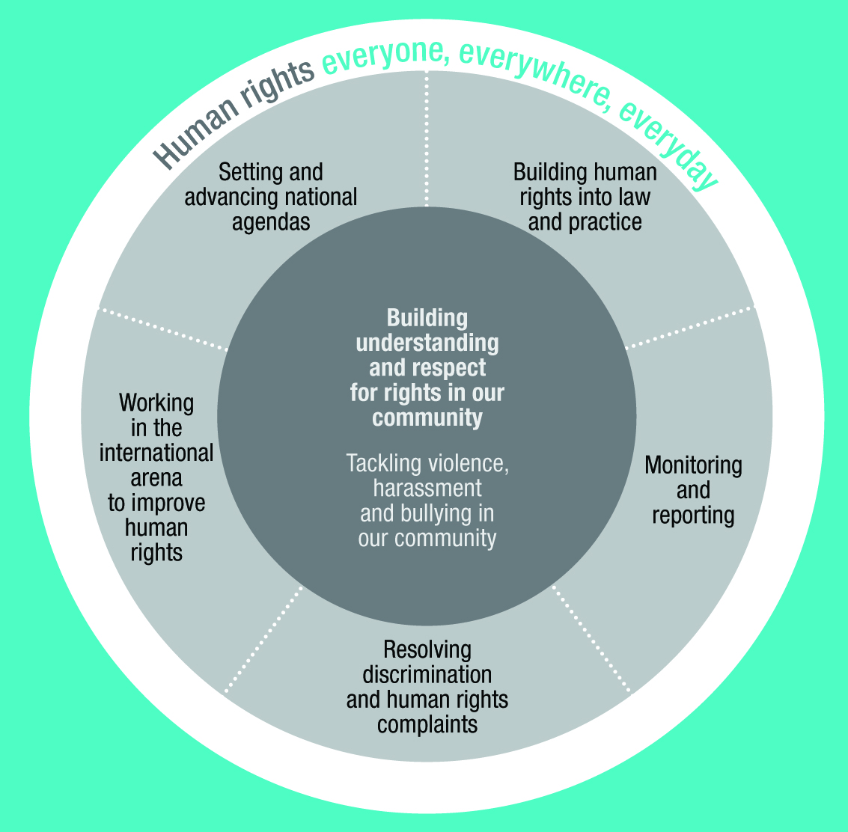

Our priorities
From 2010 through to 2014, we are prioritising work that:
tackles violence, harassment and bullying
builds understanding and respect for rights in our community.

Priority 1: Tackling violence, harassment and bullying
At home, at work, at school, online or on the street – violence, harassment and bullying can violate a person’s right to feel safe and respected. Experienced by many Australians, these damaging behaviours can also affect people’s physical and psychological health – undermining their ability to participate in employment, education, or community life.
That’s why it’s vital that we replace fear and isolation with safety and inclusion. Given that discrimination can often play a major role in acts of violence, harassment and bullying, the Commission knows how essential it is to address the underlying causes of these attitudes and behaviours.

What we’re doing
All Australians can play a part in this, with evidence emerging about the valuable role of the bystander in addressing any bullying and harassment that they witness. That is why this year, we will:
build on our exciting BackMeUp campaign which, in partnership with a range of lead agencies and social media organisations, offers young people the tools to take safe and effective action when they witness cyberbullying
To promote this campaign a competition through Facebook is encouraging teenagers to make a video about how they could help someone who is being cyberbullied. Ten winners, announced in September, will spend a week at NIDA in Sydney, learning how to make a short film.
work with governments towards the effective implementation of the National Plan to Reduce Violence Against Women and Children, as well as towards improved legal protections against violence
release the Commission’s periodic Sexual Harassment Prevalence Survey to help build understanding of sexual harassment in the community.
The Sexual Harassment Prevalence Survey results will be released in two stages. The findings relating to the Australian Defence Force will be released in August, with the main findings released later in the year.
Meanwhile, racism and prejudice continue to be experienced by people from across all sectors of the community. That is why this year, we will:
release an Agenda for Racial Equality to build greater understanding of the way that promoting equality, by both addressing racism and valuing our differences, can make us a stronger community
launch a National Anti-Racism Strategy to counter racism where it exists in our community
increase focus on the particular discrimination and intimidation that can be experienced by international students.

The Commission was asked by the federal government to lead the development of the National Anti-Racism Strategy.
Working in partnership with groups across the country, consultation on the Strategy enabled the voices and experiences of people from across the breadth of the community to be heard, often for the first time.
One participant explained that a measure of the Strategy’s success would be:
‘A dark skinned woman wearing a veil will not cause a second thought; a dark skinned male wearing a hoodie will not be suspected; our kids will experience diversity ... and not even notice.’

‘Human rights was an abstract concept but now I have a solid understanding of it and know it underpins every aspect of a human being’s life. I also realised that all polices should be rights based rather than welfare based.’
Human Rights and Advocacy for Muslim Women training course participant

Priority 2: Building understanding and respect for rights
in our community
The examples listed above demonstrate just some of the ways in which the Commission is working to build a respectful community. We all share in this obligation, but to see this realised we need to build wider understanding of how the concept of human rights applies to everyday life.
That is why the Commission is delivering community engagement and education programs which help to translate human rights values into practical reality, using social media and other tools to reach the breadth of the population. We are highlighting that equality, respect and fair play have application in all life stages –
in the playground, in the classroom, in the workplace and in the wider community.
The Commission is also working with the Australian Government to help implement its 2010 Australian Human Rights Framework, which guides the Government’s commitment to human rights.
For example, the online platform Tell me something I don’t know shares compelling and sometimes confronting facts in a concise and accessible way that debunks many assumptions in the community – including the following: ‘Jaywalking is illegal. Getting on a boat and asking Australia for protection is legal.’
Meanwhile, the platform Something in common shares the story of human rights in Australia and celebrates ordinary people doing extraordinary things. This site has attracted over 22,000 visitors since it was launched.

Twenty stories (10 short films, 10 community videos) will be made and launched by the Governor-General on 1 March 2013. The stories will portray people who have used the Disability Discrimination Act 1992 (Cth) to improve the lives of people with disabilities around Australia.

What we’re doing
This year, we will:
coordinate and launch a program of short videos by selected ‘vloggers’ that contribute their story to our popular web-based platform, Something in common
continue to coordinate the Australian Public Service Human Rights Officer’s Network, including hosting a series of forums for members to build greater understanding and commitment to human rights within government, as part of the Australian Human Rights Framework
launch the ‘Twenty Years; Twenty Stories’ series of short videos to mark the 20th anniversary of the Disability Discrimination Act 1992 (Cth) – increasing understanding of how it has improved the experience of Australians with a disability, and where change still needs to occur.

Working together for change
There is no simple way to solve complex human rights issues. From the challenges that face a person with a disability seeking independent living, through to immigration detention policy, the promotion of human rights must address both individual need and systemic change. That is why the Commission uses a range of approaches, recognising that enduring challenges require sustained energy and commitment.
To be as effective as possible, our work is structured around the following functional areas.

Setting and advancing national agendas
One of the Commission’s tasks is to draw national attention to areas in which human rights are not being properly recognised or respected.
As a result, we undertake research, provide advice, review laws, engage in public inquiry processes and work with groups from across the community to pursue reform. We develop partnerships and take a constructive approach to help us contribute to practical change.
On 25 June 2012, the Australian Parliament passed legislation to establish Australia’s first National Children’s Commissioner. The new Commissioner will be an advocate for the human rights of children, promoting public awareness, consulting directly with children and representative organisations, conducting research and education programs, as well as monitoring relevant Commonwealth legislation, policies and programs. The Commissioner is expected to take office by the end of 2012 / early 2013.

‘Constitutional reform is a complex issue and therefore it is important to educate people about it. That is what the Social Justice Report is doing.’
Stakeholder interviews (evaluation study of the Social Justice Reports)

What we’re doing
This year, we will:
support the participation of the disability sector in the implementation of the National Disability Strategy and of the proposed National Disability Insurance Scheme
continue to advocate for reform of the Australian Constitution to recognise Aboriginal and Torres Strait Islander peoples
deliver a series of consultation and dialogue events between government, NGOs and the Aboriginal and Torres Strait Islander community to support implementation of the UN Declaration on the Rights of Indigenous Peoples and lay the ground work for a national summit in 2013
continue to advocate for ways to combat discrimination against people on the basis of sexual orientation and gender identity.

Monitoring and reporting
Some people in Australia are especially vulnerable to discrimination, exclusion and unfair treatment. The Commission has a particular responsibility to monitor their experiences, identify issues of concern and propose solutions that will lead to improvement.
Sometimes we do this by holding national inquiries that examine these concerns in detail. We also undertake regular monitoring and reporting work, such as the Social Justice Commissioner’s annual Social Justice Report and Native Title Report on issues affecting Aboriginal and Torres Strait Islander communities.
We also have a long-standing role of monitoring Australia’s immigration detention system and treatment of asylum seekers, through visits to detention facilities, public awareness raising and engagement with the government, NGOs and community groups. We advocate for reforms to the system of mandatory and indefinite detention, and for greater use of community-based alternatives to holding people in closed detention facilities for prolonged periods.

What we’re doing
In the coming year, we will:
release human rights based inspection standards for immigration detention facilities in conjunction with the Commonwealth Ombudsman and Attorney-General’s Department
work with the government to advance ratification of the Optional Protocol to the Convention against Torture and the establishment of a national system of regular inspections of all places of detention (as required under the Protocol)
prepare the annual Social Justice Report and Native Title Report on human rights issues facing Aboriginal and Torres Strait Islander peoples, with a particular focus in 2012-2013 on Indigenous governance.

Building human rights into Australian laws and practices
We believe that human rights protection needs to be a central part of laws, policies and practices in order to build a fairer and more inclusive Australia.

What we’re doing
This year, we will:
launch research into the prevalence and nature of unpaid caring work in Australia, the barriers it creates for women’s equal participation in the workplace and the impact this has on women’s economic security
address age discrimination in employment by building on the Commission’s work in the 2012 report Working past our 60s: Reforming laws and policies for the older worker, which outlines policies and laws that prevent older people from working
support the implementation of the Australian Government’s National Action Plan on Human Rights and promote measurable indicators of human rights progress
contribute to the new Joint Parliamentary Committee on Human Rights and Statement of Compatibility processes for new federal law and regulations, including promoting effective arrangements for participation by community organisations.

Resolving discrimination and human rights complaints
In addition to this public advocacy work, the Commission has an equally important role in resolving individual claims of discrimination and other breaches of human rights. Through our complaints service, people can have their disputes addressed constructively and efficiently, seeking redress for discriminatory behaviour in a way that may also lead to benefits for others. Further, by appearing as amicus curiae, or ‘friend of the court’, to provide specialist advice in discrimination cases, the Commission helps to inform the understanding of relevant law as it evolves.

What we’re doing
In the coming year, we will:
continue to provide an efficient and effective complaint service – focused on accessible processes and early resolution – responding to the approximately 18,000 enquiries and 2,000 complaints that we receive each year
continue to provide information, particularly to vulnerable groups across the community, about people’s rights and responsibilities under the law
continue to work closely with the government to review, strengthen and streamline federal anti-discrimination and human rights laws.

Engaging regionally and internationally
We are often invited to share our knowledge with others in the region. As a member of the International Coordinating Committee of National Human Rights Institutions, the Asia Pacific Forum of National Human Rights Institutions and the Commonwealth Forum of National Human Rights Institutions, we share best practice approaches and respond to pressing human rights issues facing Australia and our region. This helps to build our own expertise and informs how we work domestically.
We also have an important role to play in the United Nations system, regularly providing independent reports which describe how Australia is progressing in relation to meeting its human rights obligations.
Taking stock in this way helps to highlight any gap between our international commitments and the domestic reality, contributing to wider awareness of the challenges that remain.

What we’re doing
In the coming year, we will:
chair the Commonwealth Forum of NHRIs, helping to highlight the Forum’s ongoing focus on the rights of people with disabilities, discrimination on the ground of sexual orientation and the human rights impact of climate change
submit independent reports to the United Nations on Australia’s performance under international human rights treaties relating to women, children, people with disabilities, racial discrimination and torture
work in partnership with AusAid to contribute to technical programs in the region, such as in China and Vietnam, as well as to specific activities in the Philippines, Indonesia and the Pacific.

Organisational excellence
‘… evaluation is now embedded in all Commission activities and processes – this has entailed a major cultural shift.’
Evaluation at the Commission, staff survey

In July 2011, we introduced a new Strategic Plan. It commits us to working collaboratively, innovatively, and to the highest standard of excellence. The Strategic Plan provides a framework to enable us to:
take stock of progress in our mandate
measure our impact over time and assess whether we are achieving our goals.
We also strive to lead by example – by being transparent and accountable, and by operating in accordance with the human rights standards that we expect of others. We seek to minimise our environmental footprint and to practice and inspire sound corporate social responsibility.

What we’re doing
In the coming year, we will:
maintain a workplace that reflects and respects the diversity of the Australian community
work in a collaborative way that recognises the universal and indivisible nature of human rights
use our monitoring and evaluation framework to support planning and ensure that our work is making a positive, effective and tangible difference
update the Commission’s website to include sharper navigation and search capacity, increased multimedia capacity and more interaction for users through blogs and user forums
continue to live the Commission’s values and principles by offering a broad range of flexible working arrangements to our staff and developing staff skills for personal and professional growth within the Commission and beyond.

Our leadership team
The work of the Commission is led by a President and Commissioners:
Professor Gillian Triggs
President
Mr Mick Gooda
Aboriginal and Torres Strait Islander
Social Justice Commissioner
The Hon Susan Ryan AO
Age Discrimination Commissioner
Mr Graeme Innes AM
Disability Discrimination Commissioner
Dr Helen Szoke
Race Discrimination Commissioner
Ms Elizabeth Broderick
Sex Discrimination Commissioner
It is anticipated that the inaugural National Children’s Commissioner will commence at the Commission in late 2012 / early 2013.

Organisational structure

