Guideline for promoting compliance of bus stops with the Disability Standards for Accessible Public Transport 2002
…………………………......
December 2010

© Australian Human Rights Commission 2010.
Copying is permissible with acknowledgement of the authorship of the Australian Human Rights Commission, Sydney
Acknowledgements
The Commission acknowledges the work of Strategic Transport Advisers Pty Ltd, 530 Little Collins Street, Melbourne (mail@stadvisers.com) in assisting in the preparation of this document.
For more information contact disabdis@humanrights.gov.au

Foreword
The Australian Human Rights Commission (‘the Commission’) has produced this Guideline on those aspects of the Disability Standards for Accessible Public Transport (DSAPT) that relate to bus stops following a period of extensive consultation with a wide range of individuals and organisations. Many valuable comments were made on the two separate drafts of this Guideline which were published on the Commission’s website in 2009 and 2010.
The Guideline has been prepared by the Commission to assist bus infrastructure providers (‘Providers’) to comply with the DSAPT. The Guideline does not replace the provisions of the DSAPT and does not seek to alter or expand upon the content of the DSAPT. Many comments received on earlier drafts, if incorporated, would have had the effect of changing the requirements of the DSAPT – something only Parliament can do.
The Commission encourages those who have made suggestions concerning current DSAPT provisions to make a submission to the next review to be undertaken by the Minister for Transport in consultation with the Attorney-General due in 2012.
Some submissions on earlier drafts of this Guideline commented on the need for careful consideration of, and consultation with local communities on, the positioning of new or upgraded bus stops, patron safety and serviceability. While the DSAPT does not specifically address the issue of how best to consult with affected communities, the Commission’s view is that consultation of this kind is an important aspect of the planning of public bus services. The Commission would encourages all Providers to establish mechanisms for consulting with local communities on the location and useability of bus stops.
Some submissions on the two drafts of this Guideline also encouraged the Commission to include in the Guideline more extensive material on examples of good practice and more guidance on how to address difficult real life situations including the location of bus stops. While this Guideline includes some examples of good practice the Commission refers Providers to Part 8 of this Guideline for additional information and links to other valuable resources. The Commission encourages those who have developed similar material or are aware of other resources that might assist in developing good practice for difficult bus stop sites to share this information with us at disabdis@humanrights.gov.au

Contents
1 Introduction 5
2 Use of technical specifications 8
DSAPT Technical Specifications and the Australian Standards 8
Accessibility Innovation and the ‘Equivalent access’ provisions 8
3 Basic parameters 9
Minimum level of performance for a basic accessible bus stop 9
A bus stop is not a ‘resting point’ – Part 5 of the DSAPT 9
A bus stop is not required to include a ‘waiting area’ – Part 7 of the DSAPT 9
A bus stop is a ‘boarding point’ – Part 8 of the DSAPT 10
4 Specific requirements 11
Basic boarding point 11
Ramps and kerbs 13
Level boarding point 14
Surface of boarding point 15
Tactile ground surface indicators (TGSIs) 16
Bus stops which are wider or longer than the basic boarding point 20
Unobstructed access to the bus stop 21
Placement and design of ‘Bus Stop’ signs 22
5 Additional features and atypical situations 25
Providing seating at a basic boarding point 25
Providing ‘allocated spaces’ for wheelchair users at a bus stop 26
Providing lighting in a bus shelter 27
DSAPT and DDA compliance issues at bus stop terminals 27
6 Examples of bus stop layouts 28
7 Priorities for upgrading of bus infrastructure 31
8 Additional information and useful links 33
9 Checklist for assessing compliance of Bus Stops with DSAPT 34

Introduction
1.1 The Disability Discrimination Act 1992 (the ‘DDA’) seeks to eliminate discrimination, ‘as far as possible’, against people with disability. Public transport is a service covered by the DDA. In 2002 the Disability Standards for Accessible Public Transport (the ‘DSAPT’) were issued to assist public transport operators and providers to meet their obligations under the DDA. The DDA makes it unlawful for any person to contravene a Disability Standard (including the DSAPT).,
1.2 This Guideline has been prepared by the Australian Human Rights Commission (the ‘Commission’) to assist bus infrastructure providers (‘Providers’), to comply with the DSAPT. The recommendations in this Guideline are based on the requirements outlined in the DSAPT, including the technical ‘deemed-to-satisfy’ requirements of the Australian Standards which are referenced in the DSAPT. Providers can fulfil their responsibilities by meeting the ‘deemed-to-satisfy’ requirements or by providing what the DSAPT refers to as ‘Equivalent access’ by other means (see 2.3 below).
1.3 Any bus stop constructed after 15 August 2002 is required to comply with the DSAPT. In addition, Schedule 1 of the DSAPT sets down the following timeline by which all existing bus stops are required to comply with the DSAPT:
- 31 December 2007 – 25% of bus stops;
- 31 December 2012 – 55% of bus stops;
- 31 December 2017 – 90% of bus stops; and
- 31 December 2022 – 100% of bus stops.
1.4 This Guideline gives Providers the basic information necessary to assess the compliance status of a bus stop. However, for those who require more detail, such as the design specifications of tactile ground surface indicators or kerb ramps, references are included to the sections in the DSAPT which underpin each requirement (and to clauses in Australian Standards, where specified).
1.5 There will be some locations where it is not possible to provide a DSAPT-compliant bus stop. For example, it may not be possible to provide a fully-compliant bus stop on a narrow inner-urban street with a very narrow footpath, or in an outer urban area where there is no footpath or where there are particularly difficult topographical issues. In such cases, a Provider should do as much as is possible to make the bus stop compliant. In some cases, it will not be unlawful for a Provider to fail to comply with a requirement of the DSAPT; this is limited to situations where compliance with a requirement of the DSAPT will impose an ‘unjustifiable hardship’ on the Provider. As there is no way of determining with certainty whether a Provider would be entitled to rely upon a defence of ‘unjustifiable hardship’ in a particular case, Providers should make their own assessment in relation to individual bus stop circumstances.
1.6 This Guideline is also applicable to the boarding points provided at bus terminals, Bus Rapid Transit (BRT) stations and similar facilities. However, such facilities often have to provide for more complex functions than boarding. The Guideline does not address these more complex functions.
1.7 This Guideline addresses the minimum compliance requirements for a bus stop under the DSAPT. Providers may choose to install facilities which go beyond these basic facilities. Where a Provider chooses to do so, there may be additional compliance obligations under the DSAPT. For example, if a Provider installs a shelter at a bus stop, it should meet certain circulation, positioning and dimensional requirements. It is not practical for this Guideline to provide for all such permutations, but it is assumed that organisations constructing such facilities will seek access to the expertise and resources necessary to ensure compliance with the DSAPT.
1.8 In addition to clarifying the minimum compliance standards for a bus stop under the DSAPT, the Guideline makes suggestions on prioritising works to upgrade bus stops to compliant status (see Part 7), and a checklist for assessing the compliance status of a bus stop (see Part 9).
Note:
In respect of determining who is a Provider for the purposes of the DSAPT, the Commission notes that in many parts of Australia responsibility clearly rests with one body while in other areas partnership arrangements exist, including between local and state governments. The Commission is aware, however, that in some areas there is continuing debate about responsibility for Provider obligations under the DSAPT. This Guideline does not seek to resolve that debate. It is a matter to be determined by those involved.
In respect of the chain of supply of infrastructure associated with bus stops, the Commission’s view is that a manufacturer of bus shelters is not a Provider for the purposes of the DSAPT. It is the responsibility of the Provider to ensure that any shelters or other infrastructure it procures are DSAPT compliant and that the supplier is suitably briefed as to the requirements of the DSAPT and these Guidelines.
Many Providers are already putting in new bus stops and upgrading existing bus stops in order to meet the DSAPT compliance timetables. Some have developed their own extensive compliance guidelines and checklists which may differ in some areas to the recommendations in this Guideline. For example, some Providers may have consulted with local communities and chosen to use a different approach to the use of tactile ground surface indicators at bus stops.
If Providers consider their approach meets the DSAPT requirements for a bus stop by providing Equivalent access, as described in Part 33.3 of the DSAPT, there should be no need to retro-fit the infrastructure to meet the recommendations made in this Guideline.
However, Providers may wish to seek additional expert advice on the impact of their proposed approach.

Use of technical specifications

DSAPT Technical Specifications and the Australian Standards
2.1 The DSAPT makes reference to technical ‘deemed-to-satisfy’ specifications found in a number of Australian Standards. The applicable Australian Standards are outlined in section 1.6 of the DSAPT.
2.2 Compliance with those referenced Australian Standards is regarded as compliance with the DSAPT.

Accessibility Innovation and the ‘Equivalent access’ provisions
2.3 When the DSAPT was drafted, it referenced the best available technical specifications in Australian Standards to ensure effective minimum standards for accessibility on public transport. The DSAPT recognises, however, that technologies improve over time and alternative solutions to achieving accessibility may evolve. Accordingly, the DSAPT includes an ‘Equivalent access’ provision to accommodate innovation (such as the use of revised Australian Standards) so long as the resulting alternative approach provides equivalent or better ‘amenity, availability, comfort, convenience, dignity, price and safety’.
2.4 Any Equivalent access proposal must involve consultation with service users and the Provider must be able to demonstrate that the Equivalent access provides public transport without discrimination ‘as far as possible’.
2.5 Providers who choose to achieve compliance through adopting an approach that provides Equivalent access may wish to seek additional expert advice on the applicability of later versions of Australian Standards.
2.6 Where this Guideline refers to technical specifications from later versions of Australian Standards (as opposed to the versions specified in the DSAPT) the intention is to acknowledge that an alternative technical solution has become available and is considered to provide Equivalent access. However, Providers may opt to use the earlier versions of Australian Standards if they wish to comply strictly with the technical references in the DSAPT or if they consider these to be more appropriate to their circumstances.

Basic parameters

Minimum level of performance for a basic accessible bus stop
3.1 This Guideline sets out a minimum level of performance for a basic accessible bus stop. The key performances sought in an accessible bus stop are:
- a firm, evenly graded boarding point, as level as possible;
- an unobstructed space large enough to allow for the deployment of a ramp so that a person with a mobility disability can safely get on or off a bus;
- a seamless transition between the bus stop and any connecting footpath, or the bus stop and the road where there is no footpath;
- clear signage indicating the location of the bus stop; and
- consistently-applied tactile ground surface indicators (TGSIs) to assist blind people or people with low vision to identify the presence of a bus stop and the location of the boarding point.
3.2 This Guideline presumes that passengers with a disability will both board and disembark from buses through the same entrance/exit, generally by way of vehicles’ front doors. This is consistent with the on-board location of priority seating and allocated wheelchair spaces and is more convenient for those passengers who are likely to need ready communication with the driver. In some cases, however, boarding and disembarking may occur through a central door. Where this occurs, bus service operators and Providers should work together to address any issues that may arise – for example, the location of directional and warning TGSI.

A bus stop is not a ‘resting point’ – Part 5 of the DSAPT
3.3 This Guideline is based on the view that a bus stop is not a ‘resting point’ as described in section 5.1 of the DSAPT.
3.4 Accordingly, the Guideline is drafted on the basis that a Provider is not required to provide seating at a bus stop.

A bus stop is not required to include a ‘waiting area’ – Part 7 of the DSAPT
3.5 This Guideline is also based on the view that a basic accessible bus stop is not required to include a ‘waiting area’.
3.6 However, if bus stations and interchanges and other major facilities such as BRT platforms have seating provided, they are likely to meet the definition of a ‘waiting area’ in the DSAPT.

A bus stop is a ‘boarding point’ – Part 8 of the DSAPT
3.7 A bus stop is a piece of infrastructure which functions as a boarding point. Requirements for a basic boarding point are set in Section 4 of this Guideline.

Specific requirements

Basic boarding point
4.1 The primary component of a basic accessible bus stop is a firm, evenly graded, unobstructed space which is as level as possible and large enough to allow for the deployment of a boarding ramp from a bus. Section 3.2 of the DSAPT requires that passengers using wheelchairs or mobility aids must be able to enter and exit a conveyance (such as a bus) and position their mobility aids in the allocated space.
Accordingly, wherever possible, a bus stop should have a manoeuvring area so that passengers can place their wheelchairs or other mobility aids in a position from which they may safely board the bus via the ramp provided by the bus service operator. While the DSAPT does not specify a minimum size for a basic boarding point, it requires manoeuvring areas to comply with AS1428.2 (1992), clause 6.2. That Australian Standard specifies the circulation space for a 180 degree wheelchair turn. This states that the minimum space necessary for a 180 degree turn is 2070mm in the direction of travel and not less than 1540mm wide. See Figure 1 below for an illustration of this.
Where possible this manoeuvring area should not overlap with the area required to deploy a ramp.
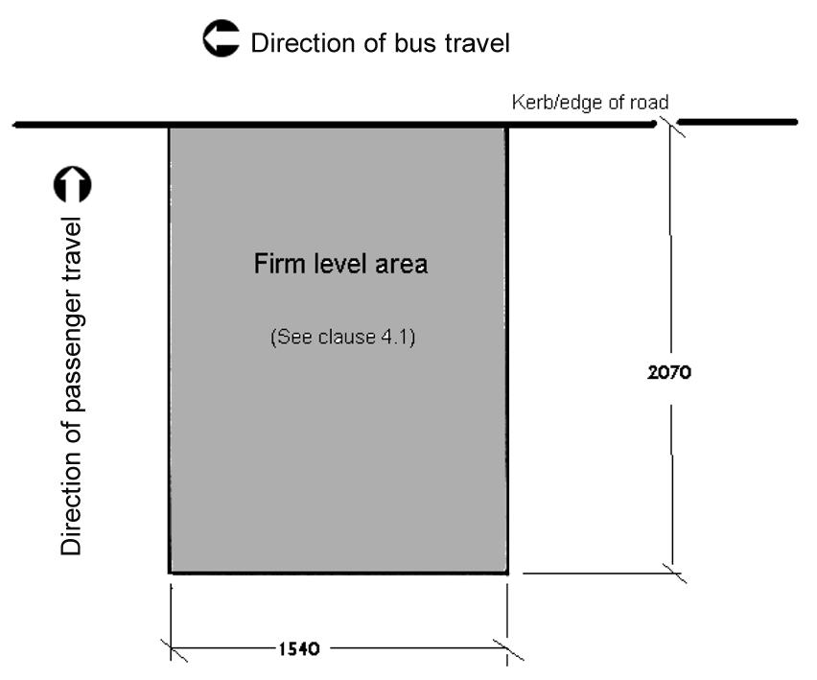
Figure 1: Basic boarding point – manoeuvring area
4.2 In some bus stop layouts (especially at bus stations) it may be more convenient to locate the manoeuvring area away from the kerb and to connect it to the bus boarding point by means of an access path (see Figure 2). This path should be 1200mm wide.
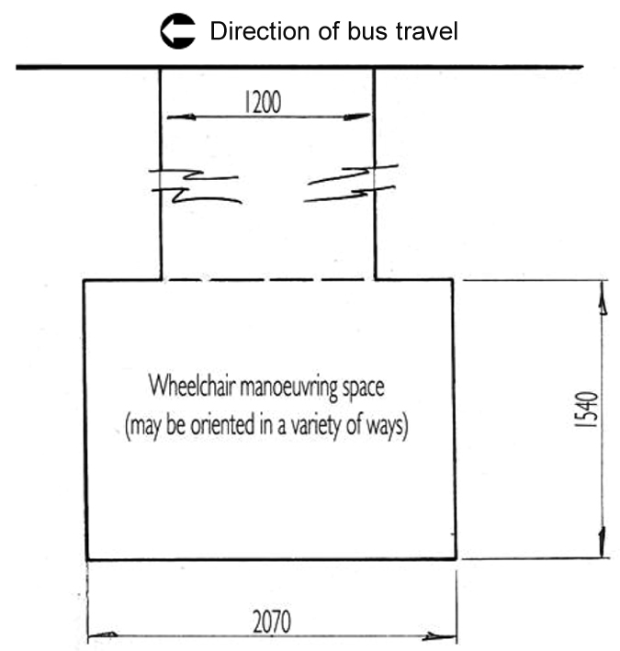
Figure 2: Example of manoeuvring space remote from boarding point
4.3 Any new bus stop being designed and built should include a manoeuvring area which meets the requirements of AS1428.2 (1992), clause 6.2. However, the Commission recognises that there are some situations, including existing bus stops, where it might not be reasonably possible to meet these requirements. In respect of these bus stops, the Commission advises that a 1500mm x 1500mm space which permits a 90 degree turn in a wheelchair would be acceptable (see Figure 3).
4.4 Similarly, in local streets where there is a footpath set back from the kerb, particularly when an existing bus stop is being upgraded and where there is limited space, a 1200mm access path from footpath to kerb is considered to be adequate for boarding (see Figure 3). Note, however, that where this configuration is used, it would be appropriate to provide infill on the inner sides of the turn, based on a notional 1500mm x 1500mm turning space required for a 90 degree turn as shown.
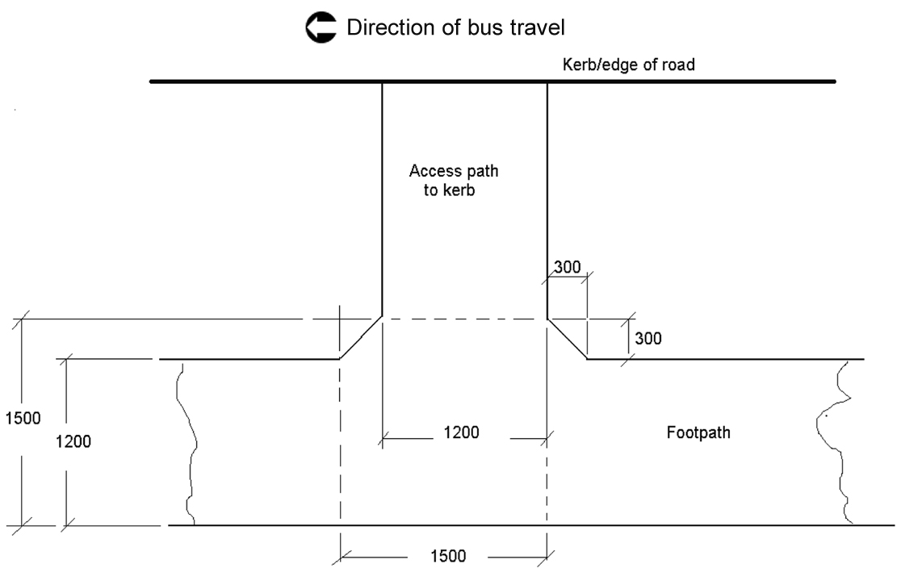
Figure 3: Bus stop alongside complying footpath

Ramps and kerbs
4.5 Boarding devices such as ramps or lifts are not a Provider obligation. These are provided by the bus service operator. The Commission notes that boarding ramps are required to meet the requirements of DSAPT Part 6 clauses 6.2, 6.3 and 6.4 (these reference clauses of AS 3856.1-1991 and AS1428.1-1993) which specify slopes of 1:12 for unassisted access, 1:8 for unassisted access where the ramp length is less than 1520mm and 1:4 for assisted access. The length of a boarding ramp will depend on whether the boarding point is elevated above the roadway and on the floor height of the buses in use.
4.6 Access ramps, however, such as a kerb ramp connecting the boarding point to an adjacent footpath or roadway are a Provider obligation. These are governed by DSAPT clause 6.1 which refers to AS1428.2-1992 clause 8. This clause further references AS1428.1-1993 clauses 5.3 to 5.8 as the primary reference material. These Australian Standards specify a maximum slope of 1:8 for ramps up to 1520mm long. For longer ramps the maximum slope of 1:14 (with landings every 6m) and 1:19 (with landings every 14m).
4.7 A Provider is not required by the DSAPT to install a kerb at a boarding point. However, if a kerb is installed, the DSAPT requires that it must be at least 150mm higher than the road surface. The purpose of this requirement is to enable bus service operators to use low-floor buses with built-in boarding ramps (see the note below for further details).
Note:
Ramps will usually be carried on board buses providing accessible services. Where the roads in the area are kerbed, the ramp will usually be built into the entry doorstep.
Where there are no kerbs on a bus route, the bus service operator might decide to operate buses with wheelchair lifts or to carry portable ramps that can be lifted out of the bus and put in position against the entry step. Such ramps may be time-consuming to deploy and, generally, a built-in ramp is a better option both for the passenger and the bus service operator. Therefore, where a route has a mix of kerbs and un-made road edges, it is strongly recommended that Providers and bus service operators jointly develop programs for the installation of kerbed boarding points at all stops so that bus service operators can commit to the procurement of buses with built-in boarding ramps. Providers and bus service operators should confer with a view to implementing the most appropriate combination of buses and boarding points.
It should not be assumed that people who use wheelchairs or other mobility aids are accompanied by people who can assist them to board. There are also passenger safety and bus driver health and safety risks in having drivers provide boarding assistance to wheelchair users. Accordingly, it is recommended that Providers and bus service operators confer with a view to jointly providing services that do not require assisted boarding: this would mean, essentially, the avoidance of 1:4 to 1.7 boarding ramps.
It is important that, in all circumstances, Providers and bus service operators confer to ensure the provision of a fully compliant bus service, particularly when there is no kerb and achieving compliance with ramp gradients may be difficult.

Level boarding point
4.8 Section 8.1 of the DSAPT specifically refers to a level surface for a boarding point, but does not provide detailed specifications on what constitutes a level surface. However, the DSAPT generally cites AS 1428.1-2001 for technical requirements relevant to a continuous accessible path of travel. AS 1428.1-2001 requires a continuous accessible path of travel to not have a gradient or crossfall greater than 1 in 40.
4.9 This requirement may not be achievable in situations where a bus stop has to be provided at a site with a steep gradient along the roadway and footpath. In such situations consideration should be given to re-locating the bus stop to a location where the road is level or less steep. However, this is not always possible and there will be bus stop locations where boarding and disembarking by people using a wheelchair or other mobility device is not safe or practical. Providers might consider ways of alerting passengers where steep gradients of the roadway and footpath mean that the bus stop may not be suitable for people using wheelchairs.
Note:
While it would be possible to construct a horizontally flat boarding point on a footpath with a steep gradient, the bus pulling up at the bus stop would be at grade with the road. Deploying a ramp from the bus at one grade to the footpath at a different grade could cause instability for the passenger and possible damage to the ramp in some situations.
It is not possible to specify a gradient that can generally be regarded as safe in all circumstances. Providers and bus service operators will need to consider a number of local factors in making a safety assessment.

Surface of boarding point
4.10 The surface of the boarding point and any transition to an adjacent access path must be non-slip. Heavily-textured or figured surfaces (such as raked-joint pavers) should be avoided. The following surfaces are specifically noted in AS 1428.1 2001 as being slip-resistant:
- Rough or textured concrete
- Exposed aggregate concrete (small aggregate)
- Bituminous concrete
- Natural stone with a rough finish
- Textured paving bricks (without chamfers)
- Slip-resistant tiles.
Other surfaces may provide Equivalent access but expert advice should be sought on their usage.
Note:
Paving bricks can be prone to movement in some environments, causing surface irregularities that can impede wheelchair movement and may also constitute a trip hazard. Providers should take care to ensure that paving bricks are securely laid and checked regularly to ensure a smooth surface. This includes limiting weed growth which may result in maintenance and safety issues.
The Commission does not consider grass and loose pebble surfaces to be compliant with the DSAPT.

Tactile ground surface indicators (TGSIs)
4.11 Tactile ground surface indicators (TGSIs) are necessary to guide passengers who are blind, or who have low vision, to a safe boarding point and to identify any hazards. Location, style and dimensions must comply with AS1428.4-1992. Refer also to the note below on the use of possible Equivalent access alternatives.
Notes on TGSIs
The DSAPT specifies that TGSI installations should conform to AS1428.4-1992. Since the DSAPT was first drafted, the Australian Standard has been revised twice, first as AS1428.4-2002 and then as AS1428.4.1-2009. In general, the Commission’s view is that the refinements proposed in the later versions of the Australian Standards have remained consistent with the intent of the DSAPT and they have, therefore, been applied to some of the examples in this Guideline.
Bus stops range from major interchanges to infrequently used local stops. The application of TGSIs should take into account the usage of the stop and the connecting pathways. Thus, a fairly simple arrangement may be satisfactory in an infrequently used location, whereas a more sophisticated wayfinding system would be more appropriate in a busy shopping precinct or a BRT platform. The examples in this Guideline are based on this approach. The Commission recommends Providers consult with local disability groups and access experts when making decisions to use alternative approaches to the application of TGSI’s.
Technically, to comply with the DSAPT (ie: AS1428.4-1992), a TGSI installation would be similar to that shown in Figure 4. However, the Commission is aware that effective TGSI performance has been delivered across Australia by a variety of alternative designs that deliver Equivalent access (consistent with DSAPT Part 33). Given the options available and the improvements that have been made to Australian Standard 1428.4 since 1992, the Commission considers that the primary consideration should be the performance requirements for TGSIs rather than strict specification of geometry. However, in the Commission’s view, based on common elements of the three editions of AS1428.4, the basic geometric principles for application of TGSIs could include the following:
- Where there is a footpath alongside the bus stop, there should be a 600mm wide row of “directional” TGSIs across the footpath leading to a 600mm square “block” of “warning” TGSIs at the boarding point (see Figure 5).
- Where the footpath is separated from the kerb by a nature strip or other non-trafficable area, there should be a 600mm wide row of directional TGSIs across the footpath, then a 300mm wide row leading from the border of the footpath to a 600mm square block of warning TGSIs at the boarding point (see Figure 6).
- Where there is no footpath, there should be a 600mm square block of “warning” TGSIs at the boarding point (see Figure 7).
- Warning TGSIs extending along the kerb are not generally required at single boarding points but may be appropriate at facilities such as bus stations, interchanges and Bus Rapid Transit platforms.
- Separation of the boarding point from the head of a line of directional TGSIs (as in the shelter in Figure 8) should be avoided but, if this is unavoidable, a 300mm wide row of directional TGSIs should connect the head of the line to the boarding point.
When positioning TGSIs on narrow pathways, it should be borne in mind that bus external rear view mirrors project 230mm or more beyond the body of the vehicle and thus may project by this amount over the kerb. It is important, therefore, that the stop’s “warning” TGSIs are always set back at least 300mm from the kerb. The Commission notes that some Providers may set the TGSI back further if there are concerns about passenger safety at particular locations.
Most people who are blind or have low vision prefer to follow the building line or fence line adjacent to footpaths and walkways, so it is important that TGSIs extend from the building line (the fence/building side of the footpath) towards the boarding point at the kerb.
Where a bus shelter, seat or other item of street furniture (or café furniture or shop merchandise) projects into a pathway or access path, additional TGSIs may be considered necessary to ensure safe passage.
TGSIs are not essential at a location which is used solely for disembarkation.
Care should be taken that any kerbside street furniture does not obstruct the disembarkation point.
When a bus stop is de-commissioned, it is expected that the Provider will remove any associated TGSIs.
Special Note
While directional and warning TGSIs serve a vital function in assisting in the safe usage of bus stops their usage should be carefully considered. As stated in the Foreword to AS 1428.4-2002:
TGSIs should not be proliferated unnecessarily, nor used to compensate for bad design. They should be used where the obstruction, hazard or change of direction of travel is less likely to be expected or anticipated and could be encountered, perhaps injuriously, in the absence of a suitably placed TGSI.
In addition, the Foreword to AS 1428.4.1-2009 states that ‘the application of TGSIs will not correct bad design or make an unsafe environment safe. Good design will minimise the need for the use of TGSIs’.

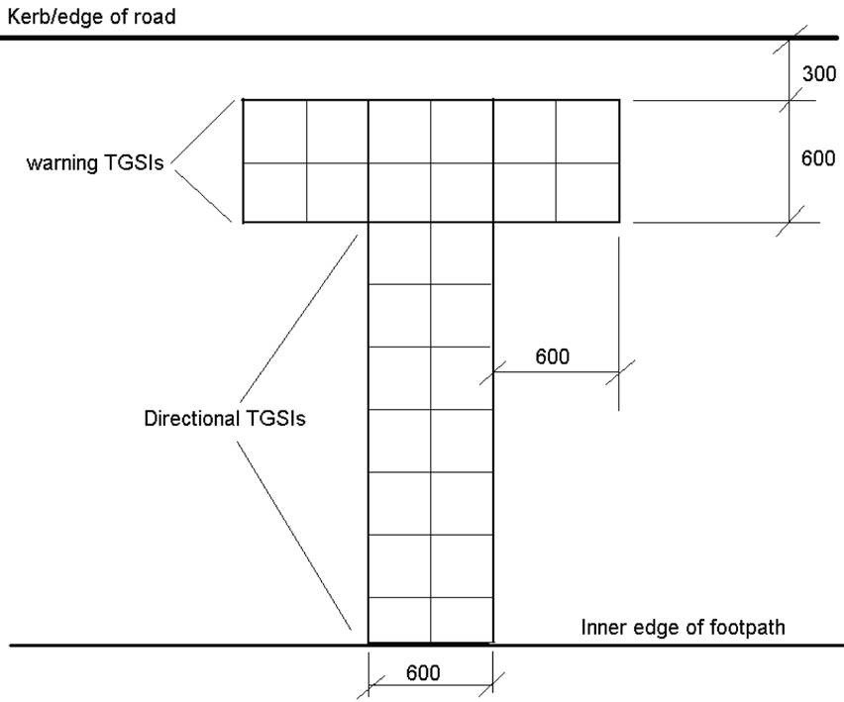
Figure 4: TGSI installation to AS1428.4-1992 as referenced in DSAPT
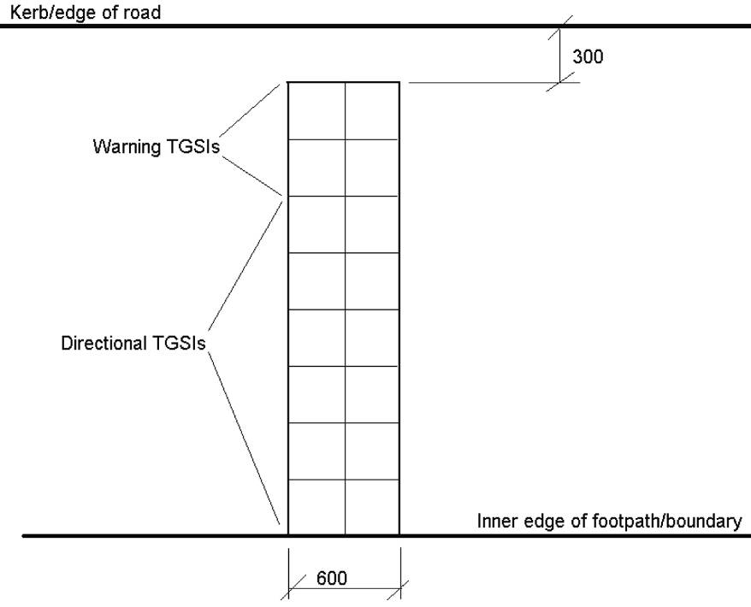
Figure 5: Alternative example of TGSI installation where footpath adjoins the kerb
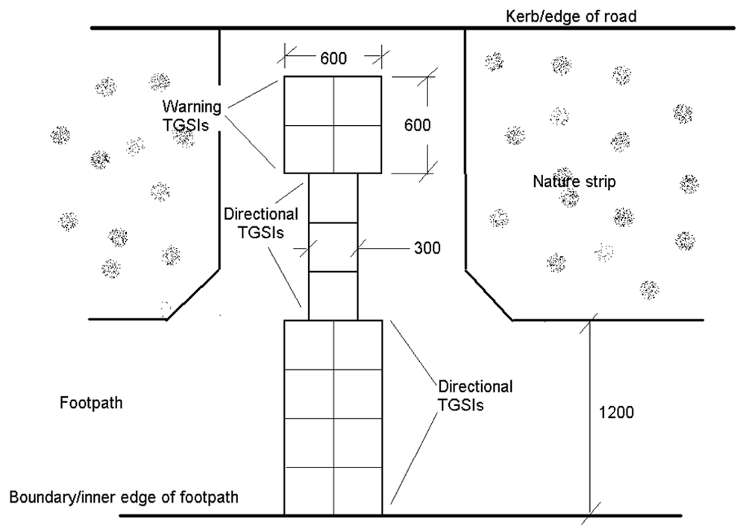
Figure 6: Alternative example of TGSI installation where access path
is separated from kerb
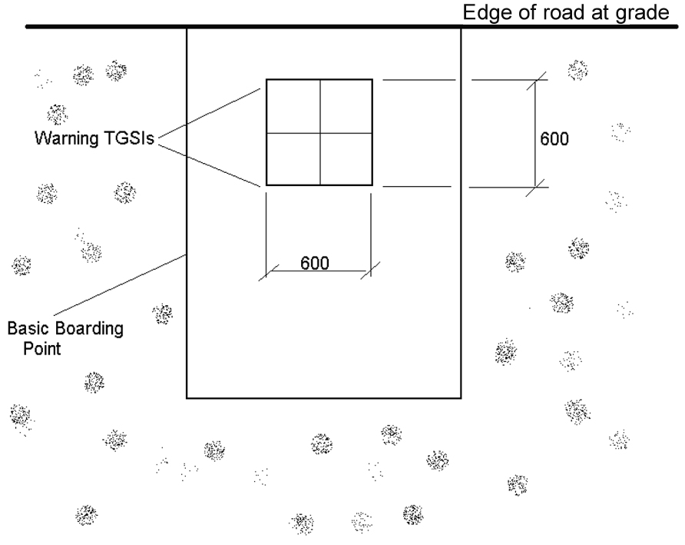
Figure 7: Example of TGSI installation for a bus stop in an area with
no kerb or footpath (boarding point is at grade with the roadway)
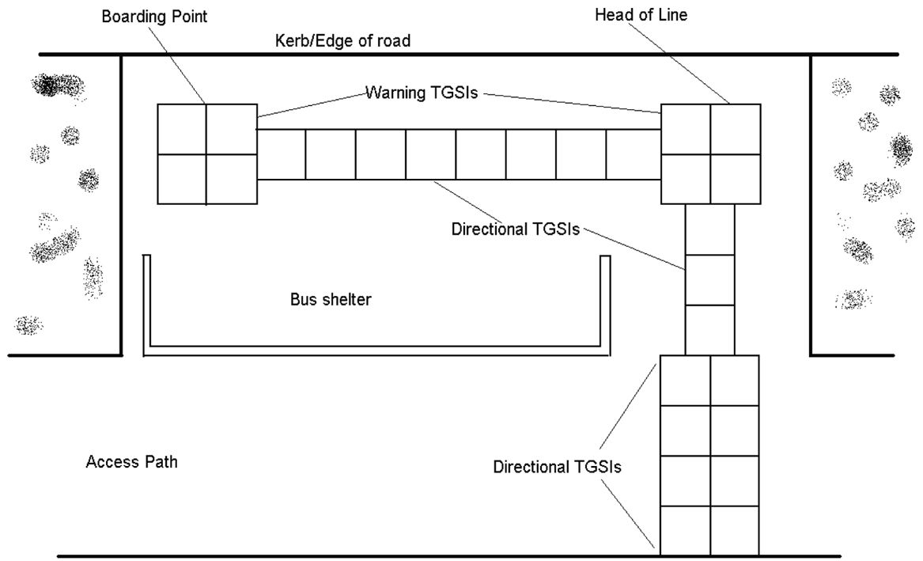
Figure 8: Example of TGSI installation at a bus stop where access is upstream from the boarding point because of the presence of a bus shelter (or other street furniture)

Bus stops which are wider or longer than the basic boarding point
4.12 Many bus stops are longer and wider than the basic boarding point. For example, bus stops may be longer or wider to:
- facilitate disembarkation from buses’ centre doors;
- provide for several buses to stand at the stop;
- provide additional standing space for intending passengers; or
- incorporate seating or a shelter.
4.13 In such cases, if an adjacent footpath is not wide enough to provide an access path between boarding/disembarkation points, the bus stop must incorporate an access path at least 1200mm wide (See Figure 9).
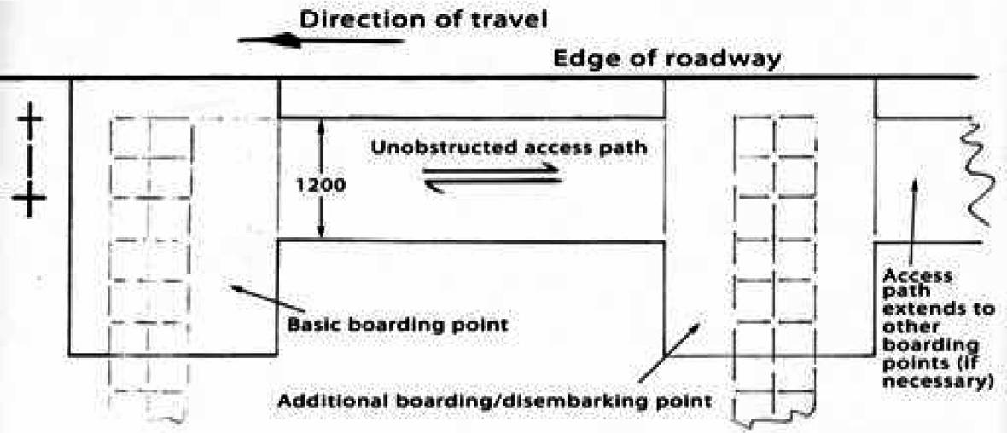
Figure 9: A bus stop extended to permit access to a nearby boarding point or to
allow for disembarkation from a buses’ centre door

Unobstructed access to the bus stop

Access path
4.14 The basic boarding point should be positioned so that any adjacent pavement, walkway or thoroughfare provides an access path that is unhindered and at least 1200mm wide. Where it is not possible for the access path to meet the minimum width (for example, if the pavement is too narrow), the Commission advises that it is permissible for the access path to pass through the boarding point, provided that the access path then meets the minimum width of 1200mm.

Basic boarding point
4.15 Where there is insufficient pavement width to provide the basic boarding point, the area in and around the bus stop should be kept as free as possible of obstructions. This is particularly important if there is insufficient width to meet the access path width requirement outside of the boarding point. An alternative might be to consider relocating the stop if this can be done within the stop-spacing rules set by transport regulation authorities.
Note:
It is preferable that any street furniture such as seating, shelters, bins or public telephones be located to the kerb side of the footpath in order to provide, as far as possible, a clear path of travel along the building or shore line. People who are blind or have low vision generally prefer to follow the building or shore line for safety, security and protection. An exception to this might be at major CBD bus stops, bus stations and Bus Rapid Transit platforms where the kerb is fully delineated by TGSIs.
The Commission has previously issued guidance on the placement of street furniture and paths of travel on footpaths. Available at: www.humanrights.gov.au/disability_rights/faq/Access/access.html#footpath
Also, optimum weather protection is provided by having shelters over the actual boarding points rather than at the building line. It is recognised that there are many bus stops that do not, and in some cases cannot, satisfy this objective. The Commission recommends that these structures are upgraded so that they are identifiable by appropriate high luminance contrast framing, or high luminance contrast visual indicators on glass panelling. In some cases, it may be appropriate to install warning TGSIs on the approach to the structure.
In some cases, the side panel of a shelter does not extend to the ground. This can cause safety problems for cane users because the tip of the cane can pass under the side panel and not alert the cane user to the presence of the structure in time to avoid it. If this issue cannot be addressed by upgrading the shelter, installing warning TGSIs ahead of the shelter will help alleviate this situation as would the use of a ground level detectable warning bar. A similar situation can occur where there is on-footpath dining near the bus stop. Relocation of the dining area to the kerb side or a suitable barrier or warning device should be considered in such circumstances.

Placement and design of ‘Bus Stop’ signs
4.16 The DSAPT states that ‘Bus Stop’ signs must meet AS1428.2 – 1992 clauses 17.1 and 17.2 which, among other things, cover comprehension and letter height requirements for such signs. While the DSAPT specifically refers to this Australian Standard as setting out the minimum requirements for compliance, the Commission acknowledges that bus stop identification varies from city to city and often depends on graphics as much as on wording. Accordingly, the Commission recommends that bus stop signs be identifiable by means of their shape, the graphics displayed, or the wording on them. To be legible, the height of any lettering on the sign must be in accordance with AS 1428.2 1992 clause 17, including the requirement that any lettering or symbol must have a 0.3 or 30% luminance contrast with the background colour.
4.17 AS 1428.2 1992 does not give guidance on the positioning of the bus stop sign post relative to the boarding point but Figure 7 in AS 1428.4 1992 provides a demonstration of an appropriate distance between a TGSI at the boarding point and the post. See Figure 10 in this Guideline. Providers should note that these are minimum dimensions and local conditions might justify different dimensions for safety reasons to ensure, for example, bus mirrors do not injure waiting passengers or damage posts.
4.18 DSAPT Part 17.2 requires ‘Bus Stop’ signs to be placed so that they are clearly visible to people in a seated or standing position. To achieve this, it is recommended that they be displayed at the departure end of the boarding point (refer to Figure 10). No part of the sign should be closer than 300mm to the kerb.
4.19 Signs in bus stations and interchanges often differ from the ‘flags’ and signboards used at local bus stops and are usually part of an integrated information and way-finding system. In such cases, it is acceptable that they be consistent with local public-domain design parameters but they should nonetheless still meet the requirements of clause 4.16 above.
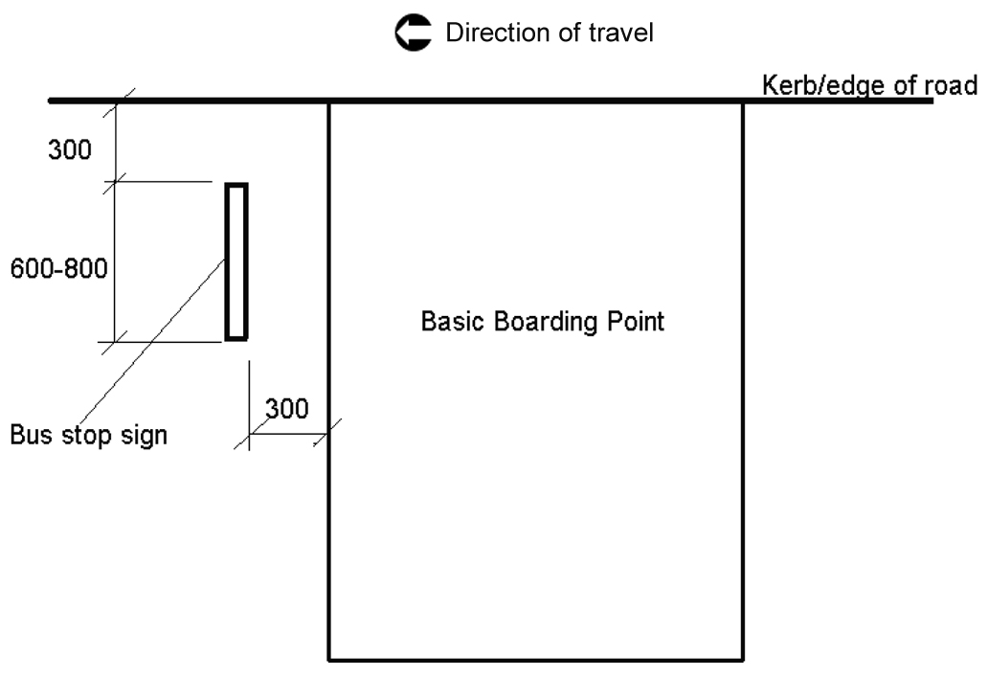
Figure 10: Placement of bus stop sign – note these are minimum dimensions
and may vary according to local conditions or operational requirements
4.20 The DSAPT does not require bus timetable information to be available at bus stops. The DSAPT does, however, require that general information about transport services must be accessible to all passengers. The DSAPT also allows for Equivalent access by direct assistance if the passenger’s preferred format cannot be provided. It is possible, therefore, to comply with this requirement by providing standard print timetable information at a bus stop and making the same information available in a range of accessible formats such as on a website or via telephone inquiry.
4.21 Providers or bus service operators are not required by the DSAPT to provide timetable information at the bus stop in large print format. If they choose to provide information at a bus stop in large print format, however, this should be in a typeface of not less than 18pt in a sans serif font such as Arial or Helvetica.
Note:
Providers should liaise with bus service operators using their stops to agree on responsibility for provision and installation of signs and timetable displays.
Information displayed on the side of the bus stop remote from the boarding point may be inaccessible to people using wheelchairs and many other people with mobility limitations. Accordingly, while it is not a requirement of the DSAPT, such displays should be avoided.
It is recommended that ‘flags’ or bus stop posts and overhead signage in shelters and bus stations have a minimum vertical clearance of 2000mm (see AS 1428.2 1992 section 6.7).
In addition to the requirements of the DSAPT, the Commission notes good practice initiatives such as those of Metlink Victoria who have initiated Braille/tactile telephone number and stop number information at bus stops.

Additional features and atypical situations
5.1 As discussed above in paragraph 3.5, the Commission’s view is that a basic accessible bus stop is a ‘boarding point’ and not a ‘waiting area’ for the purposes of the DSAPT. A Provider, therefore, is not required by the DSAPT to install a shelter or seating at a bus stop.
5.2 If, however, a Provider chooses to provide additional infrastructure in the form of a seating area or shelter as a facility for people to wait at a bus stop, this additional infrastructure would form a ‘waiting area’ under the DSAPT. Where a ‘waiting area’ is provided, it is required to comply with Parts 7, 9.1 and 23 of the DSAPT. Sections 5.5 to 5.11 below are provided as information for those who elect to provide shelters or seating.
5.3 The Commission encourages Providers to install shelters and seating at roadside bus stops, wherever possible. Providers should seek expert advice if they are unsure of the requirements for specific sites.
5.4 Providers should apply a commonsense approach to determining whether seating near a boarding point should reasonably be considered as a ‘waiting area’. For example, a park bench several metres away, and unrelated to, a boarding point does not mean that the bus stop has a ‘waiting area’. Seating adjacent to a boarding point, which has been installed by a Provider would reasonably be considered a ‘waiting area’ for the purposes of the DSAPT.

Providing seating at a basic boarding point
5.5 Part 7 of the DSAPT requires a ‘waiting area’ to have a minimum number of seats marked as available, if required, for the use of passengers with a disability. This minimum number is 5% of the seats available (but not less than 2). This indicates that, if provision of seating is contemplated at a bus stop there should always be at least two places and these should be labelled as specified. The Commission notes that as the smallest number of seats usually placed at bus stops have places for four people, this requirement should not present any difficulty. When these seats are not being used by people with disability they can be used by any passenger.
5.6 Section 23.1 of the DSAPT requires seats to comply with AS1428.2-1992, clause 27.2, which governs seating in pedestrian areas. Generally, the height of the seat above the ground should be between 400 and 450mm. AS 1428.2 also recommends (in clause 27.2 note 1) that, where a high proportion of older passengers is anticipated, a seat height of up to 520mm should be provided because it is easier to rise from a higher seat and this is also an advantage for other people with mobility impairments. As it is rarely possible to predict the demographics of bus stop users, and given the relatively large number of seniors who use public transport services, the Commission recommends that all seating identified as being priority seating for people with a disability be provided at the upper end of the height range (ie, up to 520mm).
5.7 While clause 27.2 of AS 1428.2 (as referenced in section 23.1 of the DSAPT) does not require armrests, these are recommended as shown in Figure 32 of AS 1428.2. Armrests assist older people and others with mobility impairments to seat themselves and to rise from their seats.
5.8 Seating spaces must not intrude into the circulation space required in the boarding point. See paragraphs 4.1 and 4.2 of this Guideline for the space requirements of a ‘basic boarding point’.
5.9 As a general rule, seating is not necessary at bus stops which are solely used as ‘set-down only’ points (these are often at a terminus or interchange but can also be found on some ‘outbound’ services). It should be borne in mind, however, that many ‘outbound’ stops are also boarding points for people travelling further along the route. Providers should consult with their local bus service operators in deciding which stops, if any, fall into the category of disembarkation-only points.

Providing ‘allocated spaces’ for wheelchair users at a bus stop
5.10 Section 7.2 of the DSAPT requires a ‘waiting area’ to have a minimum number of ‘allocated spaces’ available, if required, for passengers with disabilities. The minimum is 5% of the area (but not less than 2 spaces).
5.11 Section 9.1 of the DSAPT states that the minimum size for an ‘allocated space’ is 800mm by 1300mm, and it is to be made available for people using wheelchairs or other mobility aids. There are a number of configurations possible to provide 2 allocated spaces within a waiting area.
Note:
It is acknowledged that there are many bus stop shelters already in existence which only have designated space for one wheelchair user and that the addition of a second space would require substantial reconstruction. The Commission has previously expressed the opinion that such works should be programmed consistent with Providers’ resources (see section 7 of this Guideline: Priorities for Upgrading) and considers it reasonable to provide additional allocated spaces in conjunction with planned upgrades.
The Commission is also aware that some Providers have decided in some situations to only provide one identified space within a shelter. The reason for doing this may be because of limited space in existing shelters undergoing upgrade, the existence of other street furniture, or because of expected low usage of the shelter.
Making such a decision may result in liability for complaints should a person who uses a wheelchair or other mobility aid experience discrimination as a result of the decision. While the Commission understands the reason for making such decisions, it strongly recommends Providers consult with local communities about the issue.
The Commission also notes that there are many bus stop shelters in use that have sufficient area for two wheelchair users, but where the allocated spaces are not clearly identified. These spaces could be easily identified and labelled (for instance, as part of a routine street furniture maintenance process).
When allocated spaces are not being used by people using a wheelchair, the area is available for any passenger.

Providing lighting in a bus shelter
5.12 If internal lighting is provided in a bus stop shelter it should conform to minimum levels of illumination outlined in Part 20 of the DSAPT, including as shown in the notes to clause 19.1 of AS1428.2-1992 as well as AS1680.2. A light level of 150 Lx is considered to be the minimum lighting level necessary.
5.13 These requirements also apply to lighting in a bus station and BRT waiting areas, but not to street lighting external to the shelter.

DSAPT and DDA compliance issues at bus stop terminals
5.14 At major CBD bus stops, some bus stations and some BRT platforms, it is often the case that buses running on different routes may pull in one behind the other and not proceed to the head of the rank before departure. This means that intending passengers have to move up and down the rank to board their buses. This mode of operation may be problematic for people whose vision or mobility is impaired and who must therefore wait at a predetermined place. Arrangements that might be considered to resolve this issue might include:
- identifying the rank as a series of marked bus stops each with its own boarding point; or
- requiring all buses to proceed to a DSAPT-compliant boarding point at the departure end (or even the approach end) of the rank.
5.15 Another DSAPT issue that may occur at bus stations is that buses might not be constrained to using platforms according to route, but might be permitted to use whichever platform is vacant. This also may be problematic for people who are blind or have low vision and, thus, have no way of knowing where to find their buses, and others who cannot get to the current boarding point in time without foreknowledge of its location. In such cases, it is recommended that stations have provision for announcing bus departure locations or look at the possibility of identifying some form of convenient communication to allow a driver to locate a passenger.
5.16 Providers and bus service operators should confer on the most appropriate approach to resolving such situations to ensure compliance with both the DSAPT and all provisions of the DDA.

Examples of bus stop layouts
6.1 Figures 11 to 16 show some examples of bus stop layouts the Commission considers would be compliant with the DSAPT. These are not an exhaustive set of arrangements and are included to indicate basic parameters for compliance with the DSAPT. See section 8 of this Guideline for links to additional material which include other examples.
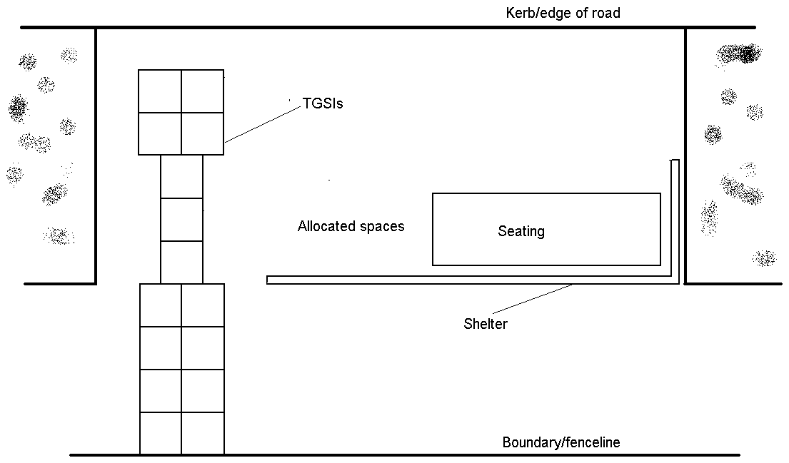
Figure 11: A bus stop with a shelter, seating and wheelchair spaces
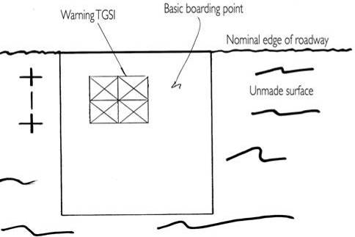
Figure 12: A bus stop in an area without kerbs, gutters or footpaths and with the boarding point at the same level as the road surface. (Note: This type of boarding point may only be feasible in an area where the bus service operator has elected to use wheelchair lifts or manually-deployable ramps which meet the requirements of clause 4.5 of this guideline)
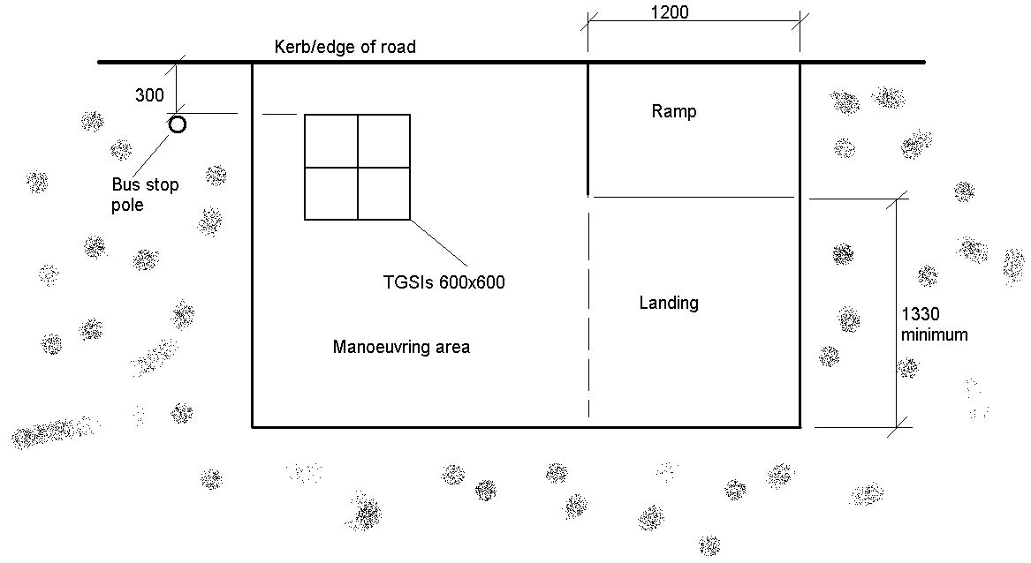
Figure 13: A bus stop in an area without footpaths but with the basic
boarding point elevated above the road surface
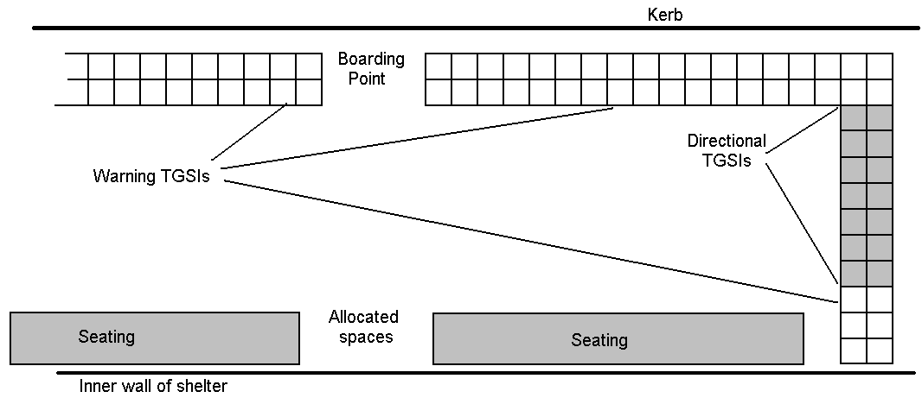
Figure 14: A section of a BRT platform showing the entry and the first boarding point
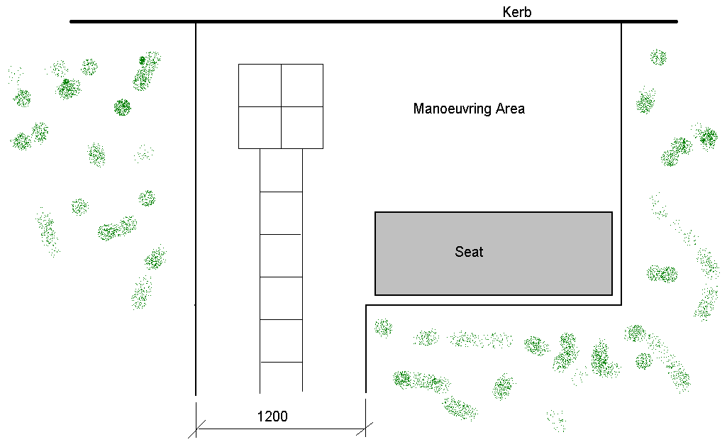
Figure 15: A suburban bus stop with a seat and an access path
connecting to the adjacent footpath
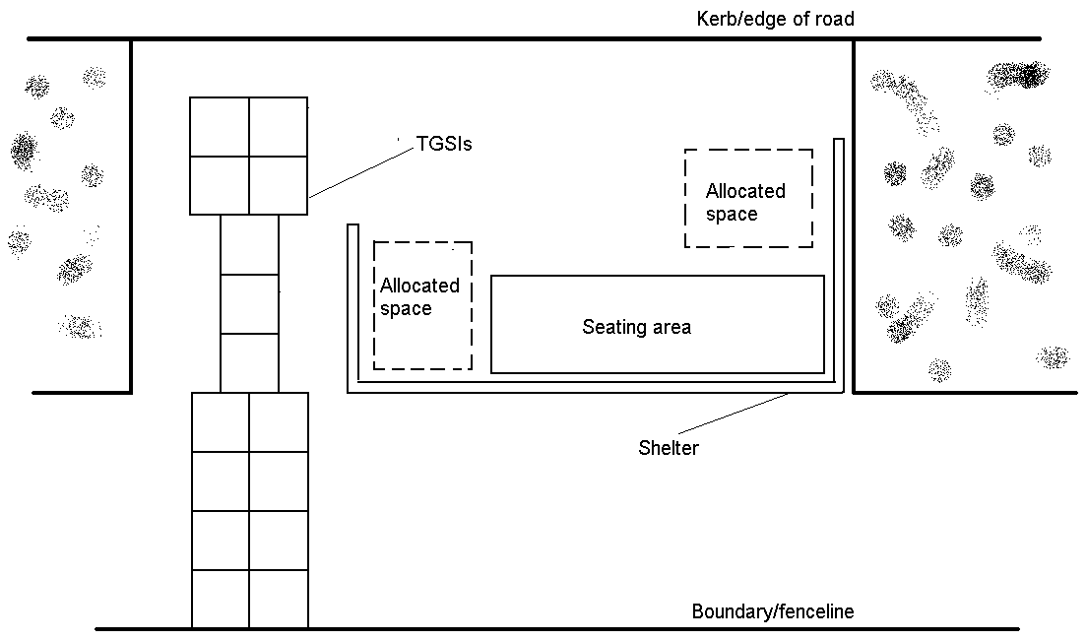
Figure 16: A bus stop originally built with one allocated wheelchair space inside
the shelter but with sufficient interior space to identify an additional
space ahead of that required for seating

Priorities for upgrading of bus infrastructure
7.1 The DSAPT came into force on 23 October 2002 and from that date all newly constructed infrastructure was required to comply. So, for example, if a new bus stop is being constructed it must comply with the requirements of the DSAPT. An ‘additional or replacement’ item of infrastructure installed at an existing bus stop must also comply, as must any existing infrastructure which undergoes ‘substantial refurbishment or alteration’.
Note:
If, for example, an existing bus stop is simply having the signage flag replaced because of vandalism the DSAPT would not require the whole bus stop to be upgraded. Similarly if a relatively new bus stop shelter is having a smashed glass pane replaced this would not trigger a requirement to upgrade the whole bus stop shelter.
However, if a program of upgrading bus stops were to involve digging up of the foundations of shelters, this would be ‘substantial refurbishment or alteration’ and all aspects of the renovated bus stop would have to comply with the requirements of the DSAPT.
Similarly if a bus stop shelter is having the roof and seating replaced because of excessive wear or deterioration, this may also be ‘substantial refurbishment or alteration’ requiring a full upgrade of the bus stop.
There will be some bus stops which cannot be modified to meet the requirements of the DSAPT. These include sites on steep hills, or on roads with extremely high edges. In these circumstances, the first consideration should be whether the bus stop can be relocated to a nearby site which can be made compliant. If relocation is not feasible, a Provider might consider whether it could seek to rely on establishing that compliance with some or all of the DSAPT requirements would impose an ‘unjustifiable hardship’.
7.2 All existing bus stops are required to comply with the DSAPT at target dates specified in Schedule 1 of the DSAPT as follows:
- 31 December 2007 – 25% of bus stops;
- 31 December 2012 – 55% of bus stops;
- 31 December 2017 – 90% of bus stops; and
- 31 December 2022 – 100% of bus stops.
7.3 Given that compliance of all bus stops with the DSAPT is to be achieved over a number of years, it is desirable that upgrading programs are initially targeted at locations where they will deliver the most benefit in the shortest period of time for people with a disability. In this regard, the following priorities are recommended:
- immediate priority to stops most likely to be patronised by people with a disability;
- 2012 target date: priority to routes serving local amenities; and
- 2017 target date: remaining bus stops in residential areas.
7.4 Bus stops most likely to be patronised by people with a disability include those on:
- routes serving central business districts and regional centres;
- routes with timetabled accessible buses;
- routes serving major educational and health facilities and high volume corridors such as Adelaide’s ‘Go-zones’, Melbourne’s ‘Smart Bus’ routes, Sydney’s ‘Strategic bus corridors’ and Brisbane’s ‘Buzz’ routes; and
- routes on bus transitways, major arterial roads and those connecting to accessible rail stations.
7.5 For the 2012 target date, priority should be given to bus stops serving local shopping centres, industrial areas, schools, hospitals, tertiary educational institutions, retirement villages, nursing homes, and rehabilitation centres.
7.6 The 2017 target date requires 90% of bus stops to comply with the DSAPT. For this target date, priority should be given to those bus stops in residential areas that were not previously identified as in need of immediate action.
Note:
The recommended priorities should not be applied so rigorously as to prevent the upgrading of lower priority bus stops in the normal course of a Provider’s business (for example, during routine maintenance or at the request of or through a partnership arrangement with an outdoor advertiser).
Providers should consult with local organisations representing the views of people with a disability such as Local Government Access Committees and local advocacy or service provider groups. In some circumstances, it might be feasible to make improvements to local bus stops where there are known to be local bus users who would benefit from the application of accessibility measures.
The priorities may also be influenced by the availability of accessible buses. Accordingly, Providers should consult with their local bus service operators to determine the most appropriate priorities for their bus stop development programs.

Additional information and useful links
A number of organisations both in Australia and overseas have developed guides in relation to accessible bus stops. While overseas compliance requirements may be different to those requirements in Australia, they might provide valuable information and ideas for responding to difficult and unique topographical or infrastructure problems. See, for example:

Western Australia
Public Transport Authority of Western Australia, Public Transport Bus Stop Site Layout Guidelines (2010)
www.pta.wa.gov.au/PublicationsandPolicies/DesignandPlanningGuidelines/tabid/109/Default.aspx

Queensland
Translink Transit Authority, Public Transport Infrastructure Manual (2007) www.translink.com.au/infrastructuremanual.php
Brisbane City Council, Standard Drawings – Roads www.brisbane.qld.gov.au/planning-building/planning-building-rules/standard-drawings/roads/index.htm

United Kingdom
Transport for London, Accessible Bus Stop Design Guidance: Bus Priority Team Technical Advice Note BP1/06 (January 2006)
www.tfl.gov.uk/assets/downloads/businessandpartners/accessibile_bus_stop_design_guidance.pdf

United States of America
Easter Seals Project Action, Toolkit for the Assessment of Bus Stop Accessibility and Safety
projectaction.easterseals.com/site/PageServer?pagename=ESPA_BusStopToolkit
Transit Cooperative Research Program, ‘Chapter 4: Curb-side Factors’ in Report 19: Guidelines for the Location and Design of Bus Stops (1996)
onlinepubs.trb.org/Onlinepubs/tcrp/tcrp_rpt_19-c.pdf

Canada
BC Transit Municipal Systems Program – Design guidelines for accessible bus stops
www.transitbc.com/corporate/resources/pdf/res-urban-21.pdf

Association of Consultants in Access Australia (ACAA)
Members of ACAA might provide additional expert advice at www.access.asn.au/

Checklist for assessing compliance of Bus Stops with DSAPT
Item | Requirement | Paragraph in Guideline | Reference – DSAPT and Australian Standards | Status | Comments
Boarding point | Minimum dimensions: 2070mm x 1540m to provide for manoeuvring of wheelchairs and location of TGSIs.  Or, where applicable:  - 1500x1500 area for a 90 degree turn  - 1200mm wide path to boarding point if wheelchair can manoeuvre elsewhere. | 4.1  4.3  4.4 | DSAPT, Part 3 and AS1428.2-1992, clause 6.2  DSAPT, Part 3  DSAPT, section 2.4
Unobstructed access to the bus stop | Access path to provide unhindered passage.  Access paths and poles and other obstacles. | 4.14 and Note | DSAPT, section 2.1  DSAPT, section 2.5
Kerb at boarding point | Kerb height not less than 150mm (only if kerb is installed). | 4.7 | DSAPT, section 8.1(2)
Surface of boarding point | Firm and non-slip, no figured surfaces. | 4.9 | DSAPT, section 10.1  AS1428.2-1992, clause 9; AS1428.1 Supplement 1 – 1993, clause 12
Access path through bus stop area to boarding point (only if bus stop area extends beyond boarding point) | Access path through bus stop: access path of minimum width of 1200mm. | 4.12, 4.13 | DSAPT, sections 2.1, 2.4  AS1428.2-1992, clauses 6.4 and 8.1
Access path to/from adjacent footpath or roadway | Minimum width: 1200mm. | 4.4 | DSAPT, section 2.1  AS1428.2-1992, clauses 6.4 and 8.1
Access ramp to bus stop required if boarding point not at same level as access path | Maximum slope of:  - 1:8, for ramps up to 1520mm long  - 1:14 if ramp less than 1520mm long. Requires rest points every 9m, otherwise 1:20 with rest points every 15m. | 4.6 | DSAPT, section 6.1  AS1428.2-1992 clause 8 (this refers to AS1428.1 – see clauses 53 and 5.8)
Seating (if provided) | 5% of seats (minimum of 2) to be identified as priority seating for people with disabilities. Design to conform to AS1428.2-1992 (recommended seat height of up to 520mm). | 5.5, 5.6 | DSAPT, section 7.1  DSAPT, section 23.1  AS1428.2-1992, clause 27.2
Shelter (if provided) | Structure not to obstruct access paths or walkways. | 4.13, 4.14 and associated Note | DSAPT, sections 2.1, 2.5
Allocated spaces | 5% of ‘waiting area’ to be identified as allocated space for wheelchairs (minimum 2 spaces). | 5.10, 5.11 | DSAPT, section 7.2
Bus stop sign | Sign should be set-back at least 300mm from kerb.  Minimum 300mm set-back from boarding point boundary. | 4.15 to 4.19 | DSAPT, section 17.1  AS1428.2-1992, clauses 17.1, 17.2, 17.4
Tactile Ground Surface Indicators (‘TGSIs’) | Where there is a footpath alongside a bus stop, there should be:  - a 600mm wide row of directional TGSIs across that adjacent footpath; and  - 600mm square of warning TGSIs at boarding point.  If footpath and boarding point are separated:  - 300mm wide row of directional TGSIs connecting the TGSIs on the footpath and boarding point. | 4.10 and associated Notes | DSAPT, Part 18  AS1428.2 ,clause 18.1  AS1428.4-2002
Where no footpath:
- 600mm square block of warning TGSIs at boarding point.
General compliance with AS1428.4-1992 (2002 and 2009 revisions are considered to provide equivalent access).
TGSIs to be colour contrasted.
Lighting in a bus stop shelter, bus station or BRT waiting area | If installed, light level of 150 Lx is considered to be the minimum. | 5.12, 5.13 | DSAPT, section 20.1  AS1428.2-1992, clause 19.1 and AS 1680.2

Disability Discrimination Act 1992 (Cth), section 3.
Disability Discrimination Act 1992 (Cth), section 32.
For a copy of the DSAPT go to: www.ag.gov.au/www/agd/agd.nsf/Page/Humanrightsandanti-discrimination_DisabilityStandardsforAccessiblePublicTransport. For further information about the obligations of bus infrastructure providers and compliance processes see the June 2006 open letter sent by the Disability Discrimination Commissioner to Local Government Authorities. Available at: www.humanrights.gov.au/disability_rights/transport/busstops.htm.
Section 1.22(1) of the DSAPT defines a ‘Provider’ as ‘a person or organisation that is responsible for the supply or maintenance of public transport infrastructure’. Section 1.18(2) notes that ‘Infrastructure does not include any area beyond immediate boarding points (for example bus stops, wharves, ranks, rail stations, terminals).’ The Commission’s view is that infrastructure includes infrastructural elements such as shelters or seating at a bus stop if there is evidence to show that they are intended to be ‘used by passengers in conjunction with travelling on a public transport service’ (see section 1.18(1) of the DSAPT).
See DSAPT, section 33.7 for guidance on what constitutes ‘unjustifiable hardship’.
Australian Standards are available from SAI Global at: http://infostore.saiglobal.com/store2/.
DSAPT, section 33.3(1)(a).
DSAPT, section 33.3(1)(b).
DSAPT, section 33.4.
DSAPT, section 33.5.
See section 4.8 of this Guideline for further discussion on this issue.
See DSAPT, Part 7.
DSAPT, section 3.1.
DSAPT, section 2.4; and AS1428.2-1992, clause 6.4.
DSAPT, section 3.1.
See also Figure 4 in AS1428.1-2009.
Note the difference in gradient specifications for boarding ramps which are carried on the bus and subject to AS 3856.1 and other ramps which connect bus stops to roadways or a footpath and which are subject to AS 1428.2.
DSAPT, section 8.1(2).
DSAPT, section 10.1; and AS1428.2-1992. clause 9; and AS1428.1 – supplement 1-1993, clause C12.
AS 1428.1 2001 clause 12.
Clause 18.3 of the DSAPT calls for ‘colour contrasted’ TGSIs. AS1428.4-1992, clause 6.1(a) states that ‘the colour shall provide a luminance contrast to the surrounding surface of not less than 0.3 (30%).’ No test method is provided but test methods are described in AS1428.4-2002, Appendix F, and in AS1428.4.1-2009, Appendix E. In the Commission’s view, either of these methods will demonstrate compliance with AS1428-1992.
DSAPT, Part 18.
See AS1428.4.1-2009, Figure D4.
DSAPT, sections 2.1 and 2.4; section 2.3 of this Guideline; and AS1428.2-1992, clauses 6.4 and 8.1.
DSAPT, Part 2.
DSAPT, section 17.1.
AS1428.2-1992, clause 17.4.
DSAPT, section 27.1.
DSAPT, section 27.2.
DSAPT, section 27.3.
DSAPT, section 32.1.
See DSAPT, sections 32.1(a)(iv) and 32.1(a)(iii).
DSAPT, section 33.7.
Both origin and destination stops are important for people with disabilities. In selecting stops for priority action it is important to invite input from such passengers in the locality. Note that for many people, a connection to the nearest shopping centre might be as important as connections to major centres.

