Chapter 5:
Legal Services

5.1 Responsibilities and overview
The Legal Section provides legal advice and representation to the Commission, the President and Commissioners. Its work includes:
- advising on human rights, discrimination and other laws relevant to the work of the Commission
- preparing notices and reports under the Human Rights and Equal Opportunity Commission Act concerning complaints of breaches of human rights or discrimination in employment
- representing the Commission in proceedings in which it intervenes to make submissions about human rights issues
- representing Commissioners as amicus curiae in unlawful discrimination proceedings
- legal education and promoting awareness of developments in human rights and discrimination law
- representing the Commission in external litigation such as review proceedings under the Administrative Decisions (Judicial Review) Act 1977 (Cth)
- preparing and advising on submissions to government and law reform bodies concerning the human rights implications of changes or proposed changes to the law
- assisting the Commission to consider applications for exemptions under the Sex Discrimination Act and Age Discrimination Act
- responding on behalf of the Commission to applications for access to information under the Freedom of Information Act 1982 (Cth)
- assisting in international technical assistance work undertaken by the Commission.

5.2 Interventions and leave granted to intervene
The Commission has a function of intervening, with the leave of the Court, in proceedings that involve issues of human rights, equal opportunity in employment and age, race, sex, marital status, pregnancy and disability discrimination.
The Commission’s intervention functions are contained in:
- sections 11(1)(o) and 31(j) of the Human Rights
and Equal Opportunity Commission Act
- section 20(1)(e) of the Racial Discrimination Act
- section 48(1)(gb) of the Sex Discrimination Act
- section 67(1)(l) of the Disability Discrimination Act
- section 53(1)(g) of the Age Discrimination Act.
In deciding whether to seek leave to intervene, the Commission considers whether the human rights or discrimination issues are significant and central to the proceedings and whether these issues are likely to be addressed adequately by the parties to the proceedings. The guidelines that the Commission uses to determine if it will seek leave to intervene in a matter are publicly available on the Commission’s website at: www.humanrights.gov.au/legal/submissions_court/intervention/interventions_in_court_proc.html.
Through its interventions, the Commission seeks to promote human rights principles and encourage the development of Australian law in line with human rights standards. The intervention functions also serve an important educative purpose, by bringing a human rights perspective to the attention of courts and parties to litigation. The Commission seeks to pursue this educational purpose further by placing all of its submissions on its website. These are available at: www.humanrights.gov.au/legal/submissions_court/index.html.
Between 1 July 2008 and 30 June 2009, the Commission intervened in five new matters and was involved in two matters that continued from the previous financial year.

5.2.1 Inquest into the death of Ian Ward
The Commission was granted leave to intervene in the inquest into the death of Mr Ian Ward in Kalgoorlie. Mr Ward died of heatstroke while being transported from Laverton to Kalgoorlie on a hot day in the rear of a van, having been remanded in custody for drink driving.
The Commission’s submissions focused on systemic human rights issues connected with the death, particularly the impact of the practices of police and custodial officers on Mr Ward’s right to humane and dignified treatment, his right to be free from arbitrary detention and his right to life. This included: the inappropriateness of the decision by police to arrest Mr Ward and refuse bail; the discharge of the duty of care to Mr Ward by the officers transporting him; the inappropriateness of the design and condition of the vehicle for prisoner transports across long distances in desert conditions; the inadequacies of relevant policies, procedures and training, including the failure of the pre-departure vehicle checklist to include a check on air-conditioning; and the inadequacy of the police investigation into Mr Ward’s death.
The Coroner handed down his findings in June 2009. The Coroner found that Mr Ward’s death was wholly avoidable and had been contributed to by the custodial officers, the custodial contractor, GSL, and the WA Department of Corrective Services.
The Coroner also found, consistent with the Commission’s submissions, that the treatment of Mr Ward breached Australia’s international legal obligations.
The Coroner made 14 recommendations aimed at systemic improvements, including that the Inspector of Custodial Services be empowered to issue a ‘show cause’ notice in cases where the Inspector is aware of issues relating to the human rights and safety of persons in custody.
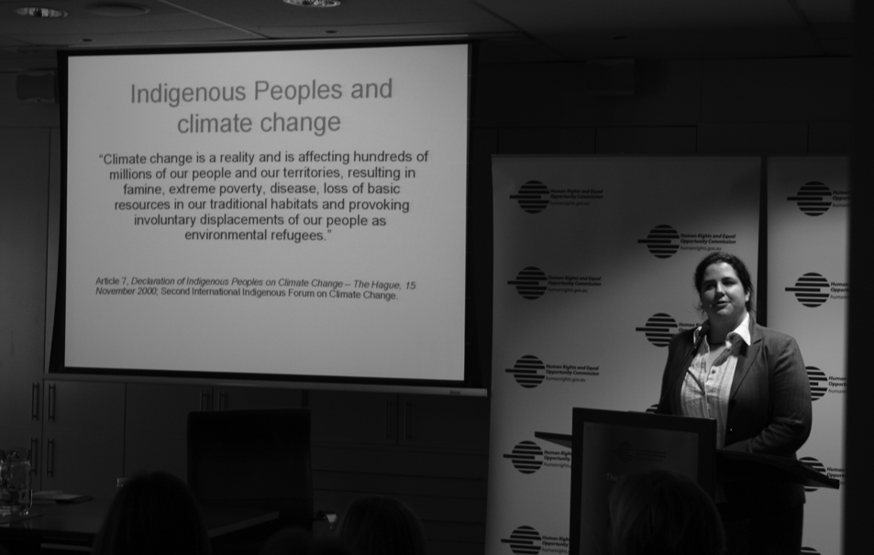
The work of the Commission’s legal section includes education and promoting awareness of developments in human rights and discrimination law. Ms Emily Gerrard, lawyer, was one of the speakers at a Commission seminar about Human Rights and Climate Change in August 2008.

5.2.2 Inquest into the death of David Gurralpa
In February 2009, the Commission was granted leave to intervene in the inquest into the death of Mr David Gurralpa in Darwin.
Mr Gurralpa died of a sudden heart attack while in police custody, either during or immediately after an intense struggle with the police. During this struggle the police held Mr Gurralpa in a ‘prone restraint’ position.
The Commission’s submissions focused on the systemic human rights issues surrounding the death of Mr Gurralpa. These included the dangers involved in the police use of the prone restraint; the risk factors that make certain persons more susceptible to death following the prone restraint; and the need for police to monitor the health of people where practicable during the restraint, as well as immediately after the use of the prone restraint.
The Coroner handed down his findings in June 2009. The Coroner found that the struggle between the police and Mr Gurralpa, particularly while the police were using the prone restraint, was a material contributing factor to his death.
The Coroner adopted most of the Commission’s suggested recommendations, which included recommendations for police training in the dangers of the prone restraint; the risk factors associated with the prone restraint; and the need to monitor a person’s health, if practical, during and certainly immediately after a person is held in the restraint position.

5.2.3 Inquest into the death of Robert Plasto-Lehner
In February 2009, the Commission was granted leave to intervene in the inquest into the death of Mr Robert Plasto-Lehner, which was heard concurrently with the inquest into the death of Mr Gurralpa (above).
Mr Plasto-Lehner died at Royal Darwin Hospital after being held face down on the ground in a prone restraint by several police officers and hospital security guards. Mr Plasto-Lehner had been brought to the hospital by the police for a mental health assessment. He was forced onto the ground after attempting to leave the hospital building, having repeatedly requested that he be able to go outside for some fresh air and to have a cigarette. As a result of being held in the prone restraint, Mr Plasto-Lehner stopped breathing and later died.
The Commission intervened to make submissions about the systemic human rights issues surrounding Mr Plasto-Lehner’s death. These issues included: the dangers and risk factors associated with the use by police of the prone restraint; the sufficiency of police training and the appropriateness of police practice in respect of the use of prone restraint; the adequacy of police training in dealing with mentally ill persons; and the adequacy of the police investigation into the incident.
In June 2009, the Coroner found that the use of the prone restraint was a material contributing factor in Mr Plasto-Lehner’s death. The Coroner was critical of the police’s conduct, describing Mr Plasto-Lehner’s death as involving ‘a litany of serious errors and misjudgements that led to the tragic and unnecessary death of the Deceased’. The Coroner also reported that a crime of assault may have been committed against Mr Plasto-Lehner.
The Coroner adopted many of the Commission’s suggested recommendations in relation to police training in the dangers and risk factors of the prone restraint, and the need to monitor a person’s health during and immediately after the use of the restraint. The Coroner also adopted the Commission’s suggested recommendations in relation to police training on the treatment of mentally ill persons.

5.2.4 Morton v Queensland Police Service
These proceedings before the District Court in Townsville involved an appeal against a conviction of possessing more than a prescribed quantity of alcohol in a prescribed area, namely Palm Island, pursuant to section 168B of the Liquor Act 1992 (Qld).
The appellant, Ms Morton, an Aboriginal woman from Palm Island, argued that the provisions of the Liquor Act 1992 (Qld) and the Liquor Regulations 2002 (Qld) are invalid on the basis that they are inconsistent with section 10(1) of the Racial Discrimination Act.
The Commission was granted leave to appear as amicus curiae. The Commission made submissions on a range of issues, including the principles of interpretation relevant to the Racial Discrimination Act, the proper approach to section 10 of the Racial Discrimination Act and the exemption for ‘special measures’ in section 8(1) of the Racial Discrimination Act. ‘Special measures’ are measures taken for the ‘sole purpose of securing the adequate advancement of certain racial or ethnic groups or individuals’ in order that they may enjoy and exercise human rights and fundamental freedoms equally with others.
The Court held that section 10, which protects the right to equality before the law, was not ‘invoked’ by the Queensland legislation because the legislation operated by reference to a particular area (Palm Island) rather than race. In the alternative, the legislation was a special measure.

5.2.5 Proceedings in the Family Court of Australia concerning medical treatment for a child
The applicants in this matter sought an order from the Family Court that they may lawfully authorise the medical treatment of their child in respect of the condition of transsexualism without an order of a court. Such treatment is proposed to include both reversible and irreversible treatment of a hormonal nature.
The proceedings therefore raised issues that include the scope of parental power to consent to such treatment. In the alternative, the parents sought an order that the court authorise such treatment and empower them to provide the authorities and consents that are necessary for the treatment to proceed.
The Commission intervened to make submissions on important issues of human rights, especially in relation to those rights recognised in the Convention on the Rights of the Child. The Commission was granted leave to intervene in March 2006 and the matter was heard by a single judge of the Family Court in November 2007.
Judgment remains reserved at the time of publication.
Note that, pursuant to section 121 of the Family Law Act 1975 (Cth), the Commission is unable to disclose any details that may disclose the identities of the parties to the proceedings.

5.2.6 R v Wei Tang
The Commission was granted leave to intervene in the High Court in R v Wei Tang in May 2008. Ms Wei Tang, a Melbourne brothel owner, was convicted in the Victorian County Court of ‘using’ and ‘possessing’ five Thai women as slaves. Ms Tang successfully appealed against her conviction on the ground that the trial judge had misdirected the jury. The Crown appealed to the High Court of Australia, which considered the elements of the offence slavery and how to interpret the definition of slavery.
The Commission made submissions about the correct interpretation of the definition of slavery under the Criminal Code Act 1995 (Cth) in light of the international jurisprudence about the meaning of slavery.
The Commission argued international law recognises that the absolute prohibition on slavery has evolved from the historical concept of ‘chattel slavery’ to encompass various contemporary forms of slavery which are based on the exercise of any of or all of the powers attaching to the right of ownership.
The Commission relied on the International Criminal Tribunal for the Former Yugoslavia case, Prosecutor v Kunarac, to identify the indicia of contemporary forms of slavery. These indicia include the control of movement, psychological control, and the denial of personal autonomy. Deception, physical or psychological abuse, and false promises may render consent either irrelevant or impossible.
In August 2008, the High Court handed down a majority decision upholding the Crown appeal against the Victorian Court of Appeal’s decision to quash
Ms Tang’s conviction and to order a retrial.
The High Court held that the definition of ‘slavery’ in the Criminal Code is not restricted to historical concepts of ‘chattel slavery’, where a person is treated like the property of another without control over any aspect of their life. The question of whether the powers exercised by the accused can be described as powers attaching to the right of ownership will depend on the nature and extent of the powers.
Consistent with the approach advocated by the Commission, the Court focused on a range of factors to identify whether an offence of slavery had occurred. The Court accepted that the indicia of slavery identified in Prosecutor v Kunarac can help distinguish between harsh and exploitative employment arrangements and the condition of slavery. The Court also added that the commodification of an individual, by treating him or her as an object of sale and purchase, is a powerful indicator of slavery.

5.3 Amicus curiae
Guidelines for the exercise of the Commission’s amicus curiae function are publicly available on the Commission’s website at: www.humanrights.gov.au/legal/submissions_court/amicus/amicus_guidelines.html.
As with the Commission’s intervention functions, the Commissioners attempt to enhance the educational role of their amicus curiae function by placing all submissions on the Commission website. These are available at: www.humanrights.gov.au/legal/submissions_court/index.html.
During 2008-09, Commissioners did not seek leave to appear as amicus curiae in any matters. The Disability Discrimination Commissioner was involved in one matter which was continued from the previous financial year, summarised below.

5.3.1 Vijayakumar v Qantas
The applicant, Mr Vijayakumar, alleges that he was discriminated against by Qantas when he was required to pay excess baggage fees for his disability aids. The events took place in Mumbai (India) on the return journey of a ticket purchased in Australia for travel between Sydney and Mumbai. Mr Vijayakumar claims that he could not afford the fees imposed and was effectively required to abandon most of his personal belongings at the airport.
Qantas has challenged the jurisdiction of the court to hear the matter on the basis that the alleged discrimination occurred in India and was therefore outside the territorial scope of the Disability Discrimination Act. By contrast,
Mr Vijayakumar argues that the relevant discrimination occurred by virtue of the conditions of his flight, which was purchased in Australia.
The Disability Discrimination Commissioner made written and oral submissions in the interlocutory hearing before Scarlett FM dealing with the jurisdictional challenge. The Commissioner submitted that no jurisdictional issue arose if part of Mr Vijayakumar’s case involved alleged discrimination occurring within Australia. In particular, the relevant sections of the Disability Discrimination Act (sections 23 and 24) are breached upon the communication or imposition of discriminatory terms upon which the premises are made available or the service is provided which, in this case, appeared to have occurred in Australia not India.
At the time of publication, the decision of Scarlett FM remains reserved.

5.4 Review of administrative decisions
made by the Commission
People affected by administrative decisions made by the Commission may be entitled to seek a review of those decisions before a court or tribunal.

5.4.1 Judicial review
Judicial review of Commission decisions can be sought by application to the Federal Court or the Federal Magistrates Court under the Administrative Decisions (Judicial Review) Act 1977 (Cth).
In accordance with established legal principle, the Commission (as decision maker) usually does not play an active role in those proceedings. This is to avoid a perception of bias in the event that a matter is remitted to the Commission for further determination. Instead, the Commission agrees to be bound by the decision of the Court and leaves the substantive parties (usually the complainant and respondent to a complaint that was before the Commission) to argue the matter.
The Commission was a respondent to two applications brought under the Administrative Decisions (Judicial Review) Act in 2007-08. One of those applications was unsuccessful, the other was ongoing at the end of the reporting period.

5.4.2 Merits review
Some decisions of the Commission or its staff (acting under instruments of delegation) are subject to merits review by the Administrative Appeals Tribunal. These include decisions made under the Freedom of Information Act 1982 (Cth), and decisions on applications for temporary exemptions under section 44 of the Sex Discrimination Act, section 55 of the Disability Discrimination Act and section 44 of the Age Discrimination Act.
There was one application for merits review of a Commission decision during the reporting period. It was ongoing at the end of the reporting period.

5.5 Education and promotion
The Legal Section plays a significant role in human rights legal education, including through publishing regular journal articles, presenting seminar papers and speaking as guest lecturers to university students on discrimination and human rights law issues.
Three of the Legal Section’s significant ongoing human rights education projects are listed below:
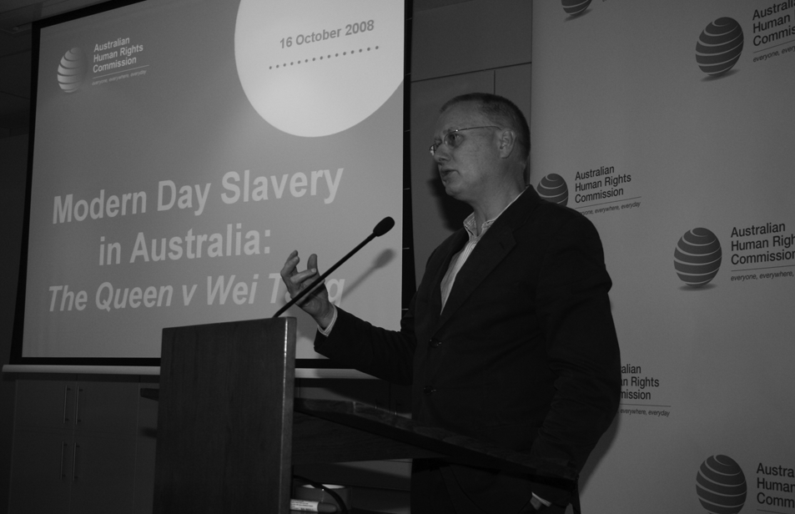
At a Commission legal seminar held in October 2008, Mr Bret Walker SC spoke about Modern Day Slavery in Australia. Mr Walker appeared as Senior Council for the Commission in R v Wei Tang.

5.5.1 Federal Discrimination Law
Federal Discrimination Law provides a comprehensive overview of the case law that has been decided in the field of federal unlawful discrimination law. In addition to detailed analysis of discrimination law jurisprudence, the publication also covers issues of practical concern for litigants and practitioners, with chapters on procedural issues, damages and remedies, and costs.
Following the launch of the 2008 edition Federal Discrimination Law, the Legal Section has periodically updated the online version, FDL Online, to take into account recent developments in the law. Users can register for free updates via the Commission’s website at: www.humanrights.gov.au/legal/FDL.

5.5.2 Workplace Discrimination Seminar Series
Members of the Legal Section presented seminars on workplace discrimination in all capital cities to promote the 2008 edition of Federal Discrimination Law.

5.5.3 Human Rights Law Seminars
The Legal Section organises Human Rights Law Seminars on topics of current interest in domestic or international human rights law. The seminars and speakers for 2008-09 were as follows:
20 August 2008: Climate Change and Human Rights
The former President, John von Doussa QC, presented this seminar with Ms Emily Gerrard, who discussed the impact of climate change on Indigenous rights.
16 October 2008: Modern Day Slavery in Australia: R v Wei Tang
Commission President, Catherine Branson QC, chaired this seminar in which Mr Bret Walker SC provided comment on the High Court’s decision in R v Wei Tang, and Sex Discrimination Commissioner Elizabeth Broderick spoke about current issues in the area of people trafficking.
11 December 2008: Human Rights, Equality and Fundamental Freedoms:
What Difference does a Human Rights Act Make?
Lord Bingham of Cornwall, former Senior Law Lord of the House of Lords, discussed the impact of the UK Human Rights Act, and Professor David Kinley, the Chair in Human Rights Law at the University of Sydney, provided a reply from an Australian perspective.

17 February 2009: Human Rights Acts and Parliamentary Sovereignty
Mr Murray Hunt, Legal Adviser to the UK Joint Committee on Human Rights, presented this session, chaired by the President, Catherine Branson QC. The seminar covered the operation of the UK Human Rights Act 10 years after its enactment and the impact of the UK Human Rights Act on the UK Parliament.
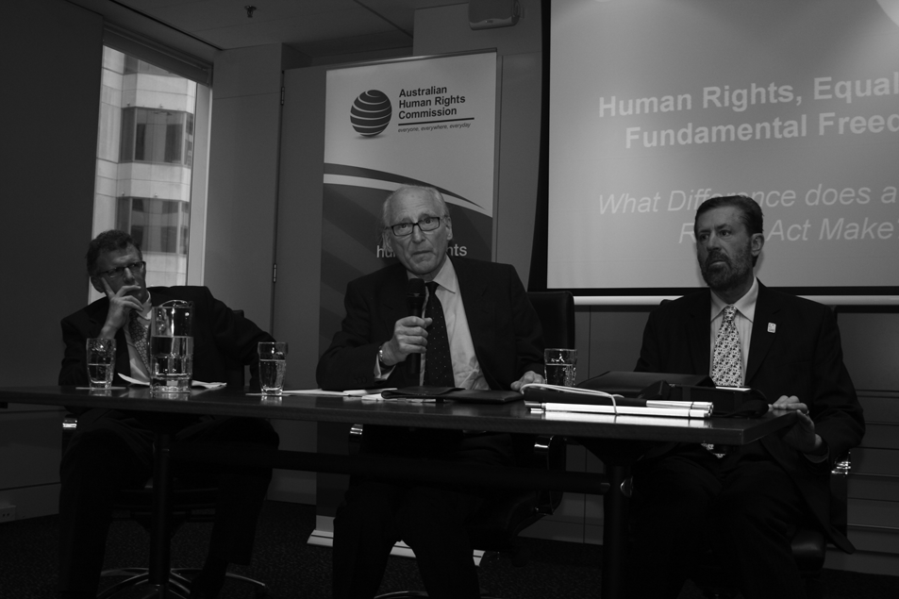
In December 2008, Professor David Kinley, Chair in Human Rights at the University of Sydney Faculty of Law and Lord Bingham, former Senior Law Lord of the House of Lords, were introduced as speakers by Human Rights Commissioner, Mr Graeme Innes, at the seminar, Human Rights, Equality and Fundamental Freedoms: What Difference Does a Human Rights Act Make?
5 March 2009: A Human Rights Act, the Courts and the Constitution
The Hon Michael McHugh AC, QC, distinguished jurist and former Justice of the High Court of Australia, presented his views on human rights in Australia and their protection through a Human Rights Act. The seminar was chaired by the President, Catherine Branson QC.
28 April 2009: The Constitution and a Human Rights Act
This seminar was conducted in conjunction with the Centre for Comparative Constitutional Studies at the University of Melbourne. It considered potential Constitutional issues raised by a Human Rights Act. The seminar was chaired by the President, Catherine Branson QC, and featured a panel of Professor Adrienne Stone, Mr Mark Moshinsky SC and Associate Professor Kristen Walker.

