Chapter 10:
Sex and Age Discrimination
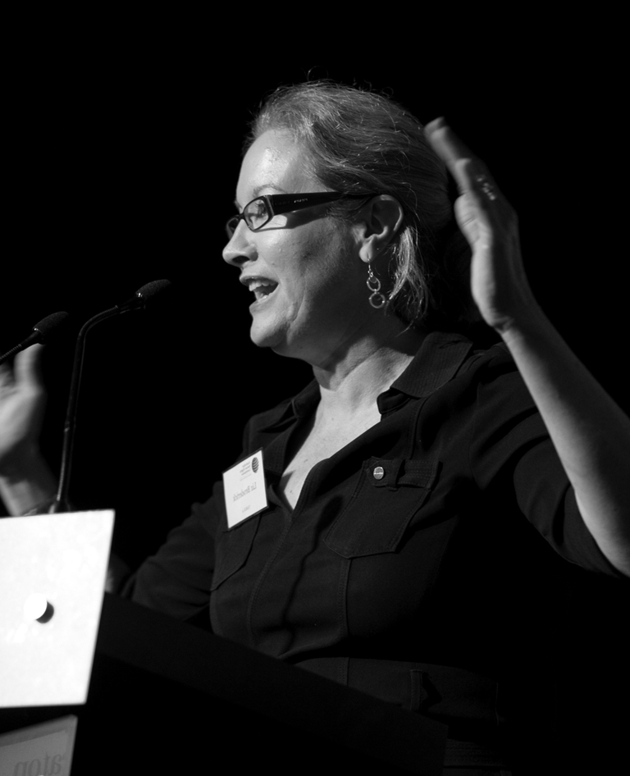
Elizabeth Broderick, Sex Discrimination Commissioner and Commissioner responsible for Age Discrimination

10.1 Statement from the Commissioner
This year marked the end of my nationwide Listening Tour and the beginning of what has been a busy but rewarding time in my term as Commissioner. I am delighted to report that it has been an exciting year for progressing gender and age equality in Australia.
The Listening Tour played an important role in setting the agenda for my term. In deciding where the Commission should focus its efforts, I was guided by three questions that emerged from the Listening Tour:

- what are the most important issues for individuals and stakeholders;
- where can the Commission have the greatest impact given our current political, social and economic context; and
- how can the Commission best complement the excellent work already being done by a great number of organisations?
On 22 July 2008, I released the Plan of action towards gender equality. With the resources available to me, this plan sets out the five areas of reform that would be pursued by the Commission during my term as Sex Discrimination Commissioner.
These priorities have been shaped by the stories I have heard from women and men across Australia. The diverse experiences of all women including Indigenous women, women with disability, women from culturally and linguistically diverse backgrounds, older women and younger women over their life cycle have underpinned our work in these areas. They will continue to do so for the remainder of my term as Commissioner.
A key achievement this year has been the Australian Government’s commitment to introduce a national Paid Parental Leave scheme starting in 2011. This significant milestone is the culmination of years of advocacy from Sex Discrimination Commissioners, past and present, unions, women’s groups, business representatives and individual women and men. The scheme is an important step towards building workplaces that enable both women and men to balance their paid work and family responsibilities.
The Senate Inquiry into the Effectiveness of the Sex Discrimination Act in eliminating sex discrimination and promoting gender equality was also a major development of the last year. It presented historic opportunities to assess how well the Sex Discrimination Act is addressing sex discrimination and sexual harassment experienced by individuals, as well as how effectively it is promoting gender equality in Australian society. The Commission made recommendations that were largely accepted by the Committee. If implemented, the changes will greatly enhance the capacity for the Sex Discrimination Act to achieve its objectives.
This year, on behalf of the Commission, I also had the privilege of supporting two inspirational women from Fitzroy Crossing for their attendance at the Commission on the Status of Women meeting at the United Nations in New York. On a global stage, they shared their courageous story of how the women in their community united to successfully address alcohol abuse and violence by lobbying for a ban on the sale of take-away full strength alcohol. Their presentation, told through the film, Yajilarra, was important for building international awareness of their successful community-based initiatives for combating family violence in Aboriginal and Torres Strait Islander communities. Their story received widespread interest from around the world and has inspired other communities struggling with endemic alcohol abuse and violence.
The establishment of key stakeholder relationships and identification of key priorities in the area of age discrimination has also been a priority of the last year. I have met with business groups, community groups, unions, academics and representatives from relevant government departments to seek feedback on current and emerging issues in the area. Based on these meetings, as well as research undertaken on age discrimination issues, I have, on behalf of the Commission, identified a number of policy reform priorities to remove workplace discrimination against mature age workers.
As we celebrate and reflect on this progress, it is important to consider the inequalities that remain in the areas of sex and age discrimination. Gender inequality remains a daily experience in Australia, and age-based discrimination and prejudice continues to affect the lives of many. With this in mind, I look forward to the challenges and opportunities of the year ahead.

10.2 Research and policy

10.2.1 The Listening Tour and Plan of action towards gender equality
The Sex Discrimination Commissioner completed a national Listening Tour in June 2008, the aim of which was to seek community and stakeholder views on gender equality in Australia. The findings of the Listening Tour were used then to inform the policy priorities of the Commissioner.
The Sex Discrimination Commissioner launched the Listening Tour Community Report, together with the Commissioner’s Plan of action towards gender equality, on 22 July 2008 at Sydney Girls’ High School. Approximately 200 key stakeholders attended the event, along with media.

The Plan of action towards gender equality identified five policy priorities for the Sex Discrimination Commissioner:
- Increasing the number of women in leadership positions,
including supporting Indigenous women’s leadership.
- Achieving greater balance between paid work and caring
responsibilities for men and women.
- Driving down the incidence and reducing the impact of
sexual harassment.
- Reducing the gender gap in retirement savings and
increasing women’s economic security over the lifecycle.
- Strengthening laws to address sex discrimination and
promote gender equality.
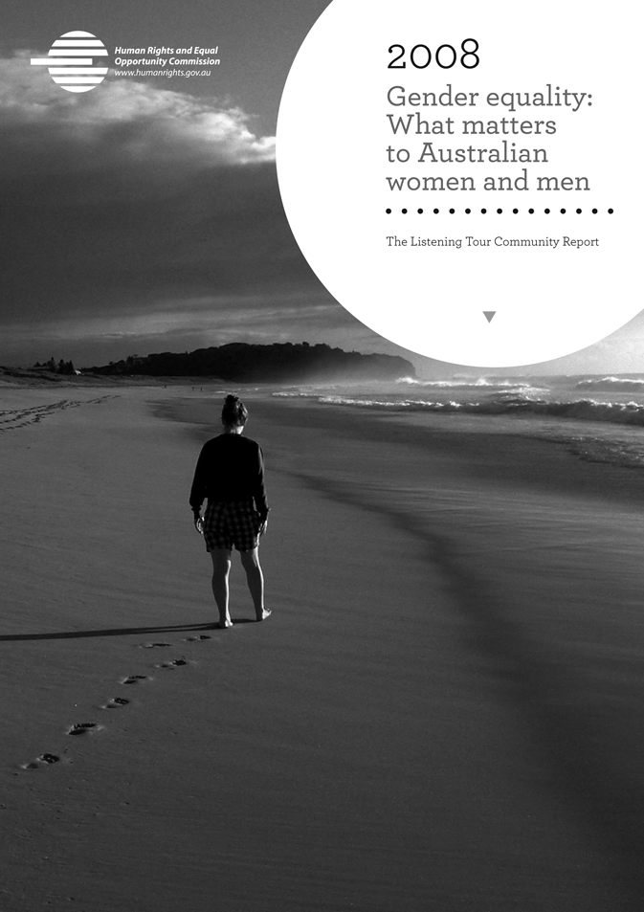
The Sex Discrimination Commissioner released the Listening Tour Community Report, Gender equality: what matters to Australian women and men at the launch of her Plan of action towards gender equality on 22 July 2008.

10.2.2 UN Commission on the Status of Women
The Commission participated as part of the Australian Delegation to the United Nations Commission on the Status of Women (CSW) 53rd Session in New York. CSW is the principal global policy-making body dedicated exclusively to gender equality and advancement of women. Every year, representatives of Member States gather at United Nations Headquarters in New York to evaluate progress on gender equality, identify challenges, set global standards and formulate concrete policies to promote gender equality and advancement of women worldwide.

10.2.3 Yajilarra: Aboriginal women leading change in remote Australia
On 4 March 2009, the Commission co-hosted a side event to the CSW Session with the Federal Office for Women. The side event featured June Oscar and Emily Carter from Marninwarntikura Women’s Resource Centre, who showed the documentary film, ‘Yajilarra’ (‘To Dream’ in the Bunuba language). Yajilarra is about their leadership in work to introduce alcohol restrictions, address family violence and build a better future for residents of Fitzroy Crossing in the Kimberley region of Australia.
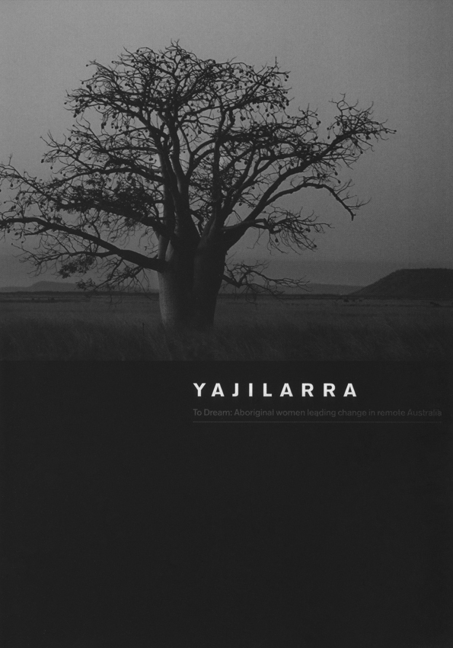
The Commission attended the UN Commission on the Status of Women in New York City and co-hosted a side event at which the film, Yajilarra, was screened.
This side event had a strong impact on the Session, as did the participation of
Ms Oscar and Ms Carter as NGO Delegates who, in a number of ways, significantly raised the awareness of Indigenous issues in Australia. These included interventions at the Asia-Pacific Caucus, participation on a panel addressing violence against women, attendance at the Pacific Region’s Reception at the New Zealand Mission and holding various informal meetings with representatives from global women’s leadership groups and delegates from the Pacific. The side event was very successful at illustrating to the world that Australia has entered a new phase in government relations with Indigenous people.
At the domestic level, Yajilarra has also raised awareness of the high incidence of Foetal Alcohol Spectrum Disorder in the Kimberley. The film has led to increased press coverage about the nature and extent of Foetal Alcohol Spectrum Disorder in Indigenous communities, in both Fitzroy Crossing and Halls Creek, and has raised awareness of the issue among health professionals.
In order to provide support and facilitate discussion about solutions to alcohol issues, the Commissioner travelled back to the Kimberley region of Western Australia in May 2009 to meet with community leaders from Halls Creek who are endeavouring to address alcohol abuse in their community.

10.2.4 NHRIs and CSW reform agenda
The Commission worked closely with the Asia-Pacific Forum of National Human Rights Institutions regarding efforts to achieve independent participation rights for National Human Rights Institutions in CSW. As a result, the Agreed Conclusions of the 53rd Session contain a number of paragraphs that incorporate new language on the role of NHRIs in CSW. The participation of the Commission, as well as the Aboriginal women from Australia who attended, made a direct contribution to this outcome.

10.2.5 Women of Influence Program
The Women of Influence Program is a pilot leadership program intended to strengthen women’s leadership and advance reconciliation between Aboriginal and Torres Strait Islander women and non-Indigenous women. The program is a joint project with the Indigenous Leadership Group in the Department of Families, Housing, Community Services and Indigenous Affairs (FaHCSIA).
The Commissioner and Ms Kerrie Tim from FaHCSIA jointly facilitated a workshop on women’s leadership. The workshop brought together 14 Indigenous community leaders and non-Indigenous corporate leaders. The objective of this workshop was to bring Indigenous and non-Indigenous female leaders together and to share their knowledge, skills and experience. It also aimed to demonstrate the strength and positive outcomes achievable through greater interaction and collaboration between Indigenous and non-Indigenous women.

10.2.6 What’s in it for women? – Women and human rights protection
in Australia
The Australian Government undertook a National Human Rights Consultation in 2009. This presented an historic opportunity for members of the Australian community to express their views on how human rights are and should best be understood and protected in Australia.
In order to support women’s participation in this significant consultation, the Commission partnered with the Queensland Working Women’s Service to hold a forum in Brisbane entitled, What’s in it for women? – women and human rights protection in Australia. The forum brought together over 80 women from a broad range of women’s organisations, including those that deal with homelessness, domestic violence, sexual assault, health, employment and community services, advocacy, human rights, Indigenous and environmental organisations, as well as feminist researchers and policy-makers.
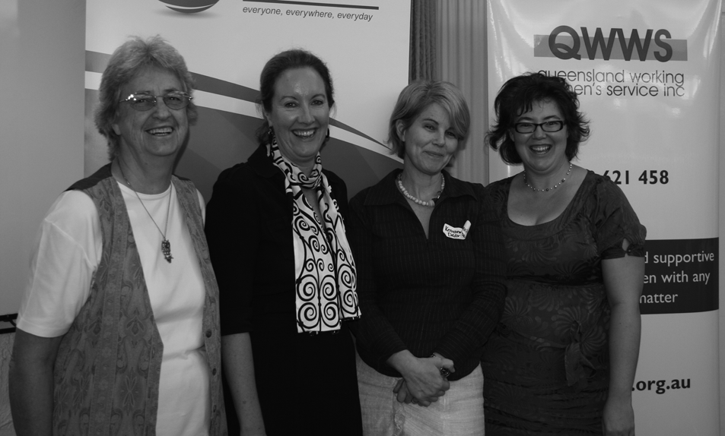
Co-hosted by the Commission and the Queensland Working Women’s Service, the What’s in it for women forum was held in Brisbane on 26 March 2009. Pictured (from right to left) are presenter, Dr Betty McLellan, Commissioner Broderick, her co-host, Ms Kerriann Dear and presenter, Dr Sue Harris-Rimmer.

The forum provided women with information that would assist them to participate fully in the Australian Government’s consultation. It included the opportunity to meet directly with a representative from the Consultation Committee in a special roundtable on the human rights issues facing women.

10.2.7 A national paid leave scheme for parents
A key priority for the last year has been the establishment of a national scheme of paid leave for parents. The Commission made two extensive written submissions to the Productivity Commission’s Inquiry into Paid Maternity Leave, Paternity Leave and Parental Leave. The submission drew on the Commission’s previous advocacy work for a national paid maternity leave scheme. The Sex Discrimination Commissioner was also involved in a number of collaborative events with business, unions and women’s organisations, that promoted the need for a national scheme.
In its submission to the Productivity Commission, the Commission proposed a two-staged approach that would achieve a world class scheme of paid leave for parents.
Stage one would provide 14 weeks of federally-funded paid maternity leave, as well as two weeks of supporting parent leave, to be implemented immediately. This first stage would be reviewed, within two years, against key objectives of the scheme. The intention of the review would be to extend entitlements to include paid parental leave, of which four weeks would be reserved for the supporting parent, to provide a total of one year’s paid leave for new parents. The Commission’s submission recognised paid maternity leave as a basic human right for working mothers. It also recognised the entitlement of fathers and other supporting parents to have paid leave in order to share in the care of babies in the crucial first year of their lives.
As part of ongoing advocacy work in the lead-up to the May 2009 Federal Budget, the Commissioner delivered a speech at the National Press Club entitled, Women on the verge of recession: Confronting gender issues in turbulent times. In order to highlight the importance of this policy reform, the Commissioner continued to liaise with a range of stakeholders, including the media, and to undertake speaking engagements. This work culminated in the Federal Budget announcement of funding for a Paid Parental Leave Scheme scheduled to commence in 2011.

10.2.8 Australian Research Council (ARC) Linkage Grants
Trends in Time – Work, Family and Social Policy in Australia 1992-2006: The Commission is an industry partner in this three-year project which is investigating trends in work and family time. The Project will draw on the 2006 ABS Time Use Survey. The Commission is providing in-kind assistance for this project.
Parental Leave in Australia – Access, utilisation and efficacy: This three-year project, in which the Commission was an industry partner, was recently completed. A final forum, Parental leave: Addressing impacts and refining policy, was held, featuring presentations which drew on this research. International speakers also offered comparative perspectives.

10.2.9 National sexual harassment telephone survey 2008
On 3 November 2008, Commissioner Broderick released Sexual harassment: Serious business, the results of the 2008 national telephone survey on sexual harassment. 2005 Telephone interviews were conducted with people aged 18 to 64. The sample of survey respondents was representative of the Australian population by age, gender and area of residence. The survey was based on a similar national telephone survey conducted by the Commission in 2003.
The survey found that sexual harassment continues to be a significant problem in Australian workplaces, despite a slight improvement since 2003. Further, the survey found that there is a lack of understanding as to what sexual harassment is, and that the large majority of sexual harassment is unreported. The report made recommendations in the areas of prevention and reporting of sexual harassment, better legal protection from sexual harassment, monitoring of sexual harassment, better support for victims of sexual harassment and further research on sexual harassment.

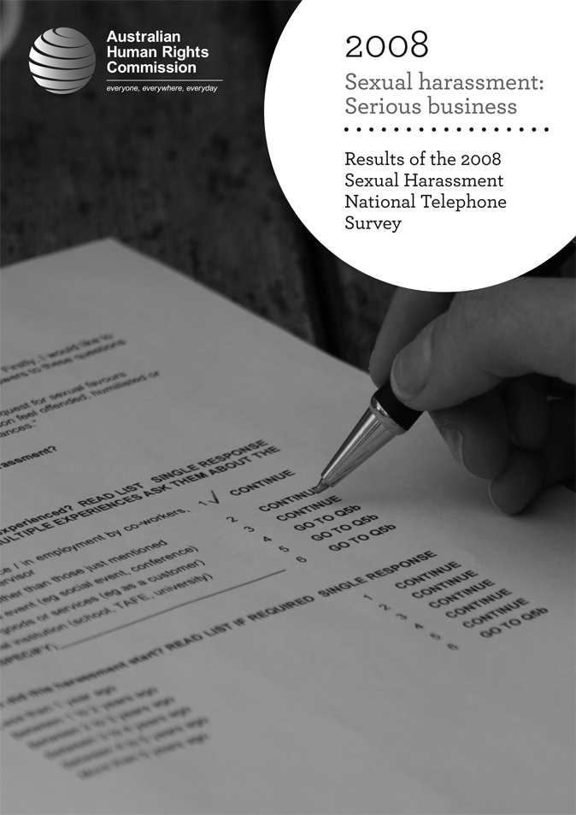
Sexual harassment: Serious business, the results of the 2008 national telephone survey on sexual harassment, was released on 3 November 2008.

10.2.10 Sexual harassment employer education
In November 2008, in collaboration with the Australian Chamber of Commerce and Industry, the Commission held a successful education forum for employers in Melbourne. The forum included a briefing on the results of the 2008 Sexual harassment national telephone survey, a session on creating positive workplace cultures and a session on the legal obligations of employers in relation to sexual harassment. The forum was attended by 90 employers.

10.2.11 Sexual Harassment Code of Practice and Quick Guide
The Commission launched the updated resource, Effectively preventing and managing sexual harassment in the workplace: A Code of Practice for employers, together with a new Quick Guide, designed particularly for small employers. The products were launched as part of an employer forum held in partnership with the Australian Chamber of Commerce and Industry in November 2008.

10.2.12 The gender gap in retirement savings
As part of the Australian Government’s review of Australia’s tax system, the Commission lodged a submission in response to the Retirement Income System discussion paper. During development of the submission and its recommendations, the Commission liaised with key researchers and key stakeholders, including women’s organisations.
Drawing upon the Commission’s previous policy work, the submission made a number of recommendations to redress women’s disadvantage in the current retirement income system and increase women’s financial security in retirement. The Commissioner continues to advocate for reform, particularly through ongoing speeches and media opportunities.
The Commission began work on an issues paper which will set out the data on the gender gap in retirement savings and retirement income, the implications of the gender gap, the contributing factors to the gender gap and potential policy solutions. The issues paper will be published online and disseminated widely as a sector resource for ongoing advocacy in the area.

10.2.13 House of Representatives Inquiry into Pay Equity
The Commission lodged a submission and attended the oral hearing for the House of Representatives Inquiry into Pay Equity and other issues associated with women’s workforce participation.
The Commission made a number of recommendations, including expanding protection from discrimination on the grounds of family responsibilities, improving data collection and monitoring of the gender pay gap and enhancing legal provisions to address pay inequity.
The Commission welcomed the incorporation of its recommendations about the legislative framework to address pay inequity in the Fair Work Act 2009 (Cth). The Inquiry is due to report in late 2009.

10.2.14 Senate Legal and Constitutional Affairs Committee Inquiry into
the Effectiveness of the Sex Discrimination Act 1984 in Eliminating Discrimination and Promoting Gender Equality
The Commissioner welcomed this Inquiry, which provided a historic opportunity to modernise the Sex Discrimination Act 1984 (Cth) and develop a strong legal framework for promoting substantive gender equality in Australia. The Inquiry also has the potential to impact on future reform of other federal anti-discrimination laws, harmonisation of federal and state and territory jurisdictions, and the Australian Government’s National Human Rights Consultation.
The Commission made a comprehensive submission to this Inquiry, recommending several priority areas for reform, including:
- extending protection for family responsibilities
- ensuring equal coverage for men
- removing discriminatory provisions for same-sex couples
- broadening standards for legal action under the
Sex Discrimination Act to public interest organisations
- removing the exemption for state instrumentalities.
The Commission has now welcomed the release of the Senate Committee report into the above Inquiry. Broadly, the Committee has adopted the vast majority of the wide-ranging recommendations in the Commission’s submission.

10.2.15 Independent monitoring of gender equality in Australia
The Commissioner continues to liaise with the Minister for the Status of Women, the Federal Office for Women and key external stakeholders about the Commission’s role in regularly monitoring key gender equality indicators at a national level.
A recommendation for the establishment of comprehensive gender equality benchmarks and regular independent monitoring and reporting on gender equality was included in the Commission’s submission to the Senate Inquiry into the Effectiveness of the Sex Discrimination Act 1984 in Eliminating Discrimination and Promoting Gender Equality. The recommendation was supported in the Inquiry Report.
The Commissioner continues to advocate for increased funding to enable this monitoring work to be undertaken. For example, this advocacy is done through the Oral Hearing in the House of Representatives Inquiry into Pay Equity, meetings with Ministers and with external advocates.

10.2.16 Violence against women and children
The Commission met with members of the National Council to Reduce Violence against Women and Children and provided information on gender-based violence and human rights to inform their work. The Commission also provided input into the development of the proposed National Plan to Reduce Violence Against Women and Children, based on the findings of the Listening Tour.
The Commission welcomed the Australian Government’s commitment to develop a National Plan to Reduce Violence Against Women in response to the Time for Action: The National Council’s Plan for Australia to Reduce Violence against Women and their Children, 2009-2021.
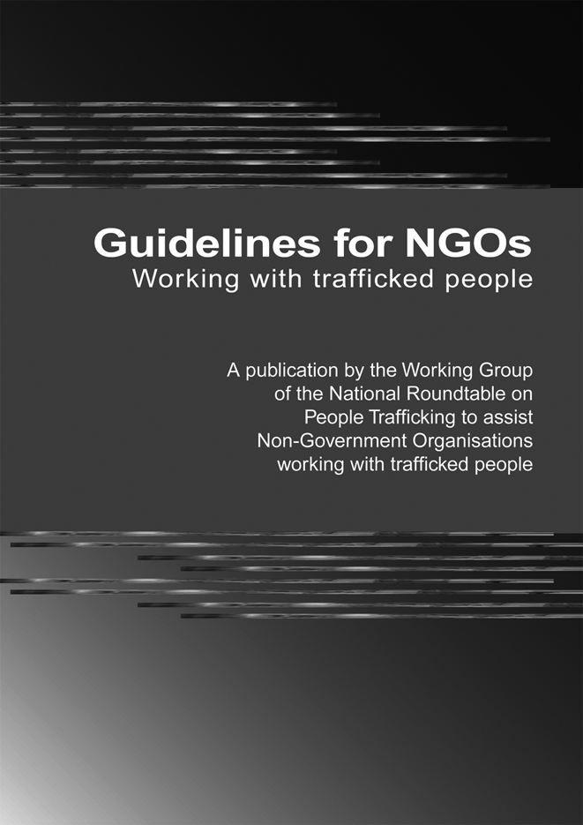
The Sex Discrimination Commissioner was part of a Working Group established at the first meeting of the National Roundtable on People Trafficking, which developed the Guidelines for NGOs working with trafficked people, released on 3 March 2009.

10.2.17 Trafficking in women
This year, the Commission continued its advocacy in the area of human trafficking. The Commissioner chaired the Working Group of the National Roundtable on People Trafficking, which produced best practice guidelines for NGOs working with trafficked persons.
Following representations from the Roundtable, the Australian Government recently announced a reform of the visa framework to ensure, not only a law enforcement response, but to better support trafficked people through a human rights based framework.

10.3 Age Discrimination

10.3.1 Mature Workers Mean Business public awareness campaign
In July 2008, based on social research undertaken for it, the Commission launched a print media and web-based campaign to promote the benefits of employing mature age workers. The Mature Workers Mean Business campaign includes positive case studies from mature age workers and their employers, and addresses a range of myths and stereotypes regarding older workers. The campaign also highlights the relevance of age discrimination protections in the workplace.

10.3.2 Mature age workers consultation strategy
During 2008-09, the Commissioner met with key stakeholders about mature-age discrimination and workforce participation. These meetings included a cross-section of groups such as business groups, community groups and service providers, unions, academics and representatives of relevant government departments.
This process proved invaluable in terms of identifying priority areas for future project and policy development. Based on these consultations the following have emerged as key issues:
- skills and re-training of mature age workers
- the impact of unpaid work and care on workforce participation
- age-based stereotypes in the pre-employment and employment context
- the adequacy of the current regulation of age discrimination in both the federal Age Discrimination Act and the broader regulatory framework
- the nature and extent of age-related discrimination and mature age workers.
As part of this process, the Commission has commenced a comprehensive review of academic and statistical material on these issues. This represents important foundational work, which will assist determination of the Commission’s strategic priorities for promotion of a substantive equality agenda on age discrimination and mature age workers.

10.3.3 Attorney-General’s Key Agencies Reference Group
on Age Discrimination
The Commission participated in the federal Attorney-General’s Key Agencies Reference Group on Age Discrimination (KARG). KARG is a high-level, cross-departmental information sharing forum which has been established as part of a ‘whole of government’ approach to age discrimination.

10.4 International activities

10.4.1 Optional Protocol to the Convention on the Elimination
of All Forms of Discrimination Against Women
The Commission advocated for the Australian Government to ratify the Optional Protocol to the Convention on the Elimination of All Forms of Discrimination Against Women (CEDAW) in order to strengthen the legal protection afforded to women under the Convention. The Optional Protocol allows people to bring a complaint to the CEDAW Committee about an alleged breach of their rights under CEDAW. In November 2008, the Commission welcomed the Australian Government’s intention to become party to the Optional Protocol, which entered into force in March 2009.

10.4.2 CEDAW community education
In December 2008, the Commissioner and the Minister for the Status of Women launched a revised CEDAW education kit. The copyright of the publication is jointly owned by the Federal Office for Women and the Commission.

10.5 Exemptions under the Sex and Age Discrimination Acts

10.5.1 Deli Women and Children’s Centre
The Deli Women and Children’s Centre applied for a temporary exemption pursuant to section 44(1) of the Sex Discrimination Act. Deli Women and Children’s Centre is a non-profit incorporated association which services women, children and families in the Sydney metropolitan area. The Centre provides a range of individual and group services, with particular focus on domestic violence, children’s services and family support. Services include individual and group counseling and casework services, a playgroup, parenting support and family support.
The Centre applied for an exemption from section 14 (discrimination in employment or in superannuation) in relation to the employment of female staff for the Centre’s therapeutic and children’s services. It also applied for an exemption from section 22 (goods, services and facilities), in relation to the provision of the Deli’s therapeutic services to female clients only.
The application is still under consideration by the Commission.

10.5.2 BoysTown
BoysTown applied for two temporary exemptions pursuant to section 44(1) of the Sex Discrimination Act. BoysTown is a non-profit company that provides a range of counselling and community services around Australia. The exemptions were sought for the organisation’s operations in the Tjurabalan region of Western Australia.
The organisation applied for a exemption for five years from section 14 (discrimination in employment or in superannuation), in relation to the employment of a male youth construction worker to work in the Tjurabalan region. It also applied for an exemption for five years from section 14 (discrimination in employment or in superannuation), in relation to the employment of a female Youth and Family Worker in the Tjurabalan region.
In response to a request for further information to support the application, BoysTown informed the Commission that the project was on hold. As no further information was provided from BoysTown, the application has been treated as being discontinued.

10.5.3 Carnival Australia
In April 2009, Carnival Plc (trading as Carnival Australia) made an application for a temporary exemption under the Age Discrimination Act. Carnival Australia is one of Australia’s leading cruise companies and is the operator of 12 cruise brands (including P&O Cruises Australia).
The temporary exemption is sought to enable Carnival Australia to restrict the ability of persons aged under 21 years of age from taking part in cruises, without a parent or guardian, during the period of 1 November to 30 January. Carnival Australia describes these months as the traditional ‘Schoolies’ period. The application does not specify a specific period of time for which the exemption is requested.
In June 2009, the Commission made a request for further information from Carnival Australia. This information was received in July 2009.
The Commission also invited a number of organisations to make a submission in response to the temporary exemption application, including other cruise companies, peak youth advocacy organisations, and anti-discrimination tribunals and Commissions in the States and Territories. The Commission received five submissions, one of which was received in-confidence. The remaining four applications were posted on the Commission’s website. Carnival Australia was provided with a copy of all five submissions and given 21 days to respond to matters raised in the submissions. Once that time has elapsed, the Commission will consider Carnival Australia’s response, and proceed to make a determination on the application for a temporary exemption.

10.6 Legislative development
The Commission contributes to legislative development by making written and oral submissions to parliamentary and other inquiries. A list of these submissions can be found in Chapter 3: Monitoring Human Rights.

10.7 Speeches
The Sex Discrimination Commissioner and her staff made over 60 speeches during 2008-09. A selection of these can be accessed on the Commission’s website at: www.humanrights.gov.au/about/media/speeches/sex_discrim/index.html.
The following is a selection of speeches presented by the Commissioner:
Gender Equality in 2008: What Matters to Australian Women and Men – Launch of the Listening Tour Community Report and Plan of action towards gender equality, Sydney, 22 July 2008.
Trafficking: The Need for a Human Rights-based Approach – Inaugural
Anti-trafficking Forum, Sydney, 24 July 2008.
Who Cares?: Managing Flexibility in the Workplace – 20th Women, Management and Employment Relations Conference, Sydney, 24 July 2008.
The Case for a National Scheme of Paid Leave for Parents – Law Institute Victoria breakfast series, Melbourne, 10 September 2008.
Slavery in the 21st Century: A Human Rights Challenge – Modern Day Slavery in Australia Seminar, Sydney, 10 October 2008.
Women’s Achievements: Untold Stories – National Council of Jewish
Women Luncheon, Melbourne, 12 November 2008.


The Sex Discrimination Commissioner launched her Plan of action towards gender equality at Sydney Girls’ High School on 22 July 2008. One of the speakers at the event was the school’s Public Speaking Captain, Ms Lucy Connell.
Sexual Harassment: Serious Business – Sexual Harassment Employer Forum, Australian Chamber of Commerce and Industry, Melbourne,
12 November 2008.
The Listening Tour Community Report – Gender Equality: What Matters to Australian Women and Me – Committee for Economic Development Australia Boardroom Luncheon, Adelaide, 13 November 2008.
Women and Leadership – The 2008 Australian Regional Women Leaders Convention, Melbourne, 19 November 2009.
Busting the Myths about Part Time Work – New South Wales Quality Part Time Work Round Table, Sydney, 19 February 2009.
Why Supporting Employees to Balance Paid Work and Caring Responsibilities is Smart Economics, American Chamber of Commerce Business Briefing, Sydney, 24 March 2009.
What’s in it for Women? Women and Human Rights Protection in Australia – What’s in it for Women Forum, Canberra, 26 March 2009.
Women and Human Rights Protection in Australia – Women and Human Rights: Time to speak up! PIAC and UTS Seminar, Sydney,
8 April 2009.
Women on the Verge of Recession: Confronting Gender Issues in Turbulent Times – National Press Club, Canberra, 29 April 2009.
Is Poverty the Reward for a Life Spent Caring? – Women in Super (NSW) Luncheon, Sydney, 30 April 2009.
Speech to the Australian Institute of Criminology – (Non-sex industry) labour trafficking: A forum to discuss trafficking in persons in contexts other than the commercial sex industry, Sydney, 18 June 2009.
Cultural Diversity in an Ageing Workforce – Ageing and Cultural Diversity Forum, Centre for Cultural Diversity in Ageing, Melbourne,
22 June 2009.

