Chapter 1:
The Australian Human
Rights Commission

1.1 Vision
Human rights: everyone, everywhere, everyday

1.2 Mission
Leading the promotion and protection of human rights in Australia by:
- making human rights values part of everyday life
and language
- empowering all people to understand and exercise
their human rights
- working with individuals, community, business and
government to inspire action
- keeping government accountable to national and
international human rights standards
- securing an Australian charter of rights.
We do this by:
- listening, learning, communicating and educating
- being open, expert, committed and impartial
- fostering a collaborative, diverse, flexible, respectful
and innovative workplace.

1.3 New Strategic Plan
In September 2008, the Commission launched its strategic plan for 2008-11.
This strategic plan is the result of HREOC21, the inclusive, Commission-wide planning process described in the 2007-08 Annual Report.
The objective of the Commission’s new strategic plan is to build on the Commission’s strengths so that it is in a better position to help build an Australian culture where human rights are understood, respected and enjoyed by ‘everyone, everywhere, everyday’.
To this end, the Commission has identified five strategic goals to guide all of its work.
Those five goals are:
Leadership
We exercise a leadership role in human rights in Australia by being visible, courageous and influential on human rights issues.
Empowerment
We support and inspire others to engage in meaningful activity on human rights.
Education
We assist all people in Australia to understand and exercise their rights and respect the rights of others.
Monitoring
We hold individuals, organisations and government responsible for their human rights obligations.
Innovation
We have a collaborative, innovative and supportive work culture that enhances the quality and impact of our work.
Flowing from the strategic plan, there have been a number of internal and external changes to the way the Commission works. For example, the Commission has:
- rebranded itself with a new name (Australian Human Rights Commission replaces the Human Rights and Equal Opportunity Commission), a modernised logo and a fresh and consistent design for all external publications
- a stronger focus on reaching new and broader audiences, and to this end, has incorporated the use of new media and social marketing strategies into its communications plan
- a stronger emphasis on developing strong and sustainable partnerships and alliances with new and existing partners, as a way to increase the breadth and depth of our impact
- launched a new intranet platform to improve internal communications
- developed more synchronised and collaborative internal planning processes.
In summary, the Commission has a stronger and clearer focus on: providing leadership on human rights issues in Australia; educating a more diverse group of people in Australia to understand the relevance of human rights to their everyday lives; and engaging those people to help create a stronger human rights culture in Australia.

1.4 Structure
The Commission is a national independent statutory body established under the Human Rights and Equal Opportunity Commission Act 1986 (see section 1.5.1 on page 7). It has a President and five Commissioners. The five positions are currently held by three persons.
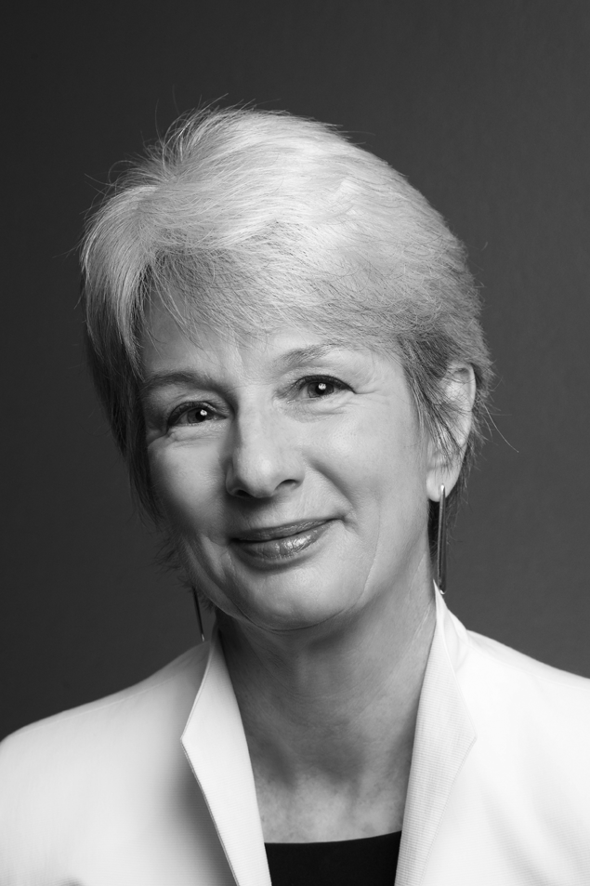

1.4.1 President – The Hon. Catherine Branson, QC
The Hon. Catherine Branson was appointed President of the Commission on
7 August 2008 and commenced her five-year term on 14 October 2008.
At the time of her appointment, she was a judge of the Federal Court of Australia, a position she had held since 1994. The jurisdiction of the Federal Court includes jurisdiction to hear and determine complaints alleging unlawful discrimination under Commonwealth anti-discrimination laws.
Justice Branson was the inaugural convenor of the Federal Court’s Equality and the Law Committee, which was created in 1997. She was also the inaugural convenor of the Court’s Human Rights Panel for New South Wales.
At the time of her appointment to the Federal Court, Ms Branson was a member of the Board of Examiners of the Supreme Court of South Australia, a council member of the University of South Australia and a Trustee of the Adelaide Festival Centre Trust. She had earlier been Deputy Chair of the Adelaide Medical Centre for Women and Children and a member of the National Women’s Advisory Council.
Ms Branson is a past President of the Australian Institute for Judicial Administration and a former member of the Board of Management of IDLO
(a governmental organisation based in Rome enjoying observer status at the United Nations). She is a member of the International Association of Judges and the International Association of Refugee Law Judges (and was until recently convenor of the association’s Human Rights Nexus Working Party).
Prior to her appointment as a judge, she practised as a barrister at the Adelaide Bar in South Australia, principally in the areas of administrative law, including discrimination law, and commercial law. She was appointed Queen’s Counsel in 1992.
Between 1984-89, she was Crown Solicitor of South Australia and the CEO of the South Australian Attorney-General’s Department.
Ms Branson holds a Bachelor of Arts and a Bachelor of Laws from the University of Adelaide.
(In addition to her role as President, Ms Branson was appointed Human Rights Commissioner on 13 July 2009).

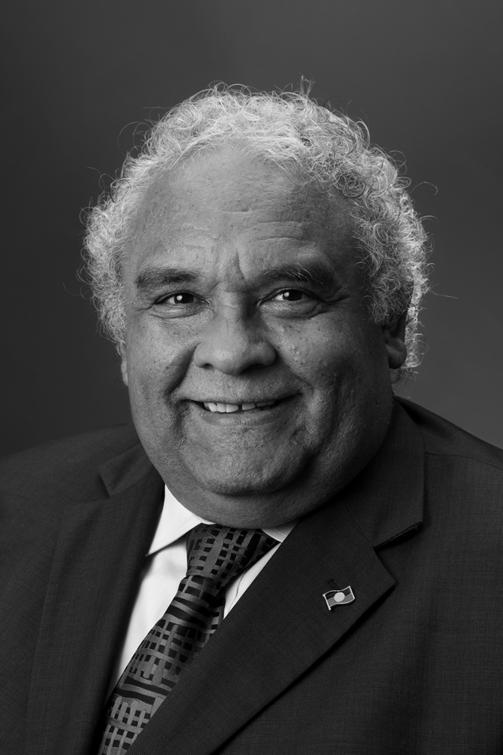

1.4.2 Aboriginal and Torres Strait Islander Social Justice Commissioner and Race Discrimination Commissioner – Mr Tom Calma
Mr Calma is an Aboriginal elder from the Kungarakan tribal group and a member of the Iwaidja tribal group whose traditional lands are south west of Darwin and on the Coburg Peninsula in Northern Territory, respectively. He has been involved in Indigenous affairs at a local, community, state, national and international level and worked in the public sector for over 35 years.
Mr Calma has broad experience in public administration, particularly in Indigenous education programs and in developing employment and training programs for Indigenous people from both a national policy and program perspective.
He served three terms as a Director of Aboriginal Hostels Ltd and as a Company Director for a private tourism and hospitality venture in the Northern Territory.
Until his appointment as Commissioner, on 12 July 2004 for five years,
Mr Calma managed the Community Development and Education Branch at Aboriginal and Torres Strait Islander Services where he worked with remote Indigenous communities to implement community-based and driven empowerment and participation programs. In 2003, he was Senior Adviser Indigenous Affairs to the Minister of Immigration, Multicultural and Indigenous Affairs.
From 1995-2002, he worked as a senior Australian diplomat in India and Vietnam representing Australia’s interests in education and training. During his time in India, he also oversaw the management of the Australian international education offices in Pakistan, Nepal and Sri Lanka.
He moved to Canberra in 1992 and undertook various assignments, including Executive Director to the Secretary and Senior Executive of the Department of Employment, Education, Training and Youth Affairs (DEETYA).
In the early 1980s, Mr Calma and Indigenous colleagues established the Aboriginal Task Force (ATF) at the Darwin Community College (which later became the Darwin Institute of Technology), which provided second chance education programs for Indigenous people. He became a senior lecturer and head of the ATF for six years.
He has also served as Race Discrimination Commissioner from 12 July 2004 until 12 July 2009.
In this role Mr Calma has convened three Australia/New Zealand Race Relations Roundtables and launched significant papers including the Voices publication as part of the 30th anniversary celebrations for the Racial Discrimination Act in 2005.
He has produced two Face the facts publications providing factual information about Australia’s cultural diversity and conducted the Unlocking Doors project with police and Muslim communities in 2006-07.
Mr Calma presented a Multiculturalism Position Paper in August 2007 to reinvigorate community debate and government commitment to multiculturalism. More recently, he launched the Freedom of religion and belief in the 21st century project in September 2008 and has undertaken a major project researching the needs of African Australians.
Commissioner Calma has been a White Ribbon Day Ambassador since 2005. White Ribbon Day is the International Day for the Elimination of Violence Against Women. Commissioner Calma has also been a national patron of the Wakakirri National Story Festival since 2006.
Mr Calma was awarded the prestigious number one position in the Indigenous category for The Bulletin magazine’s Power 100 for 2007. The Power 100 selects the 100 most powerful people in Australia. It is judged by a group of 10 who select people they consider share one common trait – the ability and desire to drive change.
Mr Calma was also awarded the 2008 Man of Inspiration award in GQ Australia magazine’s 2008 Man of the Year awards.
(In July 2009, Mr Calma’s term as Social Justice Commissioner was extended for six months until the end of January 2010).


1.4.3 Human Rights Commissioner and Disability Discrimination
Commissioner – Mr Graeme Innes, AM
Mr Innes has been Australia’s Human Rights Commissioner and Disability Discrimination Commissioner for over three years.
As Commissioner, he has led or contributed to initiatives including: the Same Sex: Same Entitlements inquiry, achieving removal of discrimination against same sex couples and their children across federal law; drafting of the United Nations Convention on the Rights of Persons with Disabilities, and ratification by Australia; three inspections of Australia’s immigration detention facilities; and development of a National Disability Strategy.
Mr Innes is a lawyer, mediator and company director. He has been a human rights practitioner for almost 30 years in NSW, WA and nationally.
Mr Innes has been a Member of the NSW Administrative Decisions Tribunal, the NSW Consumer, Trader and Tenancy Tribunal; and the Social Security Appeals Tribunal, as well as a Hearing Commissioner with the Australian Human Rights Commission.
Mr Innes was Chair of the Disability Advisory Council of Australia, and the first Chair of Vision Australia, Australia’s national blindness agency. He has been one of Australia’s delegates to the World Blind Union, and the President of its Asia-Pacific region.
Mr Innes has been a consultant on disability issues to organisations such as Westpac, Qantas, and Sydney Water. He has also been a Councillor on Ku-ring-gai Local Council.
In 1995, Mr Innes was made a Member of the Order of Australia (AM) for his contribution to Australia’s disability discrimination legislation. He was a finalist for Australian of the Year in 2003.
Mr Innes is married with an adult son and a daughter in primary school. He enjoys cricket (as a spectator) and sailing (as a participant), and relaxes by drinking fine Australian white wine.
(Mr Innes completed his term as Human Rights Commissioner on 12 July 2009 and was appointed Race Discrimination Commissioner for a three-year term on 13 July 2009).



1.4.4 Sex Discrimination Commissioner and Commissioner responsible
for Age Discrimination – Elizabeth Broderick
On 10 September 2007, Ms Broderick was appointed Sex Discrimination Commissioner and Commissioner responsible for Age Discrimination for a five-year term.
A lawyer and businesswoman, Ms Broderick was the 2001-02 Telstra NSW Business Woman of the Year and Australian Corporate Business Woman of the Year.
Prior to her appointment as Sex Discrimination Commissioner and Commissioner responsible for Age Discrimination, Ms Broderick was a partner at one of Australia’s leading law firms, Blake Dawson, and developed the firm’s business case for flexibility in the workplace. Her efforts contributed to creating a workplace where more than 20 percent of the law firm’s workforce now uses flexible work arrangements.
Ms Broderick has travelled the length and breadth of Australia, listening to the concerns of women and men about gender equality and age discrimination. In 2009, she took a group of Aboriginal women to the United Nations Commission on the Status of Women in New York City, where they told their story of rebuilding their community following years of alcohol abuse. This opportunity enabled community women’s voices to be heard on a global stage.
Ms Broderick is an advisor on women’s issues to the Australian Chief of the Defence Force, a member of the University of Technology Sydney (UTS) Advisory Board and the Vic Health Advisory Board. She is patron of the Tasmanian Education Foundation.
Ms Broderick is married and has two young children.

1.5 Legislation
The Commission is responsible for administering the following Acts:
- Human Rights and Equal Opportunity Commission Act 1986
(Human Rights and Equal Opportunity Commission Act)
- Racial Discrimination Act 1975 (Racial Discrimination Act)
- Sex Discrimination Act 1984 (Sex Discrimination Act)
- Disability Discrimination Act 1992 (Disability Discrimination Act)
- Age Discrimination Act 2004 (Age Discrimination Act).
Functions performed under these Acts are vested in the Commission as a collegiate body, in the President or individual members of the Commission or in the federal Attorney-General.
Other legislation administered through the Commission includes functions under the Native Title Act 1993, performed by the Aboriginal and Torres Strait Islander Social Justice Commissioner. The Sex Discrimination Commissioner has functions in relation to federal awards and equal pay under the Workplace Relations Act 1996.

1.5.1 Human Rights and Equal Opportunity Commission Act
The Human Rights and Equal Opportunity Commission Act established the Commission and outlines its powers and functions. Human rights are strictly defined, and only relate to the international instruments scheduled to, or declared under, the Act. They are the:
- International Covenant on Civil and Political Rights
- Convention on the Rights of the Child
- Declaration on the Rights of the Child
- Declaration on the Rights of Disabled Persons
- Declaration on the Rights of Mentally Retarded Persons
- Declaration on the Elimination of All Forms of Intolerance
and of Discrimination Based on Religion or Belief
- Convention Concerning Discrimination in Respect of
Employment and Occupation.
For further information about these international instruments, see Appendix 1.
(On 25 June 2009, Parliament passed the Disability Discrimination and Other Human Rights Amendment Act 2009 (Cth) which, among other things, changed the name of the Human Rights and Equal Opportunity Commission Act to the Australian Human Rights Commission Act 1986 (Cth). This change commenced operation on 5 August 2009).

1.5.2 Racial Discrimination Act
The Racial Discrimination Act gives effect to Australia’s obligations under the International Convention on the Elimination of All Forms of Racial Discrimination.
Its main aims are to:
- promote equality before the law for all persons, regardless
of their race, colour or national or ethnic origin
- make discrimination on the basis of race, colour, descent
or national or ethnic origin, unlawful
- provide protection against racial hatred.

1.5.3 Sex Discrimination Act
The Sex Discrimination Act gives effect to Australia’s obligations under the Convention on the Elimination of All Forms of Discrimination Against Women and certain aspects of the International Labour Organization (ILO) Convention 156.
Its main aims are to:
- promote equality between men and women
- eliminate discrimination on the basis of sex, marital status
or pregnancy, and family responsibilities
- eliminate sexual harassment at work, in educational institutions, in the provision of goods and services, accommodation and in the delivery of Commonwealth programs.

1.5.4 Disability Discrimination Act
The objectives of the Disability Discrimination Act are to:
- eliminate discrimination against people with disabilities as far as is possible
- promote community acceptance of the principle that people with disabilities have the same fundamental rights as all members of the community
- ensure as far as practicable that people with disabilities have the same rights to equality before the law as other people in the community.

1.5.5 Age Discrimination Act
The objectives of the Age Discrimination Act are to:
- promote equality before the law for all persons regardless of their age
- eliminate discrimination against persons on the ground of age in many areas of public life such as employment, education and the provision of services or facilities
- change negative stereotypes about older people.

1.6 Functions and powers
The Commission has a range of functions and powers under federal legislation, which can be grouped into four main areas:
- providing education and raising public awareness about human rights
- handling complaints of discrimination and breaches of human rights
- researching human rights issues and contributing to policy developments
- legal advocacy on human rights issues.
The Commission exercises its functions in a variety of ways, including those listed below.
The Commission investigates and conciliates complaints of discrimination or breaches of human rights under federal laws.
The Commission has developed an extensive and accessible website containing research, publications, resources and education programs designed for young people, teachers, community groups, business, media and the community at large. The website is one of the Commission’s primary education and awareness tools.
The Commission works closely with print, radio, television and new media to raise public awareness about important human rights issues and to promote human rights as broadly as possible.
The Commission works closely with organisations and leaders in the community, government and business sectors to provide education on relevant human rights issues and to support them in their efforts to better protect and promote human rights.
When the Commission identifies a systemic human rights issue of national importance, the Commission can hold public inquiries and consultations to research the problem and identify relevant, practical and principled solutions.
The Commission works closely with the federal parliament and government to provide independent advice regarding the development of laws, programs and policies that will better protect and promote human rights.
The Commission publishes annual reports on Aboriginal and Torres Strait Islander social justice and native title.
The Commission makes submissions to parliamentary and other inquiries in order to identify human rights issues which may arise in proposed or existing laws and policies.
The Commission works in the legal system through education focussed on legal professionals and by appearing as an intervener or as amicus curiae in cases that involve human rights.
The Commission works at an international level to engage and support national human rights institutions around the world, particularly through the Asia-Pacific Forum of National Human Rights Institutions. The Commission also works on human rights technical co-operations programs in China and Vietnam.

1.7 Specific functions of the President and Commissioners
In addition to the broad functions outlined above, the President, the Aboriginal and Torres Strait Islander Social Justice Commissioner and the Sex Discrimination Commissioner have specific responsibilities.

1.7.1 President
The President is the Chief Executive Officer of the Commission, responsible for its financial and administrative affairs. The President is also responsible for the complaint handling function of the Commission.

1.7.2 Aboriginal and Torres Strait Islander Social Justice Commissioner
The Aboriginal and Torres Strait Islander Social Justice Commissioner, under the Human Rights and Equal Opportunity Commission Act, prepares an annual report on the exercise and enjoyment of human rights of Indigenous people and undertakes social justice education and promotional activities.
The Commissioner also performs reporting functions under the Native Title Act 1993. This includes preparing an annual report on the operation of the Act and its effect on the exercise and enjoyment of human rights of Indigenous people. In addition, the Commissioner reports, when requested by the Minister, on any other matter relating to the rights of Indigenous people under this Act.

1.7.3 Sex Discrimination Commissioner
The Workplace Relations Act 1996 gives the Sex Discrimination Commissioner the power to initiate and refer equal pay cases to the Australian Industrial Relations Commission.

1.7.4 Amicus Curiae
Section 46PV of the Human Rights and Equal Opportunity Commission Act gives Commissioners an amicus curiae (‘friend of the court’) function. The role of an amicus curiae is to provide special assistance to a court in resolving issues raised by a case and to draw attention to aspects of the case that might otherwise have been overlooked.
Under this function, the Aboriginal and Torres Strait Islander Social Justice Commissioner, the Disability Discrimination Commissioner, the Human Rights Commissioner, the Race Discrimination Commissioner and the Sex Discrimination Commissioner may seek the permission of the Federal Court, or Federal Magistrates Court, to assist the court as amicus curiae in the hearing of unlawful discrimination applications.

1.8 The Minister
The Attorney-General, the Honourable Robert McClelland MP, is the Minister responsible in Parliament for the Commission. He has a number of powers under the Human Rights and Equal Opportunity Commission Act.

The most significant are:
- to make, vary or revoke an arrangement with states or territories for the performance of functions relating to human rights or to discrimination in employment or occupation
- to declare, after consultation with the states, an international instrument to be one relating to human rights and freedoms for the purposes of the Act
- to establish an advisory committee (or committees) to advise the Commission in relation to the performance of its functions. The Commission will, at his request, report to him on Australia’s compliance with International Labour Organization Convention 111 and advise him on national policies relating to equality of opportunity and treatment in employment and occupation.

1.9 Outcome structure
The Commission has one outcome:
An Australian society in which the human rights of all are respected, protected and promoted.
There is one output for the Commission’s outcome:
Australians have access to independent human rights complaint handling and public inquiries processes and benefit from human rights education, promotion and monitoring and compliance activities.

Table 1: Resources for outcome
Outcome 1 – An Australian society in which human rights are respected, protected and promoted through independent investigation and resolution of complaints, education and research to promote and eliminate discrimination, and monitoring, and reporting on human rights.
 | Budget*  2008-09  $’000 | Actual Expenses 2008-09 $’000 | Variation $’000
 | (a) | (b) | (a)-(b)
Output Group 1.1 – Australians have access to independent human rights complaint handling and public inquiries processes and benefit from human rights education, promotion and monitoring, and compliance activities.
Departmental Outputs
Ordinary annual services  (Appropriation Bill No.1) | 13 550 | 13 550 | –
Revenues from independent sources (Section 31) | 4100 | 5164 | (1064)
Expenses not requiring appropriation  in the budget year | 794 | 849 | (55)
Subtotal for Output Group 1.1 | 18 444 | 19,563 | (1119)
Total for Outcome 1
Departmental | 18 444 | 19 563 | (1119)
Average staffing level (number) |  | 116
* Full-year budget, including any subsequent adjustment made to the 2008-09 Budget

