2008-09 Milestones
- Ms Catherine Branson QC was appointed as President of the Australian Human Rights Commission on 7 August 2008 and commenced her five-year term on 14 October 2008.
- Mr Tom Calma was appointed Race Discrimination Commissioner on 2 July 2008 after acting in the position since 12 July 2004.
- Mr Graeme Innes was appointed Disability Discrimination Commissioner on 2 July 2008 after acting in the position since
15 December 2005.
- In July 2008, following the completion of her national Listening Tour, the Sex Discrimination Commissioner launched the Plan of action towards gender equality, setting out the five areas of reform she will pursue during her term.
- The reporting period saw Parliament pass the Same-Sex Relationships (Equal Treatment in Commonwealth Laws – Superannuation) Act 2008 (Cth) and the omnibus Same-Sex Relationships (Equal Treatment in Commonwealth Laws – General Reform) Act 2008 (Cth). The passing of these laws was an important milestone for the Commission after its Same-Sex: Same Entitlements report, tabled in Parliament in June 2007, identified
58 Commonwealth laws that discriminated against same-sex couples and their children on the basis of financial and workplace benefits.
- After many years of advocacy, the Commission welcomed the Australian Government’s commitment to introduce a national Paid Parental Leave scheme, which is scheduled to start in 2011.
- During the reporting period, the Commission welcomed the Australian Government’s formal support of the UN Declaration on the Rights of Indigenous Peoples, which commits Australia to respecting rights for Indigenous peoples. The Declaration has been a major focus of the UN Permanent Forum on Indigenous Issues over the last two years, sessions with which the Aboriginal and Torres Strait Islander Social Justice Commissioner has been heavily involved.

- The Commission also welcomed Australia’s ratification of the Convention on the Rights of Persons with Disabilities, to which Australia, the Commission and Australia’s disability community have made major contributions during its development. The process of developing a National Disability Strategy to implement the Convention has since begun.
- 2008-09 saw the draft Standards on Access to Premises tabled with bipartisan Legal and Constitutional Affairs Committee recommendations for the Standards to proceed.
- The Commission welcomed the signing of the Optional Protocol to the Convention against Torture and other Cruel, Inhuman or Degrading Treatment or Punishment by the Australian Government, a significant step toward establishing greater oversight and inspection of detention and immigration detention facilities.
- During 2008-09, the Commission participated in the Australian Government’s National Human Rights Consultation by advocating strongly for better human rights protections in Australia through a Human Rights Act. The Commission actively encouraged others to participate in the Consultation by conducting workshops around the country.
- The Commission’s sex and gender diversity project inquiry and report, Sex files: the legal recognition of sex in documents and government records, was completed during the reporting period.
- Partnering with the Australian Multicultural Foundation, RMIT and Monash University, the Commission launched its Freedom of religion and belief in the 21st century discussion paper.
- With the launch of its African Australians: a report on human rights and social inclusion discussion paper, the Commission began the first national assessment, from a human rights perspective, of the experiences and issues faced by African communities living in Australia.
- The Commission continued the China-Australia Human Rights Technical Cooperation Program, its most substantial international program, which is an integral part of Australia’s annual inter-governmental Dialogue on Human Rights with China.

- The Commission contributed to policy development and legislative review through the many submissions it made during the reporting period. Submissions were made on a range of issues, including the Native Title Amendment Bill 2009, the Review of the Sex Discrimination Act 1984, the Fair Work Bill 2009, the Review of Australia’s Future Tax System and the Disability Discrimination and Other Human Rights Legislation Amendment Bill 2008.
- During the reporting period, the Commission intervened, with leave of the Court, in five new matters and was involved in two matters that continued from the previous financial year. Commissioners did not seek leave to appear as amicus curiae in any matters, though the Disability Discrimination Commissioner was involved in one matter continued from the previous financial year.
- The President reported to the Attorney-General on one matter under the Human Rights and Equal Opportunity Act 1986 (Cth).
- The Commission hosted eight seminars on current issues of interest in domestic and international human rights law.
- The Commission received 2253 complaints in 2008-09, an
8 percent increase in comparison with the previous reporting period. Ninety-three percent of complaints were finalised in 12 months of lodgement, 48 percent of complaints were conciliated and
68 percent of all matters, where conciliation was attempted, were successfully resolved. These results are all well above key performance standards.
- During the reporting period, the Commission issued 151 media releases. The President and Commissioner had 21 opinion pieces published and, from over 1100 media inquiries, provided in excess of 520 interviews which resulted in a significant amount of print, radio, internet and television coverage.
- In addition to Commission publications being available on the website, over 75 000 publications were dispatched in hard copy. The Commission provided online translations, in various languages, of some core publications including the general Australian Human Rights Commission brochure and the Commission’s complaint process brochure. A number of education resources were updated during the reporting period, and a new resource entitled It’s your right! resource kit was released.
- The Commission increased its use of Web 2.0 technologies.
It implemented RSS and Podcasting for media releases and speeches from Commission events and launched its own YouTube channel, Twitter account, MySpace and Facebook pages. As part of the Sex files project, a blog was set up for anonymous consultation purposes. The Commission website received 3 300 132 unique visits during 2008-09, with the Aboriginal and Torres Strait Islander Social Justice, Disability Rights and Education sections attracting the most traffic.
- For the 21st year, the Commission presented its annual Human Rights Medals and Awards to winners on World Human Rights Day, 10 December 2008. On the same day, it also presented awards to three categories of winners in the 2008 Human Rights Photography Competition.
Statement from
the President
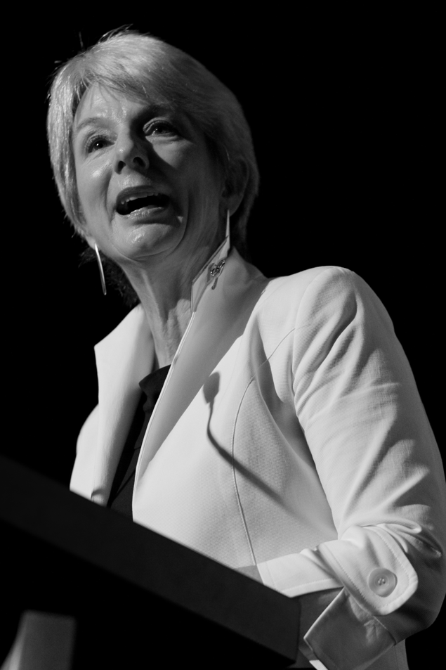
The Hon. Catherine Branson, QC, President , Australian Human Rights Commission
This is my first annual report as President of the Australian Human Rights Commission. Since commencing my five-year term in October of last year, the people with whom I have met, the stories that I have listened to, and the community centres and immigration detention facilities that I have visited have strengthened my resolve to encourage a better understanding of the place of human rights in Australia. In particular, I am determined to encourage widespread recognition of the relevance of human rights for all people, no matter who they are, where they live or what their circumstances.
I thank my predecessor, the Hon John von Doussa QC, for laying the important groundwork for this to occur. Under his leadership, the Commission (then known as the ‘Human Rights and Equal Opportunity Commission’ or ‘HREOC’) paved the way for a number of significant human rights milestones which have been realised during this reporting period. The imprints left by him during his term as President can be found throughout this annual report. They speak for themselves.
I am particularly proud to have inherited a Commission guided by a new and powerful vision statement and strong strategic plan. Our vision statement can be seen with our logo on the cover of this report. It is: human rights: everyone, everywhere, everyday.
That statement is an important reminder that human rights are about us all. We all have human rights and for this reason we should all respect the human rights of others.
Over my short time as President, I have noticed that often when people talk about human rights they talk about people in foreign countries suffering from totalitarian regimes; or they talk about people ‘other’ than themselves who are suffering particular disadvantage; or they dismiss human rights as lofty or abstract legal concepts reserved to the domain of academia.
I find it curious that many Australians – particularly Australians who fall outside the well-documented vulnerable and disadvantaged groups – do not think that human rights have any relevance to their own lives.
I am surprised by this phenomenon because to me, and to the Commission, human rights principles reflect the fundamental values that underpin so much that we treasure as Australians – democracy, justice, fairness, participation and empowerment. They also reflect what is necessary for a dignified life – safety, family life, freedom of faith and belief, access to healthcare, housing, education and employment. A human rights approach to these issues involves developing and protecting a democratic framework that ensures that all people in our increasingly diverse society – no matter who they are – can enjoy these things without discrimination.
A community that lives by human rights values will be better prepared should things go wrong; it will be much more likely to provide the protections and the safety net that any one of us, or our family, might need one day.
It is true that there are some groups of people in our society who are more likely than others to experience disadvantage and transgressions of their basic rights. Human rights principles are, of course, designed to ensure that Aboriginal or Torres Strait Islander peoples, refugees, asylum-seekers and new migrants, people with disability or mental illness, women, the elderly, young people, people of faith, gay men and lesbians, people experiencing homelessness, detainees and prisoners, people living in remote and rural areas and, indeed,
all who suffer disadvantage have their inherent dignity respected and do not experience discrimination. A human rights approach to achieving this respect and equality is an approach which seeks to empower the members of these groups so that their voices are heard and they can play a part in creating solutions that will work for them.
However, it is a mistake to quarantine the importance of human rights to these so-called ‘vulnerable’ groups.
First, the populations of these groups are far from stable. The advent of the global financial crisis makes it clearer than ever that any day any one of us might become a member of one of these groups. There are increasing numbers of people in our community who have suddenly become unemployed, who find themselves facing homelessness, who are at higher risk of mental illness or who are facing new family strains and need the immediate support of the community around them. Even if financial pressures are put to one side, any one of us could be in a car accident tomorrow and find ourselves in a wheelchair or with an acquired brain injury. All of us will eventually become elderly and have to navigate the discrimination and struggles that come with increasing age.
Secondly, a community that lives by the fundamental values I have described includes, by definition, all the members of that community. Rights can only truly be enjoyed by us all if they are respected by us all.
This year, perhaps more than ever before in the Commission’s 23-year history, we have put a great deal of energy into engaging a diverse range of Australians in a conversation about what human rights means to them and how they can be better protected in Australia.
As part of our participation in the Australian Government’s National Human Rights Consultation we distributed around 15 000 hard copy toolkits (and even more electronic copies through our website) in an endeavour to make it easier for the general community, and young people in particular, to participate in this very important conversation. We held more than 50 workshops and roundtable meetings targeting community organisations, community legal centres and young people around the country. The Commissioners and I also delivered a large number of speeches to a diverse range of audiences across Australia, encouraging participation in the Consultation and advocating for an Australian Human Rights Act.
It is both the Commission’s and my personal hope that these conversations about human rights will lead to comprehensive statutory protection of human rights and a significantly enhanced national human rights education program. But, whatever the outcome of the National Consultation, the very process of involving large numbers of Australians in discussion and debate about what is important to us as Australians was a demonstration of the vibrancy of our democracy. The consultation process contributed significantly, I believe, to greater public understanding of how human rights are relevant to all of our lives.
As Australia’s national human rights institution, the Commission has a vital role to play in the better promotion and protection of human rights in Australia.
While constrained by a tight budgetary situation, with our new strategic plan in place we intend, during the next financial year, to examine how our human rights leadership can best contribute to the achievement of social change in Australia where it most matters. We plan to think about how we can provide leadership innovatively, how we can provide human rights education effectively, how we can use human rights principles to empower others and how we can best monitor Australia’s compliance with its human rights obligations and undertakings.
Not everyone is familiar and comfortable with the language of human rights – but the ideas and principles captured by that language are attractive to us all. These ideas and principles can provide a moral compass for public decision-making. The Commission will continue to work towards making sure that everyone in Australia understands that respect for the human rights of all is critical to upholding a fair, inclusive, tolerant and secure society.

Catherine Branson QC
Figure 1: The Australian Human Rights Commission organisation chart

