2009 Social Justice and Native Title Reports

A Community Guide
A Note from the Commissioner

In my role as Aboriginal and Torres Strait Islander Social Justice Commissioner, I produce two annual reports on Aboriginal and Torres Strait Islander peoples’ human rights issues – the Social Justice Report and the Native Title Report.
The reports, which are tabled in federal Parliament, analyse the major changes and challenges in Indigenous affairs over the past year. They also include recommendations to government that promote and protect the rights of Aboriginal and Torres Strait Islander peoples.
This Community Guide gives a brief overview of some of the key issues in both reports for 2009.
In this year’s Social Justice Report I focus on three areas: justice reinvestment to reduce Indigenous over-representation in the criminal justice system; protection of Indigenous languages; and sustaining Aboriginal homeland communities.
At their core these issues speak to the need for strong communities. This might be through reinvesting money in crime prevention and keeping people out of prison; protecting language and culture that is the glue which keeps communities together; or supporting strong homelands as a model of community development and self-determination.
Our communities are not just where we come from, but who we are. They represent our family connections, proud history and rich culture. I hope that they remain strong and can in turn sustain future generations. My final Social Justice Report provides some new ideas and recommendations to do this.
In this year’s Native Title Report, I review important developments in native title law and policy that occurred during 2008-2009. During this time, the Australian Government pursued its commitment to improving the operation of the native title system.
I also consider further legislative and policy options for creating a just and equitable native title system.
Finally, I provide an update on Indigenous land tenure reform across Australia. I then set out principles that governments should follow when implementing such reforms.

Tom Calma is the Aboriginal and Torres Strait Islander Social Justice Commissioner.

Tom, an Aboriginal elder from the Kungarakan tribal group and a member of the Iwaidja tribal group of the Northern Territory, commenced his term in July 2004.
As Commissioner, he advocates for the recognition of the rights of Indigenous peoples in Australia and seeks to promote respect and understanding of these rights among the broader Australian community.
Tom has been involved in Indigenous affairs at a local, community, state, national and international level and has worked in the public sector for over 35 years.
Please be aware that this publication may contain the names or images of Aboriginal and Torres Strait Islander people who may now be deceased.
Page 2

Justice Reinvestment: a new solution to the problem of Indigenous over-representation in the criminal justice system
Indigenous over-representation in the criminal justice system is a significant social justice issue that needs urgent attention. Some worthy initiatives have been developed since the Royal Commission into Aboriginal Deaths in Custody in 1991. However, what we are doing is simply not working.
Justice reinvestment is a localised criminal justice policy approach, that first emerged in the United States. Under this approach, a portion of the public funds that would have been spent on covering the costs of imprisonment are diverted to local communities that have a high concentration of offenders. The money is invested in community programs, services and activities that are aimed at addressing the underlying causes of crime in those communities.
Justice reinvestment still retains prison as a measure for dangerous and serious offenders. However, justice reinvestment actively shifts the focus away from imprisonment to the provision of community-wide services that prevent offending. Justice reinvestment is not just about reforming the criminal justice system – it is about trying to prevent people from getting involved in the system in the first place.
Justice reinvestment is as much about economics as it is about good social policy. Justice reinvestment asks the question: is imprisonment good value for money? In Australia, we spend increasing amounts on imprisonment, yet prisoners are not being rehabilitated, and rates of return to prison are high. This is a particular problem among Aboriginal and Torres Strait Islander communities.
Indigenous imprisonment rates in Australia are unacceptably high
- Nationally, Indigenous adults are 13 times more likely to be imprisoned than non-Indigenous adults.
- Indigenous juveniles are 28 times more likely to be placed in juvenile detention than their non-Indigenous counterparts.
There is a lot we can learn from justice reinvestment policies in the United States, and emerging interest in this approach in the United Kingdom. I consider these examples in this year’s Social Justice Report.

Justice Reinvestment: A success story
Imprisonment rates are dropping in places where justice reinvestment is being implemented. For example, there was a 72% drop in juvenile incarceration in Oregon, USA, after money was reinvested in well-resourced restorative justice and community service programs for juvenile offenders.
We need to be bold and creative to shape better solutions to Indigenous offending. That is why in this year’s Social Justice Report I look to justice reinvestment as a new approach that may hold the key to unlocking Indigenous Australians from the cycle of crime and increasing imprisonment rates.

Left to Right: Jeanette Gordon, Mona Sunfly, Danika Kingsley (toddler) of the Kukutja people in Balgo, Western Australia. This photo was taken during a program with local youth who have come out of incarceration, under the Kutjungka Documentation Project. Photo: Azaria Rogers (2008)
Page 3
Respecting Indigenous land ownership
During 2008-2009, Australian governments continued to develop policies and implement new laws in relation to Indigenous land.
One of the most important developments is that the Australian Government has linked the provision of funding for essential services to government control over Indigenous land. Many Indigenous communities desperately need funding for housing. In order for some communities to be eligible for housing funding, Indigenous land owners are required to provide a lease or sublease of at least 40 years to the Australian Government.
I am concerned about these policies and the way they impact on Indigenous people across Australia. Governments have referred to these reforms as a way of promoting home ownership and economic development, but this can be misleading. I am also concerned that the Australian Government has not presented these policies in a clear and transparent way.
The Australian Government has also retained measures that were introduced as part of the Northern Territory Emergency Response (also known as the ‘Intervention’). During 2008-2009, the Government threatened to use these powers to compulsorily acquire town camp land in Alice Springs.
These reforms, and continuing policies, provide governments with control over the land. Aboriginal and Torres Strait Islander peoples have fought hard for their rights over their lands to be recognised. Shifting control of land from communities to the government creates a barrier to self-governance. It can also further marginalise Indigenous communities.
Aboriginal and Torres Strait Islander peoples have legitimate concerns about losing control over decision-making in their own communities. In this year’s Native Title Report I call on governments to consider different approaches to Indigenous land reform, and recommend that the Australian Government end compulsory five-year leases.
Governments should focus on providing improved forms of land ownership to Aboriginal and Torres Strait Islander peoples.
[G]overnment initiatives to address the housing needs of indigenous peoples, should avoid imposing leasing or other arrangements that would undermine indigenous peoples’ control over their lands.
Professor S James Anaya, UN Special Rapporteur on the situation of human rights and fundamental freedoms of indigenous people
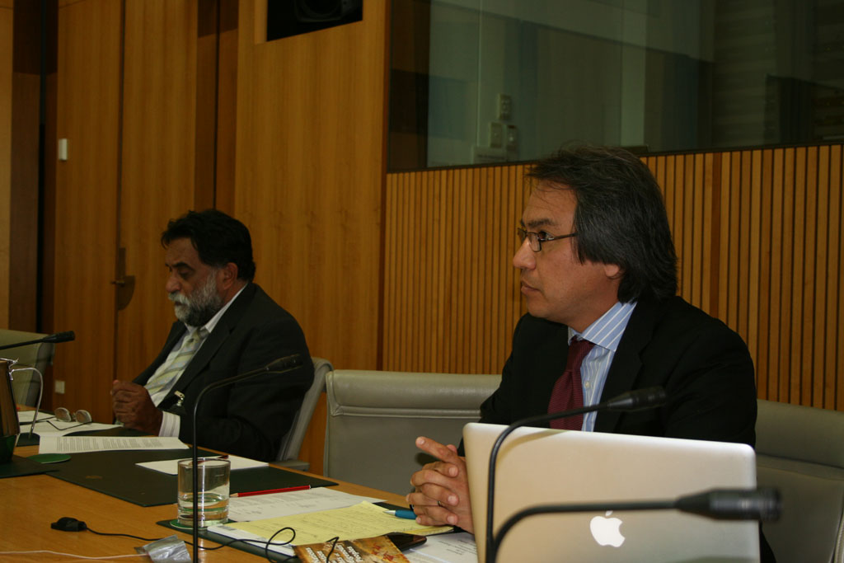

Right to Left: Professor S James Anaya (UN Special Rapporteur) and Les Malezer (Foundation for Aboriginal and Islander Research Action) at a public forum hosted by the Indigenous Peoples’ Organisations Network of Australia and the Australian Human Rights Commission on 3 December 2008. Photo: Julia Mansour (2008)

A principled approach
In the Native Title Report 2009 I identify the Australian Government’s approach to land tenure reform. I also highlight developments in land tenure reform in the Northern Territory, Queensland, New South Wales, South Australia and Western Australia.
I set out principles that should underpin the introduction of any land tenure reforms or home ownership schemes. This includes providing the community with clear and appropriate information. Respect for the free, prior and informed consent of Indigenous peoples is at the centre of these principles.

Page 4

Indigenous Languages: critically endangered
Indigenous languages are critically endangered in Australia. They continue to die out at a rapid rate. Prior to colonisation, Australia had 250 distinct languages, which could be subdivided into 600 dialects. Today, Australia has 100 Indigenous languages, though most of them are in varying stages of extinction. There are only 18 Indigenous languages that are currently spoken by all people in all age groups across a given Indigenous language group. Without intervention, it is estimated that Indigenous language usage will cease in the next 10 to 30 years.
The loss of Indigenous languages in Australia is a loss for all Australians. Cultural knowledge is carried through languages, so the loss of language means the loss of culture. This in turn has the potential to impact on the health and well-being of Indigenous peoples. Significant research shows that strong culture and identity assists us to develop resilience.
Up until the 1970s, Australian government policies and practices banned and discouraged Aboriginal and Torres Strait Islander peoples from speaking our languages. Many of those who were forcibly taken to hostels and missions lost their languages due to the prohibitionist polices and practices of governments and churches.
The preservation and promotion of Indigenous languages
Australian governments should act to preserve and promote Indigenous languages because:
- Evidence shows improved cognitive functioning in children who are bilingual
- Minority groups who speak their languages and practice their culture, enjoy better social, emotional and health outcomes than groups who do not
- Cultural knowledge has been proven to assist in the employment of Indigenous people in Australia
- There are economic and social costs associated with the loss of languages
- Indigenous languages have intrinsic value to the people who speak them.
In 2009 the Australian Government announced Australia’s first national policy exclusively focused on Indigenous languages: Indigenous Languages - A National Approach 2009. For the first time, Australia has a policy that is aimed at protecting and promoting Indigenous languages.
However, the approach of state and territory governments towards Indigenous languages is less positive.
State and territory governments have primary responsibility for school education, and some responsibility for early childhood education. These governments have differing and contradictory policies on Indigenous language preservation. This could potentially be a serious obstacle to the Australian Government’s policy as some jurisdictions, such as the Northern Territory, have gone as far as abolishing bilingual programs in schools. Schools and pre-schools are perhaps the most important places where language learning is consolidated and developed.
The new national policy is a starting point. However, Australian governments will have to take cooperative action in order to reverse the Indigenous language decline. If this is not done soon, Indigenous languages will die out in the next few generations.
In this year’s Social Justice Report I set out some of the challenges ahead for Indigenous language preservation and revitalisation in the light of this new national approach.
Language is very important to us; it is our connection to our ancestors and for those of us who still use our language can connect with the ancestors of the past. Our life blood comes from the land and what is of the land. Language holds secrets to the connection of the land.
Phyllis Darcy, Awabakal descendant in NSW
Reference: P Darcy, Aboriginal Languages Research and Resource Centre (The Languages Centre) website, New South Wales Department of Aboriginal Affairs. At http://www.alrrc.nsw.gov.au/ (viewed 3 July 2009).

Page 5

Sustaining Aboriginal homeland communities
Homelands still belong to the people, we want to build homes on our land and live there. When we come to the homeland we come back to the peace and quiet. … It is a much better environment on the homelands, better things for the children.
Peggy Brown, Mt Theo Outstation Co-Founder
Homelands provide social, spiritual, cultural, health and economic benefits to residents. They are a unique component of the Indigenous social and cultural landscape, enabling residents to live on their ancestral lands. Homelands are governed through traditional kinship structures which provide leadership and local governance.
In this year’s Social Justice Report I examine the homelands movement of the Northern Territory as an example of successful Aboriginal community development, governance and self-determination. I outline a number of case studies demonstrating the work of effective homeland communities including the Laynhapuy Homelands Association Incorporated, the Mt Theo Outstation and Mapuru.
My focus on Northern Territory homeland communities responds to the recent decisions by governments on the resources and support provided to homeland communities. These policies effectively move homeland residents into large townships to access housing, education and other services.
History has shown that moving people from homeland communities into fringe communities in rural towns increases the stresses on resources in rural townships. This can lead to increased social tensions between different community groups, reduced access to healthy food and lifestyles and loss of cultural traditions, practices and livelihoods.
Australian governments should adequately resource homeland communities. Homeland leaders should be able to actively participate in the development of policies that affect homeland communities. Failure by governments to support the ongoing development of homeland communities will lead to social and economic problems in rural townships that could further entrench Indigenous disadvantage and poverty. This could further endanger the world’s longest surviving continuous culture.
In 2009, the Australian Government formally announced that it supports the United Nations Declaration on the Rights of Indigenous Peoples (the Declaration). The Australian Government now needs to implement the Declaration. In particular, the Government needs to recognise the rights of Indigenous peoples to self-determination and support Indigenous peoples to realise their own development aspirations.
I recommend that the Australian Government and Northern Territory Government implement the Declaration by committing to:
- review the Working Future policy with the active participation of representative leaders from homeland communities
- develop and implement future homeland policies with the active participation of leaders from homeland communities
- provide funding and support for homeland communities in all states and territories through the COAG National Indigenous Reform Agreement and associated National Partnership Agreements.

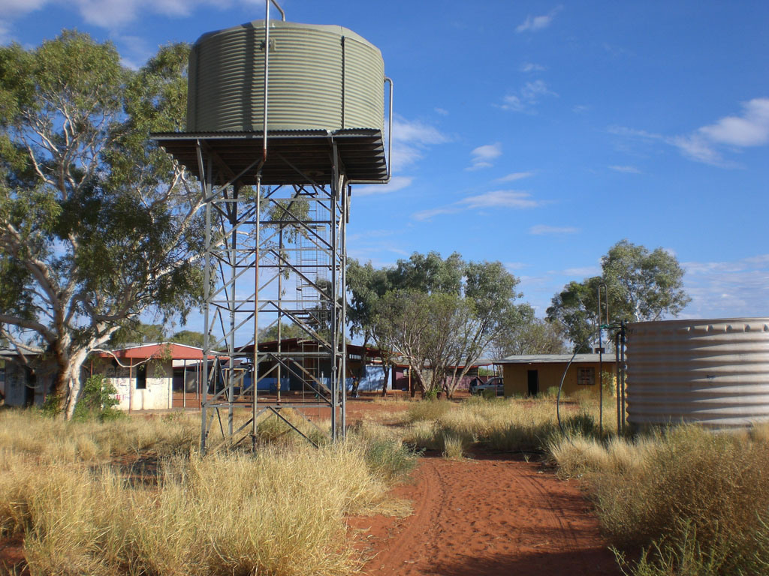
Mt Theo Outstation. Photo: Fabienne Balsamo (2009)

United Nations Declaration on the Rights of Indigenous Peoples
Article 3: Indigenous peoples have the right to self-determination. By virtue of that right they freely determine their political status and freely pursue their economic, social and cultural development.
Article 21(1): Indigenous peoples have the right, without discrimination, to the improvement of their economic and social conditions, including, inter alia, in the areas of education, employment, vocational training and retraining, housing, sanitation, health and social security.
Page 6
The state of land rights and native title policy in Australia: Promising first steps towards change
The Australian Government has committed to ‘resetting’ the relationship between Indigenous and non-Indigenous Australians. This includes reviewing aspects of the native title system. The Attorney-General has stated that native title reform is one of his top priorities. In particular, he is interested in reforms that encourage parties to negotiate rather than litigate.
In this year’s Native Title Report, I review developments in native title and land rights in 2008 – 2009. During this time, we witnessed reforms that could prove to be the first steps in transforming the native title system.
For example, the Australian Government introduced amendments to the Native Title Act to encourage broader negotiated agreements. Also, the Victorian Government unveiled an important new settlement framework.
While this shows some progress, there has been a lack of action in other areas. Prescribed Bodies Corporate are still underfunded, and the Australian Government has yet to advance its promised Indigenous Economic Development Strategy. Also, some states have not displayed a willingness to consult and communicate effectively with Aboriginal and Torres Strait Islander communities.
However, the Australian Government has said it is interested in exploring further reforms to the native title system. I hope that this new momentum for change will lead to real and lasting benefits for Aboriginal and Torres Strait Islander peoples.
Native title law: the year in review
In this year’s Native Title Report, I review three significant cases concerning native title and land rights. These cases raise issues that affect the human rights of Aboriginal and Torres Strait Islander peoples, including whether:
- aspects of the Northern Territory intervention are constitutionally valid (Wurridjal)
- a mining company had negotiated in good faith with traditional owners (FMG Pilbara Pty Ltd v Cox)
- a mining lease should be granted over a site that is particularly significant to the Martu People (Western Desert Lands Aboriginal Corporation (Jamukurnu – Yapalikunu) / Western Australia / Holocene Pty Ltd).

Business will only be finished ... when the legacies of dispossession and assimilation, of racism and disadvantage, are dismantled on every front. The possibility of genuine land justice is one such front.

Rob Hulls, Attorney General of Victoria

Reference: R Hulls (Attorney-General of Victoria), AIATSIS Native Title Conference 2009 (Speech delivered at the 10th Annual Native Title Conference, Melbourne, 4 June 2009). At http://ntru.aiatsis.gov.au/conf2009/papers/TheHon.RobertHulls.pdf (viewed 26 November 2009).

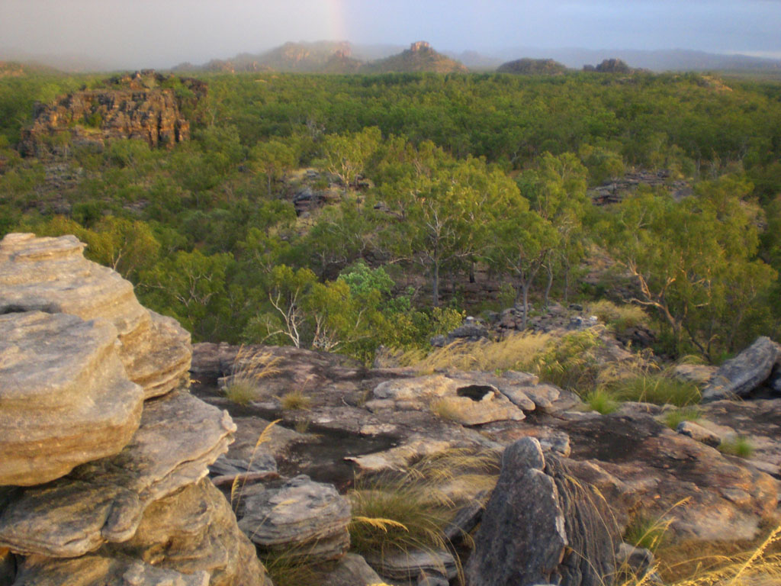

The photograph depicts the Meekin Valley on Maniligarr country, which is situated within Kakadu National Park in the Northern Territory. Permission to use the photograph was granted by Jacob Nayinggul, the senior traditional owner of Maniligarr country. Photo: Fabienne Balsamo (2009)

Page 7

Realising the potential of native title: Towards a just and equitable system
Australia has come a long way since the High Court first recognised native title in its decision in Mabo (No 2). However, even after 16 years of operation, the native title system has not fulfilled the promise of the High Court’s historic decision. For too many people, native title has become a ‘mirage’.
We need a new approach to native title. This new approach should be based on partnerships between Aboriginal and Torres Strait Islander peoples, governments and corporate interests.
We cannot simply tinker at the edges of the native title system if our goal is to create meaningful reform. The problems with the native title system can only be addressed through a comprehensive reform process. I believe that Aboriginal and Torres Strait Islander peoples must be actively involved in this process, every step of the way.
I strongly believe that native title reform should be guided by human rights principles and standards. These include the rights of Aboriginal and Torres Strait Islander peoples to:
- self-determination
- free, prior and informed consent
- non-discrimination
- the right to maintain and enjoy distinct cultures
- to determine and develop priorities and strategies for the development or use of their lands or territories and other resources.
To make the native title system work, governments and corporations need to embrace these standards and change the way they engage with Aboriginal and Torres Strait Islander peoples. I welcome further dialogue on ways to improve the native title system and I acknowledge the good work that they have commenced.
There is much unfinished business. I encourage governments across Australia, in the spirit of reconciliation, to show genuine leadership and take action to create a just and equitable native title system

The time for change is now!
In Chapter 3 of the Native Title Report 2009, I highlight elements of the native title system that need to change. I also review options for improving the native title system, such as:
- considering ways to formally recognise traditional owners
- amending the Native Title Act to shift the burden of proof in a native title claim
- encouraging states and territories to adopt more flexible approaches to connection evidence
- improving access to land tenure information
- streamlining the role of non-government respondents in native title claims
- promoting broader and more flexible native title settlement packages
- increasing the quality and quantity of anthropologists and other experts working in the native title system.



Aboriginal and Torres Strait Islander Social Justice Commissioner Tom Calma visiting Mer Island to discuss the Islanders’ views on maintaining and protecting their native title rights and interests. Photo: Cecelia Burgman (2009)
Page 8

Human Rights: Case Studies on homelands and education
Mapuru: The right to economic development
The Mapuru homeland community runs a cultural tourism project, Arnhem Weavers, where they have cultural tours and workshops for small groups of tourists who can come and live in Mapuru for 1-2 weeks, and learn about weaving and other traditional activities. For seven years the project has grown without any government funding or external assistance. This is a source of pride for the community members.
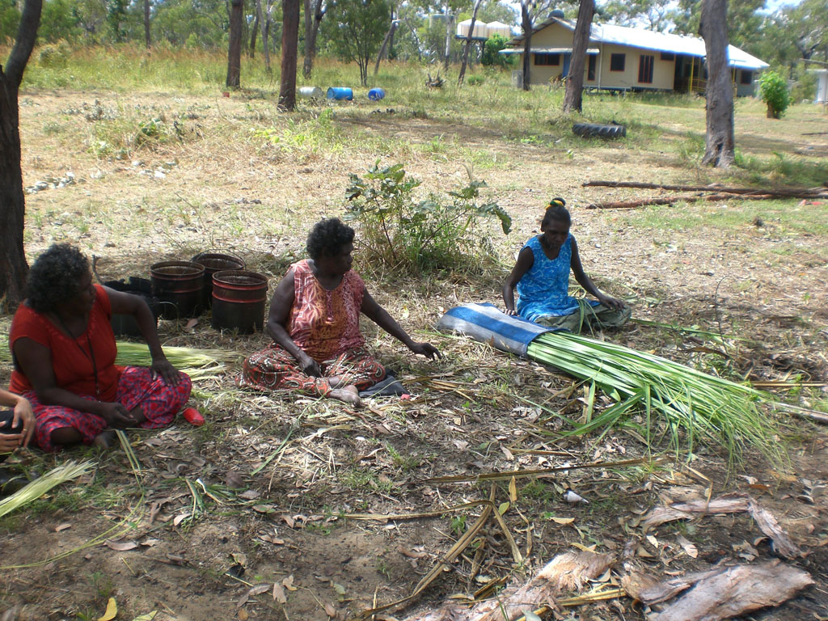
Community member Roslyn Malngumba said “We need to create work here that is economically viable. It doesn’t need to be a lot of money, but it needs to be enough to sustain the community; to enable the children to live here in the future, otherwise they have no future. These kinds of projects can’t be done in Elcho Island or Darwin, they have to be done on country.”
Roslyn Malngumba, Linda Marathuwarr and Caroline Gulumindiwuy at Mapuru. Photo: Fabienne Balsamo (2009)

Bilingual education: The right to an appropriate education

Bilingual education is the most effective learning method for students who aim to learn a second language and transfer from their mother tongue literacies to second language literacies.

In 2006, twelve of Australia’s 9,581 schools were bilingual schools instructing students in Indigenous languages, all based in the Northern Territory. They were located in remote areas where Indigenous languages are the only languages heard in the community. Interaction with English, if any, is limited. Therefore these children need the best possible approaches to learn English.
The future of the bilingual approaches in Australia is now uncertain. In October 2008 the Northern Territory Government announced a policy that has effectively dismantled bilingual education by making teaching in English mandatory for the first four hours of the school day. The policy means Indigenous language instruction is relegated to the last hour and a half of the school afternoon. In the Northern Territory, this is often the hottest time of the day and a time when quality learning is challenging.

Governments must consider whether they are abolishing one of the:

- most effective models of English language transference for minority language speakers
- most effective methods for keeping Indigenous languages alive in this country
- only ways in which successive generations of Indigenous people can develop full competence in their own languages.

More on Social Justice and Native Title
The Social Justice Report 2009 is available at: http://www.humanrights.gov.au/social_justice/sj_report/sjreport09/.

The Native Title Report 2009 is available at:
http://www.humanrights.gov.au/social_justice/nt_report/ntreport09/
For hard copies and CD-ROMs of the Social Justice and Native Title Reports and for additional copies of this Community Guide, call 1300 369 711 or order online at: www.humanrights.gov.au/about/publications/
Please send comments or feedback to: socialjustice@humanrights.gov.au or complete the online survey at:
www.humanrights.gov.au/social_justice/sj_report/sjreport09/survey.html (Social Justice Report 2009 Feedback) and
www.humanrights.gov.au/social_justice/nt_report/ntreport09/survey.html (Native Title Report 2009 Feedback).
Dealing with discrimination
The Australian Human Rights Commission is an independent organisation that investigates complaints about discrimination, harassment and unfair treatment on the basis of race, colour, descent, racial hatred, sex, disability, age and other grounds.
For free advice on discrimination and your rights, or to make a complaint, call our Complaints Information Line on 02 9284 9888, 1300 656 419 (local call) or TTY 1800 620 241.
Information about making or responding to a complaint is available at www.humanrights.gov.au. You can also email us at complaintsinfo@humanrights.gov.au.

