Getting it right
Progress towards a new national representative body

A note from the Commissioner
Late last year the Australian Government invited me to convene an independent Steering Committee to develop a preferred model for a national representative body for Aboriginal and Torres Strait Islander peoples.
By July 2009, the Steering Committee is required to:
- present a preferred model for a new national representative body for Aboriginal and Torres Strait Islander peoples to the Australian Government
- make recommendations about the establishment of an interim body to begin from August 2009, and
- ensure strong community support for the preferred model.
The first round of submissions and consultations, conducted by the government between July and December last year, showed strong community support for the establishment of a national representative body. It also highlighted the need for a further round of consultations led by Aboriginal and Torres Strait Islander peoples to arrive at a suitable model.
In March 2009 the Steering Committee convened a national workshop in Adelaide to identify the key elements of a new national representative body. While great progress has been made, there are still many issues that require discussion, feedback and direction from Aboriginal and Torres Strait Islander communities.
As the Steering Committee prepares to finalise its advice to the government, this community guide provides you with an overview of the progress so far, highlights particular issues that require further discussion and explains how you can have your say.
As I travel around the country, I sense a great deal of excitement among our people about the prospect of a new national representative body being established. While the timeframe for this to happen is short, it is vital that this new body is owned and supported by our communities if it is to be effective.
The Steering Committee encourages all Aboriginal and Torres Strait Islander people, our communities, our organisations and our peak bodies to get involved in the consultation process in the coming months.
As Klynton Wanganeen, South Australia’s Commissioner for Aboriginal Engagement, told participants at the national workshop: “Say what you want or be prepared to accept what you are given.”
Tom Calma
Aboriginal and Torres Strait Islander Social Justice Commissioner

Members of the Steering Committee
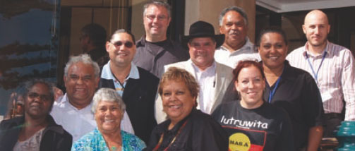
The Steering Committee for the establishment of a new national representative body for Aboriginal and Torres Strait Islander Peoples is: Tom Calma (Chair), Dr Mark Bin-Bakar, Jason Glanville, Tim Goodwin, Tanya Hosch, Dr Jackie Huggins AM, John (Toshi) Kris, Rosalie Kunoth-Monks, Nala Mansell-McKenna, Yananymul Mununggurr and Geoff Scott.
Professor Mick Dodson is Expert Advisor to the Committee.

Finding common ground: Issues of consensus
Through many community consultations and a national workshop in Adelaide, Aboriginal and Torres Strait Islander people have expressed strong support for the establishment of a new national representative body.
Agreement has emerged around three key issues:
- the objectives of the national representative body
- the principles to guide its establishment and operation, and
- its roles and functions.
Objectives
Aboriginal and Torres Strait Islander people have said that the new national representative body should:
- initiate a new partnership between governments and Aboriginal and Torres Strait Islander peoples
- ensure Aboriginal and Torres Strait Islander people contribute to and lead policy development on issues that affect us
- provide an Aboriginal and Torres Strait Islander perspective on broader government issues
- be a strong advocate for the rights of Aboriginal and Torres Strait Islander peoples
- ensure the presence of proper mechanisms to monitor government performance on Aboriginal and Torres Strait Islander issues
- ensure government commitments, such as ‘closing the gap’ on Aboriginal and Torres Strait Islander health, education and other areas of inequality, are supported by long-term action plans, and
- ensure the equal participation of Aboriginal and Torres Strait Islander women in all processes.
Guiding principles
During the consultation process, participants said that the new body should be guided by principles that:
- enable self-determination and freedom to operate independently of government influence
- align with the highest standards of ethical and moral conduct
- ensure openness, transparency and accountability to Aboriginal and Torres Strait Islander peoples
- draw on the ‘Nolan Principles on Public Life’ (see inside) as the basis for the behaviour of members
- ensure equal participation of men and women
- ensure the participation of particularly vulnerable and marginalised groups, such as young people, people with disabilities, members of the Stolen Generations, people living in remote communities and homelands and mainland Torres Strait Islanders, and
- ensure all members are Aboriginal and/ or Torres Strait Islanders and establish a process to verify identity.
Roles and functions
Aboriginal and Torres Strait Islander people identified a number of important roles and functions for the new national representative body, including:
- advocacy
- formulating policy and advising government
- reviewing government programs
- negotiating framework agreements with governments
- monitoring service delivery by governments
- conducting research and contributing to law reform processes, and
- representing Aboriginal and Torres Strait Islander peoples at the international level.
Other roles that the body could undertake include:
- acting as a ‘clearing house’ to promote the sharing of information between Aboriginal and Torres Strait Islander representative organisations and service delivery organisations, and
- conducting facilitation and mediation services for Aboriginal and Torres Strait Islander peoples.
It was widely agreed that the national representative body should not deliver services or programs. Instead it should help identify priorities for service delivery in consultation with Aboriginal and Torres Strait Islander peoples and communities.

There has been a consistent and strong view that the term ‘Indigenous’ should not be used to describe the new body. A majority of participants at the national workshop in Adelaide expressed a preference for terms such as ‘First Nations’ or ‘First Peoples’. Community consultations also identified a preference for using ‘Aboriginal’ and/ or ‘Torres Strait Islander’.

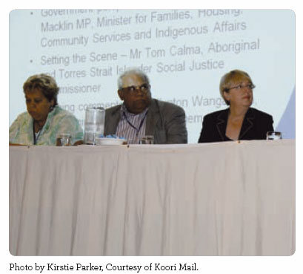

Structure of the national representative body
During the consultation process so far there has been broad agreement that:
- the national representative body should be made up of an equal number of men and women
- a merit selection process should be established to ensure members of the new body meet ethical standards and have the skills to perform their role – this process must be transparent and determined by Aboriginal and Torres Strait Islander people
- members of the national representative body should not be appointed by government;
- Aboriginal and Torres Strait Islander peak bodies have an important role, including to work collaboratively with the new body, but should not be able to directly nominate members on to the new representative body.

Working out the nuts and bolts: Issues for consideration
In recent months consensus has emerged around what the new national representative body should do. However, more work is still needed to identify how it will operate and achieve its goals.
Further consultations and discussions are required to address the following four key issues.
The Steering Committee is seeking the views of Aboriginal and Torres Strait Islander people to help ensure that the new body provides a strong, independent and credible voice on the issues that matter to Indigenous communities, now and into the future.
- Representing Aboriginal and Torres Strait Islander people and communities
There is broad agreement that the new national representative body should be informed by developments at the local and regional levels. The question remains how best to make this happen.
For instance the new body could:
- adopt a regional-level structure, similar to those established under Regional Partnership Agreements
- conduct some of its operations at a regional level, such as forums and planning exercises
- draw its national membership from the regional level, or
- use a combination of these approaches.

A related issue is whether the new body should also have a state/ territory level structure. The options for such an approach are similar to those set out above. A number of Aboriginal and Torres Strait Islander advisory bodies already exist at the state/ territory level and it will need to be determined what role they might play in the national representative body.
Another crucial question is how to ensure that the new body properly represents the diversity of Aboriginal and Torres Strait Islander people and communities and, specifically, how it will:
- ensure a place for Torres Strait Islanders, including those on the mainland
- ensure the participation of groups that are generally marginalised, including young people, people with disabilities and members of the Stolen Generations and people living in remote communities and homelands.

- Structure of the national representative body
As yet there is no clearly preferred process for selecting members to the national representative body. Some people support an election model, while others prefer a delegate model.

Election model
Members would be elected through a vote and participate on the national body as individuals. If this model is preferred, some of the issues to be decided include:
- Who would be entitled to vote?
- How would an election be conducted?
- What eligibility requirements would be required to stand for election?
Delegate model
Members would be nominated to the national body by regional or state/ territory level organisations. If this model is preferred, some of the issues to be decided include:
- Who would be responsible for nominating representatives? Would it be, for instance, regional bodies, state-wide forums or a panel of eminent Indigenous elders?
- How would the process be made open and transparent?
It is also possible that a combination of the election and delegate model could be used. For example, candidates could first be nominated to participate on the executive of the body and then a board elected.
Merit selection
A merit selection process could be developed for use in either an election or a delegate model.
One suggestion is that the national representative body has a ‘panel of eminent Aboriginal and Torres Strait Islander peers’ who assess all applications to determine whether individuals are suitable for election or nomination to the body.
If merit selection is used, some of the issues to be decided include:
- What skills and experience should applicants possess?
- What process should be set up to assess whether applicants meet established criteria?

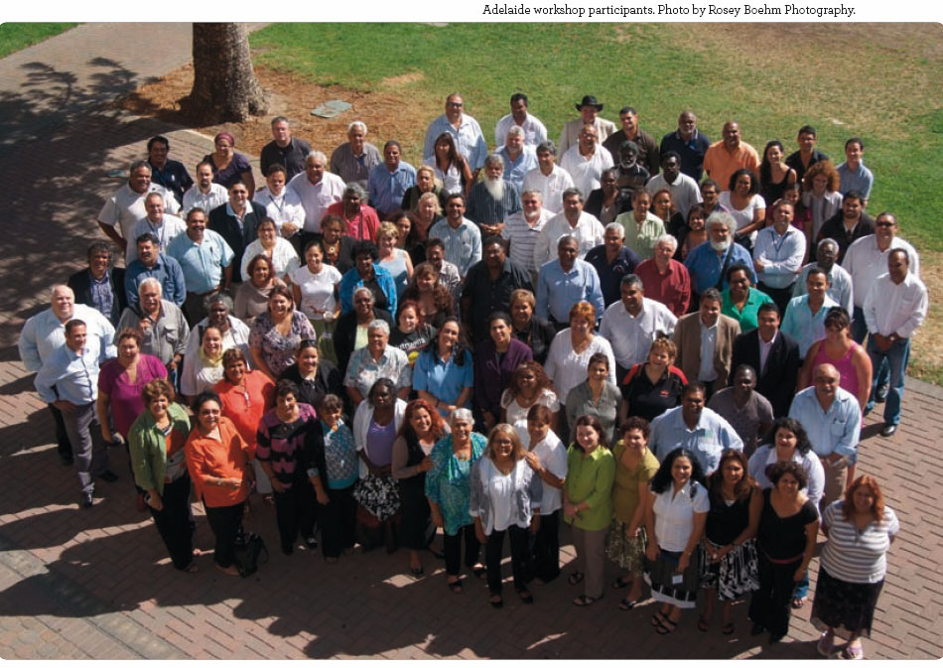
- Relationship with Government and Parliament
Aboriginal and Torres Strait Islander people want the national representative body to be free from government influence or interference, particularly when it comes to choosing the body’s members.
How the new body is constituted is, therefore, very important. The three main options include establishing it as:
- a statutory authority, which would provide it with legislated roles and functions recognised by Parliament and performed independent of government
- a company limited by guarantee, similar to Aboriginal Hostels Ltd, and funded by government; the difference being that the national representative body would not deliver services and government support would not ‘purchase services’ in the same way.
- a non-government organisation, to ensure greater independence and autonomy; however, the relationship with government would need to be established through an agreement (such as a MOU), particularly if it received public funding.
Each approach has certain advantages, as well as potential limitations and questions about resources. These issues need to be thoroughly thought through before the preferred model is chosen.
- Funding and sustainability
Throughout the consultation process, Aboriginal and Torres Strait Islander people have strongly expressed the view that the national representative body should be sustainable and able to operate independent of government funding over time.
The following funding options have been identified as ways to achieve this goal:
- establishing a fund to provide the body with a capital base (like the Indigenous Land Corporation)
- receiving untied government funding
- drawing on a ‘future fund’ financed through a percentage of mining tax receipts
- having charitable status to receive tax free donations, or
- a combination of the above.

Timeline so far: Towards a national representative body
July 2008
The Social Justice Commissioner releases a paper outlining key issues for the development of a new national representative body.
The Australian Government launches national consultations with Aboriginal and Torres Strait Islander communities.
July – December 2008
Written submissions (over 100) accepted and the first round of community consultations commence, including:
- 18 regional consultations
- community workshops (approx 80) facilitated nationally by the network of Indigenous Coordination Centres and in the Northern Territory by Government Business Managers
- consultations with peak Aboriginal and Torres Strait Islander organisations, State and Territory Governments, and as part of the Australian Government’s Indigenous Men’s and Women’s Leadership Programs.
December 2008
The Minister for Indigenous Affairs invites the Social Justice Commissioner to convene an independent Steering Committee to lead a second round of consultations.
March 2009
The Steering Committee holds a National Workshop in Adelaide (11-13 March), following a public nomination process for the 100 participants.
April 2009
Outcomes of the Adelaide workshop are publicly released to guide discussions and consultations that will help the Steering Committee finalise a preferred model for the new national representative body.

Nolan Principles on Public Life
The ‘Nolan Principles’ were developed by a United Kingdom parliamentary committee. They have been adopted by the Steering Committee and will apply to all people who are employed by or become members of the new national representative body.
Selflessness: Holders of public office should take decisions solely in terms of the public interest. They should not do so in order to gain financial or other material benefit for themselves, their family, or their friends.
Integrity: Holders of public office should not try to place themselves under any financial or other obligation to outside individuals or organisations that might influence them in the performance of their official duties.
Objectivity: In carrying out public business, including making appointments, awarding contracts or recommending individuals for rewards or benefits, holders of public office should make choices on merit.
Accountability: Holders of public office are accountable for their decisions and actions to the public and must submit themselves to whatever scrutiny is appropriate to their office.
Openness: Holders of public office should be as open as possible about all the decisions and actions that they take. The holders of public office should give reasons for their decisions and restrict information only when the wider public interest clearly demands.
Honesty: Holders of public office have a duty to declare any private interests relating to their public duties and take steps to resolve any conflicts arising in a way that protects the public interest.
Leadership: Holders of public office should promote and support these principles by leadership and example.
Behaviour: Holders of public office must exhibit at all times the exemplary levels of personal and corporate behaviour.

Questions for discussion
These questions will guide the consultation process as outlined in this guide.
Objectives and principles
- Are there other objectives or principles (not identified here) that should guide the national representative body?
Roles and functions
- Are there other roles and functions (not identified here) that the national representative body should perform?
Representing Aboriginal and Torres Strait Islander people and communities
- How should the national representative body be informed by developments at the local and regional levels?
- Should it include regional representative mechanisms as part of its structure? If so, how would they operate?
- What other mechanisms should the representative body use to engage at a regional and local level?
- How should the national representative body engage with Aboriginal and Torres Strait Islander peoples at a state/ territory level?
- How should the national representative body provide a voice for Torres Strait Islanders in the region and those living on the mainland?
- What mechanisms should the national representative body use to ensure that traditionally marginalised groups (such as people with disabilities, members of the Stolen Generations, people living in remote communities and homelands and young people) have a say in the new body?
Structure of the National Representative body
- How should the members of the national representative body be selected? Should it be by election or delegation, or a combination of these? Please explain how your preferred model would operate.
- What skills and experience should candidates for positions on the national body possess? What processes should be used to determine whether a candidate has these skills and is appropriate to be selected?
Relationship with Government and the Parliament
- How should the national representative body be established? What relationship should it have with government and the Parliament? What potential limitations and constraints may result from the body being established and operating in a particular way?
Funding
- How should the national representative body be funded to ensure that it is sustainable?

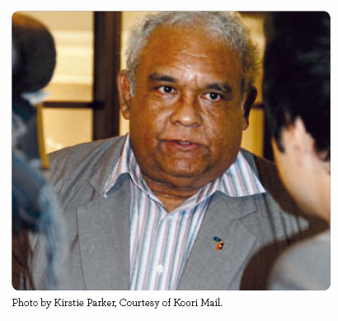

Have your say today
A preferred model for the new national representative body will be presented to the Australian Government in July 2009.
The Steering Committee encourages all Aboriginal and Torres Strait Islander people, communities, organisations and peak bodies to share their ideas about what the new body should look like, what it will do and how it will work.
There are a number of ways to get involved and have your say – and everything you need to get started is available at www.humanrights.gov.au/social_justice/repbody.
1. Organise a community meeting
The Steering Committee has developed a toolkit to help communities run their own meetings to discuss the National Representative Body. It includes a powerpoint presentation, resource and reading materials and information on how to make a written submission.
2. Make a submission
Submissions can be made using the online form. Closing date is 24 June 2009.
Written submissions should be sent to:
Email: indigenousrepbody@fahcsia.gov.au
Fax: 02 6264 5069
Post: National Indigenous Representative Body Unit
Department of Families, Housing, Community Services and Indigenous Affairs
P O Box 7576, Canberra Business Centre, ACT 2610
000
Please note: FaHCSIA is supporting the Steering Committee by processing all the submissions received. Submissions will be made public unless you request that they be kept confidential.

3. Answer an online survey
An online national survey is open to all Aboriginal and Torres Strait Islander people. Closing date is 10 June 2009 (5pm EST).

4. Come up with a name
A national competition to name the new national representative body will be advertised online and in national Aboriginal and Torres Strait Islander media during May 2009. Visit the website for further information.

The Steering Committee will also be conducting a number of focus groups with Aboriginal and Torres Strait Islander people around the country in June 2009. At this stage, the Committee does not anticipate that it will be convening a second national workshop.

Find out more
To make a submission to the Steering Committee, look through the outcomes from community consultations and the national workshop, or read the Issues Paper prepared by the Social Justice Commissioner, visit the Australian Human Rights Commission website: www. humanrights.gov.au/social_justice/repbody/
All the documents are available online.
You can also request copies by phoning FaHCSIA on 1800 202 366 or by using the contact details above.

