2011
Immigration detention in Leonora
…………………………
Summary of observations from visit to immigration detention facility in Leonora

Contents
PART A: Introductory sections 2
1 Introduction 2
2 Background 2
3 Overview: immigration detention in Leonora 2

PART B: Key concerns about immigration detention in Leonora 3
4 Mandatory detention 3
5 Length of detention 4
6 Physical conditions of detention 6
7 Children in detention 8
8 Health and mental health services 10
9 Education, recreation and excursions 12
10 Other concerns 16

PART C: Recommendations 16

PART A: Introductory sections

Introduction
The Australian Human Rights Commission visited the immigration detention facility in Leonora, Western Australia from 23 to 26 November 2010. This statement contains a brief overview of the key observations and concerns arising from the Commission’s visit. It focuses on conditions as they were at that time.
The Commission acknowledges the assistance provided by the Department of Immigration and Citizenship (DIAC) in facilitating the Commission’s visit, and the positive cooperation received from DIAC officers and detention service provider staff during the visit. This statement was provided to DIAC in advance of its publication in order to provide DIAC with an opportunity to prepare a response. DIAC’s response is available on the Commission’s website.

Background
For more than a decade, the Commission has raised significant concerns about Australia’s immigration detention system. During this time, the Commission has investigated numerous complaints from people in detention and conducted two national inquiries into the mandatory detention system. The Commission has concluded that this system breaches fundamental human rights.
Because of its ongoing concerns, the Commission undertakes monitoring activities which include conducting visits to immigration detention facilities. The overarching aim is to ensure that conditions of detention meet internationally accepted human rights standards. Further information about the Commission’s immigration detention visits and visit reports can be found on the Commission’s website.

Overview: immigration detention in Leonora
Leonora is a small town in Western Australia, approximately 830 kilometres northeast of Perth. The local population of the Leonora township is approximately 1500 people. The nearest major town is Kalgoorlie, 230 kilometres away.
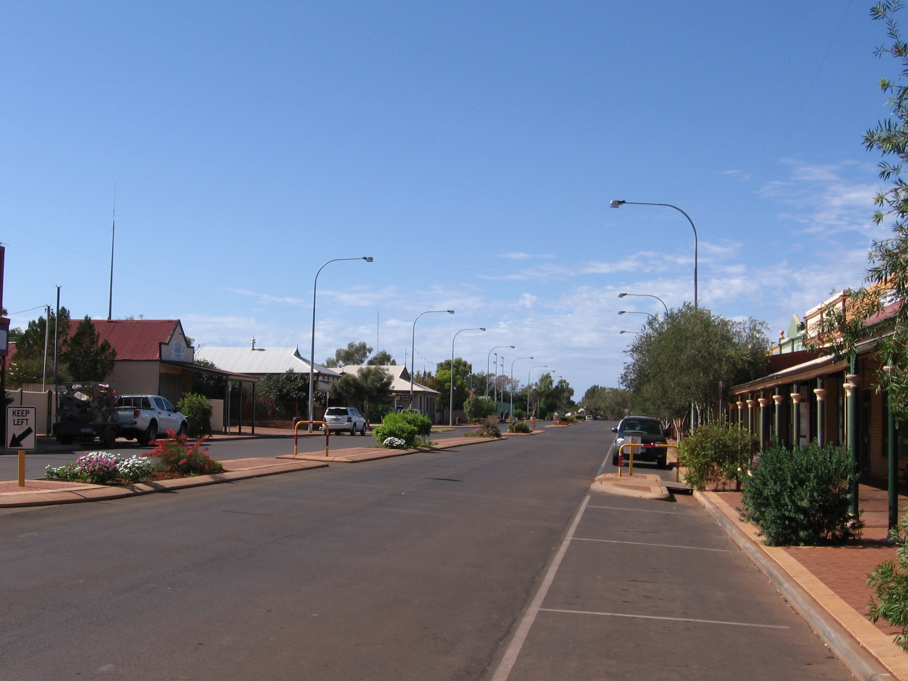 Main street, Leonora township
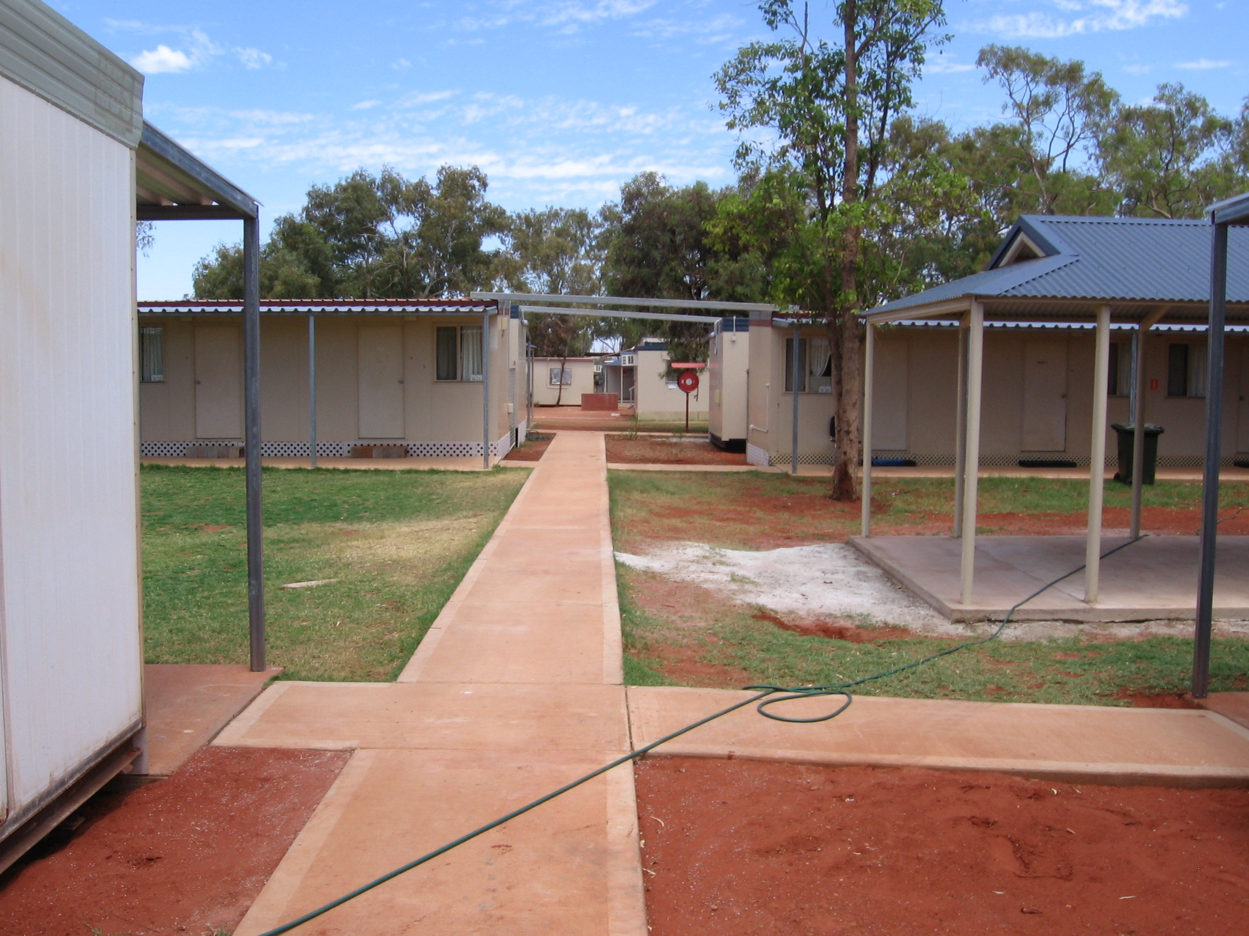 Leonora immigration detention facility
People in immigration detention in Leonora are held at the Leonora immigration detention facility. This is a privately owned property leased by the Australian Government and operated as a low-security immigration detention facility. It is primarily used for the detention of families with children. The facility is classified by DIAC as an ‘alternative place of detention’. People detained in the facility are not permitted to leave unless they are under escort.
The facility was opened as a place of immigration detention in June 2010. The facility contains demountable buildings used as accommodation, clinic rooms, a kitchen and dining room, laundry rooms, recreation spaces, a canteen, offices and interview rooms. Additional photos of the facility are available on the Commission’s website.
At the time of the Commission’s visit there were 202 people in immigration detention in Leonora – 69 men, 67 women, 35 boys and 31 girls. This included 52 people from Iran, 50 from Afghanistan, 47 from Sri Lanka, 12 from Iraq and 39 stateless people. They were all people who had arrived by boat and were seeking asylum in Australia.
At the time of the visit, the maximum capacity of the Leonora immigration detention facility was approximately 220 people. The facility was being operated by Serco Australia, the detention service provider contracted by the Australian Government.

PART B: Key concerns about immigration detention in Leonora

Mandatory detention
As has been the case with past visits to immigration detention facilities, the Commission’s overarching concern during the Leonora visit was the impact of the mandatory detention system on the human rights, wellbeing and mental health of those detained. The Commission is particularly concerned about the mandatory detention of children, as discussed in section 7 below.
Australia continues to have one of the strictest immigration detention regimes in the world – it is mandatory, it is not time limited, and people are not able to challenge the need for their detention in a court. The Commission has for many years called for an end to this system because it leads to breaches of Australia’s human rights obligations, including the obligation not to subject anyone to arbitrary detention.
To avoid being arbitrary, detention must be necessary and reasonable in all the circumstances of the case, and a proportionate means of achieving a legitimate aim. If that aim could be achieved through less invasive means than detaining a person, their detention will be rendered arbitrary.
Australia’s mandatory detention system fails to provide an individual assessment mechanism to determine whether the immigration detention of each person is necessary, reasonable or proportionate. Asylum seekers are not detained because they are individually assessed as posing some form of risk. Rather, all asylum seekers who arrive by boat are subjected to mandatory detention – and, as discussed below, many spend long periods in detention.
The Commission acknowledges that use of immigration detention may be legitimate for a strictly limited period of time in order to undertake initial health, identity and security checks. However, the need to detain a person should be assessed on a case-by-case basis taking into consideration their individual circumstances. A person should only be held in immigration detention if they are assessed as posing a risk that cannot be appropriately met in a less restrictive way, for example through reporting requirements.
Further, under Australia’s international human rights obligations, anyone deprived of their liberty should be able to challenge their detention in a court. To comply with article 9(4) of the International Covenant on Civil and Political Rights (ICCPR), the court must have the power to order the person’s release if their detention is not lawful. The lawfulness of their detention is not limited to compliance with Australia’s domestic law – it extends to whether their detention is compatible with the requirements of article 9(1) of the ICCPR, which affirms the right to liberty and prohibits arbitrary detention.
Currently, in breach of its international obligations, Australia does not provide access to such review. While people in immigration detention may be able to seek judicial review of the domestic legality of their detention, Australian courts have no authority to order that a person be released from immigration detention on the grounds that the person’s continued detention is arbitrary, in breach of article 9(1) of the ICCPR.

Length of detention
The Commission has serious concerns about the increasing length of time for which many people are being held in immigration detention. As of 3 December 2010, there were 6329 people in immigration detention in Australia, and more than forty percent of them had been detained for longer than six months. More than 200 people had been detained for longer than twelve months.
In 2008, the Commission welcomed the Australian Government’s ‘New Directions in Detention’ policy, under which immigration detention is to be used for the shortest practicable period. Under the New Directions policy, an asylum seeker should only be held in immigration detention while their health, identity and security checks are conducted. After this, the presumption should be that they will be permitted to reside in the community unless a specific risk justifies their ongoing detention. The New Directions policy recognises that once health, identity and security checks have been successfully completed ‘continued detention while immigration status is resolved is unwarranted’.
However, this policy has not been enshrined in legislation or implemented in practice. In reality, asylum seekers who arrive by boat are held in immigration detention for the duration of the processing of their refugee claims – and in some cases, beyond that, while they await the conduct of security clearances.
At the time of the Commission’s visit to Leonora, almost 80 percent of the 202 people in immigration detention there had been detained for longer than three months, and more than 60 percent had been detained for longer than six months. Eleven people, including three children, had been detained for longer than nine months. All of the people detained in Leonora had spent an initial period in detention on Christmas Island, and most were transferred from there to Leonora. Some also spent time in immigration detention in Darwin after being detained on Christmas Island and before being transferred to Leonora.
During the Leonora visit, the Commission was concerned about a number of key factors contributing to people spending prolonged periods in immigration detention:
- The suspension of processing of claims lodged by asylum seekers from Sri Lanka and Afghanistan who arrived on or after 9 April 2010 contributed to the prolonged detention of hundreds of people in Australia, including many children. At the time of the Commission’s visit, there were 76 people detained in Leonora who had been affected by the suspension, including 32 children. The Commission welcomed the lifting of both suspensions and continues to encourage DIAC to take all appropriate steps to process the backlog of asylum claims as quickly as possible.
- Delays with security clearances appeared to be contributing to the prolonged detention of a significant number of people. It is of particular concern that these delays were affecting people in respect of whom Australia has been assessed as owing protection obligations. The Commission was informed that there were 40 individuals in this situation in Leonora, some of whom remained in detention four months after receiving a positive refugee status assessment (RSA) decision. The Commission met with a number of families who had received positive RSA decisions, but who remained in detention months later awaiting a security clearance.
- The Commission has been concerned by reports over recent months that a significant number of asylum seekers in detention have not been notified of their RSA decisions until weeks or months after the decisions were made. The Commission met with a number of people in detention in Leonora who reported being affected by such delays. These delays may have the effect of prolonging people’s detention and could lead to breaches of Australia’s obligations not to subject anyone to arbitrary detention. The Commission has sought confirmation from DIAC that the delays are no longer occurring and that in all cases where there was delay in notification of a negative RSA decision, action has been taken to mitigate the delay by prioritising the case for independent merits review. DIAC has informed the Commission that people affected by delayed negative RSA outcomes have been prioritised for independent merits review where that has been sought; and that new controls are being introduced, including interim policy guidelines which set maximum timeframes for notification of decisions.
The Commission has serious concerns about the impacts that prolonged and indefinite periods of detention may have on the mental health and wellbeing of people detained. The Commission heard about some of those impacts from people in detention in Leonora, as discussed in section 8 below. Many people expressed extreme frustration about the length of time they had been detained, the indefinite nature of their detention, delays with RSA processing and security clearances, and a lack of regular provision of information about progress with their cases.

Physical conditions of detention
“Why do they discriminate? Why are the conditions better in other camps?”
(Woman detained in Leonora)
The Commission welcomes efforts by DIAC and Serco staff at the Leonora immigration detention facility to provide appropriate conditions for people in detention. During its visit, the Commission observed that individual staff members were working hard to do so. However, it appeared that they were subject to numerous constraints related to staffing levels, limited resources, remoteness and infrastructure.
During its visit the Commission had a range of concerns about the conditions of detention for people in the Leonora facility, including the following:
- The facility is located in a small town in a remote location. The Commission was pleased to hear expressions of support from members of the Leonora community, and it was clear that there had been benefits for the local community from having the immigration detention facility located there. However, the Commission has previously raised concerns about the difficulties associated with holding people in immigration detention in remote locations – concerns which apply in the case of Leonora. These include the impacts on detainees’ access to services and community-based support networks, and the challenge of attracting and retaining sufficient numbers of qualified staff willing to be based in such locations for extended periods.
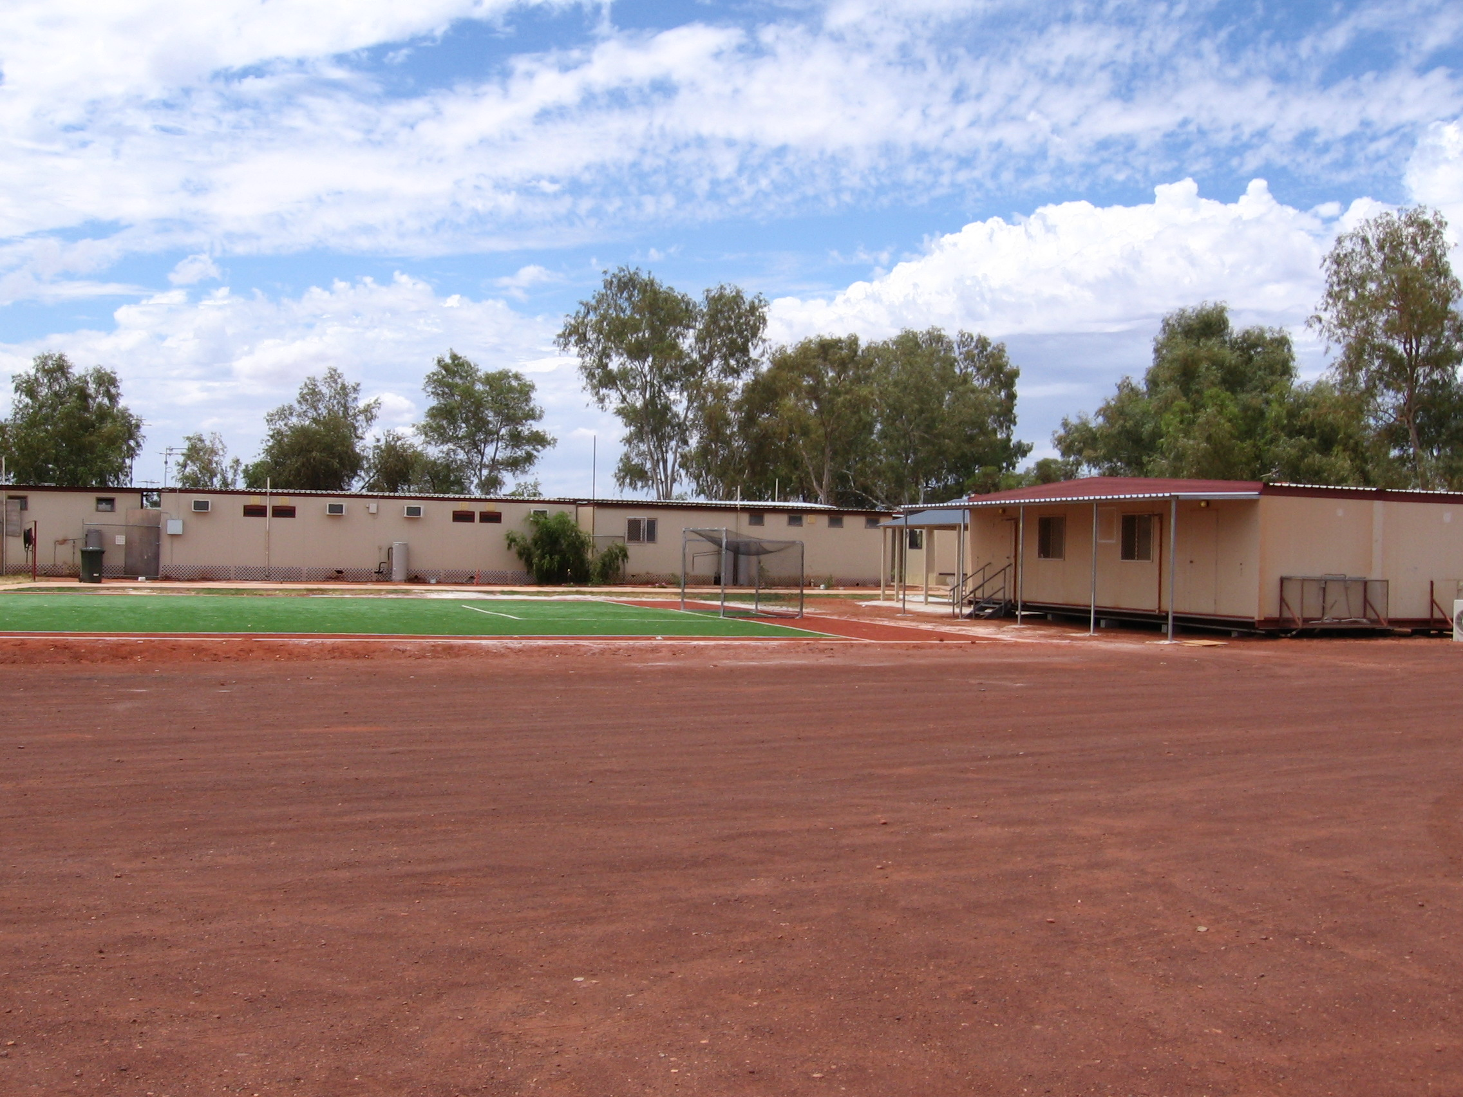
Soccer pitch, outside fence line of Leonora immigration detention facility
- The physical environment of the Leonora facility is quite harsh. It is not an appropriate place to hold families with children in detention, particularly for long periods of time. The outdoor heat is often extreme, and there is a limited amount of grassy and shaded space inside the facility. A number of the outdoor areas consist only of red dirt. Parents raised concerns about the safety and wellbeing of their young children in this hot and dusty environment. The Commission encourages DIAC to explore options for covering some of the dirt areas with grass, gardens, turf and/or paved pathways.
- The harsh nature of the outdoor environment is exacerbated by the limited amount of indoor recreation space. During the Commission’s visit there was one large recreation room inside the facility, to be shared by 200 people. Parents said there were not enough indoor areas for their young children to play away from the heat and dirt. The Commission welcomes the fact that there are minor building works underway which will result in the availability of several additional recreation rooms. The Commission urges DIAC to ensure that the work is completed as quickly as possible.
- Other than a recently installed turf volleyball court, there are limited outdoor recreation spaces inside the facility. The Commission welcomes the installation of a children’s playground and a turf soccer pitch. However, at the time of the Commission’s visit, they were located outside the facility’s fence line, with the result that people in detention had limited access to them. The Commission encourages DIAC to ensure that the fence line is moved as an urgent priority so that people will have free access to these recreation areas. The Commission also urges DIAC to ensure that plans to install shade cloth over the children’s playground are implemented as soon as possible, as the extreme heat and lack of shade make the play equipment unusable during most of the day.
- The Commission heard a significant number of complaints about the lack of a gym or exercise room inside the facility. In particular, women expressed the need for an indoor area where they could exercise in relative privacy away from the extreme heat. The Commission welcomes plans to create a gym room as part of the minor building works, and urges DIAC to ensure the completion of this work as soon as possible.

Children in detention
“This place is not suitable for our children.” (Man detained in Leonora)
“My children come home from school and ask ‘Why are they doing this to us Mum? Why are we still here?’” (Woman detained in Leonora)
The Commission has welcomed efforts over recent years to improve immigration detention conditions for children. However, the Commission continues to have serious concerns about the mandatory detention of children, the high number of children in immigration detention facilities around Australia, and the increasing length of time for which many children are being detained.
As of 3 December 2010, there were 918 children in immigration detention in Australia. The Commission welcomes the fact that children are no longer held in Australia’s high security immigration detention centres (IDCs). However, children are still detained in other types of immigration detention facilities, including the facility in Leonora.
Child asylum seekers continue to be subjected to mandatory immigration detention. This breaches Australia’s obligations under the Convention on the Rights of the Child (CRC), which require that a child should only be detained as a measure of last resort and for the shortest appropriate period of time. These principles apply not only to detention of children in high security IDCs, but also to detention of children in other facilities. The Australian Government should consider any less restrictive alternatives (including Community Detention, as discussed below) before deciding to detain a child in an immigration detention facility. Children should not be detained in such facilities as a matter of course; it should only take place in exceptional cases.
The physical environment in such facilities is preferable to IDCs in that the security measures are much less intrusive. However, they are still closed detention facilities from which children and their families are not free to come and go. Children might be escorted to an external school during the day or they might be able to take part in supervised excursions, but during the remainder of their time they are restricted to the detention facility.
During the Commission’s visit to Leonora, there were 66 children in the immigration detention facility there – 31 girls and 35 boys. The children ranged in age from four months to 17 years. There were 11 babies or toddlers aged up to two years, 18 children aged three to five years, 18 children aged six to ten years, and 19 children aged 11 to 17 years.
The Commission welcomes efforts by DIAC and Serco staff in Leonora to provide children in detention with access to appropriate conditions, services and support. It was clear that individual staff members were making significant personal efforts in this regard, despite dealing with numerous challenges.
However, during its visit the Commission had particular concerns about the following issues relating to the detention of children in Leonora:
- Many children are spending longer periods in immigration detention. At the time of the Commission’s visit, more than 80 percent of the 66 children in detention in Leonora had been detained for longer than three months. Fifty of the children had been detained for longer than six months, three of whom had been detained for ten months. The Commission has for many years raised serious concerns about the impacts of prolonged detention on children. In A last resort?, the 2004 report of the National Inquiry into Children in Immigration Detention, the Commission found that children in immigration detention for long periods were at high risk of serious mental harm.
- There was no Memorandum of Understanding between DIAC and the Western Australia Department for Child Protection. This should be pursued to ensure there are clear guidelines in place regarding responsibilities and procedures relating to the welfare and protection of children detained at the Leonora facility.
- DIAC and Serco staff had not been not provided with a written policy setting out the procedure to follow in the case of concerns that may arise about the welfare or protection of a child detained in the Leonora facility. All relevant staff working in the facility should be provided with a localised policy setting out the requirements and procedures for making child welfare and protection notifications, and training on this policy.
- As discussed in section 6 above, the physical environment of the Leonora facility is quite harsh. It is not an appropriate place to hold families with children in detention, particularly for long periods of time. Parents raised concerns about the safety and wellbeing of their young children in the hot and dusty environment.
- The Commission is pleased that school-aged children detained in Leonora are able to attend the local school. However, the Commission is concerned that pre-school aged children are provided with limited opportunities to leave the detention environment and to take part in active play and learning activities. Many parents raised concerns about the limited availability of meaningful activities for their pre-school aged children and the lack of safe spaces for them to play away from the heat and dirt. These issues are discussed further in section 9 below.
- While some people detained at the Leonora facility welcomed the quality of food in the dining room, parents expressed concerns about food for their children. Some parents expressed concerns that the food in the dining room was not appropriate for toddlers or young children, and requested that they be allowed to prepare food for their own families. Many parents raised concerns about the ban on taking food out of the dining room. This complicates feeding toddlers and young children who may not eat at prescribed meal times, but get hungry for substantial meals (as opposed to the snack packs provided) at other times. The Commission encourages DIAC to work with the kitchen contractor to remove the ban on taking food out of the dining room.
The Commission is concerned that families with children are detained in an immigration detention facility in Leonora rather than being placed in community-based alternatives to detention.
The Commission has previously raised concerns about the under-utilisation of the Community Detention system nationally. This concern applies in the case of families detained in Leonora. At the time of the Commission’s visit, there had been two referrals for consideration of Community Detention placements for people detained in Leonora. This is a very low rate of referral given that virtually all of the people detained in Leonora would appear to meet one or more of the priority criteria under the Residence Determination Guidelines.
The Commission welcomed the announcement on 18 October 2010 that the Minister for Immigration would begin to use his existing Residence Determination powers to move some families and unaccompanied minors into Community Detention. The Commission has encouraged the Australian Government to expand these efforts to include all children in immigration detention and to implement them as quickly as possible.

Health and mental health services
“Holding us here makes us stressed. We lose our tempers. We get unwell. By the time we get our visas it is too late.” (Man detained in Leonora)
Under international human rights standards, all people have a right to the highest attainable standard of physical and mental health. Each person in detention is entitled to medical care and treatment provided in a culturally appropriate manner and to a standard which is commensurate with that provided in the general community. This should include preventive and remedial medical care and treatment including dental, ophthalmological and mental health care.
The Commission is of the view that there is a need for rigorous ongoing monitoring of the delivery of health and mental health services in immigration detention facilities in Australia, and has recommended that an independent body be charged with this monitoring function. This is particularly important as more people are being detained for longer periods of time.
During its visit to Leonora, the Commission had some concerns about the provision of health and mental health services for people in immigration detention, as summarised below.

Health
Health services are provided to people in the Leonora immigration detention facility by IHMS, the contracted health service provider. A number of small clinic rooms are located inside the facility. At the time of the Commission’s visit, a new and more spacious health clinic was under construction. The onsite IHMS health team consists of a Regional Health Manager and two registered nurses. A general practitioner visits the facility to see patients during two three-hour sessions each week.
The Commission welcomes efforts by health staff to ensure that people detained in Leonora have access to appropriate services and treatment. The Commission heard some positive feedback from people in detention about the assistance provided by health staff. Other people, however, expressed dissatisfaction about the medical treatment they had received.
The Commission had some concerns about the provision of health services for people in the Leonora immigration detention facility. These included the following:
- The Commission is concerned about the impact on access to health services of detaining people in small, remote locations such as Leonora. This is a particular concern in terms of access to specialist and dental care. These services are not available for people in the Leonora facility – they require a referral and escorted transport to Kalgoorlie, a 230 kilometre drive.
- The Commission heard a number of complaints from people in detention about long waiting periods for access to dental care. In some cases this was in situations where people claimed they were experiencing significant ongoing pain or had a relatively serious complaint – for example, where a filling or a tooth had fallen out. As noted, people in the Leonora facility are not able to access dental care in Leonora – they have to be referred and escorted to Kalgoorlie. DIAC informed the Commission that consideration was being given to bringing a dentist to Leonora to offer appointments through the local hospital. The Commission encourages prompt action on this issue.
- The Commission met with a number of pregnant women in the Leonora facility, two of whom had not yet been seen by a general practitioner or provided with access to an ultrasound. They claimed they had not been informed of what antenatal care would be provided to them. The Commission has encouraged DIAC and IHMS to clarify the procedures and timeframes for provision of ante-natal care, and to ensure that this information is clearly communicated to all pregnant women in detention.

Mental health
Mental health services are provided to people in the Leonora immigration detention facility primarily by IHMS. The onsite IHMS mental health team consists of two mental health nurses and a psychologist. In addition, torture and trauma services are provided by the Association for Services to Torture and Trauma Survivors (ASeTTS). At the time of the Commission’s visit, there was one ASeTTS counsellor based at the Leonora facility, but generally there are two.
The Commission welcomes efforts by mental health staff to ensure that people detained in Leonora have access to appropriate services and support.
However, as noted in section 5 above, the Commission has serious concerns about the impacts that prolonged and indefinite periods of detention may have on the mental health and wellbeing of people detained. The Commission heard about some of those impacts from people in detention in Leonora. Many people expressed extreme frustration about the length of time they had been detained and the indefinite nature of their detention. Some people expressed concerns that the uncertainty and prolonged period in detention may have adverse psychological impacts on them if their detention continued much longer. Others expressed concerns that their mental health or that of family members had already been adversely affected.
The Commission had some concerns about the provision of mental health services for people in the Leonora immigration detention facility. These included the following:
- The Commission is concerned about the impact on access to mental health services of detaining people in small, remote locations such as Leonora. This is a particular concern in terms of access to psychiatric services. These services are not available for people in the Leonora facility – they require a referral and escorted transport to Kalgoorlie, a 230 kilometre drive.
- At the time of the Commission’s visit, DIAC and detention service provider staff in Leonora had not received training on the Psychological Support Program (the DIAC policy regarding the identification and support of people in immigration detention who are at risk of self-harm and suicide). Appropriate staff training should be conducted as soon as possible.
During its visit to Leonora, the Commission was concerned that there appeared to be cases in which people met the priority criteria for consideration of a Community Detention placement based on mental health concerns, but they had not been referred for a Residence Determination.
The Commission has encouraged the Australian Government to make full use of the Community Detention system. As noted above, the Commission welcomed the October 2010 announcement that some families and unaccompanied minors would be moved into Community Detention. Under the Residence Determination Guidelines, people with significant physical or mental health concerns, people who may have experienced torture or trauma and people whose cases will take a considerable period to substantively resolve should also be given priority consideration for Community Detention.

Education, recreation and excursions
“Please give us something to do.”
(Man detained in Leonora, requesting that people in detention be able to spend their time constructively by volunteering.)
Under international human rights standards, people in immigration detention should have access to materials and facilities for exercise, recreation, cultural expression and intellectual and educational pursuits to utilise their time in detention in a constructive manner, and for the benefit of their physical and mental health.

Educational activities

Children
The CRC protects the rights of all children to education, to engage in play and recreational activities appropriate to their age, and to participate in cultural and artistic activities.
The Commission is pleased that school-aged children in immigration detention in Leonora are able to attend the local school. This not only provides those children with the opportunity to enjoy their right to education, but importantly also provides them with opportunities to play and engage with other children outside the detention environment. The Commission heard positive comments from parents in detention about the quality of the education their children were receiving at the local school, and heard positive feedback from the school about some of the benefits of having a new group of culturally diverse children among their student body. The Commission visited the school and observed children from the detention facility engaging in meaningful educational and recreational activities.
While the Commission welcomes this situation in relation to school-aged children, the Commission is concerned that pre-school aged children in detention in Leonora are provided with limited opportunities to leave the detention environment and to take part in active learning and play activities. At the time of the Commission’s visit, there were 23 children aged four years or younger in the Leonora detention facility. As discussed in section 7 above, many parents raised concerns about the limited availability of meaningful activities for their pre-school aged children and the lack of safe spaces for them to play.
At the time of the visit, there was a small crèche room inside the facility that had been operating for a few hours each day. Parents welcomed this, but some reported that a larger space and longer hours of operation were needed. A larger crèche room was opened during the Commission’s visit. The Commission welcomed this positive development. However, the new crèche room was located outside the facility’s fence line. The Commission encourages DIAC to ensure that the fence line is moved as soon as possible so that people in detention will have freer access to this area, and to work with Serco to increase the hours during which the crèche room is accessible.
The Commission also encourages DIAC to explore the possibility of providing pre-school aged children with appropriate opportunities to take part in active learning and play activities outside the detention environment. In particular, this might include making arrangements in order to allow four year old children to attend the local pre-school.

Adults
The Commission welcomes efforts to provide onsite English classes for adults detained at the Leonora facility. Such classes are important both in providing people with a constructive way to spend their time in detention, as well as assisting them to improve their English communication skills in order to better prepare them for living in the Australian community.
However, during its visit the Commission heard numerous complaints from people in detention about the limited number of English classes for adults. Many people claimed that they were only able to attend one English class each week, and that often the level of instruction was not appropriate for them.
The Commission acknowledges the constraints that Serco staff have faced in securing an adequate number of English teachers in Leonora, which is a very small community. Such constraints reinforce the Commission’s concerns about locating detention facilities in small, remote locations.
At the time of the Commission’s visit, plans were underway to hire an additional teacher and to increase the number of English classes on offer. The Commission welcomes these plans and encourages DIAC and Serco to ensure that all people who wish to do so are able to participate in an adequate number of English classes, taught at an appropriate level.

Recreation
The provision of regular, engaging and constructive activities is vital to people’s capacity to cope in immigration detention, particularly when they are detained for long periods of time.
During the Commission’s visit to the Leonora immigration detention facility, many people expressed frustration about the length and indefinite nature of their detention, and told the Commission that they would like to be provided with further opportunities to spend their time in detention in an engaged and constructive way.
The Commission welcomes efforts over past months to increase the availability of recreational activities for people detained at the Leonora facility. Staff facilitate a range of recreational activities inside the facility including sewing, knitting, arts and crafts and occasional cultural cooking sessions. In addition, volunteers have visited the facility on several occasions to run recreational activities for people in detention.
Records provided by Serco suggested that significant efforts were being made to run a broad range of recreational activities in the facility, but that these efforts were impacted by resource constraints. In particular, staff shortages forced the cancellation of a number of scheduled activities, usually because Serco staff were required to escort people in detention to Kalgoorlie for medical appointments.
The Commission heard some positive comments from people in detention about particular recreational activities offered in the Leonora facility. However, the Commission also heard numerous complaints that there were not enough activities conducted on a regular basis. Many people expressed frustration about not having a constructive way to pass their time, and some said they felt this was having impacts on their physical and mental health. This is a particular concern given the lengthy periods many people are spending in detention.
A number of people expressed the desire to engage in some form of constructive voluntary activity, either inside or outside the detention environment. The Commission has encouraged DIAC to explore appropriate volunteering opportunities.
As discussed in sections 6 and 9.1 above, the external and internal recreation spaces in the Leonora facility were inadequate at the time of the Commission’s visit. In particular there was no onsite gym area, there was only one large recreation room to be shared by 200 people, the newly installed soccer pitch and children’s play equipment were not freely accessible, and parents raised concerns about the lack of safe spaces for their young children to play.
In addition, the Commission was concerned about the lack of reading materials for adults in the Leonora facility. There were a few books in English, but there were virtually no multilingual reading materials onsite. While a small number of people had been taken on an excursion to the local library, others were unaware this possibility existed. There were no newspapers available either in English or foreign languages, and some people expressed frustration about not being able to read news about their home country. While internet access could alleviate this to some extent, there was limited access to computers and not all people were able to access news online – for example, there was no Tamil script available on the computers.

Excursions
Providing people in immigration detention with regular opportunities to leave the detention environment can be vital in assisting them to cope with the deprivation of their liberty, particularly when they are detained for long periods of time. People detained at the Leonora facility are subjected to significant restrictions on their liberty. They are not permitted to leave the facility unless they are under escort.
The Commission welcomes efforts to provide people detained at the Leonora facility with opportunities to take part in escorted excursions to places including a local children’s playground, a local oval, the community recreation centre and a local museum. However, the Commission heard a significant number of complaints from people in detention about the limited number of excursions.
Serco provided the Commission with records which indicated that in the three months leading up to the Commission’s visit, there had been between seven and thirteen excursions conducted each week, with approximately 475 excursion places per month on average. That would have allowed each person the chance to leave the detention facility on an escorted excursion on average two or three times each month.
While the Commission welcomes these efforts, it appears that not all people in detention in Leonora were able to take part in excursions as often as that. Some people reported being able to go on an excursion approximately once each week, while others said they were able to go approximately once each month. A small number of people claimed they had not been on any external excursions during the time they had been detained in Leonora.
Some people claimed that there was ‘discrimination’ in decisions about who was selected to participate in excursions, and some women reported that men were taken on a much higher number of exercise related excursions. This may indicate a need for clearer communication with people in detention about the availability of excursions and the process for determining who participates.
The Commission encourages DIAC and Serco to ensure that all people detained in the Leonora facility are provided with regular opportunities to participate in external excursions.

Other concerns
During its visit, the Commission heard a range of other concerns from people in immigration detention in Leonora. These included the following:
- The Commission heard numerous complaints from people in detention in Leonora about the high turnover in DIAC Case Managers. Some people claimed to have been assigned a new Case Manager on a monthly basis. In combination with their prolonged period in detention and delays with processing and security clearances, this turnover appeared to be causing significant frustration and a lack of faith in the refugee status assessment process. This is not a criticism of individual Case Managers in Leonora, some of whom the Commission heard positive comments about. Rather, it is a concern about the system of posting Case Managers to detention locations for short periods of time. The Commission encourages DIAC to ensure greater continuity in the Case Management service.
- There were no regular religious services in the detention facility for people who practiced a religion other than Christianity, and people were not being provided with any opportunity to attend a place of worship outside the detention environment. The Commission welcomes efforts to provide a fortnightly Christian service inside the detention facility, and welcomes that support was provided to allow for one visit by an Imam. The Commission acknowledges the difficulties in providing access to religious services, given the limited number of religious representatives and groups in the Leonora community. However, these difficulties reinforce the Commission’s concerns about detaining people in such a small and remote location.

PART C: Recommendations
Recommendation 1: Australia’s mandatory detention law should be repealed. The Migration Act should be amended so that immigration detention occurs only when necessary. This should be the exception, not the norm. It must be for a minimal period, be reasonable and be a proportionate means of achieving at least one of the aims outlined in international law. The limited grounds for detention should be clearly prescribed in the Migration Act.
Recommendation 2: The Migration Act should be amended to accord with international law by requiring that a decision to detain a person, or a decision to continue a person’s detention, is subject to prompt review by a court. To comply with article 9(4) of the ICCPR, the court must have the power to order the person’s release if their detention is not lawful. The lawfulness of their detention is not limited to domestic legality – it includes whether the detention is compatible with the requirements of article 9(1) of the ICCPR, which affirms the right to liberty and prohibits arbitrary detention.
Recommendation 3: Until the above legislative changes are implemented, the Australian Government should avoid the prolonged detention of asylum seekers by:
- Ensuring full implementation of its New Directions policy under which asylum seekers should only be held in immigration detention while their health, identity and security checks are conducted. After this, the presumption should be that they will be permitted to reside in the community unless a specific risk justifies their ongoing detention.
- Ensuring that security checks are conducted as quickly as possible.

Recommendation 4: The Australian Government should implement the outstanding recommendations of the report of the National Inquiry into Children in Immigration Detention, A last resort?. These include that Australia’s immigration detention laws should be amended, as a matter of urgency, to comply with the Convention on the Rights of the Child. In particular, the new laws should incorporate the following minimum features:
- There should be a presumption against the detention of children for immigration purposes.
- A court or independent tribunal should assess whether there is a need to detain children for immigration purposes within 72 hours of any initial detention (for example, for the purposes of health, identity or security checks).
- There should be prompt and periodic review by a court of the legality of continuing detention of children for immigration purposes.
- All courts and independent tribunals should be guided by the following principles:
- detention of children must be a measure of last resort and for the shortest appropriate period of time
- the best interests of children must be a primary consideration
- the preservation of family unity
- special protection and assistance for unaccompanied children.

Recommendation 5: People should not be held in immigration detention in remote locations such as Leonora. If people must be held in immigration detention facilities, they should be located in metropolitan areas.

Recommendation 6: DIAC should pursue the adoption of a Memorandum of Understanding with the Western Australia Department for Child Protection in order to ensure clear guidelines are in place regarding responsibilities and procedures relating to the welfare and protection of children in immigration detention in Leonora.

Recommendation 7: DIAC should ensure that all relevant DIAC officers and staff members of detention service providers are given a localised policy setting out the requirements and procedures for making child welfare and protection notifications in relation to concerns that arise in respect of children in immigration detention in Leonora. Staff should also be provided with training on this policy.

Recommendation 8: DIAC should explore possibilities for providing pre-school aged children in immigration detention in Leonora with appropriate opportunities to take part in active learning and play activities outside the detention environment. In particular, this might include making arrangements in order to allow four year old children to attend the local pre-school.

Recommendation 9: DIAC should ensure that people in immigration detention in Leonora are provided with timely access to appropriate health and mental health services. In particular, this should include timely access to appropriate specialist, dental, ante-natal and psychiatric care.

Recommendation 10: DIAC should ensure that all people in immigration detention in Leonora have access to:
- adequate outdoor recreation spaces including sufficient grassy and shaded areas
- adequate indoor recreation spaces including a gym or exercise room, and safe and appropriate play areas for young children
- a range of recreational activities conducted on a regular basis
- a sufficient number of English classes
- an adequate supply of reading materials in the principal languages spoken by people in detention
- regular opportunities to leave the detention environment on external excursions.
Recommendation 11: DIAC should ensure that all people in immigration detention in Leonora who seek to do so have access to regular religious services conducted by qualified religious representatives.
Recommendation 12: DIAC should take appropriate measures to ensure greater continuity in the Case Management service, both in Leonora and other immigration detention locations.

See http://www.humanrights.gov.au/human_rights/immigration/idc2011_leonora_response.html.
The Commission’s reports of complaints about alleged human rights breaches in immigration detention are available at http://humanrights.gov.au/legal/humanrightsreports/index.html. The Commission’s national inquiry reports are A last resort? National Inquiry into Children in Immigration Detention (2004) (A last resort), at http://humanrights.gov.au/human_rights/children_detention_report/index.html, and Those who’ve come across the seas: Detention of unauthorised arrivals (1998) (Those who’ve come across the seas), at http://humanrights.gov.au/human_rights/immigration/seas.html (viewed 4 January 2011).
See, for example A last resort, note 2; Those who’ve come across the seas, note 2.
Further information about the Commission’s activities relating to immigration detention is available at http://humanrights.gov.au/human_rights/immigration/detention_rights.html#9.
See http://humanrights.gov.au/human_rights/immigration/detention_rights.html#9_3.
See Shire of Leonora website at http://www.leonora.wa.gov.au/about_us/leonora_township.html (viewed 4 January 2011).
See http://www.humanrights.gov.au/human_rights/immigration/idc2011_leonora_photos.html.
Figures provided by DIAC, current as of 24 November 2010.
DIAC provided the Commission with statistics current as of 24 November 2010, which list the citizenship of the 202 people in immigration detention in Leonora as follows: 52 from Iran, 50 from Afghanistan, 47 from Sri Lanka, 12 from Iraq, 39 stateless and 2 not yet known.
See International Covenant on Civil and Political Rights (1966) (ICCPR), art 9(1), at http://www2.ohchr.org/english/law/ccpr.htm (viewed 4 January 2011); Convention on the Rights of the Child (1989) (CRC), art 37(b), at http://www2.ohchr.org/english/law/crc.htm (viewed 4 January 2011).
See, for example United Nations Human Rights Committee, A v Australia, Communication No. 560/1993, UN Doc CCPR/C/59/D/560/1993 (1997), para 9.2, at http://www.unhchr.ch/tbs/doc.nsf/ 0/30c417539ddd944380256713005e80d3?Opendocument (viewed 4 January 2011); United Nations Human Rights Committee, Van Alphen v The Netherlands, Communication No. 305/1988, UN Doc CCPR/C/39/D/305/1988 (1990), para 5.8, at http://www.unhchr.ch/tbs/doc.nsf/0/a4269194de1b9228c1256ac700449405?Opendocument (viewed 4 January 2011); United Nations Human Rights Committee, Shafiq v Australia, Communication No. 1324/2004, UN Doc CCPR/C/88/D/1324/2004 (2006), para 7.2, at http://www.unhcr.org/refworld/country,,HRC,,BGD,,47975af921,0.html (viewed 4 January 2011); United Nations Human Rights Committee, Tillman v Australia, Communication No. 1635/2007, UN Doc CCPR/C/98/D/1635/2007 (2010), para 3.4, at http://www.unhcr.org/refworld/country,,UNHRC,,AUS,,4c19ea9d2,0.html (viewed 4 January 2011).
See, for example United Nations Human Rights Committee, Tillman v Australia, note 11, para 3.4; United Nations Human Rights Committee, Baban v Australia, Communication No. 1014/2001, UN Doc CCPR/C/78/D/1014/2001 (2003), para 7.2, at http://www.unhcr.org/refworld/docid/404887ee3.html (viewed 4 January 2011); United Nations Human Rights Committee, D and E v Australia, Communication No. 1050/2002, UN Doc CCPR/C/87/D/1050/2002 (2006), para 7.2, at http://www.unhchr.ch/TBS/doc.nsf/0ac7e03e4fe8f2bdc125698a0053bf66/9dbcb136a858ebc5c12571cc00532f41?OpenDocument (viewed 4 January 2011); United Nations Human Rights Committee, Kwok Yin Fong v Australia, Communication No. 1442/2005, UN Doc CCPR/C/97/D/1442/2005 (2009), para 9.3, at http://www.unhcr.org/refworld/country,,HRC,,CHN,,4b1d223d2,0.html (viewed 4 January 2011).
See further UNHCR, Revised Guidelines on Applicable Criteria and Standards Relating to the Detention of Asylum Seekers (1999), guidelines 2, 3. At http://www.unhcr.org/3bd036a74.html (viewed 4 January 2011).
See ICCPR, note 10, art 9(4); CRC, note 10, art 37(d).
See, for example United Nations Human Rights Committee, A v Australia, note 11, para 9.5.
Department of Immigration and Citizenship, Immigration Detention Statistics Summary (3 December 2010). At http://www.immi.gov.au/managing-australias-borders/detention/facilities/statistics/ (viewed 13 January 2011).
See C Evans, New Directions in Detention – Restoring Integrity to Australia’s Immigration System (Speech delivered at the Centre for International and Public Law Seminar, Australian National University, Canberra, 29 July 2008) (New Directions in Detention). At http://www.minister.immi.gov.au/media/speeches/2008/ce080729.htm (viewed 10 January 2011).
See New Directions in Detention, note 17.
These figures are based on statistics provided by DIAC, current as of 24 November 2010. They refer to the overall time in immigration detention – including on Christmas Island, in Leonora and in any other immigration detention facilities in Australia.
For further discussion of the suspension, see Australian Human Rights Commission, 2010 Immigration detention on Christmas Island (2010) (2010 Christmas Island report), section 8. At http://humanrights.gov.au/human_rights/immigration/idc2010_christmas_island.html (viewed 4 January 2011).
These figures are based on statistics provided by DIAC, current as of 24 November 2010. The total of 76 people included 34 from Afghanistan (17 adults and 17 children) and 42 from Sri Lanka (27 adults and 15 children).
Information provided by DIAC, current as of 26 November 2010.
See ICCPR, note 10, art 9(1); CRC, note 10, art 37(b).
Written communication from DIAC to the Commission, 24 December 2010.
Department of Immigration and Citizenship, Immigration Detention Statistics Summary (3 December 2010). At http://www.immi.gov.au/managing-australias-borders/detention/facilities/statistics/ (viewed 13 January 2011).
Children may be held in immigration detention in a range of immigration detention facilities including Immigration Residential Housing, Immigration Transit Accommodation and ‘alternative places of detention’. Further information about the various places of detention is available on the Commission’s website at http://humanrights.gov.au/human_rights/immigration/detention_rights.html#5.
See CRC, note 10, art 37(b). See further A last resort, note 2.
See further A last resort, note 2, sections 4.3.2, 6.6; UNHCR, Guidelines on Policies and Procedures in Dealing with Unaccompanied Children Seeking Asylum (1997), guidelines 7.6, 7.7, at http://www.unhcr.org/cgi-bin/texis/vtx/refworld/rwmain?page=search&docid=3ae6b3360 (viewed 5 January 2011); UNHCR, Revised Guidelines on Applicable Criteria and Standards Relating to the Detention of Asylum Seekers, note 13, guideline 6.
These figures are based on statistics provided by DIAC, current as of 24 November 2010.
These figures are based on statistics provided by DIAC, current as of 24 November 2010. They refer to the children’s overall time in immigration detention – including on Christmas Island, in Leonora and in any other immigration detention facilities in Australia.
A last resort, note 2, executive summary, major finding 2.
See 2010 Christmas Island report, note 20, sections 11, 13.2; Australian Human Rights Commission, 2010 Immigration detention in Darwin (2010 Darwin report), section 7, at http://humanrights.gov.au/human_rights/immigration/idc2010_darwin.html (viewed 5 January 2011).
Minister for Immigration and Citizenship, Minister’s Residence Determination Power Under S. 197AB and S. 197AD of the Migration Act 1958: Guidelines (2009) (Residence Determination Guidelines), para 4.14.
Under section 197AB of the Migration Act 1958 (Cth), the Minister for Immigration has the power to issue a Residence Determination permitting a person in immigration detention to reside at a specified place instead of in an immigration detention facility. This is known as Community Detention.
See International Covenant on Economic, Social and Cultural Rights (1966) (ICESCR), art 12, at http://www2.ohchr.org/english/law/cescr.htm (viewed 6 January 2011); CRC, note 10, art 24.
See Human Rights and Equal Opportunity Commission, Immigration Detention Guidelines (2000), section 13. At http://humanrights.gov.au/human_rights/immigration/idc_guidelines2000.html (viewed 6 January 2011).
See 2010 Christmas Island report, note 20, section 19; 2010 Darwin report, note 32, section 8.
Department of Immigration and Citizenship, Psychological Support Program for the Prevention of Self-Harm in Immigration Detention (2009).
See 2010 Christmas Island report, note 20, sections 11, 13.2; 2010 Darwin report, note 32, sections 7, 8.
Residence Determination Guidelines, note 33, para 4.1.4.
See Immigration Detention Guidelines, note 36, section 7.2.
CRC, note 10, arts 28, 31. See further A last resort, note 2, chapters 12, 13, 15.
These figures are based on statistics provided by DIAC, current as of 24 November 2010.
For example, Serco records provided to the Commission indicate that medical escorts to Kalgoorlie resulted in the cancellation of scheduled crèche sessions in the Leonora immigration detention facility at least once per week in each week of September 2010, and at least once per week in most weeks of October 2010.
Serco provided the Commission with copies of activities and excursion reports for the Leonora immigration detention facility for the months of September, October and November 2010. Based on the Commission’s analysis of these reports, during November 2010 there were 52 excursions with 538 participants; during October 2010 there were 26 excursions with 378 participants; and during September 2010 there were 28 excursions with 509 participants. It should be noted that these participants are not unique individuals – some people would have participated in more than one excursion each month.
Under UNHCR guidelines, there should be a presumption against the detention of asylum seekers–it should be the exception rather than the norm. Detention should only be resorted to if there is evidence to suggest that other alternatives (for example, reporting requirements) will not be effective in the individual case. The permissible exceptions to the general rule that detention should normally be avoided must be prescribed by law. The detention of asylum seekers may only be resorted to if necessary to verify identity; to determine the elements on which the claim to refugee status or asylum is based; to deal with cases where refugees or asylum seekers have destroyed their travel and/or identity documents or have used fraudulent documents in order to mislead the authorities of the State in which they intend to claim asylum; or to protect national security or public order. In assessing whether detention is necessary, considerations should include whether it is reasonable and whether it is proportional to the objectives to be achieved. See UNHCR, Revised Guidelines on Applicable Criteria and Standards Relating to the Detention of Asylum Seekers, note 13, guidelines 2, 3; UNHCR Executive Committee, Conclusion No. 44 (XXXVII) - Detention of Refugees and Asylum Seekers (1986), at http://www.unhcr.org/refworld/docid/3ae68c43c0.html (viewed 4 January 2011).
See, for example United Nations Human Rights Committee, A v Australia, note 11, para 9.5.
See A last resort, note 2, section 17.3.

