2010
Immigration detention in Darwin
…………………………
Summary of observations from visits to immigration detention facilities in Darwin

Contents
PART A: Introductory sections 2
1 Introduction 2
2 Background 2
3 Overview: immigration detention in Darwin 2

PART B: Key concerns about immigration detention in Darwin 4
4 Mandatory detention 4
5 Length of detention 5
6 Physical conditions of detention 6
7 Children in detention 8
8 Health and mental health services 10
9 Education, recreation and excursions 13
10 Other concerns 15

PART C: Recommendations 16

PART A: Introductory sections

Introduction
The Australian Human Rights Commission (the Commission) visited immigration detention facilities in Darwin from 6 to 10 September 2010. The visit was conducted by Commission President and Human Rights Commissioner, Catherine Branson QC, as well as Commission staff and consultants including a consultant psychiatrist.
The Commission acknowledges the assistance provided by the Department of Immigration and Citizenship (DIAC) in facilitating the visit, and the positive cooperation received from DIAC officers and detention service provider staff during the visit.
This statement contains a brief overview of the key observations and concerns arising from the Commission’s visit. It focuses on conditions as they were at the time of the visit. In addition to the issues outlined in this statement, the Commission raised a number of issues with DIAC during the visit and in subsequent communications. This statement was provided to DIAC in advance of its publication in order to provide DIAC with an opportunity to prepare a response. DIAC’s response is available on the Commission’s website.

Background
For more than a decade, the Commission has raised significant concerns about Australia’s immigration detention system. During this time, the Commission has investigated numerous complaints from people in detention and conducted two national inquiries into the mandatory detention system. The Commission has concluded that this system breaches fundamental human rights.
Because of its ongoing concerns, the Commission undertakes monitoring activities which include conducting visits to immigration detention facilities. The overarching aim is to ensure that conditions of detention meet internationally accepted human rights standards. Further information about the Commission’s immigration detention visits and visit reports can be found on the Commission’s website.

Overview: immigration detention in Darwin
At the time of the Commission’s visit there were 783 people in immigration detention in Darwin – 468 men, 67 women and 248 accompanied children and unaccompanied minors. The majority were asylum seekers who had arrived by boat (referred to by DIAC as ‘irregular maritime arrivals’). There were also a significant number of Indonesian crew members and a small number of alleged illegal foreign fishers. The largest group of people were from Afghanistan, followed by smaller groups from Indonesia, Iran, Iraq, Sri Lanka and Burma. There were also around a hundred stateless people.
During the visit, people were held in immigration detention in five facilities in Darwin, as outlined below. The facilities were operated by Serco Australia, the detention service provider contracted by the Australian Government. Photos of the facilities are available on the Commission’s website.

Northern Immigration Detention Centre
The Northern Immigration Detention Centre (NIDC) is a high-security detention centre located on the grounds of the Defence Establishment Berrimah, just outside of Darwin. The NIDC is used to detain adult men. At the time of the Commission’s visit there were 397 men detained at the NIDC, including 151 Indonesian crew.
The capacity of the NIDC is approximately 500 people. The centre is split into two main areas – the North area and the South area, each of which contains three separate compounds. Accommodation is provided in demountable buildings.

Berrimah House
Berrimah House is a low-security immigration detention facility located on the grounds of the Defence Establishment Berrimah. It is next to the NIDC, but outside the NIDC fence. Berrimah House was constructed in 2008-2009 for the purpose of accommodating unaccompanied minors in immigration detention.
At the time of the Commission’s visit there were 15 unaccompanied minors detained at Berrimah House, all of them Indonesian crew. They were all boys and they ranged in age from 11 to 17 years.
The capacity of Berrimah House is 16 people, accommodated in four shared bedrooms. The facility also contains a Serco office, a communal bathroom, a laundry room, a lounge room and a combined kitchen, dining and activities room.

Airport Lodge
The Airport Lodge is a low-security immigration detention facility located next to Darwin Airport. It is a new facility, constructed by a private owner as a lodge for workers and now leased by DIAC. The Airport Lodge is used to detain unaccompanied minors and families with children.
At the time of the Commission’s visit there were 194 people detained there, including 143 children. There were 35 accompanied children ranging in age from 8 months to 17 years and 108 unaccompanied minors ranging in age from 13 to 17 years.
At the time of the visit, the capacity of the Airport Lodge was approximately 200 people. That has recently been increased to approximately 400 people with the construction of additional accommodation.

Asti Motel
The Asti Motel is a privately owned property leased by DIAC and operated as a low-security immigration detention facility. It is located near the Darwin city centre. The Asti is used to detain unaccompanied minors and families with children.
At the time of the Commission’s visit, there were 174 people detained there, including 87 children. There were 45 accompanied children ranging in age from six weeks to 17 years and 42 unaccompanied minors ranging in age from 14 to 17 years.
The capacity of the Asti depends on the make-up of the groups being detained there. It was being used to its full capacity during the Commission’s visit.

Botanic Gardens Apartments
The Botanic Gardens Apartments are a privately owned property located near the Darwin city centre. Occasionally DIAC rents an apartment for use as an alternative place of detention. At the time of the Commission’s visit there were three unaccompanied teenagers in immigration detention in one apartment. They were all Indonesian – two were crew members and one was an alleged illegal foreign fisher.
The apartments contain bedrooms as well as kitchen and dining areas, laundry facilities and lounge areas. There are no onsite recreation facilities. DIAC informed the Commission that unaccompanied minors detained at the Botanic Gardens Apartments are taken to Berrimah House on a daily basis to participate in recreational activities there.

PART B: Key concerns about immigration detention in Darwin

Mandatory detention
“We have committed no crime, to be put in detention for seven months.”
(Man detained at the NIDC.)
As has been the case with past visits to immigration detention facilities, the Commission’s overarching concern during the Darwin visit was the impact of the mandatory detention system on the human rights, wellbeing and mental health of those detained. The Commission is particularly concerned about the mandatory detention of children, as discussed in section 7 below.
Australia continues to have one of the strictest immigration detention regimes in the world – it is mandatory, it is not time limited, and people are not able to challenge the need for their detention in a court. The Commission has for many years called for an end to this system because it leads to breaches of Australia’s international human rights obligations – in particular, the obligation not to subject anyone to arbitrary detention and the obligation to ensure that anyone deprived of their liberty is able to challenge their detention.
The Commission acknowledges that use of immigration detention may be legitimate for a strictly limited period of time in order to undertake initial health, identity and security checks. However, the need to detain a person should be assessed on a case-by-case basis taking into consideration their individual circumstances. A person should only be held in immigration detention if they are assessed as posing a risk that cannot be appropriately met in a less restrictive way.

Length of detention
“Some people have been nearly one year waiting. It is very frustrating.”
(Man detained at the NIDC.)
“One day looks like a year. It looks like the day is not going anywhere.” (Unaccompanied minor detained at the Airport Lodge.)
The Commission is concerned that many people are being held in immigration detention for prolonged periods of time. This is the case across Australia, including in Darwin. At the time of the Commission’s visit, almost 80 percent of the 783 people in immigration detention in Darwin had been detained for longer than three months, and more than 30 percent had been detained for longer than six months. Twenty people had been detained for longer than nine months. For most people, their time in detention included an initial period on Christmas Island followed by a further period in Darwin. Some also spent time in detention facilities in other locations before being transferred to Darwin.
During its Darwin visit, the Commission was concerned about a number of key factors contributing to prolonged periods of detention:
- The suspension of processing of claims lodged by asylum seekers from Sri Lanka and Afghanistan who arrived on or after 9 April 2010 contributed to the prolonged detention of hundreds of people. At the time of the Commission’s visit, there were 148 people detained in Darwin who had been affected by the suspension, including 132 unaccompanied minors. The Commission has welcomed the lifting of both suspensions and encouraged DIAC to move quickly to process the backlog of asylum claims.
- Delays in obtaining security clearances appeared to be prolonging the detention of a significant number of people in Darwin. Delay with a security clearance resulting in the prolonged detention of any person is of significant concern, but it is of particular concern in the case of people in respect of whom Australia has been assessed as owing protection obligations. The Commission met with a number of people who remained in detention awaiting a security clearance months after receiving a provisional positive refugee status assessment. This included families with children and people with significant mental health concerns.
- Delays in processing the cases of Indonesian crew members suspected of possible involvement in people-smuggling appeared to be prolonging their time in immigration detention. During the visit there were more than 160 Indonesian crew members in immigration detention in Darwin, including 17 unaccompanied minors. Many had been detained for months without charge. Frustration about their prolonged detention led to unrest at the NIDC in August 2010. Since the visit DIAC has informed the Commission that work is being undertaken with the Commonwealth Department of Public Prosecutions to expedite processes, and that 28 crew members have been moved from immigration detention in Darwin to other state jurisdictions where they will be charged.
During its visit, the Commission was concerned to hear reports that a significant number of people in detention in Darwin had not been informed of their negative refugee status assessment decisions until a number of weeks – or in some cases up to two months – after the decisions were made. This could have the effect of prolonging people’s detention. DIAC stated that there had only been delays in a handful of cases, and that in these cases action had been taken to try to mitigate the delay by requesting that the cases be moved up the waiting list for independent merits review.
The Commission was also concerned to hear reports that the three and six monthly detention review processes introduced under the 2008 New Directions reforms were not being conducted in those timeframes for some people in detention in Darwin. The Commission has raised concerns about this issue in past reports, and has encouraged the Australian Government to take steps to increase transparency surrounding these review processes.
The Commission has serious concerns about the potential impacts of prolonged and indefinite detention on the mental health of those detained. As discussed in section 8 below, these impacts were evident during the Commission’s Darwin visit.

Physical conditions of detention
During its visit, the Commission had particular concerns about some aspects of the detention infrastructure and physical conditions at the NIDC, the Airport Lodge and the Asti Motel. These concerns are summarised below.

Northern Immigration Detention Centre
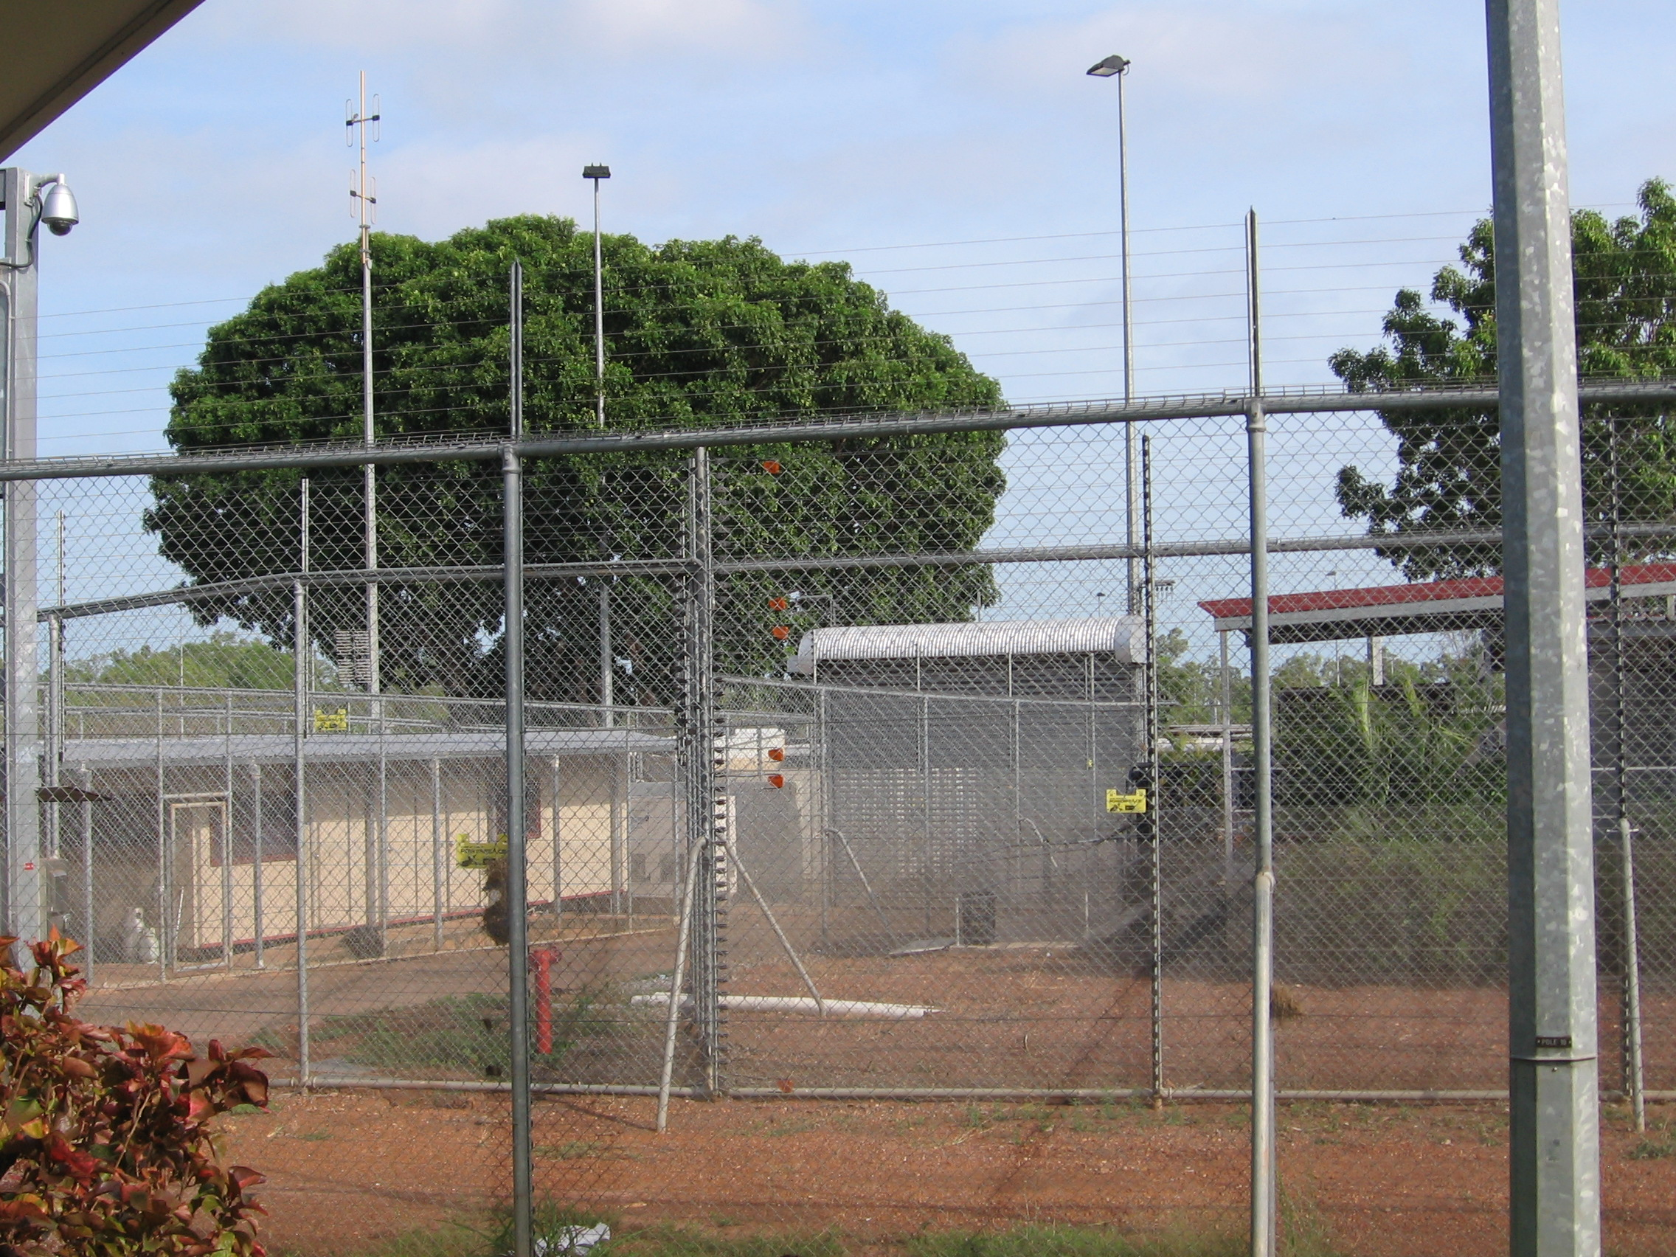
Previously, the NIDC was used for the immigration detention of alleged illegal foreign fishers, many of whom were detained for short periods. During 2010 this has changed and the centre is now used to detain asylum seekers and Indonesian crew, many of whom spend much longer periods in detention. At the time of the Commission’s visit, the centre was not adequately equipped for this purpose.
In its 2008 immigration detention report, the Commission raised concerns about the harsh physical appearance of the NIDC. These concerns remain. There is a significant amount of high wire fencing both around and within the centre, which creates a punitive feeling. The North and South areas are separated by an electrified fence. People in detention do not have freedom of movement between compounds, which creates unequal access to recreation facilities located in certain compounds.
There are few trees and there is little grass inside the NIDC. Some compounds have sheltered cabana areas, but overall the combination of the heat, dirt and lack of shade means there are few comfortable outdoor areas. Most compounds do not have an open grassy area for sport or recreation, and some compounds do not have adequate indoor recreation space. The Commission has been informed that minor works are planned to construct further recreational areas in some compounds, and that there are ongoing works aimed at increasing grassy areas. The Commission welcomes these efforts and urges the completion of this work as soon as possible.

Airport Lodge
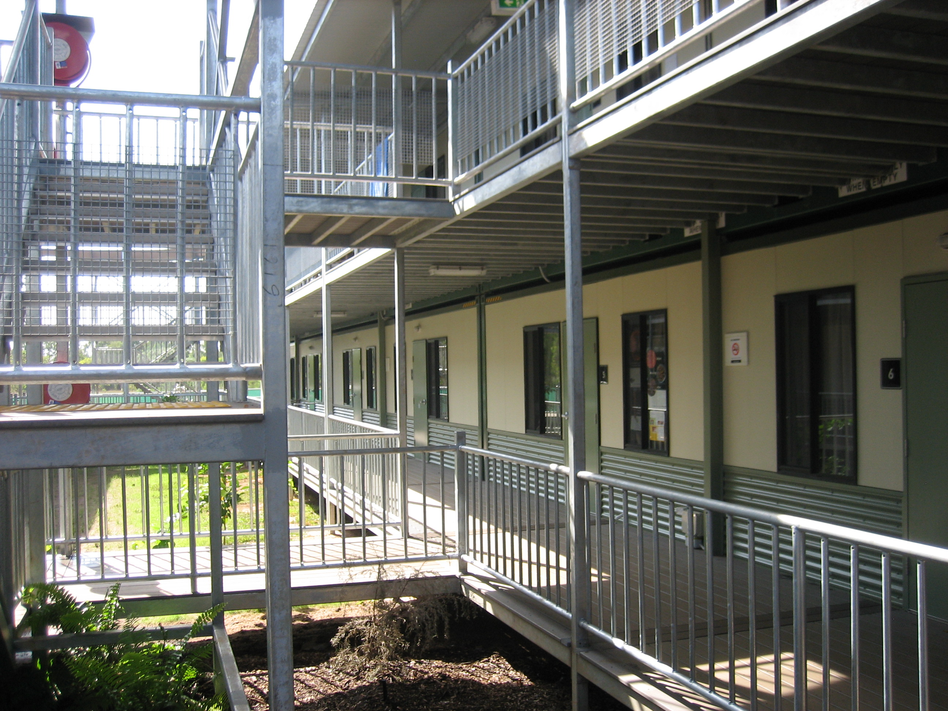
In general, the Commission welcomes the standard of accommodation at the Airport Lodge, which is higher than some detention facilities used for unaccompanied minors and families with children (such as the Asti Motel in Darwin and the Construction Camp on Christmas Island).
However, during its visit the Commission had significant concerns about the lack of recreation space in the facility, particularly given the high number of children detained there. There were no indoor recreation rooms and there was only one freely accessible outdoor recreation area which contained a table tennis table and a pool table. While there was a small oval area at the rear of the facility, it had very little shade and was not freely accessible. The Commission welcomes plans to install some shade cloth over part of the oval area.
Many parents raised concerns about the lack of safe and appropriate play areas for their young children. While there was a recently-installed playground area, it appeared to be unusable during the heat of the day because of a lack of shade. Because of the heat in Darwin and the lack of indoor recreation areas, many families reported spending the majority of their time inside their bedrooms.

Asti Motel
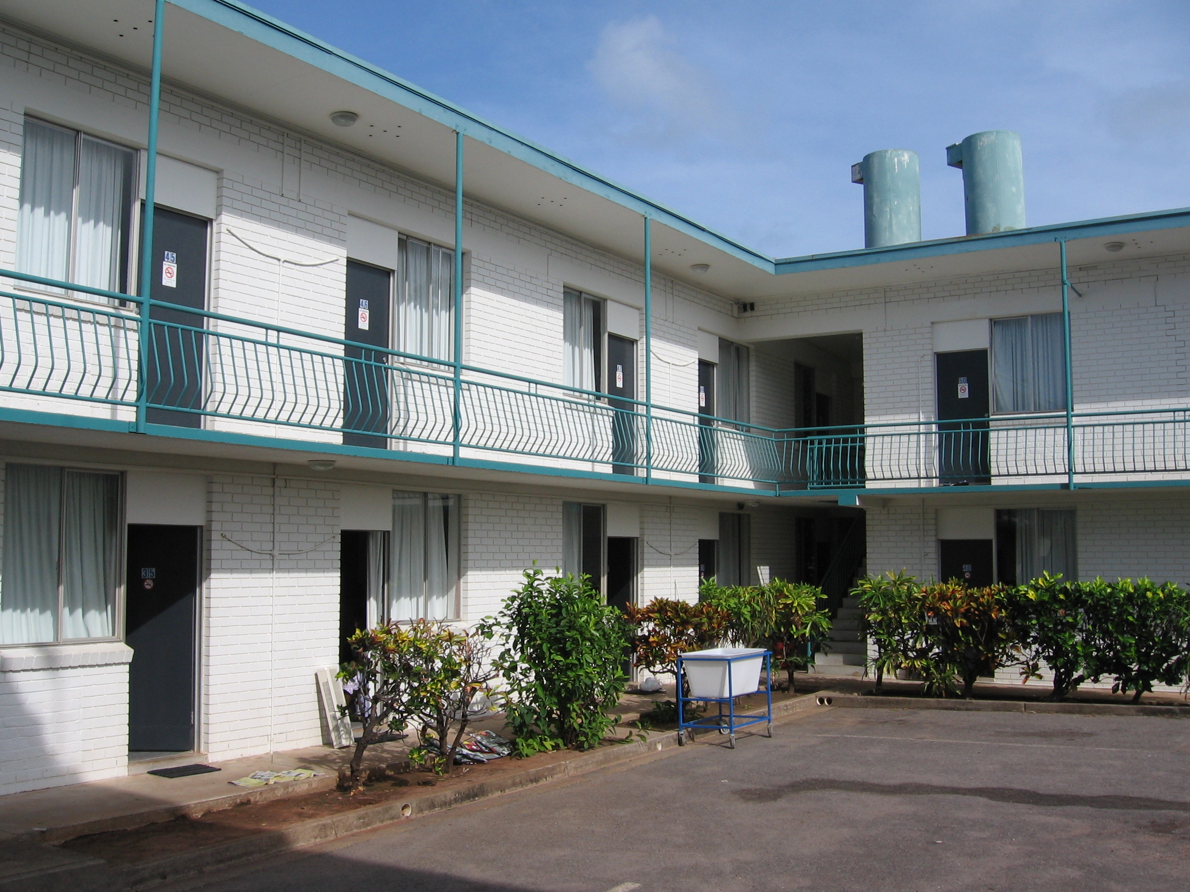
In the Commission’s view, the Asti Motel is not an appropriate place to use as an immigration detention facility, particularly for families with children and unaccompanied minors. It is the most restrictive of the detention facilities in Darwin in terms of the amount of open space.
During its visit the Commission had significant concerns about the high number of people detained at the Asti – including more than 80 young children and unaccompanied teenagers – in a very cramped environment with little room to move. The Commission was particularly concerned about the lack of indoor and outdoor recreation space. The outdoor areas were all paved or concrete and had limited shade. There were no open grassy areas. There were several rooms dedicated for recreation, but they were small and not always accessible. Many parents raised concerns about the lack of safe and appropriate play areas for their toddlers or young children.

Children in detention
“We understand but the children don’t understand – they want to go outside.” (Kurdish woman detained at the Airport Lodge.)
“We don’t understand why people under 18 are kept inside as if we are a risk to the community. We should be in the community, learning. All we do is eat and sleep.” (Unaccompanied minor detained at the Airport Lodge.)
The Commission has significant concerns about the high number of children in immigration detention facilities around Australia. During the Commission’s visit, there were 248 children in immigration detention in Darwin – 34 girls and 214 boys. This included 81 accompanied children ranging in age from six weeks to 17 years, and 167 unaccompanied minors ranging in age from 11 to 17 years.
During its Darwin visit, the Commission had particular concerns about the following issues relating to the detention of families with children and unaccompanied minors:
- Child asylum seekers continue to be subjected to mandatory immigration detention. This breaches Australia’s obligations under the Convention on the Rights of the Child, which require that a child should only be detained as a measure of last resort and for the shortest appropriate period of time.
- Many children are spending longer periods in immigration detention. At the time of the Commission’s visit, more than 70 percent of the 248 children in detention in Darwin had been detained for longer than three months. Nineteen children had been detained for longer than six months. The Commission has serious concerns about the impacts of prolonged detention on children.
- The Commission was concerned about the prolonged detention of unaccompanied minor Indonesian crew members in Darwin. There were 17 of these boys in detention at the time of the visit. They were aged between 11 and 17 years, and had been detained for periods ranging between three and eight months.
- There was no Memorandum of Understanding between DIAC and Family and Children’s Services in the Northern Territory Department of Health and Families regarding child welfare and protection concerns that may arise in relation to children in immigration detention in Darwin.
- There did not appear to be appropriate procedures in place to ensure that all staff were aware of, and complied with, requirements for making child welfare and protection notifications in relation to concerns arising in respect of children in detention in Darwin. There appeared to have been at least one incident in a detention facility in Darwin following which the appropriate notification was not made to Family and Children’s Services in the Northern Territory Department of Health and Families in a timely manner. This was not in line with DIAC and Serco policies, both of which require that notifications be made ‘immediately’.
- Unaccompanied minor asylum seekers in immigration detention fall under the legal guardianship of the Minister for Immigration. During the Commission’s visit, there appeared to be no legal guardian for those unaccompanied minors in immigration detention in Darwin who were not seeking to remain in Australia (Indonesian crew members and alleged illegal foreign fishers). The Commission continues to be of the view that independent legal guardians should be appointed for all unaccompanied minors in immigration detention.
- Some DIAC and detention service provider staff were not aware of which DIAC officer had been delegated the Minister’s powers of legal guardianship of unaccompanied minor asylum seekers in detention in Darwin, and in which situations that legal guardian should be consulted.
- It appeared that Independent Observers (provided by the organisation Life Without Barriers) were not always present in interviews involving unaccompanied minors detained in Darwin. DIAC has since informed the Commission that posters have been displayed to remind staff of when they are required to request the presence of an Independent Observer.
- As outlined above, the Commission was particularly concerned about the inappropriate nature of the Asti Motel as a place for holding children in immigration detention.
- Some parents at the Asti Motel and the Airport Lodge raised concerns about the safety of their young children in the context of sharing a closed environment with high numbers of unaccompanied teenagers, the vast majority of whom are male.
The Commission is pleased that children are not detained in the high-security environment of the NIDC. However, the Commission is concerned that hundreds of children are detained in other facilities in Darwin rather than being placed in community-based alternatives to detention.
The Commission has raised concerns about the under-utilisation of the Community Detention system both in Darwin and nationally. The Commission therefore welcomed the announcement on 18 October 2010 that the Minister for Immigration will begin to use his existing Residence Determination powers to move some families and unaccompanied minors into Community Detention. The Commission has encouraged the Australian Government to expand these efforts to include all children in immigration detention and to implement them as quickly as possible.

Health and mental health services
“My humble request. Find a solution for us before we completely lose our minds. So in future I can help myself and my family. So if accepted as refugees we can make a contribution to this country as well. If we are healthy we can make a good contribution to Australian society. If we lose our minds and are not able to help ourselves, how can we make a contribution?” (Man detained at the NIDC.)
Under international human rights standards, all people have a right to the highest attainable standard of physical and mental health. Each person in detention is entitled to medical care and treatment provided in a culturally appropriate manner and to a standard which is commensurate with that provided in the general community. This should include preventive and remedial medical care and treatment including dental, ophthalmological and mental health care.
At the time of its visit, the Commission had significant concerns about the provision of health and mental health services for people in immigration detention in Darwin. These concerns were informed by a consultant psychiatrist who was part of the Commission team conducting the visit.
The concerns about health and mental health care raised by this visit are similar to concerns raised by previous immigration detention visits. The Commission is of the view that there is a need for rigorous ongoing monitoring of the delivery of health and mental health services in immigration detention facilities, and has recommended that an independent body be charged with this monitoring function.
Staff members of the health service provider (IHMS) that the Commission met with in Darwin were clearly hard-working and committed. However, the Commission had a number of concerns about the staffing of the service and the conditions under which staff were working. These concerns included the following:
- Both the health and mental health services appeared to be understaffed given the high number of people in detention in Darwin and the complex nature of the caseload. Since the visit, the Commission has been informed that DIAC has submitted a request for additional health and mental health staff in Darwin.
- The model of care had resulted in inadequate clinical governance, particularly in the case of mental health. The health service was led by a nurse who held duty of care responsibilities, but who had limited clinical oversight. This was mitigated in part by regular contact with a general practitioner for physical health, who was potentially able to take clinical responsibility. However, there was no parallel clinical governance framework for mental health. The mental health service was led by a mental health nurse and there was no psychiatrist on staff. This resulted in mental health staff carrying significant clinical and duty of care responsibilities. This should be addressed by ensuring regular oversight by a psychiatrist able to provide clinical guidance and supervision of the clinical decision making of staff.

Health care
During its visit, the Commission heard a high number of complaints from people in immigration detention in Darwin about access to timely and appropriate health care. These included the following:
- Complaints about long waiting periods to see a doctor, particularly at the NIDC and the Airport Lodge.
- Numerous complaints about long waiting periods for dental, optometry and other specialist appointments.
- Numerous complaints from people who felt they had not been provided with prompt or appropriate treatment for a range of medical issues including kidney stones, shrapnel wounds and follow-up care after miscarriage.
- Complaints about delays in receiving test results or a lack of prompt responses from the health service provider about progress with requests for treatment.
IHMS staff reported that doctor’s appointments were arranged within 72 hours of a request being made. However, they acknowledged that the doctor’s hours at the NIDC were insufficient for the number of people detained in the centre. They also reported that they had requested the provision of further dental and optical services. Since the visit, DIAC has informed the Commission that it has submitted a request for an increase in doctor’s hours and dental hours.

Mental health care
“I have feared I will get crazy in here and will lose my mind.”
(Unaccompanied minor detained at the Airport Lodge.)
“The children suffer from the restrictions without freedom. They are affected mentally.” (Woman detained at the Airport Lodge.)
The Commission has serious concerns about the potential impacts of prolonged and indefinite detention on the mental health of those detained. Those impacts were evident during the Commission’s Darwin visit. The Commission spoke with many people in detention who expressed concerns about the psychological impacts of being detained for a lengthy and uncertain period of time.
The Commission’s key concerns about mental health included the following:
- The Commission met with people in detention who did not appear to be receiving mental health treatment despite having significant vulnerabilities.
- It appeared that many staff had not received training on DIAC’s torture and trauma policy or the Psychological Support Program (PSP), or sufficient refresher training such that they were able to confidently implement these policies. Since the visit, DIAC has informed the Commission that PSP training has been conducted in Darwin.
- There appeared to be an extremely low referral rate for specialised torture and trauma services in Darwin, given the number of asylum seekers in detention likely to have experienced significant torture or trauma.
- DIAC reported that there had been 21 self-harm incidents among people in immigration detention in Darwin during 2010. The Commission heard reports of hunger strikes, a hanging attempt and other physical acts of self-harm.
During its visit the Commission met with a number of people in detention in Darwin, including minors, who had experienced significant trauma in their home country or who had attempted self-harm while in detention. There appeared to be numerous cases where people met the priority criteria for consideration of a Community Detention placement based on mental health concerns or a background of torture or trauma, but they had not been placed in Community Detention.
The Commission has encouraged the Australian Government to make full use of the Community Detention system. As noted above, the Commission welcomed the announcement that some families and unaccompanied minors will be placed in Community Detention. Under the Residence Determination Guidelines, people with significant physical or mental health concerns, people who may have experienced torture or trauma and people whose cases will take a considerable period to substantively resolve should also be given priority consideration for Community Detention.

Education, recreation and excursions
Under international human rights standards, people in immigration detention should have access to materials and facilities for exercise, recreation, cultural expression and intellectual and educational pursuits to utilise their time in detention in a constructive manner, and for the benefit of their physical and mental health.
Meaningful recreational and educational activities and opportunities to leave the detention environment are vital to people’s capacity to cope in detention, particularly when they are detained for long and indefinite periods of time. At the time of the Commission’s visit, many people in detention in Darwin raised significant concerns about these issues.

Education for children
“It is very important for us to be in society. We are segregated. We don’t learn anything here. We should be learning.”
(Unaccompanied minor detained at the Airport Lodge.)
Under the Convention on the Rights of the Child, all children have a right to education.
The Commission has serious concerns about the protracted period during which children in immigration detention in Darwin were unable to attend external schools. At the time of the Commission’s visit, there were 248 children detained in Darwin and none of them was attending an external school or kindergarten. While the majority had been in detention in Darwin for less than three months, 50 children had been there for longer than three months.
During the Commission’s visit, many parents at the Airport Lodge and the Asti Motel expressed significant concerns about their children not being able to attend school – both for the educational opportunities and for the chance to play and socialise in a ‘normal’ environment outside the detention facility.
Parents also expressed concerns about the educational opportunities provided inside detention for children at the Airport Lodge and the Asti Motel. These opportunities were seriously inadequate at the time of the Commission’s visit. Children were only provided with a one hour English class each day. At the Asti Motel the lack of indoor recreation space meant the classes were held outdoors in the heat.
The Commission welcomes the fact that children aged 5 to 15 years in detention at the Airport Lodge and the Asti Motel were able to start attending external schools in October 2010. However, the Commission remains concerned that there are still not adequate educational opportunities provided for 16 and 17 year olds, who are not allowed to attend external schools. These minors should be provided with access to high quality educational alternatives outside the detention environment as soon as possible.

Recreation
“We don’t have a place to play.” (10 year old girl detained at the Asti Motel.)
“There are no newspapers here and we cannot access news of our country. We feel isolated culturally.” (Arabic-speaking man detained at the Airport Lodge.)
At the time of its visit, the Commission was concerned about the limited opportunities for people in immigration detention in Darwin to engage in meaningful recreational activities. This was particularly concerning given the long periods of time some people are being detained for, and the indefinite nature of their detention.
During the visit, people detained at the NIDC, the Asti Motel and the Airport Lodge expressed frustrations about the lack of regular organised activities. In particular, many parents expressed concerns about the need for more activities for toddlers and young children. Some recreational activities were offered by a combination of volunteers, Serco staff and Life Without Barriers employees. These activities were greatly appreciated by people in detention, but they did not appear to be adequate to meet the needs of the high number of people detained. The limited availability of regular purposeful activities appeared to have resulted in high levels of boredom, frustration and tension.
As noted above, external and internal recreation spaces at the NIDC, the Asti Motel and the Airport Lodge were inadequate. In particular, none of the facilities had an appropriate library area, nor were multilingual reading materials available (other than occasional foreign language newspapers at the NIDC). The majority of detainees did not have access to a gym area for exercising. Many parents raised concerns about the lack of play areas for young children.
At the Airport Lodge, space constraints and the lack of recreational facilities and toys appeared to be generating tensions between children as well as associated friction between parents. The Commission witnessed one altercation during its visit and heard about two others that had occurred the previous night.
Since the visit, DIAC has informed the Commission that greater efforts are being made to provide a range of recreational activities to people in detention in Darwin including some activities for pre-school aged children; that some reading materials have been distributed; and that efforts are being made to engage further volunteers in activities at the NIDC.

Excursions
“I want to be allowed to go outside to somewhere else.”
(10 year old girl detained at the Airport Lodge.)
“We are all forgetting what it is like to be out. We want to see what Darwin looks like. I’m forgetting the shape of a city.” (Man detained at Northern IDC.)
At the time of its visit, the Commission had serious concerns about the lack of opportunities for people in immigration detention in Darwin to leave the detention environment on external excursions.
Regular excursions were not being conducted for any of the people detained in Darwin, with the exception of the unaccompanied minors detained at Berrimah House. There were no excursions at all for irregular maritime arrivals detained at the NIDC, for anyone detained at the Airport Lodge or for unaccompanied minors detained at the Asti Motel. Family groups at the Asti were being taken on infrequent excursions to a local park. Each family was able to participate once every few weeks.
The Commission was particularly concerned about the lack of excursions for people detained at the Airport Lodge and the Asti Motel, who had limited room to move and limited access to recreational facilities inside detention. Many of them had been detained there for months without an opportunity to leave the detention environment. This had clearly caused distress and increased tension within the facilities.
Since the visit, DIAC has informed the Commission that there has been an increase in the number of excursions being conducted for people in detention in Darwin, and that excursions are now being conducted from each of the detention facilities.

Other concerns
During its visit, the Commission heard a range of other concerns from people in immigration detention in Darwin. These included the following:
- A number of people detained at the NIDC raised concerns about being referred to by their identification number rather than their name. The Commission witnessed this during the visit. Some people were distressed by the practice. For example, one man said: “They want us to respect them, but they don’t respect us.” Another man said: “We think we are not human beings anymore.” The Commission is concerned about this practice because it is dehumanising and fails to accord respect to people in detention. People should always be referred to by their name. Their identification number should only be used as a secondary identifier where this is necessary for clarification purposes.
- Many people detained at the NIDC and the Airport Lodge raised concerns about the limited number of telephones and internet terminals – both critical means of communication with the outside world for people in detention. For example, in the North 1 compound at the NIDC there were only two telephones for use by 211 detainees. Irregular maritime arrivals were not permitted to have mobile telephones, which added to the pressure on the limited landline telephones. The Commission was informed that additional telephones and internet terminals would be installed at the NIDC.
- There were no organised religious services for people in detention in Darwin, and very few people were being provided with any opportunity to attend a place of worship outside the detention environment. There was no designated prayer room at the Asti Motel or the Airport Lodge. Since the visit, DIAC has informed the Commission that the local Imam has begun conducting visits to the detention facilities, and that some external visits have been conducted to a local Church, a mosque and a Hindu temple.

PART C: Recommendations
Recommendation 1: Australia’s mandatory detention law should be repealed. The Migration Act should be amended so that immigration detention occurs only when necessary. This should be the exception, not the norm. It must be for a minimal period, be reasonable and be a proportionate means of achieving at least one of the aims outlined in international law. The limited grounds for detention should be clearly prescribed in the Migration Act.
Recommendation 2: The Migration Act should be amended to accord with international law by requiring that a decision to detain a person, or a decision to continue a person’s detention, is subject to prompt review by a court.
Recommendation 3: Until the above legislative changes are implemented, the Australian Government should avoid the prolonged detention of asylum seekers by:
- Ensuring full implementation of its New Directions policy under which asylum seekers should only be held in immigration detention while their health, identity and security checks are conducted. After this, the presumption should be that they will be permitted to reside in the community unless a specific risk justifies their ongoing detention.
- Ensuring that security clearances are conducted as quickly as possible.

Recommendation 4: The Australian Government should implement the outstanding recommendations of the report of the National Inquiry into Children in Immigration Detention, A last resort?. These include that Australia’s immigration detention laws should be amended, as a matter of urgency, to comply with the Convention on the Rights of the Child. In particular, the new laws should incorporate the following minimum features:
- There should be a presumption against the detention of children for immigration purposes.
- A court or independent tribunal should assess whether there is a need to detain children for immigration purposes within 72 hours of any initial detention (for example, for the purposes of health, identity or security checks).
- There should be prompt and periodic review by a court of the legality of continuing detention of children for immigration purposes.
- All courts and independent tribunals should be guided by the following principles:
- detention of children must be a measure of last resort and for the shortest appropriate period of time
- the best interests of children must be a primary consideration
- the preservation of family unity
- special protection and assistance for unaccompanied children.

Recommendation 5: DIAC should ensure that relevant DIAC officers and staff members of detention service providers are provided with information and training on:
- the requirements and procedures for making child welfare and protection notifications in relation to concerns that arise in respect of children in immigration detention in Darwin
- which DIAC officer or officers have been delegated the Minister’s powers of legal guardianship of unaccompanied minor asylum seekers in immigration detention in Darwin, and in which situations the guardian should be consulted.

Recommendation 6: The Australian Government should, as a matter of priority, implement the recommendations made by the Commission in A last resort? that:
- Australia’s laws should be amended so that the Minister for Immigration is no longer the legal guardian of unaccompanied children in immigration detention.
- An independent guardian should be appointed for unaccompanied children in immigration detention and they should receive appropriate support.

Recommendation 7: DIAC should ensure that people in immigration detention in Darwin are provided with timely access to appropriate health and mental health services. In particular, DIAC should enhance clinical governance of the mental health service by ensuring that a psychiatrist is available to provide clinical guidance and supervision of the clinical decision making of mental health staff.

Recommendation 8: DIAC should ensure that all people in immigration detention in Darwin have access to:
- appropriate indoor and outdoor recreational spaces including open grassy areas and, where applicable, play areas that are safe and appropriate for young children
- an adequate supply of reading materials in the principal languages spoken by detainees
- sufficient communication facilities, in particular telephones and internet terminals
- regular external excursions
- regular religious services conducted by qualified religious representatives.
Recommendation 9: The Australian Government should ensure that all school-aged children in immigration detention in Darwin and elsewhere are provided with access to educational opportunities of a standard and quality equivalent to that in Australian schools. Wherever possible, this should take place outside the detention environment by facilitating access to the Australian school system.
Recommendation 10: The Australian Government should stop using the Asti Motel in Darwin as an ‘alternative place of detention’ as soon as possible.

See http://www.humanrights.gov.au/human_rights/immigration/idc2010_darwin_response.html.
The Commission’s reports of complaints about alleged human rights breaches in immigration detention are available at http://humanrights.gov.au/legal/humanrightsreports/index.html. The Commission’s national inquiry reports are A last resort? National Inquiry into Children in Immigration Detention (2004) (A last resort), at http://humanrights.gov.au/human_rights/children_detention_report/index.html, and Those who’ve come across the seas: Detention of unauthorised arrivals (1998) (Those who’ve come across the seas), at http://humanrights.gov.au/human_rights/immigration/seas.html (viewed 9 November 2010).
See, for example A last resort, note 2; Those who’ve come across the seas, note 2.
Further information about the Commission’s activities relating to immigration detention is available at http://humanrights.gov.au/human_rights/immigration/detention_rights.html#9.
See http://humanrights.gov.au/human_rights/immigration/detention_rights.html#9_3.
Figures provided by DIAC, current as of 6 September 2010.
DIAC provided the Commission with figures current as of 6 September 2010. These figures list the nationality of the 783 people in immigration detention in Darwin as follows: 333 from Afghanistan, 169 from Indonesia, 94 stateless, 57 from Iran, 54 from Iraq, 49 from Sri Lanka, 20 from Burma, 5 from Kuwait, 1 from Bangladesh, 1 from Yemen.
See http://www.humanrights.gov.au/human_rights/immigration/idc2010_photos.html.
Figures provided by DIAC, current as of 6 September 2010.
Figures based on statistics provided by DIAC, current as of 6 September 2010.
Figures based on statistics provided by DIAC, current as of 6 September 2010.
Figures based on statistics provided by DIAC, current as of 6 September 2010.
Information provided by DIAC, 6 September 2010.
See International Covenant on Civil and Political Rights (1966) (ICCPR), art 9, at http://www2.ohchr.org/english/law/ccpr.htm (viewed 9 November 2010); Convention on the Rights of the Child (1989) (CRC), art 37, at http://www2.ohchr.org/english/law/crc.htm (viewed 9 November 2010).
See further UNHCR, Revised Guidelines on Applicable Criteria and Standards Relating to the Detention of Asylum Seekers (1999), guidelines 2, 3. At http://www.unhcr.org/3bd036a74.html (viewed 9 November 2010).
These figures are based on statistics provided by DIAC, current as of 6 September 2010. They refer to the overall time spent in immigration detention – including on Christmas Island, in Darwin and in any other immigration detention facilities in Australia.
For further discussion of the suspension, see Australian Human Rights Commission, 2010 Immigration detention on Christmas Island (2010) (2010 Christmas Island report), section 8. At http://humanrights.gov.au/human_rights/immigration/idc2010_christmas_island.html (viewed 9 November 2010).
These figures are based on statistics provided by DIAC, current as of 6 September 2010. The total of 148 people included 143 people from Afghanistan (including 130 unaccompanied minors) and five people from Sri Lanka (including two unaccompanied minors).
Figures current as of 6 September 2010.
See 2010 Christmas Island report, note 17, section 10; Australian Human Rights Commission, 2009 Immigration detention and offshore processing on Christmas Island (2009), section 9.2, at http://humanrights.gov.au/human_rights/immigration/idc2009_xmas_island.html (viewed 9 November 2010).
See Australian Human Rights Commission, 2008 Immigration detention report: Summary of observations following visits to Australia’s immigration detention facilities (2008), section 11.4. At http://humanrights.gov.au/human_rights/immigration/idc2008.html (viewed 9 November 2010).
These figures are based on statistics provided by DIAC, current as of 6 September 2010. The age breakdown of the 248 children was as follows: 32 aged 0-5 years; 28 aged 6-10 years; 60 aged 11-15 years; 128 aged 16-17 years.
See CRC, note 14, art 37(b). For further discussion see A last resort, note 2.
These figures are based on statistics provided by DIAC, current as of 6 September 2010. They refer to children’s overall time in immigration detention – including on Christmas Island, in Darwin and in any other immigration detention facilities in Australia.
In A Last resort?, the 2004 report of the National Inquiry into Children in Immigration Detention, the Commission found that children in immigration detention for long periods were at high risk of serious mental harm. See A last resort, note 2, executive summary, major finding 2.
Figures based on statistics provided by DIAC, current as of 6 September 2010.
Department of Immigration and Citizenship, Detention Services Manual, Chapter 2, Minors in Detention, section 18.3; Serco, APOD Working With Minors PPM, section 13.3 (Reporting of Abuse / Neglect).
See further 2010 Christmas Island report, note 17, section 16.2.
See further 2010 Christmas Island report, note 17, sections 11, 13.2.
See International Covenant on Economic, Social and Cultural Rights (1966) (ICESCR), art 12, at http://www2.ohchr.org/english/law/cescr.htm (viewed 9 November 2010); CRC, note 14, art 24.
See Human Rights and Equal Opportunity Commission, Immigration Detention Guidelines (2000), section 13. At http://humanrights.gov.au/human_rights/immigration/idc_guidelines2000.html (viewed 9 November 2010).
See further 2010 Christmas Island report, note 17, section 19.
According to information provided by DIAC, there were 21 self-harm incidents in immigration detention facilities in Darwin during the period 1 January to 19 October 2010.
See further 2010 Christmas Island report, note 17, sections 11, 13.2.
Minister for Immigration and Citizenship, Minister’s Residence Determination Power Under S. 197AB and S. 197AD of the Migration Act 1958: Guidelines (2009), para 4.1.4.
See Immigration Detention Guidelines, note 31, section 7.2.
CRC, note 14, art 28.
These figures are based on statistics provided by DIAC, current as of 6 September 2010. The age breakdown of the 248 children was as follows: 32 aged 0-5 years; 28 aged 6-10 years; 60 aged 11-15 years; 128 aged 16-17 years.
Figures based on statistics provided by DIAC, current as of 6 September 2010.
DIAC informed the Commission that as of 18 October 2010, all children aged 5 to 15 years in detention at the Airport Lodge and the Asti Motel would be attending external schools.
Information provided by DIAC showed that as of 13 October 2010 there were 75 minors aged 16 or 17 years in immigration detention at the Asti Motel or the Airport Lodge who were not attending external schools.
Interview with group of Afghani and Iranian men, NIDC, 7 September 2010.
Information current as of 6 September 2010.
Under United Nations High Commissioner for Refugees (UNHCR) guidelines, there should be a presumption against the detention of asylum seekers–it should be the exception rather than the norm. Detention should only be resorted to if there is evidence to suggest that other alternatives (for example, reporting requirements) will not be effective in the individual case. The permissible exceptions to the general rule that detention should normally be avoided must be prescribed by law. The detention of asylum seekers may only be resorted to if necessary to verify identity; to determine the elements on which the claim to refugee status or asylum is based; to deal with cases where refugees or asylum seekers have destroyed their travel and/or identity documents or have used fraudulent documents in order to mislead the authorities of the State in which they intend to claim asylum; or to protect national security or public order. In assessing whether detention is necessary, considerations should include whether it is reasonable and whether it is proportional to the objectives to be achieved. See UNHCR, Revised Guidelines on Applicable Criteria and Standards Relating to the Detention of Asylum Seekers, note 15, guidelines 2, 3; UNHCR Executive Committee, Conclusion No. 44 (XXXVII) - Detention of Refugees and Asylum Seekers (1986), at http://www.unhcr.org/refworld/docid/3ae68c43c0.html (viewed 9 November 2010).
To comply with article 9(4) of the ICCPR, the court must have the power to order the person’s release if their detention is not lawful. The lawfulness of their detention is not limited to domestic legality – it includes whether the detention is compatible with the requirements of article 9(1) of the ICCPR. See, for example United Nations Human Rights Committee, A v Australia, Communication No. 560/1993, UN Doc CCPR/C/59/D/560/1993 (1997), para 9.5. At http://www.unhchr.ch/tbs/doc.nsf/ 0/30c417539ddd944380256713005e80d3?Opendocument (viewed 9 November 2010).
A last resort, note 2, Section 17.3.

