

Mission Australia submission to the
Human Rights Commission on the Freedom of Religion and Belief
March 2009
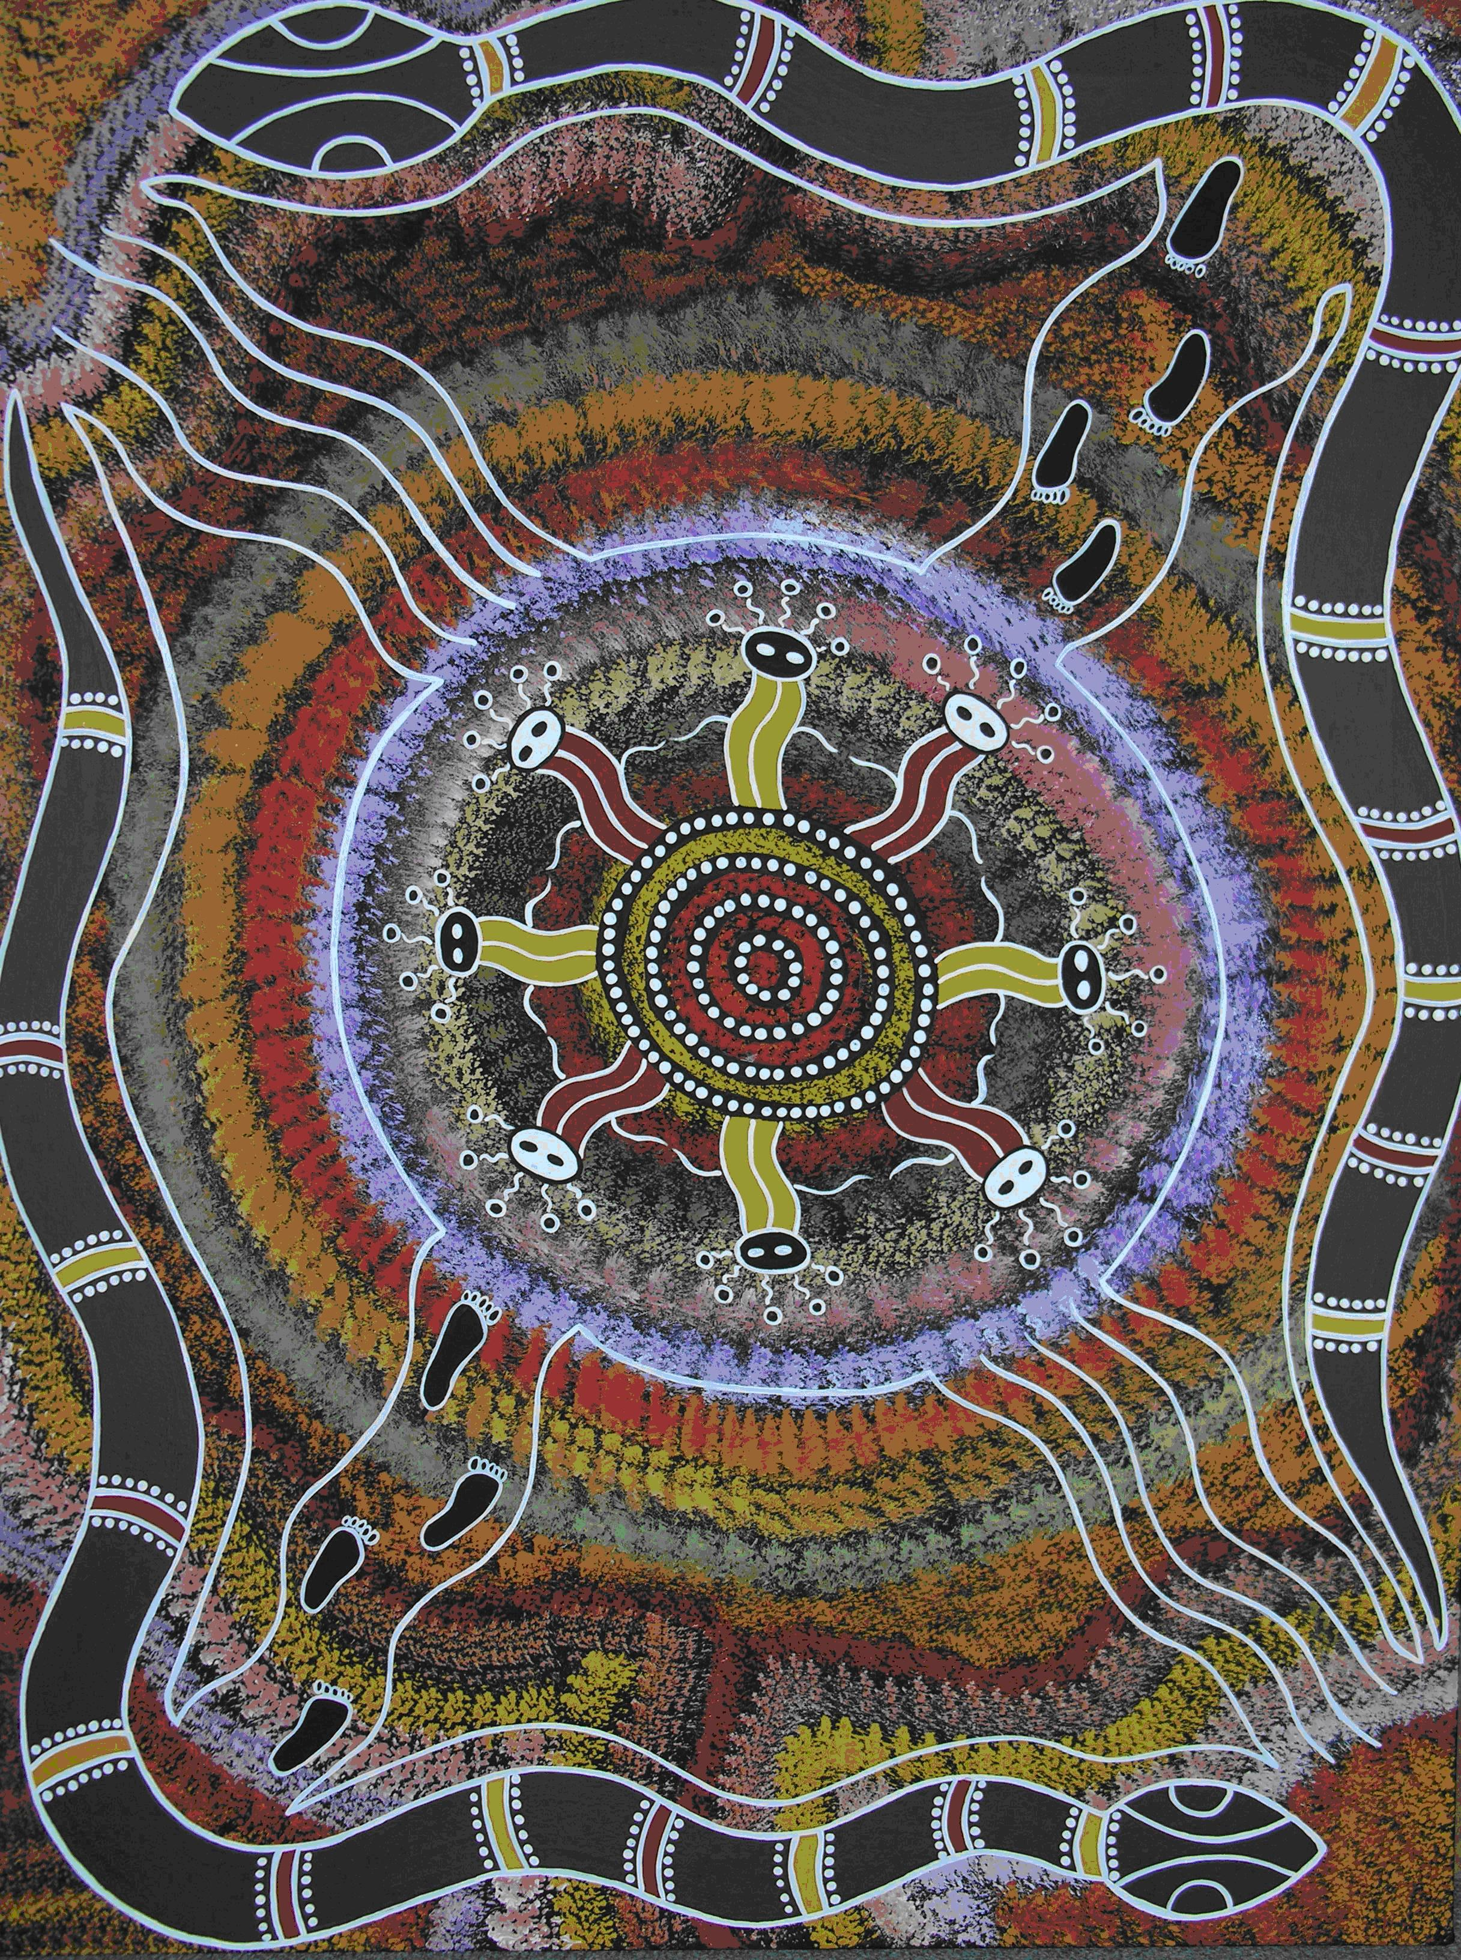

‘The spiritual journey of the joining of two spirits’
By Jade Rose, Mirri Mirri Design, 2007

This painting tells the story of the joining of two spirits. They are the spirits of the Indigenous and non-indigenous people, walking together and then joining to form a great respect and strong friendship. These two spirits share and value each others culture throughout their spiritual journey in life. The spirit creatures within this painting represent communications around a spiritual meeting place. It is a place where great decisions are made and information is shared. The meeting place and the figures are protected by the mighty rainbow serpent, who is a spiritual creator and protector of Aboriginal culture. The joining of hands between the spirit figures show that there is understanding and respect between all peoples and communities. Throughout this spiritual journey a strong bond has been formed, creating a strong and everlasting friendship, caring and sharing with each other, together forever. This is a visual representation of Mission Australia’s Statement of Principles for working with Indigenous Australians and this artwork was commissioned by Mission Australia from the artist, Jade Rose.

It is both timely and wise to revisit the complex issue of Freedom and Religious Belief in Australia.

We are a multicultural society with many varied views on what is our culture, what rights should we have as individuals and organisations to express religious belief.

Introduction
Mission Australia is a non denominational national non-profit organisation that works within the community, employment and training sectors to transform the lives of those we serve we have been doing this now for 150 years.

Our founding purpose:

'Inspired by Jesus Christ, Mission Australia exists to meet human need and to spread the knowledge of the love of God'
"This is how we know what love is: Jesus Christ laid down his life for us.
So, we also ought to lay down our lives for others."
(1 John 3:16)

Our vision: 'Our vision is to see a fairer Australia by enabling people in need to find pathways to a better life'

Our mission:
Walking alongside those in need, we help people discover;
Pathways to strong families and healthy, happy children
Pathways though a successful youth
Pathways away from homelessness
Pathways to skills and qualifications
Pathways to sustainable employment

Our values:
We live and work by our company values to help people in need find pathways to a better life.
Our values are:
Compassion
We are committed to being sensitive, understanding and
caring in our service of each other and all people.
Integrity
We are committed to being honest, accountable,
transparent and just in all our work and relationships.
Respect
We are committed to treating each person as we expect to be treated,
offering love, acceptance and a voice of support in the face of life's challenges.
Perseverance
We are committed to being the very best we can be, finding effective,
creative and environmentally responsible ways to fulfill our mission.
Celebration
We are committed to recognising and celebrating the efforts and
achievements of our staff, supporters and the people we help.
"For I was hungry and you gave me food, I was thirsty and you gave me something to drink,
I was a stranger and you welcomed me, I was naked and you gave me clothing,
I was sick and you took care of me, I was in prison and you visited me...
just as you did it to one of the least of these... you did it to me"
(Matthew 25:35-36)
In 2007-08 Mission Australia’s services supported over 331,250 people within Australia. Part of Mission Australia’s values is to respect others as such we work to support those in need and choose not to make any judgements about the person, their lifestyles there faiths or behaviours.

In this way we hope to be a great representative of our faith and our founding purpose which calls us to serve others.
We welcome the opportunity to provide a submission to the Commission on this issue and have selected areas of specific importance to us.
Our Key recommendations relate to;
Better practise are needed around employment issues and we have recommended a model we believe that could make this much easier to implement in practise.
A re working of vilification laws to provide funding to support legal costs of defendants in vilification cases. Penalties would continue to be applied to the organisation if it has carried out vilification.
Research is carried out so show if the press is unfairly and negatively influencing the public against those with faith and faith based organisations and to identify whether media coverage is offering a true right of reply to the same people.

Evaluation of the 1998 HREOC Report on Article 18: Freedom of Religion and Belief.

Mission Australia acknowledges the intent of the paper and supports a range of the recommendations that were made in it.

1. What are the areas of concern regarding the freedom to practice and express faith beliefs, within your faith community and other such communities?

Our general belief is that there is a strong acceptance across Australia of freedom to practise ones faith and beliefs and for the vast majority of the population there would be few issues or problems related to this.

2. Have new issues emerged since this report was published in 1998 relating to expression of faith.

Our view is significant issues have arisen in two areas that need further consideration the first around employment the second around vilification laws that are in place. These are detailed further on in the document.

3. Is there adequate protection against discrimination based on religion or belief and protection of ability to discriminate in particular contexts?

Generally speaking we believe there is with the exception of employment decisions where we believe stronger rights and better clarity are needed for both religious organisations and their employees. In terms of employment the issues relate to the right of a religious organisation to employ people who adhere to the faith or that organisation or not. This is a complex issue and requires better defined protections for religious organisations and those seeking employment with them.

We recommend the following approach be adopted in legislation to deal with this issue.

Recommendation 1 A new model is adopted to give clarity around where organisations can discriminate on grounds of faith.

Organisation Type | Right to discriminate for all roles | Right to discriminate for senior leadership roles | Right to discriminate for pastoral or teaching roles | Right to discriminate based on defined role needs | All other roles
Places of worship | Yes | NR | NR | NR | NR
Faith Based Service organisations | No | Yes | Yes | Yes | No
Health care organisations | No | Yes | Yes | Yes | No
Education based organisations | No | Yes | Yes | Yes | No
Aged Care | No | Yes | Yes | Yes | No
Missionary organisations | Yes | NR | NR | NR | NR
Predominant state funded schools | No | Yes | Yes | Yes | No
Predominant private funded faith based schools | Yes | NR | NR | NR | NR
Other faith run businesses | No | Yes | No | No | No

Right to discriminate for all roles

Organisations which are for the predominant purpose of furthering the faith and its teachings and its activities should be able to discriminate. The reasoning for this is to allow the faith its values and its teachings to be maintained. This would be impossible to do without the full right to employ adherents to the particular faith.

Right to discriminate for senior leadership roles

Organisations that are faith based need to be able to ensure they maintain integrity with their faith and deliver in line with the objectives of the faith that has formed them. In practise this is defined by leaders who have influence over the key decision making within the organisation. To protect the organisation its values adherence and its strategy alignment with the faith will need the services in many cases of adherents to that faith in senior leadership roles.

Right to discriminate for pastoral or teaching roles

Roles that are required to support the faith of an organisation or support adherents to the faith within the organisation or to further the understanding of the faith within the organisation clearly need to be filled by adherents to the faith.

Right to discriminate based on defined role needs

Where roles can be identified that can only be filled by an adherent to the faith this should be allowed. However this must truly require adherence to the faith for the predominant purpose of the role. A maths teacher at a Muslim school would be a role that should not involve this right a religious studies instructor in the Muslim faith would.

All other roles

For all other roles no discrimination would be allowed.

Our view is a simple model like this would give clarity to individuals seeking employment and to religious organisations or faith based organisations in making their employment choices. A clear and simple matrix like this would resolve a significant amount of cases before they began and provides protection of freedom of religion in a realistic manner.

4. How are federal and state governments managing incitement to religious hatred ands questions of control and responsibility?

In terms of religious vilification it is clear that the current laws are not working well and have either been used for vexatious purposes or have been used to bring cases which are less about vilification than about people expressing their genuine beliefs.

It is interesting to note that nearly all cases have been brought by minority faiths against those of the Christian faith. To the extent that the laws have bordered on bankrupting of some Christian organisations defending cases brought against them who have had to spend significant funds to support themselves.

Mission Australia believes all faiths should be allowed to express their genuine beliefs. For instance a Christian would not believe a Muslim will go to heaven and should be free to say that. Equally a Muslim would believe this about a Christian and should feel free to do the same. This is not vilification it is a statement of belief.

Vilification should only be raised when there is an intention to make vicious and defamatory statements about another religion or to cause harm. Not to debate core concepts of belief in different faiths otherwise the right to freedom of belief becomes impinged.

To protect organisations and in individuals in these complex cases we would

Recommendation 2 That the commission recommends that the legal costs of defendants in the cases of vilification are fully funded by the state or federal governments so that the right to state ones belief is not impinged upon by the threat of legal costs. However then any penalty which is declared for breaching legislation should be met by the defendants

5. How well have the recommendations of Article 18 Freedom of Religion and Belief been implemented by the various state governments and federal governments.

It is clear a number of recommendations have not been implemented whilst several have not. We would submit that the current core issues that need to be addressed from the original article relate to employment issues and vilification laws.

Religion and the State – the constitution, roles and responsibilities.

1. Is this section of the Constitution an adequate protection of freedom of religion and belief?

Yes

2. How should the Australian Government protect the freedom of religion and belief?

With the exception of employment issues already raised and the issues related to vilification laws the current protections are satisfactory.

3.When considering the separation of religion and state, are there any issues that presently concern you.

No

4. Do religious or faith-based groups have undue influence over government and/or does the government have undue influence over religious or faith based groups.

Generally speaking we do not see that any groups in Australia have undue influence over government. All citizens of Australia have equal rights to lobby government and its members. If there has been any undue influence in recent years we would argue this has come from the humanist movement which is a group which now seems to be presenting itself as a religion or faith in all but name.

Given the significant range of legislation that has been issued in recent years that has not been supported by the wider Christian church and a range of religious organisations it would seem clear to see that these groups do not have undue influence. In fact as a lobby/advocacy group it is disadvantaged by not being able to receive tax deductions that other advocacy organisations receive.

5. Would a legislated national Charter of Rights add to these freedoms or religion and belief?

There is little evidence from those that have implemented Charters of Rights that these do benefit freedoms. They do however create excellent fee income for lawyers. If we have a Charter of Rights it must ensure it protects rather than impinges on the rights of freedom to religion and belief.

6. What are the roles, rights and responsibilities or religious, spiritual and civil society organisations in implementing the commitment to freedom of religion and belief?

All organisations should focus on ensuring they themselves in their practises adhere to this commitment and by their actions do not impinge upon the freedoms of others in practising what they believe. It would seem often the cry is rights for me but not for you.

7. How can organisations model a cooperative approach in responding to issues of freedom of religion and belief?

At Mission Australia we have policies in place that cover these issues and outline our best intentions in dealing with these situations. We try and be clear about who we are and what we do both with our clients and employees. People understanding this find it much easier to relate to us as an organisation.

8. How well established and comprehensive is the commitment to interfaith understanding and inclusion in Australia and where should it go from here?

We think it is fine and that this issue is not related to rights or freedom of belief.

9. How should we understand the changing role and face of religion nationally and internationally?

We should protect the freedom of Religion and Belief as we do today and we should continue to do so.

Religion and the State – practise and expression

1. What are some of the consequences of the emergence of faith-based services as major government service delivery agencies?

Firstly these organisations have as much right to bid to deliver government services as any other and should not be discriminated against because of their faith base.

Secondly the Commission would be wise to consider that without these service providers the education system, the healthcare system, the aged care system, the childcare system and the employment services systems that are in place today would collapse overnight. Our projections are that it would take 48 hours from the cessation of faith based delivery organisations before the country of Australia came to a halt and would have to move to an emergency management system.

The consequences are a significant number of people are employed by these organisations and many have a better record than governments in equal opportunity employment standards.

More than that many of these organisations have been in Australia for a significant period of time – Mission Australia itself has been in Australia for over 150 years and has been delivering a range of major government services for in excess of 50 years.

The consequences are outstanding services delivered in a caring and compassionate manner in most cases. Many organisations and their staff see their work as a calling and therefore offer far higher levels of service than government agencies do. This is evidenced by a range of customer service research.

The consequences are also a lower cost to government which is why a range of services have been contracted out.

The consequences are organisations that can go and work and serve communities that government can’t or won’t serve.

The consequences are services that are delivered in nearly all cases with no judgement at all where human rights are fully maintained and people receive the care they should.

The consequences are that a number of these service providers subsidise government operations and provide a higher standard of care.

There have been some minor cases of accusation of discrimination against people of other faiths however the volume of these is minute compared to the number of staff employed by this sector. This could be alleviated by adopting our recommendations in relation to employment practises.

Now to give some context to this Mission Australia has served in the 11 years since the original Article 18 between 2.5 and 3 Million people. We are not aware of one case of complaint against us in relation to us being a faith based organisation from a client perspective.

In terms of employment we have employed over 15,000 people during this period and we are aware of less than five cases that have been raised against us in relation to us being a faith based organisation and in none of these cases have we been found to have discriminated on grounds of religion.

In the wider context of this sector which employs several hundred thousand staff and serves in one form or other nearly every Australian. There have been a very small number of cases brought on the grounds of religious discrimination either from clients or employees in fact the percentage is miniscule. When you then look at the very small number of cases it is clear a number of them are raised people who are deliberately choosing to push the boundaries of the law and human rights. There are very few cases that have proved religious discrimination took place to the extent that one would conclude that this sector is working incredibly well in what could easily been an area of contention.

The key message here is get some context, Australia needs this sector, it behaves well as an employer, it serves the community incredibly well and has been found 99.999999% of the time to protect and operate within the human rights framework we have in this country. This sector is not broken; it does not need fixing and in fact is exemplary within employment and service groups for its good practises.

Mission Australia believes that organisations delivering government services in fact any services should not proselytise. However they should be able to give an explanation of their faith if people request it and should be able to promote that they are a faith based organisation to those they serve and to their staff.

2. How should government accommodate the needs of faith groups in addressing issues such as religion and education, faith schools, the building of places of worship, religious holy days, religious symbols and religious dress practises?

Essentially this is about freedom of choice, choice to participate or not participate should always be given in terms religious education at non faith based schools.

Where schools are of a specific faith which parents have chosen to send their children to the school should be able to articulate and express that faith freely. Essentially parents by sending their children there are choosing this for their children.

There should be no issue with the building of places of worship.

Employers should as far as possible support staff in adhering to holy days.

People should be free to wear religious symbols and religious dress. Where this is in the context of places where certain standards of dress are required such as schools and workplaces with uniforms religious dress to match the uniform should be allowed.

Mission Australia has a number of Muslim staff who wear religious dress in the colours of our uniforms. We also support those staff where possible to observe religious holy days and practises through use of flexible working tools.

Question 3 No Comment.

Religion and the State – practise and expression

Questions 1/2/3 No comment.

4) Is there religious radicalism and political extremism in Australia

It is clear there are extremist views it would be wrong to refer to these as religious they are generally adopted by people who claim allegiance to a particular faith. Often their practises have no correlation to the teachings of their particular faith.

These people should be subject to the laws of the country if they breach them they should be prosecuted.

5) Can you provide any examples of social exclusion in regard to religion? How and why do issues of social exclusion develop?

There seems to be growing scepticism around people who practise religion there are a number of cases which border on persecution that have taken place in recent years mainly driven by the press.

People who act differently dress differently or behave differently from accepted norms are likely to face forms of exclusion.

Members of Hillsong church have suffered what seems to be ongoing aggression against them by Sydney Media for carrying out their faith.

Members of the Brethren church have also suffered an ongoing campaign against them because of their faith.

Many Muslims have felt isolated because of recent terrorism laws and media practises which have wrongly aligned them with terrorism.

The issue with this is that when these groups are targeted it tends to be ongoing and aggressive and they have little opportunity to defend themselves and this by its nature cause people to move towards a point where they feel defensive and socially excluded.

Religion and the State – practise and expression

1. How would you describe the interface between religion and politics and cultural aspirations of contemporary Australia?

The interface is generally good however it would seem that often religious views are ignored or maligned as naive in the process of developing legislation which may be contrary to religious beliefs.

One concern is a creeping range of legislation which requires people to carry out actions against their personal beliefs which is restricting their religious freedoms. A good example of this is medical practitioners who do not support euthanasia would have been required to refer people to those who do under recently proposed Victorian laws. In their view the question becomes is it OK to supply the gun when you didn’t pull the trigger if the answer is no because of their religious views they may find themselves breaking the law because of their beliefs.

2 How should government manage tensions between aspirations?

By solid consultation, this process is a good example of consultation that is open to all that can therefore balance a range of views. At the end of the day the government will make decisions based on what they hear.

3/4/5 How to you perceive gender in faith communities? What do you think should be the relationship to gender equality and the right to religious freedom in Australia.

Our view is that both genders are equal and should have equal rights.

However it is clear that many main stream religions do not believe this. As part of their faith organisations should be free to implement gender based practises that they believe their faith requires.

Those who do not adhere to this have a multitude of choice in terms of practising their faith. It seems to be that many people expect the faith to change to accommodate them often involving practises which have been in place for thousands of years.

The reality is if you do not believe what your faith community believes or practises you can a) Accept it b) Gently work towards change over time c) Join another faith community that believes what you believe. The choice here needs to be the individuals and not the faiths. By enforcing a faith to change its behaviour in the name of gender equality its freedom to religious belief is being denied.

So whilst we support and believe in gender equality the higher right for the faith to practise what it believes must win the day, individuals who can’t accept this in a rights framework cannot inflict their beliefs on others.

Question 6. No Comment (We do not really understand the question)

Question 7. No Comment we do not see this as core to the issues being discussed

8. Is there a role for religious voices alongside others in the policy debates of the nation?

It is hard to believe that the human rights commission is even asking this question this goes to the very heart of democracy. Of course there is a place. We are a democratic nation that supports human rights and free speech for all people.

Religious voices are part of our community and whatever their beliefs they have a right to participate. This question seems to be indicating that certain people’s rights to participate should be restrained which is unthinkable.

Put simply all people regardless of their perspectives or faith, have a part to play in policy debates and should be free to do so full stop.

- Technology and its implications

Question 1/2/3 No comment this is not relevant to the issue of freedoms or rights.

Question 4/5/6 Is your freedom to express your religion or belief hindered or helped by current media policies and practises, considering reporting, professional knowledge and right of reply

We have not experienced any issues as an organisation. However it would seem that some media polices and practises gravitate against people of faith and religious organisations. This would need in depth research but it would appear that there is a weighty balance of negative media around those holding religious beliefs and it would seem that it is hard for people or organisations that are attacked in the media to have a true right or reply.

Recommendation 3. We would recommend further in depth research into this issue.

In terms of vilification new media forms may make it easier to do but the laws are in place and should be exercised where there is true vilification.

- Religion, cultural expression and human rights

Question 1/2 Yes

Question 3/4 We believe this issue is too significant to realistically be covered here and does not specifically relate to the issue of religious freedoms. We believe it is an important issue that needs further review

Question 5. No

6/7. How is diverse sexuality perceived within faith communities?

This is a large and complex issue and the answer varies across the different faiths. We are only competent to answer this from a Christian faith viewpoint.

Firstly as an employer Mission Australia is an equal opportunities employer that employs a range of people with diverse sexuality. As a service provider we do not judge anyone we work with and in fact we work at the edges of diverse sexuality with many people that the vast majority of society would find it hard to accept. We do not we believe we are called to work with anyone who needs our help and do so however diverse their sexuality maybe.

From a Christian viewpoint diverse sexuality may be in conflict with Christian teaching, however Christ himself makes no reference at any point to the issue.
Our view is that all people should be accepted by the church regardless of their behaviours the church should be a place of acceptance for all without question. Christianity is about offering grace and a place of safety where people can work through issues in their lives.

It is important to understand that Christian leaders challenge on a regular basis a number of behaviours of people within their flocks as part of the faith and perhaps they need to put as much focus on love and grace and loving ones neighbour as they do to this issue.

There are clearly different views around diverse sexuality in leadership roles in churches and this is one best left for them to discuss and covered by our recommendations on employment.

8. Should religious organisations exclude people from employment because of their sexuality or their sex and gender identity.

Please refer to our earlier matrix on employment issues.

9. Again we find it hard to understand this question

10. Are their religious groups or practises and beliefs that you think are of concern to Australians? Should these be subject to legislative control and should they be eligible for government grants and assistance?

In simple terms there are, these really fall into two groups the first related to medical issues the second to religions that seek to harm people.

In relation to medical issues, no one regardless of religious belief should be able to restrict someone’s access to medical treatment. Where religious practise requires some form of circumcision this should only be provided by medical practitioners.

The second group is more complex suffice to say some faith organisations have as part of their practises an intention to cause harm to others. Hexes in witchcraft would be a good example of this. Some faith organisations support behaviours that will harm others and some more radical groups call for harm to be caused to others.

These should all be subject to legislative control and these organisations and faiths should be not be able to receive any government grants.

