

Australian Government
Department of Immigration and Citizenship
Refugee Resettlement Advisory Council

Mr Tom Calma
Race Discrimination Commissioner
Australian Human Rights Commission
GPO Box 5218
Sydney NSW 2001

Dear Mr Calma

Thank you for the opportunity to comment on the Freedom of Religion and Belief in the 21st Century project. I wish to provide comments on behalf of the Refugee Resettlement Advisory Council (RRAC).

By way of background, the Australian Government’s Refugee Resettlement Advisory Council, established in 1997, was re-appointed by the Minister for Immigration and Citizenship, the Hon Chris Evans, for a fifth term from March 2008 to June 2010. RRAC is an expert group on refugee and humanitarian settlement matters and is comprised of members who have a wide range of experience in working with refugees, or as former refugees themselves. RRAC has an ongoing dialogue with both the Minister for Immigration and Citizenship and the Parliamentary Secretary for Multicultural Affairs and Settlement Services.

Legal protection from discrimination and vilification for refugees from a Muslim background

Despite constitutional guarantees of non-discrimination on the grounds of religion, there are areas of discrimination against Muslim Australians including newly arrived refugees. Current legal protection against discrimination on the grounds of religion or belief, at the federal, state and territory levels lacks consistency and uniformity. This means that whether someone can seek redress under anti-discrimination laws for religious discrimination or vilification depends on where the conduct complained of occurred in Australia.

At the federal level, the Commission has the power to inquire into and attempt to conciliate complaints that a person has been discriminated against on the basis of their religion in their employment or occupation, or that their human rights in relation to religious belief have been breached by the Commonwealth. However, these complaints do not give rise to any enforceable right or remedy.

Discrimination under the Racial Discrimination Act 1975

The Racial Discrimination Act (RDA) makes direct and indirect discrimination based on

5 Chan Street, Belconnen ACT 2617
Secretariat: PO Box 25 BELCONNEN ACT 2616  Telephone (02) 6198 7280  Facsimile (02) 6198 7221

the ground of race, colour, descent, or national or ethnic origin, unlawful. However, none of the grounds for discrimination (race, colour, decent, or national or ethnic origin) used
in the RDA are defined. It is important to understand the meaning of these terms, as this will affect who is covered by the law.

For example, courts in the United Kingdom (UK) have decided that to fall within the ground of ethnic origin, the following characteristics are considered essential:

- a shared history of which the group was conscious as distinguishing it from other groups, and the memory which keeps it alive; and

- a cultural tradition of its own, including family and social customs and manners, often but not necessarily associated with religious observance.

The following characteristics are considered relevant, but not essential by courts:

- a common geographical origin or descent from a small number of common ancestors;
- a common language, not necessarily peculiar to the group;
- a common literature peculiar to the group;
- a common religion different from the neighbouring group or the general community surrounding it; and
- being a minority or an oppressed group or a dominant within a larger community.

Courts in the UK decided that Jewish people and Sikhs fall within the meaning of ethnic origin outlined above.

Australian courts have adopted the same meanings, and consider Jews to be a group of people with a common ethnic origin under the RDA. However, the courts in Australia have not yet been asked to consider whether Muslim people constitute a group with a common ethnic origin under the RDA.

Muslims do not necessarily share a common racial, national, or ethnic origin because while Muslims profess a common belief system, the Islamic faith is widespread, covering many nations and languages. A recent decision of the NSW Administrative Decisions Tribunal noted that:

There are Muslims in every continent and many different racial and ethnic backgrounds. It is common knowledge for example that there are South Asian, South-East Asian, Africans, Middle-Eastern, and European communities of Muslims. Many African-Americans, most famously Muhammad Ali, are Muslims, and that while Muslims are all adherents to Islam, they do not share common racial, national or ethnic origin.

For example, if a person has been discriminated because of their nationality (Afghani or Iraqi) rather than religious belief, they can lodge a complaint to the Commission because they are covered under the RDA.

If such complaints were made to the Commission, the President, on behalf of the Commission, would investigate the circumstances and when appropriate, assist the

parties – the person making the complaint (the complainant) and the person against whom the complaint is made (the respondent) to resolve their dispute. This is called conciliation. If the complaint can not be resolved, the President must terminate the complaint and the person making the complaint can have the dispute heard by the Federal Court of Australia or the Federal Magistrates Court. The Federal Court and the Federal Magistrates Court can make legally enforceable decisions about whether or not discrimination has occurred.

However, if a person feels they have been discriminated against solely because they are of the Islamic faith then, on the basis of current case law, it is unlikely they will be covered under the RDA.

State and Territory Laws

Anti–discrimination laws in all Australian states and territories make discrimination on the basis of race against the law. These laws generally also make discrimination on the basis of ethnic origin or ethnicity against the law. However, the laws in NSW and Tasmania are different to the other states and territories and the RDA because, in addition to the ground of ethnic origin (and in Tasmania, the ground of religion), those laws also specify that it is unlawful to discriminate against a person on the basis of their “ethno religious” origin. However, the only two groups that are considered as ethno religious groups are Jews and Sikhs.

The current lack of enforceable legal protection from acts of discrimination or vilification based solely on religion in NSW is particularly problematic as the majority of Muslim Australians live in NSW.

Conclusion

The enactment of federal legislation to make discrimination and vilification on the basis of religion unlawful would provide greater consistency and uniformity in this area and would assist Australia to satisfy its international obligations in this regard.

Recommendations

The Refugee Resettlement Advisory Council recommends that the federal government amend the Racial Discrimination Act to:
- include a ground of religion; and
- ensure that Muslims have protection under racial vilification provisions.

Thank you for your consideration.

Yours sincerely

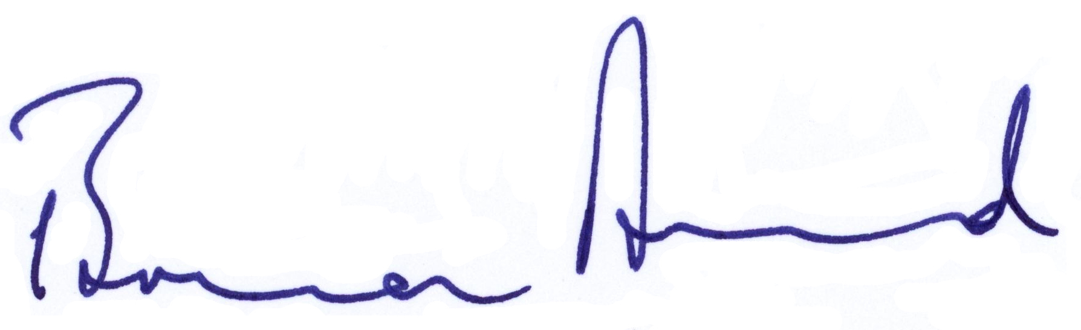
Bruce Baird
Chair
Refugee Resettlement Advisory Council
27 February 2009

