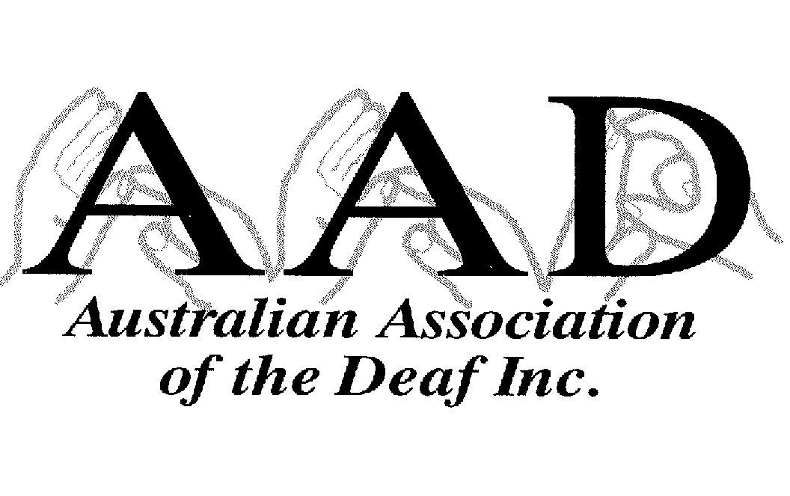

The Australian Association of the Deaf has been committed to increasing accessibility for Deaf people in Australia to television and wishes to respond to Deputy Commissioner Graeme Innes’ Request for Comments.

The Association’s Policy on Auslan clearly states that:

‘The Association aims to continue its lobbying efforts for the increased hours of captioning.’

The Association wishes to express concern about terminating the complaint. It is noted that there is not a great deal of information available about the content of the initial complaint.

The Association would like to make the following points:

- Captioning standards are a great improvement on the levels that existed at the time of complaint;

- The Association is concerned about the lack of plans to increase levels of captioning further from current levels, and that there is no long-term planning in place to ensure a higher level of captioning coverage of television, which is evident in other countries;

- The Deaf Community’s television viewing habits are not confined to prime time television and thus renders this standard somewhat inadequate. Prime time television is not the only time slot that should be accessible – daytime television, overnight television (particularly open university type programs) and other time slots are also of priority as there are also Deaf senior citizens, Deaf children and other Deaf people who watch television programs in other time slots and are equally entitled to access – thus efforts should be continued in order to cover all types of programs.

- The Association strongly recommends that processes be set in place with an end result of 95% of television programs being captioned by 2003, covering all types of programs and 100% by 2005. The infrastructure is already in place, or currently being mounted and thus there should not be considerable extra cost to the broadcasters;

- Resources available (availability of personnel and equipment) do not guarantee immediate 100% access and thus strategic planning is required to enable this;

- There is no proposed means for monitoring progress made in captioning television programs particularly in regional television broadcasts;

- There is no proposed means for community consultation, such as Forums and

- There is no consideration of world’s best practice.

Thus the Association would like to query the proposal to terminate the complaint.

ROBERT ADAM
President.

