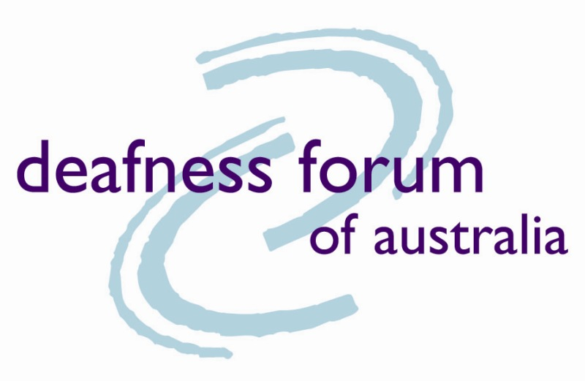 | 
218 Northbourne Avenue  Braddon ACT 2612  phone 02 6262 7808  TTY 02 6262 7809  Fax 02 6262 7810  Mob 0404 037 177  email info@deafnessforum.org.au  www.deafnessforum.org.au  www.hearingawarenessweek.org.au | PO Box 1083  Stafford Qld 4053  Phone (V): 03 3357 8266  TTY: 07 3357 8277  Fax: 07 3357 8377  Email: info@deafau.org.au  www.deafau.org.au

24 September 2008

To: The Australian Human Rights Commission

Temporary Exemption application ABC, SBS, Channel 7, 9 and 10

Deaf Australia, Deafness Forum of Australia, and the Deafness Council of Western Australia are providing this combined response to the above application. Our commitment to working together for our members and constituents demonstrates our strength and depth of feeling on this issue.

The proposed Temporary Exemption application fails to meet the legitimate and reasonable expectations of our members to work towards a negotiated agreement for achieving full and equitable access to TV broadcasting services.

Around 3.55 million Australians currently have some form of hearing loss. This number is expected to increase, partly due to the ageing of the population. Therefore, we feel this is an issue that must be addressed firmly and fairly and not swept under the table, nor should decisions be made that contribute to social exclusion.

We do not feel it is in the Australian community’s best interests to grant this exemption.
In Deaf Australia, Deafness Forum and Deafness Council of Western Australia’s submissions to the Departmental Investigation into media access we have made it clear what outcomes we are seeking in terms of the levels of captioning in the free to air TV area.

Our specific comments relating to the exemption application are listed below.

No commitment to Quality Guidelines

While the application refers to improvements in captioning quality there is no firm commitment to completing, endorsing, approving or implementing the draft Quality Guidelines or negotiating with ACMA for these to be adopted as a Code. (See Attachment A for Draft Quality Guidelines which have been widely discussed with the industry).

Our members and constituents are strongly demanding mandatory quality guidelines to ensure meaningful and useful captions are provided. This encompasses issues such as accuracy, time lag, and a formal complaints process.

We strongly believe that agreement to such a mandatory quality code should be part of this application.

100% captioning 6 am to 12 midnight

We believe that 100% captioning on all primary free to air channels between the hours of 6 am and 12 midnight should be required

While free to air broadcasters have clearly met most of their responsibilities in relation to the Human Rights Commission’s Temporary Exemption covering the period May 2003 to May 2008, it is important to note that since that time there has been no growth in the provision of captioning. While we recognise that in some cases these quotas are actually exceeded, we are also concerned by some recent measures which suggest that some broadcasters may have slightly reduced their captioned hours, back down to the amounts specified in the agreement.

We feel that if this is true, it reflects a cynical and manipulative approach to captioning.

During the last two years of the previous temporary exemption broadcasters averaged an annual increase of 7.5 per cent. Taken from the date of expiry of the previous exemption the proposed new exemption represents an annual increase of only 4.2 per cent.

This falls well short of the stated position of the Deaf and hard of hearing communities that have argued for an annual increase of at least 5 per cent per annum.

The current exemption application effectively seeks a period of 20 months (from May 2008 to December 2009) in order to achieve a further 5% increase in captioning levels up to 75%. This amounts to an 8 months ‘holiday’ period during which no increases are required.

There is no explanation as to why this period is requested and no justification for it.

We do not agree that advertising, sponsorship, promotional material and community service announcements should be exempt from captioning requirements. These should be compulsorily closed captioned.

24-hour period

While we are extremely keen to achieve 100% captioning on all primary free to air channels between the hours of 6 am and 12 midnight, we request an additional requirement, and that is that the TV broadcasting services mentioned above, begin to use the criteria of 24 hour broadcasting, to give the Australian community a true picture of the amount of captioning that occurs. Measuring captions over a 24-hour period gives a truer picture and means that those with irregular work hours or viewing habits are not disadvantaged in terms of captioned viewing.

We also seek a commitment that broadcasters are moving towards 100% captioning over the 24-hour period.

No negotiation

The previous temporary exemption was supported by representative organisations (including Deaf Australia, Deafness Forum of Australia, and the Deafness Council of Western Australia) as it reflected a negotiated agreement.

Despite the previous temporary exemption requiring broadcasters to negotiate with the community sector to develop a new proposal, FreeTV and its members failed to meet that requirement.

This application has been developed unilaterally by the broadcasters, despite several attempts by the community sector and the Human Rights Commission to engage in further negotiation.

It is extremely disappointing to us that the broadcasters are unilaterally seeking to use the Australian Human Rights Commission mechanism of temporary exemptions in this way as it undermines the negotiation process the community sector has been willing to pursue.

No commitment to further negotiation

The temporary exemption application fails to commit to or identify a mechanism for further discussion and negotiation. Broadcasters have stated that they wish to see the outcomes of the Governments Media Access Investigation before looking at future developments.

Whatever the outcome of the investigation it is inevitable that the setting of new goals and timeframes is something that must evolve out of discussions and negotiations with key stakeholders including Government. It is disappointing that this reality is not reflected in the broadcasters’ application.

Further negotiations have to address a number of issues including:

- A timeframe for meeting 100% captioning from 6 am to 12 midnight
- A timeframe for moving towards 100% captioning 24/7 – the community sector recognises that 100% 24/7 would include some negotiated exceptions such as a 1% or 2% unforseen circumstances safety net and the exclusion of some agreed upon types of programs. FreeTV must develop a strategic plan over the exemption period to move towards 100% captioning 24/7, by the end of 2015
- Addressing the low levels of captioning in regional broadcasters
- Addressing captioning levels on multi channels
- Addressing captioning on digital channels

Conclusion

Despite our serious concerns about the content of the proposed application and broadcasters lack of willingness to negotiate with the community sector we recognise that the Human Rights Commission is obliged to respond to this application.

We regret the fact that the Commission has been placed in this situation by the broadcasters as a more appropriate role for the Commission on this issue would be that of facilitator of agreements, rather than arbitrating in this manner.

In making its decision we would ask the Commission to consider attaching the following conditions to the application in the interests of the Australian community.

- The temporary exemption be granted for the period up to 30 September 2011 and not 31 December 2011. The rationale for this being, that if FreeTV and its members had met the requirements of the previous temporary exemption to negotiate further developments in captioning a new agreement would have come into force on 1 June 2008. If such an agreement had realistically achieved a 5% per annum increase we would have achieved 85% captioning by 1 June 2011. Granting the exemption on condition of achieving 85% by the end of September 2011 is in our view a reasonable compromise. In other words, FreeTV failed to meet the obligations of the last agreement and should not be given leeway to do the same again.

- FreeTV and its members commit to a series of negotiations during 2009 to address outstanding captioning issues as outlined in this paper.

- FreeTV and its members commit to completing the Quality Guidelines in negotiation with the community sector by the end of 2008 and work with ACMA to have them registered as a Code. If this is not completed as a Code by end of 2009, the entire exemption becomes invalid.

- Deaf Australia, Deafness Forum of Australia, and the Deafness Council of Western Australia do not wish to pre-empt the conclusions of the departmental investigation into media access, which we are hopeful will bring Rudd Government’s spoken commitment to social inclusion into reality as it relates to this area. Therefore, we see this exemption application as a temporary measure while awaiting results from the government investigation into media access.

- FreeTV and the broadcasters who are party to this exemption application have made it clear through their past actions that they do not feel the need to abide by the previous exemption and have failed to meet their obligations. We hope that the Australian Human Rights Commission, and the Australian Government as a whole, will state quite categorically to the broadcasters that this is not good enough, through either or both of the response to the exemption application, and the departmental investigation into media access.

- Our members and all Australians who are Deaf or have a hearing impairment are entitled to the protection of the law and the Government’s wholehearted endorsement and application of that law. If FreeTV and the broadcasters who have made this exemption application do not negotiate in good faith in future we feel the Government has no option but to mandate their actions, probably though legislation.

Yours sincerely
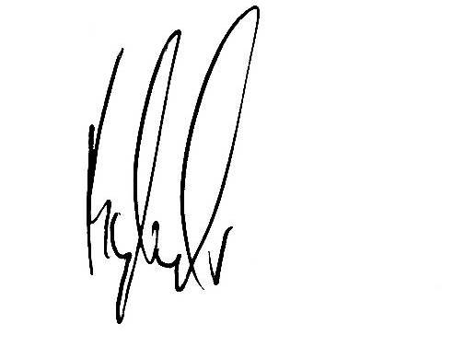
Kyle Miers
President, Deaf Australia
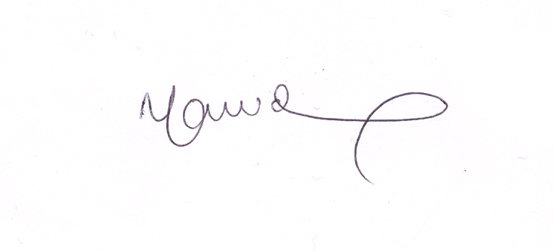
Nicole Lawder
CEO, Deafness Forum of Australia

CC
Minister for Broadband, Communications and the Digital Economy Senator Stephen Conroy
Attorney-General The Hon Robert McClelland MP
Parliamentary Secretary for Disability and Children’s’ Services The Hon Bill Shorten MP
Minister for Families, Community Services and Indigenous Affairs The Hon Jenny Macklin MP
Minister for Ageing the Hon Justine Elliot MP
Simon Cordina (DBCDE)
John Byrne, Deafness Council of WA

Attachment A

DRAFT

Captioning Guidelines

1 Introduction
These guidelines are intended to provide assistance to television networks and other captioning service providers in relation to the presentation of captions on television programs [movies, videos and DVDs and new and emerging media] by setting a benchmark for best practice. The guidelines are a tool for captioning practitioners, and do not replace existing regulatory obligations.
The document specifies visual outcomes, not production techniques. It is up to the caption provider to decide the most appropriate method to deliver the caption to the viewer, but this must take into account consumer expectations.

1.1 What are captions?
Captioning is the display in words of the aural elements of a program (i.e. the dialogue, narration and sound effects) as the program is being broadcast or played on a television or movie screen.
Captions are similar to foreign language subtitles, except that they also include non-spoken aural information such as sound effects.
In the free-to-air television environment, captions are broadcast as teletext data encoded into the television signal. Free-to-air captions are described as being ‘closed captions’, which means that viewers with digital receivers can choose whether to display the captions or not.
Viewers can elect to view their television programs with captions if they have a teletext TV or a digital set top box.

1.2 Who uses captions?
Captions are used by a variety of people including people who are Deaf or hearing impaired, people who are learning English and people viewing programs in noisy or public areas (such as shopping centres, gyms and airports).

1.3 Obligation to provide captions
Under the Broadcasting Services Act, following the roll out of digital television, free-to-air broadcasters are required to provide closed captions for news and current affairs programs and for all programs broadcast between 6.00pm and 10.30pm.
In addition, in agreements negotiated by the Human Rights and Equal Opportunity Commission (HREOC):
- Free-to-air broadcasters have committed to:
- caption all programs that commence in prime time until their conclusion (except sporting events);
- staged increases in overall captioning levels, to reach 70% of all programs (6.00am to midnight) by the end of 2007 (In SBS’s case, this target varies subject to funding);
- give priority to the captioning of pre-school and children’s programming.
- The Motion Pictures Distributors Association of Australia has committed to regular screenings of captioned movies in cinemas.
- Subscription TV broadcasters have offered a commitment to provide captioning for 25% of programs across 40 channels as a minimum by 2009.

2 The General Principles
The following general principles should be taken into account in the creation and presentation of captions:
1. Captions are primarily a form of text-based communication. Depending on the user, captions are either a substitute or a supplement for hearing the soundtrack of a program. Therefore, it is important that wherever possible:
- All parts of the soundtrack to a program, bulletin, movie, DVD or video (including trailers) are captioned, not just segments of it. This also includes downloadable, online, mobile or streaming media and other emerging and new media. TV stations that make material available via any of these media should ensure that captioning guidelines are adhered to.
- Captions should be as faithful as possible to the original wording. Where timing does not allow captioning to be verbatim, captions should match what is said in meaning and complexity.
- Captions should include obvious speech and sound effects;
- Captions should not be positioned to impede/interfere with any text that may be on the screen and:
- Captions should coincide with the relevant soundtrack, so that the relationship between the visuals and the sound is preserved for the caption viewer.
2. Television, movies, DVDs, videos etc are visual mediums. Therefore, captions should be able to be read while the viewer is simultaneously watching the action on-screen;
3. Television broadcasts and movie screenings do not allow viewers to pause or go back over something they haven’t understood. Therefore, captions should be of a length and complexity suitable to convey information in a single reading;
4. Where material is licensed or imported from overseas and already includes captions, it would be preferable for Australian broadcasters or distributors of that material to re-caption it with ‘Australian style’ captions. Technology exists which makes conversion of captions from all capital letters to sentence case (the Australian preference) a quick and simple process. Deaf and hearing impaired caption users find it more difficult to read all-capital-letter captioning, and research carried out overseas supports this.
Further details in relation to meeting these general principles are set out in the best practice guidelines below.
It is recognised that these general principles (and the guidelines) can involve competing objectives, and therefore compromise will be required in some extreme circumstances. In particular, the caption viewer’s desire to receive as much information as possible needs to be balanced against the practical constraints of how quickly captions can be read and how much visual information can appropriately be displayed on the screen at any one time.
Where incompatible standards apply, captioners must exercise their judgement in terms of how best to meet the needs of caption users.
Where appropriate, broadcasters will make reference to these guidelines when responding to viewer queries about the presentation of captions.

3 The Guidelines
Caption service providers should endeavour to ensure the captioning complies with the following best practice guidelines, to the extent practicable in the circumstances.

3.1 General Grammar and Presentation
- Punctuation should make captions as easy as possible for viewers to read.
- Punctuation should follow normal style and conventions (such as the Commonwealth Government style manual).
- Punctuation should convey, as much as possible, the way speech is delivered.
- Sentence case should be used.
- Spelling should be accurate.
- It is not necessary to repeat, in caption form, any information that is already on the screen (such as the name of a presenter or temperatures read out in a weather report).
- Captions should not overlap or impede any text based information already on the screen

3.2 Timing and Editing
- Captions should coincide with the relevant soundtrack, so that the relation between sound and visuals is preserved for the caption viewer.
- A caption should stay as close as possible to the original wording while allowing the viewer enough time to absorb the caption’s contents and still watch the action of the program.
- Programs should be captioned at an appropriate reading speed for the intended audience. For adults this is 180 words per minute (i.e. 3 words per second).
- Where time allows, a caption should be verbatim (word for word).
- The essence of reduction is remaining faithful to the script. Vocabulary and sentence structure should be preserved as much as possible.
- Line breaks and caption breaks should reflect the natural flow of the sentence and its punctuation.
- Captions should never be more than three lines in length. The preference is for one-line or two-line captions to be used.

3.3 Colour and font
- Different colours should be used to help identify different speakers.
- White captions should be used as much as possible as they are the easiest to read.
- Sound effects should be identified using a different (but consistent) colour.
- A black background box should be used to aid readability.
- Preferred font for captions is Arial or other Sans Serif font)

3.4 Positioning
- Positioning should be used to identify who is speaking, especially when there are several speakers in the scene.
- Positioning of captions should, where possible, avoid obscuring important information on the screen, e.g. supers, graphics text descriptors or activities, or the speaker’s lips. For example, it is clearly important that captions not obscure scores in sports broadcasts.

3.5 Sound Effects
- Any noise or music that enhances the visuals, contributes to characterisation or adds atmosphere must be captioned.
- A caption viewer should not receive any more information than a hearing viewer would get.

3.6 Children’s Programs
- Children’s programs should be captioned at around 150 - 120 words per minute.
- Programs aimed at pre-school children should be captioned at around 180 words per minute. This is in recognition that the main benefit of a pre-school show being captioned is so that the Deaf or hearing impaired parent of a hearing child can understand what their child is watching, in which case it should be captioned verbatim and at adult-equivalent speeds.
- [However, there may be occasions, such as where a story is being read or a song being sung, where captioning at a faster rate will be necessary to provide a better learning experience for the child.]
- In a children’s program, if captioning is not verbatim, it is important to ensure substitute words or phrases are not more complicated than the original wording.

4. Open and closed captions
- Matters of pubic importance, national importance, and emergencies must be open captioned.
- Government advertising including election material must always be open captioned.
- Advertising and promos must always be closed captioned.

5. Live Captioning
The standard of captioning that is deliverable varies considerably, depending on whether programs are pre-recorded, live or near live. Programs should only be captioned live if it is impossible to pre-caption them.
Live captioning must be at a required minimum level of accuracy of 98% or 2% error rate. This equates to approximately one word error in every five captions, which should be easily achievable. (This does not make sense. “every five captions” refers to what? Words? Lines of captioning? Sentences?)
For sports captioning, a minimum of 95% accuracy would be acceptable (this equates to an error in every two captions. (As for above comment.)
(We don’t think this is acceptable. In particular, assuming that “emergencies” means, for eg a natural disaster, it is important that the captioning be understandable.)

5.1 Pre-recorded Captioning
Pre-recorded captioning (or ‘off-line captioning’) is where the captioner adds captions to a pre-recorded tape of a program.
Pre-recorded captions are generally used for all ‘non-live’ television programs, such as movies, documentaries, drama series, web-based materials such as YouTube, webinars and infotainment programs, as well as for captioning on cinematic broadcasts, videos and DVDs.
However, live captions may be used for some pre-recorded programs, such as where pre-recorded programs are not available in time for pre-recorded captions to be added, or where broadcasters need to make last minute changes to programs before transmission. Therefore, live captioning may be used for some pre-recorded programs. Live captioning should only be used when pre-recorded captioning is impossible.

5.2 Live captioning
Live captioning is extremely challenging, as it involves transcribing the oral elements of a program in real time (i.e. captioning a television program as it is broadcast).
Live captioning is most commonly used for programs such as news and current affairs, sport, special events such as concerts, and other television or web-based content that is broadcast live, or partially live.
Live captioning can currently be dealt with in three main ways – stenocaptioning, summary captioning, and voice recognition software
Stenocaptioning is a system based on the stenographic shorthand used by court reporters. The captioner listens to a program's dialogue as it is being broadcast and enters the words phonetically in stenographic shorthand code. Multiple keys are depressed simultaneously on a stenographic machine to create different word combinations. Computer software translates the stenographic shorthand into words and converts them to captions.
Summary captioning is performed without stenographic assistance. Captioners listen to what is being said and type a summary or précis. This is not a preferred method of captioning for consumers.
To the extent practicable in the circumstances, caption service providers should endeavour to ensure that live captioning complies with the best practice guidelines set out in section 3. However, clearly, it is not possible to achieve the same quality and presentation standard for live captioning as for pre-recorded captioning.
In particular, in the live captioning environment:
- There will always be a time lag between the audio and the caption.
- Errors will be more frequent since there is no opportunity for live captioners to look up words or to proof read their work. Also, due to the nature of stenographic shorthand, mistakes will often be in the form of incorrect, though phonetically similar, words. Due to the nature of summary captioning, typographical errors often result.
- Some speech or other audio elements may be left out, summarised or only partially captioned, since there is no opportunity for the captioner to replay segments that were missed or that were difficult to understand. This will particularly be the case where numerous people are speaking at the same time.
- Live captioning, whether presented stenographically or in summary form, will not have the grammatical and presentation quality of pre-recorded captioning.
- Similarities in speakers’ voices, where changes in speakers aren’t easily discernible, can result in the same colour being used at times for different speakers.
- It can be difficult to avoid placing captions over rapidly changing graphics, speakers’ lips and other relevant vision.
- Depending on the mode of live captioning, scrolling captions or pop-up captions are used. (scrolling being least preferred by consumers).
Captions should coincide as closely as possible with the relevant soundtrack, so that the relationship between the visuals and the sound is preserved for the caption viewer. Captions which are many frames behind the action are not acceptable. News and current affairs are of interest to Deaf and hearing impaired Australians and are difficult to follow when the images and captions do not coincide adequately.
For live captioning, the priority is always to transcribe as much of the spoken content of the program as possible.

6. Complaints
Complaints about captioning can be made direct to TV stations, or directly to ACMA. Deafness sector organisations will encourage complainants to complain to TV first.
TV stations will ensure that their staff who take calls from the public are aware of captions and their impact on viewers who are Deaf or hearing impaired and have sufficient training and information to respond appropriately to these callers.
Complaints about captioning should be lodged with the relevant TV station within 30 calendar days of the occurrence which prompted the complaint. Complaints can be lodged in whatever manner the viewer prefers, acknowledging that people who are Deaf or hearing impaired may have difficulty using some communication media and may have personal preference related to that. Therefore, complaints may be lodged in the form of any one of phone call, fax, email, letter, online if the station has an online feedback mechanism.
TV stations will provide a written acknowledgement of receipt of the complaint within 14 calendar days of lodgement of the complaint.
TV stations will respond in writing to the complainant (and, in addition, in a different media if requested by the complainant, to best meet their communication needs) within 45 calendar days of receipt of the complaint in whatever format it is received. This response must address the substantive issues in the complaint, not merely be an acknowledgement of complaint. This response should also include an action plan of how the station will address the issue and endeavour to ensure it does not occur again.
In some cases providing a DVD copy of the program, with appropriate captions, will be an adequate response to the complaint. This means that the viewer can enjoy the program after all.
Free TV will undertake to respond to complaints on behalf of all free to air broadcasters.
If no acknowledgement is provided within 14 working days and no adequate response within 45 days of the complaint, the consumer can complain to ACMA. ACMA will take into account these quality guidelines in responding.
Generally speaking, if a complaint is about lack of captions or unintelligible captions, TV stations will address the matter with urgency. A comparable example would be if the sound disappeared from broadcasts.

