9 May 2003

Mr S Ozdowski, OAM
Disability Discrimination Commissioner
Human Rights and Equal Opportunity Commission
GPO Box 5218

SYDNEY NSW 1042

Attention: Disability Rights Unit

Dear Commissioner:

BROADCAST TELEVISION CAPTIONING:
Applications for Exemption under s 55 of the Disability Discrimination Act, 1992

Thank you for the opportunity to comment on the application(s) of the ABC, SBS, Network Ten, Channel Nine and the Seven Network (‘the application’) (‘the broadcasters’) for a temporary exemption under s 55 of the Disability Discrimination Act, 1992 (‘the Act’) in relation to broadcast television captioning.

We note that in the background to this application there have been extensive negotiations between the broadcasters, representative groups for deaf and hearing-impaired persons and the Human Rights and Equal Opportunity Commission (‘the Commission’) about the obligations of broadcasters under the Act to provide captioning of television programs. Beyond that, these negotiations have arisen in response to a number of complaints against the broadcasters lodged under the Act that allege discrimination in programming due to a failure to provide captioning of television programs.

The application for exemption takes the substance and outcomes of these negotiations as understood by the anticipated respondents to the application. The application is therefore lodged in summary form only. The Commission appears to have encouraged, or at least does not object to this approach. This presents significant difficulties for other respondents to the application for exemption, such as us, who have not been involved in the detailed negotiations leading up to the lodgement of the application.

It is not clear on the face of the documentation how or why certain positions have been reached: for example, why captioning of sport telecasts, advertising, sponsorship, promotional material, and community service announcements have been excluded from the requirements for captioning.

Sport programs are of great interest in the Australian community, including to people who are deaf or hearing impaired. While we can see that live-to-air broadcasts of
sport would be more difficult to caption (though far from impossible), we cannot see any difficulty in captioning replays.

Similarly, advertising, sponsorship, promotional material, and community service announcements will often contain information of great interest to all viewers, including people who are deaf and hearing impaired. Community service announcements, in particular, may contain very important information for people who are deaf and hearing impaired – for example, information about community events, emergency warnings etc. Given that these items are usually pre-recorded it is not clear why they have been excluded from the captioning proposals.

Although we have not closely analysed the operation of the Act in relation to advertising etc, we presume that an obligation not to discriminate in the provision of television services falls both on the advertiser and on the broadcaster. The broadcaster is therefore in a position to pass on the costs of captioning as an essential input cost to advertisers. Where the broadcasters provide community service announcements gratis as a public service, they ought to be persuaded that captioning is essential to ensure that these announcements reach the whole community.

The broadcasters assert as evidence in support of the application that there is a shortage of appropriately skilled captioners. That may currently be the case (we have not investigated the matter). However, it does not follow that it will take years to rectify this situation. It is our understanding that captioners can be trained within a relatively short period of time, and therefore, we do not agree that this is a factor justifying significant delay in the provision of captioning.

The broadcasters also assert in support of the application that the overall costs of captioning cannot be absorbed at once, and must be taken up in a staged way. We are sympathetic to this point in principle; however, it is salutary to note that the Act has now been in force ten years. Ten years has provided a very significant period of time for the broadcasters to adjust to their responsibilities under the Act.

While we acknowledge that the broadcasters have made some progress in the provision of captioning over the past 10 years, it is now very late in the day to assert that further time is required to adjust to the obligations imposed by the Act. Service providers who have sat on their hands for the last 10 years in terms of their obligations under the Act (we do not say that the position of the broadcasters is as extreme as this) ought not now to be entitled to claim the benefit of an exemption under s 55 of the Act. They ought to remain exposed to its penalties.

The question of cost must also be considered in light to the resources available to the broadcasters as a whole, and in this respect, the additional costs appear to us to be marginal.

We are also somewhat disconcerted by what appears to be the assumption of the broadcasters that the grant of the exemption application is a fait accompli given that the broadcasters have reached agreement with major representative groups for deaf and hearing impaired people in the negotiations facilitated by the Commission arising from the complaints lodged under the Act. Indeed, in the attachment to the application the broadcasters state that the application would not have been lodged unless, prior to
it being lodged, the representative groups agreed to accept the proposal.

We take for granted the Commission’s call for submissions from the public in relation to the exemption application is a genuine effort to allow for the participation of other stakeholder groups in its consideration of the application. We also take for granted that those representative groups for people who are deaf and hearing impaired that participated in the negotiations pursued the best possible outcome on behalf of their constituencies. However, an unfortunate impression has been created that a deal has been struck in negotiations prior to the exemption application, and that as a result, further public comment will have little or no impact on the outcome of the exemption application.

In light of the above, it is our view that the use of the s 55 exemption power to, in effect, settle representative complaints (or at least individual complaints with representative aspects) warrants further consideration. An exemption will, if granted, bind the class of persons with an interest in television captioning, however, the process that has led to the class being bound does not provide the same level of protection for the class as is provided for the prosecution of representative complaints, ultimately through the Federal Court Rules.

These issues aside, it is clear that overall, the broadcaster’s proposals for increases in the level of captioning during the five year period for which an exemption from the Act is sought are very positive. They will lead to very substantial improvements in the availability of captioning for all audiences. We are particularly impressed by the captioning commitments in respect of children’s programs.

In our submission, the Commission ought to grant the exemption on the terms sought by the broadcasters, subject to:

- The inclusion of sport, advertising, sponsorship, promotional material, and community service announcements in the proposals for increased captioning that support the application. With respect to sport programs this should include an acceptable proposal for both live to air broadcasts and replays.
- Rigorous and transparent testing of the broadcaster’s assertions in relation to the availability of captioners and the costs of captioning, with a view to reducing the period, or varying the terms, of the exemption where the evidence does not support the application in the terms sought.

We congratulate the broadcasters, the Commission, and those representative groups for people who are deaf and hearing impaired who were involved in the development of the proposal in support of this application.

Yours sincerely
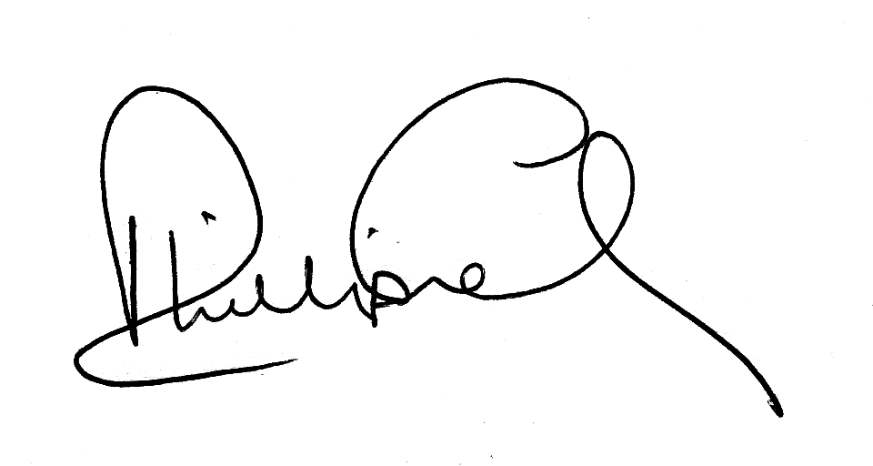
PHILLIP FRENCH
Executive Officer

