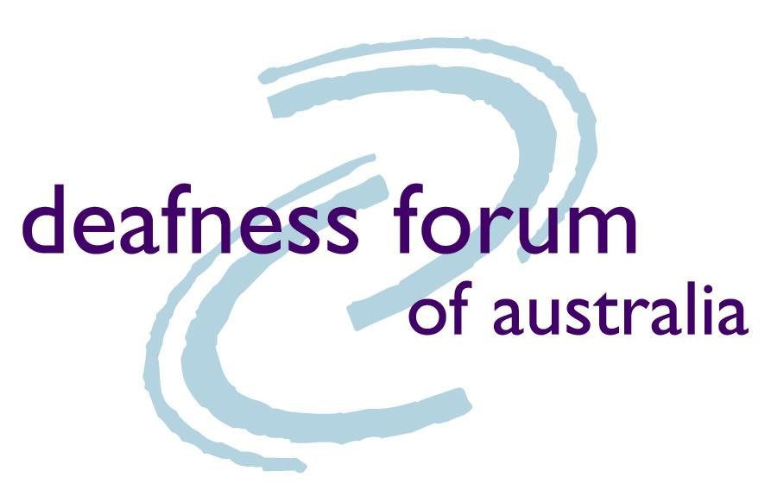

Submission to Australian Human Rights Commission

Application for further temporary exemption: Free to air television captioning (no. 4)

27 January 2012
- Introduction
One in six Australians, in all walks of life, has some form of hearing impairment, and this is projected to increase to one in four Australians by 2050.
It is imperative that the needs of this large, vital and growing sector of society are satisfactorily met.

About the Deafness Forum
Deafness Forum is the peak body for deafness in Australia. Established in early 1993 at the instigation of the Federal government, Deafness Forum represents all interests and viewpoints of the Deaf and hearing impaired communities of Australia (including those people who have a chronic disorder of the ear and those who are Deafblind).
Deafness Forum exists to improve the quality of life for Australians who are Deaf, have a hearing impairment or have a chronic disorder of the ear by:
- advocating for government policy change and development
- making input into policy and legislation
- generating public awareness
- providing a forum for information sharing and
- creating better understanding between all areas of deafness

Our consultation process
Deafness Forum has consulted with members, seeking their comments on this application by Free TV for an extension of its temporary exemption under s55 (1) of the DDA.
- Our position
Deafness Forum of Australia does NOT oppose this exemption request.
Since 2008, the free-to-air TV broadcasters have been providing captioning on their primary channels in accordance with a previous Australian Human Rights Commission (AHRC) exemption request. As at 31 December 2011, 85% (or more) of the content shown on the primary channels of the free-to-air broadcasters between 6am and midnight each day, was captioned.
Notwithstanding the progress that has been made, the members of Deafness Forum of Australia strongly advocate that, should the current exemption request be granted, it must be the final AHRC exemption request by these parties in respect of captioning levels.
[Explanatory Note: Deafness Forum fully expects that the Federal Government will pass legislation in the first half of 2012, which will mandate captioning levels as part of the Broadcasting Services Act 1992. In addition, the Government will also move to prescribe the sections of the Broadcasting Services Act 1992 that mandate captioning targets under sub-section 47(2) of the Disability Discrimination Act 1992.]

Quality of captioning
An immediate and equally important issue that must be addressed is the quality and accuracy of captioning.
Deafness Forum of Australia and its members believe that the quality of captioning has steadily declined in recent years. The quality of captions, particularly with the recent increase in live captioning by broadcasters, is an issue of deep dissatisfaction for our members.
While increasing the quantity of captioned services is vital and urgent, caption quality guidelines – consistent with international best practice – must be implemented in the immediate future.
Deafness Forum will provide feedback to the next digital TV multichannel review scheduled to take place before 31 December 2012.
Deafness Forum’s position is that captioning should be provided on ALL free-to-air television channels. The last review in 2010, stated that a further review would be required, "...in the light of the rapidly evolving broadcast environment".
Deafness Forum recommends that the Government mandates the same captioning quantitative levels for free-to-air TV broadcasters' digital multi-channels at its earliest opportunity, which appears to be during the first half of 2012.

Conclusion
Deafness Forum of Australia does not oppose this request for a further temporary exemption: Free to air television captioning (no.4).
However, the quality of captions remains an issue of importance to our members. Deafness Forum will continue to press for a captioning quality guidelines document which reflects our members’ expectations for quality and accuracy of captioning.

- Contact
If you have any questions about the information contained in this submission, please contact:
Steve Williamson
Chief Executive
Deafness Forum of Australia
218 Northbourne Avenue
Braddon ACT 2612
Phone 02 6262 7808
steve.williamson@deafnessforum.org.au
www.deafnessforum.org.au

Access Economics: Listen Hear! The economic impact and cost of hearing loss in Australia, February 2006, pp.41

