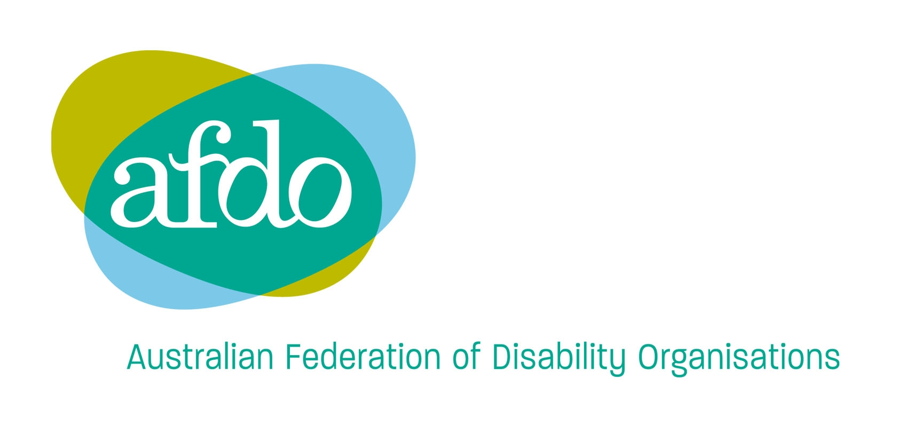
247 Flinders Lane
Melbourne VIC 3000
Phone: 03 9662 3324
TTY: 03 9662 3374
Fax: 03 9662 3325
Email: office@afdo.org.au
Web: www.afdo.org.au

6 December 2007
Mr David Mason
Director
Disability Policy Unit
Human Rights and
Equal Opportunity Commission
Via email to: davidmason@humanrights.gov.au

Dear David

Thank you for the opportunity to comment on the REX Airlines Exemption Application. I apologise that this response is late.

The Australian Federation of Disability Organisations (AFDO) requests that Rex Airlines be required to submit an Action Plan that proposes a framework of measures to be taken over the period of the exemption that will lead to a reduced level of restrictions being imposed on people with disability.

AFDO would be pleased to consult with REX Airlines about their proposed restrictions to assist them to adequately plan to overcome them in the future. We note that international airlines do not have many of these restrictions.

We make the following broad comments in response to the application.

- QANTAS has devised the “eagle lifter”. It would be possible for Rex Airlines to work on such a project.

- It is not clear how the provisions of the exemption application related to people who can comprehend instruction would impact on unaccompanied children flying on Rex Flights.

- The companion card is applicable in other public transport provision. It should be investigated for air flight as well. Blind people have had a provision for companions for many years.

- Boarding arrangements are better able to be controlled when staff provide assistance. Training of ground staff is essential.

- People with disability need to supervise the handling of electric wheelchairs because this important equipment can be damaged by poor handling.

- Requiring people with disability to provide extra booking information and time is discriminatory. People with disability are continuously providing detailed knowledge of their situation. Frequent Flyer schemes assist other airlines.

- There is no provision in the Standards for the limitation of weight of wheelchairs. If there had been input into the Standards from the airline industry this provision could have been included.

- In the Standards there are already details of priority bookings.

- The limit of 2 wheelchair passengers with only one 64Kg wheelchair would make it impossible for some friends and partners to travel together.

- The excess baggage provision does not allow for a person who needs to carry extra chairs, for example, a commode chair.

- Rex Airlines needs to consult with organisations representing people with intellectual disability about training for people with an intellectual disability to travel on airlines. Similar training is already provided in relation to other forms of public transport.

- The ambiguity around what is a prescribed contagious disease is unacceptable.

We note that the REX Airlines application is taking place in the context of a broader decline in access to air travel for people with disability.
This includes:

- Passengers with disability are being told that they must travel with a carer because in an emergency the staff on the aircraft would not help them and they would not be able to assist themselves with oxygen masks etc.

- Passengers have been turned away from flights as a result of this policy. There has also been a refusal to provide attendant assistance to the aircraft.

- There has also been a refusal to carry wheelchairs of certain specification on certain aircraft and a restriction on the number of wheelchairs to be carried per flight. These restrictions have been explained by the inadequacy of the aircraft to carry the wheelchairs as baggage in the baggage compartment.

- Requests for in-flight adjustments have been severely curtailed so that the use of aisle chairs and assistance with them is not forthcoming. The accessibility of toilets has become a problem.

- The provision of information to people who are deaf or hearing impaired needs further investigation, particularly in relation to safety demonstrations and changes in procedures in emergency situations. Carriers need to ensure that all audio-announcements are provided in visual format at the same time. The lack of signage about timely information not only causes embarrassment but also can be unsafe.

- For blind and vision impaired people the safety demonstrations information needs to be provided in alternative formats with special provisions for emergency situations and change in procedures. There is a lack of appropriate signage and alternative formats for blind and vision impaired people.

- There have been restrictions placed on the number of assistance animals that are able to travel on each aircraft. The provision of a sanitary mat for the animal has become a problem. There is also a lack of recognition that assistance animals may be used by a broad range of people with disability.

- At the check-ins people who are deaf or hearing impaired and blind and vision impaired need assistance to access the new seat allocation system, the long queues and delays. People in wheelchairs are being asked to abandon their own wheelchairs for long waiting periods and this can lead to medical problems. A check-in system that allowed for individuals requirements would be of great benefit.

People with disability have travelled by aircraft for more than 30 years and these restrictions to their travel have naturally led to a large number of complaints under the Disability Discrimination Act (DDA) 1992.

There is a genuine commitment from many people with disability to work with the airlines to achieve a reasonable solution in a constructive relationship.

Should you require further information, please do not hesitate to contact Ms Collette O’Neill, National Policy Officer, on 03 9662 3324.

Yours sincerely

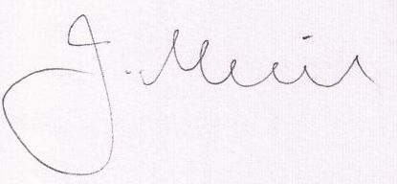

Jeremy Muir
Chief Executive Officer

