Mr Small
Director of Disability Rights Policy
Australian Human Rights Commission

3 December 2009

Dear Mr Small

Re: Application for exemption under DDA section 55: Cinema captioning and audio description
Thank you for the opportunity to respond to this application for exemption.
NSW Disability Discrimination Legal Centre (DDLC) opposes the application under s. 55 of the Disability Discrimination Act 1992 Cth (DDA) on behalf of Hoyts Corporation, Greater Union Organisation, Village Cinemas and Reading Cinemas (the applicants) for a Temporary Exemption.

At the outset we would like to highlight that granting this exemption would contradict Australia’s obligations under the UN Convention on the Rights of Persons with Disabilities (CRPD). Article 30 of CRPD provides for participation in cultural life, recreation, leisure and sport. This obligation includes taking appropriate measures to ensure that people with disability have access to films and cinema, including providing films in accessible formats.

DDLC had discussions with Media Access, Deafness Forum and cinemas last year. Our concern is that there has been minimal progress in this area for ten years. Currently, there are only twelve cinemas in Australia that have open captioning and audio description was only introduced in twelve cinemas this year.

In comparison, Australia is behind most other English speaking countries in the provision of accessible cinema. For example, “in mid-2007 the USA had over 830 accessible cinemas, representing about 15% of locations and an accessible cinema for every 357,000 people.” This is a significantly higher ratio than Australia. Therefore, based on international comparisons, there is no reason that major cinemas are unable to provide access. Consequently, they would be unlikely to succeed on the grounds of unjustifiable hardship.

The problems faced by people with sensory disabilities are highlighted in the following case study:

Our client had a hearing impairment who required captions when attending movies. Neither of his two local cinemas (both part of major chains) provided captioning services. He lived a significant distance from the nearest cinema that provided a captioning service and therefore was unable to go to the cinema as frequently as he wished. The only type of captioning system that was available in Australia is digital captioning. The system cost only $15000, including installation which was not an unjustifiable hardship for a major national cinema chain.

We hope you give careful consideration to the concerns that we have outlined in this letter in regards to this exemption.

Yours Sincerely

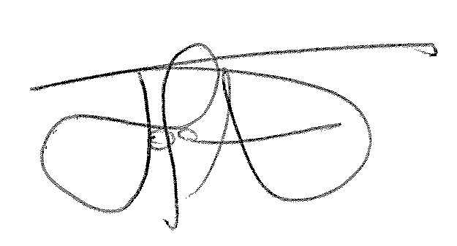
Fiona Given Joanna Shulman
Policy Officer Principal Solicitor

Media Access Australia, Accessible Cinema Captioned and Audio Described, http://www.yourlocalcinema.com.au/about-accessible-cinema/background-and-international-comparisons
Ibid

