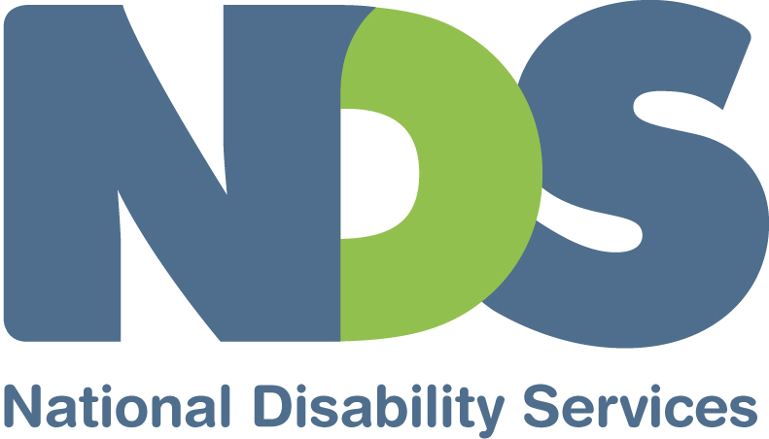

In collaboration with the
AUSTRALIAN BLINDNESS FORUM

Response to Application for Temporary Exemption under DDA Section 55:

Cinema captioning and audio description

INTRODUCTION

National Disability Services (NDS), in conjunction with the Australian Blindness Forum (ABF), welcomes the opportunity to make this response to the application for temporary exemption made by Hoyts Corporation, Greater Union Organisation, Village Cinemas and Reading Cinemas. This response focuses on the need for audio description in cinemas for people who are blind or vision-impaired.

An estimated 500,000 Australians are vision-impaired. They include 50,000 who are blind, 4,000 of whom have a form of deafblindness. Without audio description (AD), this population is denied access to electronic media. By 2024, the total number of people affected by vision loss will increase to nearly 800,000 causing a significantly increased demand for access to audio-described material and programs.

COMMENTS

In the event that the temporary exemption sought by the applicants is granted, NDS and the ABF ask that the following conditions are included.

- All cinemas that are built or undergo substantial refurbishment during the period of the Temporary Exemption are to be fitted with audio-description capabilities.
- If a timeframe of retro-fitting and new installations by any of the applicants is not adhered to, the exemption relating to the applicant becomes invalid.
- The temporary exemption does not apply to any franchise cinemas in which the applicants have a stake.
- Screenings of audio-described films should be at all screenings of an accessible movie in an accessible venue, not determined solely on the basis of perceived demand and not confined to periods that exclude access to reduced ticket price sessions.
- Cinemas should be required to have a prescribed minimum number of headsets available for audio-described screenings (as per Media Access Australia’s recommended 10).
- In addition to acquiring and installing the equipment for AD, the applicants should be required to source audio-described content.
- Audio-described content should be promoted by the applicants through relevant disability organisations and media, for example, RPH Australia.
- The applicants’ own promotional channels, such as their websites and IVR telephone services, must carry information about audio-described content and screening times and that those channels must be disability access-friendly.
- The applicants should explore the ‘best’ technology for AD distribution. For instance, mostly the current systems use infra-red whereas FM distribution would probably deliver a better cinema experience.
- The applicants will set up a working party, including representatives from the key blindness organisations, to explore more effective technological solutions for providing AD.

It is imperative that increased access to AD in the electronic media is accompanied by national guidelines for quality control. AD is a kind of literary art form – a few well-chosen words conjure vivid images. Quality audio description requires quality trained audio describers. Poorly or inadequately audio-described media can fail in its goal of improving understanding of the material or program. Avenues for complaints about poor audio description should be covered by national guidelines.

December 2009

Contact: Margaret Verick
02 6283 3214
margaret.verick@nds.org.au

About NATIONAL DISABILITY SERVICES

National Disability Services (NDS) is the peak industry body for non-government disability services. Its purpose is to promote and advance services for people with disability. Its membership includes more than 650 not-for-profit organisations, located in all parts of Australia, which collectively support people with all forms of disability.

About AUSTRALIAN BLINDNESS FORUM

Australian Blindness Forum (ABF) was first formed as an unincorporated body in 1992, funded only by its members. On 23 April 2007, the ABF became an Australian public company limited by guarantee, funded by its members and governed by a board of directors. The purpose of the ABF is to operate as a peak body representing the blindness sector for the benefit of people who are blind or vision impaired.

Clear Insight, The Economic Impact and Cost of Vision Loss in Australia, an Overview, Eye Research Australia and Access Economics, 2004
For example, Arts and Visually Impaired Audiences in Washington, USA provides training for audio describers (http://www.artsvia.org/mission.htm)

