Temporary Exemption application Cinema
The Deafness Forum exists to improve the quality of life for Australians who are Deaf, deafblind, have a hearing impairment or a chronic disorder of the ear by:
- advocating for government policy change and development
- making input into policy and legislation
- generating public awareness
- providing a forum for information sharing and
- creating better understanding between all areas of deafness.
The major cinema chains have applied to the Australian Human Rights Commission (AHRC) for an exemption under the Disability Discrimination Act 1992 (DDA). This exemption would apply to its members only. We note that independent cinemas are not included in this exemption and as such complaints can still made to AHRC against independent cinemas even if this exemption is approved.
The exemption application from those cinema groups offers to increase the number of screens in cinemas operated by the applicants capable of delivering captions from 12 to 35 over the next two and a half years. In exchange the industry is seeking a Temporary Exemption for this period.
Deafness Forum members, whose views are incorporated into this submission, include those of:
- individual consumers
- consumer associations (such as Better Hearing Australia branches, SHHH Australia (Self Help for Hard of Hearing People), CICADA groups (Cochlear implantees); Parents of Hearing Impaired Children groups
- service provider associations such as State-based Deaf societies, Audiology Australia, teacher of the Deaf associations, etc.
We have consulted with our membership who have informed us that they have severe concerns about this offer.
We note:
- There has been a longstanding failure on the part of industry to take meaningful positive steps towards improved cinema access. Despite a clear responsibility to not discriminate industry has fought our attempts to constructively map out a path towards equality. After several years of trying to negotiate, our assessment is that industry will not voluntarily initiate any improved access unless they are locked into an agreement such as the one offered through a temporary exemption.
- Despite encouraging and supporting our members over the past two or three years to use the DDA complaints mechanism to try to achieve change little has been achieved. This is because industry has failed to enter into meaningful conciliation and forced individuals to face the personal and potential financial cost of taking their complaints to the Federal Court. Despite the validity of complaints it is not surprising individuals feel reluctant to pursue their complaints that far. Our assessment is that even if a number of complaints were lodged now, as a result of the increased public awareness of the failure of industry to take action in the past, it would be 2 to 3 years before complaints would find their way through the Court system. Our assessment is that industry would do nothing in the meantime so that would be two to three years during which we would have no progress at all.
- Despite the claims by Federal Government of a commitment to social inclusion, the ratification of the UN Convention on the Right of Persons with Disabilities and positive statements of intent in the Cultural Ministers Council National Arts and Disability Strategy the Federal Government shows no sign whatsoever of actually doing anything to encourage or force industry to do the right thing. The recent release of a Discussion Report into media access by Minister Conroy and Parliamentary Secretary Bill Shorten is extremely disappointing in that its only proposal in relation to cinema access is to review the level of access in 2013. In other words the Minister and Parliamentary Secretary have signalled to industry they will not take any action to support our claims for equality for at least 3 years. This is a serious failure on the part of Government and we will be advocating strongly over the next few months to try and achieve a change in approach.
- The inclusion of audio description will be a positive first step for access to cinema for people who are blind/vision impaired.
Apart from further entrenching systemic discrimination and exclusion, the application in itself does not contain sufficient detail with regards to
- improving the number of session times and access, for example using Rear Window Captioning
- detailing plans for inclusion of an captioning in any new or significantly refurbished cinema, which clearly should be upgraded to include captioning during an exemption period.

Despite our grave fears over consumers losing their right to make complaints during the exemption period, given all the above factors, and in order to be able to continue to constructively contribute to future improvements, we have decided to support his application. Not because we think it is a good proposal but because we believe at this point in time it represents the only way to achieve improvements over the next 2 years while we work on other strategies to ensure a longer tern progressive move towards equitable access.
Yours sincerely

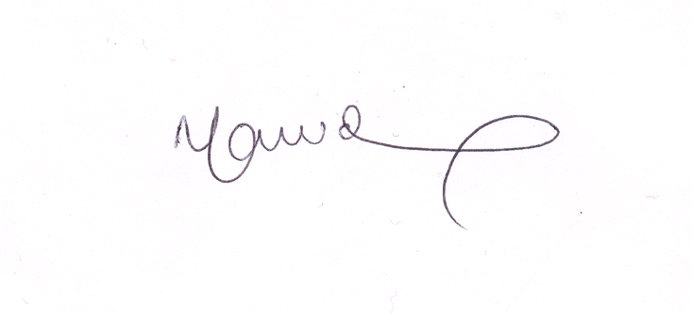

Nicole Lawder
CEO, Deafness Forum of Australia

