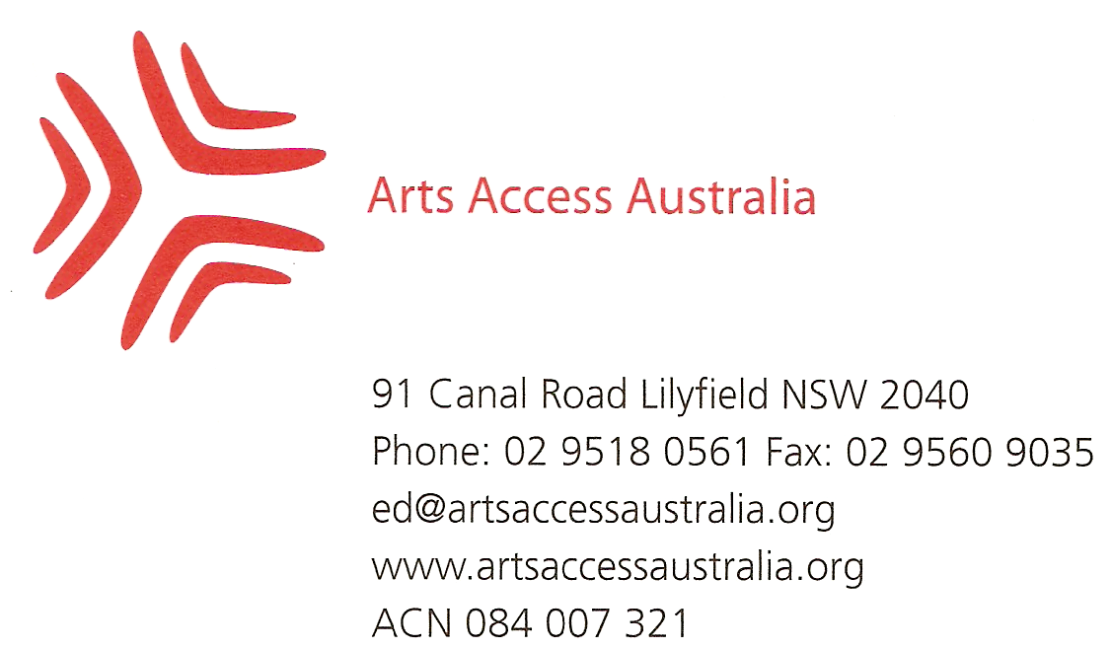
7 December 2009

Mr Graeme Innes AM
Disability Discrimination Commissioner
Australian Human Rights Commission
Email: disabdis@humanrights.gov.au

Dear Graeme

RE: Cinema captioning and audio description: Submission in response to application for temporary exemption under Disability Discrimination Act (DDA) section 55

Thank you for the opportunity to provide a submission in response to the Village Roadshow, Greater Union, Hoyts and Reading Cinemas application for exemption from the Disability Discrimination Act for a period of two and a half years. Arts Access Australia, the national body for arts and disability, urges you to reject the application on the basis that it does not represent a progressive move towards DDA compliance.

The provision of captioning and audio description in cinemas is of direct relevance to more than a million Australians with hearing and vision impairments, their families, friends and carers. If accepted the exemption means that these Australians will lose their right to complain to the Australian Human Rights Commission about the lack of provision of captioning and audio description at the 125 cinemas (1182 screens) owned by these four exhibitors. Even if the exemption is granted the cinemas will only provide captioning and audio description for a minimum of three screenings a week in 35 cinemas which, in Arts Access Australia’s view, is insufficient to justify the removal of rights elsewhere. This cinema access issue also highlights the weaknesses of the Disability Discrimination Act (DDA) and provides an opportunity to consider alternate solutions to the exemption application.

The many individual citizens with disabilities, and peak organizations representing them, are all working to improve access and making complex decisions about the best way forward. There is a danger in all of our work that we become captive to the constraints of the current DDA without the resources or energy to also argue for legislative reform and alternate solutions. Those in favour of the exemption request are acting in recognition of the discriminatory burden the passive complaints based DDA, by requiring an individual who is discriminated against to self-fund court action, places on people with disabilities to have their rights upheld. Those in favour of the exemption request are also afraid. This fear is an understandable response to the cinema industries implied threat to either: accept the exemption request and linked offer to make some improvements to access, or reject the exemption request and see no improvements at all. Negotiation with the cinema industry has achieved little in the last 15 years and there is a view in the disability sector that, without accepting the exemption request, the cinemas will sit back and await developments in government policy, changes to legislation or successful court action before improving access. The Federal government’s current Media Access Discussion Report, which is inviting submissions on potential improvements to audio description and captioning levels, indicates that the government will need some encouragement to act as the Report proposes a review of captioning and audio description in 2013. Arts Access Australia observes that the proposed 2013 review of captioning and audio description fits neatly with the DDA exemption request before the Australian Human Rights Commission. There is overall agreement from all individuals and peak disability organizations about the need to improve access and that the exemption application offer from the cinemas is at the low end of what might reasonably be expected. By rejecting the exemption application you will be pushing the government and cinema industry to improve their support for the rights of people with disabilities and challenging the low expectations about what might be achieved in the next two and a half years.

The minimal nature of the cinema exhibitors proposed increase in captioning and audio description is revealed through international comparisons with the USA and UK. Media Access Australia provides figures indicating that in mid-2007 the USA had over 830 accessible cinemas, representing about 15% of locations and an accessible cinema for every 357,000 people; while the UK had over 250 cinemas, representing nearly 38% of locations and an accessible cinema for every 243,000 people. Applying the same methodology to the Australian exemption application, and assuming no other exhibitors spontaneously decide to improve access, indicates that by 2013 Australia will have accessible cinemas in 10% of locations and an accessible cinema for every 630,000 people. So by 2013 Australia will still be well behind where the rest of the world was six years earlier.

Arts Access Australia suggests that the cinema captioning and audio description discussion has achieved its own unique historical trajectory at odds with overall movement within government and society. The lengthy discussions over cinema access have effectively been leap-frogged by the rising expectations of people with disabilities supported by broader government policy initiatives including; responsibility to implement the United National Convention of the Rights of Persons with Disabilities (UNCRPD), development of a National Disability Strategy and the Social Inclusion Agenda. This is part of the Rudd government momentum on disability that you spoke of in your 2 December 2009 Radio National interview. For example the National People With Disabilities and Carer Council (NPWDACC) believes the strategic priorities of the Rudd Government’s National Disability Strategy should include “increasing the social, economic and cultural participation of people with disabilities and their families, friends and carers”. In addition, as part of the Social Inclusion Agenda, the Cultural Ministers Council National Arts and Disability Strategy priority projects include “Film, television and broadcast industry: Explore opportunities to enhance accessibility and inclusive practices in the film, television and broadcast industry. This may include programs in Auslan and efforts to increase captioning and audio-description services…. “.

Further support for rejecting the exemption application is found in the demographic reality of an ageing population. The impact of an ageing population on cinema access has already been recognized by The Hon Justine Elliott, Minister for Ageing, through the 2009 “Helping Older Australians Enjoy the Movies: Accessible Cinema” project. The project is part of the Federal Government’s commitment to a greater focus on positive and active ageing – as part of its agenda to promote social inclusion and participation, as well as reducing social isolation. In announcing this $350,000 in one-off Accessible Cinema funding for 12 independent cinemas to install captioning, audio description equipment and assistance with promoting the new equipment to local citizens the Minister for Ageing said:

“ Older Australians have told me that they want to share in the pleasure of going to the movies with their grandchildren during the school holidays but cannot enjoy the films because they are unable to hear them.”

“ I am hopeful that cinemas all over the country will realize the commercial gains that are possible by catering for this demographic”

The economic cost benefits of increasing cinema access, and potential rationale for additional government support, bear further consideration. Arts Access Australia notes that the cinema exhibitors are not seeking exemption from the DDA on the basis of ‘unjustifiable hardship’. Screen Australia provides data about the cinema industry, from 2000, which indicates there were 173 businesses operating over 326 sites with a gross income (before tax) of $832 million. Based on the Federal government’s Accessible Cinema project $30,000 is sufficient to provide captioning, audio description equipment and promotional support bringing the total cost of providing improved access at all 326 sites to an estimated $9.5 million. This $9.5 million to improve access could be financed through Federal economic stimulus package money and tax incentives. The need for government support could then be reduced through means testing, based on updated Screen Australia figures, and weighted for the number of sites to provide 100% support for businesses earning less than $100,000 and tapering out for the 99 businesses earning up to $1 million before cutting out for the eight businesses earning more than $8 million.

Any need for government support could also be assessed in light of a business case which models costs and potential increases in attendance and revenue as there is significant unmet demand for captioning and audio description. Using Australian Bureau of Statistics figures the Cultural Ministers Council found that in a twelve-month period 43% of people with disabilities, and 34% of older people (aged over 60), reported attending the cinema compared with 65% of all Australians aged 15 years and over. Therefore, in broad terms, if one million additional attendances at the cinema can be generated from Australians with hearing or vision impairments, their families, friends and carers, through the provision of captioning and audio description in all 326 sites then, at an average ticket price of $10 allowing for concessions, the cinema exhibitors would recoup their costs in the first year.

The cinema exhibitors have had over a decade to explore these, and other options, if they haven’t done so then that is no reason to accept their application for exemption from the DDA for the next two and a half years. In this context Arts Access Australia welcomes your comments, of 2 December 2009 on ABC Radio National, expressing disappointment with the cinema industry’s approach to access:

“I’m particularly frustrated with movie sessions because we’ve been working for a long time on captioning of movies and for a shorter time on audio description of movies …. But it’s pretty disappointing that a million Australians with a hearing impairment, with 30,000 who are completely deaf, only get to access movies on 24 out of the 3,000 screens around Australia and, even then, only two or three times a week… the cinema industry have seriously dropped the ball on this.”

Add in the 300,000 Australians with partial to total loss of sight, the rapidly increasing prevalence of disability as the Australian population ages, and the importance of rejecting the proposed exemption is apparent.

By rejecting this application you will be putting pressure on the government and cinemas to support more positive developments to occur over the next two and a half years. These could include:

- Amendments to the DDA to allow the Commissioner to conduct test cases
- The introduction of mandatory captioning levels
- The development of a stronger overall legislative framework than the current complaint based DDA based on USA and UK models where there is a positive obligation on the business to provide access
- People with a disabilities increased willingness to complain under the DDA and take the issue to court
- The cinema chains improving access in response to public pressure and the knowledge that the cost is unlikely to constitute ‘unjustifiable hardship’
- The Federal government providing funds for the provision of access equipment for those cinemas where ‘unjustifiable hardship’ may be a consideration
- Modelling the business case of the costs of access provision against increases to attendance and income and attendance

Arts Access Australia urges the Australian Human Rights Commission to respond in favour of the many submissions from people with disabilities, and support the right to enjoy visiting their local cinema, by rejecting the exemption application. Should you have any queries about Arts Access Australia, or this submission, then I can be contacted by phone on 02 9518 0561, 0419 201 338 or email ed@artsaccessaustralia.org

Yours sincerely
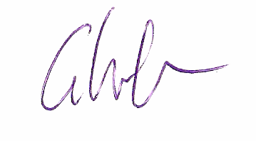

Gareth Wreford
Executive Director

Sources of Data (all accessed 7 December 2009)

Cultural Ministers Council National Arts and Disability Strategy http://www.cmc.gov.au/working_groups/national_arts_and_disability_strategy

Cultural Ministers Council – Participation by Persons with Disability and Older Persons
http://www.culturaldata.gov.au/publications/statistics_working_group/cultural_participation/cultural_participation_by_persons_with_a_disability_and_older_persons,_2003

Screen Australia – Cinema Industry Overview
http://www.screenaustralia.gov.au/gtp/cinema.html

The National People With Disabilities and Carer Council - National Disability Strategy http://www.fahcsia.gov.au/sa/disability/pubs/policy/community_consult/Pages/executive_summary.aspx

Media Access Discussion Report http://www.dbcde.gov.au/television/television_captioning/television_captioning_discussion_paper/media_access_discussion_report

Media Access Australia – International Comparisons
http://www.yourlocalcinema.com.au/about-accessible-cinema/background-and-international-comparisons

Disability Discrimination Commissioner Graeme Innes AM Radio National
http://www.mediaaccess.org.au/index.php?option=com_content&view=article&id=751:disability-discrimination-commissioner-speaks-out-on-access&catid=1:cinema&Itemid=15

The Victorian Deaf Society estimates of hearing loss. http://www.vicdeaf.com.au/statistics-on-deafness-amp-hearing-loss

Radio for the Print Handicapped (RPH) Australia estimates of vision impairment.
http://www.rph.org.au/html/vision_impairment.html

