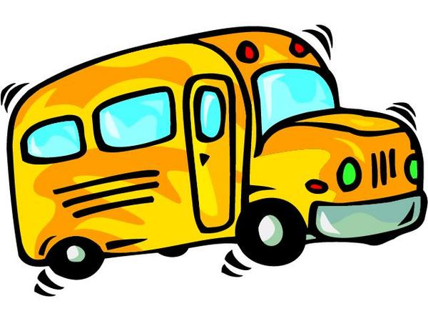
BUCHAN BUS N FREIGHT
DREW BEAVEN
BUCHAN BUS N FREIGHT
RMB. 2342 GELANTIPY RD
W-TREE 3885 VICTORIA
Ph. (03) 51550356
Email: BUCHANBUSNFREIGHT@ Hotmail.com

Dear David Mason;

Buchan Bus n Freight would like to apply to the Human Rights and Equal Opportunity Commission for an ‘exemption’ to the Disability Discrimination Act 1992.
The grounds for this application are based on unjustifiable hardship, which would occur if Buchan Bus n Freight were made to comply with the act.
Buchan Bus n Freight is attempting to start a service for our local isolated community of approximately three hundred households. There has never been a public bus or freight service in this community; However many locals have tried to start such a service only to find that there is no local council or government financial support. I am starting this service with full commercial risk. The bus was purchased second-hand from a sawmill; it was used to transport their workers. The bus is newly introduced to the public transport service.
I am giving the service a trial period until March 2004, when I will review whether the service is financially viable. On this point it is vital that the service be allowed to start as soon as possible, to capture the summer trade, proving the viability of the service.
Buchan is an isolated rural community seventy-four kilometers from the nearest hospital in Bairnsdale, as such there are no severely disabled people in the community. I have spoken to the local ‘Bush Nurse’, who cannot identify anyone who would be discriminated against if there were no wheelchair facility to access the bus. There are several people in the community on disability support; Two of which drive motorized disabled scooters. One person is in a wheelchair, but can walk for short distances. The bus will tow an enclosed trailer for freight purposes. Such wheelchairs and scooters will be transported in the trailer as freight.
As this service is set up as a friendly, public community bus, the driver will assist members of the community on and off the bus with person and belongings. This is a goodwill service provided to the elderly, persons with children and others who need assistance as part of our friendly service.

