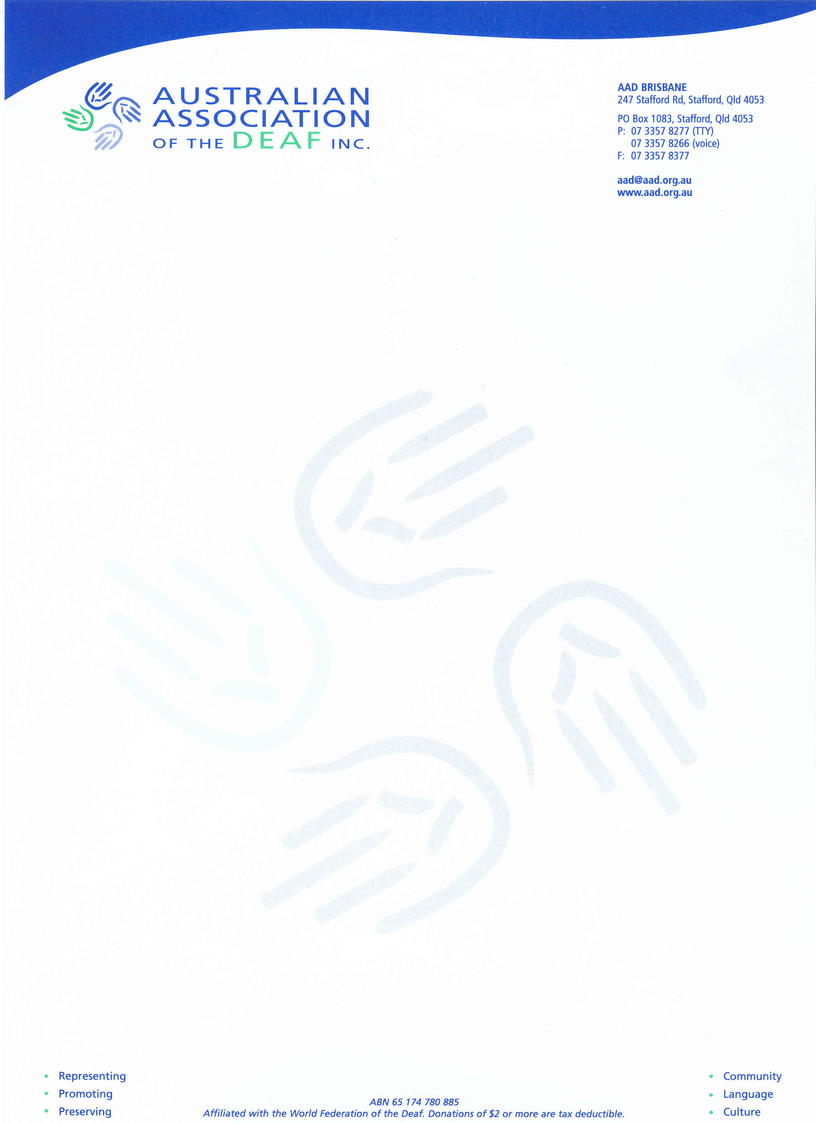

To: Human Rights and Equal Opportunity Commission

Response to ASTRA application for exemption under section 55 of the Disability Discrimination Act, in relation to closed captioning on Subscription Television.

Australian Association of the Deaf (AAD) is pleased to have this opportunity to comment on the application, and commends HREOC for this open and transparent process.

AAD would like to make the following comments about the application and the process of negotiating the introduction of captioning on subscription television to date:

AAD has been a member of the HREOC working party on captioning on subscription television since its inception. We have attended meetings of the working party and have put forward our view. Essentially our view has been and remains that:

- all subscription television should be captioned;
- we are willing to negotiate the phasing in of captioning, but eventually, and within a reasonable timeframe, all television content should be captioned;
- the subscription TV industry needs to re-examine its mind-set and understand that rather than simply a “cost”, the Deaf community is a market. They cannot expect people to buy something that is not accessible to them, but when they make their programs accessible to Deaf people (ie with captioning) then Deaf people are more likely to buy their product. The industry needs to realise the benefits to themselves of providing captioning, as well as their obligations under the Disability Discrimination Act to provide access to their products for Deaf people.

Prior to the exemption application being lodged with HREOC, AAD was approached by the consultants who have been working with ASTRA for the past 18 months, to discuss the contents of the exemption application before it was submitted. After discussion with our colleagues on the working party, the WA Deafness Council and Deafness Forum, AAD agreed to meet with the consultants and ASTRA to be briefed on the contents of the proposal. We indicated that we would not be negotiating the contents of the proposal outside of the HREOC forum. At this briefing session, one of our colleagues made some suggestions for changes to the proposal in relation to clarification of a particular clause, identification of captioned programs in printed and electronic program guides, showing of captions if commercials are provided with them and support for all imported TV sets to have caption capacity, and these changes have been included in the proposal that has been lodged.

Following this briefing session, AAD held internal discussions about the proposal and consulted with our colleagues, and all three organizations agreed on a joint response to the captioning rollout plan detailed in the proposal. Apart from comments about follow-up on the suggestions for change made by our colleague at the briefing session, this response was:

We would also like the rate of increase in captioning to be increased to 10% in the fourth and fifth years of the roll out plan. However if this will result in a delay in the exemption application, we will support an exemption for three years at the 5% pa increase proposed in the application for the first three years. This will allow time to negotiate the rate for subsequent years without compromising early roll out.

AAD is happy to discuss the proposal further with ASTRA but requests that this be done within the HREOC negotiation framework already in place. We understand that the subscription television industry is relatively new in Australia and needs time to get to grips with an issue that many channel providers have not previously considered. We believe we have already shown a great deal of patience in giving the industry almost three years to come up with this proposal.

We have come under pressure from some of our members to reject the proposal because in their view it is too limited: what, after all, is 25% access to total program hours to them when they have to pay the same subscription fees as people who have access to 100% of program hours? Channel providers need to understand this point of view – why should a Deaf person pay subscriptions to a service that they can only access for 25% of the available hours? Only when subscription TV is fully accessible with 100% captioning, will the industry realize the full potential of the Deaf market.

However, AAD understands and appreciates the enormous effort that ASTRA has put into arriving at this proposal. We understand that the industry is complex and arriving at this agreement has been very difficult and time consuming with many hours of negotiation with channel providers.

We therefore wish to congratulate ASTRA on what we believe is a good step forward. We are of the view that rather than rejecting this limited proposal outright and returning to square one, as some of our members believe we should, it is better to accept this proposal as an entry level to what eventually must become full captioning of subscription TV. In our view it is not a question of if captioning becomes available; it is a question of when, and for how long subscription TV providers can cry poor. Presumably subscription TV will eventually become profitable and the old standby tactic of using the “unjustifiable hardship” argument will become an obvious nonsense. In the meantime, 5% captioning with annual increases is a good start.

We are however, of the view that key aspects of captioning provision have not been adequately addressed in the exemption application. For example:

- Comparisons with free to air TV, while not invalid, need to be qualified and explained. For example, although it is true to say that free to air TV will be broadcasting fewer total captioned hours in comparison with the subscription TV proposal, the program content on free to air TV requires much more original captioning than subscription TV’s program content, which largely involves buying already created caption files. Original captioning of program content is more expensive than buying already created caption files. Also, subscription TV contains a much higher percentage of repeat broadcasting than free to air TV does. This means that in effect, subscription TV might very well be captioning 25% of programming hours, but only a very small percentage of actual programs might be captioned; whereas free to air TV might be captioning a lower percentage of programming hours but a higher percentage of actual programs. This is a significant difference from a viewer’s perspective. More hours of the same repeat program is not better than or more expensive than less hours of a wider range and number of different programs.

It should also be noted that the proposed total 25% of program hours (by year 5) includes subtitles on foreign films. On free to air TV, these subtitles are outside the definition of captioning.

- There is insufficient information about the costs of captioning. In item (k.) the exemption application states that the cost of acquiring and broadcasting an already existing caption file is 25-65% of the cost of original captioning. This cost range is very large and the statement is too general and too vague. ASTRA needs to provide more detailed information about costs, and community organizations also need time to investigate these claims further.

AAD is also of the view that rather than simply relying on ASTRA to report on compliance on an annual basis, some form of formal compliance monitoring should be established. This formal monitoring should include input from Deaf and hearing impaired consumers.

As indicated above, AAD will support the application for five years if ASTRA agrees to increase the level of captioning increase to 10% in years four and five. If ASTRA will not agree to this change, then AAD believes it is in the interests of our members to support the exemption application for three years. This will enable the roll out to commence and allow time to investigate such issues as cost, spread of captioned program content and benefits to the industry, and for the industry and community to develop a better mutual understanding of the issues. AAD is happy to consult further with ASTRA on these matters and, once captioning commences, to allow time for agreement to be reached on the percentages for captioning beyond year three.

