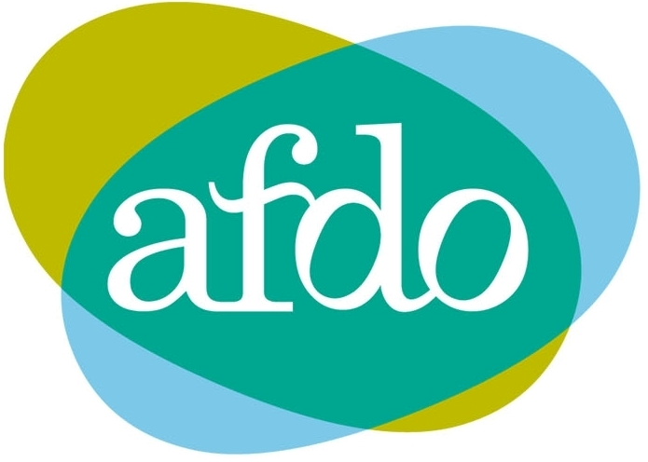
Australian Federation of Disability Organisations response to the preliminary HREOC decision on the
Australasian Railways Association application for a temporary exemption under the DDA

Introduction
The Australian Federation of Disability Organisation (AFDO) has considered the revised Australasian Railways Association (ARA) application for an exemption under the DDA in the light of the preliminary response prepared by the Human Rights and Equal Opportunity Commission (HREOC).

In preparing our response we have reviewed previous applications for exemptions that may serve as precedents. In the case of the Melbourne Trams application, HREOC did not approve an exemption merely on the basis of unjustifiable hardship. In the case of the Airnorth application, HREOC approved the application on the proviso that the applicant agree to explore options for improving access and removing barriers to access, and to reporting to HREOC on this work. In the case of Airport Direct, HREOC refused the request for an exemption because the operator did not provide evidence that barriers to disability access would be removed over time.

Given the above precedents, AFDO considers that the ARA application does not meet the burden of proof requirement contained in the HREOC guidelines for exemption applications. These guidelines have been developed to ensure compliance with the requirements and spirit of the DDA and Standards. AFDO supports the ongoing adherence to these guidelines otherwise we risk a dangerous precedent that erodes hard fought Standards for accessible transport.

The ARA, as a national body, represents some of the largest transport operators across Australia and has considerable resources to consult with people with disability and their representative organisations about difficulties they are experiencing complying with Standards. The ARA also has the resources to confirm acceptable equivalent access measures and incorporate these into a Disability Action Plan.

We are disappointed that the ARA has not done this. We recognise that underlying the ARA application is a commitment to the development of flexible and innovative solutions to achieving access. However, we have fundamental concerns about the original and the revised ARA applications: proposed technical solutions have not been satisfactorily tested; exemptions sought are insufficiently targeted; and exemptions are sought where none is needed. The exemption seeks changes to wording within the Standards but does not explain how the changes will effect services to people with a disability and lead to the removal of barriers. The exemption application also fails to demonstrate a commitment to the objects of the DDA and the removal of barriers over time - to our knowledge the ARA has not lodged a Disability Action Plan.

We are pleased to note that the Commission has recognised these issues in its preliminary response.

It is our position that the ARA could have done substantially more to consult with disability organisations about the access issues they were encountering. In our response to the original application and at a meeting convened by the Commission on 6 April 2006, AFDO expressed our strong concerns about the lack of consultation with people with disability and about the unduly complicated and unacceptable format of the application. We are aware that other disability organisations have expressed similar concerns.

Not withstanding these concerns, AFDO provided to the HREOC a comprehensive submission on the original ARA application. The submission identified exemptions AFDO believed should be granted, exemptions we believed should be rejected, and exemptions which required more discussion.

The ARA has subsequently prepared a second application for exemption. Despite the concerns raised by the disability sector, this application is again poorly constructed and inaccessible. This has made it extremely difficult to respond to the application. It has also unnecessarily undermined the exemption process. While some of the exemptions sought may be reasonable, the lack of a robust evidence base to the application and the poor engagement with people with disability arguably leaves HREOC decisions on the application open to legal challenge.

We recommend that the ARA amend their current application, addressing the deficiencies identified above, and that the revised application be accompanied by a Disability Action Plan. In the mean time, we are happy to provide this response to the Commission’s preliminary response. It should be read in the light of our earlier submission. Our responses are grouped as follows:

- Exemptions which should not be granted
- Issues on which it appears that a decision in favour of an exemption should be recommended
- Issues on which further consultation with ARA, APTJC and the disability community could assist

At the November 2005 meeting about the application, hosted by the Commission, it was suggested that the ARA application may lead to the development of a rail specific guide for implementing the Standards and that the equivalent access measures within the application might form the basis of an Action Plan. AFDO sees great value in these documents being developed and we urge the Commission to progress this.

Within the Commission’s preliminary response document there are numerous recommendations related to improved reporting of progress against the Standards, including progress towards achieving equivalent access. We would reiterate that an Action Plan or similar goal setting mechanism could establish a basis for implementation of the Standards by ARA.

Finally, AFDO is pleased to continue to contribute to discussions aimed at improving the effective implementation of the Standards.

Response to Preliminary Decisions

- Exemptions which should not be granted

The Commission identified that many clauses that either did not stand as independent points of exemption or that did not require exemptions. AFDO agrees with the assessments made in these cases.

AFDO does not agree with a number of Commission recommendations that an exemption be granted. These are listed below.

1.15X Disability Aid

AFDO considers there to be value in rail operators providing guidance to staff and passengers on the treatment of disability aids. Developing a process for this may form part of an Action Plan. However, we are not convinced that an exemption is required for this.

2.5 Poles and obstacles, etc: requirement for contrast

The ARA has not substantiated the need for an exemption in this area.

8.7 Boarding – Signals requesting use of boarding ramp

The ARA has not substantiated the need for an exemption in this area.

9.6 Number of allocated spaces to be provided – train cars etc

Granting this exemption would lead to an unacceptable reduction in the amenity enjoyed by people with disability. We are also concerned about the possible implication of an exemption being granted in this area at the same time as proposed changes to the access path and nominated boarding points are being considered.

11.2 Handrails and grabrails – Handrails to be provided on access paths

The ARA has not substantiated the need for an exemption in this area.

12.1 Doorways and doors – Doors on access paths

The ARA has not substantiated the need for an exemption in this area.

14.1 Stairs – Stairs not to be sole means of access

The ARA has not substantiated the need for an exemption in this area.

14.3 Stairs – Compliance with Australian Standards – conveyances

An exemption that allows the design of stairs in a particular conveyance to be different from the design of stairs in other locations is not supported because a lack of consistency is a safety hazard for blind and vision impaired people. In addition, AFDO does not support the introduction of the term ‘colour-contrast’ into the Standard.

16.5 Symbols – Accessibility symbol to be visible on accessible doors

The ARA has not substantiated the need for an exemption in this area.

17.4 Signs – Destination signs to be visible from boarding point

AFDO is concerned that the ‘access path’ is being interpreted by the ARA too narrowly, at the expense of the access needs of people who have impairments other than mobility impairments. People who are hearing impaired or Deaf would be disadvantaged by this exemption.

17.5 Signs – Electronic notices

The ARA has not substantiated the need for an exemption in this area.

18.1 – Tactile ground surface indicators – Location

The ARA has not substantiated the need for an exemption in this area.

20.1 Lighting – Illumination levels – premises and infrastructure

AFDO understands that the proposed clause is an improvement on the Standard; therefore an exemption is not required.
22.5 Accessible sleeping berths – trains

The ARA has not substantiated the need for an exemption in this area.

25.4 Payment of fares – circulation space in front of vending machines

The ARA has not substantiated the need for an exemption in this area.

28.1 Booked services – notice of requirement for accessible travel;
28.2 Booked services – period of notice of requirement for accessible travel

The ARA has not substantiated the need for exemption in these areas.

30.1 Belongings – Disability aids and mobility aids to be in addition to baggage allowance

The ARA has not substantiated the need for an exemption in this area.

- Issues on which it appears that a decision in favour of an exemption should be recommended

AFDO agrees that exemptions should be considered on the basis indicated in the Commission’s preliminary decisions in relation to the following clauses, subject to:
- the exemptions being tightly targeted, with the exemptions limited where appropriate to individual operators; and,
- the ARA agreeing to strict reporting requirements and the ARA agreeing to document the processes it will use to ensure that equivalent access is achieved.

In relation to access paths, exemptions should be worded in such a way that it remains clear that an access path must cater to the needs of all people with disability, including people with vision and hearing impairment.

2.1 Access Paths
- subject to there being a timetable for compliance and a potential trigger for full upgrade linked to the Access to Premises Standard

2.4X Access paths – Minimum obstructed width for railway platforms

5.1 Resting points – when resting points must be provided

11.3 Handrails and grabrails – Handrails on steps

31 Priority – Priority seating
- subject to the provision that the specified seats enjoy equal view and amenity

- Issues on which further consultation with the ARA, APTJC and the disability community could assist

AFDO sees merit in there being further discussion about the following requested exemptions.

1.9 Access path

1.11AX Assistance animals

1.19AX Mobility aid

1X1 Mobility aid

1X2 Performance criteria

1X3 Orientation

2.5AX Level crossings

2.6 Access paths – Access paths – conveyances

  - Manoeuvring areas – Circulation space for wheelchairs to turn in
4.2 Passing areas – Two-way access paths and aerobridges

4.3 Passing areas – Passing areas - conveyances

5.1 Resting points – When resting points must be provided

8.1 Boarding – Boarding points and kerbs

8.8 Boarding – Notification by passenger of need for boarding device

9.1 Allocated space – Minimum size for allocated space

11.1 Handrails and grabrails – Compliance with Australian Standard

11.6 Grabrail to be provided where fares are to be paid

12.4 Doorways and doors – Clear opening of doors

15.1 Toilets – Unisex accessible toilet – premises and infrastructure

15.2 Toilets – Location of accessible toilets

15.4 Toilets – Requirements for accessible rail cars

17.6 Signs – Raised lettering or symbols or use of Braille

18.2 Tactile ground surface indicators – style and dimensions

21.1 Controls – Compliance with Australian Standard

21.2 Controls – Passenger-operated devices

21.3 Controls – Location of passenger-operated controls

22.1 Furniture and fitments

24.1 Gateways – Gateways and checkouts

25.3 Payment of fares – vending machines
26.2 Hearing augmentation – listening systems

27.2 Direct assistance to be provided

27.3 Information – Size and format of printing

