Enquiries to Mike Milln
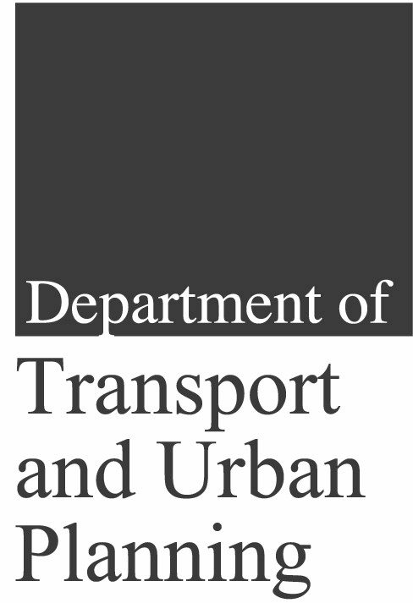

Transport Planning
Agency

Level 9
Roma Mitchell House
136 North Terrace
ADELAIDE SA 5000

Telephone: 8343 2222
Facsimile: 8343 2585
PO Box 1
WALKERVILLE SA 5081

Telephone (08) 8343 2793

27 May 2003

Mr Graeme Innes
Deputy Disability Discrimination Commissioner
Human Rights and Equal Opportunity Commission
GPO Box 5218
SYDNEY NSW 1042

Copy by e-mail to disabdis@humanrights.gov.au

Dear Mr Innes,

Air North Temporary Exemption Under the Disability Discrimination Act 1992 (DDA)

The following comments on the above application have been made also to the National Transport Secretariat, which has been tasked with the provision of advice to the Commission on applications for temporary exemption from the Disability Standards for Accessible Public Transport.

The exemption sought is virtually identical to that granted by HREOC to Kendell Airlines on 22 August 2000. The Kendell exemption was granted for 5 years subject to Kendell reporting to HREOC within 12 months on a range of matters that would maximise the extent to which the airline could provide access to its aircraft for disabled passengers. Kendell did not provide the required report and the exemption lapsed. Regional Express, which purchased Kendell Airlines in August 2002, has not made a corresponding application for the same aircraft.

On the basis that the exemptions sought are similar to the Kendell Airlines exemption and are for similarly sized aircraft (both for 19-seat Metro 23 aircraft, and for 30-seat Brasilias versus Kendell’s 34-seat Saab 340s), it seems reasonable that the Air North application could be approved with conditions similar to those applied to Kendell Airlines in August 2000.

However, the clear intent of the Kendell approval was to give the airline time to improve access to its aircraft through the purchase of narrow boarding-wheelchairs, the installation of moveable seat armrests and the investigation of other means to improve access.

The Air North application, on the other hand, claims that the nature of the aircraft involved makes it technically unachievable or unreasonably expensive to provide access to certain types of disabled passengers without putting its employees at unreasonable risk of injury, for as long as the aircraft remain in service. Rather than propose means to improve access, it puts forward a system of categorising passengers according to their disablement and proposes courses of action to deal with them ranging from refusal of carriage to carriage at reduced fares for the passenger and a passenger-provided assistant.

The proposal to categorise disablement has been supported by the Regional Aviation Association of Australia (RAAA) as a model for the regional aviation industry as a whole. However, the application includes no indication or documentation of discussion with people with disabilities in developing the proposal, which should be a matter of some concern.

The Air North proposal places constraints on people with acute, advanced or unstable medical conditions, which would seem to be an issue separate from the provision of access for disabled people. This aspect of the Air North proposal is therefore not considered further here except to note that the proposed Passenger’s Declaration (waiver) to be signed by passengers requiring medical clearance to travel appears unreasonably open-ended. The third paragraph, “I am prepared, at my own risk, to bear any consequences which carriage by air may have for my state of health and I release the carrier, its employees and agents from any liability for such consequences” as written might serve to absolve Air North from liability to the passenger unrelated to his/her medical condition – a liability that might continue to apply to other passengers – such as injury during turbulence or other in-flight incidents. I suggest that few informed passengers would be prepared to sign it.

However, general constraints on travel by some people with disabilities in the proposed application include:

- Bookings with the airline must be made at least 96 hours (4 days) in advance of travel and a proforma of “Particulars of Passenger with Special Needs” must be lodged 72 hours in advance, which will remove spontaneity for travellers;

- Air North may determine, in some cases, if a companion must accompany traveller (albeit at reduced fare) to provide inflight assistance to the traveller; and

- Air North will determine if a companion is required for communication, comprehension or language difficulties.

It is our view that these requirements will be rejected by HREOC on the ground that they will be offensive to people with disabilities and do not reflect the objectives of the DDA.

The Disability Standards for Accessible Public Transport, formulated under the DDA, prescribe Standards for transport and infrastructure providers to meet in order to comply with the DDA. Although certain of the Standards do not apply to operators of aircraft of less than 30 seats, none of them come into effect for existing aircraft until 31 December 2007. Under this circumstance, our advice from HREOC is that in the event of a complaint against an operator of an aircraft with less than 30 seats, notwithstanding the Disability Standards for Accessible Public Transport, the operator would need to satisfy the Disability Discrimination Commissioner that the provision of access would involve unjustifiable hardship to the operator.

This advice suggests that every operator of aircraft of less than 30 seats should seek specific exemption from the provisions of sections 23 and 24 of the DDA as is Air North’s intention. This does not seem sensible and it is generally understood that the reason certain of the Standards were not applied to these aircraft was in order to remove the need for individual operators of such aircraft to seek exemptions.

Clearly the situation for operators of aircraft with 30 seats or more is different. This distinction is made in the Disability Standards because it is reasonable to provide assisted access to many aircraft of this size. Applications for exemption under the DDA for this category of aircraft would need to be very carefully considered according to the particular characteristics of each aircraft. For instance, Air North claims that the aisle width of the Brasilia precludes use of even specialised boarding wheelchairs while they may be used on the Saab 340. It claims it must load disabled passengers through the rear emergency exit door of the Brasilia, which involves risk to the aircraft from loading equipment because of the proximity of wing flaps, while the front passenger entry door may be used on the Saab 340.

Air North’s application refers to less than 100 passengers “unable to fend for themselves” travelling annually, without providing figures for other categories. Irrespective of the numbers who have travelled in the past, trends indicate that people with disabilities wish to, and are travelling more than ever before on public transport (buses, trains, trams, taxis and airplanes). More than ten years after the introduction of DDA, consumers have higher expectations of service providers and are prepared to challenge insufficient services or inappropriate behaviour and hardship through HREOC.

Having made those points, our views on this particular application can be summarised as follows:

- Air North’s application, as it applies to its Metro 23 aircraft, appears reasonable and should be approved subject to consultation on and modification if necessary of the categorisation of people with disabilities it includes, and its advance booking and documentation requirements. These proposals should not be supported without clear evidence of consultation with the disability sector.

- However, it is not reasonable (although obviously operationally desirable) for an operator to claim justification for an exemption merely in order to standardise practices across a fleet including both categories of aircraft.

- The exemption as it applies to Brasilia aircraft requires further justification prior to approval. For instance:

- It is not clear why Air North uses a forklift to lift disabled passengers to aircraft floor height when relatively inexpensive wheelchair lifts are available (and have been purchased by Kendell/Regional Express). These are hand positioned rather than driven and thus may reduce the risk of flap damage;

- Air North should provide specifications of the aircraft’s aisle width and the width of the narrowest specialised aircraft-boarding wheelchair to demonstrate that wheelchair access to this aircraft is not possible;

- It is not clear why the cabin attendant carried on Brasilia aircraft could not assist any passenger, disabled or otherwise, to apply an oxygen mask or put on a life jacket in the event of an emergency; and

- Requiring a passenger who cannot understand instructions given by the flight crew (even if instructions are available in both visual and audible form) to be accompanied by an assistant suggests that this requirement might apply to any passenger unable to speak or read English (this reservation applies also to Metro 23 aircraft).

It has become clear during the preparation of these comments that regional airline operators in South Australia (and probably elsewhere in Australia) have little idea of their obligations under the DDA.

Companies operating aircraft of less than 30 seats seem to have made the assumption that the Disability Standards for Accessible Public Transport effectively exempt them from their obligations under the DDA.

We are not aware of any companies in South Australia that have developed formal policies in relation to the carriage of people with disabilities or that are in the process of drawing up Action Plans to demonstrate the steps they will be taking to comply with the DDA.

We therefore make the further general recommendations that:

- HREOC formally recognise to industry the difficulties associated with provision of air transport to people with disabilities requiring wheelchair access in aircraft having less than 30 seats;

- HREOC clarify the requirements of the DDA and the Disability Standards for Accessible Public Transport for the carriage of passengers using wheelchairs in aircraft having less than 30 seats;

- HREOC promote the need for all service providers operating with aircraft of less than 30 seats to develop, in conjunction with people with disabilities, practical solutions for addressing difficulties associated with the carriage of people with disabilities in such aircraft; and/or

- HREOC actively promote the need for representatives of Federal, State and industry bodies to facilitate the development of nationally acceptable guidelines governing the carriage of people with disabilities in aircraft of less than 30 seats.

While these comments advocate caution in accepting certain provisions of the Air North application, they should not be taken as criticism of the proactive approach the airline has taken in seeking to ensure that it can comply with the DDA to the maximum extent it considers possible without subjecting its employees to risk of injury. We propose that Transport SA and the Passenger Transport Board will use this case as an opportunity to increase awareness within the SA aviation industry of its obligations under the DDA and the implications of the Transport Standards on service delivery.

If you have any questions about these comments, please direct them to Mike Milln, Senior Adviser-Aviation at telephone (08) 8343 2793 or by e-mail to him at mike.milln@transport.sa.gov.au.

Yours sincerely,

TF Steele
A/EXECUTIVE DIRECTOR

