Employment Inquiry
Disability Rights Unit
Human Rights and Equal Opportunity Commission

Response by the Disability Council of NSW to the Interim Report for the National Inquiry into Employment and Disability

The Disability Council of NSW (DCNSW) made a submission to this inquiry earlier in the year and is pleased to note that many of the concerns and issues raised in our submission were reflected in the interim report. Furthermore DCNSW supports the recommendations that the Human Rights and Equal Opportunity Commission (HREOC) has made in the interim report as practical steps towards improving the employment and retention of employees with disability.

The Disability Council also welcomed the opportunity to participate in a number of the working groups HREOC drew together to consider innovative models that would facilitate the employment of people with disability. DCNSW would be interested in supporting or participating in any further such initiatives pursued by HREOC, or key agencies such as the Department of Employment and Workplace Relations.

If the Disability Council could at any time provide any further information or assistance on this matter then please contact Dougie Herd, Director at the Office of the Disability Council on d.herd.disabilitycouncil@dadhc.nsw.gov.au or (02) 9211 2866.

Yours sincerely

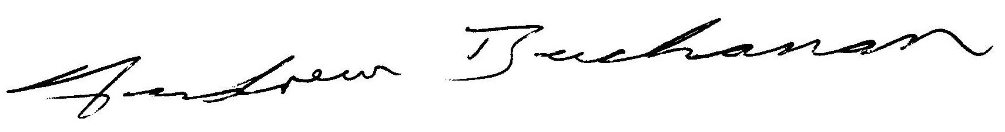

Andrew Buchanan
Chair
Disability Council of NSW

29 September 2005

