African Australians: A report on human rights and social inclusion issues
Discussion paper
…………………………
Australian Human Rights Commission
March 2009

© Human Rights and Equal Opportunity Commission March 2009.

This work is protected by copyright. Apart from any use permitted under the Copyright Act 1968 (Cth), no part may be used or reproduced by
any process without prior written permission from the Human Rights and Equal Opportunity Commission. Enquiries should be addressed to Public Affairs at: paffairs@humanrights.gov.au.

ISBN 978-1-921449-11-6

Acknowledgements

Discussion paper prepared by Claire Moroney.
The Australian Human Rights Commission thanks all members of the project Steering Committee and Community Reference Group who
contributed their knowledge and expertise towards this Discussion paper.

This publication can be found in electronic format on the Australian Human Rights Commission’s website at:
www.humanrights.gov.au/africanaus

For further information about the Australian Human Rights Commission, please visit: www.humanrights.gov.au or email: paffairs@humanrights.gov.au.

You can also write to:

Public Affairs
Australian Human Rights Commission
GPO Box 5218
Sydney NSW 2001

Design and layout
Jo Clark

Printing
Bloxham and Chambers

Cover photography
Blend Images

Foreword
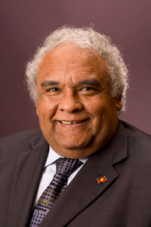

The Australia of 2009 is a proud multicultural nation. It is a nation, culturally, socially and economically formed by the unique combination of its First Nation peoples, its early settlers, and by the many waves of subsequent migration. As such, negotiating diversity and respecting people of all faiths, races, cultures and identities has evolved into an important characteristic of being a member of Australian society.
Over the past couple of decades Australia’s breadth of cultural diversity has widened with new and emerging communities, comprised of people who bring additional skills, culture and talent, as did the migrants of yester-year. Such contributions enhance the social fabric of our nation as well as increase economic development. Many of these new and emerging communities in Australia have come from Africa.
It is a common misconception that people from African backgrounds are one and the same. While the strong African spirit and pride certainly unifies, people from African backgrounds represent tremendous diversity in ethnicity, race, language, culture and religion. After all, the African continent comprises more than 50 countries.
The impression of homogeneity is only one of many misconceptions about African Australians. Even though Australians pride themselves in giving everyone ‘a fair go’, it would appear that many African Australians have not been fully given this chance. Settling into a new country is seldom easy and there are many challenges in building a new life. Recent public debate has voiced a number of myths and stereotypes about African Australians reinforcing the discrimination that many may continue to experience.
However, it is facts, not myths, which tell the truth. And it is listening to people tell their stories that enables the wider community to begin to actually understand and relate to an experience and to humanise and personalise those who appear to be ‘different’.
Many, but not all, African Australians underwent a refugee experience prior to their arrival in Australia. A refugee experience often involves a denial of some or all human rights. Newly-arrived refugees need our compassion, but compassion alone is not enough. Those who have survived the refugee experience are resilient. Australia needs to recognise that African Australians have much to offer and contribute. But is this happening?
This project is a first. It is time, at the national level, to find out about human rights and social inclusion issues for African Australians. For both new arrivals and those who have been here for a longer period. It is also time to suggest solutions to the issues raised, share best practice, and discover pathways to help African Australians meet their personal potential and in so doing, both improve their quality of life and add enormous human resources that will help contribute to our whole nation.
The Australian Human Rights Commission and partner agencies want to hear from African Australians. It is also important to hear from others who work with, provide services to, or undertake research about issues for African Australians. It is for these reasons that I launch this discussion paper.

Tom Calma
Race Discrimination Commissioner
and Aboriginal and Torres Strait Islander Social Justice Commissioner
March 2009
Contents
Introduction 6
Background 6
Aim of the project 7
Focus of the project 7
Parameters of the project 7
Framework for the project 8
Content for consideration 10
Overarching consideration 10
1. Employment and training 11
2. Education 13
3. Health 15
4. Housing 18
5. Justice 20
Anything else? 23
Project methodology 24
Project partners and governance 26
Consultants 26
Background papers 27
Translation 27
Outcomes of the project 28
Final report 28
Formal review 28
Appendix 1 – Arrivals to Australia 29
As refugees – via off-shore resettlement 29
Under the Special Humanitarian Program (SHP) – via off-shore resettlement 29
As asylum seekers – via onshore protection 30
As voluntary migrants 30
Australia’s international obligations to refugees 31
Appendix 2 – Some information about human rights 32
The right to work 32
The right to education 33
The right to health 33
The right to housing 34
The right to justice 34
Submissions 35
How to make a submission 35
Confidentiality 35
Find out more 36

Introduction
This Discussion paper will:
- provide background to the project African Australians: A report on human rights and social inclusion issues
- explain the aim and focus of the project
- provide a ‘Content for consideration’ section which expands upon the areas of focus for the project by specifying themes and listing questions as a guide for participants
- explain the project methodology and provide information on the project partners, governance and consultants
- outline the project outcomes
- provide additional information in two appendices
- provide information on how to make a submission to the project.

Background
In 2006, all Australian governments, through the Ministerial Council on Immigration and Multicultural Affairs (MCIMA), endorsed the National Action Plan to Build on Social Cohesion, Harmony and Security (NAP)
The Australian Human Rights Commission is Australia’s independent statutory human rights agency that reports to federal Parliament though the Attorney-General. As part of the NAP, the Commission has been funded to undertake a range of projects.
To deliver these projects, the Commission established the Community Partnerships for Human Rights (CPHR) program. The overall goal of the CPHR program is to increase social inclusion and counteract discriminatory views and intolerance of Muslim Australian communities.
African Australians: A report on human rights and social inclusion issues is one of the CPHR partnership projects. This project acknowledges that people from African backgrounds coming to Australia are highly diverse. Refer to Appendix 1 (page 29) for information about the ways in which people arrive in Australia and Australia’s obligations to refugees.
In this paper, the term African Australians is used on the understanding that it encompasses the great diversity of people from African backgrounds.

Aim of the project
The aim of the project, African Australians: A report on human rights and social inclusion issues is two-fold:
- to explore the issues relating to the settlement of African Australians into the Australian community from a human rights perspective,
- to suggest solutions to issues raised and make recommendations to stakeholders to inform future policy, program and service design as well as public debate and education.

Focus of the project
The last 10 years has seen several conferences and reports directed at issues for African communities in Australia, most with a localised or state/territory perspective. The Commission felt it timely to build on this valuable foundation, but also elevate issues to the national level.
There has been no national report that looks at the issues facing African Australians from a human rights perspective. This project will seek to address this identified research ‘gap’.
There have been debates in the media about the numbers, ‘integration potential’ and settlement needs of African Australians. Unfortunately, the media usually focuses on crime or on political commentary about African Australians – and has often been negative or critical, and sometimes misleading. This has contributed to general community confusion or concern about African Australians, and has caused distress to many.
This project will work to ensure that a more accurate documentation of the experiences of African Australians is developed, as well as illustrating the multi-dimensional nature of these experiences and related issues. As stated in the project aim, the project will also put forward suggestions and make recommendations.

Parameters of the project
This project will investigate the support available to African communities and the issues impacting upon their inclusion, with particular reference to:
- Employment and training
- Education
- Health
- Housing
- Justice

Refer to Appendix 2 (page 32) for information about these human rights.

Framework for the project
The issues relating to the areas of employment and training, education, health, housing and justice will be analysed through a legal and moral human rights framework also informed by social inclusion policy principles.
The framework allows the Commission to examine the extent to which individuals are able to exercise their human rights and identifies any barriers to individuals enjoying these rights.
For example, this project will explore the extent to which African Australians are able to exercise their right to employment without discrimination. The submission and consultation process will allow for individuals and organisations to identify issues, opportunities and barriers in relation to African Australians and employment.
The parameters and framework of the project is illustrated in the diagram below. The diagram indicates the many areas of intersection between all five areas, as experienced by African communities in Australia. The diagram also shows a sixth area – emerging issues – as the project is likely to uncover a range of emerging issues that are important to consider.

Project parameters framework
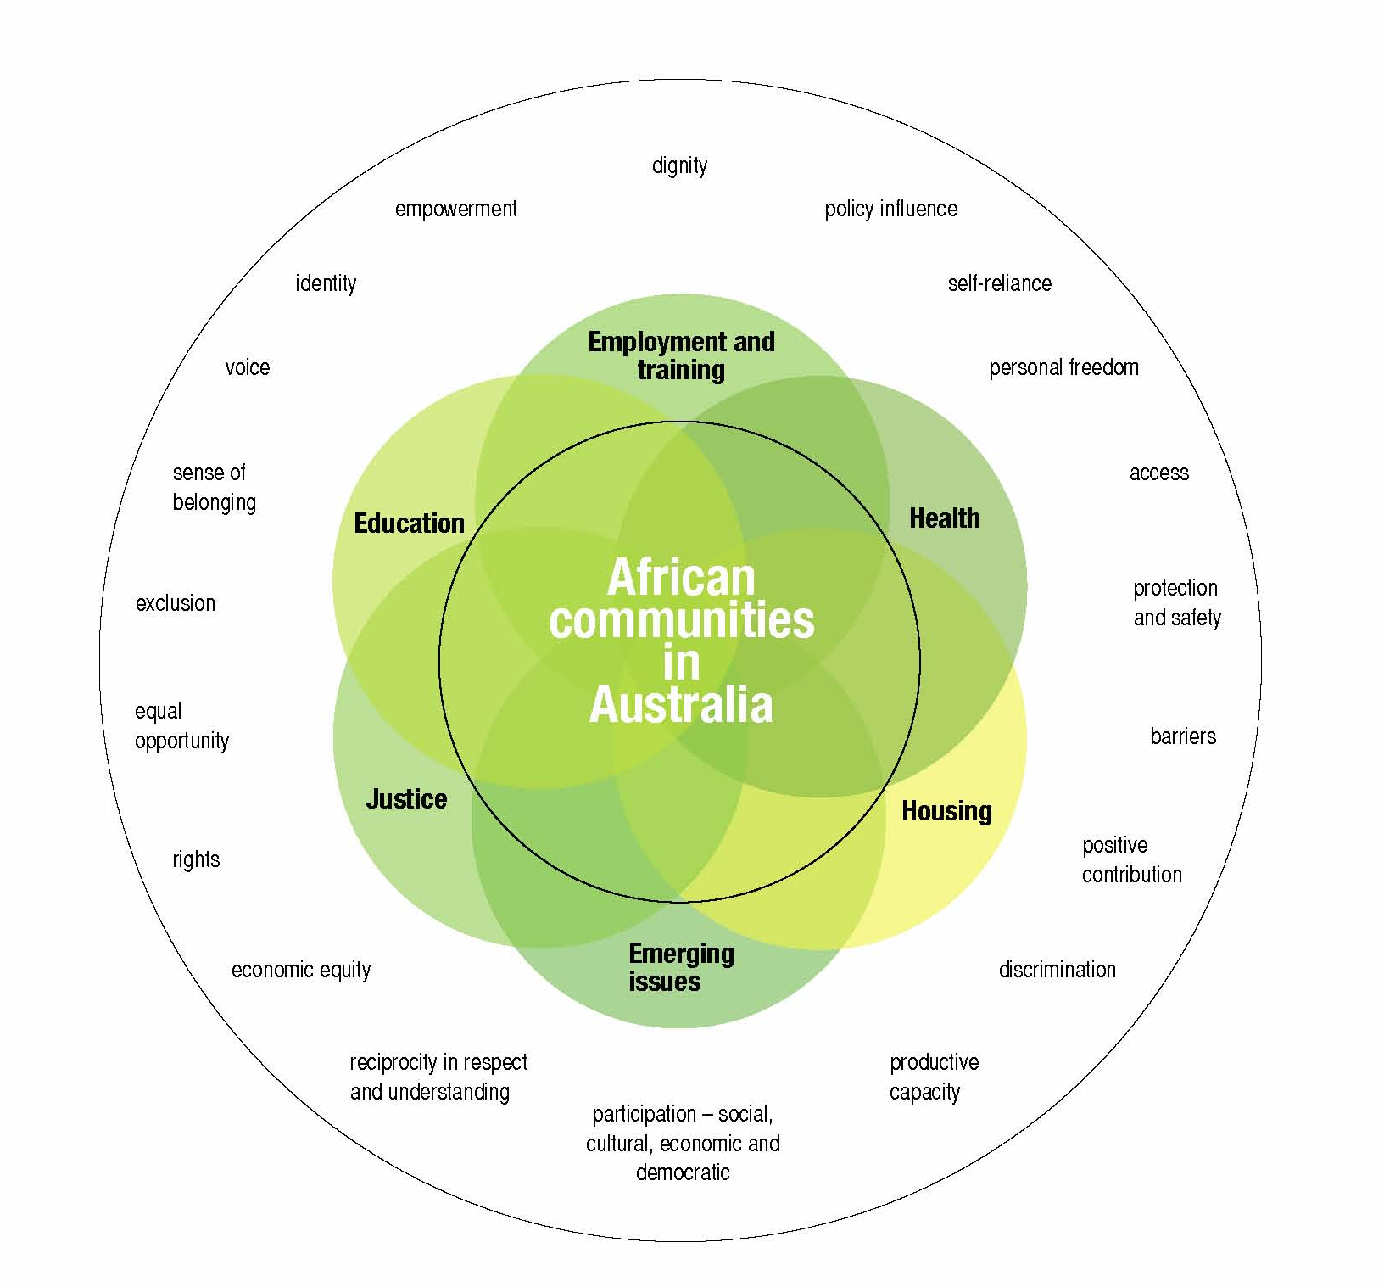

The project will have a special focus on issues faced by groups that may experience greater vulnerabilities:
- young people
- African Muslim communities
- African Muslim women.
We will also explore the impacts of gender throughout the project.

Content for consideration
We would like to hear from anyone that is interested in human rights and social inclusion issues for African Australians, especially:
  - members of African Australian communities
  - friends of African Australians
  - all levels of government
  - the non-government sector (NGOs)
  - community organisations
  - service providers (specialised and mainstream)
  - academia.
The following sections (pages 11 – 23) outline the five areas that the report is exploring. The questions in each area have been grouped under separate themes.
- you do not have to answer every question
- while the research questions help to provide context to each area, they are a guide only and you should not feel limited by these
- rather than answer the questions, you may instead prefer to comment on the themes
- if you would prefer to share your experiences through storytelling, please do so. The Commission welcomes storytelling as an effective and powerful way to communicate messages
- you may provide us with research in order to answer a question or respond to a theme.
Note: Is it accepted that some of the following questions may be applicable to other groups in Australian society, but for the purposes of this project we request that your answers have a primary focus on African Australians.

Overarching consideration
We ask that you reflect on the following question before you consider each of the five areas in detail:
- How can governments go beyond consultation and support the genuine participation of African Australians in decision-making about program and service design and implementation across all areas?

1. Employment and training
Employment and training are critical to successful settlement. African Australians want to build their new life and contribute to Australian society but many, especially newer arrivals, have to confront numerous barriers when accessing employment and training.
Common barriers faced by African Australians are visible difference, access issues related to English language skills, and local experience in the employment arena. These and many more barriers are often linked to discrimination and barriers maintained by professional bodies.
Through the themes and questions in this section we hope to gain a better understanding of the existing support available to African Australians, the issues impacting upon their social inclusion with reference to employment and training, and suggestions for improvement.
If you do not want to answer the questions…
Can you tell us about your employment and training experiences in Australia?

If you want to answer questions…
Only answer those questions that are relevant to you.
Access to training
- What barriers do African Australians face in accessing training opportunities?
- What specific training opportunities would be most helpful to newly-arrived African Australians?
- How can interpreting and translation services be improved to provide better access and assistance to African Australians in the training and employment sectors?
Employment and training needs
- Can you give examples of genuine training and employment pathways available to African Australians?
- Please comment on what is meant by ‘securing meaningful employment’ from your personal and/ or professional perspective?
- What career advice is helpful for newly-arrived African Australians?
Employment services
- What barriers do African Australians encounter in using services of employment agencies (including the Job Network)?
- Do employment agencies provide culturally appropriate services to African Australians? If yes, then how?
Government, employment and training policies
- Have you as an African Australian (or anyone else you know) had your/ their overseas qualifications recognised in another developed country similar to Australia?
- Does government employment and training policy and program design meet the needs of African Australians? Please give reasons in your answer.
Employment opportunities
- What are the key challenges faced by African Australians in finding and retaining employment (e.g. recognition of qualifications, English language requirements etc.)?
- What can be done to increase employment opportunities for African Australians?
- What are the health, social and cultural impacts of unemployment and underemployment for African Australians?
- As an African Australian, if you have not had difficulty in securing employment in Australia, please tell us about it and some of the reasons that contributed to your success?
Discrimination in employment and training
- Can you provide examples of how African Australians are treated differently when seeking employment and/ or training?
- What is the impact of this discrimination?
- How can African Australian workers be made aware of and supported to exercise their rights in relation to discrimination in the workplace?
The effect of religion, age, gender, sexuality and disability
- Are experiences of employment and training different for African Australians based on religion, age, gender, sexuality or disability? Please provide reasons in your answer.

2. Education
It is not uncommon for African refugees to have had limited use of technologies and disrupted schooling because of war and displacement, as well as limited education opportunities prior to the cause of their displacement. But in no way does this diminish the value of education to people from African backgrounds.
Adjusting to the formal education system and learning environment in Australia can create challenges for some African Australian students. At the same time, the system is challenged to meet the socialisation and educational needs of African Australian students. Considering the amount of time a student spends in school and at study, the education setting is an important place to explore the experiences of African Australians.
Through the themes and questions in this section we hope to gain a better understanding of the existing support available to African Australians, the issues impacting upon their social inclusion with reference to education, and suggestions for improvement.
If you do not want to answer the questions…
Can you tell us about your education experiences in Australia?

If you want to answer questions…
Only answer those questions that are relevant to you.
Access to education
- How do African Australians find out about education services available to them?
- What barriers do African Australians face in accessing education opportunities?
- What specific education opportunities would be most helpful to newly-arrived African Australians?
- How can interpreting and translation services be improved to provide better access and assistance to African Australians in the education sector?
Education experiences
- What are the experiences of young African Australians in educational institutions (e.g. schools, universities, TAFE, colleges) in Australia?
- As a parent do you think that schools (public and private) have been helpful and supportive to your children and offered a good education and opportunities to learn?
- As a parent are you actively involved in the school that your children attend and if yes, how did this happen and what is your involvement?
- How can young African Australians manage any conflict that may arise between their family responsibilities and education?
- Are there any issues you are aware of for overseas students (fee-paying or subsidised) from African countries?
Educational needs for African Australian students
- Can you suggest any programs and services that can provide additional support to African Australian students during their education?
- How can Australian education institutions (e.g. schools, universities, TAFE, colleges) meet and support the specific cultural needs of African Australian students, especially those who arrive as refugees or asylum seekers?
- What training and support should be put in place to assist educators to better understand complex refugee situations?
Discrimination in education
- Can you provide examples of how African Australians are treated differently in the education sector?
- What is the impact of this discrimination?
The effect of religion, age, gender, sexuality and disability
- Are the education experiences of African Australians different based on religion, age, gender, sexuality or disability? Please provide reasons in your answer.
Government and education policies
- Do government education policies and program design meet the needs of African Australians? Please give reasons in your answer.

3. Health
Many African refugees who arrive in Australia have survived devastating experiences that many other Australians will never have to endure in their lifetime. For example, the journey to Australia may have taken many years and for any individual is likely to have involved some or all of the following: time in refugee camps in other countries, illness, malnutrition or starvation, separation from and/or loss of family, witnessing and/or experiencing torture, trauma, violence and sexual violence.
Such circumstances can have significant impacts upon a person’s health. However at the same time, people from African backgrounds demonstrate a strong, determined spirit and resilience that has helped them to survive.
In this paper, the term health refers to the World Health Organisation definition: health is a state of complete physical, mental and social well-being and not merely the absence of disease or infirmity.
Resettling in a country such as Australia, which is very different to their home country, poses many new challenges for people from African backgrounds. While they will be helped and supported in a range of ways, they will also often encounter obstacles as they build their new life.
The themes and questions in this section aim to explore the support currently available to African Australians, the issues impacting upon their social inclusion with reference to health, and suggestions for improvement.
If you do not want to answer the questions…
Can you tell us about your experiences with Australian health systems and services in regard to your health and well-being?

If you want to answer questions…
Only answer those questions that are relevant to you.
Health issues for African Australians
- What are the main areas of concern for African Australians in regard to health, well-being and health care:
3.1.1 in their first year after arrival in Australia,
3.1.2 in the longer term (from the second year of settlement onwards)?
- Does the Australian health care system adequately meet the needs of African Australians, especially newly-arrived refugees? Please provide some examples.
- As an African Australian, do you generally find Australian health services good quality and are staff professional and polite?
- Please comment on any gender-specific or youth-specific health issues for African Australians.
- What are the issues for African Australians with disabilities in relation to the Australian health care system?
Mental health and well-being
- If you used a torture, trauma and rehabilitation service, did it help to meet your needs? Do you have any suggestions for improvement to the service?
- How do the effects of family separation impact upon the mental health and well-being of African Australian families?
- How do you feel your mental health and well-being has changed since coming to Australia?
- How can the stigma attached to mental health be addressed in African Australian communities?
- Can you provide best practice examples of how to treat sustained mental health issues for African Australians?
Access to health services
- What are examples of successful ways to explain the Australian health care system to newly-arrived Africans?
- Even though African Australians may know how to access certain health services, they do not always utilise all the services that they are offered and entitled to. What can be done to change this?
- How can interpreting and translation services be improved to provide better access and assistance to African Australians in the health sector?
Culture and health
- What are some important issues/ facts about being from African backgrounds that would be helpful for Australian health service providers to know?
- What training and support should be put in place to assist health professionals to provide culturally-appropriate services to African Australians?
- What can governments, NGOs, communities and health services change to improve the interaction between an African Australian and the health care system?
- Cross-cultural competence in the health care system is essential to ensure that all patients are treated with dignity and provided with appropriate care. Do you know of any best practice examples in the health sector for African Australians?
Discrimination and health
- Can you provide examples of how African Australians are treated differently in the health sector?
- What is the impact of this discrimination?
The effect of religion, age, gender, sexuality and disability
- Are the experiences of African Australians, in regard to health, different based on religion, age, gender, sexuality or disability? Please provide reasons in your answer.
Government and health
- What actions can governments take (or what targets can government set) to ensure African Australians:
- are healthy
- can better overcome any physical or mental health issues from their refugee or migration experience, and
- can thrive upon arrival in Australia?

4. Housing
It is widely acknowledged that people of African backgrounds encounter significant difficulties accessing adequate and appropriate housing in Australia. These difficulties need to be understood so that strategies can be developed to assist African Australian families meet their accommodation needs. It is also necessary to explore structural and systemic practices that prevent African Australians accessing suitable accommodation.
In this section, the themes and questions seek to research the housing support that is available to African Australians, the issues impacting upon their social inclusion with reference to housing, and ideas for improvement.
If you do not want to answer the questions…
Can you tell us about your housing experiences in Australia?

If you want to answer questions…
Only answer those questions that are relevant to you.
Housing needs
- What is the experience of African Australians, especially new arrivals, in regard to housing assistance and support?
- What are the most significant concerns for African Australians in relation to housing?
- How common is homelessness (including ‘couch-surfing’, rough sleeping and short-term hostel accommodation) amongst African Australians?
- Searching for housing can put significant stress on families. What support is required to minimise the stress on African families?
Access to housing
- What barriers do African Australians face in accessing appropriate and affordable long-term housing?
- In the private rental market, real estate agents and landlords require evidence of prior rental history in Australia. This poses a major block to newly-arrived African families as they cannot compete with ‘more desirable’ applicants who have such rental history. In what ways can real estate agents and landlords be more inclusive of newly-arrived African families?
- What type of education/ training could assist real estate agents, landlords and public housing officers to better service African Australians, in particular, new arrivals?
- If you have been involved in a housing appeals process, please tell us about your experiences?
Housing rights and discrimination
- Can you provide examples of discrimination experienced by African Australians in the private rental market and/ or in the public housing sector?
- What is the impact of this discrimination?
- Many African Australians are not aware of their rights and responsibilities as tenants. What other important housing-related information do African Australians need to know, and how can this information be provided?
The effect of religion, age, gender, sexuality and disability
- Are the housing experiences of African Australians different based on religion, age, gender, sexuality or disability? Please provide reasons in your answer.
Housing sector support
- How can governments and NGOs better regulate real estate agents and landlords who service African Australians?
- A person’s housing situation (including the search for housing) can compromise other important needs such as health care, education and employment. How can services be better coordinated to ensure that all vital needs of African Australians are met?

5. Justice
The justice system of every country has its own peculiarities. It can be challenging for a person born in the country to understand the intricacies of the system, let alone a newcomer.
When people from African backgrounds come to Australia they need to learn about the new justice system, but information is not always readily available or accessible. This is often complicated by negative experiences and interaction that people of African backgrounds have had with authority prior to resettlement, which have led to fear and mistrust of authority.
The themes and questions in this section will analyse the current support available to African Australians, the issues impacting upon their social inclusion with reference to justice, and suggestions for improvement.
.
If you do not want to answer the questions…
Can you tell us about your experiences with the Australian justice and legal systems?

If you want to answer questions…
Only answer those questions that are relevant to you.
Legal and justice needs of African Australians
- Do you have any comments/ observations/ stories on the experience of African Australians (including African youth) with the legal and justice systems?
- What concerns do African Australians have about the Australian legal and justice systems?
Rights, justice and the law
- As an African Australian, do you feel protected by the Australian legal and justice systems?
- What services exist to explain to African Australians what their rights are when they are involved in the legal and justice systems?
- Can you provide examples of any incidences where the rights of African Australians were denied in the justice and law enforcement setting?
- What factors can contribute to negative interactions between African Australians and law enforcement?

Access to the legal and justice systems
- What barriers do African Australians face in accessing the legal and justice systems?
- What information about the legal and justice systems should be provided to African Australians to empower them? And when is the best time to provide such information (e.g. when a person is in the legal system, or at different time)?
- Following on from question 5.8 above – how, or through what mechanism/s, can information about the legal and justice systems be best provided to African Australians?
- What can be done to decrease the level of non-reporting of crime by African Australians?
Combating family violence
- What are effective strategies that can be used by governments, NGOs or service providers to combat family violence issues for African Australians?
- How can governments, NGOs and service providers better coordinate family violence services for African Australians?
Discrimination in the legal and justice systems
- Can you provide examples of how African Australians, particularly young people, are treated differently by the legal and justice systems?
- What is the impact of this discrimination?
The effect of religion, age, gender, sexuality and disability
- Are experiences of justice different for African Australians based on religion, age, gender, sexuality or disability? Please provide reasons in your answer.
Cross-cultural training
- Do workers in the justice system and law enforcement receive adequate cross-cultural awareness training? If not, what type of cross-cultural training is required?
Improved community relations
- In recent times some media outlets have portrayed African Australian youth as ‘unruly gangs’ who get in trouble with police. How can the media be encouraged to provide more balanced reporting of issues for African Australians, especially African Australian youth?
- How can governments, service providers and communities work to break down the fear and mistrust of authority that is felt by many African Australians?
- How are long-term, trusting and positive relationships created between African Australians and the justice system and law enforcement?
- Do you know of successful models of African community and law enforcement relationships?

Anything else?
You may have other issues or concerns for African Australians that you believe are important to tell us. You may have more to tell us about employment and training, education, health, housing and justice, or you may have other thoughts to discuss, for example:
- cultural maintenance, cultural heritage and values
- immigration experience
- negotiating gender relations
- intergenerational issues
- faith-related issues
- relationships between African and other minority groups
- community relationships and tensions
- media
- transport
- sport and its role in contributing to social inclusion
We will do our best to consider any other issues and concerns that you share with us.

If you want further information about discrimination or want to find out more about your rights under discrimination law, the Australian Human Rights Commission can help:
- go to www.humanrights.gov.au/complaints_information/index.html
- call the Complaints Information Line on 1300 656 419

Project methodology
The project will comprise a number of components:
- background papers – see page 27
- Discussion paper
- national consultations - interviews, focus groups, meetings with representative groups
- public call for submissions – seeking submissions (responses) from the public
- analysis of information gathered from the national consultations, call for submissions and research
- final report – see page 28
- plain language guide – this will be like an executive summary of the report
- formal review – see page 28
- evaluation – as part of the CPHR program evaluation.

See below for a representation of the project components:

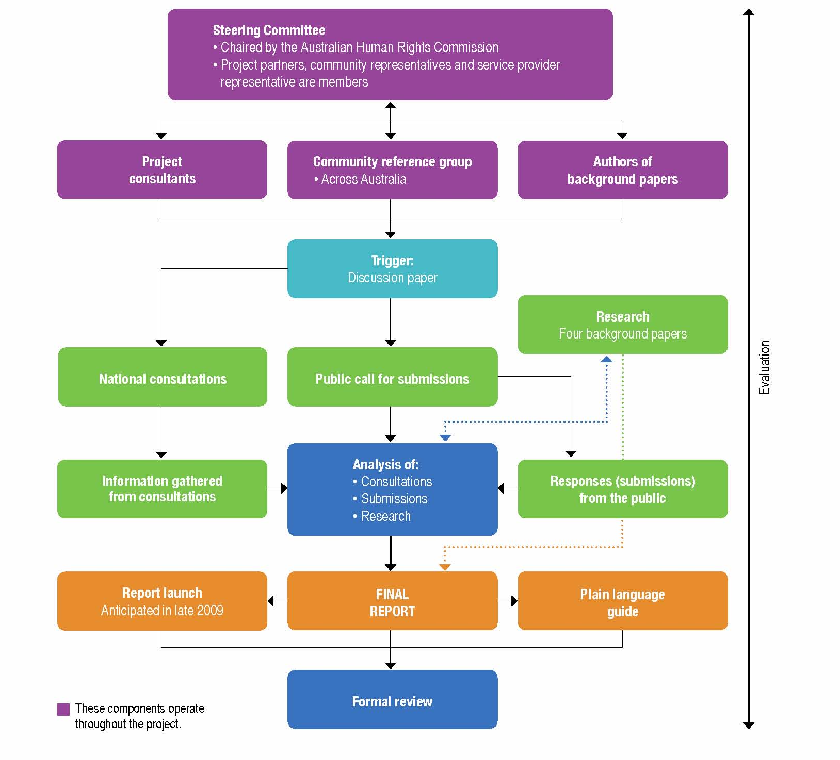

Project partners and governance
The project is being undertaken as a partnership between:
- Australian Human Rights Commission
- Adult Multicultural Education Services (AMES) in Victoria
- Australian Red Cross
- Diversity Health Institute
- Australian Government Department of Families, Housing, Community Services and Indigenous Affairs (FaHCSIA)
The project is governed by a Steering Committee that is chaired by the Commission. All funding partner organisations are represented and the Committee also has two community representatives: Samia Baho, Executive Director of the Centre for African - Australian Women’s Issues and Abeselom Nega, Immediate Past Chair of the Federation of African Communities Council; and a service provider representative Eugenia Tsoulis, Executive Director of the Migrant Resource Centre of South Australia.
The purpose of the Steering Committee is to provide overall governance and accountability to and for funding partners of the project, as well as provide expert advice. The committee will also help ensure quality control and direction to the planning, conduct and completion of the project.
In addition, the project also has input from a national Community Reference Group (CRG). The purpose of the CRG is to provide strong content knowledge, links and representation to African communities and service provider agencies. The group will be used as a forum to debate issues, the scope and approaches of the report, and solutions to problems.

Consultants
Myriad Consultants have been commissioned to work with the Steering Committee and CRG to undertake this project. Myriad Consultants will organise and facilitate the national consultation process, undertake research and analysis, and prepare the final report.
Myriad Consultants have extensive experience working in collaborative partnerships with government, public sector, private sector, NGOs and voluntary organisations. They have a proven track record in undertaking social research, including consultation with diverse communities, particularly with new and emerging communities.

Background papers
Four background papers will be written as part of the project to set the scene and provide context to the issues, findings and recommendations of the final report:
- Demographic analysis – by Prof. Graeme Hugo, University of Adelaide.
- Australia’s migration policies – by Prof. Andrew Jakubowicz, University of Technology, Sydney.
- International and national human rights issues relating to refugees and immigrants – by Prof. Simon Rice, Australian National University.
- Literature review – by Ann Wayne Reiner, post-graduate intern with the Australian Human Rights Commission.

Translation
African communities are diverse and speak many languages. This project will use an inclusive approach to ensure that all people who want to participate are able to. However it is not possible for the project to work with all languages, so the Steering Committee has recommended the following 10:
- Amahric | - Nuer
- Arabic | - Oromo
- Dinka | - Somali
- Kirundi | - Swahili
- Krio | - Tigrinya
Refer to www.humanrights.gov.au/africanaus for translated summaries of this Discussion paper. If your first language is one of those mentioned above, you can make submissions in your first language rather than write in English. Translation and/ or interpreting of the 10 languages above will be incorporated, where appropriate, in national consultations.

Outcomes of the project

Final report
It is anticipated that a final report will be produced and released in late 2009. The final report will include the main report prepared by the consultants, as well as the four background papers. A plain language guide will also be developed, as an overview of the final report. It is hoped that the plain language guide can be translated into the 10 languages above.
The final report will provide factual information around the key issues as per the project focus areas. The report aims to inform public debate, public policy and the potential design of settlement, and related programs by agencies at all levels of government, NGOs, community organisations and academia.

Formal review
It is hoped that this report will be a catalyst to activate the improvement of those policy, program and service areas identified as disabling the capacity of African Australians to be engaged with and participating in all aspects of Australian life.
To this end, the Commission has committed to a timeframe for review.
In order to take stock of the progress that has been made since the release of the report, the Commission will determine which recommendations from the report have been taken up and which have not. In preparing its review, the Commission will work with and seek input from African Australian communities.
It is hoped that within 12 months after the release of the report, the Commission can report back to the Australian Government and submit its review.

Appendix 1 – Arrivals to Australia
People from African backgrounds coming to Australia arrive in different ways. This section provides general explanation about how people, including those from African backgrounds, arrive in Australia. It also outlines Australia’s obligations to refugees.

As refugees – via off-shore resettlement
Some refugees arrive in Australia through a process of forced migration. Forced migration does not allow someone to choose the destination which will become their new home.
According to the Convention and Protocol Relating to the Status of Refugees, a refugee is a person, who:
owing to a well-founded fear of being persecuted for reasons of race, religion, nationality, membership of a particular social group, or political opinion, is outside the country of his nationality, and is unable to or, owing to such fear, is unwilling to avail himself of the protection of that country…
However it is also important to acknowledge the wider use of the term ‘refugee’ for the purposes of this Discussion paper:
In popular use, the term refugee is often interpreted more broadly than its legal definition, to include all people who flee their homes seeking refuge from harm. There are many circumstances which could force someone to flee to safety, including war or civil strife, domestic violence, poverty and natural or man-made disasters. However, the Refugee Convention only recognises people as refugees if they are displaced from their home country because of persecution (or a well founded fear of persecution) on the basis of their race, religion, nationality and their membership of a particular social group or political opinion.

Under the Special Humanitarian Program (SHP) – via off-shore resettlement
Other refugees arrive in Australia under the SHP. This program is for people outside their home country who are subject to substantial discrimination amounting to gross violation of their human rights in their home country, including conflict-induced displacement. SPH applications for entry into Australia must be supported by a proposer who is an Australian citizen, permanent resident or eligible New Zealand citizen, or an organisation that is based in Australia.

As asylum seekers – via onshore protection
An asylum seeker is someone who has fled their own country and applies to the government of another country for protection as a refugee. As a signatory to the Refugee Convention, Australia must comply with its obligations and ensure that all those who make claims for protection while in Australia have their claims assessed in accordance with the Refugee Convention. A person is a refugee the moment he/she fulfils the criteria of this Convention.
People can seek to be recognised as refugees once they are already in Australia by applying for a ‘Protection Visa’ (PV). While applying for a longer-term visa such as a PV, some asylum seekers may be granted a temporary bridging visa. The bridging visa enables people to reside legally in the community while they are applying for a permanent visa, appealing a decision related to their application, or waiting to depart Australia.
However, bridging visas often come with conditions and restrictions in relation to work rights and health care entitlements. Some bridging visa holders also have no access to social security benefits. The conditions and restrictions placed on bridging visa holders can impact significantly on their ability to exercise basic human rights.
The government provides assistance for some asylum seekers when their applications for protection are processed, including financial assistance to eligible PV applicants who are unable to meet their basic needs for food, accommodation and health care while their application is being processed.

As voluntary migrants
Migrants choose to leave their home country and resettle in another country of their choice. Australia offers several migration streams/visas under which people can enter the country. Refer to the Australian Department of Immigration and Citizenship’s website for details: www.immi.gov.au/migrants/
It is important to explain how refugees and migrants differ:
Refugees are not in the same situation as migrants, although the definitions of the two groups are often confused. Migrants choose when to leave their country, where they go and when they return. Refugees flee their country for their own safety and cannot return unless the situation that forced them to leave improves. Migrants, however, may still be a vulnerable group who face many challenges while travelling to, and settling in, a new country. Refugees and migrants are fundamentally different and are treated differently under international law.

Australia’s international obligations to refugees
Australia acceded to the United Nations 1951 Convention Relating to the Status of Refugees (the 'Refugee Convention') on 22 January 1954 and acceded to the 1967 Protocol on 13 December 1973. This means that under international law, Australia has clear obligations and responsibilities relating to the rights and protection of refugees.
The United Nations High Commissioner for Refugees (UNHCR) leads and co-ordinates international action to protect refugees worldwide. Its primary purpose is to safeguard the rights and well-being of refugees.
One of the key principles set out under the Refugee Convention is that refugees should not be returned to places where their lives or their freedom would be threatened. The UNHCR identify their preferred durable solutions for refugees as:
- the voluntary return to their country of origin in conditions of safety and dignity
- the local integration into a country of asylum if a safe return to the country of origin is not possible
- resettlement into a third country if neither of the first two options are suitable or possible.
The majority of refugees in Australia have been and are resettled from other countries through Australia's off-shore humanitarian resettlement program.
The UNHCR outlines the rationale for its durable solutions framework, including the following points, which are significant to this project:
…refugees bring human and material assets and resources. They are people with tremendous courage, determination and potential to thrive - a potential demonstrated time and again by them. Refugee women in particular have shown resilience and survival skills. When given the opportunity refugees become progressively less reliant on State aid or humanitarian assistance, attaining a growing degree of self-reliance and becoming able to pursue sustainable livelihoods, equally contributing to the economic development of the host country.
Confining refugees however, to humanitarian assistance for years on end, often deprived of the right to freedom of movement and without access to education, skills training and income-generating opportunities prevents them from developing their human potential and limits their ability to systematically make a positive contribution to the economy and society of the asylum country.

Appendix 2 – Some information about human rights
Everyone in the world has human rights. Australia has agreed to uphold the human rights standards set out in a number of international treaties and declarations, including:
- the International Covenant on Economic, Social and Cultural Rights (ICESCR) at www.unhchr.ch/html/menu3/b/a_cescr.htm
- the International Covenant on Civil and Political Rights (ICCPR) at www.unhchr.ch/html/menu3/b/a_ccpr.htm
These conventions give binding effect to the rights recognised in the Universal Declaration of Human Rights (UDHR) at
www.unhchr.ch/udhr/lang/eng.htm
www.un.org/Overview/rights.html
This means that all members of the Australian community have rights, including those relevant to this project: the right to work, to education, to health, to housing, and to a range of civil and political rights. This section provides a summary about each and tells you where you can find out more information.

The right to work
Every person has the right to decent work. The right to work includes:
- the right of everyone to the opportunity to gain their living by freely chosen or accepted work
- technical and vocational guidance and training
- policies to achieve steady economic, social and cultural development, and full and productive employment
- the right to just and favourable working conditions
- fair wages with equal pay for equal work
- earning a decent living for themselves and their family
- safe and healthy working conditions
- equal employment opportunity
- adequate rest and leisure
- limited working hours and regular paid holidays
- the right to form and join trade unions
- the right to strike.
To find out more about the right to education refer to Articles 6, 7 and 8 of the ICESCR and Articles 23, 24 of the UDHR.

The right to education
The right to education includes:
- the provision of free, universal and compulsory primary education
- generally available and accessible secondary education (including technical and vocational training)
- equally accessible higher education
- the availability of all forms of education without discrimination
- development of a school system, an adequate fellowship system and continuous improvement of the material conditions of teaching staff
- the right to educational freedom for all (including parents)
- academic freedom of students and staff.
To find out more about the right to education refer to Articles 13 and 14 of the ICESCR, including the general comment on implementation of each, and Article 26 of the UDHR.

The right to health
Every person has the right to enjoy the highest attainable standard of physical and mental health. States must protect this right by ensuring that everyone within their jurisdiction has access to the underlying determinants of health, such as clean water, sanitation, food, nutrition and housing, and through a comprehensive system of healthcare, which is available to everyone without discrimination, and economically accessible to all.
The right to health includes:
- the right to a system of health protection which provides equality of opportunity for people to enjoy the highest attainable level of health
- provision to reduce infant mortality and the stillbirth-rate, and improve child health
- improvement of all aspects of environmental and industrial hygiene
- prevention, treatment and control of epidemic, endemic, occupational and other diseases
- creation of conditions which assure medical service and medical attention to everyone in the event of sickness
- the right to control one's health and body, including sexual and reproductive freedom
- the right to be free from interference, such as the right to be free from torture, non-consensual medical treatment and experimentation.
To find out more about the right to health refer to Article 12 of the ICESCR, including the general comment on its implementation, and Article 25 of the UDHR.

The right to housing
Every person has the right to an adequate standard of living, which includes the right to adequate housing.
The right to housing is more than simply a right to shelter. It is a right to have somewhere to live that is adequate. Whether housing is adequate depends on a range of factors including:
- legal security of tenure
- availability of services, materials, facilities and infrastructure
- affordability
- accessibility
- habitability
- location
- cultural adequacy.
To find out more about the right to housing, refer to Article 11 of the ICESCR and Article 25 of the UDHR.

The right to justice
Civil and political rights are protected by the ICCPR. The main provisions under ICCPR relevant to this project relate to:
- right to political participation (organise a political party, vote, voice contempt for current political authority)
- procedural fairness in law (rule of law, rights upon arrest, trial, basic conditions must be met when imprisoned, rights to a lawyer, impartial process in trial)
- individual freedom of belief, speech, association, freedom of press, right to hold assembly
- protection on individual's physical integrity (against things such as execution, torture, and arbitrary arrest)
- equality before the law and equal protection of the law for everyone – without discrimination based on gender, religious, racial or other forms of discrimination.
To find out more about civil and political rights, refer to the ICCPR and the UDHR.

Submissions
Submissions are invited on human rights and social inclusion issues for African Australians. In particular, the Commission is interested in your responses to any or all of the questions in the Discussion paper, as well as any other issues of concern.

How to make a submission
Electronic submissions are encouraged on any of the issues in this paper. Please send comments via email to: africanaus@humanrights.gov.au
However, if you would like to make a submission in hard copy, please send to:
African Australians project submission
Education and Partnerships Section
Race Discrimination Unit
Australian Human Rights Commission
GPO Box 5218
Sydney NSW 2001
or by fax to: (02) 9284 9849.
For any queries please telephone: (02) 9284 9600 or 1800 620 241 (TTY)
CLOSING DATE FOR SUBMISSIONS:
30 June 2009

Confidentiality
Submissions will be treated as public documents unless confidentiality is requested. The Australian Human Rights Commission will:
- include a list of submissions in its final report;
- refer to submissions in the text of the final report and other Commission publications; and
- publish selected submissions on its website.
If you want your submission, or any part of it, to be treated as confidential, please indicate this clearly.
Requests by members of the public for access to confidential submissions will be determined in accordance with the Freedom of Information Act 1982 (Cth).

Find out more
For more information about the project, go online at www.humanrights.gov.au/africanaus
or contact us:
Email:
africanaus@humanrights.gov.au
Mail:
Claire Moroney
Project Manager
Education and Partnerships Section
Race Discrimination Unit
Australian Human Rights Commission
GPO Box 5218
Sydney NSW 2001
Phone:
(02) 9284 9600 or 1800 620 241 (TTY)

www.immi.gov.au/living-in-australia/a-diverse-australia/national-action-plan/nap.htm
For more information about the CPHR program: www.humanrights.gov.au/partnerships/index.html (viewed 19 January 2009).
World Health Organisation, Frequently asked questions. At www.who.int/suggestions/faq/en/index.html (viewed 10 February 2009)
The Convention and Protocol Relating to the Status of Refugees, 1967, art 1, p 16. At www.unhcr.org/protect/PROTECTION/3b66c2aa10.pdf (viewed 19 January 2009).
Australian Human Rights Commission, 2008 Face the Facts (2008), p 46. At www.humanrights.gov.au/racial_discrimination/face_facts/FTF_2008_Web.pdf (viewed 19 January 2009).
Department of Immigration and Citizenship, Australia’s Refugee and Humanitarian Program, Fact Sheet 60. At www.immi.gov.au/media/fact-sheets/60refugee.htm (viewed 19 January 2009).
Australian Human Rights Commission, 2008 Face the Facts (2008), p 45. At www.humanrights.gov.au/racial_discrimination/face_facts/FTF_2008_Web.pdf (viewed 19 January 2009).
Australian Human Rights Commission, Factsheet: The impact of bridging visa restrictions on human rights. At www.humanrights.gov.au/human_rights/immigration/bridging_visas_factsheet.html (viewed 19 January 2009).
Department of Immigration and Citizenship, Assistance for asylum seekers in Australia, Fact Sheet 62. At www.immi.gov.au/media/fact-sheets/62assistance.htm (viewed 19 January 2009).
Australian Human Rights Commission, 2008 Face the Facts (2008), p 47. At www.humanrights.gov.au/racial_discrimination/face_facts/FTF_2008_Web.pdf (viewed 19 January 2009).
Department of Immigration and Citizenship, Seeking asylum within Australia, Fact Sheet 61. At www.immi.gov.au/media/fact-sheets/61asylum.htm (viewed 19 January 2009).
UNHCR, Framework for Durable Solutions for Refugees and Persons of Concern (2003), p 9. At www.unhcr.org/partners/PARTNERS/3f1408764.pdf (viewed 19 January 2009).
Australian Human Rights Commission, Housing, homelessness and human rights. At www.humanrights.gov.au/human_rights/housing/index.html#housing (viewed 19 January 2009).

