Appendix 4

The complaint handling process

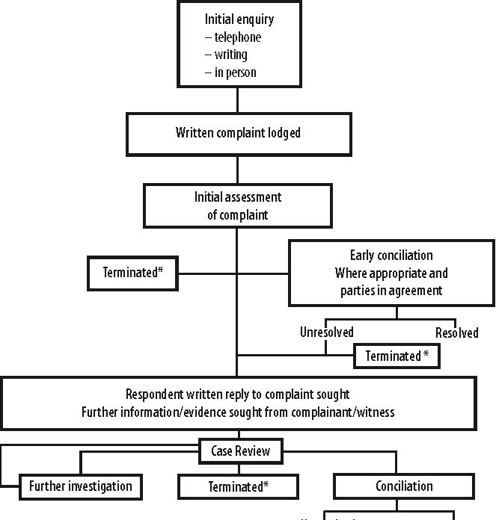
Unresolved Resolved
* When complaints under the Age, Racial, Sex and Disability Discrimination Acts are terminated, the complainant may apply to have the allegations heard and determined by the Federal Court of Australia or the Federal Magistrates Court.
** Complaints under the Human Rights and Equal Opportunity Commission Act concerning discrimination in employment or a breach of human rights, which cannot be conciliated, cannot be taken to court. If the President is satisfied that the subject matter of the complaint constitutes discrimination or a breach of human rights these findings are reported to the Attorney-General for tabling in Parliament.

