Headshot photo - Commissioner Tan

Chin Tan

Race Discrimination Commissioner

FIFTH YEAR OF TERM

‘Celebrating harmony and eliminating racial discrimination are two sides of the same coin. We cannot eradicate racism without fostering multiculturalism and social cohesion, and vice versa.’

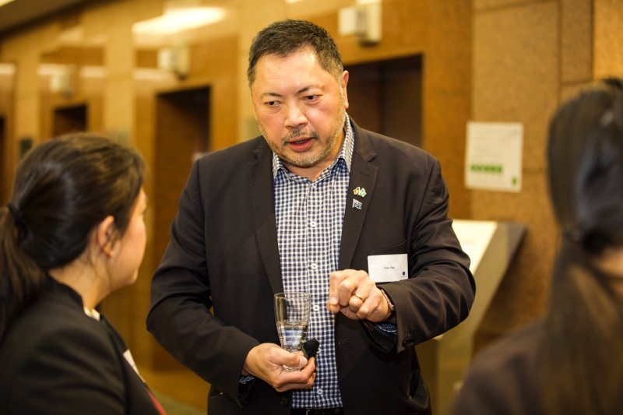

Commissioner Tan attending the William Ah Ket Scholarship launch in June 2021. Photo by Peter Bongiorno.

TERM GOALS

* Improve protections against racial discrimination.
* Reduce institutional racism and systemic inequities.
* Increase capacity for multicultural and racial minority communities to advocate for their rights.
* Increase awareness of racism and racial discrimination.

PRINCIPLES / APPROACH

* Focusing on education and capacity building around racism and racial discrimination and supporting strategies to address them and build social cohesion and inclusion.
* Empowering communities through participation and strengths-based engagement—consulting and amplifying community voices on key issues.
* Engaging, collaborating, and partnering with key stakeholders to increase the reach and scope of work addressing racism and racial discrimination and promoting social cohesion, inclusion and diversity.
* Supporting equal participation including by promoting the benefits of culturally diverse workplaces and leaders.
* Using an evidence-based approach to shape Australia’s conversation on racism, racial discrimination, social cohesion, inclusion, and diversity.

KEY ACTIVITES: 2022–23 WORKPLAN

|  |  |
| --- | --- |
| Leading the national conversation on race relations | * Progressing the development of a National Anti-Racism Framework with government, civil society and community partners. The Framework will reflect an agreed national approach to tackling racism and promoting social cohesion by outlining guiding principles and identifying national priorities. This year’s focus is on delivering a Conversation and Consultation Report on the project’s scoping phase including a process solution to expand the project through further consultation, research and solution design. |
| Driving institutional and organisational change | * Driving change with a program of work to identify and address institutional racism including initiatives promoting equal participation and culturally competent workplaces such as a Workplace Cultural Diversity Tool launched early in the 2022–23 planning period. Collaborations with key stakeholders will seek to achieve organisational change around racism and racial discrimination. |
| Delivering education and raising community awareness | * Raising community awareness about racism and racial discrimination by designing and delivering anti-racism information, tools, and resources to the community including resources about institutional and structural racism. The Racism. It Stops With Me campaign delivers core anti-racism and social cohesion messages and contribute to a national discussion about racism from an interpersonal, institutional and systemic perspective. With the campaign released early in the 2022–23 planning period the immediate focus will be leveraging the engagement and public discussion on the campaign to combat racism. |
| Building robust evidence for change | * Giving voice to the experiences of racism and racial discrimination in Australia and gathering evidence and intelligence to support Commission initiatives including through ongoing advocacy for national data collection. This year the Commission will investigate national data collection focussed on the prevalence and severity of racism identified by the National Anti-Racism Framework Project as a priority need. This program of work will also contribute to the Commission’s understanding of racist extremism. |
| Advocating for greater protections against race discrimination | * Working with experts and government and community partners to consider the operation of racial discrimination and related laws and policies and taking appropriate advocacy action including around the regulation of online spaces and the media landscape. Initiatives relating to such protections will be informed by the National Anti-Racism Framework project and other Commission work. |