HUMAN RIGHTS AND EQUAL OPPORTUNITY COMMISSION
AGE DISCRIMINATION ACT 2004 (Cth)
Section 44(1)
NOTICE OF REJECTION OF APPLICATION FOR EXEMPTION
By this instrument, the Human Rights and Equal Opportunity Commission (‘the Commission’) declines to grant to Plus 40 Pty Limited (‘Plus 40’) a temporary exemption pursuant to s 44(1) of the Age Discrimination Act 2004 (Cth) (‘ADA’).
1. EXEMPTION APPLICATION
  - By letter dated 5 July 2005, Plus 40 applied to the Commission for a temporary exemption from s 24(1) of the ADA (‘the exemption application’).
  - The Commission derives its power to grant temporary exemptions from s 44 of the ADA and accordingly it is under that section that the exemption application has been considered.
  - Plus 40 is described in the exemption application as a new web-based employment and training service established specifically to service the needs of unemployed and employed people who are over 40 years of age. Plus 40 aims to actively promote:
1.3.1 the re-employment of experienced workers;
    - the opportunity to improve the employment status of experienced workers; and
    - the re-skilling of experienced workers;
where those 'experienced' workers are over 40 years of age. Plus 40 stated in the exemption application that it intends to establish 40 years of age as the minimum age required to utilise its services.
  - Section 24(1) of the ADA relevantly provides as follows:
24 Employment agencies
(1) It is unlawful for an employment agency to discriminate against a person on the ground of the person’s age:
(a) by refusing to provide the person with any of its services; or
(b) in the terms or conditions on which it offers to provide the person with any of its services; or
(c) in the manner in which it provides the person with any of its services.
  - Plus 40 stated in the exemption application that the activities of Plus 40 may fall within the s 33 permanent exemption to the ADA for positive discrimination. Plus 40 provided the following reasons:
1.5.1 There is an invisible use by date for people over 40 years of age in industry that leaves many experienced workers either under employed or unemployed. Plus 40 will be specifically marketing the value and experience that the over 40 worker can bring to any organisation.
    - Services abound to promote youth employment and re-skill the long term unemployed, many of whom are under 40 years of age. Plus 40 will focus its efforts exclusively on workers over 40 who have not received the appropriate support from the workplace to date.
    - The Federal Government has recognised the shortage of services for (mature aged) experienced workers and has recently announced future funding packages to address the needs for this demographic. Plus 40 will be providing services to promote the employment prospects of experienced workers.
  - By letter dated 4 August 2005, Plus 40 provided the following further information to assist the Commission in assessing the application:
1.6.1 The Australian Bureau of Statistices (ABS) publication 'Australian Social Trends - Work - Mature Age Workers, June 15 2004' contends that there are lower labour force participation rates for men and women from their forties and fifties onwards. The ABS publication also mentions that although the unemployment rate for workers over 45 is lower than the general population, mature workers constitute a higher proportion of unemployed looking for full time work and have almost double the rate of long term unemployment compared to the total labour force.
    - The Council of Ageing found in 2002 that 'the extent of mature age unemployment is masked by large numbers leaving the workforce'.
    - A June 2000 report to the House of Representatives entitled 'Age Counts' noted that 'the greatest difficulty for the mature aged unemployed is the reluctance of employers to hire or promote older workers.'
    - The Drake White Paper 'The Age Chasm' noted that 'employers are more likely to invest training resources in younger people than older people'.
    - Plus 40 stated that ‘numerous reports, media articles and publications support our contention that there is a shortage of effective employment and training services for the people over 40 years of age.’
- FINDINGS ON MATERIAL QUESTIONS OF FACT
  - Based on the evidence referred to in paragraphs 1.3 – 1.6 above, the Commission makes the following findings on material questions of fact in relation to this application:
2.1.1 Plus 40 is an employment and training service.
    - Plus 40 has been established to service the needs of unemployed and employed people who are over 40 years.
    - 40 years will be the minimum age required to utilise the services of Plus 40.
    - Plus 40 has formed the view that many people over 40 years of age are either under employed or unemployed.
    - Plus 40 has formed the view that there is a shortage of effective employment and training services for the people over 40 years.
    - Plus 40 will be providing services intended to promote the employment prospects of people over 40 years.
- REASONS FOR DECLINING TO GRANT A TEMPORARY EXEMPTION
  - In considering an application for a temporary exemption, the Commission will have regard to whether the activities in respect of which the exemption is sought might constitute discrimination under the ADA. In particular, the Commission will consider whether any of the permanent exemptions to the ADA may apply. If the circumstances are not at least arguably discriminatory within the terms of the ADA, then there is no need for the Commission to grant an exemption.
  - For the reasons set out below, the Commission is of the view that the exemption application does not demonstrate an arguable case that the proposed activities of Plus 40 constitute unlawful discrimination under the ADA.
  - The Commission notes that the permanent exemption for positive discrimination at s 33 of the ADA is relevant to the application. Section 33 relevantly provides:
33 Positive discrimination
This Part does not make it unlawful for a person to discriminate against another person, on the ground of another person's age, by an act that is consistent with the purposes of this Act, if:
(a) …
(b) the act is intended to meet a need that arises out of the age of persons of a particular age; or
Example: Young people often have a greater need for welfare services (including information, support and referral) than other people. This paragraph would therefore cover the provision of welfare services to young homeless people, because such services are intended to meet a need arising out of the age of such people.
(c) the act is intended to reduce a disadvantage experienced by people of a particular age.
Example: Older people are often more disadvantaged by retrenchment than are other people. This paragraph would therefore cover the provision of additional notice entitlements for older workers, because such entitlements are intended to reduce a disadvantage experienced by older people.
  - The explanatory memorandum to s 33 of the ADA states as follows:
The legislation exempts “positive discrimination”, which refers to three different types of beneficial age-based treatment (which may in some circumstances overlap):
(a) …
- measures intended to meet age-related needs. This aspect of the positive discrimination provision recognises and permits measures that seek to address the needs of particular ages that are different to or more acute than the needs of people of other ages…
- measures intended to reduce disadvantage. This aspect of the positive discrimination provision recognises and permits measures that seek to overcome age-related disadvantage…For example, where older people experience longer periods of unemployment, extra assistance to help them find work would be permitted.
  - In order for an act to fall within the s 33 exemption it must be consistent with the purposes of the ADA. The objects of the ADA are set out at s 3 of the Act and relevantly (for the purposes of this application) include:
(e) to respond to demographic change by:
(i) removing barriers to older people participating in society, particularly in the workforce; and
(ii) changing negative stereotypes about older people...
  - In the Commission’s view, the s 33(b) and/or 33(c) permanent exemption applies to the activities of Plus 40. The activities of Plus 40 are intended to:
3.6.1 meet an age related need. Plus 40 has formed the view that there is a shortage of effective employment and training services for the people over 40 years (s 33(b)); and/or
3.6.2 reduce a disadvantage experienced by people over 40. Plus 40 has formed the view that many people over 40 years of age are either under employed or unemployed (s 33(c)).
  - Plus 40 will be providing employment and training services intended to promote the employment prospects of people over 40 years.
  - The Commission is also of the view that the activities of Plus 40 appear to be consistent with the objects of the ADA and in particular s 3(e).
  - As there is not, in the view of the Commission, an arguable case of discrimination disclosed in the present application, a temporary exemption under s 44(1) is unnecessary. The Commission refuses the application by Plus 40 for a temporary exemption.
Dated this 30th day of August 2005
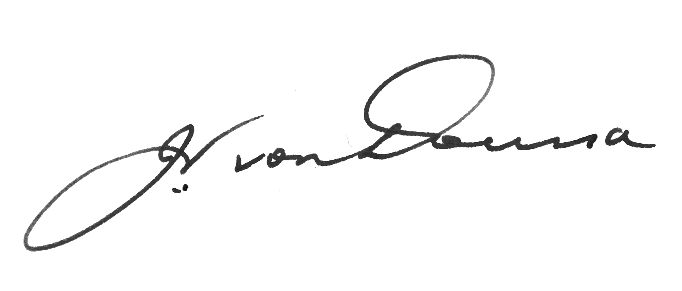
Signed by the President, John von Doussa QC, on behalf of the Commission.
Please note
Subject to the Administrative Appeals Tribunal Act 1975, application may be made to the Administrative Appeals Tribunal for a review of a decision to which this notice relates by or on behalf of any person or persons whose interests are affected by the decision.

