

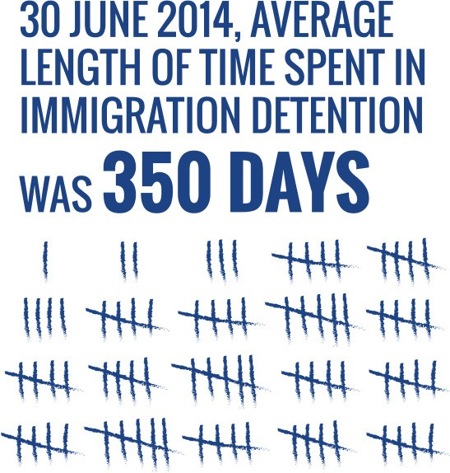

**Face the facts:**

ASYLUM SEEKERS AND REFUGEES • **2014**

The Australian Human Rights Commission encourages the dissemination and exchange of information provided in this publication. All material presented in this publication is provided under Creative Commons Attribution 3.0 Australia, with the exception of:

* the Australian Human Rights Commission Logo
* photographs and images
* any content or material provided by third parties.

The details of the relevant licence conditions are available on the Creative Commons website, as is the full legal code for the CC BY 3.0 AU licence.

**Attribution**

Material obtained from this publication is to be attributed to the Australian Human Rights Commission with the following copyright notice:

© Australian Human Rights Commission 2014.

**Face the Facts:** Asylum seekers and refugees • **2014 IISBN** 978-1-921449-67-3

**Design and layout** Dancingirl Designs

**Infographic Design** Firefly Interactive

**Content** James Iliffe, Black and White Media Australia

**Electronic format**

This publication can be found in electronic format on the website of the Australian Human Rights Commission:

[**http://www.humanrights.gov.au/publications**](http://www.humanrights.gov.au/publications/sex-discrimination)

**Contact details**

For further information about the Australian Human Rights Commission, please visit

[**www.humanrights.gov.au**](http://www.humanrights.gov.au/)or email [**communications@humanrights.gov.au**.](mailto:communications@humanrights.gov.au) You can also write to:

Communications Team

Australian Human Rights Commission GPO Box 5218

Sydney NSW 2001

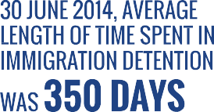



## 

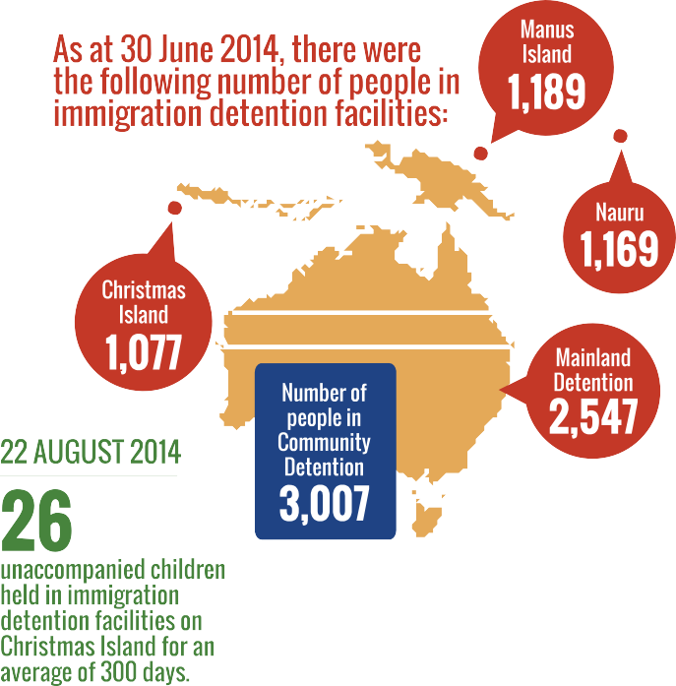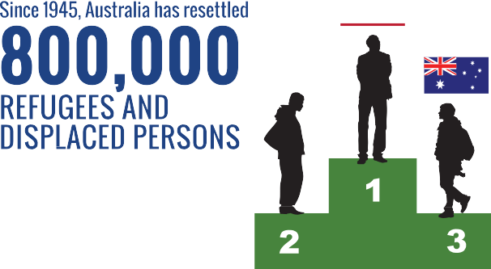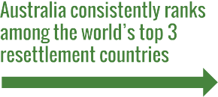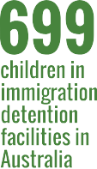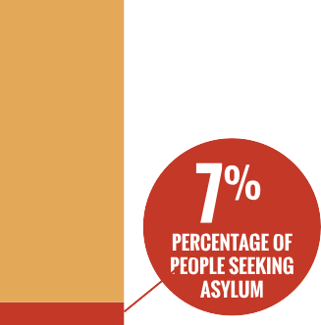



## 



[**www.humanrights.gov.au/face-facts**](http://www.humanrights.gov.au/face-facts)



**Face the Facts:** Asylum seekers and refugees • **2014** • 1

Asylum seekers and refugees

Seeking asylum in Australia is not illegal. In fact, it is a basic human right. All people are entitled to protection of their human rights, including the right to seek asylum, regardless of how or where they arrive in Australia.

Countries that have ratified the [Convention Relating to the](http://www.unhcr.org/3b66c2aa10.html) [Status of Refugees 1951](http://www.unhcr.org/3b66c2aa10.html), such as Australia, are required to assess asylum seekers’ claims for protection from persecution. The Refugee Convention defines who is a refugee and sets out the basic rights that countries should guarantee to refugees.

Australia’s policy of mandatory immigration detention was introduced in 1992. Under the [Migration Act 1958](http://www.austlii.edu.au/au/legis/cth/consol_act/ma1958118/), any non-citizen who is in Australia without a valid visa must be detained.

In August 2012, the Australian Government introduced “third country” processing. Under this system, asylum seekers who arrive by boat without a valid visa are transferred to and detained in Nauru or Papua New Guinea (PNG). Those asylum seekers who are transferred will have their claims for protection assessed under Nauruan or PNG law, not Australian law.

# About

* + As at 31 January 2014, there were 5,867 people in immigration detention facilities and 3,391 people in community detention in Australia.1 Forty-three per cent (3,967) were detained in facilities on the mainland,

37 per cent were in community detention (3,391) and 20 per cent were held on Christmas Island (1,900).2

* + As at 31 January 2014, there were 1,012 asylum seekers who had been transferred by the Australian Government and detained in Nauru. There were a further 1,353 asylum seekers detained on Manus Island in PNG.
* As at 31 January 2014 there were 1,006 children in immigration detention facilities in Australia and 132 children detained in Nauru.3 As at 19 August

2013, there were 358 unaccompanied minors held in immigration detention facilities, ranging in age from seven to 17 years.4 The average age of children in closed detention facilities in September 2013 was

10 years.5

* The number of people seeking asylum in 2012 (15,963)6 made up less than seven per cent of Australia’s annual immigration intake and four per cent of our overall population growth.7 The top five source countries for asylum seekers who arrived in Australia by boat in 2012 were Afghanistan, Sri Lanka, Iran, Pakistan and Iraq.8
* Around 90 per cent of asylum seekers who arrive in Australia by boat are ultimately found to be refugees and are granted protection visas.9

# Key issues for asylum seekers and refugees

* Australia has one of the most restrictive immigration detention systems in the world. It is mandatory, indefinite and provides no opportunity for people to challenge the need for their detention in court.10 As at 31 January 2014, the average length of time a person spent in immigration detention was seven months and nine days. However, 119 people had been held in immigration detention for over two years.11
* Prolonged detention can have a devastating and long- lasting impact on the mental health of asylum seekers, especially children. Further, the cost of treating

mental illnesses caused or made worse by prolonged detention is conservatively estimated at an average of

$25,000 per person.12

* + In 2012–13, there were 846 reported incidents of self-harm across Australia’s immigration detention system.13
  + Asylum seekers arriving in Australia by boat on or after 13 August 2012 who have been granted bridging visas are not allowed to work.14 This restriction on working and earning an income can have serious effects on a person’s well-being and contribute to problems with physical health, mental health, social isolation and family breakdown.15
  + Implementing Australia’s policy of mandatory immigration detention cost Australian taxpayers $1.235 billion in 2011–2012.16

# Supporting asylum seekers and refugees

* + Australia has resettled around 800,000 refugees since 1945 and consistently ranks among the world’s top three resettlement countries.17
  + A total of 13,750 people will be accepted through Australia’s [Humanitarian Program](http://www.immi.gov.au/media/fact-sheets/60refugee.htm) in 2013-2014.18
  + Alternatives to closed immigration detention, such as community arrangements, save Australian taxpayers money and involve fewer risks to the health, safety and well-being of asylum seekers and refugees. This helps lower rates of self-harm and leads to fewer claims for compensation.19

# Did you know?

As of August 2013, there were **52 refugees who faced indefinite detention in Australia** because ASIO had deemed them a security risk. The United Nations Human Rights Committee found that the indefinite detention of a group of refugees with adverse security assessments was inflicting serious psychological harm upon them, amounting to cruel, inhuman or degrading treatment.

# Find out more

* Australian Human Rights Commission, [*Asylum*](http://www.humanrights.gov.au/publications/asylum-seekers-refugees-and-human-rights-snapshot-report)[*seekers, refugees and human rights: Snapshot Report*](http://www.humanrights.gov.au/publications/asylum-seekers-refugees-and-human-rights-snapshot-report)(2013)
* Australian Human Rights Commission, [*A last resort?*](http://www.humanrights.gov.au/last-resort-report-national-inquiry-children-immigration-detention-2004)[*Report of the National Inquiry into Children in*](http://www.humanrights.gov.au/last-resort-report-national-inquiry-children-immigration-detention-2004)[*Immigration Detention*](http://www.humanrights.gov.au/last-resort-report-national-inquiry-children-immigration-detention-2004)(2004)
* [Convention Relating to the Status of Refugees 1951](http://www.unhcr.org/3b66c2aa10.html) and [Protocol Relating to the Status of Refugees 1967](http://www.unhcr.org/protect/PROTECTION/3b66c2aa10.pdf)
* A. Houston, P. Aristotle and M. L.’Estrange, [*Report of*](http://expertpanelonasylumseekers.dpmc.gov.au/)[*the Expert Panel on Asylum Seekers*](http://expertpanelonasylumseekers.dpmc.gov.au/)(2012)
* UN Refugee Agency (UNHCR), Monitoring visit to [Manus Island](http://unhcr.org.au/unhcr/images/2013-11-26%20Report%20of%20UNHCR%20Visit%20to%20Manus%20Island%20PNG%2023-25%20October%202013.pdf) (2013) and [Nauru](http://unhcr.org.au/unhcr/images/UNHCR%20Monitoring%20Report%20Nauru.pdf) (2013)

# Our role

The Commission has undertaken extensive work in the area of Australian law, policy and practice relating to asylum seekers, refugees and immigration detention. This has included conducting national inquiries; examining proposed

legislation; monitoring and reporting on immigration detention; and investigating complaints from individuals subject to Australia’s immigration laws and policies.

We have also developed minimum [human rights standards for](https://www.humanrights.gov.au/publications/human-rights-standards-immigration-detention) [immigration detention](https://www.humanrights.gov.au/publications/human-rights-standards-immigration-detention) and [advocated for stronger federal laws](https://www.humanrights.gov.au/publications/addressing-sexual-orientation-and-sex-andor-gender-identity-discrimination-consultati-0) to ensure that the conditions in immigration detention meet international standards.

The [National Children’s Commissioner](https://www.humanrights.gov.au/about/commissioners/ms-megan-mitchell-national-childrens-commissioner) works collaboratively within the Commission to protect the rights of child asylum seekers and unaccompanied minors.

Find out more about [our work](https://www.humanrights.gov.au/commissions-role) in this area.

**Face the Facts:** Asylum seekers and refugees • **2014** • 3

In February 2014, the Commission announced that

it would undertake a follow-up [National Inquiry into](https://www.humanrights.gov.au/our-work/asylum-seekers-and-refugees/national-inquiry-children-immigration-detention-2014) [Children in Immigration Detention](https://www.humanrights.gov.au/our-work/asylum-seekers-and-refugees/national-inquiry-children-immigration-detention-2014). The inquiry will investigate what has changed in the ten years since the Commission released [*A last resort? Report of the*](https://www.humanrights.gov.au/publications/last-resort-national-inquiry-children-immigration-detention)[*National Inquiry into Children in Immigration Detention*](https://www.humanrights.gov.au/publications/last-resort-national-inquiry-children-immigration-detention)in 2004.

**Face the Facts:** Asylum seekers and refugees • **2014** • 3

Endnotes

1. Department of Immigration and Border Protection, Australian Government, [*Immigration Detention and Community Statistics Summary:*](http://www.immi.gov.au/managing-australias-borders/detention/_pdf/immigration-detention-statistics-jan2014.pdf)[*31 January 2014*](http://www.immi.gov.au/managing-australias-borders/detention/_pdf/immigration-detention-statistics-jan2014.pdf)(2014) p 3.
2. Department of Immigration and Border Protection, Australian Government, above, p 3.
3. Department of Immigration and Border Protection, Australian Government note 1, pp 3-4.
4. Australian Human Rights Commission, [*Asylum seekers, refugees*](http://www.humanrights.gov.au/publications/asylum-seekers-refugees-and-human-rights-snapshot-report)[*and human rights: Snapshot Report, October 2013*](http://www.humanrights.gov.au/publications/asylum-seekers-refugees-and-human-rights-snapshot-report), footnote 54, 55.

Department of Immigration and Citizenship, Response to the Australian Human Rights Commission’s 13 August 2013 request for information concerning detention and asylum seekers, provided by email to the Commission on 16 September 2013, p 3.

1. Australian Human Rights Commission, above, footnote 43.
2. Australian Human Rights Commission, note 4, footnote 18, 19; Department of Immigration and Citizenship, [*Asylum statistics – Australia,*](http://www.immi.gov.au/media/publications/statistics/asylum/)[*Quarterly tables – March Quarter 2013*](http://www.immi.gov.au/media/publications/statistics/asylum/)(2013), p 1; United Nations High Commissioner for Refugees (UNHCR), [*UNHCR Global Trends 2012,*](http://unhcr.org/globaltrendsjune2013/)[*Displacement: The New 21st Century Challenge*](http://unhcr.org/globaltrendsjune2013/)(2013), p 3.
3. Australian Human Rights Commission, note 4, footnote 20, 21; Australian Bureau of Statistics, [*3101.0–Australian Demographic Statistics, Dec 2012*](http://www.abs.gov.au/AUSSTATS/abs%40.nsf/allprimarymainfeatures/7B8C452A1CDFAB9FCA257BF100136758?opendocument)(June 2013).
4. Australian Human Rights Commission, note 4, p 8.
5. See, for example, the statistics provided by the Department of Immigration and Border Protection for the last five financial years in [*Asylum Trends – Australia: 2012-13 Annual Publication*](http://www.immi.gov.au/media/publications/statistics/)(2013), p 30.
6. Australian Human Rights Commission, note 4, Executive Summary.
7. Department of Immigration and Border Protection, Australian Government, note 1, p 10.
8. Australian Human Rights Commission, note 4, footnote 94; T Ward, [*Long-*](http://www.yarrainstitute.org.au/Portals/0/docs/Ward.long-term%20costs)[*term health costs of extended mandatory detention of asylum seekers*](http://www.yarrainstitute.org.au/Portals/0/docs/Ward.long-term%20costs)(2011).
9. Australian Human Rights Commission, note 4, Executive Summary.
10. Australian Human Rights Commission, [*Tell Me About: Bridging Visas*](http://www.humanrights.gov.au/publications/tell-me-about-bridging-visas-asylum-seekers)[*for Asylum Seekers*](http://www.humanrights.gov.au/publications/tell-me-about-bridging-visas-asylum-seekers)(April 2013).
11. Australian Human Rights Commission, above, footnote 5.
12. Australian Human Rights Commission, note 4, footnote 39; Australian National Audit Office, [*Individual Management Services Provided to*](http://www.anao.gov.au/Publications/Audit-Reports/2012-2013/Individual-Management-Services-Provided-to-People-in-Immigration-Detention)[*People in Immigration Detention, Report No 21*](http://www.anao.gov.au/Publications/Audit-Reports/2012-2013/Individual-Management-Services-Provided-to-People-in-Immigration-Detention)(2013), p 12.
13. Australian Human Rights Commission, note 4, Executive Summary.
14. See [*Mid-Year Economic and Fiscal Outlook, Appendix A: Policy decisions*](http://www.budget.gov.au/2013-14/content/myefo/html/12_appendix_a_expense-12.htm)[*taken since the 2013-14 Budget –Expense Measures – Immigration and*](http://www.budget.gov.au/2013-14/content/myefo/html/12_appendix_a_expense-12.htm)[*Border Protection*](http://www.budget.gov.au/2013-14/content/myefo/html/12_appendix_a_expense-12.htm).
15. Australian Human Rights Commission, note 4, footnote 103; International Detention Coalition and La Trobe Refugee Research Centre, *There*

*are alternatives: A handbook for preventing unnecessary immigration detention* (2011), section 5.