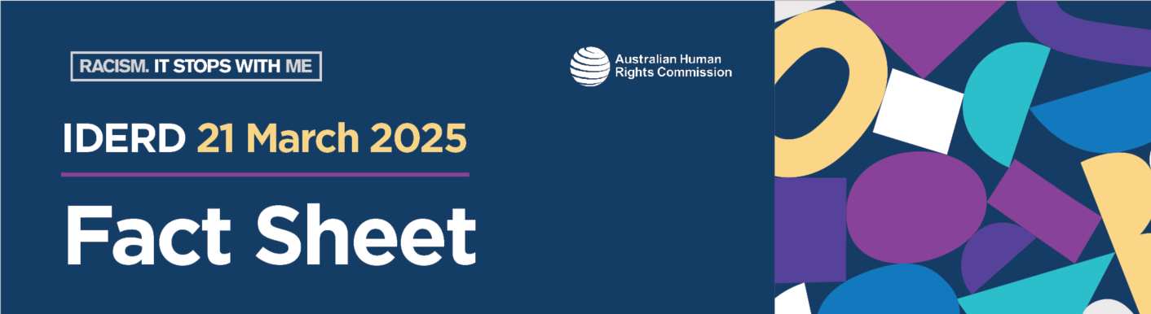

How ‘harmony’ hides systemic racism
Key details
March 21 is the International Day for the Elimination of Racial Discrimination (IDERD). In Australia, this day has been called ‘Harmony Day’ since 1999. The concept of ‘harmony’ hides the true meaning behind this day. It overlooks the real issues and harms caused by systemic racism. This fact sheet explains why.
The history of IDERD
On 21 March 1960, police in Sharpeville, South Africa, shot at peaceful anti-apartheid protesters. They were demonstrating against the Pass Laws Act of 1952. This law meant that Black South Africans over 16 years old had to carry a ‘passbook’. The government enforced the use of this internal passport, called ‘dompas’, to enforce segregation and limit movement. A Black South African who forgot to, or refused to, carry the dompas could face arrest and imprisonment. This is an example of systemic racism as the South African Government used the law to separate and harm people, because of race.
On this day, many protestors gathered at the police station in Sharpeville. They did not have their dompas. They were using their rights, such as: freedom of movement; the right to peaceful assembly; and the right to live free from racial segregation and discrimination. The peaceful protest turned into a massacre when police opened fire on the crowd of 7,000 people. The attack killed 69 people and injured 180 others.
In 1979, the United Nations General Assembly decided to hold a week of solidarity. This week, which begins on IDERD, supports people fighting against racism and racial discrimination and continues to be marked on 21 March each year.
Since then, the fight against racism across the globe has been guided by the International Convention on the Elimination of Racial Discrimination. Australia ratified this Convention in 1975, which resulted in Australia's first national law against racial discrimination: the Racial Discrimination Act 1975 (Cth).
Many people and communities around the world, like those in Australia, still deal with the injustice and stigma of systemic racism.
IDERD is an important focus to help people unite and raise their voices against racism. It drives action against racial discrimination and supports strategies for change.
Creation of ‘Harmony Day’ in Australia
In 1998, the Australian Government’s Department of Immigration and Citizenship conducted research on how Australians feel about race.
The research recommended that the Government should promote and celebrate a harmonious Australian society. Many people in Australia, particularly those from communities that do not experience the harms of racism, felt and continue to feel uncomfortable when talking about racism and its impacts. This was reflected in the survey’s recommendations and the push for ‘harmony’ as the core focus of the day.
This is one of the reasons why Australia renamed IDERD 'Harmony Day' in 1999. Overnight, this change turned the focus of the day from a protest against racial discrimination into a celebration.
The renaming of this day hides the long-standing systemic racial discrimination many people have faced in Australia. For example, First Nations peoples in Australia have experienced devastating impacts flowing from the colonisation of their lands by the British from 1788 onwards. These impacts continue to be felt today. To give just one example, First Nations peoples are, on average, likely to live 8-9 years less than non-Indigenous people in Australia. Additionally, a study conducted in 2018 by the Australian Human Rights Commission showed that only 5% of the 2490 people occupying the most senior roles in Australia were from non-European backgrounds.
Moving from IDERD to ‘Harmony Day’ and ‘Harmony Week' prevents a deeper understanding of the need to eliminate racism and the harms it causes.
The problem with Harmony Day
The concept of ‘harmony’ has significantly shaped Australia's policy and politics in recent decades. The goal of harmony is of course worthwhile. The problem is that the focus on harmony can gloss over racism, stop people from discussing it or cause people to think that speaking up upsets the idea of a ‘harmonious’ Australian society. It can make it harder for people to question the way things are and can reinforce inequality.
Calling the commemoration of IDERD ‘Harmony Day/Week’ can therefore damage and weaken our anti-racism efforts. It distracts from recognising and addressing the harm that racism causes to communities.
Australia is not free from racism. Understanding the true meaning behind IDERD encourages us to examine how racism affects our society and strengthens our promise to fight against racism. We can only build a fair and equal society when we recognise the human rights and freedoms of everyone.
Anti-racism and IDERD
We all have a responsibility to listen to people harmed by racism, learn more about the way racism works, and to come together to end racism for good.
No matter where you are in your individual anti-racism journey, the Racism. It Stops With Me website is a place to learn more about racism and take action to create change.
This list of readings about Harmony Day covers the history and the original purpose of IDERD. This includes acknowledging the harm caused by racism and working together for change.
- It's the International Day of Eliminating Racial Discrimination. Why does Australia call it 'Harmony Day'? by Dan Butler, NITV (SBS Australia)
- From a massacre in apartheid South Africa to 'feel good' multiculturalism: The dark history of Harmony Day by Ahmed Yussuf, ABC News
- It's Harmony Week, but let's discuss what it is really about: racism by Erwin Renaldi, ABC News
- The corporate world could learn some lessons from the schoolyard when it comes to celebrating multiculturalism by Emma Ruben, ABC News
Key terms
Anti-apartheid: ‘Apartheid’ was a racist system that enforced the racial separation and discrimination of Black South Africans by the all-white government. Anti-apartheid efforts describe the acts of resistance taken up between 1948 to the early 1990s that helped end the oppression of non-Europeans in South Africa. These acts of resistance included boycotts, strikes and protests like the one described in this fact sheet.
Interpersonal racism: Interpersonal racism refers to racism that occurs in everyday interactions. This can be between individuals or groups and is what most people recognise as racism. It can take many forms, such as abusive language, harassment, exclusion, or humiliation. Interpersonal racism might also be expressed through casual remarks or jokes.
Segregation: Segregation is the act of keeping groups or people separate from each other. Racial segregation is when this separation is forced on communities by a dominant racial group. During the apartheid era, non-Europeans were segregated from white South Africans, and excluded from specific places and opportunities. As discussed in this fact sheet, laws and violence were used by the South African government to keep these practices in place.
Systemic racism: Systemic racism is the way a society or institution’s culture, laws, policies, and practices result in unfair treatment and outcomes. Systemic racism involves entire systems, for example, legal, health, education, criminal justice, and the structures that support them.
Example: The difference in health outcomes based on race. Racism impacts people’s health, the quality of treatment and care that they receive. Evidence shows differences in life expectancy experienced by people of different races.

