Factsheet Series: Positive Duty under the Sex Discrimination Act 1984 (Cth)
Factsheet for Workers
September 2024

Your rights at work
Everyone has the right to be free from sexual harassment and sexist behaviour at work.
This includes if it happens at your place of work, online or somewhere else if it is connected to work. It includes behaviour from people you work with and from other people like customers, clients or patients at your work.
Under the positive duty, workplaces must try to stop this behaviour before it happens, as well as respond to it well if it does happen.

What sexual harassment or sexist behaviour may look like at work?
- Unwanted touching
- Unwanted staring
- Repeated unwanted requests to go on dates
- Sexual jokes
- Questions or comments about your body
- Displays of rude pictures
- Not hiring or promoting someone because of their sex.

Treating someone badly because they spoke up about sexual harassment or sexist behaviour is also not okay.

Sometimes your cultural background, your gender identity or sexuality is also a part of the sexual harassment or sexist behaviour.
Even if sexual harassment or sexist behaviour only happened one time or the other person did not mean it in a bad way it is still not okay.
You can find more information about the behaviour that's covered and the positive duty on the Australian Human Rights Commission’s website in seven community languages and an easy read version.

Are you worried about your workplace?
You do not have to put up with sexual harassment or sexist behaviour at work. If it is happening at your work, you can call us or email for help to understand your options. This service is free and confidential.
The Australian Human Rights Commission handles complaints about this type of behaviour and works with organisations and businesses to check that they take proper steps to stop the behaviour happening again.

Contact us
The Australian Human Rights Commission has set up the Respect@Work Information Service to help you decide what to do if you are worried about sexual harassment or sexist behaviour connected to your work. You can make a complaint or tell us about your concerns in the Positive Duty Online Form on our website.
Follow the QR code for more information about the Information Service and how to contact us.
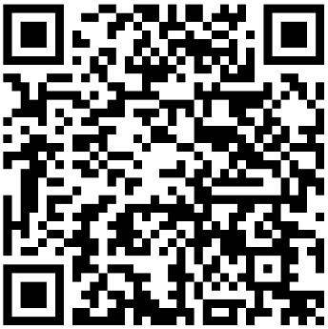

You can contact the Respect@Work Information Service by:
- Phone: 1300 656 419 (Option 1)
- Email: respect@humanrights.gov.au
- Fax: 02 92 84 96 11
For information in your language call the:
- Translating and Interpreting Service on 131 450
If you are D/deaf or find it hard to hear or speak on the phone, you can contact:
- National Relay Service on 1300 555 727
- TTY on 1800 620 241

Counselling and Support Services
People who experience or see sexual harassment, sexist behaviour, discrimination or other behaviours covered by the positive duty may feel distressed. You can access a list of free and confidential counselling and support services on the Australian Human Rights Commission’s website.

You can find more information about the positive duty under the Sex Discrimination Act on the Commission’s website. Resources include Guidelines for Complying with the Positive Duty, an Information Guide: Relevant Unlawful Conduct, Drivers, Risk Factors and Impacts, a Quick Guide, Small Business Resource, and other factsheets.

