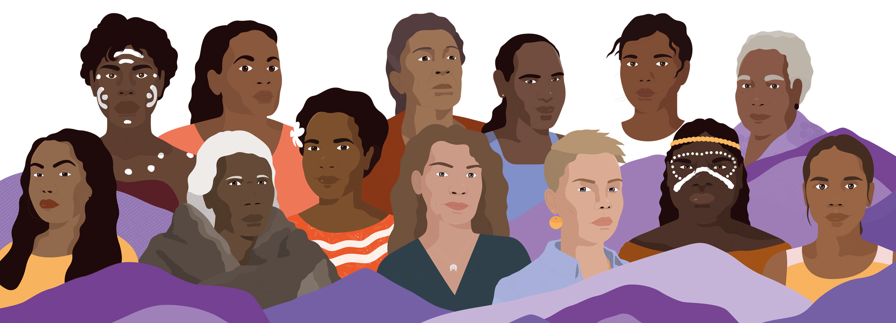

C O M M U N I Q U É

Over four days, 900 First Nations women from all reaches of the continent have come together in our nation’s capital, with non-indigenous women collaborators.
Our women of all ages have had big, creative, respectful, and robust conversations to design a future of our own. Alongside this Communiqué sits our powerful Youth Statement that says:
we are the light in the darkness, we will transform the future and we have the right to self- direct our freedom
The landmark Wiyi Yani U Thangani (Women’s Voices) project holds our stories and truths. The Report and supporting documents are our blakprint for systemic and structural reform. We’ve come to this historic gathering, the first of its kind in Australia, to determine how to translate this substantial body of work, our collective voices, into shaping the future we want and have a right to. We know that real, meaningful change will only come from us, We Are The Change!
Together, our women and our youth, resoundingly endorse the next steps: A National Framework for Action and an Institute for First Nations Gender Justice and Equality. This work is about constructing our own table, so we have power and control over the decisions that impact our lives. The energy
of our sisterhood, the spirit of this Summit, will create the foundations, scaffolding and focus of the Framework and Institute.
Australia has never had a consistent and coherent national plan or approach to respond to our rights and interests as First Nations women and girls. Nor have we had an independent space, belonging to us. The Institute will be our place, where we will create the research agenda, design the models
to support thriving societies for our women and families on the ground, and put forward our stories and lived experiences as evidence-based and innovative policy.
Through the Summit, as we awaken the force of action drawing from our collective strengths, wisdom, knowledges and lived experiences, it is time we make this happen.

What we discussed

Over the last four days we have had conversations around the major interconnected thematic areas of Wiyi Yani U Thangani. These are Leadership and Self-Determination; Culture, Languages, Country and Water Rights; Societal Healing; and Economic Justice, all of which are foundational to a healthy, well and engaged existence.
Across these spaces, all workshops and presentations, we have had a diversity of conversations that brings together the incredible richness of initiatives, ideas and perspectives of First Nations women and our young ones. We have spoken about how Blak women can step into politics, the need to guarantee our women’s place in leadership positions, how to tell our own stories from a position of strength, what types of economies really work for us, how care is at the heart of well and functioning societies, how languages and our women’s Law keep our identity strong and our relationships to one another and the land interwoven.
Our voices on all these matters, reflects our incredible intersectional complexities and strengths, and we are so proud of that. The work we’ve showcased, and our lived experiences and strengths speak to our millennial old systems, grounded in our truths and culture, that have withstood the test of tens of thousands of years of time—we know they work.
These are our rights, we live them—it’s our self-determination, our cultural practices our Aboriginal Law and Ailan Kastom, our right to determine our governance structures and pursue our own forms of education through lifelong learning. They are set out across the Articles of the United Nations Declaration on the Rights of Indigenous Peoples, that our peoples played such a significant role in developing. But the legal and policy structures of Australia do not effectively recognise our rights, all of who we are, and everything we’ve done and what we are doing to shape the world we want to live within.
As First Nations women and girls, we sing out, we know we have a right to our voice and to be responded to. We are not invisible or silent—you cannot ignore us.
We are the leaders of society and the drivers of social and economic change. We are the staunch, brave and loving mothers, aunties, grandmothers, daughters and sisters caring for everyone, Country, kin, and all our non-human relatives, regenerating ecosystems of support and reciprocity, connectedness and kindness.
At a point in history when big structural reforms and social and environmental shifts are occurring, listening and responding to our women and girls’ voices has never been more vital. To design a future grounded in our self-determination, which recognises, affirms and supports all that we are and will achieve, and enables us to reclaim and regenerate our systems that work, we call for:

Our voices, experiences and solutions to be centred in decision-making about our futures
We sit at and construct our own decision-making tables to determine what our societies will become.

2 |

The recognition that our cultures are foundational to societal and ecological health and wellbeing
Culture is essential to all existence, connecting us to kin and Country and keeping our identity strong.

The development of models for financial reinvestment through a First Nations gender lens
Invest in and design systems to support the vital work and leadership of women to improve life for all.

Placing care at the heart of policy design
Policies informed by First Nations conceptions of care will form healthier, safer and more just societies.

Genuine and authentic collaborations to address and overcome systemic challenges
Trusting partnerships matter to dismantle systemic and harmful barriers and build systems that work.

Policies for First Nations women to embrace our voices equally in all their diversity, including sistergirls and transwomen, non-binary people, children and people with disability.
We are always stronger when we embrace our diverse and wonderful perspectives and lived experiences.

To ensure this happens we want all Australian governments and those in positions of influence, including current and future collaborators, to commit to:
- Recognising, responding and being accountable to the National Framework for Action as our First Nations women and girls’ mechanism to achieve First Nations Gender Justice and Equality.
- Recognise and invest in the First Nations Gender Justice Institute as a unique women and girls self-determining entity best placed to provide evidence-based policy advice to governments and other partners.
- Continuously support First Nations women and girls to engage in the ongoing development of the Framework for Action as priorities and objectives evolve.
- Governments to align existing key frameworks, policies and national plans to the Framework for Action as the most consultative approach on First Nations women and girls’ rights and interests.

Wiyi Yani U Thangani (Women’s Voices) • National Summit Communiqué • 2023 | 3

