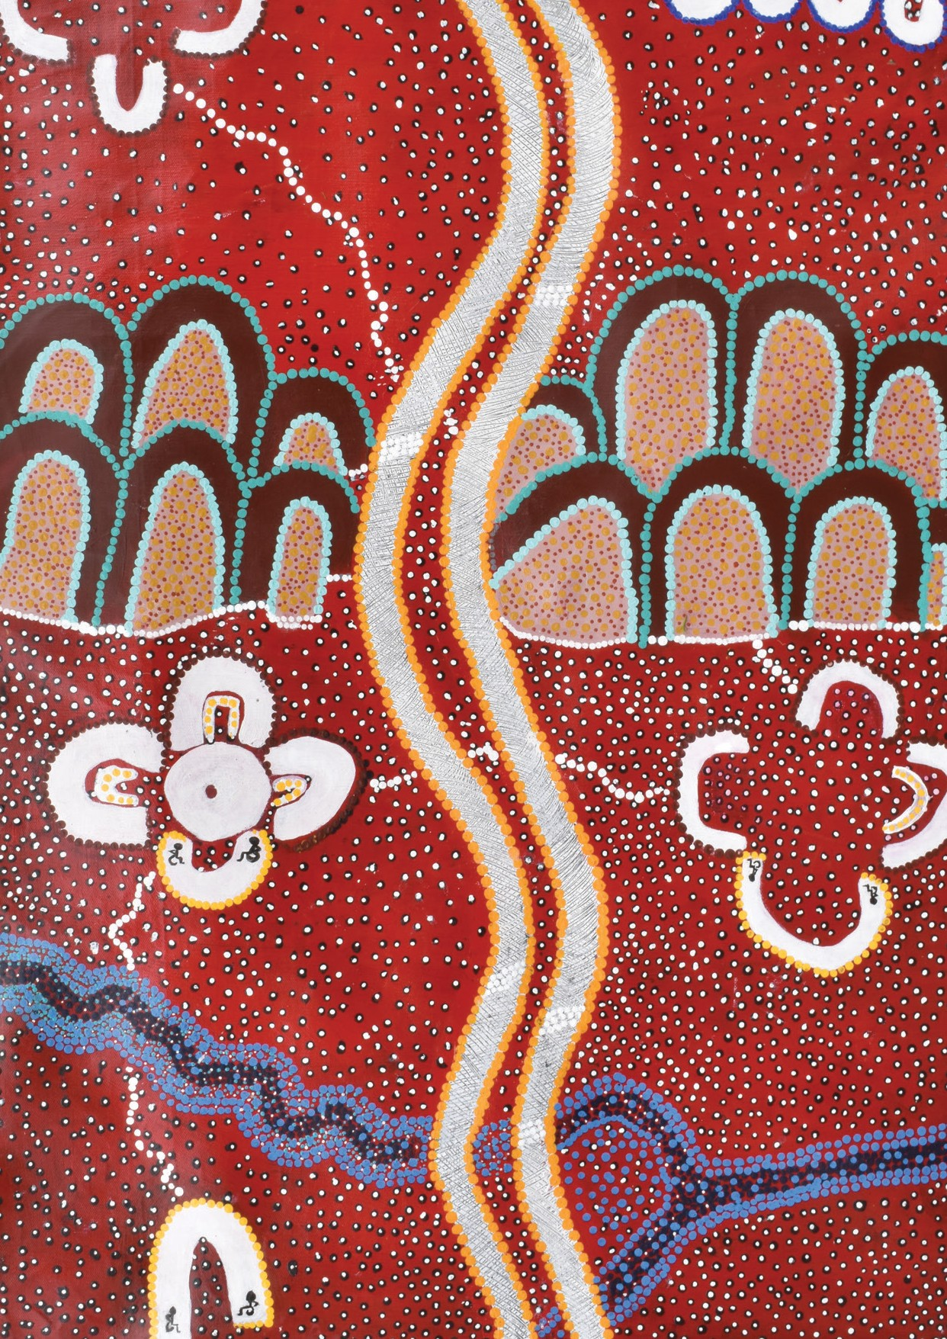
We nurture our culture for our future, and our culture nurtures us. | i

WE NURTURE OUR CULTURE FOR OUR FUTURE, AND OUR CULTURE NURTURES US.

A report prepared by the Lowitja Institute for the Close the Gap Steering Committee | March 2020

Acknowledgements
This report is a collaborative effort of the Close the Gap Campaign Steering Committee.
Authors: The Lowitja Institute
Writing and editing team: Janine Mohamed, Leonie Williamson, Phoebe Dent, Josh Power, Amy Coopes, Marie McInerney, Croakey Professional Services, Cristina Lochert
Design and Layout: Hyve Design
Printing: IndigiPrint
Published by: The Close the Gap Campaign Steering Committee
@ Close the Gap Campaign Steering Committee for Indigenous Health Equality, 2020
This work is licensed under the Creative Commons Attribution – NonCommercial – ShareAlike 2.5 Australia License. To view a copy of this license, visit: http:// creativecommons. org/licenses/ by-nc-sa/2.5/au or send a letter to Creative Commons, 171 Second Street, Suite 300, San Francisco,California, 94105, USA.
Copies of this report and more information are available to download at
https://www.humanrights.gov.au/our-work/ aboriginal-and-torres-strait-islander-social- justice/projects/close-gap-indigenous- health#qGu1R
https://www.antar.org.au/campaigns/national- close-gap-day
Cover Artwork: Tracks on the Sand, Brendan Ball, Wudjal Wudjal. The painting tells the story of Brendan’s journey to eventually becoming an Elder for Disability Business, and shows that not everyone leaves foot prints in their journey,
some people leave tracks from their wheelchair.
It talks about where he lives now, and how he spends time with community and Elders,
listening and learning about our people and how to stay strong. Eventually he will travel back to the Country of his ancestors to learn more and share knowledge about disability in our culture and how we stay strong, eventually with him taking his place as an Elder and supporting
and guiding other people with disability as they make their own tracks in the sand.

Contents

Foreword 2
Executive Summary 4
Recommendations 6
SECTION 1
8
Introduction and Overview
Why a theme of culture? 10
Why now? 12
What are cultural determinants? 13
Domains featured in this report 15
SECTION 2
16
Self-determination and Leadership
Coalition of Peaks – Collective action towards self-determination 18
Law Yarn – Wuchopperen Health Service 20
Mäwaya Health Justice Program – NAAJA and Miwatj 22

SECTION 3
24
Indigenous Beliefs and Knowledge
Lowitja Institute – Growing the Aboriginal and
Torres Strait Islander Health Research Workforce 25
Mayi Kuwayu – Understanding the Cultural Determinants of Health 26
SECTION 4
30
Cultural Expression and Continuity
NuunaRon – Identity and Belonging Through Cultural Connection 31
Creating a Culturally Safe Health System to Facilitate Cultural
Expression and Wellbeing 34
SECTION 5
36
Connection to Country
Strong Women on Country and Working for our Country 37
Aboriginal and Torres Strait Islander people should be aware that this document may contain images or names of people who have passed away.
Climate Change – An Existential Threat to Culture, Community and Country 40
Conclusion 42
Acronyms and Abbreviations 43
Endnotes 44
Close the Gap Campaign Steering Committee Members 48

Ganinyi ngarri ingga manjawurrmagi ngindaji thangani. Thangani gurrijbarra nganggawarra buga yani u, yulngarrawu. Binarri yawurrmagi biyirranggu thangani, Thirrili ngarri warawirragi, Thirrili ngarri wilawirragi, Ganbawirragi ngindaji thangani, Yarrangi dinyjili. Ngindaji thangani jurali nhi, Winyiwunggurragi yarrangi nhingi thangani.
Our ancestors that came before, created this knowledge. Our voices carry this knowledge to give to our children to carry forever. They must learn their knowledge so they can stand and speak with strength. So they can follow and know this wisdom. This
is our umbilical chord to life. This knowledge is from long ago, listen to our voices.
June Oscar AO, Bunuba language

Foreword
The failure over the past 12 years to close the gaps in Aboriginal and Torres Strait Islander health inequality, and other measures of social and economic
disadvantage, cannot be justified by more rhetoric or data in another report. Over the years we have seen so many of these gaps and measures ignored, overlooked and disregarded. Aboriginal and Torres Strait Islander peoples are not deficits
or statistics. These just hide the truth of our lived realities. For us, the harrowing failure to close the gap is felt through sorry business, the countless funerals of family and friends, the hospital visits and the coronial inquiries that we continue to painfully endure.
So many of our losses were and are preventable – that is the failure and pain we carry. Had governments had the grace to genuinely listen to our voices, to the truth, to solutions and calls to action, perhaps this, the 11th Close the Gap Campaign Report, would not be needed.
A sensible way of doing business is long overdue as, apart from small gains (2 out of 7 targets on track), the attempts to close the gaps in Aboriginal and Torres Strait Islander life
expectancy, health and education have failed. However, with a ten-year national shared decision-making agreement now signed between the Council of Australian Governments and the Coalition of Aboriginal and Torres Strait Islander Peak Organisations, we are entering a new era.
Our Campaign’s first ‘shadow’ report in 2010 asked for a seat at this table. The benefits that come from our playing a driving role and having legitimate decision-making power over our

own lives -- ‘nothing about us, without us’ -- should not be underestimated. In this report, we again demonstrate
that, through evidence and case studies with a focus on the cultural determinants of our health and wellbeing.
Our culture comes from our lore, a very deep and sacred place. The cultural determinants of our health provide many of the remedies for Aboriginal and Torres Strait Islander health equity and these determinants should be respected, understood and embraced by all. This report shows us what can be achieved by Aboriginal and Torres Strait Islander people through leadership and self-determination, owning our knowledge, continuing our cultures and maintaining connections to Country and kin.
After ongoing failures, the forthcoming Closing the Gap refresh must be backed by real action. Every year since 2010, our reports have called for significant investment, not the funding cuts we have suffered. Further investment must be directed towards our capability, our strength, our resilience, our cultures. Failure means more preventable deaths from diseases that are rare in the developed world, more shamefully high suicide rates driven by poverty unheard of in comparable countries. It means more deaths in custody.
Now more than ever is the time to listen to Aboriginal and Torres Strait Islander ways of knowing, being, doing. As our Countries burned during the 2019-20 summer, more than a billion animals perished and sacred sites were destroyed. Never before has such devastating impact of the neglect of Country been witnessed by all Australians. Going forward we must heed the wisdom of Aboriginal and Torres Strait Islander peoples. Our knowledge and cultures must be viewed as integral to improving not only the health and wellbeing of our people but of our nation. No Australian can afford further repetition of the mistakes of the past.
Finally, as Co-Chairs, we would like to thank the wider Australian public and the 52 Close the Gap Campaign members for their contribution to this work and for their ongoing support and commitment to better health outcomes for Aboriginal and Torres Strait Islander peoples.

Ms June Oscar AO Aboriginal and Torres Strait Islander
Social Justice Commissioner

Mr Karl Briscoe
CEO National Aboriginal and Torres Strait Islander Health Workers Association

Co-Chairs - Close the Gap Campaign

Executive Summary

With this report — We nurture our culture for our future, and our culture
nurtures us — we have sought to reflect the reciprocal and cyclical relationship between culture and wellbeing, whereby nurturing culture keeps us, and our future generations, healthy and strong.
Janine Mohamed, CEO, Lowitja Institute

Over the last twelve years, successive governments have failed to deliver the reforms needed to close the gap on health outcomes for Aboriginal and Torres Strait Islander people.
At the heart of this report is the recognition of Aboriginal and Torres Strait Islander empowerment as vital to wellbeing. The featured case studies have been selected
to highlight Aboriginal and Torres Strait Islander-driven approaches to health policy and program reform across four domains of the cultural determinants:
- Self-determination and leadership involve practices and processes that incorporate not only self-governance and shared decision-making, but also rights to express and
pass on culture, language, and relationships with Country.
Aboriginal and Torres Strait Islander Community Controlled Health Organisations and
the Coalition of Peaks are examples of self-determination and leadership in action. Self- determination and leadership in health and wellbeing empowers communities through culturally centred processes of decision making and delivers solutions that respond to local context.

Indigenous beliefs and knowledge
Aboriginal and Torres Strait Islander people hold complex and important knowledge systems. Embedding Aboriginal and Torres Strait Islander holistic definitions
of health and wellbeing in the way we deliver health
services is critical to improving outcomes. Recognising the expertise of Aboriginal and Torres Strait Islander people and communities in health research, policy and program development is key.

  - Cultural expression and continuity are great sources of strength and resilience for Aboriginal and Torres Strait Islander people. The trauma of cultural disruption and suppression has had a
profound effect on Aboriginal and Torres Strait Islander people’s health and wellbeing. Ongoing racism within the health system and externally continues to contribute to this trauma. Measures to promote cultural expression as a health protective factor and ensure the cultural safety of the health system are two elements that can be progressed under this domain.
  - Connection to Country Aboriginal and Torres Strait Islander society is
interconnected with land, sea and Country. Identity, cultural practices, social systems, traditions and concepts of spirituality are all drawn from, and depend upon, connection to Country. Aboriginal and Torres Strait Islander people are uniquely affected by
accelerating climate change and it is with increasing urgency that we must consider connection to Country in health and wellbeing policy.
These domains have been selected because of pragmatic limitations, not as a reflection of importance
or priority against the remaining
cultural domains of language, and family, kinship and community.
The interconnected relationship of the different domains means that they can never truly operate in isolation and we hope that evidence of the importance of the remaining domains is also relayed in this report.
As with the 2019 Close the Gap Report, we have relied on the narratives of Aboriginal and Torres Strait Islander people to provide
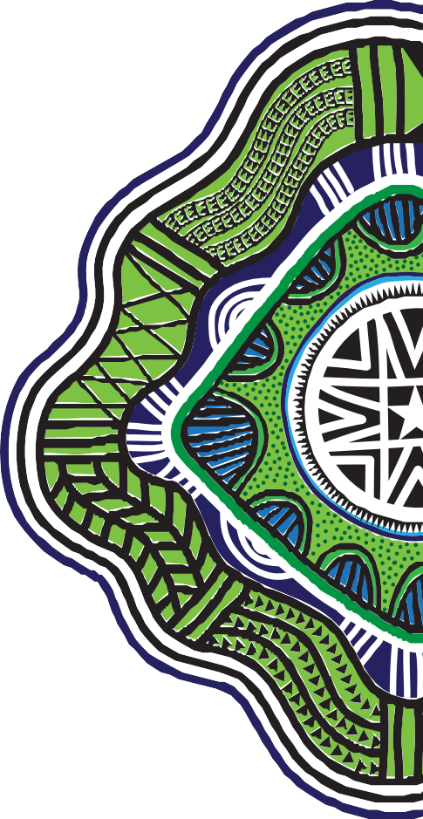
a strengths-based analysis of Aboriginal and Torres Strait Islander health and wellbeing. This is in recognition of the hard work, resilience and aspirations of Australia’s First Peoples to keep their families, communities and Country strong.
However, a strengths-based approach does not overlook the relationship of power and inequality on health outcomes and the responsibility of governments in leading systems reform. The work of communities must be matched by governments through shared decision-making, equitable (and sustained) funding and a cohesive policy approach.

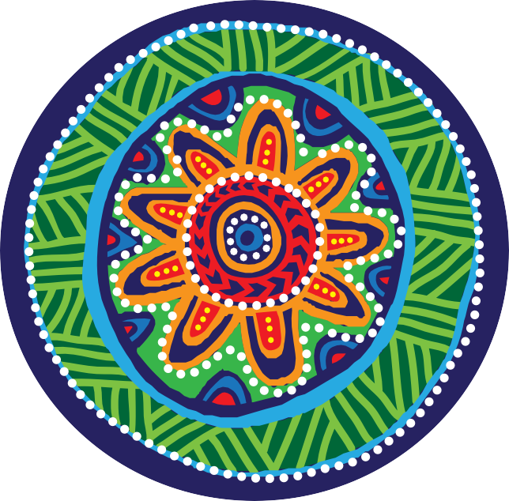Recommendations

For millennia, Aboriginal and Torres Strait Islander peoples have kept their cultures strong to nurture their health and wellbeing.

To set us on the path for systems reform that supports the cultural determinants of health that have been outlined and showcased in this Report, we affirm the following messages and calls to action:

When Aboriginal and Torres Strait Islander people are in control of the decisions that affect their lives, they have better health and wellbeing. We call on
governments and policy makers to adopt the changes needed to support Aboriginal and Torres Strait Islander self-determination and leadership. They include to:

- Take swift and comprehensive action to support the calls by Aboriginal and Torres Strait Islander people for a Voice to Parliament. As has been so eloquently stated in the Uluru Statement from the Heart:
“We seek constitutional reforms that will empower our people and to take a rightful place in our own country. When we have power over our destiny our children will flourish. They will walk in two worlds and their culture will be a gift to their country.”
This call must be heard.

- Support the Coalition of Peaks Priority Reform areas for the next Closing the Gap agreement, including investing in community control. This must be reflected by upholding the role of Aboriginal
Community Controlled Health Organisations as a fundamental component of the Australian health system.
- Embed the social and cultural determinants of health and wellbeing in the systems undertaking reform. This must include investment in First Nations’ (re)building and development to support shared aspirations and collective decision making.
- Work together and partner to effect change and ensure the cultural determinants of health are embedded across health, and Indigenous affairs more broadly. While we are starting to see the results from partnerships across sectors, and with governments, more needs to be done to ensure that this work is fully funded and implemented.
- Develop mutually agreed principles and parameters of partnerships and co-design processes, to ensure the legitimacy and sustainability of joint decision-making arrangements. This must include measures to assess the strength and effectiveness of partnerships on a regular basis.

6 | We nurture our culture for our future, and our culture nurtures us.
6 | We nurture our culture for our future, and our culture nurtures us.

Aboriginal and Torres Strait Islander people know the solutions to the issues affecting their lives and they must be in the driver’s seat of health reforms and service delivery for their people. More must be done to link Aboriginal and Torres Strait Islander ways of knowing, being and doing with health and wellbeing policies and programs, including to:

- Put Aboriginal and Torres Strait Islander people in charge of their own data (and decisions) by recognising and upholding the principles of Indigenous Data Sovereignty.
- Invest in Aboriginal and Torres Strait Islander led health and wellbeing research, including knowledge translation and research impact.
- Recognise and restore Indigenous wellbeing methods and practices, including healing, plant-based medicines and ceremony, through development of social enterprise. These should be utilised within healthcare service settings and provided appropriate intellectual property protections.
- Support and build the Aboriginal and Torres Strait Islander health workforce, including Aboriginal and Torres Strait Islander Health Workers, Health Practitioners and community researchers as important cultural brokers.

Culture is a protective factor for health and wellbeing, and cultural expression is healing and has health benefits. We must nurture culture to facilitate its expression and continuity for future generations and ensure that this expression is valued and respected by all Australians. This will need governments and health systems to:

- Invest in long term Aboriginal and Torres Strait Islander designed and led place-based initiatives that use cultural expression to enhance health and wellbeing.
- Pursue truth telling as relevant to health system reform and as an important vehicle for resetting the relationship with Aboriginal and Torres Strait Islander people.
- Create a culturally safe Australian health care system that is responsive to the needs of Aboriginal and Torres Strait Islander peoples. This means building a robust, equitable and transparent
health care system where: institutional racism is acknowledged, measured and addressed; cultural safety training is undertaken regularly and valued as an important step in closing the gap; and Aboriginal and Torres Strait Islander people are integral and valued members of the health workforce.

Connection to Country is intertwined with Aboriginal and Torres Strait Islander health and wellbeing and is a cultural determinant of health. While at the frontlines of climate change, Aboriginal and Torres Strait Islander peoples also hold unique knowledge and practices relevant to addressing the climate crisis. These solutions stand to benefit both the environment and the health of all Australians. We call on governments to:

- Grow and secure the Indigenous rangers and Indigenous Protected Areas programs in line with calls made by the Country Needs People Campaign, including committing to a 10-year funding horizon and supporting a long term target of 5,000 jobs in Indigenous land and sea management across Australia.
- Act to repair, restore and protect Country from future harm. This includes local, national and international cooperation. While Indigenous caring for Country practices are important, they must be coupled with government actions and regulations. We all must take responsibility for looking after Country.

We nurture our culture for our future, and our culture nurtures us. | 7
We nurture our culture for our future, and our culture nurtures us. | 7

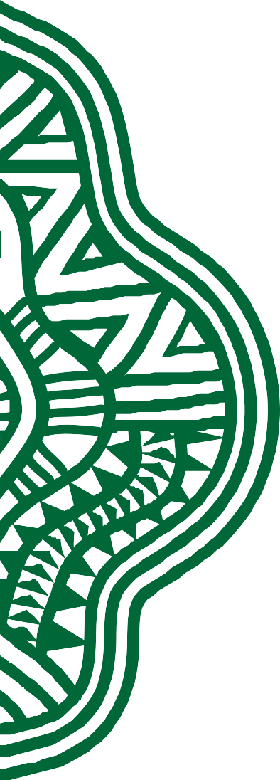
Introduction and Overview

In 2005, the then Aboriginal and Torres Strait Islander Social Justice Commissioner Tom Calma called for Australian governments to commit to achieving equality for Aboriginal and Torres Strait Islander people in health and life expectancy within 25 years. The Close the Gap Campaign for Indigenous Health Equality (Close the Gap Campaign) was first convened by Commissioner Calma in 2006 and the first National Close the Gap Day was held in 2007. At the heart of the Campaign was the rights-based approach outlined in the 2005 Report.1

Driven by these calls a Close the Gap Statement of Intent was signed in 2008, as a compact between governments of Australia and
the Aboriginal and Torres Strait Islander peoples, to work together to achieve equality in health status
and life expectancy. Later that same year the Council of Australian Governments (COAG), representing all tiers of governments, also agreed to focus on addressing Indigenous disadvantage through
a commitment to meet six Closing

FIGURE 1:
Life tables for Aboriginal and Torres Strait Islander Australians, 2015–2017 (extract)

Source: Australian Bureau of Statistics 2018, Life tables for Aboriginal and Torres Strait Islander Australians, 2015–
2017, Cat. no. 3302.0.55.003,
ABS: Canberra. Cited in Closing the Gap 2020
100
90
80
70
60
Years
50
40
30
20
10
0

Males Females

Indigenous Non-Indigenous

the Gap targets, including to close the life expectancy gap within a generation.2
The COAG agreement recognised that overcoming Indigenous disadvantage would require a long- term, generational commitment with major effort to be directed across
a range of strategic platforms or ‘Building Blocks’ including early childhood, schooling, health, economic participation, healthy homes, safe communities, and governance and leadership.
After an ongoing series of changes and the introduction of a seventh Closing the Gap target by Australian governments, in 2018 the Close the Gap Campaign delivered a ten-year review that found:
  - Governments had failed to coherently implement the Closing the Gap Strategy, including failure to appropriately fund policy commitments and undertake the required systemic reform.
  - Governments had effectively abandoned the Closing the Gap Strategy after five years.
The review warned that, without a reset, the targets would continue to measure nothing “but the collective failure of Australian governments to work together and stay the course”.3
Consistent with this prediction, the 2020 Prime Minister’s Closing the Gap Report found that only two of the seven targets are on track. Despite 12 years of action little progress has been made. The whole-of-government Closing the Gap policy agenda has fallen well short of the mark.
The 2020 report shows a life expectancy gap of 8.6 years for males and 7.8 years for females remains (Figure 1).4 The Indigenous burden of disease rate continues to be 2.3 times higher than for
non-Indigenous Australians, with mental and substance use disorder (19%), injuries (including suicide) (15%), cardiovascular diseases
(12%), cancer (9%) and respiratory diseases (8%) the leading causes of total disease burden.5 It is clear a reset in our approach is needed.

When I think about
the injustices experienced by Aboriginal and Torres Strait Islander peoples, I sometimes feel overwhelmed. A widening gap in life
expectancy, soaring rates of incarceration, our children taken away from their families at 10 times the rate of non-Indigenous children, our women dying at epidemic levels from domestic and family violence. Where do we even start?
June Oscar AO
Aboriginal and Torres Strait Islander Social Justice Commissioner6

Why a theme of culture?

Aboriginal and Torres Strait Islander people hold a culturally centred view of health and wellbeing.
This is anchored in ways of knowing, being and doing that have existed and continued for tens of
thousands of years, shared through complex kinship systems and passed down through systems of law, ceremony and song.
Contemporarily this has been expressed by Aboriginal and Torres Strait Islander people in policy documents such as the 1989 National Aboriginal Health Strategy’s definition of health,
the emphasis on the social and cultural determinants of health within the National Aboriginal and Torres Strait Islander Health Plan 2013–2023 (NATSIHP) and the
United Nations Declaration of the Rights of Indigenous Peoples.
This view of health and wellbeing was again reflected back by the community in the My Life, My Lead national consultations conducted by the Australian Government where the submissions and consultations emphasised the centrality of culture and recognised that strong connections to culture and family were vital for good health and wellbeing.7 Yet repeated governments have failed to
address the structural and systemic discrimination that inhibits our cultures, and to undertake the reforms needed to truly embrace a culturally centred approach.
The 1970s have been described as marking the beginning of a ‘cultural renaissance’8 of Aboriginal and Torres Strait Islander people. As oppressive laws of assimilation and segregation lifted, Indigenous writers, artists, musicians and philosophers emerged.
In 2020 this resurgence of cultural knowledge and practices continues to gain momentum.
Practices that have been hidden, or laid dormant, under colonial practices of assimilation are being revived by Aboriginal and Torres Strait Islander peoples who are working to restore the wellbeing of their communities and future generations. Examples include the Firesticks Alliance, an Indigenous led network to re-invigorate

National Aboriginal Health Strategy 1989
– Definition of health

‘Aboriginal health’ means not just the physical well-being of an individual but refers
to the social, emotional and cultural well-being of the whole Community in which each individual is able to achieve their full potential as a human being, thereby
bringing about the total well- being of their Community.
It is a whole of life view and includes the cyclical concept of life-death-life.

United Nations Declaration on the Rights of Indigenous Peoples 2006– Article 24

- Indigenous peoples have the right to their traditional medicines and to maintain their health practices, including the conservation of their vital medicinal plants, animals and minerals. Indigenous individuals also have the right to access, without any discrimination, to all social and health services.
- Indigenous individuals have an equal right to the enjoyment of the highest attainable standard
of physical and mental health. States shall take the necessary steps with a view to achieving progressively the full realization of this right.

cultural burning, revival of Birthing on Country practices, and the rebuilding of languages through initiatives such as the Ngunnawal language revival project being
led by the Australian Institute of Aboriginal and Torres Strait Islander Studies (AIATSIS) and the Living First Language Program through the Australian Literacy & Numeracy Foundation (ALNF).
Across the country Aboriginal and Torres Strait Islander communities are leading the way, shaping a vision of health and wellbeing built upon a foundation of culture. The challenge for health systems committed to achieving positive change is: how to shift institutions and thinking beyond embedded medical models of health towards a model that puts culture as the

foundation for good health and wellbeing?
This Report aims to address this question and to illustrate the pathway forward through case studies that speak to four domains of the cultural determinants of health:
- Self-determination and leadership

- Indigenous beliefs and knowledge
- Cultural expression and continuity
- Connection to Country.

It is hoped that by showcasing these examples we can help articulate Indigenous-led opportunities for broader systems reform.

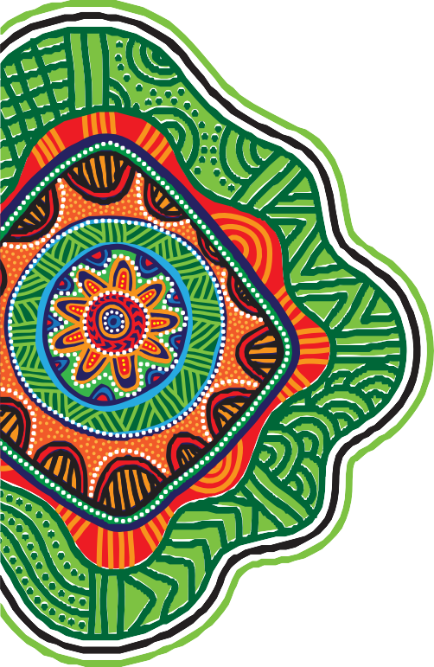
Why now?

In the 12 years since the Close the Gap Statement of Intent was first developed, the debate on health equality versus health equity has grown.
This has included critiques of the Closing the Gap strategy’s target- driven emphasis on statistical deficit (or disadvantage) rather than a culturally centred analysis of health and wellbeing.9 Part
of what has driven this deficit discourse has been the reliance of governments on what can easily be tracked within the parameters of existing government knowledge
and statistical resource—rather than an understanding of the inherent elements of wellbeing as identified by Aboriginal and Torres Strait Islander people.

Aboriginal and Torres Strait Islander communities and organisations have pushed back on this deficit discourse and called for system reforms that support Indigenous ways of knowing, being and
doing in health policies, programs and services—approaches that centralise self-determination and respect their voices and choices.
The challenge of interpreting culture within a framework that can be broadly applied to health policy and programs, and to be measured,
has tested health researchers and policy makers over the last decade.
However, we are beginning to see new ways of knowing, being and doing emerge to promote
a broader understanding of the cultural strengths and resilience of Aboriginal and Torres Strait Islander peoples.

Social Determinants of Health

The World Health Organization (WHO) defines the Social Determinants of Health as the conditions in which people are born, grow, work, live, and age. These circumstances are shaped by the distribution of money, power and resources at global, national and local levels. The social determinants of health are mostly responsible for health inequities — the unfair and avoidable differences in health status seen within and between countries.10 Examples of areas where cross-sectoral policy action to address the health determinants can be focused include housing, energy, environment, education, transport and social protection.
It has been estimated that up to a third (34%) of the gap between Aboriginal and Torres Strait Islander and other Australians’ health outcomes can be explained by social determinants of health, such as education, employment, housing and income, which all exert a powerful effect on the health and wellbeing of all peoples.11
More recently the WHO has framed a Health in all Policies approach, that focuses on policy coherence of health across all sectors of government and is an important component of progressing the United Nation’s Sustainable Development Goals.

What are cultural determinants?

In the mid-2000s the WHO Commission on Social Determinants of Health helped promote broad health policy understanding of the social and economic factors leading to health inequality.
Cultural Determinants originate from and promote a strength based
perspective, acknowledging that stronger connections to culture and country build stronger individual and collective identities, a sense of self-esteem, resilience, and improved outcomes across the other determinants of health, including education, economic stability and community safety.
Professor Ngiare Brown12

While this work played an important role in understanding poor health outcomes in communities such as First Nations, it was recognised that the role of culture as a determinant of health remained largely unexplored.13
For Aboriginal and Torres Strait Islander people, the concept of health has always been understood to be holistic and to encompass mental, physical, cultural, environmental and spiritual health.14
In 2011, in a collaborative process with the Australian Government, Aboriginal and Torres Strait Islander people ensured that the NATSIHP 2013–2023 placed culture at the centre of health and wellbeing and spoke to the social determinants
of health. So too does the National Strategic Framework for Aboriginal and Torres Strait Islander Peoples’ Mental Health and Social and Emotional Wellbeing 2017–2023, which notes that communities
can be “sources of support and resilience that promote social and emotional wellbeing when community organisation and functioning is culturally informed and provides for cultural practice and transmission”.15

Professor Ngiare Brown offered a strong understanding of the cultural determinants of health in her definition (above). However, for some time there was still a struggle to articulate how the
critical elements of culture could be observed, understood and utilised to drive improvements in individual and community wellbeing.16
In 2014, the Lowitja Institute, Australia’s national institute for Aboriginal and Torres Strait Islander health research, held a roundtable to discuss the need to promote
a greater understanding and appreciation of the relationship between Aboriginal and Torres Strait Islander culture and health to policy makers, and to provide evidence to support that need, particularly in the Australian context.
Organisations such as the Australian Indigenous Psychologists Association (AIPA),17 Australian Indigenous Doctors’ Association (AIDA)18 and Yawuru19 have also contributed to this work by offering frameworks that define wellbeing by

Aboriginal and Torres Strait Islander standards and within a cultural context.
Perhaps the most notable step, so far, in developing contemporary research on the role of Aboriginal and Torres Strait Islander culture and wellbeing was the launch of the Mayi Kuwayu National Study of Aboriginal and Torres Strait Islander Wellbeing in 2014. As part of its groundbreaking work (featured as
a case study in Section 3 of this Report), it has identified six main domains to describe culture specific to Aboriginal and Torres Strait Islander peoples in Australia (see Table 1).20

Domains and sub domains for describing culture specific to Aboriginal and Torres Strait Islander peoples in Australia as identified in the Mayi Kuwayu literature review
The six domains are:
Connection to Country
SUB-DOMAINS

spiritual connection health and traditional foods
living on Country land rights and autonomy
caring for Country
“Our country is like our garden – we need to look after it. There are trees, birds, waterways, fish, mammals and reptiles, and they are all important. We keep country healthy and country keeps us healthy.”
Dhimurru Senior Ranger Fiona Yupunu Marika
Family, kinship and community
SUB-DOMAINS

family and kinship community
“A child is a gift to the family—that is to the entire kinship network: he or she is the living evidence that the culture is alive and surviving.”21
Indigenous beliefs and knowledge
SUB-DOMAINS

spiritual and religious beliefs traditional knowledge traditional healing
knowledge transmission and continuity
“Culture is central to identity since it “defines who we are, how we think, how we communicate, what we value and what is important to us.”
Steve Larkins22
Cultural expression and continuity
SUB-DOMAINS

identity cultural practices
art and music
“Having your own voice is very powerful and healing… [M]usic was great therapy for me – it still is.
It gave me a way to express myself…”
Archie Roach AM23
Indigenous language
SUB-DOMAINS

impacts of language on health language revitalisation
Aboriginal and Torres Strait Islander language education
“The research shows that knowledge of language helps Aboriginal and Torres Strait Islander people strengthen their cultural identity, integral to health and wellbeing and by extension, the health and wellbeing of society as a whole.”
Craig Ritchie, CEO AIATSIS24
Self-determination and leadership
SUB-DOMAINS

cultural safety
self-determination and wellbeing leadership.
“We need to own our own risk and that any dramatic shift and change in our circumstances for the better of our children
and families can only come from our own determination, our discipline, commitment and leadership, at an individual and
collective level, in driving the change required.”
Peter Yu, CEO Nyamba Buru Yawuru25

Domains featured in this report

The domains identified in the Mayi Kuwayu study have been used to inform and frame the cultural determinants of health discussed in this Report, which is ordered under four of these domains:

  - Self-determination and leadership
  - Indigenous beliefs and knowledge
  - Cultural expression and continuity
  - Connection to Country.
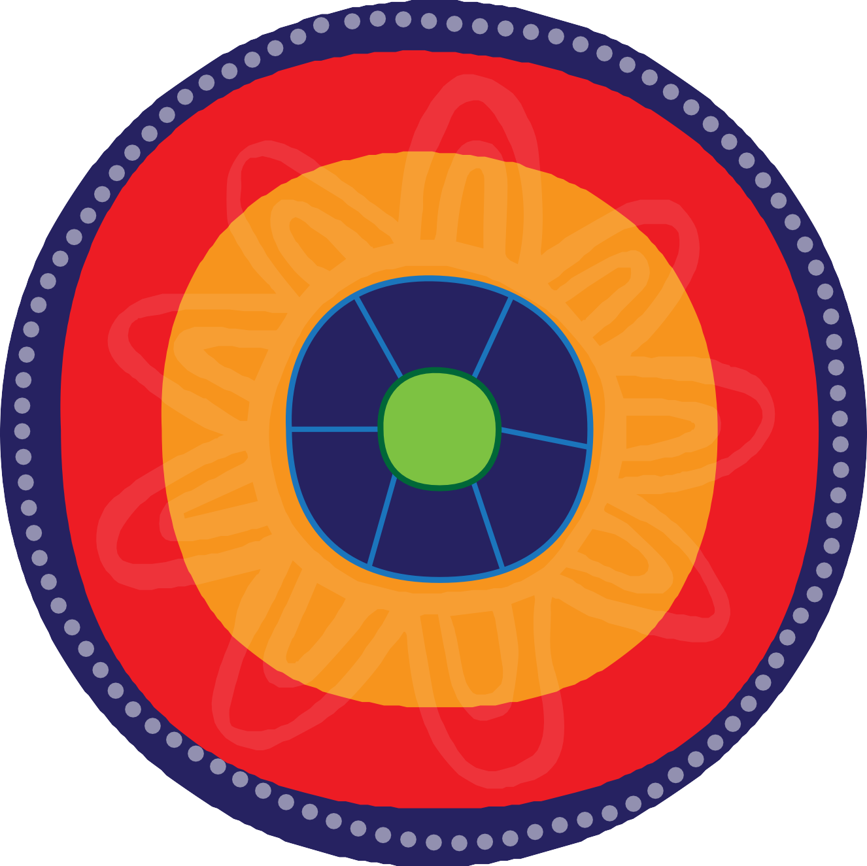This is not a position on priority or order, rather a pragmatic limitation to the amount of material considered.
a
s
Culture
u
A
n a

wh
g•
o
or
s a
- e
- i

Self-determination and Leadership

The right to self-determination is one of the central principles enshrined by the United Nations Declaration on the Rights of Indigenous Peoples, acknowledging the right to self-govern, participate in decisions and exercise control.
Freedom to exercise one’s own values and beliefs, or culture, is also a critical element.26

‘Sustainable development’ is a term that has been coined to frame an understanding of self-determination as a “process premised on the notion that evolving indigenous livelihoods, food security, community governance, relationships to homelands and the natural world, and ceremonial life can be practiced today locally and regionally, thus enabling
the transmission of these traditions and practices to future generations”.27
Effectively implementing the cultural determinants of health requires the leadership and self-determination of Aboriginal and Torres Strait Islander peoples. It requires a process whereby community define their shared aspirations and lead the design and delivery of policies and programs accordingly.
As drawn out in work by Dudgeon et. al. on Indigenous governance for suicide prevention:
“When communities are in control of process, better outcomes could be expected. And not only because tailored and culturally adapted mainstream interventions ‘owned’ (by) a community are likely to be significantly more impactful. But more importantly
… broader design processes under Indigenous governance will identify and address other deeper, structural problems that could also be contributing to suicide, or could protect against it.”28

16 | OUR VOICES, OUR CHOICES.
16 | We nurture our culture for our future, and our culture nurtures us.

This can occur through many forms, including the operation of Aboriginal and Torres Strait Islander
community controlled organisations, Indigenous governance practices, informal community driven reforms to services and systems, and through partnerships.
Formal partnerships, which ensure the full involvement of Aboriginal and Torres Strait Islander people in shared decision-making, are needed at national, state, local and regional levels. To effectively embed the expertise, ownership and responsibility of Aboriginal and Torres Strait Islander people, partnerships require clear arrangements which say who
is making decisions, how those decisions will be made and what those decisions will be about.
The Partnership Agreement on Closing the Gap, agreed in March 2019 and signed by the Australian Government, all State and Territory governments and the Australian Local Government Association, has set a benchmark for partnerships with Aboriginal and Torres Strait Islander people. It sets out how governments and Aboriginal and Torres Strait Islander peak bodies will work together to agree a new national agreement on Closing the Gap, including any new Closing the Gap targets and implementation and monitoring arrangements.
ACCHOs – A history of self-determination and nation rebuilding
“The first Aboriginal community controlled health service was established by the local Aboriginal community in Redfern in July 1971 to address the blatant discrimination experienced in mainstream services, the ill health and premature deaths of Aboriginal people, and the need for culturally appropriate and accessible health services.” Aboriginal Health & Medical Research Council of NSW
Since that first service in Redfern, Aboriginal Community Controlled Health Organisations (ACCHOs) have pioneered needs-based primary health care and social justice driven services across Australia. Today they form a network of over 141 organisations nationwide.
From local community driven organisations, they have created an infrastructure of regional, state and national bodies to ensure more effective knowledge creation and translation, program management and political advocacy. Importantly, ACCHOs have provided centres for Nation rebuilding where Aboriginal and Torres Strait Islander people across urban, regional and remote communities have been able to come together and form governance structures to enact shared decision making and deliver outcomes for their communities. 30
For Aboriginal and Torres Strait Islander people control over health and wellbeing has always been significant.29 It is a matter that has united communities and driven
the establishment of community governed services and advocacy bodies over many years (see Box ACCHOs).
Today ACCHOs continue to be at the forefront of ensuring needs- based service delivery reform.
The implementation of Health Justice Partnerships (see Box Health Justice Partnerships) within community controlled settings to address the complex intersection between health and legal needs is another example of Aboriginal and Torres Strait Islander community driven solutions.
These community driven responses raise important questions for policy makers about what resources are needed for communities to build the governance structures for participation in high-level decision making, and how local needs can shape higher-level system reforms.
Despite the innovation and resilience evident within their history, ACCHOs and other community controlled sectors have long struggled to
make ends meet under inequitable and burdensome funding frameworks and processes.31 The significance of community control to self-determination, and of self- determination to wellbeing, is in stark contrast with the funding arrangements, or lack of funding, that so often leaves community organisations and Indigenous leadership vulnerable to changes in government.
The Close the Gap Campaign continues to call for an equitable funding framework to not only sustain, but expand the work of community controlled organisations.

Coalition of Peaks – Collective Action Towards Self-determination

The Coalition of Peaks is a representative body made up of almost 50 Aboriginal and Torres Strait Islander community controlled organisations. It is working with governments to finalise a new national agreement on Closing the Gap. This is the first time that Aboriginal and Torres Strait Islander people, through their peak body representatives, will share formal decision making with governments on policies that affect us.
“The truth is that the existing Closing the Gap framework was doomed to fail when it was designed without the input of
Aboriginal and Torres Strait Islander people,” Pat Turner said, on behalf of the Coalition of Peaks when the 2020 Closing the Gap report was released by the Prime Minster.
“We know what will work best for our communities and the Prime Minister even acknowledges in this (latest) report that our voice was the missing ingredient from original framework.”
The Partnership Agreement, formally agreed by COAG and the Coalition of Peaks in 2019, sets out how they will work together over the next ten years on Closing the Gap.
It sets a new benchmark for partnerships between Aboriginal
and Torres Strait Islander people and governments. It is also an acknowledgement that Aboriginal and Torres Strait Islander people have been silenced on policies and approaches to close the gap in the past and that outcomes for
Aboriginal and Torres Strait Islander people are not going to change without their genuine involvement in policies and programs.
This historic partnership has the potential to transform how Closing the Gap policy and programs are designed and delivered.
Knowing that it is vital that other Aboriginal and Torres Strait Islander organisations and communities have their say on the next phase
of Closing the Gap, the Coalition of Peaks has led a series of engagements across Australia, in order to hear what changes are needed to improve the lives of
Aboriginal and Torres Strait Islander

The Coalition of Peaks is a case study in self-determination. We
have exercised political agency by leading the way, challenging the possibilities and creating a future of shared decision- making with governments on policies and programs that impact on our people and our communities.
Pat Turner, Lead Convener of the Coalition of Peaks, and CEO of the National Aboriginal Community Controlled Health Organisation (NACCHO)
people.

Among many contributions was this from a community member in Broome: “Rather than ‘closing the
gap’, governments should ‘open the gate’ to Aboriginal and Torres Strait Islander people making decisions that affect their lives.”
Reflecting on the success of these engagements, Pat Turner notes “the conversation is different when Aboriginal and Torres Strait Islander organisations lead the conversation with our people. It leads to better outcomes.”

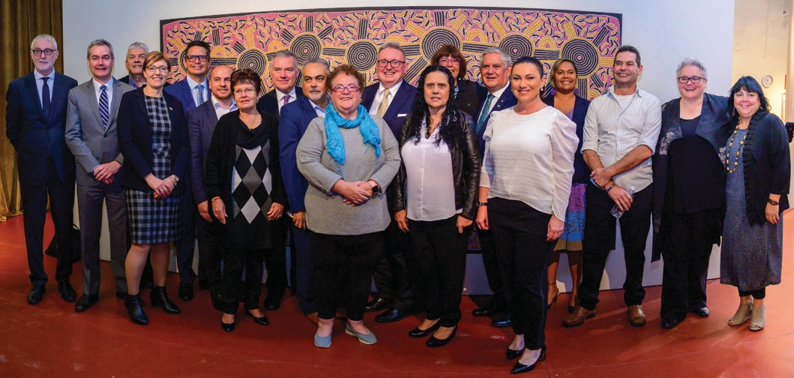
PHOTO: Joint Council on Closing the Gap meeting 23 August 2019, Adelaide, South Australia. L–R: Gavin Jennings, David O’Loughlin, John Paterson, Rachel Stephen-Smith, Ben Wyatt, Jamie Lowe, Vicki O’Donnell, Stephen Wade, Trevor Pearce, Cindy Berwick, Don Harwin, Muriel Bamblett, Pat Turner, Ken
Wyatt, Natalie Lewis, Selena Uibo, David Warrener, Katrina Fanning, Cheryl Axleby

The Coalition of Peaks have proposed three Priority Reforms to change the way governments work with Aboriginal and Torres Strait Islander people and accelerate progress on closing the gap. They are:
    - Priority Reform 1: Developing and strengthening structures to ensure the full involvement of Aboriginal and Torres Strait Islander peoples in shared
decision making at the national, state and local or regional level and embedding their ownership, responsibility and expertise to close the gap.
    - Priority Reform 2: Building the formal Aboriginal and Torres Strait Islander community
controlled services sector to deliver Closing the Gap services and programs in agreed priority areas.
- Priority Reform 3: Ensuring all mainstream government agencies and institutions undertake systemic and structural transformation to contribute to Closing the Gap.
The Coalition of Peaks reported overwhelming support for the Priority Reforms during the engagements. One theme that regularly emerged was that shared decision-making depends on all parties having access to the same information. That is leading to the development of local data projects as a fourth Priority Reform.
The Coalition of Peaks is now working hard with Australian governments to ensure the outcomes of the engagements are reflected in the new National Agreement on Closing the Gap,
which is expected to be finalised in mid-2020.
Pat recognises that the priority reforms are not new, they are “what Aboriginal and Torres Strait Islander peoples have been saying for a long time is needed to close the gap
and we now have a formal structure in place to put those solutions to governments.”

Law Yarn – Wuchopperen Health Service

Nearly two years ago, a group of Elders in northern Queensland were struggling with the process of reclaiming wages that had been stolen for decades by the Queensland Government.

Wuchopperen Health Service represents a home for my mob. I knew
that, if we were able to put lawyers in that space, that was going to shift the narrative in a way that my people could access health and justice, in the one place, through community, through culture, through those systems that are able to make us feel strong.
Donnella Mills

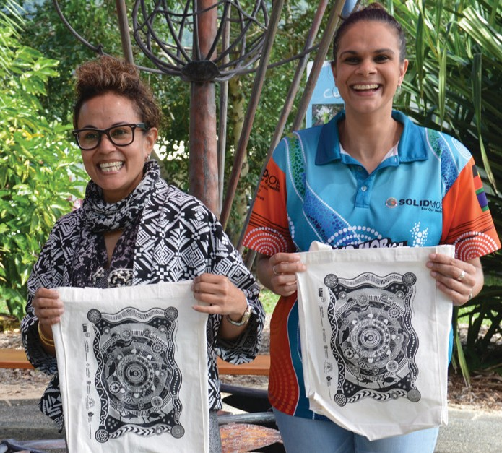
PHOTO: Donella Mills (Project Lawyer, LawRight), Gail Sevallos (Wuchopperen Health Service)
They weren’t sure how to get justice when they already had so many reasons to distrust government.
Doctors at the Aboriginal community controlled Wuchopperen Health Service, which works on
the traditional lands of the Gimuy- walubarra yidi, Yirrganydji and Yidinji peoples in and around Cairns, saw that this worry was affecting the Elders’ health.
They referred the Elders to their onsite lawyer Donnella Mills, from the community legal service Law Right. Donnella is a Torres Strait Islander woman who is now also chair of NACCHO.
“All this historic distrust of government had come into play in a really strong way,” she says of the Stolen Wages case. “It was causing high blood pressure and anxiety for
the Elders because they didn’t know how to navigate all the different systems that were involved.”
But having a legal centre that is embedded at Wuchopperen through a Health Justice Partnership with Law Right has opened a new pathway to justice.
“We did week after week of ‘pop up’ clinics, we would bring busloads of old people to the clinic, we would help them with the paperwork and give them legal advice,” Donnella says.
As well as returning stolen wages to around 100 clients, the Elders gained “a sense of being empowered and of finally being heard about these historical injustices.”

For Donnella, it was one of many examples she has seen in her work at Wuchopperen of where justice and health intersect.
Others, she said, can be in the stress of having to go to court, eyesight issues that limit capacity to respond to letters of demand, sickness that means someone cannot work and therefore cannot pay a fine. It can be that people do not know their rights when they live with poor plumbing, in overcrowded housing, or with other tenancy issues that can affect health and wellbeing.
Donnella also describes another case where she acted for a young pregnant woman who was experiencing family violence and
It documented health and wellbeing impacts that have been profound for individuals and the community: less exposure to family violence, reduced anxiety, improved connection to health services, improved financial resilience, increased capacity to exercise rights, prevention of homelessness and support for victims of crime and historic injustice.
The evaluation looks particularly at the cultural determinants of
health, measuring impact in a range of areas, from “being heard and validated in a culturally capable way” to “addressing racism and personal and structural social exclusion”. It concludes:
“This particular (Health Justice Partnership) is much more than just about ‘delivering legal advice in a different space’. It reinforces community control and self-
determination, and also strengthens culture.”

likely would have lost custody of her baby because of a range of structural issues affecting her.
However, the health centre worked with Donnella to keep the woman and her newborn safe and together.
Donnella says this is a powerful example of the way that the health justice partnership is delivering prevention and early intervention in culturally safe ways, stopping unmet civil and family issues from escalating into over-representation of Aboriginal and Torres Strait Islander children in out of home care and prisons “bulging with our men and women”.
A formal evaluation of the Wuchopperen Health Justice Partnership found that every client experienced better health and wellbeing as a result of their legal needs being met, and that 86 per cent of those clients would not have accessed legal support if it had not been based at Wuchopperen.
Health Justice Partnerships
The impact of intersecting health and legal needs on Aboriginal and Torres Strait Islander people has been well documented within inquiries and reports such as the Royal Commission into Black Deaths in Custody and Ampe Akelyernemane Meke Mekarle: ‘Little Children are Sacred’: Report of the Northern Territory Board of
Inquiry into the Protection of Aboriginal Children from Sexual Abuse.

However, the continual growth in rates of Indigenous incarceration, deaths in custody and child removal indicate a failure to enact the type of systems reforms needed.
Health Justice Partnerships place lawyers in health and wellbeing services to work collaboratively with health care professionals.
They recognise the complexity of health and wellbeing, and that unaddressed legal needs (such as housing advocacy, unpaid fines and family violence) can have a health harming impact.
Health Justice Partnerships are built around a social determinant approach to health and wellbeing. Embedding these services within the Aboriginal and Torres Strait Islander community controlled sector extends this rights based approach for Aboriginal and Torres Strait Islander people and communities by coupling them with culturally safe care.
Health Justice Australia, the national centre of excellence in health justice partnerships, has recorded 17 health justice services located in Aboriginal and Torres Strait Islander support settings, including 15 partnered with Aboriginal Community Controlled Health Organisations.32

Mäwaya Health Justice Program – NAAJA and Miwatj

Locating lawyers within health services in remote East Arnhem Land communities is promising to be a ‘game-changer’ for Yolngu people, stopping many legal issues from escalating into criminal and health issues.
The arrangement has come about through a pilot Health Justice program, called Mäwaya, between the Darwin-based North Australian Aboriginal Justice Agency (NAAJA) and the Miwatj Health Aboriginal Corporation.
It is the first collaboration of its kind between Aboriginal community controlled legal and health services in Australia.
Previously, lawyers from NAAJA set up their legal support for East Arnhem Land communities in front of the Yirrkala art centre or in the Nhulunbuy town square. But after they moved into a health service, their ability to engage with clients
and with members of the community who had previously not accessed legal services was transformed.
NAAJA CEO Priscilla Atkins says that having lawyers working regularly as ‘visiting specialists’ in a health service that is embedded in the community and in community ways is a huge

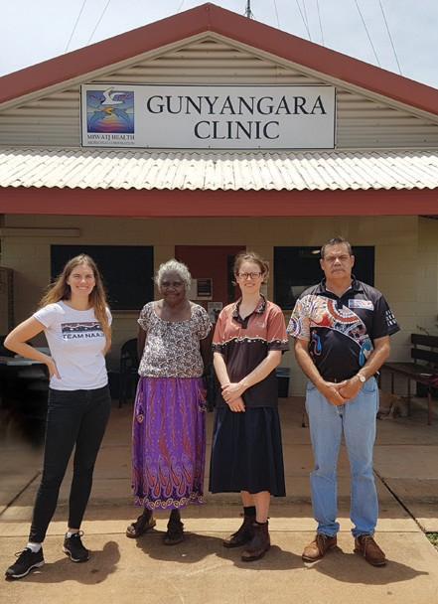
Having a Health Justice program means it is health working hand in hand with justice. The impact on health issues is huge if we’re addressing legal issues at an early stage.
Priscilla Atkins, CEO, NAAJA

PHOTO: NAAJA, Miwatj Health and Aboriginal Interpreter Service staff delivering
co-located services under the Mäwaya Health Justice Program at Gunyangara Clinic, East Arnhem Land
L–R: Michaela Vaughan, Gayili Marika, Jordina Rust,
Vernon Patullo

answer to wellbeing in Aboriginal communities across Australia.
“Most of our mob go to Aboriginal medical services on a regular basis, it’s a safe place, a trusted place, people know each other,” says Priscilla, who is an Eastern Arrernte woman from Central Australia.
“This is the next big thing, it’s changing how an Aboriginal Medical Service and an Aboriginal Legal Service work,” she says.
As with the program at Wuchopperen, the collaboration is important because it stops many legal issues from escalating into criminal and health issues.
“The biggest issue for our mob is that they don’t realise they can treat their legal problems early, or don’t identify that something is a legal problem that can be easily addressed,” Priscilla says.
“Yolngu people have also been caught up in unfair practices, for example, where people from
remote communities have been sold expensive, inappropriate mobile phone plans that they did not understand and could not afford— causing huge debts and anxieties.”
Children have been taken into care because of ‘failure to thrive’ when a child actually has a medical issue that was not identified by child protection workers because they did not use an interpreter when talking with people for whom English is a third or fourth language.
These are the sorts of issues that NAAJA and Miwatj staff now work on jointly, with health workers learning skills to untangle legal issues, to ask clients “how’s it all going with your housing?” or ‘”anything of concern for your kids?”, and to then refer them for quick legal support, whether for housing, discrimination, health or child protection issues.
What makes the NAAJA/Miwatj collaboration even better is the cultural strength the two community controlled services bring to the program.

Child removal
In 2018, Aboriginal and Torres Strait Islander children were 10.2 times more likely to be living in out-of-home care than non-Indigenous children.
Aboriginal and Torres Strait Islander children represent 37.3 per cent of the total out-of-home care population, including foster care, but only 5.5 per cent of the total population of Australian children.
Without urgent action, the number of Aboriginal and Torres Strait Islander children in out-of-home care is projected to double within the next 10 years.
Nationally, Aboriginal and Torres Strait Islander children are 2.6 times more likely to be developmentally delayed at the age of five.33
The intent is to build the collaboration from a pilot program to a Health Justice Partnership. A funding proposal and evaluation of the
pilot is currently with the Australian Government for consideration.
Priscilla says the dynamics are very different when Aboriginal
organisations governed by Aboriginal people with Aboriginal staff are working together.

Incarceration
Aboriginal and Torres Strait Islander people represent 28 per cent of the total adult prison population34 despite making up 2% of the total
Australian adult population.35
Aboriginal and Torres Strait Islander young people are 17 times more likely to be under youth justice supervision than non-Indigenous young people.36
Aboriginal and Torres Strait Islander women represent 34 per cent of the prison population37 and more than 80 per cent of Aboriginal women in prison are mothers.38
Research on the health and wellbeing of Aboriginal mothers in prison has found that intergenerational trauma and the forced removal of their children by government services were the most
significant factors affecting the health and wellbeing of Aboriginal women in prison.39
“We routinely use interpreters, all staff—Indigenous and non-
Indigenous—have to have cultural training, we take direction from our Aboriginal board and management, and it’s our Aboriginal board and members who ensure we are following cultural protocols in community and working respectfully with the Elders in the community,” she says.

Mäwaya was a name given to this project by Miwatj’s Raypirri Rom (Social and Emotional Wellbeing) workers who are all Yolngu people.
It is common when translating Yolngu Matha into English for words to have multiple meanings. Mäwaya is a term that can apply to thoughts of respect, money, family, housing, health, harmony and peace. The term reminds Yolngu of their roots, where they come from and who they are.

Indigenous Beliefs and Knowledge

For tens of thousands of years Aboriginal and Torres Strait Islander people have developed complex, and diverse, knowledge banks through which concepts of physical health interacted with spiritual, emotional and cultural understandings to shape a holistic idea of wellbeing.40 This included healing practices, medicines and ceremony to mark progress through the lifecycle.

Colonisation brought about widespread dispossession through forced removal of lands, separation of families, eradication of languages and other practices. Further, racialised ideas privileged Western philosophy and discredited Aboriginal and Torres Strait Islander ways of knowing.41
Despite this, Aboriginal and Torres Strait Islander knowledges have continued, often through repatriation, regeneration or modification of knowledge, or knowledge related practices.
Examples are the inclusion of Birthing on Country practices within health care settings, employment of traditional healers (Ngangkari) within hospitals, and development of social enterprises built around bush medicines, such as the Akeyulerre healing centre in Alice Springs.
The recognition of Aboriginal and Torres Strait Islander health and wellbeing expertise within research and academia has also been an area of ongoing advocacy and action for reform by Aboriginal and Torres Strait Islander people.
Over the last few decades Aboriginal and Torres Strait Islander people have made in-roads into the health professions and today can be found working as health care providers, policy makers, researchers and program evaluators. However, there remains much work to be done bridging the gap between the wisdom of Aboriginal and Torres Strait Islander ways of knowing, being and doing, and health and wellbeing research and service provision.42 As one important report stated:
“(T)here is a long history of Australian health researchers emphasising the importance of cultural factors to health outcomes for Aboriginal and migrant groups, while simultaneously failing to undertake any systematic analysis of this observation.”43
Today Aboriginal and Torres Strait Islander researchers and organisations are leading the way on work to understand, measure and apply the cultural determinants of health, providing important lessons and models for other sectors. This includes shifting the way Indigenous health research resources are allocated and how the process of knowledge creation and translation occurs with communities.

SECTION 3 INDIGENOUS BELIEFS AND KNOWLEDGE

24 | We nurture our culture for our future, and our culture nurtures us.

24 | OUR VOICES, OUR CHOICES.

Lowitja Institute: Growing the Aboriginal and Torres Strait Islander Health Research Workforce

The Lowitja Institute is the national Aboriginal and Torres Strait Islander health research institute.
It works for the health and wellbeing of Australia’s First Peoples by investing in quality research, knowledge translation, and by supporting Aboriginal and Torres Strait Islander researchers. With an emphasis on creating networks and dialogues that support and encourage Aboriginal and Torres Strait Islander-led research, 68 per cent of its funded projects are led by a senior Aboriginal and Torres Strait Islander researchers.
To a great extent this has been driven by an unwavering commitment
to health research workforce development. The Lowitja Institute, and the Cooperative Research Centres for Aboriginal and Torres Strait Islander health, which preceded it, have provided scholarships and other support for postgraduate
research training, coursework degrees, undergraduate and vocational
training, and 63 PhD and postdoctoral
early and enduring supporter of his Aboriginal and Torres Strait Islander disability research.
He says it played a critical role in his work: “from the moment I was encouraged to do a PhD, to getting
my research up and running, falling on my face then getting back up again, to finishing the PhD and setting up a research career”.
“Having the backing from a collective of well-respected Aboriginal and Torres Strait Islander researchers gives you the confidence not just to take on your research dream, but also to do it in a way that gives respect to the values and principles of Community,” he says.
By setting and controlling the Aboriginal and Torres Strait Islander research agenda, the Lowitja Institute has been able identify, nurture and fund ground- breaking research projects.
A number of these have garnered significant funding and interest from other research and policy bodies and will deliver significant benefit to Aboriginal and Torres Strait Islander
communities into the future. For example, Mayi Kuwayu, the national study of Aboriginal and Torres
Strait Islander wellbeing, now also funded by the National Health and Medical Research Council, is the first study in Australia to look at the link between Aboriginal and Torres Strait Islander wellbeing and the cultural determinants of health.
Lowitja Institute Chair, Pat Anderson, says the many projects that it steers are conducted in stark contrast to the way research was done in the past, where Aboriginal and Torres Strait Islander people and communities were treated as passive subjects rather than active participants. As a result, they too often failed to translate findings into meaningful changes in health policy or practice, or indeed, in Aboriginal and Torres Strait Islander lives.
“Our vision was always, for us — First Nations people — to stop being the subject of research but, rather, to set the research agenda, and control it,” she says.

scholarships.

These scholars have gone on to make a significant contribution to Aboriginal and Torres Strait Islander health research and policy and have fundamentally influenced how research into Aboriginal and Torres Strait Islander health is done in Australia.
For Dr Scott Avery, Senior Lecturer, Western Sydney University and Strategic Policy and Research Director at the First Peoples Disability Network Australia, the Lowitja Institute was an
In the early 1990s, when I was the CEO of the Danila Dilba Health Service in
Darwin, many of us were having conversations about finding a new and more effective way of doing research. This was a time of growing advocacy and independence for Aboriginal and Torres Strait Islander organisations and we saw health research, culturally appropriate research, as a rights issue.
Pat Anderson AO, Chairperson, Lowitja Institute

Mayi Kuwayu – Understanding the Cultural Determinants of Health

This ground- breaking study asks what culture means to our people and aims to create an understanding of how culture affects our wellbeing, including health outcomes.
www.mkstudy.com.au
The Mayi Kuwayu National Study of Aboriginal and Torres Strait Islander Wellbeing seeks to be an exemplar of Aboriginal and Torres Strait Islander research governance, to address poor research practices of the past that have caused harm and suspicion in communities, to give it the best chance of succeeding, and to set a new standard for research.
“Mayi Kuwayu is governed, designed and led by Aboriginal people themselves and that’s the difference,” says Associate Professor Ray Lovett, Program Leader of Aboriginal and Torres Strait Islander Health Program at the ANU’s National Centre for Epidemiology and Population
Health, who is leading the landmark study.
“Our first priority is engagement at the community level. That’s normal for Aboriginal and Torres Strait Islander people but it’s not always the case in research. We know that if we don’t have good buy-in from the community, the research is not going to work.”
Mayi Kuwayu is the largest longitudinal study of Aboriginal and Torres Strait Islander people in Australia, hoping to track the
same people’s life experiences and wellbeing for the next 20–30 years. Ray is a Wongaibon (Ngiyampaa) man from western New South Wales and Mayi Kuwayu means ‘to follow Aboriginal people over time’ in his Ngiyampaa language. To date, more than 10,000 Aboriginal and Torres Strait Islander people are involved.
The ambitious study aims to understand the link between culture, health and wellbeing for Aboriginal and Torres Strait Islander people— something they instinctively know
is linked, but which is under- researched and often regarded in Western research as ‘intangible’.
And that lack of understanding
has a cost, Ray says. It means that culture does not get factored into the ways policies and programs are shaped, funded, implemented, evaluated or understood.
For example, he says culture was placed at the core of the Federal Government’s National Aboriginal and Torres Strait Islander Health Plan 2013–2023, “but the document itself was silent on what culture was and how it was to be enacted”.
“In addition, there was no framework for how we could measure, monitor and understand those links so you could see how strong culture could promote better health and wellbeing.”

Culture and wellbeing are ‘inextricably linked’
Ray knows well that defining and exploring ‘cultural determinants of health’ presents many challenges at a Western academic level.
It is complex conceptually but he says that using tools that traverse Indigenous knowledges, epidemiology, psychology,
sociology, anthropology and history helps understanding.
With the mostly Aboriginal and Torres Strait Islander Mayi Kuwayu

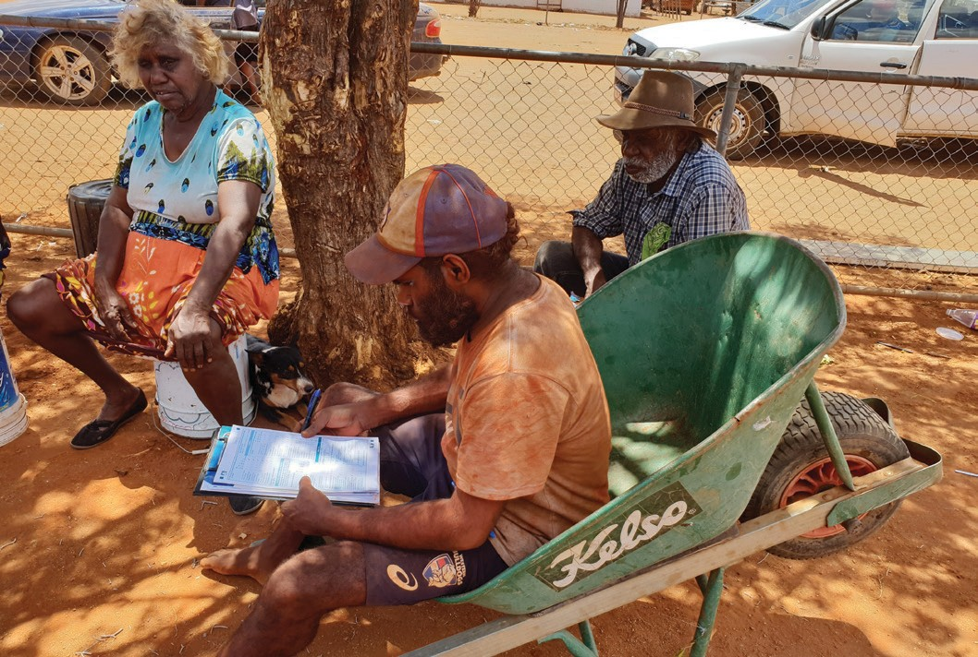

Research team knowing, from their own experiences and those of their families and communities, that culture and wellbeing are ‘inextricably linked’ for Aboriginal and Torres Strait Islander people, he says they did something ‘really simple’ with their protocols.
As they developed the study and the survey that is putting 110 questions on health and wellbeing to Aboriginal and Torres Strait Islander people, they went out and talked to members of more than 30 communities across Australia, from Wiradjuri land in New South Wales to the Torres Strait Islands, from the Anangu Pitjantjatjara Yankunytjatjara (APY) lands in central Australia to the Palawa in Tasmania.
“Ray and his team built up a relationship with us at the
Tangentyere research hub, meeting with us to make sure the survey
is culturally appropriate for all Aboriginal participants in and around Central Australia,” said Senior Researcher Vanessa Davis, from the Tangentyere Council Research Hub in Alice Springs.
“Before the actual survey was rolled out, I worked with the Mayi Kuwayu staff to conduct a trial survey in our town camps.”
In 2018 the project also undertook an extensive literature review of articles discussing Indigenous cultures, wellbeing and health spanning 20 years (1997–2017).
This review is currently the most
PHOTO: Engawala community, 180km north-east of Alice Springs. Carl Inkamala (in wheelbarrow) is a local man employed by MK to help explain the study, recruit community members and assist them with the survey, interviewing people in their first language of Eastern Arrernte

PHOTO: MK ambassador Nathan Schrieber, Gurugulu Clan of the Gunggandji people of Yarrabah, far north Queensland, where he is a language teacher
comprehensive and robust research on the cultural determinants of health for Aboriginal and Torres Strait Islander people that has been undertaken in Australia.
With the insights from both the review and the community consultations,
the Mayi Kuwayu team has identified six core cultural domains that now provide the framework for the study: connection to country, cultural beliefs and knowledge, language, family, kinship and community, expression and cultural continuity, and self- determination and leadership. The Mayi Kuwayu survey also aims to capture historical and contemporary experiences of Aboriginal and
Torres Strait Islander peoples, including exposure to racism, family and community wellbeing, and familial experiences of the Stolen Generations as well as health conditions.

Showing the way on data and governance
Having this study designed, led and governed by Aboriginal and Torres Strait Islander people, as well as deep engagement at the community level, are critical. So too is embedding Indigenous data sovereignty into the research, and independence.
The research team has set up an Indigenous data governance system that requires people who want to use the data—including
the Mayi Kuwayu team itself—to be vetted against a set of principles developed through the Maiam nayri Wingara Aboriginal and Torres Strait Islander Data Sovereignty Collective (see box Maiam nayri Wingara).
In addition, communities involved in the study are given back their own

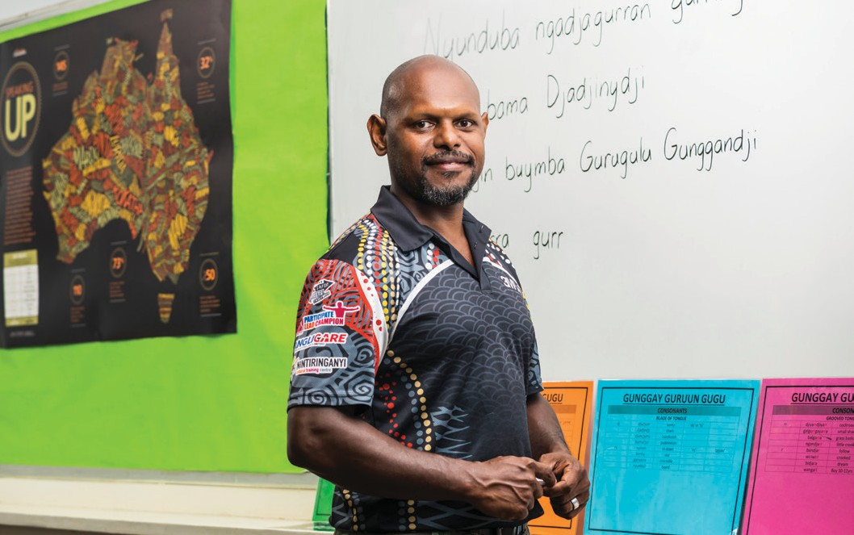

data in a way that suits them so that it can be used for their benefit.
As an example, the Central Land Council in Alice Springs knows the economic benefits of Ranger work but also wants to understand the benefits for health and wellbeing. The Mayi Kuwayu study is providing data over the long-term to measure this, as well as providing local training in understanding and demystifying statistical language and training people to undertake their own statistical analysis locally.
“We go for long-term working relationships, not one-off, short- term ones,” Ray says.
The study already has high recognition in many communities and is championed by local and national leaders, but it faces plenty of risks too.
Determined to be driven by community priorities, not a government agenda, the team made the decision from the start not to seek or accept any government funding. That makes it even more vulnerable to competitive research funding cycles but there are
hopes that the growing interest in the study by governments and
government agencies, who will have to pay for vetted access to the data, will help sustain it.
The long-term hope, Ray says, is that it will begin to shape policy and practice, providing the first community derived measures of culture and identifying opportunities to incorporate culture in programs and policy to improve Aboriginal and Torres Strait Islander wellbeing.

Maiam nayri Wingara Indigenous Data Sovereignty Collective
Indigenous Data Sovereignty is a global movement concerned with the right of Indigenous peoples to govern the creation, collection, ownership and application of their data.
Indigenous Data Sovereignty in Australia is derived from the inherent right of Aboriginal and Torres Strait Islander peoples to govern themselves, Country (including lands, waters and sky) and resources, as outlined in the United Nations Declaration on the Rights of Indigenous Peoples (UNDRIP), for which Australia has declared its support.
The Maiam nayri Wingara Aboriginal and Torres Strait Islander Data Sovereignty Collective was formed in early 2017 in order to develop Aboriginal and Torres Strait Islander data sovereignty principles and to identify Aboriginal and Torres Strait Islander strategic data assets.
It is made up of a key Working Group of Aboriginal and Torres Strait Islander academics with the aim of ‘empowering Aboriginal and Torres Strait Islanders to engage in Indigenous Data Sovereignty and to advocate for rights (informed by UNDRIP) using data to inform development.
The collective asserts that:

‘(D)ata is a cultural, strategic, and economic asset for Indigenous peoples. Indigenous Australians have always been active in what is now known as ‘data’. Yet in modern times we have been isolated from the language, control and production of data at community, state and national levels.
This has resulted in data that are overly focused on Indigenous peoples as the problem. Existing data and data infrastructure does not recognise or privilege our knowledges and worldviews nor meet our current and future needs.’

Source: Information reproduced from the Maiam nayri Wingara website. www.maiamnayriwingara.org

Cultural Expression and Continuity

Cultural expression, family, kinship and community are great sources of strength and resilience for Aboriginal and Torres Strait Islander peoples. As cultural determinants of health, they lie at the core of health and wellbeing.44 Ceremony, dance, song, stories, music, art, caring for Country, respect for Elders, family and community connections, and language are all
elements of Aboriginal and Torres Strait Islander peoples’ cultural expression.
Their practice promotes cultural identity, cultural continuity, healing, health and wellbeing.

Through colonisation, Aboriginal and Torres Strait Islander cultural practices were actively banned, punished and prohibited. This trauma of cultural suppression has had a profound effect on Aboriginal and Torres Strait Islander people’s identity, sense of belonging and, critically, their health and wellbeing. Cultural expression and practice can act as a means to overcome past trauma and can be the start of healing, with
practices such as art and art therapy having been found to enhance mental health and emotional and social wellbeing.45
The work of groups like NuunaRon (see case study, opposite) shows that the resurgence, practice
and nurturing of culture is healing and enhances health and wellbeing in ways other biomedical
approaches do not. Such programs, which provide opportunities for individual and community cultural practice and expression, need dedicated support and funding streams within government programs.
Due to the strength and resilience of Aboriginal and Torres Strait Islander peoples, cultural expression has survived the forces of colonisation and across the nation there are many examples of increasing recognition, respect and value for Aboriginal and Torres Strait Islander cultures within wider society.
Despite this growing recognition and respect, the effects of colonisation continue to play out today in ongoing racism experienced by Aboriginal and Torres Strait Islander people. It has been well documented that experiences of racism damage health and are a barrier for Aboriginal and Torres Strait Islander people accessing the health system and receiving high quality care.
Experiences of racism affect people’s sense of belonging and preparedness to be their ‘authentic selves’. Institutional racism and a lack of culturally safe work environments are also barriers to the recruitment and retention of Aboriginal and Torres Strait Islander health professionals.
Increasing the cultural safety of the health system is essential to adopting a zero-tolerance approach to racism and increasing access to and the quality of health care for Aboriginal and Torres Strait Islander people. Cultural safety can facilitate the systemic changes required to create the right environment across the health system for Aboriginal and Torres Strait Islander people, both as members of the health workforce and as clients seeking care, to be valued, respected, understood and treated as their full and authentic selves.

SECTION 4 CULTURAL EXPRESSION AND CONTINUITY

30 | We nurture our culture for our future, and our culture nurtures us.

30 | OUR VOICES, OUR CHOICES.

NuunaRon – Identity and Belonging Through Cultural Connection

Wiradjuri Elder Uncle Paul Constable-Calcott tells the story behind the painting he did for the Culture
is Inclusion exhibition at the United Nations

headquarters in Geneva in 2019.
Titled Mungo Man, it was inspired by the discovery of one of the oldest archaeological sites in Australia, at Lake Mungo in New South Wales.
Estimated to be over 40,000 years old, the site contains footprints in the mudflats of Aboriginal people who have been out hunting emus and kangaroos, including from a one- legged man who appears to have used a walking stick.
It’s a powerful message for Uncle Paul, who also uses a walking stick after having contracted polio as an infant, that ‘demonstrates that people with disabilities in our
community were participating in and contributing to community life back then’.
‘It shows we had a culture of inclusion and participation 40,000 years ago,’ He says. ‘That’s why it’s important to have culture at the heart of support for people with disabilities.’
Uncle Paul is the founder and facilitator of the deadly Queensland- based NuunaRon group of Aboriginal and Torres Strait artists and emerging artists living with disability.
With only about two months’ notice last year, the group completed 12 paintings on the Culture is Inclusion theme to mark and celebrate meetings on the United Nations Convention on the Rights of Persons with Disability (UNCRPD) at the Palais De Nations in Geneva.
It was a huge honour and achievement for a group that is unfunded and meets mostly out of Uncle Paul’s garage on the Sunshine Coast. Having tried unsuccessfully many times to attract funding, the group is grateful for the support
of the First Peoples Disability Network (FPDN) and the E.L.D.A group (Elders Living With Disability Australia).
The NuunaRon group is also represented on the advisory group for The National Arts and Disability Strategy, recognised for best practice on how to engage
Aboriginal and Torres Strait Islander people with disability in arts and storytelling.
Disability in Aboriginal and Torres Strait Islander communities is twice as prevalent, more complex in terms of co-occurring disabilities, and compressed within a shorter life expectancy compared to other Australians, says Dr Scott Avery, Research and Policy Director of the FPDN.
In his report, Culture is Inclusion: A narrative of Aboriginal and Torres Strait Islander people with disability, Scott notes that the sole category that is an exception to the inequalities experienced by

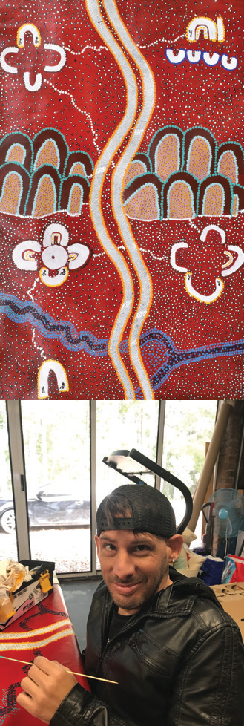
PHOTO: Brendan Ball working on his painting Tracks on the Sand, featured on the cover of this report

There was no massive plan, we just created this space
and it just grew, and people have found their identity there. We are a story telling people, but so many people have not had the opportunity to access and embrace culture. The impact it has on people is incredible.
Uncle Paul Constable-Calcott, Wiradjuri Elder

Aboriginal and Torres Strait Islander people with disability is their social participation within their own communities. Rates of participation by Aboriginal and Torres Strait Islander people with disability in cultural and community activities are on par with other Aboriginal and Torres Strait Islander people.
He concludes that a culture of inclusion ‘is a moderating force on social health and wellbeing and has a mitigating impact on intersectional inequality’.
That’s been the experience of NuunaRon, which was named in memory of two Elders who were among its early members: Aunty Nuuna, who was a saltwater Noonuccal woman, and Uncle Ron, a Kamilaroi man. Both were talented artists who lived with disability and supported others.
Uncle Paul says the group is ‘a bit of a mini United Nations ourselves’. It brings together people and language groups from across Australia, including Wiradjuri, Ningi Ningi, Wudjal Wudjal, Tharawal,
Kuku Yalanji and Djabugay, Djungan, Pitjantjatjara, palawan, Kalkadoon and Karbi Karbi.
All its members are living with disability or caring for someone with disability, ranging from Down Syndrome and autism, to mental illness, spina bifida, and heart disease.
Each artist has their own powerful story that they share in artworks, mapping journeys of struggle
and healing through connection, community, country and culture.
Yagambeh woman Allison Carey’s ‘Rising son’ tells the story of her son and his acceptance by community. Brendan Ball, a Wudjal man who uses a wheelchair, painted tyre marks in the sand because ‘not everybody leaves a footprint, but they might leave tracks’.
‘It’s pretty empowering to be able to share culture in other mob’s country,’ he says in one of a series of videos produced by the group.
Uncle Paul has his own stories, not least that his Wiradjuri father used to hide when government officials would come and visit the family home because he was so fearful, they would ‘take away his fair- skinned boy with a disability’.

45%
Aboriginal and Torres Strait Islander people living with
disability or long-term health condition
7.7%
Aboriginal and Torres Strait Islander people living with severe or profound disability
2.1x
More likely to be living with disability than
other Australians
19%
Aboriginal and Torres Strait Islander people with disability participate in the workforce
5x
More likely to experience mental illness than other Australians
.
First People with disability participate in cultural activities at the same rate as First
People without disability

Now Uncle Paul speaks with huge pride of the NuunaRon group and how they have taken one of the world’s oldest living cultures onto the world stage through their art.
‘I’ve seen one member go from being a young girl who wouldn’t look at anyone else to be a beautiful artist who now stands before crowds to tell her story,’ he says.
He hears from local mental health and disability services that group members no longer need as much professional support because they are supported by spending time in the group with Elders, developing long-term friendships, and sharing their stories through art.
Some have told Uncle Paul that belonging to the group is the first

time they have felt important. One said: ‘NuunaRon makes me want to get better.’ Another told him: ‘I don’t really need to see a psychologist anymore, sitting down with the Elders makes my spirit heal.’
It all speaks to the power of addressing social isolation and providing a safe place for community members living with disability to come together and build resilience, connect to culture, and support each other in keeping strong.
‘You might make someone better with tablets, but if they’re not leaving the house, not connecting to community, not finding their way to connect culturally, then all the Band Aids and medications in the world are not going to heal that side of things,’ Uncle Paul says.

Sources: Australian Bureau of Statistics 2016, National Aboriginal and Torres Strait Islander Social Survey, (NATSISS) 2014–15. Rel.
4714.0. & Avery, S. Culture is Inclusion: A narrative of Aboriginal and Torres Strait Islander people with disability. First Peoples Disability Network, Sydney

Creating a Culturally Safe Health System to Facilitate Cultural Expression and Wellbeing

Cultural safety is turning the gaze back on yourself and understanding your own biases, beliefs, racial profiling and where they come from, and then
understanding how to deal with that individually, in an organisation, and systemically. It’s a lifelong journey.
Janine Mohamed, CEO
Lowitja Institute

Over the last decade, there have been growing efforts from Aboriginal and Torres Strait Islander organisations to embed cultural safety across the health system and within health education, most significantly led by the
Aboriginal and Torres Strait Islander health workforce.
In response to calls from Aboriginal and Torres Strait Islander nurses and midwives, the Congress of Aboriginal and Torres Strait Islander Nurses and Midwives (CATSINaM), spearheaded a push away from cultural competence—a non- Indigenous philosophy originating in the United States—to the Indigenous theory of cultural safety developed by New Zealand Maori nurse Dr Irihapeti Ramsden.
These efforts culminated in cultural safety being embedded in the new codes of conduct for nurses and midwives in 2018, accompanied by a joint statement from CATSINaM and the Nursing and Midwifery Board of Australia on culturally safe and respectful care.
In 2018, CATSINaM’s leadership and advocacy led to 36 health peak bodies joining on as signatories to the Australian Health Practitioner
Regulation Agency (AHPRA) Statement of Intent on Aboriginal and Torres Strait Islander Health, which commits national boards, accreditation authorities and peak bodies in Indigenous health to making patient safety the norm for Aboriginal and Torres Strait Islander peoples and acknowledging the inextricable link between clinical and cultural safety.
Though far from a silver bullet for the systemic racism experienced by Aboriginal and Torres Strait Islander people, this has been an important step to put cultural safety on AHPRA’s agenda, together with parallel work to embed cultural safety in the National Safety and
Quality Health Service Standards for accreditation of hospitals and other health service organisations.
The move is already having a positive impact, engendering a real sense of pride among Aboriginal and Torres Strait Islander people working in the health system who, at the outset of the process, had expressed the stress of having to ‘walk in two worlds’.
Karl Briscoe, CEO of the National Aboriginal and Torres Strait Islander Health Worker Association (NATSIHWA), says racism and the burden of constantly having to
educate non-Indigenous colleagues on cultural safety are major contributors to burnout among the Indigenous workforce.

Aboriginal Health Workers and Health Practitioners are pivotal to advancing the cultural safety agenda, bringing a ‘cultural intellect’ that encompasses not only their lived experience but an emphasis on mind, body and spirit that considers social and
emotional wellbeing, importance of the extended family, connection to Country and the cycle of life-death- life.
Unique in Australia and the world, Karl says the Aboriginal and Torres Strait Islander workforce has been instrumental in gains to health
and wellbeing across a range of indicators. However, these gains
will continue to be incremental until cultural safety is mandated, in legislation, as part of medical education and registration for all doctors, nurses and allied health professionals, he said.
Lowitja Institute CEO Janine Mohamed recommends the next step will be for non-Indigenous allies to take up the challenge, in partnership with Aboriginal and Torres Strait Islander peoples, in acknowledging a shared history.
‘That’s the work of cultural safety: being brave, having hard conversations and stepping into your responsibility,’ she says.

PHOTO: NATSIHWA Board, L–R:
Front row: Yancy Laifoo (TSI), Aunty Thelma Western (ACT), Raeylene McKenna (WA)
Back row: Robert Dann (SA), Judith Parnham (Qld), Suzie Smith (Tas), Christine Ingram (Vic), Natalie Pangquee (NT) David Follent (NSW), Karl Briscoe (CEO)
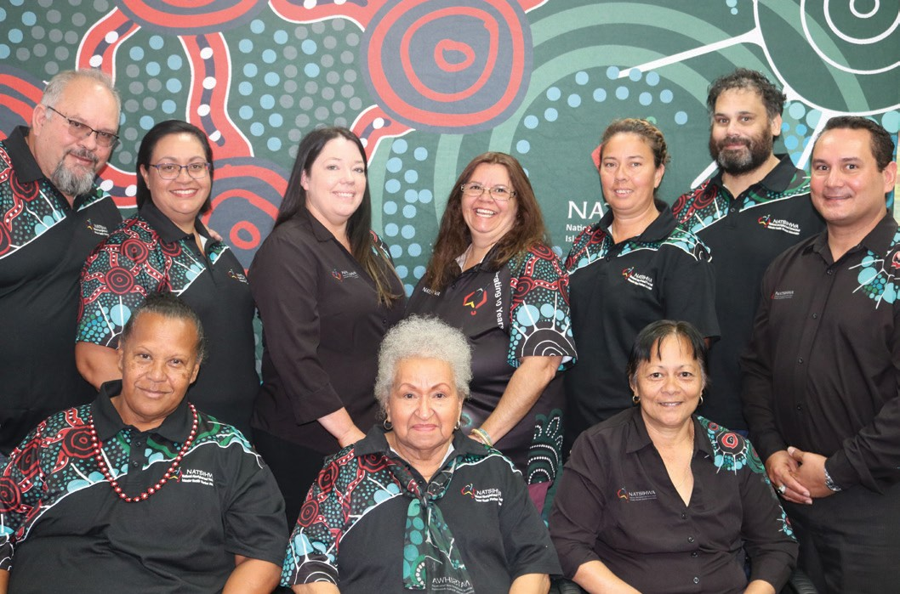

SECTION 5 CONNECTION TO COUNTRY

36 | We nurture our culture for our future, and our culture nurtures us.

Connection to Country

Aboriginal and Torres Strait Islander society is interconnected with land, sea and Country. Identity, cultural practices, social systems, traditions and concepts of spirituality all are drawn from and depend upon connection to Country. This connection has physical, spiritual and cultural dimensions, linking people to the Dreaming, language, kinship systems, law and culture, as well as to traditional foods and medicines.46
Aboriginal and Torres Strait Islander health is viewed in a holistic context, that encompasses mental health and physical, cultural and spiritual health. Land is central to wellbeing.
Crucially, it must be understood that
when the harmony of these interrelations is disrupted, Aboriginal and Torres Strait Islander ill health will persist.

Principle 1– National Strategic Framework for Aboriginal and Torres Strait Islander Peoples’ Mental Health and Social and Emotional Wellbeing 2017–2023

Caring for Country is not just the physical management of a geographic location, but refers to tending to the values, places, resources, stories and cultural obligations associated with that area as well as processes of spiritual renewal, connection with ancestors, maintenance of kin relations and food provision.47
By fostering a sense of identity, pride, belonging and autonomy, being on and caring for Country empowers and promotes health. As well as health benefits, Indigenous land management also has tangible benefits for the environment, contributing to emissions reduction, capture of greenhouse gases, soil stabilisation, mitigation of dust storms and bushfire smoke, and threatened species conservation.48 49
Fire has always been a part of caring for Country, and the unparalleled 2019–20 bushfire crisis has renewed interest in cultural burning practices, with anecdotal evidence of properties where such burns were carried out remaining untouched in fire-affected areas of NSW. These ‘cool’ or ‘mosaic’ methods are not only beneficial in terms of land management, they also have an important role in passing on local knowledge and connection to land.
Explains Yuin Elder Noel Webster from the Firesticks Alliance:
“Indigenous fire methodology is about reading landscape, listening to Country, and Country is boss. Country has the ultimate say, no legislation or piece of paper, or threshold, policy or procedure. Country is boss and that is the most important part to read when you do fire practice.”50

36 | OUR VOICES, OUR CHOICES.

Strong Women on Country and Working for our Country

The Country Needs People campaign is a growing group—of more than 40 Aboriginal and Torres Strait Islander land and sea management organisations, the Pew Charitable Trusts and tens of thousands of
Australians—that is calling on governments to invest in Indigenous rangers
and Indigenous Protected Areas across Australia.
The call comes amid evidence that working on Country has a strong influence on the health of people engaged in Indigenous Protected Area and Indigenous
ranger programs, with 70 per cent of projects reporting an improvement in the health and overall wellbeing of their rangers.
Peer reviewed medical research shows that caring for Country is associated with better nutrition, more frequent physical activity and fewer chronic disease risk factors and diagnoses.
The Country Needs People campaign last year published the Strong Women on Country report, showcasing the success of women caring for Country as Indigenous rangers and celebrating their work as ‘a contemporary expression of the unbroken and ancient connection of Aboriginal and Torres Strait Islander people to this continent’.
The report maps how Aboriginal and Torres Strait Islander women play a vital role across Australia protecting nature and cultural heritage for the benefit of every Australian.
‘Women rangers tackle environmental threats like feral animals, invasive weeds and destructive wildfires, as well as undertake cultural site and tourism infrastructure maintenance,’ it says. ‘At the same time, their work has transformative benefits for families, communities and for the women themselves.’
The following two pages highlight snapshots from the report: women working on Country across Australia talk about what the work means to them, and to culture, to community and Country.

This IPA, it’s the best medicine… it’s going back to country.
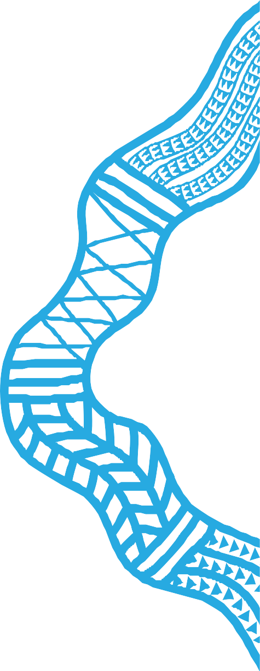
Margaret Nungarrayi Martin, Northern Tanami Indigenous Protected Area (IPA)

We need to teach our young people about culture so when they have kids and grow them up, they can teach them about the country they live in.
Karajarri Senior Cultural Ranger Jess Bangu in 2006 became the first woman ranger employed through the Kimberley Land Council. She has been involved in plant conservation through
a Kimberley seed bank, documentation of Karajarri knowledge about plants, worked to protect important coastal swale thickets, recorded five different dialects for a digitised Karajarri dictionary and led biodiversity surveys to record ecological knowledge.

Looking after country is more than just a job for me, it’s part of who I am. The trees, the soil, the water, the animals—we’re responsible for keeping them healthy. And when we keep country healthy, it sets us right too.
Joelwyn Johnson is a Nantawarrina Ranger working in the Nantawarrina Indigenous Protected Area in northern South Australia. It
was Australia’s first Indigenous Protected Area and celebrated its 20th anniversary in 2018. Now over 67 million hectares of Australia—10 times the size of Tasmania and close to half of the Australian National Reserve System—are cared for through Indigenous Protected Areas.

PHOTO: Nantawarrina Rangers, Julette Johnson and Joelwyn Johnson. Credit Annette Ruzicka

I want our country to be a place where our children learn cultural values as well as have access to economic and social opportunities. Our country
is a meeting place for family and community gatherings where knowledge is shared and what we see now, generations will see in the future.
Tanya Elone has grown Banbai Enterprise Development Aboriginal Corporation to become the largest employer of Aboriginal people in the Northern Tablelands of New South Wales, working in the Banbai- Wattleridge Indigenous Protection Area, the first to be declared in the state. It has become a springboard for employment, new businesses opportunities and a revitalisation of cultural knowledge and pride.
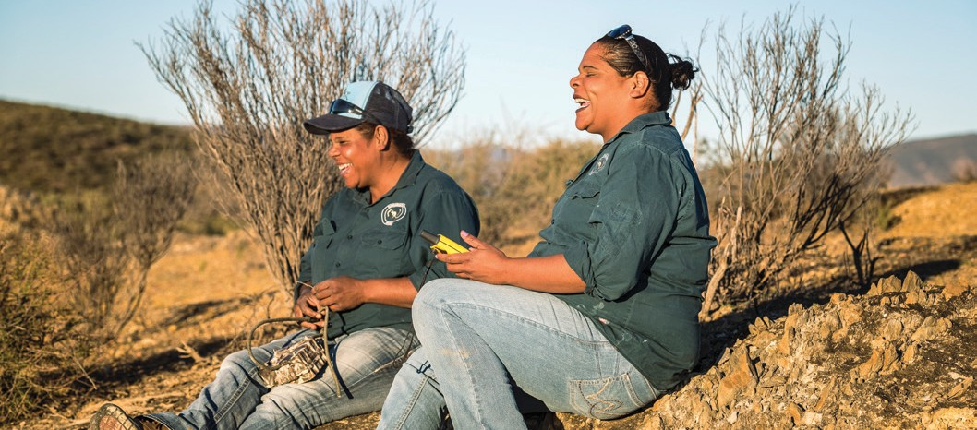

The work we do on our land makes not only the Traditional Owners happy, but the land itself. It also makes us feel proud of ourselves and what we’re doing. Sometimes I feel very emotional because the work we’re doing is the work our ancestors have been doing for many years before we came along.
Barbara Petrick works with the Arltarpilta Inelye Rangers, based at the Atitjere (Harts Range) community in the Northern Territory. The group’s bush medicine program has led to the development of a range of bush medicine products, training for local nursing staff in their use, and the launch of the 2016 Bush Medicines of the Plenty Region resource for community members in schools, health clinics, child care centres and women’s centres in the region.

Strong Women on Country: The success of women caring for Country as Indigenous rangers and on Indigenous Protected Areas, available at: https://www.countryneedspeople.org.au/empowering_women

Only some of us know the traditional names of animals, birds, marine creatures, tides, seasons, and plants; the traditional usage for cooking and medication. We share and seek confirmation and gather more information from our elders, so that this knowledge is stored in the Traditional Ecological Knowledge information system for future generations.
Laura Pearson is a senior ranger supervisor for the Torres Strait Regional Authority Rangers, working on the central island cluster of Iama, Poruma and Warraber Islands. As well as managing staff, her work includes tagging and monitoring turtles, Indigenous Protected Area surveys, weed eradication, and educating the community about the sustainable management of turtles and dugong. She is also involved in work bringing together Elders with the community to record and revive language and traditional knowledge.

PHOTO: Lama Lama Rangers. Credit Annette Ruzicka
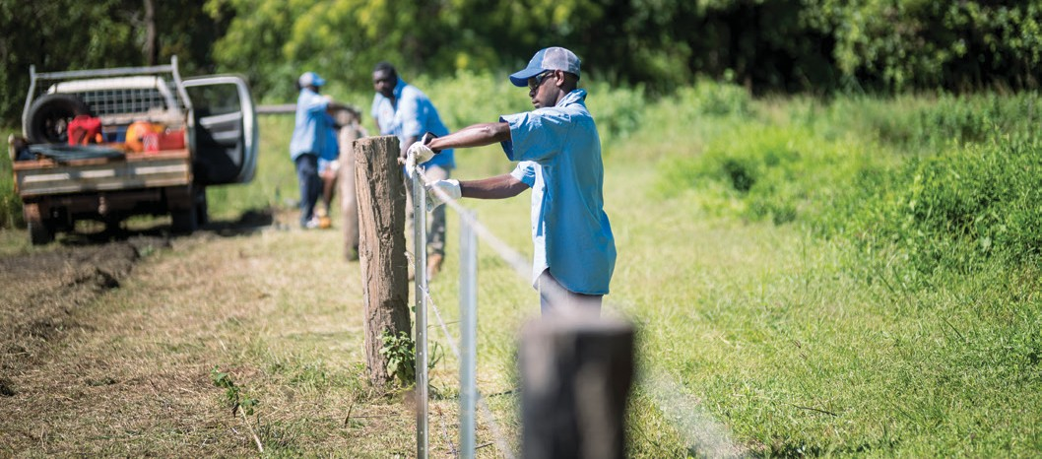

Climate Change – An Existential Threat to Culture, Community and Country
As custodians of cultures with holistic and enduring ties to the land dating back at least 65,000 years, Aboriginal and Torres Strait Islander people stand to be uniquely affected by accelerating climate change.

Climate change is already presenting urgent existential threats to Aboriginal and Torres Strait Islander communities. The widespread and ongoing exclusion of Aboriginal and Torres Strait Islander peoples from accessing and managing traditional homelands creates intense trauma and grief from witnessing unprecedented climatic events such as the 2019–2020 bushfires, which affect significant landforms, animals, plants and sacred sites on Country.51 52
Ongoing drought has meant almost 100 towns across NSW and Queensland, including places with significant Aboriginal populations, have been running out of water. Water sourced
from the Great Artesian Basin has been found to contain sodium at 15 times the level recommended for people with chronic health conditions. Water insecurity has also affected
the use of evaporative cooling, and personal or community cultivation of fresh produce.
Food insecurity is experienced by at least one- third of remote households.53 In the New South Wales town of Walgett, community members have relied on packaged water donations distributed by the Aboriginal Medical Service after the Namoi and Barwon rivers dried up.
The impact on the local Yuwaalaraay/ Gamilaraay people has been profound, as AMS CEO Christine Corby explained in a report from the Yuwaya Ngarra-li Walgett Food Forum:
“The devastation to our rivers, no rain, the lack of water flow, loss of fishing for traditional foods and gathering of plant food is very
significant to the deterioration of the social and emotional wellbeing of our community.”54
Outstations in Central Australia face similar water shortages, and poor quality housing has left many Aboriginal communities vulnerable to extreme and prolonged heat events.55 There are fears that accelerating climate change
will soon render significant areas of the Northern Territory unliveable, displacing tens of thousands of people from their homelands.56 Extreme heat events have also been found to pose a risk to expectant Aboriginal mothers in Central Australia by increasing the chances of early birth.57
In the Torres Strait, rising seas, coastal erosion, king tides and extreme weather are threatening livelihoods and traditional ways of life, with the region’s rich socio-ecological endowment now dangerously depleted.58 Homes, fishing and burial grounds are being overrun, disrupting connection to Country and ancestors, with forced migration from the islands expected in coming decades.
While at the frontlines of climate change, Aboriginal and Torres Strait Islander peoples are also uniquely equipped to meet its impacts and are already driving innovative solutions to the climate crisis. Examples include:

- 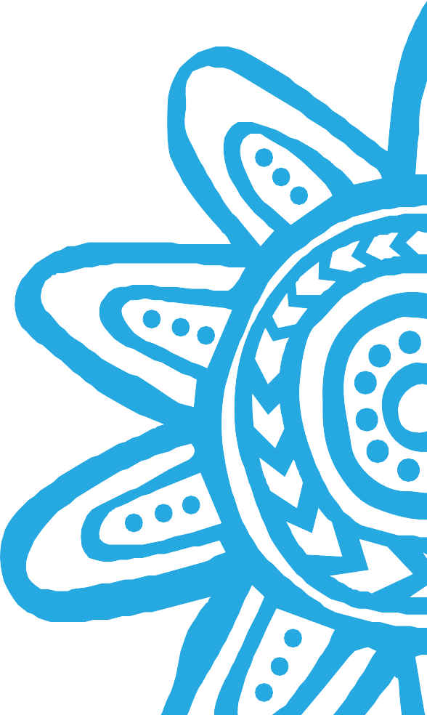The Yuwaya Ngarra-li (Vision) collaboration between the Dharriwaa Elders Group, the University of NSW and the Walgett Aboriginal Medical Service which is centring community conceived responses to the town’s food and water crisis, including communal gardens, bush foods and a co-op café.60
- In Central Australia and Cape York, the Apunipima Cape York Council and Central Australian Aboriginal Congress are co-leading a University of Queensland food security pilot using loyalty cards to discount and promote purchase of healthy foods.61
- In the Torres Strait, the Meriba buay—ngalpan wakaythoemamay (We come together to share our thinking) community of practice is combining Western science and research with local experiential (personal, traditional and cultural) knowledge to confront the climate emergency. In collaboration with Elders, the group is using stories, music, dance and visual art to grow community awareness and ownership of the impacts of climate change and to explore solutions.62
The researchers say:

“Our communities know that climate change is very real and is impacting on their communities in very real and very dramatic ways, almost on an annual basis. There’s no turning back climate change and environmental devastation.”
“But how do we own that, how do we motivate our communities to have agency, to be able to use both our own knowledge, our own experiential knowledge, our traditional knowledge, our cultural knowledge, and
how do we use that, together with research knowledge or scientific evidence about climate change, to make a real difference in terms of strength and resilience in our communities?”

Sixty years from now youfla all islan people e listen. Them islan e gor underneath water.
Youfla gor be like seagulls roaming the skies forever, with nowhere to land.59
Elder Jeffrey Aniba Waia

Conclusion

For millennia, Aboriginal and Torres Strait Islander peoples have kept their cultures strong to nurture their health and wellbeing.

The case studies and examples in this report show the continuation of this practice. Through self- determination, leadership, sharing and creating knowledge, cultural expression and exchange, and caring for Country, Aboriginal and Torres Strait Islander peoples are nurturing their culture for their health and wellbeing and that of future generations.
Just like the struggle Aboriginal and Torres Strait peoples have fought over recent decades to see the continuity and resurgence of their culture, the cultural determinants
of health will continue to be the foundation for Aboriginal and Torres Strait Islander health and wellbeing into the future. This future path
can continue to happen through the determination and resilience of Aboriginal and Torres Strait Islander people moving against the tide of the health system and dominant culture or it can happen through
a swell of system reform and supportive action from governments and organisations determined to enhance the health and wellbeing of First Nations peoples.

Together it is people like yourselves, here today, who need to imagine
what a completely different system would look like and to make that a reality.
Commissioner June Oscar AO63

Acronyms and Abbreviations

ACCHOs | Aboriginal Community Controlled Health Organisations |  | FPDN | First Peoples Disability Network
AHPRA | Australian Health Practitioner Regulation Agency |  | IPA | Northern Tanami Indigenous Protected Area
APY | Anangu Pitjantjatjara Yankunytjatjara |  | NATSIHP | National Aboriginal and Torres Strait Islander Health Plan 2013– 2023
AIATSIS | Australian Institute of Aboriginal and Torres Strait Islander Studies |  | NATSIHWA | National Aboriginal and Torres Strait Islander Health Worker Association
AIDA | Australian Indigenous Doctors’ Association |  | NAAJA | North Australian Aboriginal Justice Agency
AIPA | Australian Indigenous Psychologists Association |  | UNDRIP | United Nations Declaration on the Rights of Indigenous Peoples
ALNF | Australian Literacy & Numeracy Foundation |  | UNCRPD | United Nations Convention on the Rights of Persons with Disability
CATSINaM | Congress of Aboriginal and Torres Strait Islander Nurses and  Midwives |  | WHO | World Health Organization
COAG | Council of Australian Governments

Endnotes

- Human Rights and Equal Opportunity Commission (2005), Social Justice Report: Report of the Aboriginal & Torres Strait Islander Social Justice Commissioner, available at https://www.humanrights. gov.au/sites/default/files/content/social_justice/ sj_report/sjreport05/pdf/SocialJustice2005.pdf
- Gardiner-Garden, J. (2013), Closing the Gap, Parliament of Australia, accessed 21 February 2019 at https://www.aph.gov.au/About_Parliament/ Parliamentary_Departments/Parliamentary_Library/ pubs/BriefingBook44p/ClosingGap
- The Close the Gap Campaign Steering Committee (2018), A ten-year review: the Closing the Gap Strategy and recommendations for reset, available at https://www.humanrights.gov.au/our-work/aboriginal- and-torres-strait-islander-social-justice/publications/ close-gap-10-year-review
- National Indigenous Australians Agency (2020), Closing the Gap Report 2020, Australian Government, available at https://ctgreport.niaa.gov. au/life-expectancy
- Australian Institute of Health and Welfare (2016), Australian Burden of Disease Study: Impact and causes of illness and death in Aboriginal and Torres Strait Islander people 2011—Summary report, Australian Burden of Disease Study series no. 7. Cat. no. BOD 8., AIHW, Canberra.
- Oscar, J. (2020), ‘June Oscar’s 2020s vision: Reaching our potential as a nation begins with truth-telling’, Guardian Australia, 31 January 2020,
available at https://www.theguardian.com/australia- news/2020/jan/31/june-oscars-2020s-vision- reaching-our-potential-as-a-nation-begins-with-truth- telling
- Commonwealth of Australia (2017), My Life My Lead - Opportunities for strengthening approaches to the social determinants and cultural determinants of Indigenous health: Report on the national
consultations December 2017, Department of Health, available at https://www1.health.gov.au/internet/ main/publishing.nsf/Content/D2F6B905F3F667DA CA2580D400014BF1/$File/My%20Life%20My%20
Lead%20Consultation%20Report.pdf
- Parbury, N. (1986), Survival, a history of Aboriginal life in New South Wales, New South Wales Ministry of Aboriginal Affairs, Sydney.
- Fogarty, W., Bulloch, H., McDonnell, S. & Davis, M. (2018), Deficit Discourse and Indigenous Health: How narrative framings of Aboriginal and Torres Strait Islander people are reproduced in policy, The Lowitja Institute, Melbourne.
- World Health Organization, Social determinants of health, available at https://www.who.int/social_ determinants/sdh_definition/en/
- Australian Institute of Health and Welfare (2016),
Australia’s health 2016, Australia’s health series no.
15. Cat. no. AUS 199, Canberra, available at https:// www.aihw.gov.au/getmedia/d115fe0f-9452-4475- b31e-bf6e7d099693/ah16-4-2-social-determinants- indigenous-health.pdf.aspx
- Brown, N. (2014), Promoting a social and cultural determinants approach to Aboriginal and Torres Strait Islander Affairs, paper to the Lowitja Institute Cultural Determinants Roundtable, November.
- Anderson, I., Baum, F. & Bentley, M. (eds) (2004), Beyond Bandaids: Exploring the underlying social determinants of Aboriginal health. Papers from the Social Determinants of Aboriginal Health Workshop, Adelaide, July 2004, Cooperative Research Centre for Aboriginal Health, Darwin.
- Salmon, M., Doery, K., Dance, P., Chapman, J., Gilbert, R., Williams, R. & Lovett, R. (2019), Defining the Indefinable: Descriptors of Aboriginal and Torres Strait Islander Peoples’ cultures and their links to health and wellbeing, Aboriginal and Torres Strait Islander Health Team, Research School of Population Health, The Australian National University, Canberra, p1.
- Department of the Prime Minister and Cabinet (2017), National strategic framework for Aboriginal and Torres Strait Islander peoples’ mental health and social and emotional wellbeing 2017-2023, Commonwealth of Australia, Canberra.

- Lowitja Institute (2014), Cultural Determinants Roundtable, 26 November 2014: Background Paper, available at https://www.lowitja.org.au/content/ Document/PDF/Cultural-Determinants-Roundtable- Background-Paper.pdf
- Gee, G., Dudgeon, P., Schultz, C., Hart, A & Kelly, K (2014), Aboriginal and Torres Strait Islander social and emotional wellbeing, in Dudgeon, P., Milroy, H., Walker, R., (ed), Working together: Aboriginal and Torres Strait Islander mental health and wellbeing principles and practice (2nd ed., pp. 55-68), Department of the Prime Minister and Cabinet, Canberra; Commonwealth of Australia (2017), National Strategic Framework for Aboriginal and Torres Strait Islander Peoples’ Mental Health and Social and Emotional Wellbeing, Department of the Prime Minister and Cabinet, Canberra
- Milroy, H. (2010), ‘The Dance of Life’ Concept Framework applied in the Australian Indigenous Doctors’ Association and Centre for Health Equity Training, Research and Evaluation, UNSW. Health Impact Assessment of the Northern Territory Emergency Response, Australian Indigenous Doctors’ Association.
- Yap, M. & Yu, E. (2016) ‘Community wellbeing from the ground up: a Yawuru example’, Bankwest Curtin Economics Centre Research Report 3/16 August, available at http://www.curtin.edu.au/local/docs/ bcec-community-wellbeing-from-the-ground-up-a- yawuru-example.pdf
- Salmon, M., et al (2019), op cit.
- Franks, C. & Curr, B. (1996), cited at piii, Australian Indigenous Doctors’ Association and Centre for Health Equity Training, Research and Evaluation, UNSW, Health Impact Assessment of the Northern Territory Emergency Response, Canberra, 2010, available at https://www.aida.org.au/wp-content/ uploads/2017/08/AIDA_HIA.pdf.
- Salmon, M., et al (2019), op cit. p24
- Israel, I. (2017), ‘Archie Roach on the healing power of song: ‘Music was great therapy for me’’, Guardian Australia, accessed at 25 February 2020, available at https://www.theguardian.com/culture/2017/feb/22/ archie-roach-on-the-healing-power-of-song-music- was-great-therapy-for-me
- Indigenous Voice (2019), UN declares International Decade of Indigenous Languages, 22 December 2019, available at https://www.indigenousvoice.com/ en/un-declares-international-decade-of-indigenous- languages.html
- Yu, P., (2018), ANU Reconciliation Lecture: Reconciliation, Treaty Making and Nation Building, Australian National University, Canberra, 27 February 2018, available at https://www.anu.edu.au/news/
all-news/2018-anu-reconciliation-lecture-full-speech- by-peter-yu
- Australian Human Rights Commission and National Congress of Australia’s First People, (2010), The Community Reference Guide to the UN Declaration on the Rights of Indigenous People, available at https://www.humanrights.gov.au/our-work/aboriginal- and-torres-strait-islander-social-justice/publications/ community-guide-un.
- Corntassel, J. (2008), ‘Towards sustainable self- determination: Rethinking the contemporary Indigenous-rights discourse’, Alternatives, Vol 33, Issue 1, 2008.
- Dudgeon, P., Calma, T., Milroy, J., McPhee, R., Darwin, L., Von Helle, S. & Holland, C. (2018), Indigenous governance for suicide prevention in Aboriginal and Torres Strait Islander communities: A guide for primary health networks, Centre of Best Practice in Aboriginal and Torres Strait Islander Suicide Prevention, Poche Centre for Indigenous
Health and Wellbeing, University of Western Australia & Black Dog Institute, available at https://www. cbpatsisp.com.au/wp-content/uploads/2019/09/ FINAL-WEB-COPY-IGF-v8.pdf
29. Salmon, M., et al (2019), p29.

  - Australian Indigenous Governance Institute and Reconciliation Australia, Indigenous Governance Fact Sheets (6), Nation Building and Development, accessed at 16 January 2020 https://www. reconciliation.org.au/wp-content/uploads/2018/07/ nation-building.jpg
  - Martini, A., Marlina, U., Dwyer, J., Lavoie, J., O’Donnell, K. & Sullivan, P. (2011), Aboriginal Community Controlled Health Service Funding: Report to the Sector 2011, The Lowitja Institute, Melbourne.
  - Forell, S. & Nagy, M. (2019), Joining the dots: 2018 census of the Australian health justice landscape, Health Justice Australia, Sydney.
  - SNAICC – National Voice for our Children (2019), The Family Matter Report 2019, available at https://www. familymatters.org.au/the-family-matters-report-2019/
  - Australian Bureau of Statistics, 4512.0 Corrective Services, Australia, September Quarter 2019.
  - Australian Bureau of Statistics, 4517.0 Prisoners in Australia, 2018.
  - Australian Institute of Health and Welfare (2019),
Youth Justice in Australia 2017-18, AIHW, Canberra.
  - Change the Record, Get the facts, available at https://changetherecord.org.au/get-the-facts
  - Kendall, S., Baldry, E., Sullivan, E., Sherwood,
J. & Lighton, S. (2019), ‘Aboriginal mothers are incarcerated at alarming rates – and their mental and physical health suffers’, The Conversation, 22 May 2019, available: https://theconversation.com/ aboriginal-mothers-are-incarcerated-at-alarming- rates-and-their-mental-and-physical-health- suffers-116827
  - ibid
  - Shibasaki, S., Sibthorpe, B., Watkin Lui, F., Harvey, A., Grainger, D., Hunter, C. & Tsey, K. (2019), ‘Flipping the researcher knowledge translation perspective
on knowledge use: a scoping study’, AlterNative, An International Journal of Indigenous Peoples, Vol 15, Issue 3, 2019
  - Morrissey, M., Pe-Pua, R., Brown, A. & Latif, A. (2004), ‘Culture as a determinant of Aboriginal health’, in Anderson, I., Baum, F., Bentley, M. (eds) (2004), op cit.
  - Shibasaki, S. et al (2019), op cit.
  - Morrissey, M. et al (2004), op cit.
  - Salmon, M. et al (2019), p24.
  - ibid, p26
  - ibid
  - Weir, J.K., Stacey, C. & Youngentob, K. (2011), The benefits associated with Caring for Country: Literature Review, Report for the Department of Sustainability, Environment, Water, Population and Communities (SEWPaC), SEWPaC, Canberra, available at https://aiatsis.gov.au/publications/ products/benefits-associated-caring-country
  - Campbell, D. (2015), ‘Aboriginal involvement in caring-for-country: an economic case study in primary preventative health’, Australasian Psychiatry, 23(6), 623-625. 10.1177/1039856215612985.
  - Rose, D. B. (1996), Nourishing Terrains: Australian Aboriginal views of landscape and wilderness, Australian Heritage Commission, Canberra.
  - Knowles, R. (2020), ‘Talk is cheap, time for action: Yuin man promotes traditional fire management practices’, National Indigenous Times, https://nit. com.au/talk-is-cheap-time-for-action-yuin-man- promotes-traditional-fire-management-practices/
  - Williamson, B., Weir, J. & Cavanagh, V. (2020), ‘Strength from perpetual grief: how Aboriginal people experience the bushfire crisis’, The Conversation, 10 January 2020, available at https://theconversation. com/strength-from-perpetual-grief-how-aboriginal- people-experience-the-bushfire-crisis-129448.
  - Pickrell, J. (2020), ‘Thousands of ancient Aboriginal sites probably damaged in Australian fires’, Nature, 23 January 2020, available at https://www.nature. com/articles/d41586-020-00164-8.
  - Australian Bureau of Statistics (2015), 4727.0.55.005
- Australian Aboriginal and Torres Strait Islander Health Survey: Nutrition Results - Food and Nutrients, 2012-13.
  - Yuwaya Ngarra-li Walgett Food Forum , 2019 Forum Report (2019), available at https://www. dharriwaaeldersgroup.org.au/images/downloads/ YuwayaNgarra-liFoodForumReport27June.pdf

  - Grata Fund, First Nations Remote Housing Rights
– Santa Teresa, accessed on 12 February 2020 at https://www.gratafund.org.au/remote_aboriginal_ housing_rights
  - Allam, L. & Evershed, N. (2019), ‘Too hot for humans? First Nations people fear becoming Australia’s first climate refugees’, Guardian Australia, available at https://www.theguardian.com/australia-news/2019/ dec/18/too-hot-for-humans-first-nations-people-fear- becoming-australias-first-climate-refugees
  - Auger, N., Naimi, A., Smargiassi, A., Lo, E., Kosatsky, T. (2014), ‘Extreme heat and risk of early delivery among preterm and term pregnancies’, Epidemiology, 25(3):344-50. doi: 10.1097/ EDE.0000000000000074.
  - Shibasaki, S. & Watkin Lui, F. (2019), ‘Profiling Torres Strait Islander solutions for environmental sustainability’, Croakey, available at https://croakey. org/profiling-torres-strait-islander-solutions-for- environmental-sustainability/
  - Quote from Jeffrey Aniba Waia, Woer Wayepa, Meriba buay – ngalpan wakaythoemamay (We come together to share our thinking), available at https:// www.youtube.com/watch?v=MqwQMpDignY&featur e=youtu.be
  - Yuwaya Ngarra-li Walgett Food Forum (2019), op cit.
  - University of Queensland (2020), Study to fight food insecurity in Indigenous communities, available at https://www.uq.edu.au/news/article/2020/01/study- fight-food-insecurity-indigenous-communities
  - Shibasaki, S. et al (2019), op cit.
  - 61. Oscar, J. (2019), ‘Strong Communities, Strong Kids’, Speech to the AbSec Biennial Conference, 20 November 2019, available at https://www. humanrights.gov.au/about/news/speeches/strong-
communities-strong-kids-absec-biennial-conference

Close the Gap Campaign Steering Committee Members

- Aboriginal Health and Medical Research Council of New South Wales
- Aboriginal Health Council of South Australia (AHCSA)
- ANTaR
- Australian College of Emergency Medicine
- Australian College of Midwives
- Australian College of Nursing
- Australian College of Rural and Remote Medicine
- Australian Council of Social Service
- Australian Healthcare and Hospitals Association
- Australian Human Rights Commission
- Australian Indigenous Doctors’ Association
- Australian Indigenous Psychologists’ Association
- Australian Medical Association
- Australian Physiotherapy Association
- Australian Student and Novice Nurse Association
- Beyond Blue
- Cancer Council of Australia
- Community Mental Health Australia
- Congress of Aboriginal and Torres Strait Islander Nurses and Midwives
- CRANAplus
- Expert Adviser – Alcohol and Other Drugs, Professor Pat Dudgeon
- Expert Adviser – Epidemiology and Public Health, Professor Ian Ring
- First Peoples Disability Network
- Heart Foundation Australia
- Indigenous Allied Health Australia
- Indigenous Dentists’ Association of Australia
- Indigenous Eye Health Unit, University of Melbourne
48 | We nurture our culture for our future, and our culture nurtures us.
- Kidney Health Australia
- Lowitja Institute
- Menzies School of Health Research
- National Aboriginal and Torres Strait Islander Health Workers’ Association
- National Aboriginal Community Controlled Health Organisation (NACCHO)
- National Association of Aboriginal and Torres Strait Islander Physiotherapists
- National Congress of Australia’s First Peoples
- National Coordinator: Tackling Indigenous Smoking - Dr Tom Calma AO, Campaign founder and former Aboriginal and Torres Strait Islander Social Justice Commissioner
- National Family Violence Prevention Legal Services
- National Rural Health Alliance
- NSW Aboriginal Land Council
- Oxfam Australia
- Palliative Care Australia
- PHILE Network
- Public Health Association of Australia
- Reconciliation Australia
- Royal Australasian College of Physicians
- Royal Australian College of General Practitioners
- SBS, the home of National Indigenous Television (NITV)
- The Fred Hollows Foundation
- The Healing Foundation
- The Pharmacy Guild of Australia
- Torres Strait Regional Authority
- Victorian Aboriginal Community Controlled Health Organisation (VACCHO)
- Winnunga Nimmityjah Aboriginal Health Service

We nurture our culture for our future, and our culture nurtures us. | 49

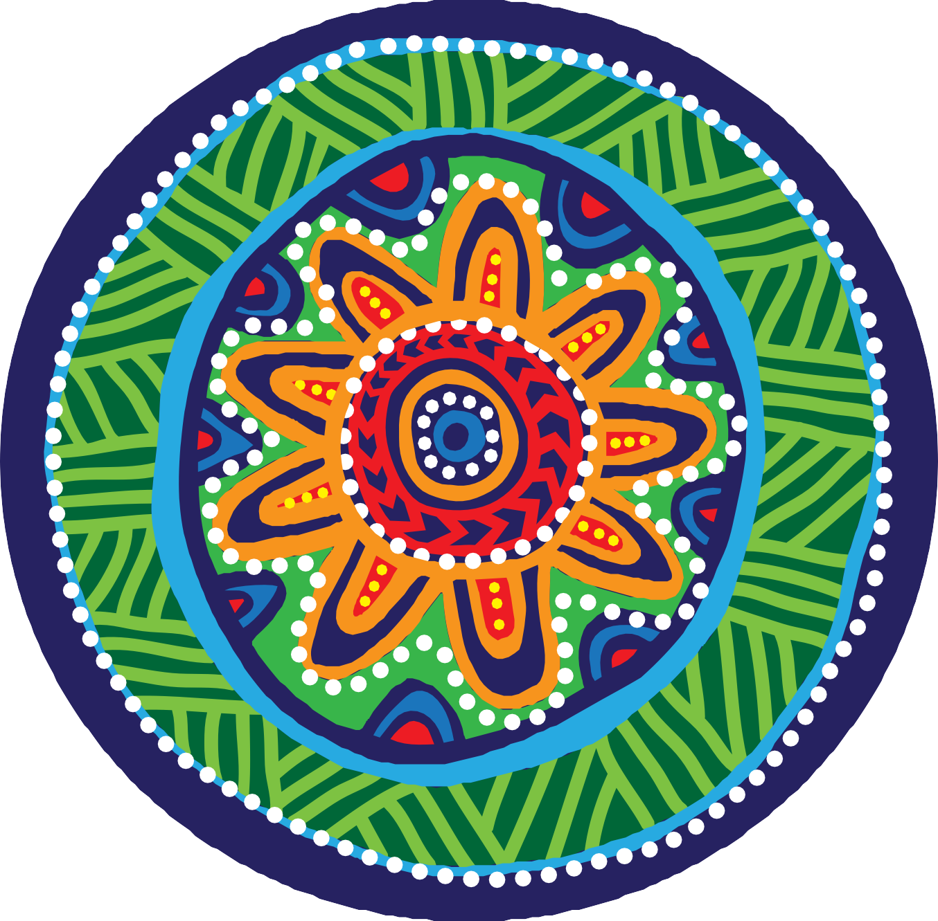

50 | We nurture our culture for our future, and our culture nurtures us.

